

Should police be attending and dealing with mental health incidents?

Student: Annelise Williams
Student number: 2134290

Degree: BSc (Hons) Professional Policing Practice
UWTSD 2025

Acknowledgement
Firstly, I would like to thank all of the university and police staff from my time at training who have helped me throughout this process. I would also like to thank all my colleagues who have been very supportive.
In addition, I would also like to thank you to my mentor Fern Thomas who has offered me guidance, support and directing me towards successfully completing my dissertation.
Finally, I would like to thank my parents who have offered me great level of support throughout my three years of university whilst also working fulltime.

Declaration
This work has not previously been accepted in substance for any degree and is not being concurrently submitted in candidature for any degree.
Signed: Awilliams
Date: 27/03/2025

STATEMENT 1
This dissertation is being submitted in partial fulfilment of the requirements for the degree of BA.
Signed: Awilliams
Date: 27/03/2025

STATEMENT 2
This dissertation is the result of my own independent work/investigation, except where otherwise stated.
Other sources are acknowledged by footnotes giving explicit references. A bibliography is appended.
Signed: Awilliams
Date: 27/03/2025

STATEMENT 3
I hereby give consent for my dissertation, if accepted, to be available for photocopying and for interlibrary loan, and for the title and summary to be made available to outside organisations.
Signed: Awilliams
Date: 27/03/2025

STATEMENT 4
I hereby give consent for my dissertation, if accepted, to be available on the university’s IT system to those who have consent to use the system.
Signed: Awilliams
Date: 27/03/2025

Abstract
The aim of this dissertation is to evaluate whether police officers should be attending and dealing with mental health incidents.
The researcher believes that this is a significant area of research, as police officers deal with a high volume of mental health incidents. Mental health incidents take up a lot of police officers time and often many officers feel like they have had inadequate training to deal with these incidents and instead should be dealt with by mental health professionals.
The researcher has carried out a critical analysis of existing research surrounding mental health training that officers receive, the Right Care Right Person approach and if it has reduced police involvement within mental health incidents and has evaluated best practices for mental health incidents. To assist with the researcher’s own research, the researcher compiled their own survey which was completed by current serving response officers. The data which was compiled, evaluated and compared to existing research highlighting interesting results as well as areas identified for further research.
Having completed the research, it was possible to answer the research question which has been supported academically, as well as identifying further areas for future research.

Table of contents
Chapter 1: Introduction
1.1: Introduction………………………………………………………………………………………………………7
1.2: Background and rationale………………………………………………………………………………….7
1.3: Aims and objectives………………………………………………………………………………………….7-8
Chapter 2: Literature review
2.1 Background…………………………………………………………………………………………………………9
2.2 Do police officers have enough training to deal with mental health calls?.................9-11
2.3 The ‘Right Care Right Person’ approach…………………………………………………………..11-13
2.4 Best practise for handling mental health incidents………………………………………….13-14
2.5 The gaps in the research……………………………………………………………………………………..14
2.6 Conclusion…………………………………………………………………………………………………………15
Chapter 3: Methodology
3.1 Introduction…………………………………………………………………………………………………………………...16
3.2 Research strategy………………………………………………………………………………………………………16-17
3.3 Data collection………………………………………………………………………………………………………………..17
3.4 Limitations…………………………………………………………………………………………………………………….18
3.5 Conclusion…………………………………………………………………………………………………………………….18
Chapter 4: Analysis of results and findings
4.1 Introduction…………………………………………………………………………………………………………………19
4.2 Data analysis and finding’s objective 1………………………………………………………………………19-21
4.3 Data analysis and finding’s objective 2………………………………………………………………………21-24
4.4 Data analysis and finding’s objective 3………………………………………………………………………24-25
Chapter 5: Conclusions and recommendations
5.1 Conclusion……………………………………………………………………………………………………………………26
5.2 Recommendations……………………………………………………………………………………………………26-27
5.3 Limitations……………………………………………………………………………………………………………………27
5.4 Practical implications……………………………………………………………………………………………………28
Chapter 6: Bibliography………………………………………………………………………………………29-31
Chapter 7: Appendices
7.1……………………………………………………………………………………………………………………32-36
7.2………………………………………………………………………………………………………………………37
7.3……………………………………………………………………………………………………………………37-38

Chapter 1: Introduction
  - Introduction
This dissertation will look at whether police constables should be attending and dealing with mental health calls within police forces in the United Kingdom. It will discuss whether there is enough training given to police to deal with mental health incidents and if new approaches have helped in reducing the amount of time police spend at these incidents. It will then also compare how different police forces deal with mental health incidents and evaluate which approach is the best practice to deal with mental health.
  - Background and rationale
This subject was chosen by the researcher as this is something they have a firsthand experience with. Due to their personal role in the police force, they deal with mental health related incidents on a day-to-day basis. It was of interest to the researcher as to why the police force in this current day and age are attending and dealing with so many mental health incidents and more should be done to look at the best interest of the person suffering with mental health and what is the best agency that should be dealing and safeguarding, for example mental health practitioners.
The rationale of this project was made after looking at the statistics. The amount of people experiencing severe mental health issues increased significantly from 11.7% during the period before the COVID pandemic to 28.1% by April 2020 (Vice, 2021). 45% of calls received by police were not crime related, nor did the individual present a risk of harm or serious injury. All though there is no direct measures of the impact of mental health calls upon police forces of England and Wales it is apparent this presents a barrier in productivity of modern policing (Home Office 2024). This percentage of calls received that were not crime related or present a risk shows the importance of why it is worthy of consideration as an undergraduate dissertation.
Looking into the best practices for handling mental health incidents and hopefully reducing the amount of time police spend at these incidents is crucial.
1.3 Aims and objectives
The aim of this dissertation is to gain a better understanding of whether police officers should be attending mental health incidents and whether police have enough training to deal with these types of incidents. As well as gaining an insight into what the best practise is going forward to handling mental health incidents.
This will be done by answering the following objectives:
- Evaluate training and preparedness of police officers within mental health.
- Investigate if ‘Right Care Right Person’ reduces police involvement with mental health incidents.
- Evaluate best practice for handling mental health incidents.
These objectives because been chosen as combined they offer a valid analysis of the research question.

Chapter 2: Literature review
2.1 Background
The World Health Organization (2024) defines mental health as “a state of mental well-being that enables people to cope with the stresses of life, realize their abilities, learn well and work well and contribute to their community”. Individual, family, community and structural variables can all work together to either support or compromise mental health. Even though most people are resilient, those who experience negative situations such as poverty, violence, disability or inequality are more likely to suffer from a mental health condition.
There are numerous varieties of mental health disorders. Mental health conditions can also be used to describe mental disorders. The latter phrase is more general and includes mental disorders, psychosocial impairments and other mental states linked to severe suffering, functional impairment, or at risk of self-harm. One in every eight people in the world live with a mental disorder (World Health Organization, 2022).
As a police constable within South Wales Police mental health incidents are one of the most common incidents constables attend. According to the Police Federation (2022) it is said that up to 40 percent of police officers time is taken up by responding to mental health incidents and police officers shouldn’t be spending so much time on non-crime related incidents.
An article on the BBC News by Gavin Fischer (2019) explains that a Chief Constable has said that attending and supporting mental health patients can occupy police officers for 10 to 12 hours before doctors can make an assessment. This shows that a considerable amount of police time is consumed by situations that could be more effectively managed by healthcare professionals. The National Chiefs’ Council (2022) highlight that 5.1% of all police recorded incidents are mental health related, which means that on average 54 incidents involving mental health incidents are attended by police officer per hour.
2.2 Do police officers have enough training to deal with mental health calls?
Mental health-related calls have become a significant part of police work, often requiring officers to act as first responders in situation traditionally handled by mental health professionals. Although estimates place the percentage of police incidents in the United Kingdom involving an individual with mental health, at around 15%. Officers receive little in the way of mental health training (Lane,2019).
Underfunding and fragmentation of mental health services have led to a greater dependence on police to handle mental health crises, although many feel that this is not within their remit due to other pressures on police time. Lane (2019) identifies that police officers radicalize the exclusion of mental health work from their role by either discounting individuals with mental health disorders as unworthy of police time or associating them with violence, that underpins the use of forceful interventions. These attitudes combined with poor training cast serious concerns about the adequacy and suitability of police interventions into mental health crises.
The Independent Commission on Mental Health and Policing Report (2013) further highlights the inadequacy of police training in handling mental health incidents. The report identifies systematic failures in responding to vulnerable individuals, including the use of excessive force, ineffective de-escalation, and lack of coordination with mental health services. The report reviewed cases where the Metropolitan Police had attended mental health incidents where the person felt suicidal, upon reviewing those cases the report explains how those cases demonstrate how inadequate police policies and practices are in handling mental health concerns. As well as unclear guidelines on suicide prevention and insufficient coverage of mental health issues.
Mc Daniel, Moss and Pease (2020) explore the theoretical and practical aspects of policing and mental health, noting that whilst some training programs exist, they are often insufficient. Police training typically emphasizes physical intervention and crisis containment rather than therapeutic or de-escalation techniques. This limited focus can lead to negative outcomes, including escalations that result in harm to both officers and individuals experiencing mental health crisis.
Police officers perceive current mental health training as inadequate for the purposes of handing mental health crises. An article from Marsden et al (2020) examined United Kingdom police officer’s views and experiences of their involvement within responding to mental health crises. While they are urged to use the National Decision-Making Model, they struggle to do so as real-life situations cannot be replicated in training, and this aspect is not fully addresses in training. Police officers utilise the National Decision-Making Model as a tool to structure their decision-making process when conducting policing activities. It offers a structure for analysing and contesting judgements, with the code of ethics serving as its primary point of reference (College of Policing, 2013). Officers rely more on experience, intuition, and instinctive response rather than systematic training emphasizing the significance of ‘on the job’ learning. Marsden et al (2020) believes that better training would improve decision-making. They suggest changes in training to account for legislative changes, better implantation of training in practise, and away from theory-based models and more towards practical based models for the building of competence and confidence. This study suggests that police officers do not receive enough training and together the points raised within the study suggests that police officers so not receive enough relevant practical training to effectively handle mental health incidents.
However, there are many criticisms of this practice. A review from Booth et al (2017) found that there was no clear best practise in mental health training for police as there were discrepancies and poor-quality evidence. However, it did suggest that training led by mental health professionals which involves acting or role-play could be an effective way of training police officers within handling mental health incidents.
Furthermore, a study from Wondemaghen (2021) highlighted how police officers struggle with the use of Section 136 of the Mental Health Act, which allows police officers to detain individuals in a crisis for their own safety. Both mental health nurses and police officers expressed concerns that officers often lack the necessary training and understanding to assess and manage mental health crises effectively. Officers may report to detaining individuals unnecessarily or fail to recognise when intervention is needed, suggesting that training does not adequately prepare them for complex mental health situations. One of the key issues that participants within the study raised was that while police spend a lot of time at mental health incidents, police mental health training is inefficient or entirely absent. Some police forces are provided with occasional lectures or brief workshops, whilst others like Gloucestershire reported having no training at all. This study suggests that police forces across the United Kingdom receive different levels of mental health training which is inconsistent.
Overall, it appears from the literature review that police officers within the United Kingdom do not receive sufficient training to effectively manage mental health incidents. Whilst there have been improvements within mental health awareness and training initiatives, many officers still feel unprepared for mental health incidents due to inadequate practical training, unclear guidelines and limited multi-agency support.
2.3 The ‘Right Care Right Person’ approach
The Right Care Right Person approach initiative was introduced by the United Kingdom government in 2023 with aims to reduce police involvement within mental health incidents by ensuring that health professionals, rather than police officers respond to non-criminal mental health incidents (Home Office, 2023). This model seeks to ensure that individuals in crisis receive appropriate care whilst allowing the police to focus on crime-related duties.
Ensuring vulnerable individuals receive the appropriate help from the most appropriate emergency services is the goal of Right Care Right Person. This is applicable to service calls regarding a concern for the welfare of an individual, people who have left a healthcare setting, individuals who are absent without leave from mental health services and medical incidents (Hill, 2024).
South Wales Police (n.d) explain that the aim of the Right Care Right Person strategy seeks to provide people with the appropriate assistance as quickly as possible in order to avoid them from experiencing more stress and to free up police resources for crime prevention, property and life protection as well as maintaining public order.
In order to assist police forces in responding to mental health incidents, the College of Policing (2023) has developed a toolkit. The College of Policing’s Right Care Right Person toolkit, developed in partnership with the National Police Chiefs Council, helps forces in England and Wales to administer Right Care Right Person in a consistent and efficient way, working with partner agencies.
The National Police Chief’s council (2023) reports that since implementing Right Care Right Person, it could save police officers approximately one million hours per year. This suggests a substantial reduction in police time spent responding to mental health incidents. By redirecting these calls to health care professionals, Right Care Right Person helps to alleviate the burden on police forces.
Humberside Police was where the Right Care Right Person model was initially used. Between May 2020 and November 2021, Humberside implemented Right Care Right Person in four stages (Office of the Police and Crime Commissioner for Surrey, n.d). Prior to the implantation of Right Care Right Person, Humberside Police determined that the force was called to an average of 1,566 incidents per month involving welfare concerns, mental health incidents or missing persons. However, since the implementation of Right Care Right Person in Humberside it resulted in an average reduction of 508 deployments, or 1,132 officer hours Metropolitan Police (n.d).
However, an article from Duggan (2024) raises concerns that whilst Right Care Right Person reduces police involvement, it may not always result to better outcomes if mental health services are unable to respond in a timely manner as they have not been given sufficient time or resources to build capacity to respond to the demand. This raises questions around whether the initiative is simply shifting the burden without addressing systematic issues within mental health care. Without adequate resources, individuals in crisis could face longer response times or be left without immediate support.
Similarly, Wondemaghen (2021) examines the use of Section 136 of the Mental Health Act. The study finds that in cases where mental health services are unavailable, police officers remain the first responders by default. This suggests that the literature shows that while Right Care Right Person aims to reduce police involvement, it cannot succeed without a robust support system in place. Therefore, linking to objective two, it can be said that the Right Care Right Person approach does reduce police involvement when applied properly.
2.4 Best practise for handling mental health incidents
Finding best practices is crucial to ensuring efficient and compassionate responses given the complexity of police engagement within mental health incidents. Key approach in handling mental health incidents involves Co-Response Models, where police officers and mental health professionals work together to assess and manage crises. Lamanna et al (2017) investigated the effectiveness of such programmes in a large urban setting, focusing on service users experience and outcomes. Their study found that mental health crisis individuals reported lower distress levels and higher satisfaction when they were treated by joint police and mental health teams. The presence of mental health professionals provided de-escalation techniques and alternatives to hospital admissions which service users preferred as opposed to traditional police only interventions. The literature therefore suggests that mental health practitioners should be used rather than just police officers.
A further form of best practice is using the technique above to reduce police call outs. Puntis et al (2018) conducted a systematic review of police mental health “street” triage models and found that co-responder approaches have led to a reduction of the use of Section 136 of the Mental Health Act, fewer arrests, and improved referral pathways to healthcare services. Their findings showed that early intervention and specialised mental health knowledge improved crisis resolution. However, they also reported inconsistencies within the programme implementation, with variations in staffing, training and availability of mental health professionals affecting overall effectiveness.
To evaluate the models discussed, Morgan and Paterson (2019) approached the issue from a human rights perspective, raising concerns about the vulnerability of individuals in police custody and the appropriateness of police interventions in mental health crises. Their research criticized the use of Section 136 of the Mental Health Act, arguing that such practices risk criminalising mental ill-health and failing to provide adequate care.
This study explored the experimental use of mental health triage pilots in England and Wales as a potential solution to these human rights concerns. Through undertaking interviews with police officers involved within the triage pilots, the authors found that it helped to improve decision-making and reduced inappropriate detentions. However, they insisted in a broader realignment of the police-health nexus, advocating for crisis intervention approaches that align with the United Nations sustainable development goals for 2030, which emphasised human-rights based mental healthcare.
Blais and Brisebois (2021) investigated the effectiveness of co-response models within suicide-related emergencies, addressing concerns that a “one size fits all” approach could not effectively provide support for individuals at risk of harming themselves. Their research, employing propensity score matching methods, assessed the influence of a co-response program launched by the Laval Police Department. The results indicated co-response teams reduced police use of force and fewer hospital transports, whilst increasing referrals to community resources and the involvement of individuals social networks.
These findings suggest that Co-Response Models improve crisis intervention for those experiencing suicide-related distress, offering less coercive and more community-based interventions. The research also underpins the requirement for specialised crisis response strategies, as different mental health emergencies may require distinct approaches.
Based on the findings from the literature, best practice recommendations for handling mental health incidents within the United Kingdom include, expanding Co-Responder Models, reducing over reliance on police only responses, enhancing mental health training for police officers, improving multi-agency collaboration and addressing funding and resource gaps, as is the aim of the dissertation.
2.5 The gaps in the research
From the research conducted, it is clear that police deal with a large amount of mental health incidents, despite growing recognition of the need for mental health training for police officers several issues remain. One of the primary issues is that there is no standardized training for police forces in the United Kingdom. Some force have specialized training such as crisis intervention teams, training or Co-Response Models, but others provide very minimal training. The Policing Productivity Review (2024) notes these inconsistencies but does not evaluate their impact on policing outcomes. Research comparing different training approached is needed to determine best practices, showing the gap in the research.
Another issue is the limited evaluation of training effectiveness, there is little evidence linking training to measurable improvements within crisis de-escalation, reduced use of force, or better service user outcomes. In order to evaluate the effects, long term research is required.
Additionally, insufficient research explored officer’s attitudes and resistance to mental-health related duties. Lane (2019) highlights that many officers feel that mental health work is outside of their professional role, which could affect training uptake and application. Further studies should examine how officer perceptions influence the effectiveness of mental health training and if organisational culture changes are needed to support it.
2.6 Conclusion
To summarise, this literature review has addressed training police officers receive within mental health, the Right Care Right Person approach, and best practices in handling mental health incidents within the United Kingdom. The studies suggest that whilst mental health training has improved officers’ awareness and response, there still remains a lack of consistency across police forces. Without a standardised national training framework, variations in officers’ preparedness continues to exist. The literature suggests several issues which will be considered later in the dissertation and recommendations given.
The implementation of Right Care Right Person has the potential to reduce the burden on police forces by redirecting mental-health related incidents to the most appropriate healthcare professionals. However, its success depends on the availability, capacity and funding of mental health services. Best practices dictate that collaborative approaches, such as co-response teams, and improved mental health training, could ensure that individuals in crisis receive the most appropriate support.

Chapter 3 Research Methodology
3.1 Introduction
In the previous chapter It was demonstrated that gaps existed in the research focussing on whether police officers should be attending and dealing with mental health incidents. The main gap was that police officers are not adequately trained. In order to progress this research, answer the research question and to gain a better understanding, this chapter will set out the methodological approach for this study.
3.2 Research Strategy
Throughout the research to focus on the above rationale, the study collected data via the primary research method of surveys. A survey in research refers to the process of collecting primary data by observing, recording and measuring the activities, ideas, or behaviours of people, objects or events (Walliman, N. 2006, p87). Surveys provide quantitative data which will be highly valuable for this research as quantitative analysis involves the use of numerical and mathematical techniques to examine patterns, relationships and trends in research allowing the researcher to discover quantitative data relating to the research question (Walliman, N. 2006, p112).
The survey will utilise a mixture of open and closed questions, closed questions are where the participants choose from a choice of given answers, whereas open questions are where participants can answer the questions in their own words (Walliman, N. 2006, p90). A mixture of open and closed questions were chosen as closed questions will determine numerical data which the researcher can turn into graphs and charts and open questions will gain a deeper understanding of officers’ thoughts. The reason why the survey method was chosen for this research is because it should allow the police outlook on whether police should be attending and dealing with mental health incidents. The research falls within the positivism research philosophy. Positivism is the idea that knowledge comes from objective and measurable observations, to study a problem researchers analyse observable facts using quantitative data such as statistics and numerical measurements to ensure accuracy (Elgeddawy, M. & Abouraia, M. 2024).
The sample is also an important part of the research process. Sampling is the process of choosing a small subset of people from a large group (Walliman, N. 2006, p75). For this research, the sample focused upon response police officers. The sample was a purposive sample and was chosen to accurately and thoroughly answer the research question in order to determine the perspectives of police officers within the South Wales Police Force. Purposive sampling is the process of choosing a sample using specific criteria or specialised knowledge (Walliman, N. 2006, p79). In this case the sample was police officers, choosing response officers enabled their thoughts to be compared and noted on the topic via surveys and then linked back to a strategy that will be developed as part of this research.
The sample has been chosen, and responsive officers were selected as this data will give an impartial view from police officers who deal with mental health incidents on a day-to-day basis and can give a first-hand opinion on the topic.
After completing an ethics form, the University of Wales Trinity Saint David Ethics Committee initially approved the study. Taking ethical considerations into account, the sample was collected through the workplace where officers were approached via email and a police site used by all police officers and the research aims explained. The research chose to approach the participants in this way, as it was the most practical and ethical way. Participants were fully briefed of the aims of the research and what the survey would be used to do, a tick form consent was put at the start of the survey to ensure they understood that that their answers would be anonymous. At the start of the survey the following statement was said “The questionnaire should only take approximately 5 minutes to complete, and all responses will remain anonymous and will only be used for research purposes”. It was made clear within the tick form consent that answers would remain anonymous and that they cannot be identified from the answers they provide to protect confidentiality. The tick form consent consisted of the following questions to ensure they understood, “I confirm that I have read the information about this research project, and I understand the aims and context” and “I understand that anything I say will be treated confidentially and only used for research purposes”. This was a statement of consent allowing officers to understand how their data would be used.
3.3 Data Collection
To then move onto the analysis of the findings, this survey data was quantitative in nature. The surveys were conducted on Microsoft forms. Officers were given a range of questions to complete before submitting their survey. Findings were then collected through the forms as a spreadsheet. This information was analysed via a variety of quantitative data methods such as bar graphs, tables and pie charts to uncover patterns and trends. The intended analysis method which will be discussed in later chapters looked at survey responses picking out correlations and contrasts in response which will be presented to answer the research question. Responses once compared should show ‘how prepared police officers feel when responding to mental health incidents’ (Objective 1). It should also show ‘how they view the Right Care Right Person approach’ (Objective 2). From this analysis, a strategy will be suggested.

3.4 Limitations
Due to the nature of the study on mental health and the fact that it is a sensitive subject, it was decided early on that it would be difficult to approach members of the public. As the research is focused on police opinions, it was decided to focus the sample on officers only, hopefully reducing any potential sensitivity issues. Another potential limitation of the research would be that officers taking part in the survey would feel uncomfortable with their opinions being shared. However, this has been eliminated as a risk because all of their information would be kept anonymous to preserve the responder’s privacy. It was explained in the start of the survey that their responses would be kept anonymous. Furthermore, time constraints brought on by working shift patterns are a limitation as the research is an undergraduate dissertation alongside working a full-time job within the police force. The sample size has been constrained as a result, but because of the officer’s specialised experiences in relation to attending mental health incidents, a variety of viewpoints will still be collected. Therefore, still enabling valid data to be gathered. The research planned to gain forty responses, however due to this limitation, only gained thirty-three responses. However, it is still a good sample size and reliable data can still be gained.
3.5 Conclusion
Overall, this methodology is the most suitable for this research, allowing a clear focus on the research objectives. The upcoming chapters will present the analysis and findings, leading to the conclusions and findings.

Chapter 4 – Analysis of results and findings
4.1 Introduction
The previous chapters of research methodology and literature review demonstrated the gap in the research when it comes to whether or not police officers receive enough training to deal and attend with mental health incidents. In this chapter the aim is to analyse data gathered through a quantitative method. This was executed by sending out a survey to response officers who have experience within attending and dealing with mental health incidents. The objective of this chapter is to analyse the research question, suggest solutions and evaluate best practice through the primary research method of surveys.
4.2 Data analysis and finding’s objective 1
Evaluate training and preparedness of police officers within mental health
Firstly, the data revealed that on the whole the majority of officers questioned felt that they did not receive enough training to deal with mental health related incidents. As per Figure 1, 86% of officers with 1-3 years’ service believed they did not have adequate training whereas 14% believed that they did. Comparatively, officers with a lot longer service of 10 years plus also believe they did not have enough training (90%). Across the spectrum of officers, it is clear that most do not feel adequately trained, linking to the objective.
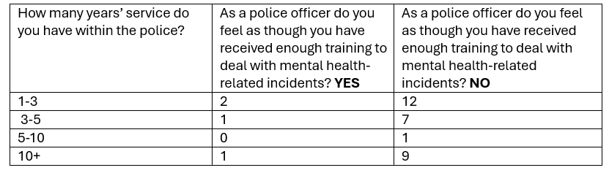
Figure 1 - Table (survey questions 4 and 5)

Officers were also questioned on what training they did receive relating to mental health. Even the officers who answered yes revealed within their open responses that the training they received was ‘minimal’ (officer 6). Officer 16 stated that ‘The training was brief and in the classroom with fellow colleagues – it was nothing like a real-life situation’. Most officers revealed through their responses a lack of training and preparedness.
Furthermore, as linked to figure 2 the majority of officers questioned believed that more training was required relating to mental health incidents linking to the objective.
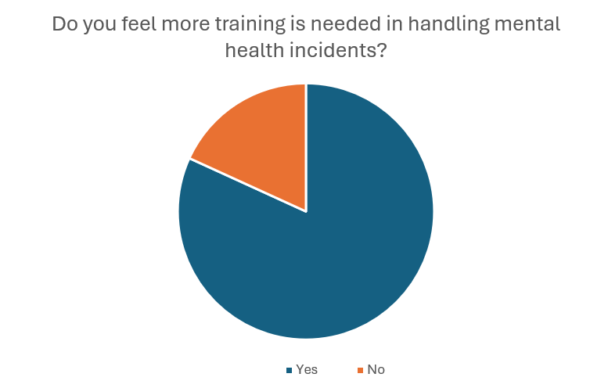
Figure 2 - Pie chart (survey question 7)

As well as requiring more training, the majority of officers also noted in the survey (see figure 3) that they were called more than once during their shift to a mental health related incident. An average shift would be nine hours, most officers noted that they attended one or two mental health incidents which is a high amount per shift when they are also dealing with crime and paperwork. These finding were supported in the literature review by Lane 2019 and The Independent Commission on Mental Health and Policing Report 2013.
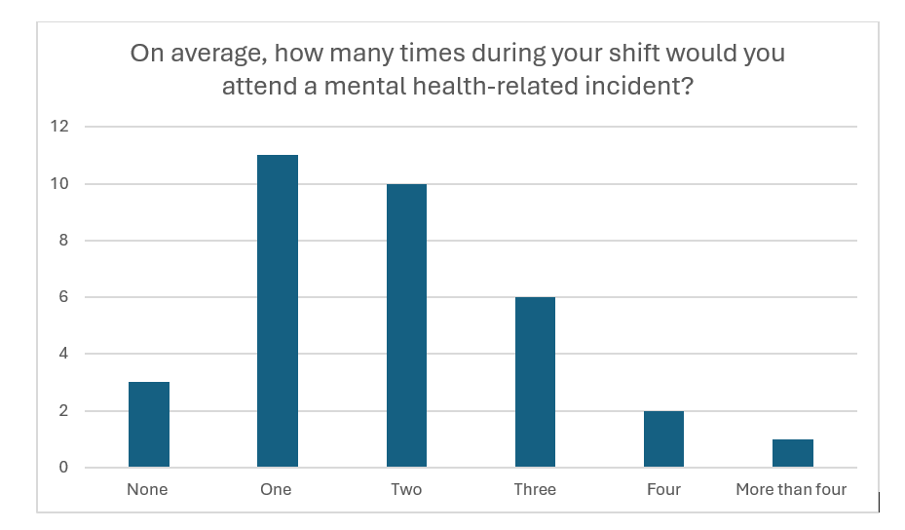
Figure 3 - Bar chart (survey question 8)

As well as feeling inadequately trained, 94% of officers felt that when they do attend mental health related incidents it takes up a lot of time during their shift (question 9). This is taking them away from other things during their shift such as dealing with their own workload or having a prisoner to interview and deal with. This was highlighted in the literature review when Marsden et al 2020 found that police struggle to use the NDM when it comes to mental health calls due to workload.
Overall, the data within the survey for this objective reveals that police officers do not feel adequately trained or prepared for mental health incidents linking to the overall research question and the literature review that perhaps they should not be attending and dealing with mental health incidents on their own without other agencies.

4.3 Data analysis and findings objective 2
Investigate if the ‘Right Care Right Person’ approach reduces police involvement with mental health incidents.
Firstly, the data revealed that 100% of officers are aware of the Right Care Right Person approach (question 10).
Figure 4 - Pie chart (survey question 11)
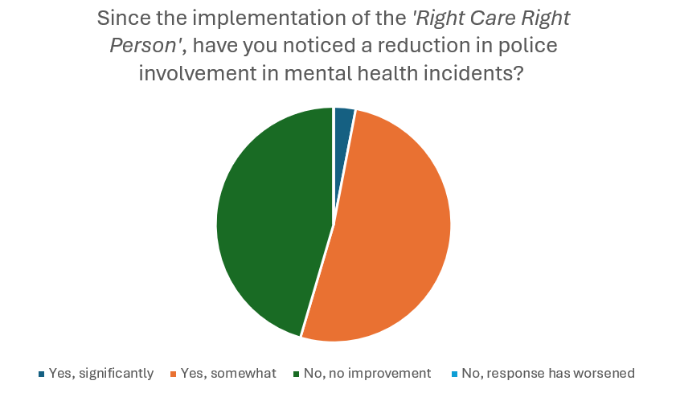

Even though the data revealed that officers were comfortable with the Right Care Right Person approach, further findings highlighted issues with it. As per figure 4, 52% of officers think that the Right Care Right Person approach has somewhat reduced police involvement in mental health incidents, 45% of officers saw no improvement and 3% saw a significant improvement. This data shows that the Right Care Right Person has sometimes lowered the amount of police involvement within mental health incidents, however it’s still not being utilised for around half of officers.
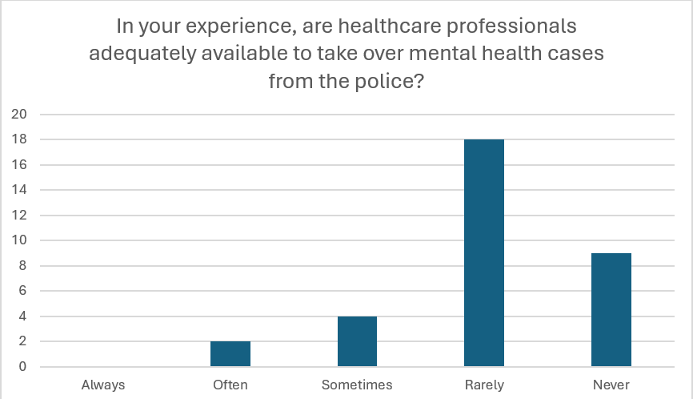
Figure 5 - Bar chart (survey question 12)

Furthermore, despite the Right Care Right Person approach suggesting that health professionals, rather than police officers should respond to non-criminal mental health incidents (Home Office, 2023), most police officers within the survey (18) found that there were rarely any health care professionals available to take over from them. 9 officers said that there were never any health care professionals to take over. This shows that the Right Care Right Person approach is not working in practise. Once prompted to expand their answers officers revealed the issues of this approach were: not enough NHS staff, the ambulance service still ask for police to attend and finally it is difficult to know if the threshold has met for it to fall under the Right Care Right Person. Some officers even mentioned difficulties relating to accountability for the police and partner agencies.
Figure 6 - Pie chart (survey question 17)
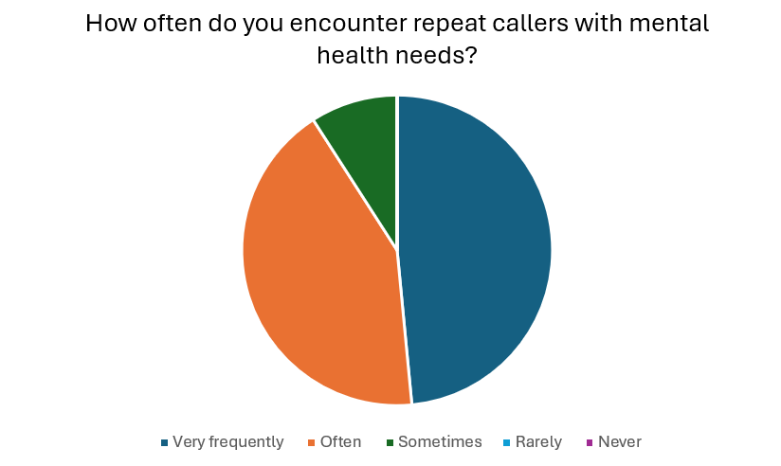

All of the issues shown within this objective highlight the problems with this approach, especially that, as per figure 6 officers are often encountering repeat callers with mental health needs. The pie chart reveals that the majority of officers encounter these repeat callers very frequently.

4.4 Data analysis and findings objective 3
Evaluate best practice for handling mental health incidents
Objective 3 relates to evaluating best practise from the officers surveyed. A lot of officers suggested that community engagement was key in mental health incidents. Other officers referred to using the crisis team. Whilst some officers mention the South Wales Police mental health professional line. The amount of different responses shows that there is a variety of best practise within South Wales Police highlighting that currently there is not one best way to deal with this crisis. Majority of these findings were similar to what was found in the literature review especially the use of Co-Response Models (see chapter 2.4).
100% of officers surveyed believed that police officers should not be the first to attend mental health incidents again highlighting that the current way of dealing with mental health calls Is not effective. When asked to give a reason for this answer police officer 2 stated that ‘it is not the fundamental role of police to deal with mental health issues of the public’. Police officer 16 stated that ‘there are better trained responders for mental health calls…a uniformed officer is only likely to scare a person having a mental health crisis’. A lot of police officers questioned mentioned a lack of training as a reason why current approaches are not effective.

Chapter 5- Conclusions and Recommendations
5.1 Conclusion
The overall focus of this study looked at whether or not police officers should be attending and dealing with mental health incidents, before identifying clear recommendations on how South Wales Police can support their approaches to officers attending and dealing with mental health incidents.
The findings of the literature review showed the challenges that police forces within the United Kingdom face in responding to mental health crises due to insufficient training, leading to inconsistent and often forceful interventions. Whilst initiatives like the Right Care Right Person approach aims to reduce police involvement, concerns remain about mental health services capacity to meet the demand. Expanding Co-Response Models, enhancing officer training, and improving multi agency collaboration are essential for effective crisis management. Addressing funding and resource gaps will be crucial in ensuring that individuals in crisis receive appropriate care while allowing police to focus on crime-related duties, fostering a more effective and compassionate response to mental health incidents. The research data analysis supported this fully.
On the whole, the quantitative analysis showed that most police officers also agreed with the lack of training. The issues with the initiatives mentioned and general concerns about training and workload. Highlights clear links between the quantitative data and literature review.
5.2 Recommendations
Overall, the research suggests that most officers believe, and the literature suggests that police should not be attending mental health incidents as a singular force. However, from this dissertation the full solution to the problem can not be identified and further research would be beneficial. However, from the survey undertaken and the analysis of the literature, recommendations are able to be suggested.
Generally, these are:
- Further training for mental health generally including scenarios and practical application
- Use of the Right Care Right Person approach for all agencies involved
- Increase mental health funding across Wales
At a specific level these are:
The first recommendation would be further training for officers in the best practise of dealing with mental health. This would involve multi agency training, especially in the Co-Response Model allowing police to feel confident when dealing with a range of mental health concerns. This could also include specific scenarios given during training where police could use the NDM to deal with different mental health incidents.
The second recommendation would be a better application of the right care right person approach as in principle from the literature review this seems to work. However, from the survey officers are revealing that in reality this is not being applied currently.
This links to the final recommendation which would be further finding for mental health in Wales. This would also include multi agency working and a better awareness of who is to deal with each incident. The police and NHS should be adequately funded to cover a range of issues preventing workload falling on one agency alone. Although these solutions are mostly long-term solutions, this dissertation suggests that they are the best ways to deal with the issues stated.
All of these findings were also influenced by the survey responses where officers were asked what additions support would help improve their response to mental health incidents (question 18). Officer 1 stated that more knowledge and support from partner agencies was needed, this was shared with officer 11 also. Linking to recommendation 3, officer 21 even suggested a specific mental health call car working in each BCU. This suggestion was shared by officer 10 and a similar suggestion was suggested by officer 8 who advocated for a mobile mental health resource. Furthermore, question 19 in the survey asked officers to expand on their opinions and the majority of officers referred to more collaboration with mental health professionals and a more multi agency approach.
5.3 Limitations
This research project whilst revealing useful data and findings did include limitations that have to be considered. Overall, the main limitation of this study would be the approach itself and its context. The study focused on South Wales Police and research completed was focused on police officers within South Wales Police Force. Therefore, the research was too specific and would perhaps be difficult to apply to other areas, including those which are more affluent. If the researcher was to complete the research again, they could ask staff from the NHS and muti agencies to get their view, ask voluntary members of the public who has suffered with mental health or send out surveys to response officers in other force areas this would allow a wider comparison to be made. However, the data combined when combined with the literature review could be easily applied to a national context as it explains the generic context of policing within mental health incidents.
5.4 Practical implications
The entire research project was of great use within the area of mental health incidents within policing and will hopefully have practical implications. Firstly, it was positive to see that officers were willing to share with viewpoints on mental health and that an awareness of further training is needed. Practically, when attending further mental health incidents my awareness of the bugger picture will be altered, and my understanding of mental health incidents has improved. Despite this there were some practical limitations such as the timings required to complete the research and the workload implications.
To conclude, the key takeaway from this dissertation is that mental health incidents are not being dealt with effectively currently in Wales and despite there being best practise, the majority of police officers surveyed did not feel that this worked or was being utilised effectively. However, further research would be needed to fully understand the best solutions to this problem.

Chapter 6 – Bibliography
- “Mental Health.” World Health Organization, 2024, www.who.int/health-topics/mental-health#tab=tab_1.

- “Policing Productivity Review (Accessible).” Gov.uk, 23 Apr. 2024. Available at: www.gov.uk/government/publications/policing-productivity-review/policing-productivity-review-accessible.

- “Right Care Right Person (RCRP) National Guidance Launched.” College of Policing, 25 July 2023, www.college.police.uk/article/rcrp-national-guidance-launched.

- Blais, E., & Brisebois, D. (2021). Improving police responses to suicide‐related emergencies: New evidence on the effectiveness of co‐response police‐mental health programs. Suicide & Life-Threatening Behavior, 51(6), 1095–1105. https://doi.org/10.1111/sltb.12792

- Booth, Alison, et al. “Mental Health Training Programmes for Non-Mental Health Trained Professionals Coming into Contact with People with Mental Ill Health: A Systematic Review of Effectiveness.” BMC Psychiatry, vol. 17, no. 1, 25 May 2017, https://doi.org/10.1186/s12888-017-1356-5.

- College of Policing. “National Decision Model.” College of Policing, 23 Oct. 2013, www.college.police.uk/app/national-decision-model.

- Duggan, Sean. “The Police’s Rushed Withdrawal from Mental Healthcare Is Creating Serious Risks | NHS Confederation.” Www.nhsconfed.org, 26 Apr. 2024, www.nhsconfed.org/articles/polices-rushed-withdrawal-mental-healthcare-creating-serious-risks.

- Elgeddawy, M. & Abouraia, M. 2024, Pragmatism as a Research Paradigm, Academic Conferences International Limited, Reading.

- Fischer, Gavin. ““Police Officers Taken off Beat to Deal with Mental Health Calls.”” BBC News, 2 Sept. 2019, www.bbc.co.uk/news/uk-wales-49498208.

- Hill, Helen. “Right Care, Right Person.” Wales Safer Communities, 21 Feb. 2024, safercommunities.wales/right-care-right-person/.

- Home Office. “National Partnership Agreement: Right Care, Right Person (RCRP).” GOV.UK, 26 July 2023. Available at: www.gov.uk/government/publications/national-partnership-agreement-right-care-right-person/national-partnership-agreement-right-care-right-person-rcrp.
- Independent Commission on Mental Health and Policing Report. Independent Commission on Mental Health and Policing Report. 2013.

- Lamanna, Denise, et al. “Co-Responding Police-Mental Health Programmes: Service User Experiences and Outcomes in a Large Urban Centre.” International Journal of Mental Health Nursing, vol. 27, no. 2, 17 Oct. 2017, pp. 891–900, https://doi.org/10.1111/inm.12384.

- Lane, R. (2019). “I’m a police officer not a social worker or mental health nurse”: Online discourses of exclusion and resistance regarding mental health‐related police work. Journal of Community & Applied Social Psychology, 29(5), 429–442. https://doi.org/10.1002/casp.2410

- Marsden, Molly, et al. “Investigating Police Officers’ Perceptions of Their Role in Pathways to Mental Healthcare.” Health & Social Care in the Community, vol. 28, no. 3, 9 Jan. 2020, https://doi.org/10.1111/hsc.12922.

- McDaniel, J. L. M., Moss, K., & Pease, K. (Kenneth) (Eds.). (2020). Policing and mental health: theory, policy and practice. Routledge. https://doi.org/10.4324/9780429470882

- Metropolitan Police (n.d) Introduction to the Right Care Right Person. Available at: https://www.met.police.uk/notices/met/introduction-right-care-right-person-model/ Accessed: 12th February 2025

- Morgan, M., & Paterson, C. (2019). ‘It’s Mental Health, Not Mental Police’: A Human Rights Approach to Mental Health Triage and Section 136 of the Mental Health Act 1983. Policing : A Journal of Policy and Practice, 13(2), 123–133. https://doi.org/10.1093/police/pax047

- National Police Chiefs Council. “1M Officer Hours Saved with New Approach to Mental Health.” National Police Chiefs’ Council (NPCC), 26 July 2023. Available at: news.npcc.police.uk/releases/police-to-save-1-million-officer-hours-as-forces-adopt-new-model-to-ensure-specialist-care-for-health-incidents.

- National Police Chiefs’ Council (2022) Mental Health & Policing Strategy 2022 – 2025. Available at: https://www.npcc.police.uk/SysSiteAssets/media/downloads/publications/publications-log/2022/npcc-mental-health-strategy.pdf (Accessed 03/03/2025)

- Office of the Police and Crime Commissioner for Surrey (n.d) “Right Care, Right Person | Police & Crime Commissioner Surrey.” Office of the Police & Crime Commissioner for Surrey. Available at: www.surrey-pcc.gov.uk/performance/right-care-right-person/.

- Police Federation. “Police Officers Shouldn’t Be Spending so Much Time on Non-Crime Calls.” Www.polfed.org, 24 Mar. 2022, www.polfed.org/wilts/news/2022/police-officers-shouldnt-be-spending-so-much-time-on-non-crime-calls/.

- Puntis, Stephen, et al. “A Systematic Review of Co-Responder Models of Police Mental Health “Street” Triage.” BMC Psychiatry, vol. 18, no. 1, 15 Aug. 2018, bmcpsychiatry.biomedcentral.com/articles/10.1186/s12888-018-1836-2, https://doi.org/10.1186/s12888-018-1836-2.

- South Wales police (n.d) ‘Right Care, Right Person’. Available at https://www.south-wales.police.uk/advice/advice-and-information/concern-for-welfare/right-care-right-person/ Accessed: 9th February 2025

- Vice, Dave. “Share of People in Wales Experiencing Severe Mental Health Issues More than Doubled during Pandemic, Report Finds - Mental Health Wales.” Mental Health Wales, 21 July 2021, mentalhealthwales.net/2021/07/share-of-people-in-wales-experiencing-severe-mental-health-issues-more-than-doubled-during-pandemic-report-finds/. Accessed 2 Feb. 2025.

- Walliman, N. (2006) Social Research Methods. London: SAGE.

- Wondemaghen M. Policing mental illness: Police use of section 136 – Perspectives from police and mental-health nurses. Medicine, Science and the Law. 2021;61(4):266-274. doi:10.1177/0025802421993363

- World Health Organization. “Mental Disorders.” World Health Organization, 8 June 2022, www.who.int/news-room/fact-sheets/detail/mental-disorders.

Chapter 7 – Appendices
7.1 Copy of survey from Microsoft forms available at (link sent out)
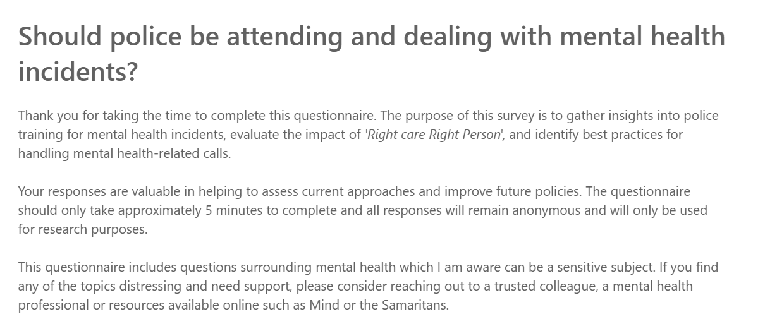

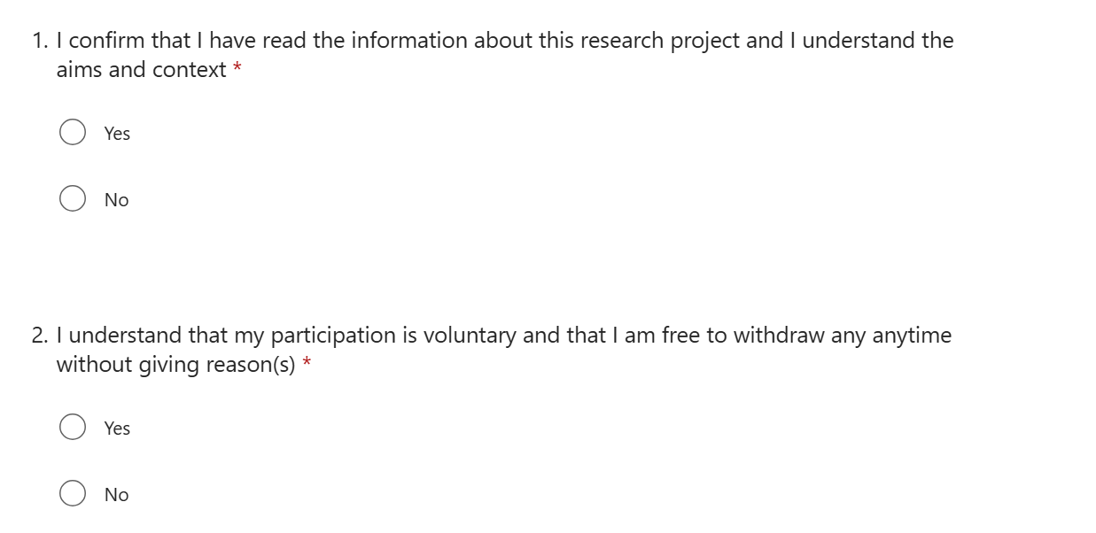

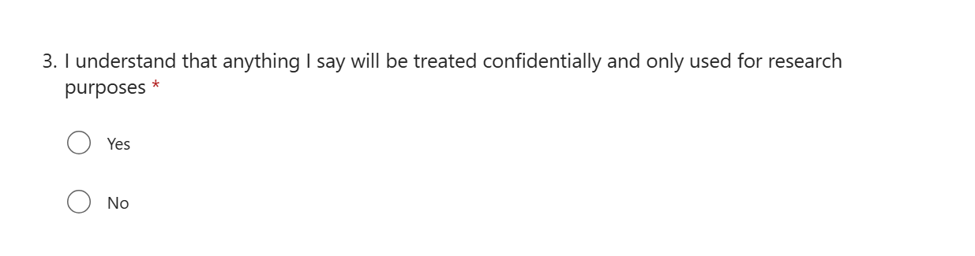

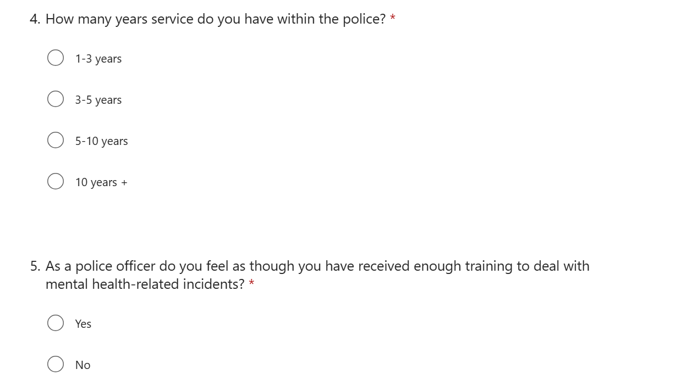

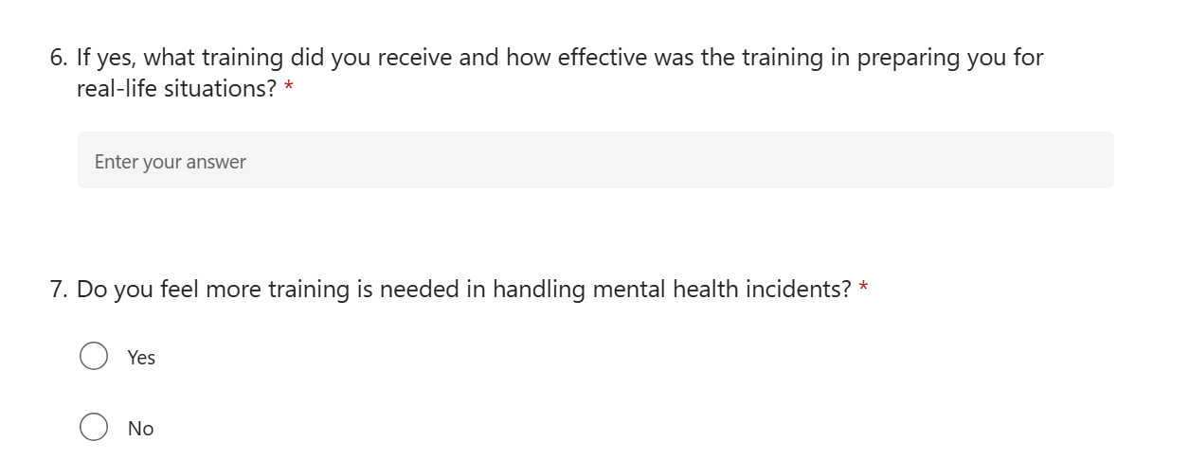

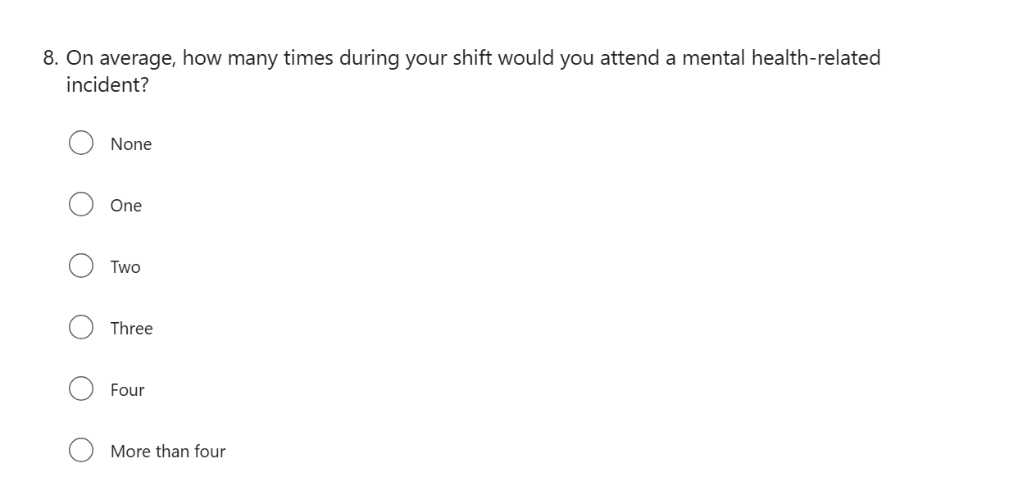

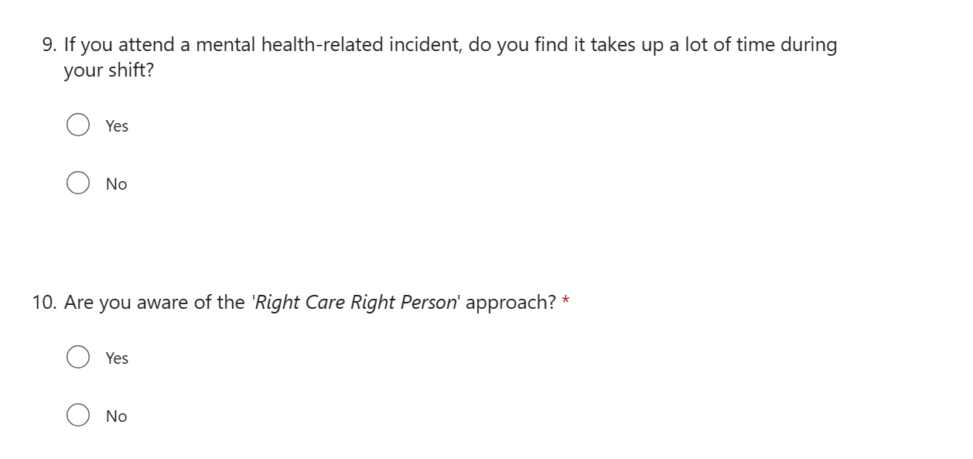
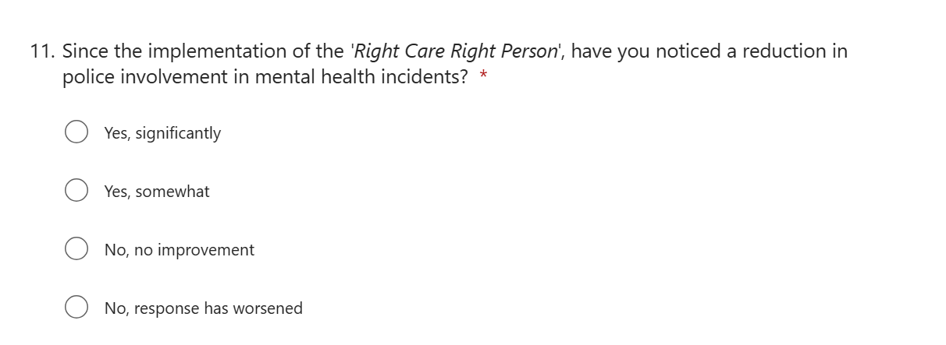

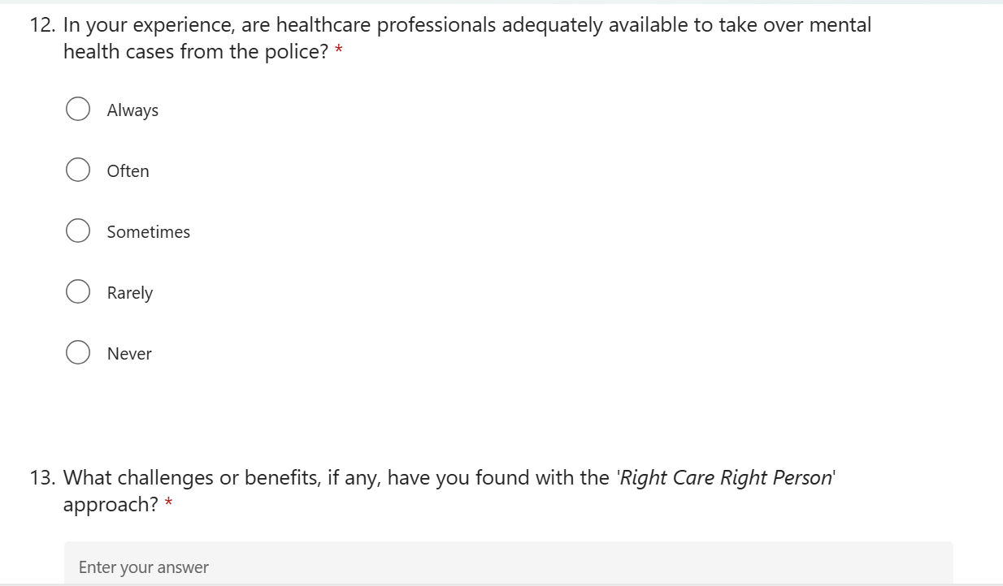

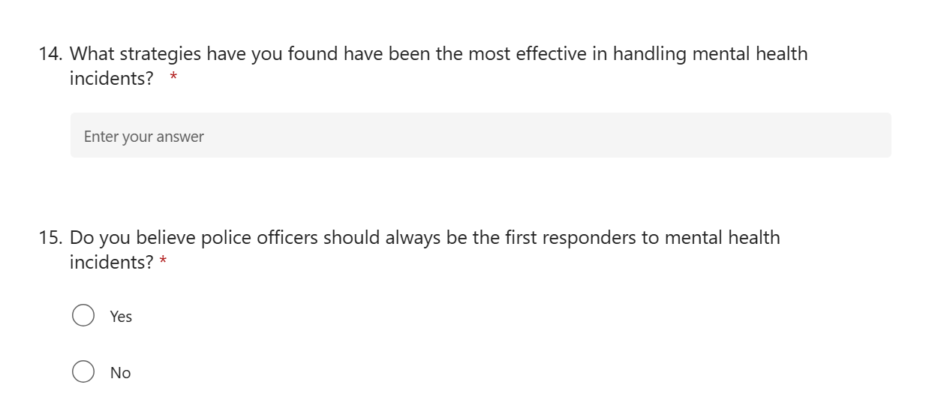

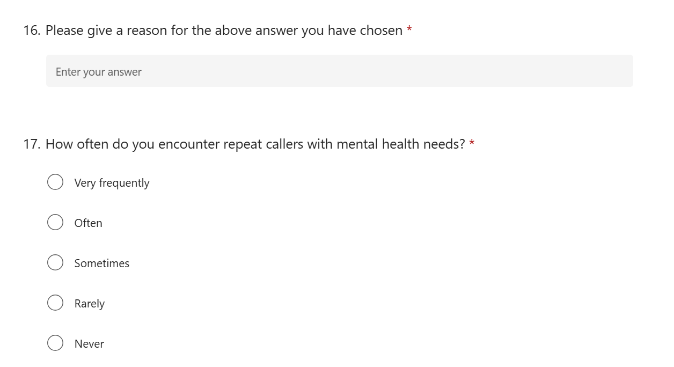

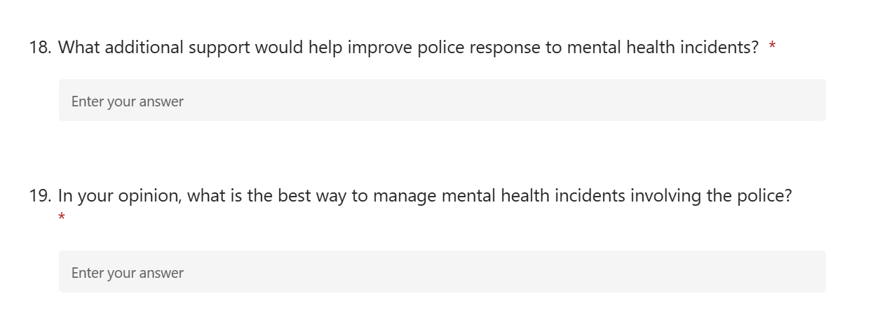

7.2 Survey posted on police website to gather responses
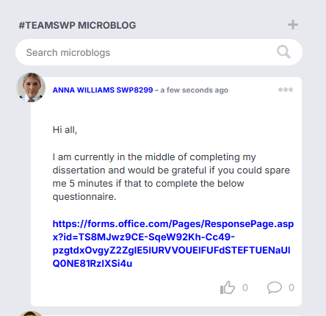

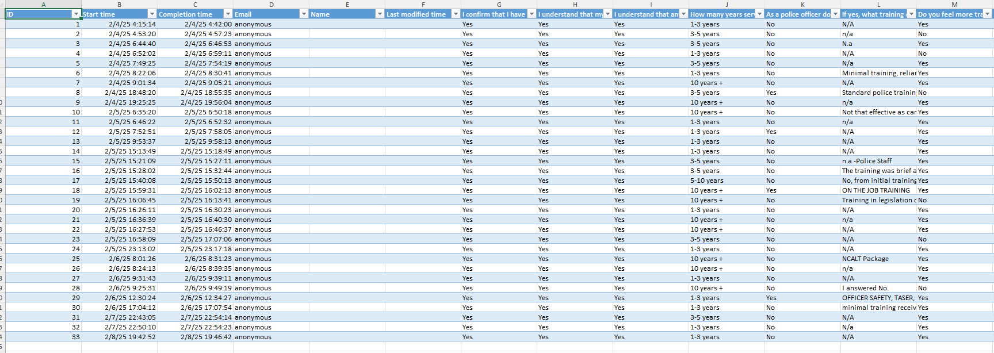
7.3 Copy of survey responses collected on an excel document



