

Name – Dalton Brown.

Student Number – 1908063.

Course – HND Quantity Surveying.

Module – BIM.

Assignment Title – Client letter and draft BEP.

Tutor – Gavin Traylor.

Table of Contents.
- Introduction.
- Letter to the client.
- BIM Execution Plan.
- Conclusion.
- References.

Introduction.
Within this assignment I have been given the chance to be the lead consultant in delivering a state-of-the-art community facility located in Swansea. The project will be jointly funded with the Welsh government and will require to meet the standards of BIM maturity (BIM level 2). I will begin by writing a letter to the client which will be Swansea City Council regarding BIM level 2 and the requirements for the project. The details will find on how the information can be shared, coordinated, and managed through the appropriate international standards. I will also be carrying out a full BIM execution plan which I will be including key project information, management, planning and documentation, standards, methods, and procedures and all IT solutions.

Letter – Swansea City Council.

Brown Limited
Lowri Road
Glynneath
Neath
SA11 5UN

Swansea City Council
Oyster mouth Road
Civic Centre
Swansea
SA1 3SN.
Dear Swansea City Council,
My name is Dalton Brown I am the lead consultant who will oversee delivering the new state of the art community facility located in Swansea. The project will be a joint funded venture with the Welsh government which will require the use of BIM level 2. I am writing to you to inform you the use of BIM level 2 will control all the information needed in carrying out the works to the new state of the art community facility Pipers walk day centre. I will be outlining the measures that we will be carrying out as a team to successfully reach and achieve BIM level 2.
Before I begin in discussing BIM level 2, I will firstly discuss what BIM is. BIM is a 3D model-based process that provides the construction, architecture, and engineering professionals the understanding to enable them to design, plan and construct more efficiently. It also allows the professionals to manage the buildings and infrastructure effectively (Autodesk Inc, 2016). It will allow the professionals involved within the project to manage the project much more effectively. Throughout the project and use of BIM it will allow a clear path, better decision making, whilst helping cost savings and sustainable options. Producing 3D models, it will help in demonstrating the full potential of the project in hand. If the processes are used efficiently, it will create a happy working environment and a successful project throughout. As yourself as the client I feel the use of BIM level 2 on this project will be a huge benefit in producing a high-quality build whilst also helping in lowering of the costs. Health and safety are another big aspect of the project this will minimise any health and safety issues by improving the safe of all workers on site.
To achieve the levels of BIM level 2 it must result in us working together and in a collaborative way. All the relative information which is discovered within the project must be accessible for everyone to use across the project. This is a requirement which has been set out by the UK government and is across all construction-based work. This means that all chosen contractors on the project will need to show that they can work to this way. If they show, they can’t not be permitted to any fundings which will be released by the treasury (storma group 2019).
Factors included in BIM level 2 (The CAD Room, 2020):
- Covers the creation of federal model.
- The common classification of data.
- Collaborative working.
- Employers Information Requirement (EIR)
- Information exchange methods
Standards will need to be met to achieve BIM level 2.
BS EN ISO 19650 1 2018 | BS 1192-4:2014
BS EN ISO 19650 2 2018 | PAS 1192-6:2018
ISO 19650 - 3 | BS 7000-4:2013
ISO 19650 - 5 | ISO 22014
BS 8536-1:2015 | ISO 22057

All the project information regarding our BIM models will be stored and saved within a CDE which is known as a common data environment. CDE can help projects store and manage project information
By using CDE is will ensure all the project information is in one place and can be stored safely which will limit the number of errors and avoid any duplications. It will also provide clear audit trials of all the changes throughout the project and any amendments. Collaboration will also be used to improve the results along with the efficiencies, is the main reason to executing a BIM on construction projects.
By using BIM level 2 this will ensure Pipers Day walk centre can be completed in the smoothest way possible which will be hugely beneficial for you as the client. Below is a BIM execution plan for Pipers walk which will outline the process and give a more understanding on everything I have mentioned.
Alongside this letter I will also prepare and complete a BIM execution Plan which will have the following key points within:
- Project Information
- Management
- Planning and Documentation
- Standards, Methods, and Procedures
- IT Solutions

Many thanks for taking the time to read my letter if you require any further information, please do not hesitate in contacting me.

Dalton Brown
Lead Consultant

BIM Execution Plan (BEP).

Project – Pipers Day Walk Centre.

Author – Dalton Brown.

Brown Limited.

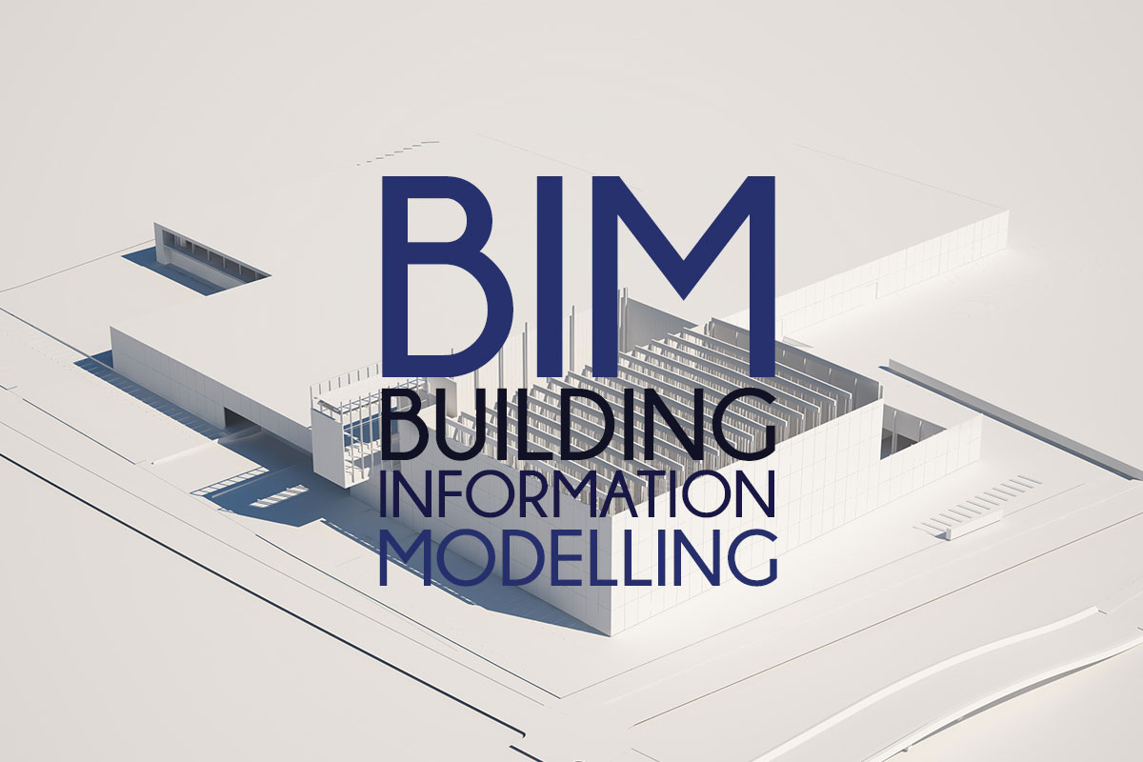

BIM Execution Plan.
1.Purpose of Document.
Under the BS EN 19650 2, it is proposed that the BIM Execution Plan is directly responded to the Employer’s Information Requirements. (Trimble 2020) EIR is an immensely key document to any project which outlines all the information that is required by Louis Ltd the principal contractor. The document guides the key decision points and the project stages and is aimed to work in collaboration to the project goals and the brief set out prior to starting on site. (Storma Group 2020)
Building Information Modelling Execution Plan is an approved document which will define the BIM strategy and processes for the successful completion of the project delivering a high-quality new school at Pipers Day walk centre. Whilst completing all BIM targets set out by Swansea City Council.
This document will outline key fundamentals required by Swansea Council and will provide immense support to the contract coordinator throughout the timeframe of the project:
- Project Information
- Management Teams
- Planning
- Standards, Methods, and Procedures
- IT Solutions
Throughout the project all BIM models must comply with all documentation and any other key paperwork.
Throughout the project the document must be kept up to date with outlining any changes noted to inform the Client.
Amendments should be brought up by the team on the project which will then need to be authorised to move forward with the changes.
2. Project Information
2.1 Project Information
Table 1.
Project Number: | 5010.
Project Title: | Pipers Walk Day Centre.
Project Description: | State of the art community facility.
Site Location: | Swansea.
Client: | Swansea City Council.
Lead Consultant: | Brown Limited

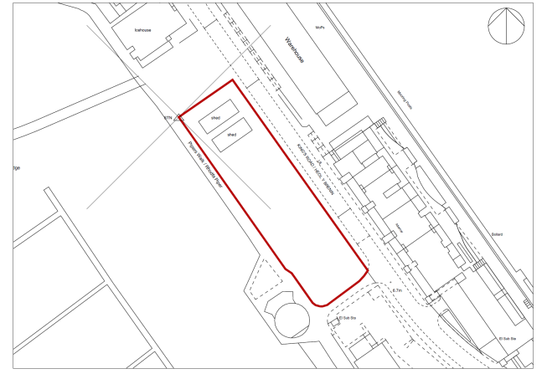
2.2 Site Location Plan.

Above shows the site location indicated with the red lines.
2.3 Project Disciplines and Companies.
Below is a list showing the personnel involved within the project with their represented companies and roles within.
Company | Name | Role | Contact Information | Properties
Swansea City Council. | Swansea Council | Client | Info@swanseacouncil.com | SSC
Brown Limited | Dalton Brown | Lead Consultant | daltonbrown@live.co.uk | LC
Thomas Architects. | Lowri Thomas | Architect | Lowri.thomas@TAC.co.uk | A
Louis LTD | Louis Thomas | Main Contractor | Louis@LTDbuild.co.uk | MC
Keith Engineers | Keaton Davies | Structural engineer | keith@SEngineers.co.uk | SE
Gadd Engineering | Neil Gadd | Electrical Engineer | Neil.gadd@LME.co.uk | EE
RB landscaping | Rob Brown | Landscape | Rob.ThomasB@live.co.uk | L

2.4 Project Co-ordination.
Pipers’ day walk centre will be using the survey points of N 192934 and E 266355 co ordinates and will have an elevation of 0. Throughout the timeframe of the project the software used on Pipers Day walk centre will all be from same origin point. Drawings and specification to be used on same orientation this will limit errors on the project.
2.5 Project Targets.
The project targets will be set out and used in a form a project management tool. This can be used as a factor of scheduling the project from start to finish. Work set out by the client will be discussed with the contractors and lead consultant to set out key milestones. Milestones within the project can be:
- Project start date
- Completion of design stage
- Completion of work activities
- Contractors who are appointed
- Project completion date
3. Management.
To gain success within the project there are numerous roles and responsibilities which will need to be followed to deliver a project the client is going to be happy with.

3.1 Consultant.
As the consultant of the project the decisions on the construction will all come from the consultant. The consultant will also oversee where the information is to be stored and other parties can then access it too. The consultant will also be the main point of contact between the client and the team. The consultant will have a tight relationship with the team to ensure the use of CDE is being followed whilst also being shared in the correct way.
3.2 Client.
As having a client as big as Swansea Council the client must ensure that throughout the timeframe of the project that all building regulations are followed to high standards. The client must always be informed when any changes are made throughout the project. The client will also need to be involved in the processes of BIM to ensure all BIM targets are met.
3.3 Architect.
The architect of the project will be responsible for the delivery of all plans for the project which will set the parties guidelines to delivering a successful construction. Drawings will also be produced by the designers making the architects and designers working very closely to meet all building standards and meeting BIM level 2.
3.4 Principal Contractor.
The principal contractor will be in control of the construction phase of the project. They would be appointed by the client to plan, manage, monitor, and organise all health and safety throughout the duration of the project.
3.5 Structural Engineer.
The structural engineer will have the responsibility of creating the drawings and the specification for the project. Calculations may need to be formed and certain checks may need to be carried out on other engineers.
3.6 Electrical Engineer.
As the electrical engineer on the project the contractor will be responsible for all electrical elements and design within the construction of the project.

3.7. Consultant Task Teams
The process of BIM will never change the design responsibilities from the consultants who would have been appointed preconstruction. The consultants would then rectify changes and understand their main responsibilities which would be outlined by the principal contractor LOUIS Ltd in their documents. The consultant would then also have to follow any specifications in this document and would oversee the project information model during the time frame of the project.

3.8. Roles, Responsibilities and Authorities
Before the project begins roles and responsibilities will be outlined and explained to any key management who will then be appointed. It’s important this is done at the beginning of the project as it allows the information management to be delivered as successful as it can be through the timeframe of the project. On any project understanding the severity and size of the project may have an impact on certain roles and key management. With one person could be looking after several roles within the project. The document would then need to be kept up to date throughout the time frame.

4 Planning and Documentation
Within the project key aspects like supply chain appraisals will pop up. It’s important that the production of any documents must be carried out at the earliest chance.

4.1 Delivery Plan

The delivery plan is yet to be agreed between the consultant and client, below is a draft version of the deliver plan. The plan shows everyone involved within the project including all parties and key date dates which have been set out by the client. The delivery plan must be signed by the client to ensure of confirmation. Draft delivery plan:
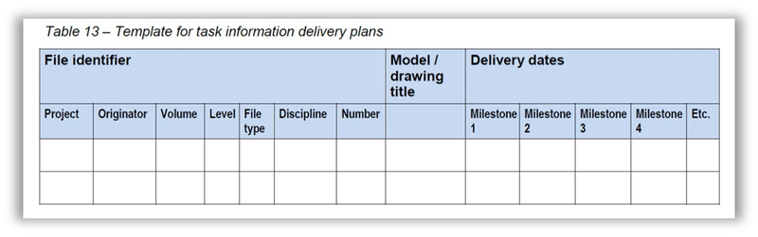

(Bailey BIM standards)

4.1. Supply chain capability
Supply chains are within any construction project and will be referred to as subcontractors or designers who will then need to be evaluated towards their ability to meet the requirements set out before starting any work on site. On site a project delivery manger will then oversee the works and take responsibility to make sure the suppliers are delivering the requirements of the project.
The BIM capability assessment must be completed by all subcontractors before starting any work. The consultants chosen by BROWN limited will also need to complete the assessment.
All assessments completed will need to be recorded and kept by BROWN limited who will then need to ensure its on hand if the council requests it.

5. Standard Method and Procedure
To reach the targets at BIM Level 2 there are aspects of the specification that will be aimed at guaranteeing the development of PIM which will then fulfil the methods and procedures successfully. This will allow all information models to be at the highest quality.

5.1. Volume Strategy
Prior to the design stage on site a strategy of volume will be used to outline any 3d spatial coordination for each of the principles selected. Before the project has started if the use of volume is needed it will be down to the design team to be agree the required volume and then will be viable to see within a shared document.

5.2. Spatial Location
Grid levels will need to be confirmed by all used members of the design team and should be identified to understand the level of definition matrix.

5.3 Units and Measurements
When it comes to units and measurements its vital that they are always rounded up to the closest centre meter with also the units being m2 for all area and volume used.

5.4. File Naming Convention
Please see below for the use of naming files that would be shared within the common data environment.
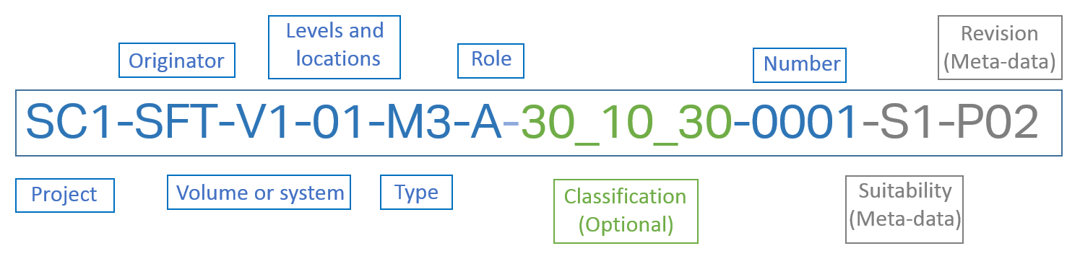
Field | Obligation | Description
Project | Required | Code for project
Originator | Required | Code for organisation creating information.
Volume or system | Required | Code for system reference.
Levels and location | Required | Code to locate info (Floor 1 etc)
Type | Required | Code for type of file Cost Plan, method statement etc)
Role | Required | Code for role of organisation (A - Architect etc)
Classification | Optional | Code to reference asset
Number | Required | Sequential file number
Suitability | Meta-data | Code for status of data (WIP, Shared, published etc)
Revision | Meta- data | Code for revision of data.
Table 1: Summary of Naming Convention

Levels & Locations
ZZ | Multiple Levels
XX | No Level Applicable
GF | Ground Floor
00 | Base Level of Building or linear Asset
Floor Levels
01 | Floor 1
02 | Floor 2, etc
Mezzanine Levels
M1 | Mezzanine above Level 1
M2 | Mezzanine above Level 2
Below Ground Floors
B1 | Floor -1
B2 | Floor -2
Table 2: Summary of Levels & Locations

Codes for Drawings & Models
AF | Animation File
CM | Combined Model
CR | Specific for the clash process
DR | 2d Drawing
M2 | 2D Model file
M3 | 3D Model file
MR | Model rendition file for other renditions (thermal analysis)
VS | Visualisation
Codes for Documents
BQ | Bills od Quantities
CA | Calculations
CO | Correspondence
CP | Cost Plan
DB | Database
FN | File Note
HS | Health & Safety
IE | Information Exchange
MI | Minutes/Action Notes
MS | Method Statements
PP | Presentation
RD | Programme
RI | Request for information
RP | Report
SA | Schedule of accommodation
SH | Schedule
SN | Snagging List
SP | Specification
SU | Survey
Table 3: Summary codes for document types

Codes for disciplines & roles
A | Architect
B | Building Surveyor
C | Civil Engineer
D | Drainage, Highways Engineer
E | Electrical Engineer
F | Facilities Manager
G | Geographical and Land Surveyor
H | Heating & Ventilation Designer
I | Interior Designer
K | Client
L | Landscape Architect
M | Mechanical Engineer
P | Public Health Engineer
Q | Quantity Surveyor
S | Structural Engineer
T | Town and County Planner
W | Contractor
X | Sub-Contractor
Y | Specialist Designer
Z | General
Table 4: Codes for Roles & Discipline

Status | Description | Graphical | Non- Graphical | Document
Work in Progress
SO | Initial Status of WIP | Yes | Yes | Yes
Shared (Non-Contractual)
S1 | Suitable for co-ordination | Yes | Yes | Yes
S2 | Suitable for Information | Yes | Yes | Yes
S3 | Suitable for review | No | Yes | Yes
S4 | Suitable for approval | No | Yes | Yes
WIP to Publish
D1 | Suitable for costing | Yes | Yes | Yes
D2 | Suitable for tender | Yes | Yes | Yes
D3 | Suitable for design | Yes | Yes | Yes
D4 | Suitable for manufacture | Yes | Yes | Yes
Published Docs
A1, A2, A3 | Approved/Accepted | Yes | Yes | No
B1, B2, B3 | Partial sign off | Yes | Yes | No

5.5 Room numbering and naming.
The project will need to be correctly labelled with the rooms being numbered too, this will allow all parties involved in the project to know which location is which without causing any guessing or errors, making this method very beneficial. All the drawings will be required to be in line with the correct software. As said above all project drawings will need to be labelled correctly and saved in the relative naming conventions.
5.6 Levels and Sections
Between the parties involved within the project they must be agreed and confirmed that all levels and grid references are to be used correctly. In every model processed it must have the levels and sections the same to have the benefit of full collaboration process to work.

5.7 Title Block.
For each drawing created it must follow in lines of using the title block. Please see below the labelled title block:
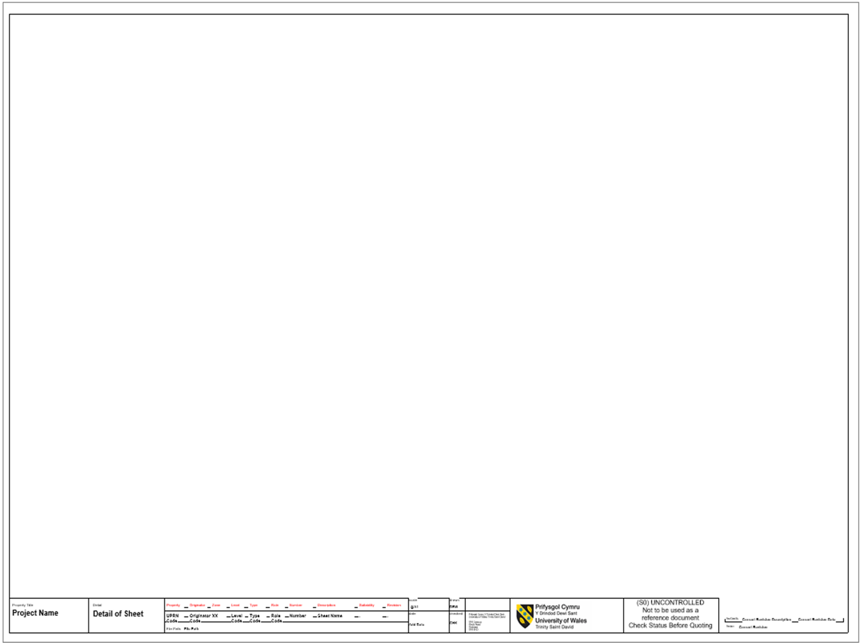

6.0 IT Solutions
Pipers’ day walk centre will be using Revit 2022 as a software and PDF for all 2D drawings to develop and design the state-of-the-art community facility in Swansea. Every party involved within the project must be working on the same version of the software to make sure everyone is using the same information to limit any mistakes in the timeframe of the project. By all parties using the same software this will allow the date to shared and stored correctly. All the data collected will be kept safe within the CDE with the use of the correct naming conventions. Please see below the relative software which is going to be used to carry out the project:
Version | Software | Application | File Format
2022 | Revit | 3D modelling for the project. | RVT Files
2022 | PDF | 2D drawings and any documents. | PDF files

Conclusion.
Throughout this assignment I have found that by using BIM in construction projects is a huge benefit to have as it helps to manage projects in a more efficient way whilst also storing and sharing information of the project which will reduce the mistakes and costs on site. To learn the understanding of BIM can take some time but I feel once you’ve learnt the software it can be straight forward, I feel BIM is growing quickly within the industry which can save time and energy in construction projects. The benefits of using BIM can show clear information which is very effective and can help both the design team and client in running a successful project.
By using a BIM execution plan this will outline all the key points and guidelines which will be used within the project. It will show what personnel are involved and their responsibilities on the project and how all the data throughout the project can be safely stored shared and managed. This will then provide clear information for all parties to understand the outlines of the project in hand from start to finish. In my opinion BIM is a great software to have on any project if it’s used correctly.

References.
BIM delivery plan NG bailey BIM standards -
https://www.google.com/search?q=bim+delivery+plan+example&rlz=1C1GCEA_enGB967GB967&hl=en-GB&sxsrf=ALiCzsaaHi07qTe9Z6BJCV0Fa_zmCP3x4w:1657875777104&source=lnms&tbm=isch&sa=X&ved=2ahUKEwir9JnGxPr4AhWwgVwKHTTQBLIQ_AUoAXoECAMQAw&biw=1536&bih=754&dpr=1.25#imgrc=nlvW8Pv7Hw-tXM
The CAD Room Ltd (2021) BIM Compliance: Are You Ready for BIM Level 2? from: https://www.thecadroom.com/bim-compliance-ready-bim-level-2/
Stroma Group Ltd (2020) BIM Levels Explained from: https://www.stroma.com/certification/news/bim-levels
Autodesk Inc (2020) Building Information Modelling. from: https://www.autodesk.com/solutions/bim
Trimble (2020) What is BIM (Building Information Modelling)? from: https://constructible.trimble.com/construction-industry/what-is-bim-building-information-modeling

