

Employability of BA Accounting and BA Business and Finance Graduates

A comparison of Student and Employer Perspectives

Date: 5th May 2017
Author: Emily Brooks (P138883)
Supervisor: Richard Dunstan

This dissertation will look into the skills and abilities that employers expect from BA Accounting and BA Business and Finance students compared with students’ perceptions of what the most desired skills and abilities are.

DECLARATION
This work has not previously been accepted in substance for any degree and is not being concurrently submitted in candidature for any degree

Signed……………………………………………

Date………………………………………………

STATEMENT 1
This dissertation is being submitted in partial fulfilment of the requirements for the degree of BA.

Signed…………………………………………….

Date………………………………………………

STATEMENT 2
This dissertation is the result of my own independent work/investigation, except where otherwise stated.
Other sources are acknowledged by footnotes giving explicit references. A bibliography is appended.

Signed……………………………………………

Date………………………………………………
STATEMENT 3
I hereby give consent for my dissertation, if accepted, to be available for photocopying and for interlibrary loan, and for the title and summary to be made available to outside organisations.

Signed………………………………………………

Date…………………………………………………

STATEMENT 4
I hereby give consent for my dissertation, if accepted, to be available on the university’s IT system to those who have consent to use the system.

Signed………………………………………………

Date…………………………………………………

Abstract

The aim of this dissertation is to critically analyse the employability skills of BA Accounting and BA Business and Finance graduates from the perspective of employers compared with the perspective of students.

The literature review in chapter 2 provides the background and theoretical information that is available from relevant literature and was gathered from books, journals, news articles and websites. This review of the literature revealed that there seems to be a gap between thee skills and abilities that employers desire and those that graduates have developed during their university programme. The majority of the employers and students in the literature appeared to agree on the specific skills that were most important, identifying communication and teamwork as the top two. It was also identified that there is a risk that the teaching of more generic skills may be taking away from the teaching of the more technical skills in the university programme.

Surveys were used to gather data from employers across Wales and from current and previous students of UWTSD in order to establish their perceptions of employability skills and identify if a difference of perspective exists and also establish if the skills required are being taught by the current BA Accounting and BA Business and Finance programme.

The Research showed that the skills identified in the literature review were all supported as being important. However, the students surveyed placed innovation and leadership as their top two as opposed to communication and teamwork identified in the literature. These two skills are actually placed as least important by the students surveyed.

The research supported the argument that there is a gap between what employers’ desire and what students are furnished with the ability to deliver. It also identified that there may be a lack of real world work experience, confidence and technical ability.

Table of Contents
Abstract 4
Chapter 1 Introduction 7
1.1 Background of the study 7
1.2 Research Rationale 7
1.3.1 Aims and Objectives 8
1.3 Research Design 9
Chapter 2 Literature Review 10
2.1 What Are Employability Skills? 10
2.2 Skills Required By Employers 13
2.3 Student’s perceptions of skills acquired during BA Accounting and BA Business and Finance Programme 17
2.4 Conclusion 19
Chapter 3 Research Methodology 21
3.1 Objectives 21
3.2 Research design 22
3.3 Data Collection 23
3.4 Reliability and validity 26
3.4 Ethical considerations 27
Chapter 4 Data Analysis 29
4.1 Initial Observations 30
4.1.1 Student Online Survey 30
4.1.2 Employer Online Survey 30
4.2 Student Survey Results 32
4.2.1 Profile of Respondents 32
4.2.2 Level of Agreement to Statements 34
4.2.3 Q7 Perspective of Importance of Skills 38
4.2.4 Q8 Perspective of Relevance of Teaching 40
4.2.5 Q9 Any Other Skills relevant to employability 41
4.2.6 Q10 Further Comments 43
4.3 Employer Survey Results 44
4.3.1 Profile of Respondents 44
4.3.2 Q4 Perspective of level of Importance of Skills 45
4.3.3 Q5 Accounting Graduates Skills 46
4.3.4 Q6 Other Important Skills 47
4.3.5 Q7 Do Graduates Present Skills at interview 49
4.3.6 Q8 Further Comments 50
4.4 Comparison of Results 51
4.4.1 Objective One: Establish the skills and abilities that employers expect from BA Accounting and BA Business and Finance graduates 51
4.4.2 Objective Two: Establish the skills and abilities that graduates perceive to be the most desirable 51
4.4.3 Objective Three: Investigate whether the skills that are perceived to be important are taught as part of the normal BA Accounting and BA Business and Finance syllabus 51
4.4.4 Objective Four: Discuss any improvements that could be made to the teaching of BA Accounting and BA Business and Finance in order to ensure that graduates are able to develop the required employability skills 51
4.4.5 Summary 52
Chapter 5 Discussions, Conclusions and Recommendations 53
5.1 Discussions 53
5.1.1 Objective one: Establish the skills and abilities that employers expect from BA Accounting and BA Business and Finance graduates 53
5.1.2 Objective Two: Establish the skills and abilities that graduates perceive to be the most desirable 54
5.1.3 Objective Three: Investigate whether the skills that are perceived to be important are taught as part of the normal BA Accounting and BA Business and Finance syllabus 54
5.2 Conclusions 55
5.3 Problems arising during the research 56
5.4 Recommendations 57
5.5 Opportunities for future research 58
Bibliography 59
Appendices 64
Appendix 1 Detailed responses to student survey open questions 64
A1.1 Student Survey Q9 64
A1.2 Student Survey Q10 65
Appendix 2 Detailed Responses to Employer survey open questions 66
A2.1 Employer survey Q6 66
A2.2 Employer Survey Q7 67
A2.3 Employer Survey Q8 68
Appendix 3 Student Survey 69
Appendix 4 Employers Survey 73
Appendix 5 E2 Ethics Form 77

Chapter 1 Introduction

Background of the study

In her book, Employability Skills, Frances Trought states that, “Employability is forever”. It is a continuous thing, something that is learnt. It can be taken from job to job. It is, “learnt, honed and practised” (2012, p. x). The degree is merely the first point of entry and she states that it is the, “demonstration of employability skills that is used to differentiate between the candidates.” (2012, p. 3). This is supported by The Higher Education Academy who state that employability is, “A set of achievements – skills, understandings and personal attributes – that makes graduates more likely to gain employment and be successful in their chosen occupations, which benefits themselves, the workforce, the community and the economy.” (Gallagher, 2013, p. xvii). Also supporting these statements is Steve Rook, who says that employability is, “knowledge, commitment and especially skills” (2013, p. 8).

All these authors seem to agree that employability is becoming more important in the workplace. In the business world generally, but particularly in the field of accounting, it is becoming more obvious that there is a need for compatibility between the employability skills and abilities that employers desire and require, what education provides and what graduates possess. Generally. Employability needs to be given more importance in education (Altrawneh, 2016).

Research Rationale

This dissertation looks into the current employability of BA Accounting and BA Business and Finance Graduates. It considers the skills that are perceived to be most and least important for employability from the perspectives of UWTSD students and employers around Wales. The researcher has analysed whether the current BA Accounting and BA Business and Finance qualification provides students with the employability skills they require in order to meet employers’ needs.

Accounting as a profession changes and develops alongside the business environment. This means that education needs to be changing and developing alongside the profession in order to provide society with a workforce that has the desired skills and abilities to fill the demand. It has been argued that accounting education has a tendency to lean towards the practical accounting skills rather than any other skills which creates a gap in the skills needed and the skills acquired (Altrawneh, 2016).
A study into the skills and attributes expected by Sri Lankan employers identified, “team work, interpersonal skills and planning and organising skills” as the main skills alongside, “positivity, loyalty, flexibility, professionalism and ethics” as the main attributes that employers desire (Galhena, 2015)This is supported by Wimalasiri et al in their study in Asia (2015) where some of the skills identified were; the ability to plan and organise, strong interpersonal skills and the ability to work in a team. Alongside these abilities some of the personality traits that employers tended to desire were identified as; loyalty, professionalism and a positive work ethic.

A study in Spain identified that there are differences between the emotional intelligence competencies that are considered important by employers and those that are displayed by graduates (Jameson, et al., 2016). This is supported by a study by Alex Tymon who also identified a large difference between what employers perceive to be important skills and abilities and what students perceive to be important skills and abilities (2013). This would suggest that there is a need to improve the development of these skills in accounting education.

1.3.1 Aims and Objectives

The aim of the research was to analyse and evaluate the differences and similarities between the employability skills required by employers and the employability skills that UWTSD students consider to be important and desirable as well as analyse if the BA Accounting and BA Business and Finance programme delivers the skills perceived to be important. In order for this to be achieved there were precise objective set. These were the tasks that needed to be done in order to achieve the desired outcomes of the research.

- Establish the skills and abilities that employers expect from BA Accounting and BA Business and Finance graduates
- Establish the skills and abilities that graduates perceive to be the most desirable
- Investigate whether the skills and abilities that are perceived to be important are taught as part of the BA Accounting and BA Business and Finance syllabus
- Discuss any improvements that could be made to the teaching of the BA Accounting and BA Business and Finance programme in order to ensure that graduates are able to develop the required employability skills and abilities.

Research Design

Chapter 1. This chapter will provide an introduction to the study. It will also provide a clear understanding of the aims and objectives that the researcher will achieve.

Chapter 2. This chapter will provide an analysis of the literature available on the topic of employability with particular reference to the employability of accounting graduates. The literature will be collected from a wide variety of reliable sources such as; text books, academic journals, websites and newspapers.

Chapter 3. This chapter will explain the research methods used for this study. Why they were chosen and how they will be used.

Chapter 4. Here the data collected from the primary research will be analysed making reference to the conclusions of the research collected in chapter 2.

Chapter 5. This chapter will provide some conclusion from all of the research and data analysed and provide answers to the objectives laid out. Recommendations for the future teaching of employability skills will be included here as well as any recommendations for future research.

Chapter 2 Literature Review

2.1 What Are Employability Skills?

Employability is the ability to be employed. It can be seen as a perception of how a person may see their ability to obtain employment and an employer will look for particular abilities in their recruitment process (Vanhercke, et al., 2014). The concept of employability is to match the skills employers need with thee skills provided to them by their potential employees (Rosenberg, et al., 2012).
According to the Accounting Journal, “the accounting profession seems to be more popular than ever” (Smith, 2015, p. 68). This year has seen the top training accounting firms drop the UCAS points scoring from there recruitment process (Smith, 2016). This means that the level of the degree obtained by accounting students will have no effect on their position in the recruitment process. Employers are focussing more on other skills and achievements such as communication and team work, involvement with student council or sports (Smith, 2016). The degree is merely a method of entry to the industry. This is being done in an effort to remove any discrimination within the industry in accordance to background as it is easier for students with a simple life outside of university to obtain a higher level of degree. They are also introducing ‘name-blind’ applications which helps to reduce discrimination based on ethnic background (Smith, 2016). As a result, employability skills are now more important than ever in improving graduates’ chances of obtaining employability in the field of accounting.
It is, therefore, becoming more and more important to understand the skills that employers desire over and above the academic qualification to be sure that students are provided with these skills. As a result employers are able to find the skills in potential employees more readily and students are more likely to be able to find employment in their field (Finch, et al., 2013)
Employability can be defined as, “A set of achievements – skills, understandings and personal attributes – that make graduates more likely to gain employment and be successful in their chosen occupations” (Gallagher, 2013, p. xvii). It is the view of a number of authors that employability is a growing trend. It is being recognised and is fast becoming more and more important in the employment market in the modern world and that a degree is simply a method of entry into the market (Trought, 2012) (Rook, 2013).
Finch et al describe it as a, “multi-dimensional construct” (2013, p. 3). They give the construct three dimensions; securing first employment, transferring between positions in the same place and securing new employment (Finch, et al., 2013).
It is argued that in the business world, and particularly in the field of accounting, providing students with the employability skills that employers’ desire is becoming more important than education of the topic of the degree being studied (Altrawneh, 2016).
Accounting is a profession that is ever changing, this means that graduates need to be prepared for continuous learning and development throughout their career. Jackling and Natoli suggest that the accounting degree is just the beginning (2015). The traditional accounting tasks, such as; preparing financial reports and statements, day to day book keeping and financial forecasting, have become more and more automated to a degree. The modern software that is available and widely used has been developed to the point that is highly reliable and relatively simple to use. This means that basic, traditional accounting skills are one of the least of the required skills required by employers. Higher up that list are soft skills such as; critical thinking, problem solving and analysis. The skills that are required by accounting professionals has changed over recent years due to the changing role, the accounting professional now is seen as a source of knowledge to the business and as a result requires a different skill set to that required by a traditional accountant that may only have been concerned with the financial reports of the business (Jackling & Natoli, 2015).
The change in desired skills could also be attributed to the need for managers that are able to make faster, reliable decisions and work in an ethically acceptable way. A requirement that has developed for many reasons including; changes in technology, globalisation, increasing competition, the desire for improved competitive advantage and the knowledge of global high profile corporate accounting failures (Jackling & Natoli, 2015).
In an article for the Guardian newspaper entitled “Graduate Careers: The Importance of employability skills”, Lisa Bachelor states the vast majority of HR professionals said, “Better employability skills would be more likely to encourage them to hire young people than financial incentives” (2012). It has been noted that there is a lack of soft skills in graduate students and this can limit their chances of employment in their chosen field (Jackling & Natoli, 2015). Over the years the government has often put employability as one of their main concerns, placing it in a priority position in a number of reports (Wild & Wood, 2013). The Dearing report 1997 suggests that systems needed to be put into place over the following 20 years in order to, “both to sustain the UK's economic competitiveness and to meet the legitimate aspirations of its citizens to improve their qualifications and employability” (The National Committee of Inquiry into Higher Education , 1997, p. 263). The white paper entitled The Future of Education (2003) states that there will be funding to, “promote the critical role of less research-intensive HE institutions in transferring technologies and knowledge in skills development” (2003, p. 21) and that there is a need to develop relationships with business so that, “ they can ensure that the skills taught meet the employers’ needs” (2003, p. 24). This seems to highlight the need for Higher Education establishments to focus on employability of students as compared to the traditional role of research and learning. Employability is heavily stressed in the Wilson Review (2012). It stresses the need for, “strategies to ensure the development and recording of students’ employability, enterprise and entrepreneurial skills” (2012, p. 2) to be implemented by the universities. It also states that, “Careers and employability support will become a recognised part of the ongoing student experience” (2012, p. 12). It suggests that currently employability is something that is only really stressed in the final stages of the degree, a time that is really a bit late for skill development (Wilson Review, 2012). Universities are now placing more and more importance on the teaching of employability as part of their degree courses from the very beginning (Wild & Wood, 2013).

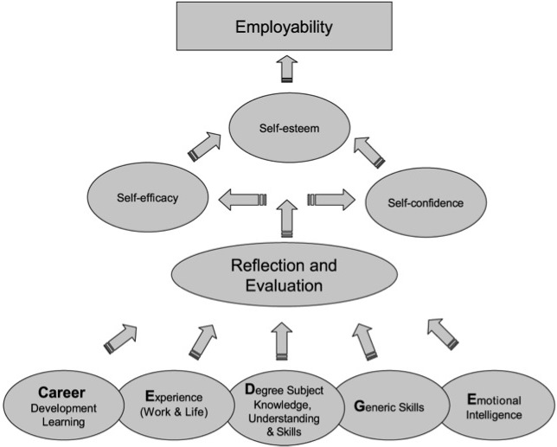

Figure 1 the key to employability (Dacre Pool & Sewell, 2007)

The model in Figure 1 shows the various skills and abilities students need to develop in order to improve their level of employability (Dacre Pool & Sewell, 2007). This project will be focussing on the generic (soft) skills from the perspectives of employers and students.
Dacre Pool and Sewell suggest that employability is something that a person needs to continue to work on for life, that there is no way to achieve complete employability and that students should revisit and review their position in the model regularly (Dacre Pool & Sewell, 2007).
Traditionally, universities were perceived to be providers of higher education as the pursuit of truth, places of research and academic learning. They were not perceived to be places that provided students with the necessary skills to gain employment. This view of the university has changed and now the reason that the majority of students attend university is in order to improve their employability by way of further education and qualification (Ansell, 2016). Universities are now very aware of the fact that students need employability skills in order to be able to secure employment at the end of their time in university. However, there is still some separation between university study and work. It seems that students do leave university with some of the skills required such as; research analysis, writing ability and critical analysis. But they don’t seem to possess the desired level of workplace skills such as; communication, professionalism and time management (Campbell, 2015).
In the US, The Secretary’s Commission on Achieving Necessary Skills (SCANS) report identifies skills required for employability. These are; critical thinking skills, leadership skills, management skills, interpersonal skills, information technology skills, systems thinking skills and work ethic (Rosenberg, et al., 2012). In the UK, the City & Guilds Centre for Skills Development (CSD) identifies very similar skills and attributes (Rosenberg, et al., 2012).

2.2 Skills Required By Employers

The CSD reported that employers are willing to train employees in the specifics of the job but expect them to portray the skills to make them possible to train (Rosenberg, et al., 2012).
It has become known that employers now have a tendency to value soft skills in potential employees over academic qualifications (Finch, et al., 2013). In the modern workplace, employers expect that time spent at university or college will provide graduates with the soft skills as well as the academic qualification they require (Rosenberg, et al., 2012).
In June 2016, CIMA (Chartered Institute of Management Accountants) conducted their own study into the skills employers expected of management accountants. Their conclusions essentially mirrored those of other studies in that the skills that were expected were very similar to those identified previously with ethics, integrity and professionalism being the underpinning elements of all of the desired attributes (CIMA, 2016). However, they also identified that the syllabus’ being taught and the employability skills required did not necessarily match and that this was a gap that required bridging and claim to have updated their own syllabus accordingly (CIMA, 2016). They claim that this gap is creating an employability crisis as there are many jobs to fill but not enough people with the desired skill set (CIMA, 2016).
Employers want potential employees to have other skills as well as a good degree. According to the Independent newspaper, “79 per cent of employers’ state that knowledge and awareness of the wider world is more important than a degree and subject classification” (Pettitt, 2013).
In an article for the Independent newspaper, Andrew Sharp, future talent manager at Mars UK, lists the things that he wants graduates to be able to do. These are; Embrace responsibility, Deliver through people, be results-orientated, focused on personal development, and be curious (Sharp, 2016). In another article, Lizzie Hart describes seven key skills that are needed. She lists these as; Verbal and written communication skills, confidence and assertiveness, ability to manage time, lateral and critical thinking skills, emotional intelligence and empathy, and the ability to work in a team (Hart, 2016).
In the accounting profession there is a growing need for graduates to possess non-accounting skills in order to gain competitive advantage and continue to progress in the modern accounting environment. They still need the traditional accounting skills but alongside that they need skills such as; organisational behaviour, strategic management and analytical skills (Kavanagh, 2006).
Kavanagh suggests that employers rate problem solving, business awareness and experience, and basic accounting skills as the most important skills they require. After these come; oral communication, ethical awareness, teamwork, written communication and interpersonal skills as well as a desire for continuous learning (2006). This is supported by Finch et al in their study in Canada. Finch et al collected data from 145 employers beginning with one-to-one interviews with 30 hiring managers and expanding the findings by examining a further 115 employers from a wide range of industries. It was found that from an employer’s perspective the more generic soft skills are more important than academic reputation (Finch, et al., 2013). These soft skills were identified as; problem solving skills, job specific functional skills, and work experience.
Lim et al, analysed the perceptions of employers of accounting students as junior auditors in Malaysia (2016) and identified time management, communication and analytical skills as those that employers desire. Maxwell et al support this argument. In their paper entitled, “Employers as stakeholders in postgraduate employability skills development” developed in Glasgow they also identified communication and problem solving as the skills with the most importance to employers (Maxwell, et al., 2010).
Lim et al also identified that there was an issue with a lack of technical knowledge in graduates. This could possibly suggest that the teaching of more generic skills may be over shadowing the teaching of the necessary technical skills that are also needed. Maxwell et al suggest that one solution could be that employers of graduate students work in partnership with universities in order to tailor the courses to ensure that students possess the skills that they desire (Maxwell, et al., 2010).
In their study of the employability skills of international accounting graduates in Australia, Jackling and Natoli discovered that employers find that there is a general lack of soft skills in graduates and even more so in international graduates, mostly in communication. This has caused a problem as oral and written communication are one of the top skills that employers’ desire (2015). This discovery aligns with the findings of Kulkarni and Chachadi in their study of skills for employability in India. They concluded that; Human skills, Professional skills and communication skills were preferred over technical skills when it came to choosing a graduate employee (Kulkarni & Chachadi, 2014). The British Chambers of Commerce have also agreed that students often do not possess the necessary communication and motivation skills that are needed to enter the workplace (Jinman, 2015).
The Confederation of Business Industry describe employability skills as skills that are not specific to one type of job or one specific field. They describe employability skills more as skills that can be used in any line of work and adapted to suit all fields (Littlemore, 2011). They list their view of the skills for employability as; self-management, team work, business and customer awareness, problem solving, communication, numeracy and information technology and, most importantly, a positive attitude (Littlemore, 2011). They argue that these skills show that graduates can deliver results under pressure.

Figure 2 Employability Skills of Top Three Accounting Employers

PwC | EY | KPMG
Whole Leadership  The ability to lead, make a difference and deliver results | People who Excel  Leadership skills and commercial acumen | Career Motivation  Identify why KPMG and why the chosen field
Relationships  The ability to build genuine, trust-based relationships | People who are good at working in teams  Good at listening, sharing, learning, developing and working with others | Delivers Quality  Can meet deadlines, able to plan, prioritise and prepare
Business Acumen  The ability to bring business knowledge and awareness | People with Integrity  Clear sense of personal professional accountability | Drives Collaboration and Inclusion  Builds relationships, enjoys sharing and discussing ideas making lasting connections
Technical Capabilities  These create value for the customer and PwC | Demonstrate Respect  Recognize the value of different backgrounds and points of view, build strong relationships | Strives for Continual Development  Motivation to achieve potential
Global Acumen  Transcending boundaries of geography, politics, race and culture | People with energy, enthusiasm and the courage to lead  Be passionate and excited for the future | Exercises Professional Judgement  Ability to analyse information and provide solutions with clarity and confidence
Makes an Impact
Communicates clearly and professionally both verbally and in writing
Seizes Business Opportunities
Understands the external marketplace and client issues, passionate about the business world
Demonstrates Innovation and Curiosity
Solve problems in innovative ways, think creatively, strong problem solvers
Resilience
React to challenges and keep motivated in difficult situations

The table shown in figure 2 shows the employability skills that PwC, Ernst and Young, and KPMG describe as the skills they seek on their websites (ACCA, 2015) (EY, 2017) (KPMG, 2016). It can be seen from this table that all three of these globally recognised companies seek very similar skills from the people they look to recruit. The majority of the skills mentioned are ‘soft’ skills with technical ability is only being mentioned by one. It is clear that the skills mentioned by these companies are also very similar to the skills identified by the literature. An observation that can be made could be that; although the skills desired by these employers and those in the literature are the same in their nature, the wording that is used to describe them can be different. This may be something that leads to confusion in accounting education.

2.3 Student’s perceptions of skills acquired during BA Accounting and BA Business and Finance Programme

In their research paper entitled, “Basic Employability Skills: A Triangular Design Approach”, Rosenberg et al concluded that when students enter university or college, they generally expect to leave armed with the necessary skills they require in order to gain employment in the field they choose (2012). This conclusion supports the findings of Kavanagh in 2006 where it was suggested that attending university or college lays the foundations of a student’s career and in order to progress with that career a student expects to leave education with at least the basics of what they require (Kavanagh, 2006). It also supports the conclusions of Littlemore in 2011 in their article for the Guardian newspaper, “CBI pushes for students to gain 'employability' skills”. Littlemore wrote, that, in a survey by the Confederation of British Industry and the National Union of Students undertaken for the purposes of developing a guide on boosting students’ skills, published in 2011, it was identified that the highest ranked reason for students attending university was to improve their job prospects. A desire to learn new things was their secondary reason (Littlemore, 2011).
Kavanagh analysed 322 graduating students in 3 major universities in Australia as well as 28 practitioners in different organisations and industries that employ graduate accounting students (2006). Kavanagh reports that students are aware that they need to develop certain skills in order to increase chances of employment. The students in Kavanagh’s study identified skills such as; communication and time management, teamwork, and presentation skills as some of the most important skills (2006). It is also identified that students do not necessarily feel that the skills they need are being taught effectively (Kavanagh, 2006).
In Kavanagh’s report, students identify continuous learning as the most important factor followed by teamwork, communication, motivation, professionalism, computer literacy, flexibility and a strong work ethic (2006).
UWTSD claims on their website that the BA Accounting and BA Business and Finance course that they offer works to develop many of the employability skills identified in previous theory. They promote skills such as communication, numeracy, ICT, team work, leadership, self-management, ethical reasoning and critical reasoning (UWTSD , 2016). These skills are promoted in order that graduates develop the skills required to be able to function effectively in a diverse environment (UWTSD , 2016).
The ACCA have a number of articles on their website regarding employability, in these articles they identify skills such as building trust, demonstrating responsibility, striving for excellence, adding value and representing your profession as the five essential qualities for a professional finance manager (ACCA, 2015). In another article they identify the eight skills that they consider improve employability. These eight are, “initiative, Commercial acumen, Professionalism, Innovation, project management, Communication and presentation, Teamwork, and networking” (ACCA, 2015).
In their employability guide, PwC identify ten ways in which to improve employability. These are, “Always wanting to improve, Being a strong communicator, Share and Innovate, Be a team player, Build networks, Be open and honest, Be organised, Prepare for the unexpected, Keep developing your knowledge, and Be passionate” (PwC, 2016).
In their study, “Embedding Generic Employability Skills in an Accounting Degree: Development and Impairments” (2010), Stoner and Milner worked with 7 focus groups of 6/7 students each over the academic year 2007/8 in Scotland. They identified critical analysis and critical thinking skills as highly important employability skills, they also identified that the students they studied were unable to present with these skills despite them being specifically targeted in the taught modules highlighting that even when skills are part of the module they are not necessarily being effectively taught so that the skills are developed in the students. However, there were clear weaknesses in the research as the study was conducted purely by way of focus groupd of students which created a potential bias to the results (Stoner & Milner, 2010).
In her study, “Generic Attributes in Accounting: The Significance of the disciplinary context” undertaken in Australia in 2007, Anna Jones interviewed academic staff in 2 large research intensive universities covering the disciplines of; history, physics, economics, law and medicine. The study analysed the assessment tasks, subject outlines, and lists of generic skills in the subject objectives and each departmental version of university graduate attributes. It was determined that the way in which students perceive what skills are most important is influenced largely by how they are taught (2010). She found that, even within the same university, skills such as critical thinking, problem solving and communication were understood differently between disciplines. These are the three skills that have been identified in this project as being the most commonly considered most important by many employers in the accounting sector. The results of her study suggest that the way in which these skills are taught is incredibly important in order to ensure that the relevant emphasis is being placed on the relevant skills so that the employability skills that are desired by the employers are indeed the skills that have the greatest emphasis and the importance of them is effectively communicated to the students.

2.4 Conclusion

It has generally been discovered in the many studies conducted in both the UK and internationally, that there is a gap between what employers consider to be highly desirable skills and attributes and the skills and attributes that graduate students are furnished with as part of their higher education. Students and employers tend to agree on many of the desirable employability skills that are required, although they do rate some skills in differing orders of importance, a view that is supported by Kavanagh (2006).
Rosenberg et al suggest that there is growing concern over graduates receiving the training in relevant employability skills that are desired by employees (2012).
As can be seen, many similar skills have been identified as the most desirable employability skills although they have been called a number of different things by different people. It could be argued that agreeing terminology for these skills may make it simpler to identify if they are provided by education and thus possessed by graduates.

There also appears to be a lack in communication between employers and the universities and colleges teaching the students. However, this gap has been reducing over time. Progress towards closing the gap continues as the programmes are restructured every five years using data and feedback from employers in the field. It seems vital that this communication is established and maintained in order to be sure that the employability skills required by employers are the same employability skills that are being taught to the students in order to produce graduates that are employable and meet the demands of the current market (Rosenberg, et al., 2012).
Kavanagh looks at studies into employability by; Kim, Gosh & Meng (1993), Radhakrishna & Bruening (1994) and Gabric & McFadden (2000). It can be seen in their report that there are differences in the perceptions of employers and students on the order of importance of skills. It is still believed by some students that exam results are the most important criteria ahead of skills such as communication and teamwork (2006).
It has been noted that in accounting the technical accounting skills need to be supported by further generic skills in order for the future accountant to be able to fully utilise the skills obtained during their time in education by being able to adapt the skills obtained to the real-life workplace (Jackling & Natoli, 2015).
David Docherty, writing for the Guardian newspaper, argues that employability in university graduates is currently measured in their ability to gain employment in their field of study rather than their job readiness (2014). He suggests that a better way to grade graduates’ employability would be to analyse their progress in their early careers to discover how they advance in their sector (2014).

The results of Jones’ study (2010) suggest that the way in which these skills are taught is incredibly important in order to ensure that the relevant emphasis is being placed on the relevant skills so that the employability skills that are desired by the employers are indeed the skills that have the greatest emphasis and the importance of them is effectively communicated to the students.
It has been identified that there is some research that believes the teaching of employability skills takes too much time away from the teaching of the traditional technical curriculum. However, there is also another line of research that argues the opposite, that the skills required are of equal if not higher importance than the technical skills in order to furnish the students with the ability to perform in the positions to which they are likely to be applying (Jones, 2010). It would seem that a balance needs to be found.
It has been noted that there is a vast amount of research available on the topic of employability skills and the perspectives of both students and employers. Accounting education dedicated an entire volume to this topic in 2010 (Stoner & Milner) (Jones) (Bui & Porter) (Willcoxson, et al.) (Fortin & Legault) (Awayiga, et al.). This research will look to confirm if the conclusions reached by these studies are relevant when applied to university students in Swansea and employers in the south wales area with particular focus in the accounting sector.

Chapter 3 Research Methodology

This chapter will describe the design of the research, the data collection tools used, the process used and analysis of the data in order to achieve the research aims and objectives.
The overall aim of the research is to analyse and evaluate the differences and similarities between the employability skills required by local employers and the employability skills that Swansea students consider to be important and desirable. In order to achieve this the researcher will set objectives. Saunders et al state that these variables need to be, “precisely written and lead to observable outcomes” (2007, p. 40). Hart adds to this and describes them as, “the tasks required to actualize adequately the main elements of the research” (2009, p. 88). The following objectives are the tasks that need to be done in order to achieve the desired outcome of the research.

3.1 Objectives

- Establish the skills and abilities that employers expect from BA Accounting and BA Business and Finance graduates
- Establish the skills and abilities that graduates perceive to be the most desirable
- Investigate whether the skills that are perceived to be important are taught as part of the normal BA Accounting and BA Business and Finance syllabus
- Discuss any improvements that could be made to the teaching of BA Accounting and BA Business and Finance in order to ensure that graduates are able to develop the required employability skills

Research can be defined as, “The systematic collection and interpretation of information with a clear purpose, to find things out” (Saunders, et al., 2007, p. 488). Collis and Hussey believe that the generally research is, “a process of enquiry and investigation, systematic and methodical, and increases knowledge” (2009, p. 3). It can be seen that research is about finding out more information on a given subject in order to prove or disprove a theory and that research methodology is the process used to find that information. Many things need to be considered in order to decide on the most suitable research methodology. These could be: the research question, previous research on the topic, availability of data, time, resources, reliability, validity and ethics as well as who the research is for (Veal, 2005). The most efficient method of research needs to be identified.

3.2 Research design

Effective research design is paramount for an effective research project. It can be defined in a number of ways. It is, “the structure that holds the research together and enables the researcher to address the research questions” (Hart, 2009, p. 313). It is also described as, “the blueprint for the collection of, measurement and analysis of data” (Cooper & Schindler, 2014, p. 125). As well as, “the plan and structure of investigation” (Cooper & Schindler, 2014, p. 125). Ultimately, research design plans out what needs to be done in order to achieve the objectives.
Research is made up of two parts, primary and secondary. Primary research is new research carried out by the researcher solely for the purposes of the project. Some examples could be: questionnaires, surveys, focus groups and interviews. Secondary research is the analysis of data that already exists. Some examples are: books, journals and newspaper articles. The secondary research is what makes up the literature review of the project.

Figure 3 the Research Onion
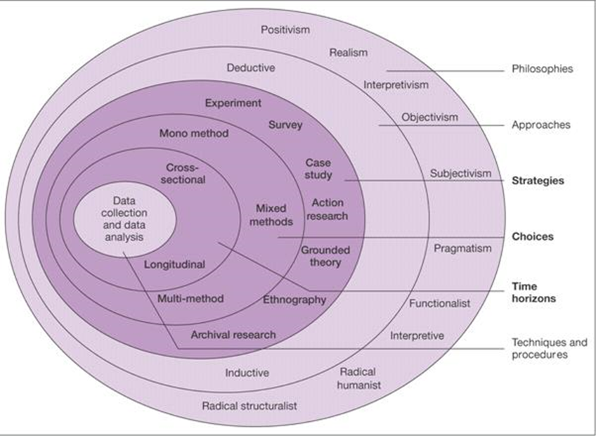
(Saunders, et al., 2007, p. 132)
When referring to the research onion shown in figure 1, it can be see that it is shown as having six layers. The first, or outer, two layers show the research paradigms or approaches. The paradigm chosen reflects the theory surrounding the project. The following three layers depict the strategy used including methods of data collection. The choices made by the researcher will depend on the method that best suits the type of data required and also the time available for the project. The centre of the onion shows the data collection and analysis that will be used. This is how the data will be recorded and stored so that it can be referred back to for the duration of the project.
Working through the layers of the research onion in figure 1 for the purposes of this project it can be established that the research is cross-sectional, it was carried out at one point in time largely due to the time constraints of the academic year. Longitudinal research would have been the alternative, however that would require much more time than is available. As there is only one type of data collection method, namely surveys, the research is Mono method (Saunders, et al., 2016).
The main two types of research according to Saunders et al are positivism and phenomenology. In the case of this project the philosophy chosen was difficult to place into just one of these brackets. This is identified by Saunders et al as being a common problem with most research. It was decided that elements of both approaches would be considered. As it considers both approaches, the research is also both inductive and deductive, deductive being aligned with positivism and inductive with phenomenology. It can be noted, however, that it is mostly inductive in nature, it is used to explore a phenomenon and identify themes in the area. A phenomenological approach is the major approach that has been taken, the data collected is dependent on perspective and opinion (Saunders, et al., 2016).
For the purposes of this project, a phenomenological approach has been taken. Creswell defines phenomenology study as, “the common meaning for several individuals of their lived experiences of a concept” (2013, p. 76). Carol Grbich describes phenomenology as, “exploring experiences to clarify their essence” (2011, p. 84)
The phenomenological approach is taken when people’s experiences, opinions, and perspectives are being researched to be interpreted. It is usually used in subjects where there is little or no in depth data.
As Roy Horn states, “Phenomenologists are interested in the nature of the subjective experience from the perspective of research participants themselves” (2012, p. 89). This describes the main objective of this project exactly in that the researcher is seeking to establish the perspectives of employers and students. It is less about hard facts and more about perspective and opinion.

3.3 Data Collection

The data and information collected from the review of the literature was used as a basis for the questions for both of the surveys in order to achieve the first three objectives of this research project. Both qualitative and quantitative data was collected. The majority of the data collected for this project is qualitative, it is based on perspectives of students and employers in the accounting sector. Qualitative data is, essentially, the opposite of quantitative data in that it is not numerical data based on hard facts. It cannot be quantified and analysed by way of percentages or as effectively as quantitative (Saunders, et al., 2007). It is about what people think, what their opinions are. It can be used to find an insight into the motivations behind the way people behave (Marks, 2000).
In qualitative research, the data collected is seen as more contextualized than in quantitative research. It is more detailed in that it is about understanding a problem or scenario by building a picture of the problem or scenario based on the views of respondents (White & Rayner, 2014). It is an interpretive approach, the main purpose of which is to understand the meaning of a particular ‘phenomena’. Qualitative data is divided into three terms; constructivist, relativist and phenomenological (White & Rayner, 2014).
Saunders et al describe qualitative data as being, “any data collection technique or data analysis that generates or uses non-numerical data” (2016, p. 170). This description of the separation of quantitative and qualitative can be a bit narrow because a lot of research designs are likely to use a combination of numerical and non-numerical data. As with this project, some of the qualitative that is collected may be analysed in a numerical, and therefore quantitative, way (Saunders, et al., 2016).
Qualitative data collection is normally associated with an interpretive philosophy. This is because researchers are striving to understand the subject by way of expression. It is most common for this type of data collection to use just one method. Generally, surveys are not used for qualitative data collection unless they contain a lot of open questions. By this determination, this project does have some quantitative collection being used.
The primary research of this project is made up of two surveys. One to collect information on the perspectives of students and the other to collect information on the perspectives of employers. The sample used was to be accounting firms in the Swansea area, with the possibility of expanding the field to include more areas if necessary to achieve an effective level of respondents. The student sample was to include BA Accounting and BA Business and Finance students and BA Business and Finance students of UWTSD with the possibility of expanding the field to include students of Swansea University if necessary to achieve an effective level of respondents. Secondary research was also carried out for this project. The researcher used research available in books, academic journals and websites as well as reliable newspapers such as The Guardian and The Independent. Only academic sources that were not biased were used for the purposes of the research.
Initially, the researcher planned to collect data by way of two online surveys. The first being targeted towards UWTSD BA Accounting and BA Business and Finance and BA Business and Finance students at levels 4, 5 and 6. The table below shows the numbers of students registered on the programmes at all levels.

Figure 4 UWTSD Students

 | Level 4 | Level 5 | Level 6 | Total
BA Accounting | 14 | 11 | 9 | 34
BA Business and Finance | 4 | 3 | 11 | 18

As can be seen, the maximum number of students that would be available may not be sufficient to obtain reliable data therefore widening the research base may be desirable. It was decided that this could be achieved by contacting students that had recently graduated from the BA Accounting and BA Business and Finance and Business and Finance Programmes.
The second survey was to be targeted towards accounting firms, potential employers of accounting graduates. Initially the aim was to contact accounting firms in the Swansea area with a target response rate of 50 firms. However, it became clear that there were insufficient numbers of accounting firms in the Swansea area alone and that the sample area would need to be widened in order to ensure reliable data collection.
Saunders et al (2007) identify seven strategies to research: survey, case study, experiment, grounded theory, ethnography, action research and archival research. Surveys were chosen for the purposes of this research as they are simple to understand and simple to administer. They should also provide reliable data that is easy to interpret and provide the researcher with an element of control. Surveys allow the researcher to collect large amounts of data over a short period of time and in a relatively economical way. The data collected will be quantitative and it may be possible to predict relationships between variables such as age of student and knowledge of employability skills or size of accounting firm and employability skills desired. Some disadvantages to using surveys are that the data collected can be limited in detail and they are time consuming to create.
Many of the questions were closed questions as these are easy to analyse by the researcher as well as being easy to understand and respond to by the respondent (Collis & Hussey, 2009). The survey was created using survey monkey. This was in order to simplify the design, distribution and analysis of the results.
Pilot surveys were distributed to a few respondents before the main surveys were distributed. This was done to establish if they contained any mistakes or badly worded questions that may affect the results. As a result of this pilot the wording of some questions in the student survey were changed.
The data was collected overall from February 12th to March 21st. The survey for the students contained questions that aimed to assess the level of understanding of employability skills, students’ perceptions of the level of importance attached to specific skills, and students’ perspective as to whether the degree course they are studying meets the needs of the employers. The survey for the accounting firms contained questions that aimed to assess the level of importance that employers place on employability skills that they desire as well as their perspective of whether accounting graduates are furnished with these skills.
The survey for the students were distributed by way of a link shared during lectures and students were then encouraged to complete the survey.
The survey for the accounting firms was distributed by way of a link shared via email to accounting firms in the Carmarthen, Llanelli, Swansea, Bridgend, Neath Port Talbot and Cardiff areas initially. The emails were sent over the 16th and 17th of February to 113 firms. The link was also emailed to the big 4 accounting firms with the view to compare the results with those of the more local firms.
Unfortunately, over the first week following the distribution of the link to accounting firms, there was a disappointing response rate of just under 10%. With this in mind, the researcher extended the sample to include professionals in the Newport and Pembroke areas. A further 53 companies were contacted which again yielded a 10% response rate. The researcher broadened the sample area further including the whole of South Wales.

3.4 Reliability and validity

Reliability of research can be threatened in a number of ways. Some of the main threats are:
- Participant Bias – participants in the survey may answer the question in a way that they perceive as what the researcher wants them to say. One way to avoid this may be to ensure anonymity in the survey so that the participant is aware that they are not identified personally in the data. Both of the surveys created for this research project are anonymous.
- Participant error – surveys may be completed incorrectly. Questions may be misinterpreted. One way to avoid this would be to run a pilot. This was done with both of these surveys, no problems were detected at the pilot stage and the only result was to add extra questions. However, during data collection, the question on the accounting firms’ survey relating to area covered was misinterpreted multiple times with participants providing the area as accounting and finance as opposed to the desired geographical area.
- Observer Bias – the researcher may interpret the data to suit their personal beliefs or the conclusion that they desire. This threat can be reduce by being as specific as possible in the questions so that the answers cannot be misinterpreted.
- Observer error – the researcher may interpret the data incorrectly. This is reduced by using specific questions and using software to help to interpret the data.
Validity is about ensuring that the picture created by the data findings truly reflect the real picture (Hartas, 2010). Saunders et al define validity as being, “concerned with whether the findings are really about what they appear to be about” (Saunders, et al., 2007, p. 150).
In order to ensure validity in this project, it was important for the questions to be relevant. Therefore, the researcher based the questions for both of the surveys on the findings of the literature review in order to ensure relevance. The survey was conducted online, which served to reduce the risk as limitations could be added to the structuring of the questions.

3.4 Ethical considerations

There were ethical considerations and limitations to be considered during the data collection stage of this project. Research ethics are defined by Saunders et al as, “the standards of behaviour that guide our conduct in relation to the rights of those who become the subject of your work or are affected by it” (2007, p. 178).
Cooper and Schindler state that the importance of research ethics is to ensure that research undertaken is, “methodically sound and morally defensible to all those who are involved” (2014, p. 178). In the case of this project it was important to ensure that consent was obtained from the universities, both UWTSD and Swansea University, before the surveys were distributed to the students. The researcher is also subject UWTSD’s code of ethics. A copy of the ethics form E3, completed by the researcher, can be found in the appendices.
The Human rights of the people involved in the research needs to be protected. The topic of this project is not particularly sensitive, it doesn’t involve the need for financial or confidential information. The data is largely opinion based, however it does require some personal information such as gender and age that some people may be uncomfortable sharing unless it is safe. The surveys to the students achieved anonymity by not asking for any names or contact details. The surveys to accounting firms did ask for company names, however no personal names or contact details were requested. All subjects, for both surveys, were informed of the purpose of the study and of how the information collected would be used.

Chapter 4 Data Analysis

The aim of this research project, as identified in chapter 1, was to analyse the employability skills of graduate students from the perceptions of employers and students. Identifying the key skills required by employers, the students’ perception of key skills to employment as well as identifying whether these key skills are taught by the university in order to ensure graduates possess the desired level of employability skills.

Data analysis is about organising and breaking down the data collected in order to make it more manageable. It aims to discover patterns and find out what is important (Bogdan & Biklen, 2007).

This chapter will analyse and present the results from the online survey of employers that received a total of 20 responses as well as the results of the online survey of students that received a total of 41 responses. It will evaluate the level of perception of importance placed on the employability skills identified by both employers and students as well as the perception of whether students are furnished with these skills upon graduation. This will be done in relation to the research objectives as set out previously:

- Establish the skills and abilities that employers expect from BA Accounting and BA Business and Finance graduates
- Establish the skills and abilities that graduates perceive to be the most desirable
- Investigate whether the skills that are perceived to be important are taught as part of the normal BA Accounting and BA Business and Finance syllabus
- Discuss any improvements that could be made to the teaching of BA Accounting and BA Business and Finance in order to ensure that graduates are able to develop the required employability skills
This chapter will attempt to meet these objectives by way of analysis of the primary data collected in contrast to the secondary data analysed in chapter 2.

4.1 Initial Observations

In this section the initial observations of the primary data collected is noted.

4.1.1 Student Online Survey

The student survey results were slow to start. In the first week there were very few respondents to the survey. The target of 50 respondents was, unfortunately, not reached. The numbers studying at UWTSD Swansea were too low to achieve the desired target and another university that were to be included in the study decided not to participate. A total of 41 respondents were eventually reached after including the alumni of UWTSD Swansea, these graduates made up the majority of the respondents.

Due to the other university choosing not to participate in the study, Question three of the survey, “University Attended”, became irrelevant as all of the respondents attended UWTSD Swansea (previously Swansea Metropolitan University – SMU).

There was an almost equal male / female split in the respondents. The majority being in the 18-24 age bracket.

A more detailed analysis of the student survey is found in the following section. The initial observations of the data are: Most of the respondents agree with the statements in question 6. The main response to question 7 was that the skills mentioned were important or very important. Barely any of the skills were deemed to be not at all important or not very important. It seems that students perceive that there is some teaching of most of the skills mentioned, with only a few being very well taught. Unfortunately very few students took the opportunity to make further comment on their perceptions of employability in questions 9 and 10.

4.1.2 Employer Online Survey

The employer results proved difficult to collect. The employer response rate was lower than 10% with a total of 20 responses being collected despite more than 200 requests being sent to employers across Wales. The majority of the respondents were small to medium companies. These results were disappointing, however the responses that were collected were thorough, detailed responses.

The majority of the respondents perceived that the skills mentioned were either important or very important with very little deemed as unimportant. The employers perceived that there was some skill level presented by graduates, although some had no opinion on the level of skill presented. These results could be due to the size of the companies that responded having little experience of employing graduates.

The employer respondents took advantage of the open questions, 6, 7 and 8, providing the researcher with various perceptions and opinions on the importance of skills and graduates’ levels of employability.

4.2 Student Survey Results

In this section the results from the students’ survey will be analysed. Responses to each of the questions will be discussed. The researcher will be looking for patterns in the data as well as how the data relates to the secondary data analysed in chapter 2.

4.2.1 Profile of Respondents

Figure 5 Gender Figure 6 Age Group

Figure 7 Area of Study Figure 8 Level of Study

Figures 5 to 8 demonstrate the data collected in questions 1 to 5 of the student survey. As previously mentioned question 3 became irrelevant so has not been included. The majority of the student data was collected from recent graduates of UWTSD Swansea with the next highest response being from level 6 students. 76% of the respondents were from BA Accounting, 15% were from BA Business and Finance and the remaining 9% were from other programmes that were unwanted responses done in error. They was a fairly even male and female divide with 46% male respondents and 54% female respondents. The majority were either in the 18-24 or 25-34 year old bracket.

These demographics suggest that the data collected may not be as current as desired as it is mostly from recent graduates rather than current students. However, it could also be argued that this may add to the validity of the data as the recent graduates will have had experience of trying to further their career and therefore will have a clearer view of whether their degree has provided them with the employability skills that they need.

The data collected is relevant to the research questions as there is not a gender bias and is collected mostly from BA Accounting and BA Business and Finance students. The age range of the respondents seems to reflect the majority age range of accounting students in general.

4.2.2 Level of Agreement to Statements

Figure 9 Student Survey Q6

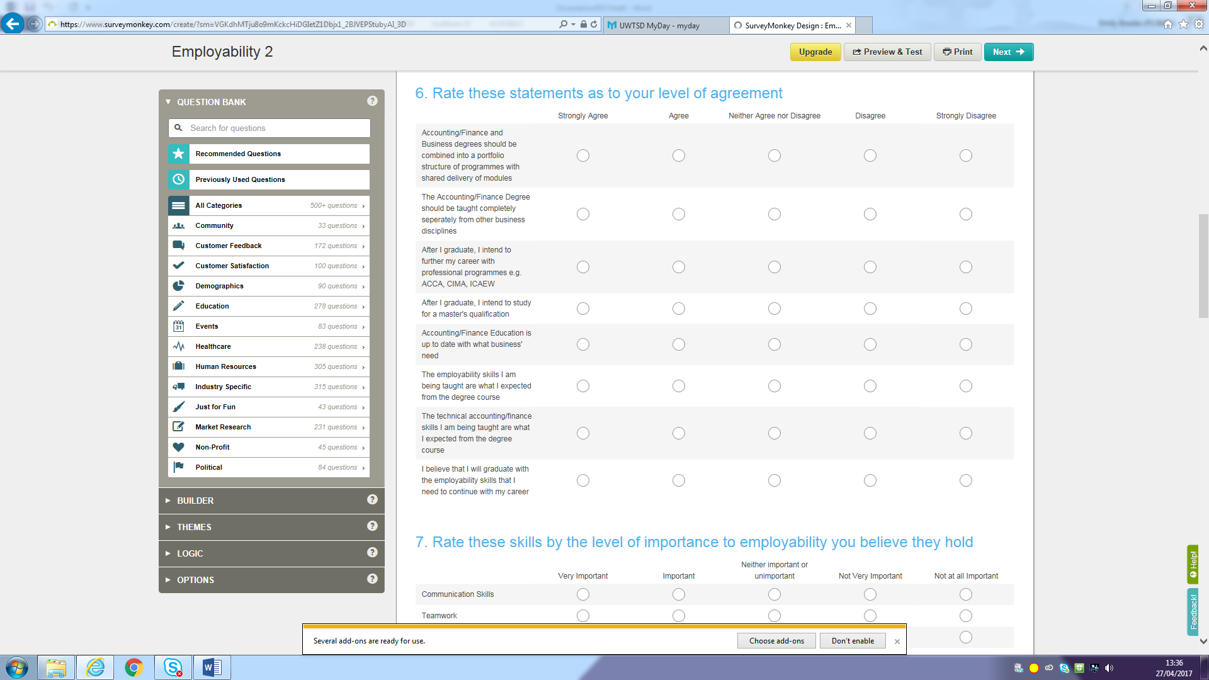

Figure 10 Graph to show overall results of question 6

Figure 9 shows the list of statements put to the students surveyed, requesting their level of agreement to the statements in order to identify the perception of the students in regard to the courses that they are being taught. The graph in figure 10 shows the level of agreement that the students have in response to the statements that were put to them in the survey.

Figure 11 Graphs to show the level of responses to each of the individual statements in student survey question 6

The graphs in figure 11 show the individual levels of agreement to each of the individual statements from question 6 of the student survey.

A large number (46%) of the students agreed that Accounting and Business degrees should be combined with shared delivery of modules, supporting the way in which the programmes are currently delivered. In contrast, the results for statement 2 suggest that the students are undecided as to whether accounting should be taught separately, a very balanced spit of 34%:32% between agree and disagree with 15% neither agreeing nor disagreeing. Where it is possible that these are different students, it does appear that some students may not have given a lot of thought to the answers that they gave and actually agreed with the two contradicting statements.

It can be seen from the graph that the majority of 56% of the student respondents strongly agreed that they intended to further their career with professional programmes with a very minor 7% disagreeing. The results of statement 4 support these results as they suggest that students are undecided as to whether to study for a master’s qualification with a majority 32% opting to neither agree nor disagree. It could be argued that students do wish to further their career after graduation but are leaning towards the professional qualification over the academic one.

The results for statements 5 to 8 show that students perceive the accounting degree is up to date with what business’ need 59% of students agree and 10% strongly agree. The skills taught are perceived what students expected along with the technical skills taught. The results suggest that students believe they will graduate with the employability and technical skills that they require to continue to further their career. A majority of 58% in total strongly agree or agree with a very small 3% disagreeing with this statement.

4.2.3 Q7 Perspective of Importance of Skills

Figure 12 Student Survey Q7

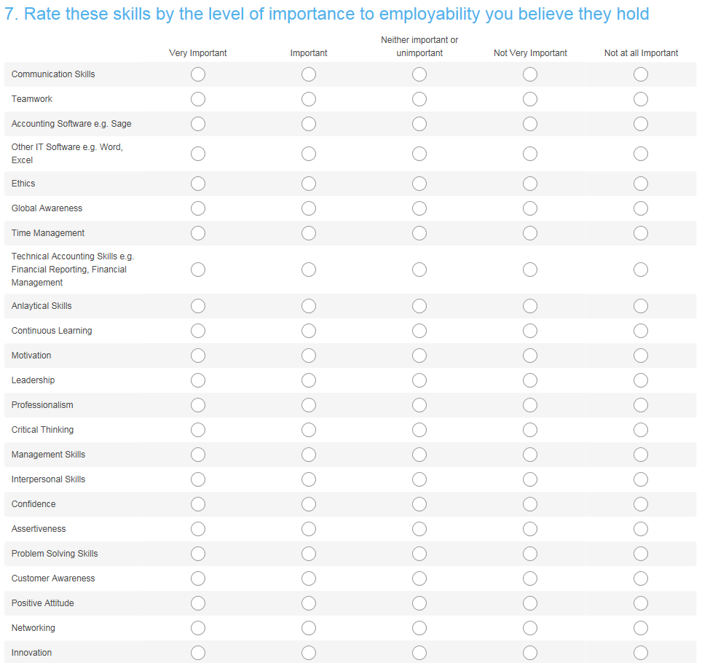

Figure 13 Graph showing results of student survey Q7

Question 7 of the student survey, shown in figure 12, was designed to assess the level of importance that the students perceive to be connected to the skills mentioned. Figure 13 shows a graph of the results, derived by weighted average of responses to the student survey. These results suggest that the students do not levy a very high importance on any specific skills. Some are rated of higher importance than others with Innovation and Leadership taking top positions and less importance given to skills such as time management and communication. These results are in contrast to the results in the literature where most of the results, particularly those from Kavanagh and Jones identified communication and time management as skills that students perceived to be most important. Innovation and Leadership are not mentioned as highly important in the literature reviewed from the students’ perspective, however, they are skills deemed important by employers such as PwC and KPMG.

4.2.4 Q8 Perspective of Relevance of Teaching

Figure 14 Graph showing results of student survey Q8

Question 8 was designed to assess the students’ perspective of the level of teaching that they receive in regard to the same skills detailed in question 7 (figure 12). The graph shown in figure 14 is derived from the weighted average of the responses given. From these results it can be seen that Technical Accounting Skills, Accounting Software and Problem Solving skills would appear to be the best taught skills from the students’ perspective. The results from the survey argue that communication is something the students’ feel they are taught as part of their programme. This is in contrast to arguments from Kavanagh (2006), Jackling and Natoli (2015), and Jinman (2015) who argue that communication is the skill that is lacking in graduate students. None of the skills mentioned are thought to be poorly taught or not taught at all overall.

4.2.5 Q9 Any Other Skills relevant to employability

Figure 15 Responses to student survey Q9
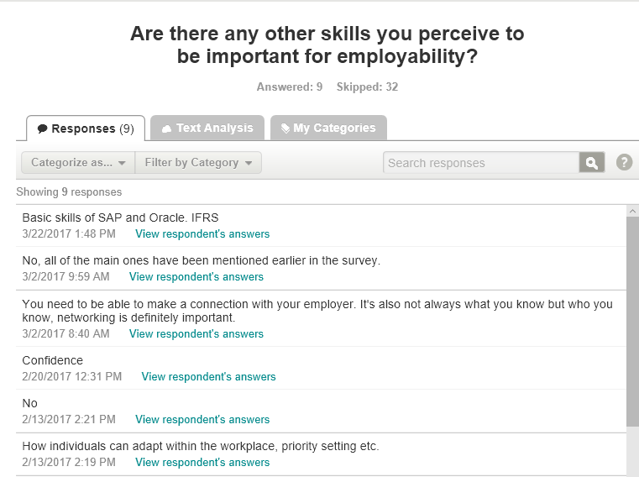
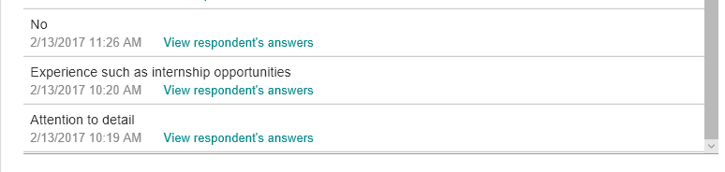

Figure 15 shows the results collected from the student survey. Unfortunately, there was not a high response to this question. Only five serious responses were given. Technical skills that were suggested were basic skills of SAP and ORACLE as well as knowledge of IFRS. SAP is cloud accounting software that claims to be the best cloud accounting software available. It covers financial management, risk analysis and compliance as well as core accounting and reporting, management of accounts receivable and shared services. The accounts receivable function is particularly effective as it claims to be able to investigate the causes behind late payments and therefore regain payments faster. The shared services function means that managers are looking at the same information as the accountants so communication is simplified. The software conforms to the usual GAAP and IFRS standards and applications within the software support the risk management functions and integrate with the general ledger in order to ensure compliance. There are 45 country specific versions of the software which suggests that it is a popular choice (Software Advice, 2017). The SAP website claims that, “SAP solutions for accounting automatically record and valuate finance and logistics business activities into a single source of truth across the general ledger and all sub ledgers. This enables real -time self-service analytics directly from granular operational data. It helps improve quality, close books more quickly at less cost, deliver better reports, and enable smarter and faster decision making.” (SAP.com, 2017). Oracle is also cloud software. Oracle is best known for database management systems, however they do offer a range of software including integrated cloud accounting software. Similarly to SAP, Oracle claim to be the best available and the most recognised. They claim to be intent on claiming their top position through constant innovation. They provide much the same functions; accounts payable and receivable, advanced cost accounting, environmental accounting and reporting, expense management, fixed asset accounting, general ledger support for IFRS. This software also has the ability to allow expenses to be added by way of mobile devices and updated in real time and for invoices to be scanned and automatically updated (CompareAccounting.com, 2017). It is easy to see how skills in the use of both of these software packages would be beneficial to the accounting graduate. It should be mentioned here that although UWTSD do not currently teach these specific software packages, they are one of very few universities that teach any of the accounting software on the programme.

IFRS is something that is fairly well covered in UWTSD’s current teaching. It is covered in the corporate financial reporting, corporate governance, Financial Reporting and Auditing modules covered in the BA Accounting and BA Business and Finance programme. The student that made this suggestion can be identified as a recent graduate so it is possible that the teaching of IFRS wasn’t as well incorporated during the time they studied for the programme.

Other skills suggested by the students were the more generic soft skills of; confidence, priority setting, adapting to the workplace and attention to detail. Again, it is easy to see the benefits of
these skills to the accounting graduate.

4.2.6 Q10 Further Comments

Figure 16 Results of student survey Q10

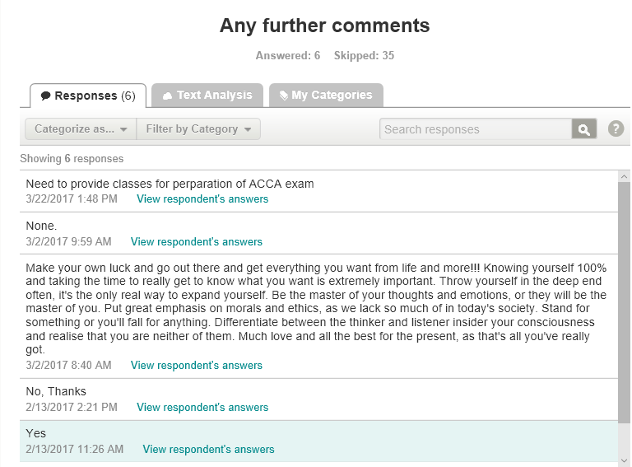
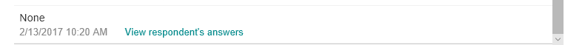

Figure 16 shows the results collected from question 10 of the student survey. Once again, unfortunately, there were only two useful responses. The first suggested a need for universities to provide classes to prepare for ACCA. The other was very philosophical in their response commenting that students need to “go out and get what they want”, “make your own luck” and “know yourself 100%”. This comment, while philosophical seems to suggest confidence and drive as being important, something with which the literature would agree, particularly in reference to the large organisations such as PwC, Ernst & Young and KPMG.

4.3 Employer Survey Results

4.3.1 Profile of Respondents

Figure 17 Q2 How many employees do you have?

As can be seen in figure 17, there were very few respondents from large companies. The majority of the respondents had less than 10 employees. Some of these had no employees at all. Unfortunately none of the big four responded to the survey. It would have been interesting to be able to compare the responses of larger companies with smaller ones, on this occasion that is not possible.

Companies across Wales were contacted and asked to participate in this survey. Unfortunately there was an extremely low response rate of less than 10% resulting in only 20 overall respondents. The results also show that the majority of the respondents that gave their geographical area were from South Wales and the surrounding areas.

4.3.2 Q4 Perspective of level of Importance of Skills

Figure 18 Q4 Rate these accounting graduate skills by the level of importance to employability that you believe they hold

From the graph in figure 18 it can be seen that the employers’ placed a much higher importance on all of the skills mentioned than the students did with most of the skills being classed in the very important category. Positive Attitude, Customer Awareness, Professionalism and Communication seem to be the top skills. This is in agreement with the literature, particularly in the case of communication and attitude, these are skills that are identified by a number of authors such as; Kulkarni and Chachadi, Jackling and Natoli, Maxwell et al and Lim et al as well as being deemed important by the Confederation of Business Industry.

4.3.3 Q5 Accounting Graduates Skills

Figure 19 Q5 Rate the same skills by whether you feel accounting graduates generally present with these skills

In this chart, it does seem that although employers perceive students to present with the majority of the skills, none of them are perceived to have an excellent skill level, only really making it to some skill level. This is in agreement with the literature reviewed as CIMA (2016) identified a gap in what is taught and what is required. Also Kavanagh identified that students felt that skills were not being taught effectively. What may seem surprising is that one of the skills that the students believed was important and they were being taught well was accounting software. However it can be seen here as the lowest ranking skill that they present with in the view of the employer.

4.3.4 Q6 Other Important Skills

Figure 20 Responses to employer survey Q6
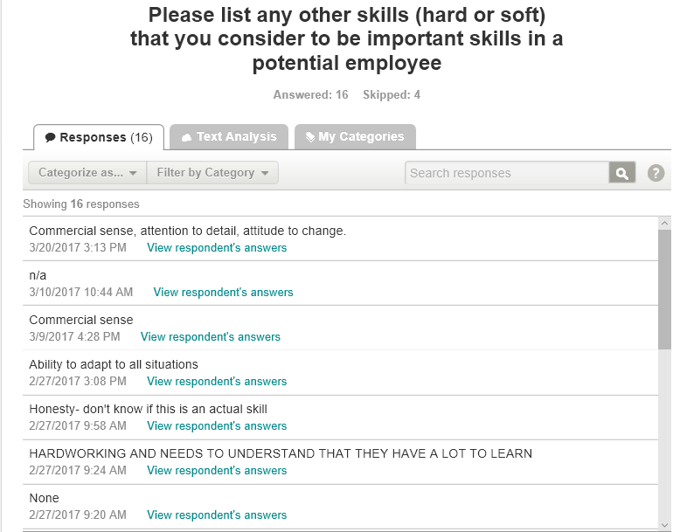
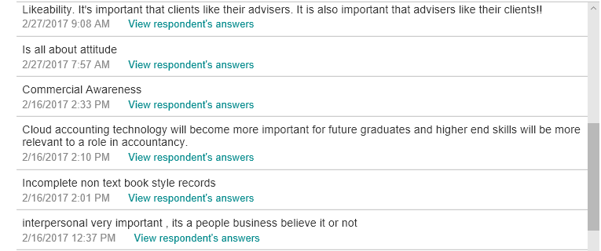
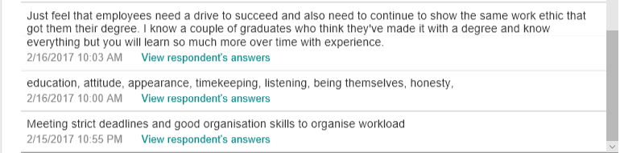
Figure 20 shows the responses to the employer survey question 6. In similarity to the student survey the majority of the suggestions are for more generic soft skills such as; commercial sense, attitude, interpersonal skills and a good work ethic. The employers also suggest cloud accounting as a technical skill that would be beneficial. Cloud accounting is still a relatively new concept. Clearly there will be a growing number of businesses that will use it into the future.

4.3.5 Q7 Do Graduates Present Skills at interview

Figure 21 Responses to employer survey Q7
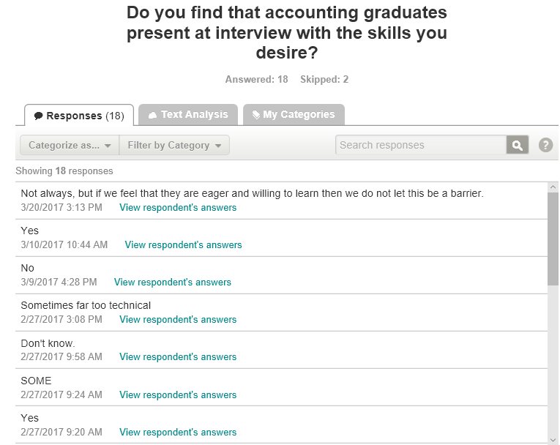
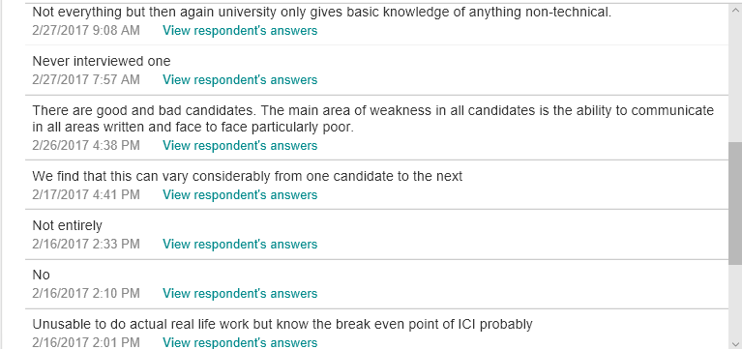
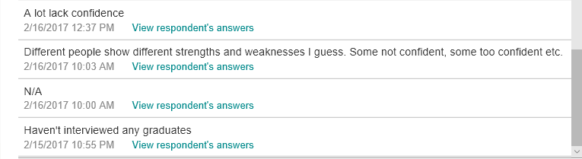
Figure 21 shows the responses collected from the employer survey question 7. As can be seen many of the employers mention the same things. The main observation from these comments would be that the employability skills presented by BA graduates vary greatly from case to case. However the main skills that are perceived to be lacking are an inability to communicate effectively, a lack of confidence and a lack in technical skills. As has been mentioned previously, the technical skills are something that UWTSD teaches at a level that is advanced in comparison to many other universities.

4.3.6 Q8 Further Comments

Figure 22 Responses to employer survey Q8
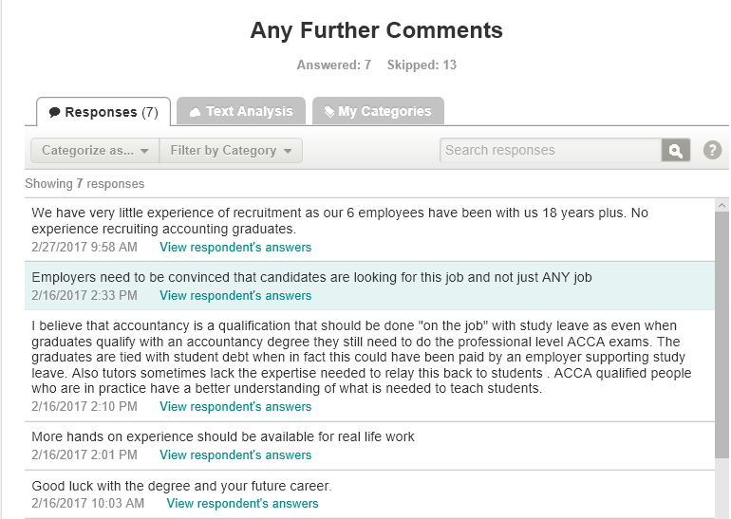
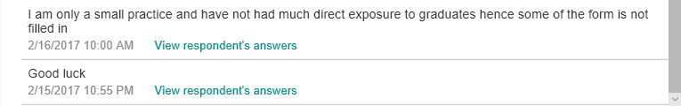

Figure 22 shows the responses collected from the employer survey question 8. There were some interesting comments made in this section. Employers’ suggested that accounting is a subject that should be learned ‘on the job’. The graduates lack ‘hands on’ experience. One employer suggested that doing an accounting degree was essentially pointless and that students would be better off learning through employer supported learning, gaining their ACCA qualification whilst working for an accounting firm to gain the hands on experience and thus qualifying without being left with massive debts.

Comparison of Results

4.4.1 Objective One: Establish the skills and abilities that employers expect from BA Accounting and BA Business and Finance graduates
The data collected suggests that the skills that are most important to the employers surveyed are; communication, positive attitude and professionalism. The employers rated all of the skills as being quite highly important suggesting that the skills desired are actually incredibly broad and varied and most certainly not limited to technical skills.

4.4.2 Objective Two: Establish the skills and abilities that graduates perceive to be the most desirable
In contrast to the results for objective one, the data collected suggests that the skills perceived to be most important by the students surveyed are; innovation and leadership. It can also be seen that the students do not place a high value on any of the skills suggesting that they are not fully aware of the level of importance that they hold with employers and may believe that, although they are desirable by some and would be useful, it is not absolutely necessary that they possess them.

4.4.3 Objective Three: Investigate whether the skills that are perceived to be important are taught as part of the normal BA Accounting and BA Business and Finance syllabus
In relation to this objective, the data suggests that while the majority of the syllabus currently being taught is valid, there is room for improvement. Employers identify a lack in communication skills and confidence as well as limited real world experience. Some technical ability, particularly cloud computing software is identified by both the students and the employers as a skill that is missing, lacking or not being taught.

4.4.4 Objective Four: Discuss any improvements that could be made to the teaching of BA Accounting and BA Business and Finance in order to ensure that graduates are able to develop the required employability skills
The immediate suggestions for improvement are identified by the students and employers as being; real world experience, an increase in co-operation and communication with employers, and an increase in the teaching of technical skills, particularly in the field of cloud accounting. These ideas will be discussed in further detail in chapter 5 of this study.

4.4.5 Summary

It can be seen from these results that students and employers do not entirely agree on which skills are the most important, nor do they agree on whether students are being furnished with the skills that they require. Employers perceive that communication, positive attitude and professionalism are the skills that are most important and that students are lacking in confidence, non-technical skills and communication skills. Students perceive that innovation and leadership as the most important skills with communication being one of the least important. The students also perceive that they are being taught all of the skills that they require. As suggested in the literature there is a clear gap between the skills desired by employers and those perceived to be important by students. The results from the employers appear to agree with the literature reviewed whereby they believe that the ability to communicate effectively is a very important skill to have and graduates are generally lacking in that specific skill. Both the students and the employers have identified that knowledge of cloud accounting is a skill that will increasingly be in demand in the modern workplace.

Chapter 5 Discussions, Conclusions and Recommendations

5.1 Discussions

The purpose of this study was to look at the employability skills of BA Accounting and BA Business and Finance graduates. The aim was to establish which skills are perceived to be most and least important to employability in the accounting sector from the perspectives of students and employers and also to analyse whether current accounting education furnishes students with the employability skills that the employers desire.

5.1.1 Objective one: Establish the skills and abilities that employers expect from BA Accounting and BA Business and Finance graduates

In terms of the first research objective “Establish the skills and abilities that employers expect from BA Accounting and BA Business and Finance graduates”, the research shows that the skills identified in the literature review are supported by the skills identified in the primary research. For example, Lim et al in their study of thee perceptions of employers of accounting students as junior auditors in Malaysia (2016), identified communication, time-management, and analytical skills as most desired. This is supported by the primary research all receiving high rankings from the employers surveyed.

Maxwell et al, in their study of employers as stakeholders in postgraduate employability skills development in Glasgow (2010), identified communication and problem solving skills as the most important. Again this is supported by the research, communication receiving the highest ranking and problem solving skills being given a very high ranking of over 4.

In an article entitled, “The 7 key soft skills every graduate job hunter needs” (2016), Lizzie Hart, writing for The Independent newspaper lists; communication, confidence, assertiveness, time management, critical thinking, teamwork and empathy as key skills. These are well supported by the research. All of the skills listed here that were put to the employers surveyed received a very high ranking.

If one skill was to be chosen as the most important skill overall it can easily be identified as communication. All three of the authors mentioned here identify it as highly important as well as other authors in the literature such as; Littlemore (2011), Jinman (2015), KulKarni and Chachadi (2014), and Smith (2016) and professional bodies such as; CIMA (2016) and ACCA (2015). It is also the highest ranked skill by employers in the primary research.

5.1.2 Objective Two: Establish the skills and abilities that graduates perceive to be the most desirable

In terms of the second research objective “Establish the skills and abilities that graduates perceive to be the most desirable”, the research shows that the skills identified in the literature are not supported by the primary research. In the literature, Kavanagh’s study of graduating students in Australia (2006) identified communication, time management, teamwork, and presentation skills. The research gives these skills very low rankings of less than 2 out of 5 suggesting that the students surveyed did not hold the in a position of high importance.

Stoner and Milner, in their study entitled, “Embedding Generic Employability Skills in an Accounting Degree” (2010) in Scotland, listed critical analysis and critical thinking as skills perceived to be highly important by the students they studied. The research for this project rated these skills again below 2 out of 5, suggesting that the surveyed for this project did not agree that these were important skills.

The students surveyed for this project did not give a high ranking for any of the skills put to them. The skills that were ranked the highest were innovation, networking, leadership and global awareness and even these only made it to just over 2 out 0f 5.

In actual fact, the two types of research have given opposing results with the literature placing emphasis on communication and time management and yet the primary research identified these as least important whilst identifying leadership and innovation as more important. This result could be because the students surveyed for the primary research were from a single university and these may be the skills that have been stressed as being the most important for the duration of their course.

5.1.3 Objective Three: Investigate whether the skills that are perceived to be important are taught as part of the normal BA Accounting and BA Business and Finance syllabus

In terms of the third research objective “Investigate whether the skills that are perceived to be important are taught as part of the normal BA Accounting and BA Business and Finance syllabus”, the research shows that the literature review identifies that there is a definite gap to be seen between the skills that are desired by employers and those that graduates present with. CIMA, in June 2016, conducted a study into the skills employers expect. They identified that the syllabus taught and the skills required did not match and that there was a gap that needed bridging (CIMA, 2016). Rosenberg et al, in their study of basic employability skills (2012), suggested that there is growing concern that the students may not be receiving the training they need to furnish them with the skills that employers require.

The findings of the research support this in that employers feel that graduates are lacking, particularly in soft skills such as communication. The employers also identified a lack of real world experience. In the review of the literature it was identified that universities may have taken the need to ensure that students are furnished with employability skills to the extreme that now there is a lacking in the technical skills that graduates obtain. Certainly, the research appears to suggest that an increase in technical, real world experience is something that employers’ desire.

5.2 Conclusions

The research for this project supports the view identified in the literature by Kavanagh (2006) that a gap exists between the skills that employers require and the skills that students possess when they graduate.

When analysing the literature and the results from the research, it seems that the overall structure of the syllabus is valid. The generic skills taught are the same skills that employers require. It may be that the importance of these skills is something that the students do not quite understand. It could be argued that there is room for improvement in the area of technical skills, particularly in regards to cloud accounting and cloud accounting software.

Also, the lack of communication between employers and universities identified by Rosenberg et al (2012) in the literature is an issue that needs to be consistently worked upon in order for the universities to remain in line with the employers.

Employability is an ongoing, ever-changing set of skills. It has been becoming more and more important in the work place. The generic soft skills of employability have been argued to be of more importance than the technical skills gained academically. For example, the large companies such as PwC and KPMG seek graduates with a degree plus a number of key employability skills. The programme of the degree is irrelevant as this is not what they deem important. The emphasis is more on the generic, soft skills of employability.

5.3 Problems arising during the research

The findings of this study were limited due to some problems that arose during the research. Initially data was to be collected from UWTSD students studying for the BA Accounting and Business and Finance Programmes. It was identified that there was not enough numbers of students to validate the research this way. One solution for this was to attempt to include students from another university however this proved unsuccessful. The problem was solved to some degree by contacting recently graduated students of UWTSD, however the target of 50 respondents wasn’t quite achieved. This means that the results may not be as reliable as they would have been if the target respondents had been achieved.

There was also a low level of response from the employers. Initially the researcher aimed to collect data from only local employers and the Big 4 in order to be able to compare and contrast the results and discover if there were any differences in the employability skills desired and if so what they were and why analyse why these differences may exist. The response rate was lower than 10% so the choice was made to expand the area to south wales. The response rate remained below 10% meaning that the area needed to be expanded further resulting in over 200 companies being contacted across the whole of Wales with a response rate of less than 10%. Only one of the Big 4 responded to the contact being made with an email to state that due to the large number of requests that they receive they were unable to help. This meant that, again, the target of 50 respondents was not reached and therefore the validity of the results may have been affected.

The low level of response from the employers, particularly the more local employers, was surprising as it was assumed that they would be keen to communicate the employability skills they desire and achieve the possibility of closing any gap that exists.

One of the questions on the employers’ survey regarding geographical area was misinterpreted by many of the respondents who completed it with area of accounting covered rather than geographical area. This was a little disappointing as it has meant the results for this question were then of little use in determining the geographical area of respondents.

5.4 Recommendations

Some suggestions for recommendations for universities to improve the teaching of the BA Accounting and BA Business and Finance programme in order to improve the employability of BA Accounting and BA Business and Finance graduates would be:

- The inclusion of obligatory internships or volunteer hours to BA Accounting and BA Business and Finance courses. This would help students to graduate with a level of real world experience. This is a level of employability that was suggested as lacking by Finch et al (2013) in the literature and was also identified in the comments section of question 8 of the employer survey. Students are currently encouraged to undertake internship positions during their time in university but it is not obligatory for the BA Accounting and BA Business and Finance course. There are other degrees that have volunteer hours as a necessary part of the degree, this may be a good way of ensuring that graduates have relevant work experience when they are seeking employment. Providing students with volunteer placements gives employers the opportunity to show students directly what a career in accounting is like in the real world. Through volunteer work, supported by the university, students would be able to understand the skills that employers look for and why they look for them. Also, if they were encouraged to take placements with multiple companies, the students would develop a network of connections that could prove invaluable to gaining full time employment after graduation.

- Developing good relationships with employers, particularly local employers. This could help universities to understand the employability skills that the employers desire in graduates. The gap in communication has been discussed in the literature by Rosenberg et al (2012) and Kavanagh (2006) and supported by the literature. As has been shown in the research, accounting is a field of constant change and learning. Through relationships between universities and employers any potential gaps in the employability of students would be rapidly closed before they even really began to develop.

- Introducing an apprenticeship programme. Changing the BA Accounting and BA Business and Finance degree programme so that it becomes more of an apprenticeship programme or introducing an additional programme that takes an apprenticeship approach. One approach to this may be that students attend university full time for the first year, developing the basic skills needed to enter the market. This could then be followed by two years sharing time between a placement and university, graduating still with a BA in Accounting but included in that two years of work experience.

- Increase teaching of technical skills. The research raised the point that there is a lack of technical skills, particularly in the area of cloud accounting. This point was raised in the surveys by both thee students and the employers. Cloud accounting is, currently, a fairly new concept. However, in the modern digital age it is certain that it is something that is bound to become commonplace in a very short space of time.

5.5 Opportunities for future research

It would be suggested that the researcher made better contact with employers at an earlier point in the research, possibly by way of questionnaire delivered in person. Alternatively, by way of one to one interviews either in person or on the phone or skype. These approaches may obtain more in-depth answers and information and give the researcher the ability to develop the questions in areas where the respondent shows a desire to expand on the questions, for example some of the points raised in the comments section of the survey could be further investigated in this way.

Another suggestion for future research would be to involve students from different universities as this would provide the opportunity to analyse perceptions in more depth and also discover if students from different universities share the same perceptions.

Bibliography

ACCA, 2015. key skills for improving your employability. [Online]
Available at: http://careers.accaglobal.com/careers-advice/career-development/enhancing-your-employability/key-skills-employability.html
[Accessed 02 12 2016].
ACCA, 2015. what makes a finance professional?. [Online]
Available at: http://careers.accaglobal.com/careers-advice/career-development/enhancing-your-employability/what-makes-a-finance-professional.html
[Accessed 02 12 2016].
Altrawneh, G. A., 2016. An Empirical Evaluation of Accounting Graduates' Employability Sills from Jordanian Employers' Perspective. International Business Research, Jan, 9(1), pp. 55-65.
Ansell, M., 2016. Snobbery is outdated – universities have to train students for jobs. [Online]
Available at: https://www.theguardian.com/higher-education-network/2016/mar/31/snobbery-is-outdated-universities-have-to-train-students-for-jobs
[Accessed 17 11 2016].
Awayiga, J. Y., Onumah, J. M. & Tsamenyi, M., 2010. Knowledge and Skills Development of Accounting Graduates: The Perceptions of Graduates and Employers in Ghana. Accounting Education, 19(1/2), pp. 139-158.
Bachelor, L., 2012. Graduate careers: the importance of employability skills. [Online]
Available at: https://www.theguardian.com/money/2012/jun/08/graduate-careers-employability-skills
[Accessed 17 11 2016].
Bogdan, R. & Biklen, S. K., 2007. Qualitative Research for Education: An Introduction to Theories and Methods. London: Pearson Education Ltd.
Bui, B. & Porter, B., 2010. The Expecctation-Performance Gap in Accounting Education: An Exploratory Study. Accounting Education, 19(1/2), pp. 23-50.
Campbell, A., 2015. When it comes down to it, what are universities really for?. [Online]
Available at: https://www.theguardian.com/commentisfree/2015/dec/17/when-it-comes-down-to-it-what-are-universities-really-for
[Accessed 17 11 2016].
CIMA, 2016. Ready for business: bridging the employability gap. [Online]
Available at: http://www.cimaglobal.com/Research--Insight/Ready-for-business-bridging-the-employability-gap/
[Accessed 02 12 2016].
Collis, J. & Hussey, R., 2009. Business Research: A practical Guide for Undergraduate & Postgraduate Students. Basingstoke: Palgrave Macmillan.
CompareAccounting.com, 2017. The Benefits of Oracle Accounting Software. [Online]
Available at: http://www.compareaccounting.com/article/the-benefits-of-oracle-accounting-software/
[Accessed 28 April 2017].
Cooper, D. R. & Schindler, P. S., 2014. Business Research Methods. New York: McGraw Hill Education.
Creswell, J. W., 2013. Qualitative Inquiry & Research Design. 3rd ed. London: Sage Publications Ltd.
Dacre Pool, L. & Sewell, P., 2007. The Key to Employability: developing a practical model of graduate employability. Education & Training, 49(4), pp. 277-289.
Docherty, D., 2014. Universities must produce graduates who are ready for any workplace. [Online]
Available at: https://www.theguardian.com/higher-education-network/2014/may/22/universities-must-produce-graduates-who-are-ready-for-workplace
[Accessed 17 November 2016].
EY, 2017. Joining EY. [Online]
Available at: http://www.ey.com/uk/en/careers/students/joining-ey#fragment-3-na
[Accessed 1 February 2017].
Finch, D., Hamilton, L., Baldwin, R. & Zehner, M., 2013. An exploratoryy study of factors affecting undergraduate employability, London: Emrald Group Publishing Limited.
Fortin, A. & Legault, M., 2010. Development of Generic Competencies: Impact of a Mixed Teaching Approach on Student's Perceptions. Accounting Education, 19(1/2), pp. 93-122.
Galhena, R. D. D. P. G. R. W. S. P. W. U. W. W. a. W. R., 2015. Employer’s perception on employability skills and attitudes of new graduates’: Qualitative insights from the employer’s in Sri Lanka. [Online]
Available at: http://repository.kln.ac.lk/handle/123456789/13584
[Accessed 21 10 2016].
Gallagher, K., 2013. Skills Development for Business and Management Students. 2nd ed. Oxford: Oxkord University Press.
Grbich, C., 2011. Qualitative data analysis: An Introduction. London: Sage Publications Ltd.
Hartas, D., 2010. Educational Research and Inquiry: Qualitative and Quantitative Approaches. London: Continuum Publishing Group.
Hart, C., 2009. Doing your Masters Dissertation. London: Sage Publications Ltd.
Hart, L., 2016. The 7 key soft skills every graduate job-hunter needs. [Online]
Available at: http://www.independent.co.uk/student/career-planning/getting-job/the-7-key-soft-skills-every-graduate-job-hunter-needs-a6812986.html
[Accessed 23 November 2016].
Horn, R., 2012. Researching and Writing Dissertations. London: Chartered Instituts of Personnel and Development.
Jackling, B. & Natoli, R., 2015. Employability skills of international accounting graduates: Internship providers' perspectives, London: Emerald group Publishing Limited.
Jameson, A., Carthy, A., McGuiness, C. & McSweeney, F., 2016. Emotional Intelligence and Graduates - Employers' Perspectives, s.l.: Elsevier Ltd.
Jinman, R., 2015. Students lack the skills and discipline essential in a workplace, warns boss. [Online]
Available at: http://www.independent.co.uk/student/news/students-lack-the-skills-and-discipline-essential-in-a-workplace-warns-boss-10457428.html
[Accessed 23 November 2016].
Jones, A., 2010. Generic Attributes in Accounting: The Significance of the Disciplinary Context. Accounting Education, 19(1/2), pp. 5-21.
Kavanagh, M. H., 2006. What skills and attributes does an accounting graduate need? Evidence from student perceptions and employer perceptions, Brisbane: Brisbane Graduate School of Business.
KPMG, 2016. Behavioural capabilities. [Online]
Available at: https://www.kpmgcareers.co.uk/graduates/how-to-apply/behavioural-capabilities
[Accessed 1 February 2017].
Kulkarni, N. & Chachadi, A. H., 2014. Skills for Employability: Employer's Perspective. SCMS Journal of Indian Management, 11(3), pp. 64-70.
Lim, Y.-M., Lee, T. H., Yap, C. S. & Ling, C. C., 2016. Employability Skills, Personal Qualitiies, and Early emloyment problems of entry level auditors: Perspectives fom employers, lecturers, auditors and students. Journal of Education for Business, 91(4), pp. 185-192.
Littlemore, S., 2011. CBI pushes for students to gain 'employability' skills. [Online]
Available at: https://www.theguardian.com/higher-education-network/2011/may/16/cbi-students-gain-employability-skills
[Accessed 17 November 2016].
Marks, L., 2000. Qualitative Research in Context, Henley-on-Thames: Admap Publications.
Maxwell, G., Scott, B., Macfarlane, D. & Williamson, E., 2010. Employers as Stakeholders in Postgraduate Employability Skills Development. IInternational Journal of Management Education, 8(2), pp. 1-11.
Pettitt, M., 2013. UK industry needs 'global graduates'. But what does that mean?. [Online]
Available at: http://www.independent.co.uk/student/study-abroad/uk-industry-needs-global-graduates-but-what-does-that-mean-8613898.html
[Accessed 23 11 2016].
PwC, 2016. Employability Guide. [Online]
Available at: http://www.pwc.co.uk/careers/documents/employability-brochure-2017.pdf
[Accessed 02 12 2016].
Rook, S., 2013. The Graduate Career Guidebook. Basingstoke: Palgrave Macmillan.
Rosenberg, S., Heimler, R. & Morote, E.-S., 2012. Basic employability skills: a triangular design approach. Education & Training, pp. 7-20.
SAP.com, 2017. Accounting Solutions. [Online]
Available at: https://www.sap.com/uk/solution/lob/finance/accounting.html
[Accessed 28 April 2017].
SAP.com, 2017. Accounts. [Online]
Available at: https://www.sap.com/uk/documents/2015/11/eeb8b949-4c7c-0010-82c7-eda71af511fa.html
[Accessed 28 April 2017].
Saunders, M., Lewis, P. & Thornhill, A., 2007. Research Methods for Business Students. Essex: Pearson Education Ltd.
Saunders, M., Lewis, P. & Thornhill, A., 2016. Research Methods for Business Students. 7th ed. Essex: Pearson Education Ltd.
Sharp, A., 2016. Landing a spot on a top graduate scheme, 5 ways how. [Online]
Available at: http://www.independent.co.uk/student/career-planning/graduate-job-hunting-tips-top-uk-grad-schemes-applying-for-a-job-after-university-a7217956.html
[Accessed 23 November 2016].
Smith, P., 2015. A Battle For The Best. Accounting, Volume March 2015, pp. 68-71.
Smith, P., 2016. Competing For Talent. Accounting, Volume March 2016, pp. 70-73.
Software Advice, 2017. SAP ERP Core Finance Software. [Online]
Available at: http://www.softwareadvice.com/uk/accounting/sap-accounting-profile/
[Accessed 28 April 2017].
Stoner, G. & Milner, M., 2010. Embedding Generic Employability Skills in an Accounting Degree: Development and Impairments. Accounting Education, 19(1/2), pp. 123-138.
The future of Higher Education, 2003. The Future of Higher Education, London: House of commons education and skills committee.
The National Committee of Inquiry into Higher Education , 1997. The Dearing Report (1997). [Online]
Available at: http://www.educationengland.org.uk/documents/dearing1997/dearing1997.html
[Accessed 17 02 2017].
Trought, F., 2012. Employability Skills: How to stand out from the crowd in the graduate job market. Harlow: Pearson Education Limited.
Tymon, A., 2013. The student perspective on employability. Studies in Higher Education, 13(6), pp. 841-856.
UWTSD , 2016. BA Acounting. [Online]
Available at: http://www.uwtsd.ac.uk/ba-accounting/
[Accessed 02 12 201].
Vanhercke, D., De Cuyper, N., Peeters, E. & De Witte, H., 2014. Defining perceived employability: a psychological approach. Personnel Review, pp. 592-605.
Veal, A. J., 2005. Business Research Methods: A Managerial Approach. Frenchs Forest: Pearson Education Australia.
White, B. & Rayner, S., 2014. Dissertation Skills for Business and Management Students. Andover: Cengage Learning EMEA.
Wild, W. & Wood, J., 2013. Employability: Transferable skills ranked by students and recruiters. Learning and Teaching In Action, 9(3), pp. 3-12.
Willcoxson, L., Wyndor, M. & Laing, G., 2010. A whole-of-Programme approach to the development of Generic and Professional Skills in a University Accounting Programme. Accounting Education, 19(1/2), pp. 65-91.
Wilson Review, 2012. A Review of Business–University Collaboration , London: Department for Business, Innovation & Skills.
Wimalasiri, H. S., 2015. Employer’s perception on employability skills and attitudes of new graduates’. Asian Journal of Multidisciplinary Studies, 3(11).

Appendices

Appendix 1 Detailed responses to student survey open questions

A1.1 Student Survey Q9

A1.2 Student Survey Q10

Appendix 2 Detailed Responses to Employer survey open questions

A2.1 Employer survey Q6

A2.2 Employer Survey Q7

A2.3 Employer Survey Q8

Appendix 3 Student Survey

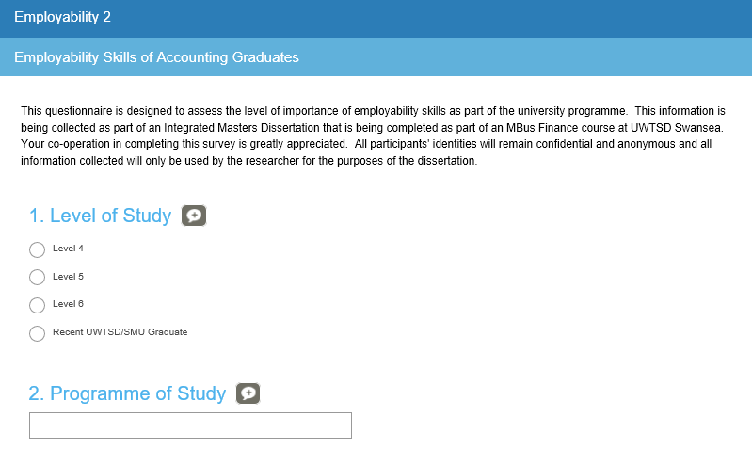
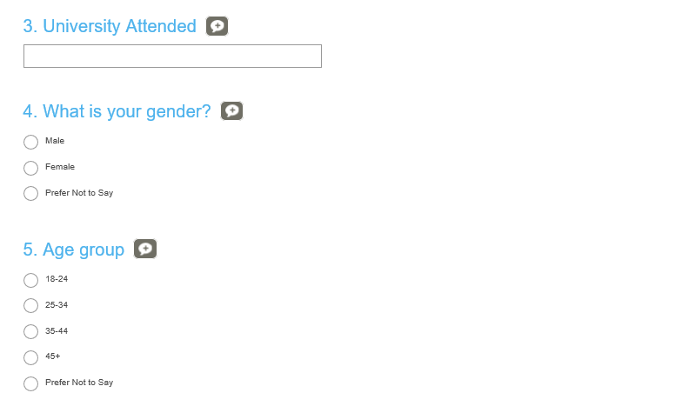
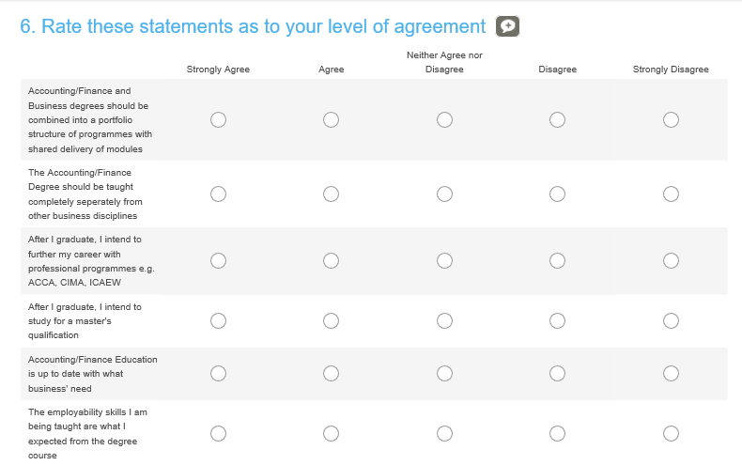
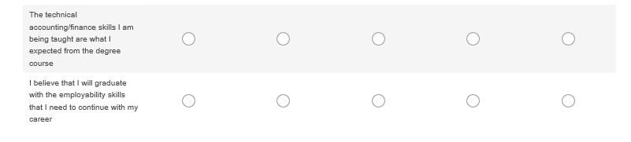

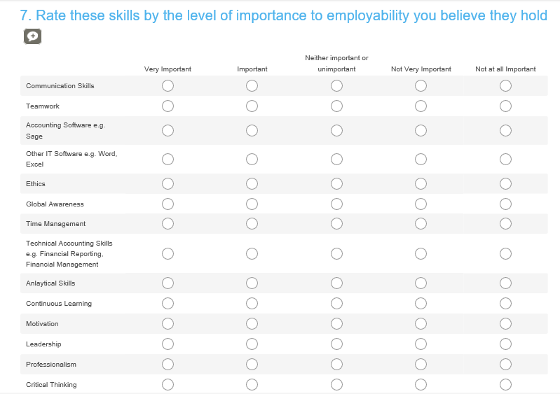
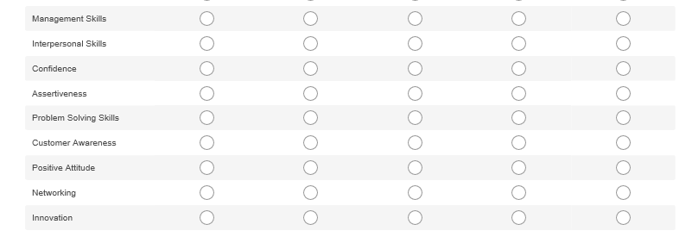

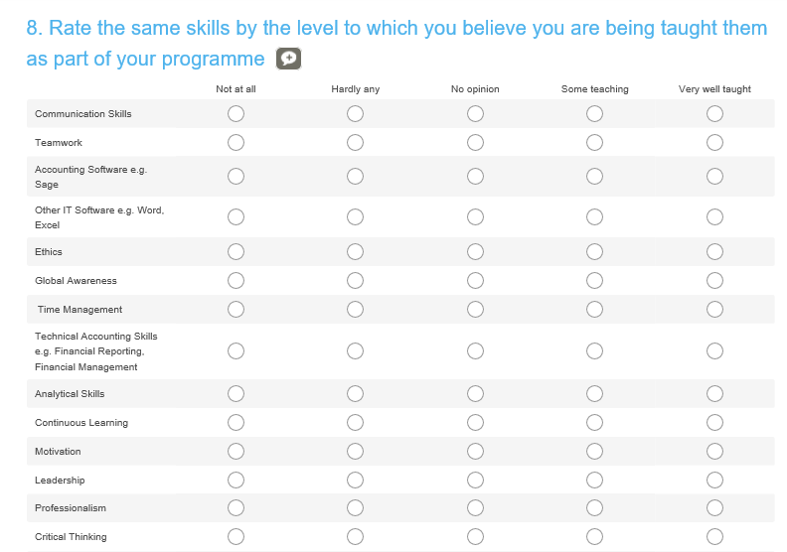
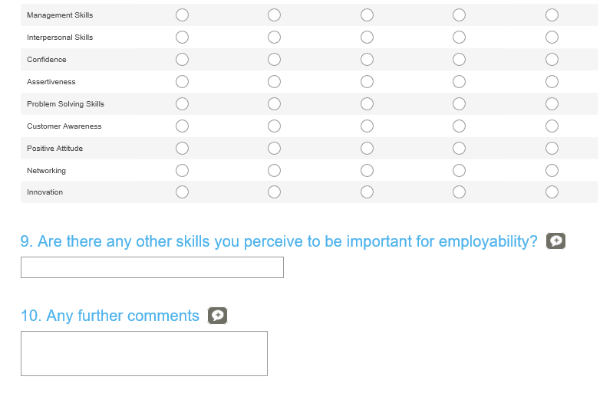

Appendix 4 Employers Survey

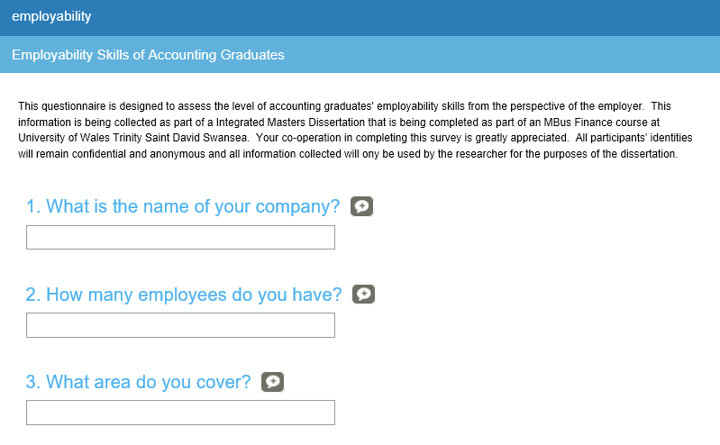

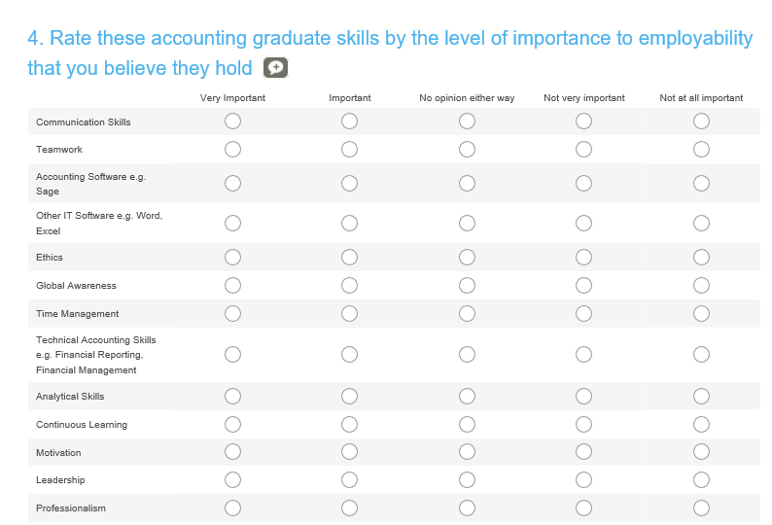
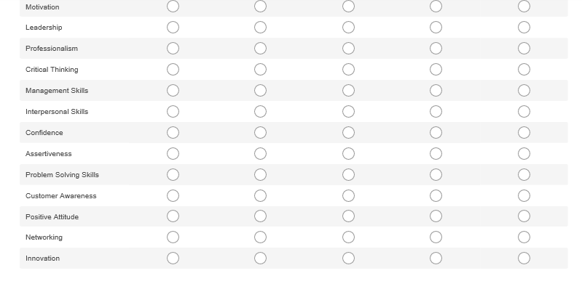

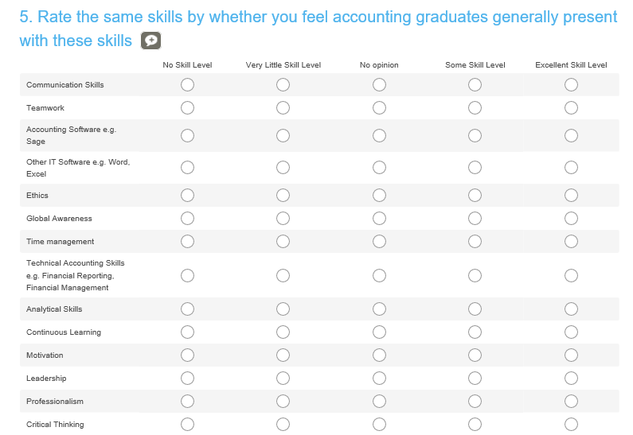
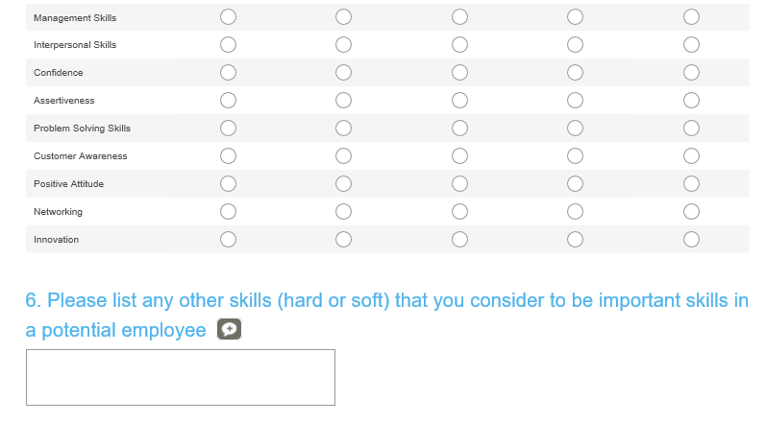

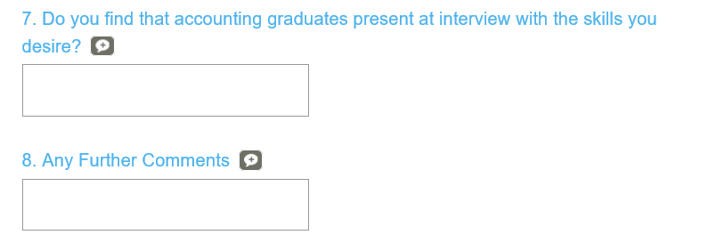

Appendix 5 E2 Ethics Form

 |  |  | E2 FORM
APPLICATION FOR ETHICAL APPROVAL – MA level

CAIS AM GYMERADWYAETH MOESEGOL – Lefel MA

CEFNOGWYD /APPROVED |  | A GYFEIRIWYD / REFERRED |  |  | NIS CEFNOGWYD/ NOT SUPPORTED
Mae'r ffurflen hon i'w llenwi gan bob myfyriwr MA cynnal ymchwil, prosiectau neu gynyrchiadau. Dylai'r ffurflen hon gael ei chwblhau gan y myfyriwr mewn ymgynghoriad â thiwtor y modiwl. Rhaid i bob ffurflen gael ei ystyried gan y Pennaeth Ysgol/Cyfadran / Gyfadran. Rhaid i bob ffurflen gael ei gyflwyno i Fwrdd y Gyfadran Moeseg. Bydd y ffurflen yn cael ei adrodd i'r Pwyllgor Moeseg y BrifYsgol/Cyfadran os anarferol a / neu y tu allan arfer arferol. |  |  | This form is to be completed by all MA students conducting research, projects or productions. This form should be completed by the student in consultation with the module tutor. All forms must be considered by the Head of School/Faculty/Faculty. All forms must be presented to the Faculty Ethics Board. The form is only to be reported to the University Ethics Committee if it is unusual and/or falls outside of normal practice.
ADRAN 1 – MANYLION MYFYRIWR SECTION 1 - STUDENT DETAILS

Enw Llawn  Full Name | Emily Jane Brooks
Ysgol/Cyfadran/ Cyfadran  School/Faculty | UWTSD Swansea Business School |  |  | Rhif Myfyriwr Student Number |  | P13883
Tiwtor y Modiwl  Module Tutor | Caroline Jawad |  |  | Enw'r Gradd  Name of Degree |  | MBus Finance
Teitl dangosol yr Traethawd Hir: |  |  |  | Indicative Title of Dissertation:
Employability Skills of BA Accounting and BA Business and Finance Graduates – A Comparison of UWTSD student and employer perspectives

ADRAN 2 – GWEITHGAREDD YMCHWIL |  | SECTION 2 – RESEARCH ACTIVITY
Ydy’r prosiect yn cynnwys: | Does the project include: |  | Ydy / Yes | Nac ydy/No
Defnyddio holiadur neu offeryn ymchwil tebyg (cysylltwch gopi)) | Use of questionnaire or similar research instrument (attach copy) |  | X
Defnyddio prawf ysgrifenedig neu gyfrifiadurol | Use of written or computerised test |  |  | X
Cyfweliad (cysylltwch gwestiynau posibl) | Interview (attach provisional questions) |  |  | X
Dyddiaduron | Diaries
Arsylwi ar gyfranogwyr a hwythau'n ymwybodol o hynny | Participant observation with their knowledge |  |  | x
Arsylwi ar gyfranogwyr a hwythau ddim yn ymwybodol o hynny | Participant observation without their knowledge |  |  | x
Recordio fideo neu sain | Video or audio-taping |  |  | x
Mynediad i wybodaeth bersonol neu gyfrinachol heb gydsyniad penodol y cyfranogwyr | Access to personal or confidential information without the participants specific consent |  |  | x
Defnyddio unrhyw gwestiynau, ysgogiadau prawf, cyflwyniad y gallai rhai cyfranogwyr eu profi fel rhywbeth sy'n achosi niwed / tramgwydd corfforol, meddyliol neu emosiynol | Administration of any questions, test stimuli, presentation that may be experienced as physically, mentally or emotionally harmful / offensive |  |  | x
Cyflawni unrhyw weithredoedd allai achosi embaras neu effeithio ar hunan-barch | Performance of any acts which may cause embarrassment or affect self-esteem |  |  | x
Ymchwilio i gyfranogwyr sy’n ymwneud â gweithgareddau anghyfreithlon | Investigation of participants involved in illegal activities |  |  | x
Gweithdrefnau lle defnyddir twyll | Procedures that involve deception |  |  | x
Gweini unrhyw sylwedd, cyfrwng neu blasebo | Administration of any substance, agent or placebo |  |  | x
Dull arall o gasglu data neu fformat cyflwyno (esboniwch) | Other method of data collection or presentation format (please explain) |  |  | x

Os 'Na' wedi cael ei dicio ym mhob blwch, dylai'r ffurflen gael ei llofnodi gan Bennaeth yr Ysgol/Cyfadran / Gyfadran a'r canlyniad a adroddwyd i'r Pwyllgor Moeseg ar ddiwedd y semester.  Os 'Ydw' wedi cael ei dicio mewn un neu fwy o'r blychau, rhaid i'r myfyriwr gwblhau'r ffurflen hon a'i chyflwyno i diwtor y modiwl. Rhaid i'r ffurflen wedyn yn cael ei ystyried yn y Bwrdd Moeseg Gyfadran cyn dechrau ar unrhyw waith ymchwil. | If ‘No’ has been ticked in each box, the form should be signed by the Head of School/Faculty/Faculty and the outcome reported to the Ethics Committee at the end of the semester.  If Yes has been ticked in one or more boxes, the student must complete this form and submit it to the module tutor. The form must then be considered at the Faculty Ethics Board prior to the start of any research.
Llofnodau  Os nad oes unrhyw faterion moesegol sylweddol, dylid ffurflen hon gael ei chwblhau a'i llofnodi gan y myfyriwr a'r goruchwyliwr ac yna llofnodi gan Bennaeth yr Ysgol/Cyfadran. | Signatures  If there are no significant ethical issues, this form should be completed and signed by both the student and the supervisor and then signed by the Head of School/Faculty.
Myfyriwr / Student
Dyddiad: / Date:
Cydlynydd y prosiect / Project co-ordinator / Tutor

Dyddiad: / Date:
Arolygwr / Supervisor
Dyddiad: / Date
Pennaeth Ysgol/Cyfadran / Head of School/Faculty

Dyddiad: / Date

ADRAN 3 – MANYLION Y PROSIECT / YMCHWIL / CYNHYRCHIAD |  |  | SECTION 3 – PROJECT / RESEARCH / PRODUCTION DETAILS
1. |  | Braslun o’r prosiect | Project outline
This dissertation will look into the current employability of BA Accounting and BA Business and Finance graduates. It will consider the skills that are perceived to be most and least important for employability from the perspectives of UWTSD students and local employers. The researcher will analyse whether the current BA Accounting and BA Business and Finance qualification provides students with the employability skills they require in order to meet employers’ needs.

2. |  | Disgrifiad  Rhowch fraslun cryno o’r prosiect, heb unrhyw jargon, ac yn cynnwys beth bydd angen i’r cyfranogwyr ei wneud. Esboniwch unrhyw dermau technegol neu derminoleg sy'n benodol i'r ddisgyblaeth (Uchafswm 300 o eiriau.) | Description  Provide a brief outline, free from jargon, of the project including what participants will be required to do. Explain any technical terms or discipline specific terminology (Max 300 words.)
The participants will be required to complete an online survey of a maximum of ten questions via a link sent to them via email.

3. |  | Dulliau Arfaethedig:  Rhowch fraslun o'r dulliau casglu data neu o natur yr amser mewn ymarferiadau (hyd at 500 o eiriau). | Proposed Methods:  Outline how the data will be collected or the nature of rehearsal time (up to 500 words).
The data will be collected using the survey monkey software.

5. |  | Lledaenu Gwybodaeth / Cynulleidfa:  Rhestrwch i bwy y rhoddir neu y dangosir copi o’r canlyniadau neu adroddiad / cyflwyniad terfynol. | Dissemination of Information / Audience:  List to whom a copy of the results or final report / presentation will be given or shown.
UWTSD Swansea Business School

6. |  | Lleoliad y Prosiect:  Nodwch bob lleoliad lle y cesglir data neu y cynhelir ymarferiadau / cynhyrchiad. | Location of Project:  Identify all locations where data will be collected or rehearsals/ production will take place.
7. | Cymeradwyaeth Arall: Oes angen cael cymeradwyaeth unrhyw sefydliad arall cyn cychwyn neu gwblhau’r prosiect? Os felly, gan bwy ac a ydy wedi'i sicrhau eisoes? |  | Other Approvals: Is there a requirement for approval from any other organisation / institution prior to starting or completing the project? If so, by whom and has it been obtained?

ADRAN 4 – MANYLION CYFRANOGWYR / CYNULLEIDFA |  |  | SECTION 4 - PARTICIPANT / AUDIENCE DETAILS
Pwy yw’r cyfranogwyr arfaethedig? |  | Who are the intended participants? |  |  | Ydw / Yes | Na / No
Myfyrwyr / staff Y Drindod Dewi Sant |  | Students / staff of Trinity Saint David |  |  | X
Oedolion (dros oed 16 ac yn gymwys i gydsynio) |  | Adults (over the age of 16 and competent to give consent) |  |  | X
Plant a phobl ifanc dan oed |  | Children / legal minors |  |  |  | X
Cleifion neu gleientiaid gweithwyr proffesiynol |  | Patients or clients of professionals |  |  |  | X
Rhywun sy’n cael ei gadw yn y ddalfa neu y mae’r llys wedi cymryd cyfrifoldeb amdano |  | Anyone in custodial care or for whom the court has assumed responsibility |  |  |  | X
Aelod o unrhyw sefydliad lle mae’n bosibl bod angen i unigolyn arall hefyd gydsynio. |  | A member of any organisation where another individual may also need to give consent. |  |  |  | X
Eraill: Nodwch: / Others: please identify: Accountancy Firms in the Swansea area

Nifer, Oed a Ffynhonnell y Cyfranogwyr  Rhowch fanylion yr demograffeg y cyfranogwyr / gynulleidfa. |  |  |  | Participant / Audience Number and Age  Provide details of the demographics of the participants / audience.
Nifer o Gyfranogwyr / yn y Gynulleidfa | Participant/ Audience number |  |  | 30
Grŵp oedran y Cyfranogwyr/y Gynulleidfa | Participant/ Audience age group |  |  | 18 +

ADRAN 5 – RISGIAU YN PROSIECT | SECTION 5 – RISKS IN PROJECT
Bydd y diffyg ateb cadarnhaol i bob un o'r cwestiynau hyn yn arwain at y gofyniad eglurhad a gallai arwain at oedi yn eich ymchwil. Dim neu Dim NID yn dderbyniol. | A lack of a positive answer to all of these questions may result in the requirement of further explanation and a delay in your research. None or Nil is not acceptable.

Risg Posibl:  (corfforol, seicolegol, cyfreithiol, cymdeithasol neu economaidd) |  |  |  | Potential Risk:  (physical, psychological, legal, social or economic)
A oes unrhyw risg bosibl i: |  | Is there any potential risk to: |  |  |  |  | Ydw / Yes |  | Na / No
A | Cyfranogwyr? | Participants? |  |  |  |  | X
B | Ymchwilydd? | Researcher? |  |  |  |  | X
C | BrifYsgol/Cyfadran? | University? |  |  |  |  | X
2 | Rheoli Risg:  Os oes, beth yw'r risg a sut y bydd yn cael ei reoli? | Management of Risk:  If yes, what is the risk and how will it be managed?
Researcher – there is a risk that not enough data will be collected. This will be managed by then broadening the survey and potentially using different sources

Participants -there is a risk that confidentiality could be broken. This will be managed by ensuring that every attempt is made to maintain confidentiality. Information will be kept password protected

University – there is a risk to reputation. This will be managed by the researcher ensuring that their actions do not damage the reputation of the university in any way.
ADRAN 6 – MONITRO, ADBORTH A CHYFRINACHEDD |  | SECTION 6 - MONITORING, FEEDBACK AND CONFIDENTIALITY
1. | Monitro:  Os ydych yn sylwi ar unrhyw ymddygiad sy'n groes Cod y BrifYsgol/Cyfadran Ymarfer, unrhyw ganllawiau a gyhoeddir gan y gymdeithas broffesiynol priodol neu weithred anghyfreithlon. Amlinellwch eich strategaeth adrodd. |  |  |  | Monitoring:  Should you observe any behaviour that contravenes the University’s Code of Practice, any guidelines published by the appropriate professional association or is illegal outline the strategy of your reporting action.
 |  |  |  |  |  | Ydw / Yes |  | Na / No
A wnewch chi roi gwybod am unrhyw ymddygiad sydd yn erbyn Cod Ymarfer y BrifYsgol/Cyfadran neu sy'n anghyfreithlon? |  | Will you report any behaviour that is against the University’s Code of Practice or is illegal? |  |  |  | X
A ydych yn darparu adborth i'r cyfranogwyr? |  | Will feedback be provided to participants? |  |  |  | X
A fyddwch yn dogfennu'r 'caniatâd i gymryd rhan yn y prosiect' |  | Will you be documenting the ‘consent to participate in the project’ |  |  |  | X
ADRAN 7 – STORIO, DIOGELWCH A MYNEDIAD I DDATA |  |  |  | SECTION 7 - DATA ACCESS, STORAGE AND SECURITY
 |  |  |  |  |  | Ydw / Yes |  | Na / No
1. | Ydych chi'n gyfrifol am storio a diogelwch y data eu casglu? | Are you responsible for the storage and security of the data collected? |  |  |  | x
2. | Sut y bydd y data yn cael ei storio? | How will the data be stored?
The data will be stored on a memory stick that is kept in the researcher’s possession at all times and is password protected

3. | Mynediad i Ddata:  Pwy fydd yn cael mynediad at y data? A oes unrhyw amodau i gael mynediad? |  | Data Access:  Who will have access to the data? Are there are any conditions to access?
Emily Brooks and Supervisor Richard Dunstan

4. | Cyfrinachedd / Anhysbysrwydd:  Rhestrwch y dulliau a fydd yn cael eu defnyddio i sicrhau cyfrinachedd ac anhysbysrwydd y cyfranogwyr. |  | Confidentiality / Anonymity:  List the methods that will be used to ensure the confidentiality and anonymity of participants.
No names or addresses will be used in the collection of the data

ADRAN 7 – DATGANIAD |  | SECTION 7 - DECLARATION
Rhaid i’r adran hon gael ei chwblhau gan bob parti perthnasol cyn y gellir cyflwyno’ r cais i’r Bwrdd Moeseg Gyfadran. |  | This section must be completed by all concerned parties before it can be submitted to the Faculty Ethics Board.
Datganiad  Mae'r wybodaeth a gynhwysir yma yn gywir, hyd eithaf fy ngwybodaeth a’m cred. Rwyf wedi ceisio dynodi unrhyw risgiau a phroblemau sy’n gysylltiedig â’r prosiect / ymchwil neu gynhyrchiad ac rwyf yn cydnabod f’ymrwymiadau innau a hawliau’r cyfranogwyr. |  | Declaration  The information contained herein is, to the best of my knowledge and belief, accurate. I have attempted to identify any risks and issues related to the project/research or production and acknowledge my obligations and the rights of the participants.
Llofnodau  Dylai'r ffurflen hon gael ei chwblhau a'i llofnodi gan y myfyriwr a'r goruchwyliwr lofnodi ac yna gan Bennaeth yr Ysgol/Cyfadran/ |  | Signatures  This form should be completed and signed by both the student and the supervisor and then signed by the Head of School/Faculty
Myfyriwr / Student
Emily Brooks Dyddiad: / Date: 01/11/2016
Cydlynydd y prosiect / Project co-ordinator / Tutor

Dyddiad: / Date:
Arolygwr / Supervisor
Dyddiad: / Date
Pennaeth Ysgol/Cyfadran / Head of School/Faculty

Dyddiad: / Date
Rhaid i bob cais am ymchwil ar sail cyfweliadau gynnwys y dogfennau canlynol: | All interview based research applications must provide the following pro-forma documents:
1. Ffurflen gydsynio ddrafft  2. Sampl o’r cwestiynau a ofynnir  3. Taflen wybodaeth am yr ymchwil sy'n esbonio'n glir ddiben y prosiect, y deilliannau disgwyliedig a'r rheini y dangosir y canlyniadau iddynt. | - A draft consent form  - A sample of the questions that will be asked  - An information sheet on the research that clearly explains what the project is, what the expected outcomes are and who the results will be shown to.

