  ACBA4016 | Abstract  Report on the Concrete frame Unite’d’Habitaion Marseilles France and Steel frame Kasumigaseki Building Tokyo Japan with a comparison of steel and concrete frames  Patrick Furlong  ACBA4016 Materials
t
Table of Contents
1.0 Concrete frame Unite’d’Habitaion Marseilles France 1
1.1 References 10
2.0 Kasumigaseki Building 12
2.1 References 19
3 Comparison of Steel Frame and Concrete Frame Buildings 20
4 Glossary 23

1.0 Concrete frame Unite’d’Habitaion Marseilles France
The Unite’d’Habitaion Figure 1 is 24 m wide, 56 m high, 135 m long and is divided into 4 sections by 3 vertical expansion joints Gargiani, R. and Rosellini, A. (2011). Constructed in Marseilles France from 1947-1952 “the 17-storey block was built to house 1,600 people and was famously conceived as a vertical city in the sky, with integral community facilities such as shops, nursery and restaurant” by the Swiss French architect Le Corbusier Tonbridge (2011).
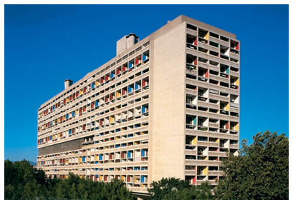
Figure 1 Unite’d’Habitaion Marseilles France Ballantyne, A. (2012)
An experiment in “mass” housing following the 2nd world war Stoane (2020) and an epoch in architecture Pogharian (1985). It influenced Brutalist and modern movement architecture O’Sullivan et al (2013). Along with concepts like Brise soleil Bernardo (2023) and modular prefabrication "Boîte acier tôle" steel box and “bouteilleur” or wine rack Gargiani, R. and Rosellini, A. (2011) Figure 2.
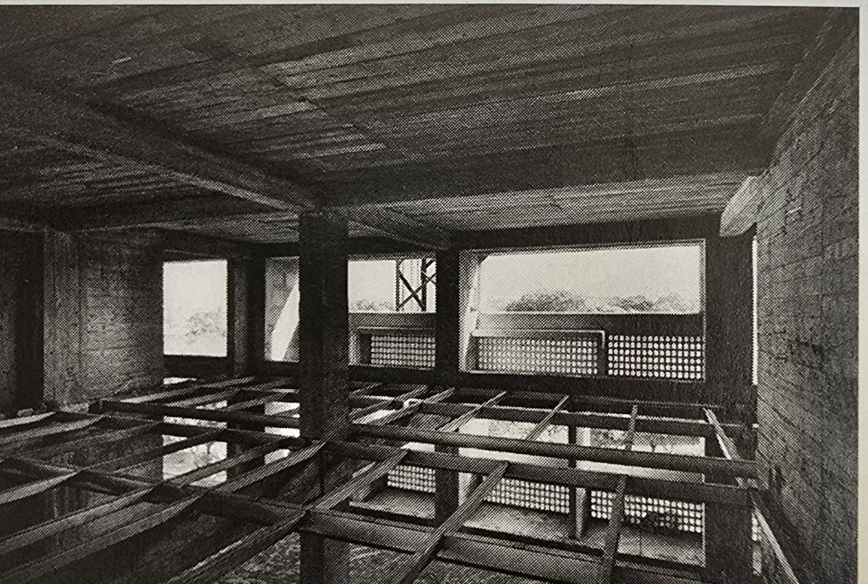
Figure 2 reinforced concrete and metal skeleton (bouteilleur) Gargiani, R. and Rosellini, A. (2011)
Modular apartments manufactured off site would slide into the building frame like ‘bottles into a wine-rack" Figure 3; the building frame was going to be steel however concrete was used due to material shortages Millais (2015), with steel on intermediate floors Gargiani, R. and Rosellini, A. (2011) Figure 2. The modular system was abandoned but “the idea of prefabrication was not and was applied to precast concrete units on the façade and to interior timber panels for the floor and wall construction” Millais (2015).
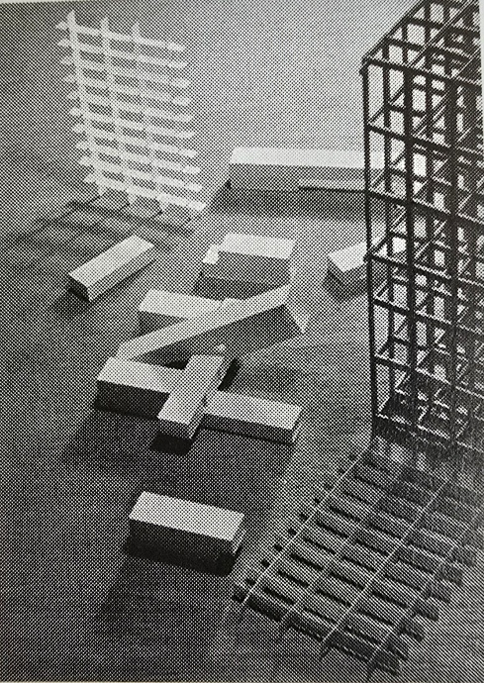
Figure 3 The bottle rack with 3 types of modular units that slide in Gargiani, R. and Rosellini, A. (2011)
Corbusier saw the building as a machine for living Tonbridge (2011) with the dimensions of the apartments based on his “Modulor” anthropocentric system Gargiani, R. and Rosellini, A. (2011) Figure 4.
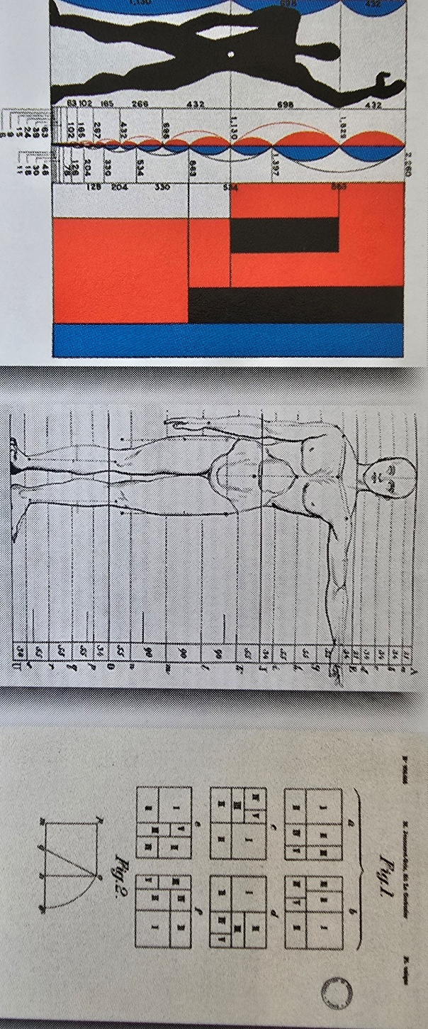
Figure 4 Diagram of the Modulor Gargiani, R. and Rosellini, A. (2011)
The term “brutalism” originated from the French term “béton brut,” meaning raw concrete Ballantyne, A. (2012) Figure 5.
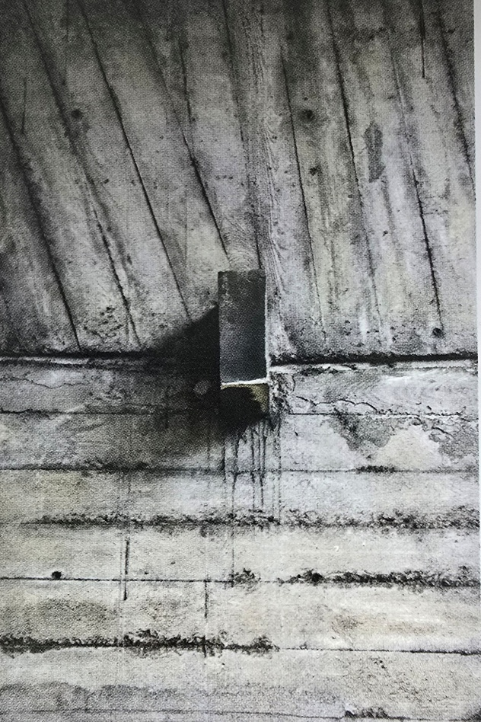
Figure 5 Béton brut concrete on the Pilotis of Unite’d’Habitaion Gargiani, R. and Rosellini, A. (2011)
The choice of Béton Brut instead of smoothing was economic and was created by the imprint of the wooden formwork Figure 6 Gargiani, R. and Rosellini, A. (2011). Its rough nature also a reflected the difficult times JL Déotte (2013).
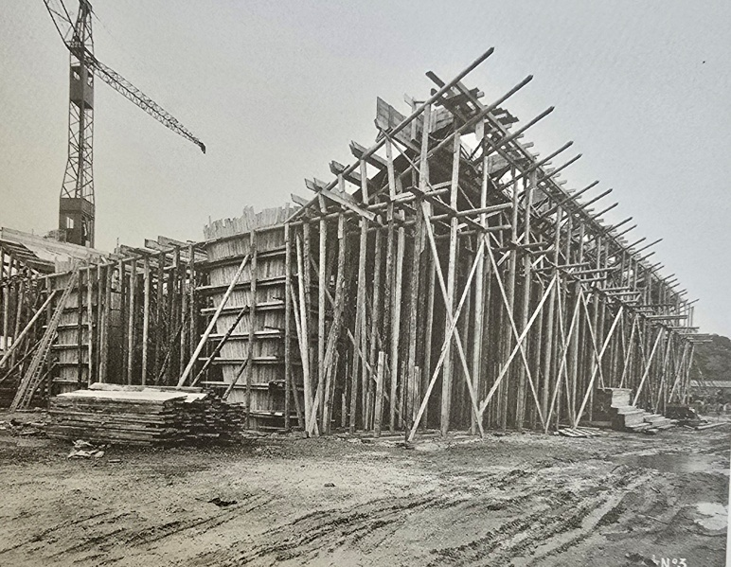
Figure 6 Formwork on the Pilotis of Unite’d’Habitaion Gargiani, R. and Rosellini, A. (2011)
The structure stands on Pilotis Figure 7, 1 of Corbusier 5 points of architecture Figure 8. To achieve the finish the formwork requires meticulously attention to detail, the concrete mix had to be perfect and was susceptible to rain damage; It’s time consuming especially the Pilotis with concrete bucketed in by hand and the formwork had to be left in place until the platform above was constructed due lack of stability Gargiani, R. and Rosellini, A. (2011).
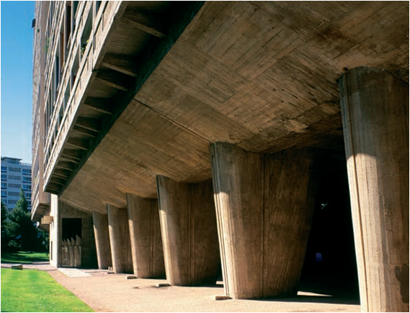
Figure 7 Pilotis Unite’d’Habitaion Ballantyne, A. (2012)
1. Buildings should be raised up on columns – pilotis.

2. There should be no internal load-bearing walls allowing a planning freedom – plan libre.

3. External walls should be non-load-bearing – façade libre.

4. Windows should be in long strips – fenêtre en longeur.

5. The roof should be flat and used as a garden – toit jardin.

Figure 8 Le Corbusier Five Points of Architecture Balletti, C. et al. (2017)
Reinforced concrete allowed Corbusier to achieve his 5 points of architecture; Its ability to withstand high compressive loads means the weight of the building can be transferred onto the pilotis. Formation of long strip windows would be dependent upon non-load bearing façade which would be impossible to achieve with traditional construction. The no load bearing inner walls is made possible by connecting the parallel walls (voiles) to each other via the floor slab and this provides stiffness to resist lateral forces such as wind loading Gargiani, R. and Rosellini, A. (2011).

Marseilles has hot summers with mild winters and little rainfall but due to the proximity to the sea it can experience frost, moderate rainfall and strong Mistral (north) winds. The concrete roof and walls keep indoor air temperatures in summer 2.5K lower due to its thermal mass Staszczuk, A. and Kuczyński, T. (2021). The building is orientated so the mistral hits the narrow north elevation which is unusual for Marseille Gargiani, R. and Rosellini, A. (2011) and this was done to achieve dual aspect of the coast and mountains in all apartments Figure 9.
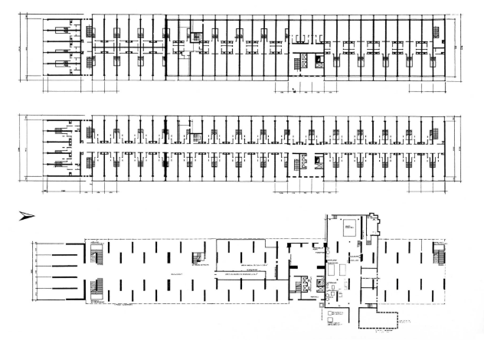
Figure 9 From above: Apartment floor, corridor floor, ground floor Berlin State Archives (1957)
Concrete can be poured into complex shapes, and this enabled Corbusier to express his artistic intuition Gargiani, R. and Rosellini, A. (2011) Figure 10.
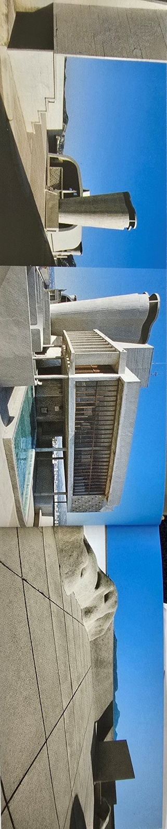
Figure 10 Views of the roof Gargiani, R. and Rosellini, A. (2011.
The building's proximity to the sea and defective workmanship, concrete mix and location of steel reinforcement is the cause of many the buildings’ problems Delemontey (2016). A higher water content mix is required to achieve the Breton Brut, so the concrete has higher permeability and lower durability; water permeability allows for chemical attack, frost damage and corrosion of the steel Taylor (2002). A lack of concrete cover over the reinforcement means increased corrosion. In fact, in some places there is no cover which needed to be rendered over Figure 11.
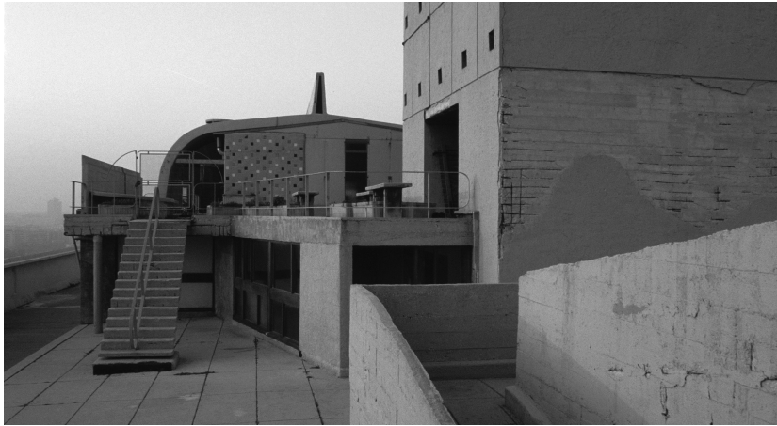
Figure 11 Exposed steel reinforcement spalling and cracking of concrete caused by permeability Delemontey (2016)
The way Corbusier designed the building also created problems with noise Figure 13 and fire Figure 12, usually strengths of reinforced concrete Taylor (2002).
“On 9 February 2012, a violent fire destroyed several apartments and hotel rooms in the Unité d’Habitation. The statement of damage revealed “the weakness of the internal structures in the wooden walls and the utility ducting that spread the fire” Delemontey (2016)
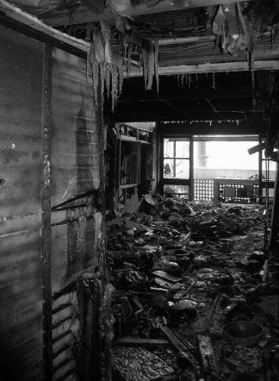
Figure 12 Fire damaged apartment Delemontey (2016)
The modular design meant that bedrooms sat over living spaces thus the need for specialist sound insulation Fischer (2019) and apartments siting on lead shoes, which lead to some residents being uncomfortable with the eerie silence Figure 13 Fischer (2019).
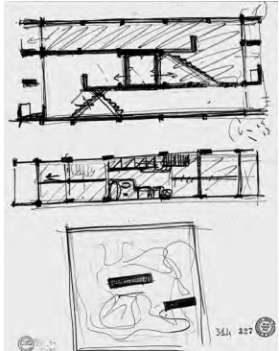
Figure 13 The interlocking of the residential units and the overlapping of living and sleeping areas in the Unité d'habitation in Marseille led to a planning crisis due to the increased demands on sound insulation Fischer (2019)
The legacy to the community is mixed, the building is locally known as Maison du Fada (House of the Crazies) and none of the shops are occupied. The long construction time, design issues, concrete mix and poor workmanship meant that some of the strengths of the concrete frame are lost, and the poor durability of the concrete led to it being described as a permanent construction site Delemontey (2016). However, it is now a UNESCO listed building and “is respected and even loved by those who choose to live there” Glancey (2013).

1.1 References
Ballantyne, A. (2012) Key buildings from prehistory to the present: plans, sections and elevations. London: Laurence King Publishing.
Balletti, C. et al. (2017) ‘VILLA STEIN-DE-MONZIE BY LE CORBUSIER (1926–1928): CONSERVATION STRATEGIES BETWEEN RESEARCH AND EDUCATION’, in International archives of the photogrammetry, remote sensing and spatial information sciences. Gottingen: Copernicus GmbH, pp. 615–621. Available at: https://doi.org/10.5194/isprs-archives-XLII-5-W1-615-2017
Berlin State Archives (1957), Official Catalogue of the International Building Exhibition Berlin Available at: https://hansaviertel.berlin/en/bauwerke/flatowallee-16-unite-dhabitation-typ-berlinle-corbusier/
Bernardo, G. (2023) ‘THE BRISE-SOLEIL AS A FORMAL AND FUNCTIONAL COMPONENT IN THE ARCHITECTURE OF THE MODERN MOVEMENT’, Vitruvio, 8, pp. 4–17. Available at: https://doi.org/10.4995/vitruvioijats.2023.18830
Clarke, M. (2010) ‘béton brut’, The Concise Oxford Dictionary of Art Terms. 2nd edn. Oxford University Press.
Déotte, J,L. (2013) “From the interpenetration of spaces in W. Benjamin to Le Corbusier's Unités d'habitation”issue 12, Available at : https://doi.org/10.4000/apparatus.1934
von Fischer, S. (2019) Das Akustische Argument : Wissenschaft und Hörerfahrung in der Architektur des 20. Jahrhunderts. Zürich: gta Verlag,Zürich.
Glancey, J. (2013), “Le Corbusier's Unité: Is it a modern classic?” available at: https://www.bbc.co.uk/culture/article/20130423-design-icon-or-concrete-horror
Gargiani, R. and Rosellini, A. (2011) Le Corbusier : Béton Brut and ineffable space, 1940-1965 : surface materials and psychophysiology of vision. 1st ed. Abingdon: Routledge.
Millais, M. (2015) ‘A critical appraisal of the design, construction and influence of the Unité d’Habitation, Marseilles, France’, Journal of architecture and urbanism, 39(2). Available at: https://doi.org/10.3846/20297955.2015.1062636.

O’Sullivan, K. and University of South Australia. School of Art, A. and Design.A.M. (2013) Concrete expressions : brutalism and the government buildings precinct, Adelaide. Adelaide: School of Art, Architecture and Design, University of South Australia.
Pogharian, S, V. (1985) “Que Sont Devenues les Quatre Maisons du Fada? Francois Chaslin”. Available at : https://fifthcolumn.library.mcgill.ca/issue/view/18
Staszczuk, A. and Kuczyński, T. (2021) ‘The impact of wall and roof material on the summer thermal performance of building in a temperate climate’, Energy (Oxford), 228, pp. 120482-. Available at: https://doi.org/10.1016/j.energy.2021.120482.
Taylor, G.D. and Chartered Institute of Building. (2002) Materials in construction : principles, practice and performance. 2nd ed. Harlow: Longman.
Stoane, A. (2020) “Mass” Housing in the Social and the Post-Social Worlds: Reading Hannah Arendt’s “Mass Society”, Architecture and Culture, 8:3-4, 513-528, DOI: 10.1080/20507828.2020.1792151
Tonbridge (2011) “INSPIRATION: UNITE D'HABITATION - Le Corbusier's machine for living in”, CMP Information Ltd; Building Design p.16, Available at: https://librarysearch.uwtsd.ac.uk/permalink/44WHELF_UWTSD/1ir6fgh/cdi_proquest_reports_907140174

2.0 Kasumigaseki Building
Kasumigaseki Building completed in 1968 (Figure 1) is one of the first examples of steel-framed high-rise buildings in Asia and was the first high-rise in Japan to exceed 100 meters in height Gondo et al. (2021).

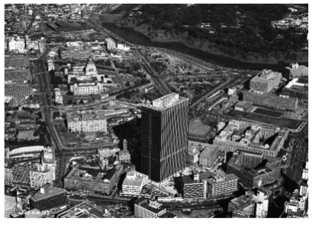
Figure 1 Kasumigaseki Building Gondo et al. (2021).
It was constructed in an earthquake-and-typhoon-prone area; steel framed buildings have been shown to perform well in earthquakes Figure 2.
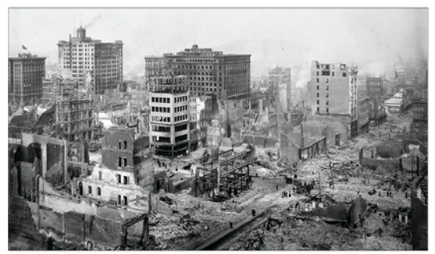
Figure 2 Steel frame buildings in downtown San Francisco 1906 earthquake O. Hamburger and O. Malley (2016)
It stands at 147M high with 37 floors above ground and 3 basement floors. The building is 84 x42.4 M giving a footprint of 3,561.6 M² and a total of 153,226 M² for the whole building. The machinery room is located on the roof level within a penthouse structure Muto (1968). The lower part of the building is constructed with a combination of OPC concrete, composite reinforced concrete and steel frame up to the 2nd floor and steel frame from the 2nd to 37th floor. The steel used on site was specifically developed by Fuji Steel and has a very high tensile strength Gondo, T. et al. (2021).
Just because a building is made from steel doesn’t mean it will perform well in an earthquake. Steel buildings are sensitive to cyclic action, so it is essential to consider design; A key weakness in steel frames is the jointing sections Figure 3.
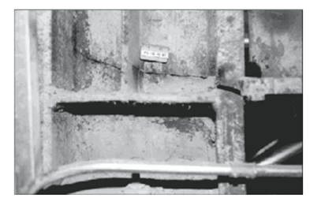
Figure 3 Fracture in a column at welded beam-to-column connection after an earthquake O. Hamburger and O. Malley (2016)
In modern building design techniques such as strong column weak beam allows the formation of plastic hinges, this allows for the distribution of drift created in an earthquake to be spread over the whole structure Figure 4.

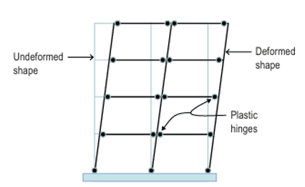
Figure 4 Idealised sideway mechanism intended for strong-column/weak-beam design O. Hamburger and O. Malley (2016)
This is achieved through the incorporation of reduced beam sections (RBS) or dog boning Figure 5; this consists on weakening the beam member of the connection to concentrate plastic strains away from the connection/joint and into the beam O. Hamburger and O. Malley (2016).
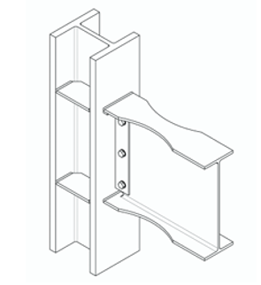
Figure 5 Dog bone or RBS section O. Hamburger and O. Malley (2016)
Concentrically braced frames Figure 6 are now commonly used as lateral resisting systems in seismic design of steel buildings Wald and Jandera (2019).
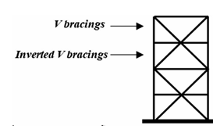
Figure 6 lateral force resisting design Wald and Jandera (2019).
However, the Kasumigaseki building was designed to be a “flexible (soft) structure” Gondo, T. et al. (2021). The structure consists of a rigid central core frame and a less rigid exterior frame. The inner core incorporates a shear wall to resist lateral forces with a “slitted (slotted) wall” Figure 7 (reinforced concrete with slits/ slots) the slits provide increased ductility Deng, K. et al. (2017) and allows large deformation by effective interaction with the steel frame Muto (1968). The need for shear walls is essential because of the wind loading experienced by tall buildings, given the building is at risk of exposure to typhoon strength winds this is an important design element.
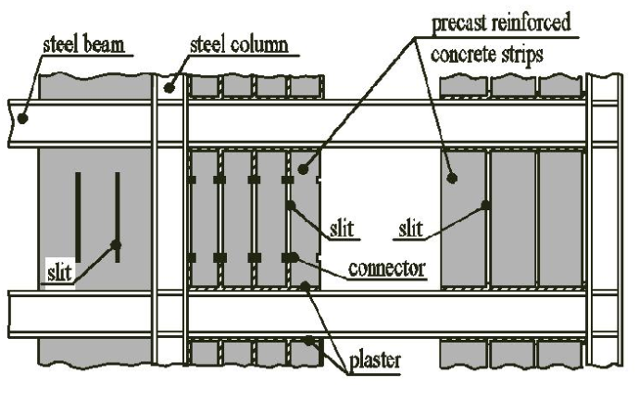
Figure 7 Slotted RC wall Băetu (2010)
The transverse or floor beams consist of a H section edge or spandrel beam infilled with castellated beam Figure 8 cut from a single wide H was used Muto (1968). In the Kasumigaseki Building, emphasis was placed on weight reduction Gondo, T. et al. (2021) and castellated beams enable an increased depth which improves strength and stiffness without adding additional weight Barkiah and Darmawan (2021). The reduction in weight means if the building shakes that there will be less forces to deal with and less kinetic energy to cause damage to the structure.
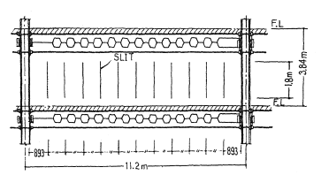
Figure 8 Castellated beams and slit wall Muto (1968)
The castellated or honeycomb beams utilised in the building reduced installation time of services as it was easy to pass services through the open spaces Figure 9 and it also made it easier to renovate the building which has happened 3 times since it was built Kumagi (2019).
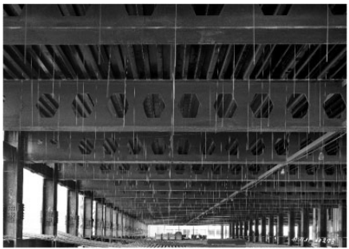
Figure 9 Castellated beams Gondo, T. et al. (2021).
Various construction innovations had their origin in the Kasumigaseki Building; Several prefabrication and dry construction technologies were used, particularly in fireproofing materials, electricals, and piping, along with methods for lifting large amounts of materials and personnel to achieve continuous repetitive construction Kumagi (2019). U-shaped deck plates were developed for the floor, this meant concrete could be poured directly onto the floor plate which eliminated the need for time-consuming form work Gondo, T. et al. (2021).
The use of planning tools such as Program Evaluation and Review Technique (PERT) were used during construction, identifying areas which would slow construction (critical paths (CPM, Critical path method) and this information was fed into a computer (SERAC) which created a schedule for 455,000 people. The detailed planning also meant the project was finished on time and there were no fatalities and therefore minimising the impact on the local community.
The crane on the Kasumigaseki building was modified meaning that the height of the crane could be increased in one day as opposed to the traditional six days Gondo, T. et al. (2021).
The use of offsite prefabrication and clever design such as the elimination of brackets while connecting the columns and beams Figure 10. Instead of using short mounting brackets and an infill beam, longer brackets were utilised, eliminating the infill beam which reduces assembly time on site Gondo, T. et al. (2021).
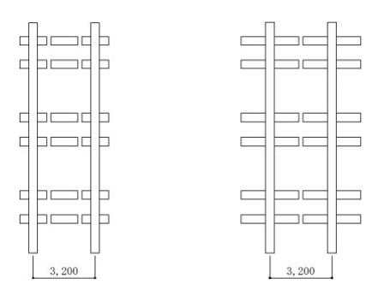
Figure 10 left image traditional method with infill beam on the right Kasumigaseki building reduces number of brackets Gondo, T. et al. (2021).
Steel frames can be susceptible to failure with poor fire resistance due to the deformation of key structural elements caused by the high temperatures Liew (2008). It is important for structural steel elements to be protected by fireproofing materials. Fireproofing in the Kasumigaseki Building was prefabricated as a moulded plate which was then attached on site using adhesive Gondo, T. et al. (2021).
Steel framing is ideally suited to prefabrication, thus enables much of the work to be carried out in factory conditions providing better conditions for workers. This reduces erection times due to ease of assemble from the high precision achieved in factory and means construction can be achieved in narrow time windows, especially as the location has high humidity and the risk of dangerous powerful storms making work outside dangerous. Prefabrication also improves sustainability by minimizing waste and the use of dry techniques reduces risk to local environment Burgan and Sansom (2006).

2.1 References
Barkiah, I. and Darmawan, A.R. (2021) ‘Comparative analysis of the flexural capacity of conventional steel beams with Castellated beams’, IOP conference series. Earth and environmental science, 780(1), pp. 12013-. Available at: https://doi.org/10.1088/1755-1315/780/1/012013
Burgan, B.A. and Sansom, M.R. (2006) ‘Sustainable steel construction’, Journal of constructional steel research, 62(11), pp. 1178–1183. Available at: https://doi.org/10.1016/j.jcsr.2006.06.029
Deng, K. et al. (2017) ‘Experimental study on slotted RC wall with steel energy dissipation links for seismic protection of buildings’, Engineering structures, 145, pp. 1–11. Available at: https://doi.org/10.1016/j.engstruct.2017.05.006

Gondo, T. et al. (2021) ‘Technological development in the construction of Kasumigaseki Building: Japan’s first super high-rise’, in History of Construction Cultures. 1st edn. CRC Press, pp. 100–107. Available at: https://doi.org/10.1201/9781003173359-14
Muto, K. (1968), “Earthquake Resistant Design of 36-storied Kasumigaseki building”, IV WCEE Special Report, Kasumigasekihttps://www.iitk.ac.in/nicee/wcee/article/4_vol3_J4-15.pdf
Liew, J.Y.R. (2008) ‘Survivability of steel frame structures subject to blast and fire’, Journal of constructional steel research, 64(7), pp. 854–866. Available at: https://doi.org/10.1016/j.jcsr.2007.12.013
O. Hamburger, R and O. Malley, J ( 2016) “Seismic Design of Steel Special Moment Frames: A Guide for Practicing Engineers”, Second Edition available at: https://nvlpubs.nist.gov/nistpubs/gcr/2016/nist.gcr.16-917-41.pdf
Kumagi, R. (2019) “The Kasumigaseki Building’s Planning and Technology: Japan’s First Skyscraper from the Viewpoint of Renewal” CIB World Building Congress 2019 Hong Kong SAR, China 17 – 21 June 2019, Tokyo University of Science, Tokyo, Japan Available at: https://www.irbnet.de/daten/iconda/CIB_DC33582.pdf
Băetu, S. and Ciongradi, I. (2010) ‘Seismic Behaviour of Reinforced Concrete Slit Shear Walls Energy Dissipators’, Buletinul Institutului Politehnic din Iași. Secția 6, Construcții, arhitectura, LVI (LX)(2), pp. 27–36.

Wald, F. (František) and Jandera, M. (2019) ‘Stability and ductility of steel structures 2019’, in. S.l: CRC PRESS.

3 Comparison of Steel Frame and Concrete Frame Buildings

 | Steel frame | Concrete
Structural strength and bearing capacity | High tensile strength to weight ratio which allows for flexible and light weight designs. | Good compressive strength but tensile strength is 1/10th of compressive strength. Suitable for mass structures and heavy loads. Lower strength to weight ratio. Elements under tensile or flexural load will normally require some form of reinforcement
Construction speed | Sections are manufactured and fabricated in factory conditions and can be rapidly assembled on site without expensive “falsework”. Factory work allows for high tolerances meaning fewer install problems. This reduces construction times and environmental delays. | Some prefabrication is possible however, the majority of work is done on site. Requires formwork, reinforcement and curing time. This makes onsite construction slower and susceptible to environmental delays.
Design considerations | Wide range of sections and manufacturing techniques allows for increased versatility with steel being consider an architectural material in its own right. High tensile strength allows for large open spaces. | The mix can be altered to suit the application however due to the density there is an increased need for columns and reduction of open space spans.
WLEC kgCO2e/m2 | 228  This is an average value, steel framed buildings that have a smaller footprint and are lighter perform better | 185  This is an average value; RC framed buildings with a large footprint and need to carry heavy loads perform better
Fire Resistance | Steel can soften and melt with exposure to extremely high temperatures. It requires the addition of passive fire protection, such as spray-on fireproofing. | Concrete requires no additional fireproofing treatments. The risk for reinforced concrete is failure of the steel in soffits which is near the surface. Lower density concretes perform better because they limit heat transfer. 50mm of concrete cover will as a general rule provide 2 hours fire resistance. When a high degree of fire resistance is required, the type of aggregate used is important.
Environmental | High energy is required to produce steel, but less material may be required due to its favourable weight to strength ratio. However, steel is highly recyclable, reducing long-term environmental impact. | Reinforced or prestressed concrete can be perceived as environmentally attractive materials compared to structural frames because of the high energy needs to produce steel which is confined to limited areas where tensile strength is required.  Separation of concrete from steel can prove difficult on demolition for reuse countering the argument of environmentally attractiveness.
Conduction | Excellent conductor of heat, electricity and sound. Requires thermal and noise insulation and potential earth bonding for electrical safety. | High thermal mass helps control indoor temperatures, mitigating the need for mechanical cooling and heating. Concrete mass provides good acoustic attenuation.
Durability | Steel is strong, resistant to impact and will undergo go elastic as well as plastic deformation. Its main weakness is susceptibility to corrosion. Steel requires protective measures to prevent corrosion such as coatings (which require ongoing maintenance), treatment such as galvanising or use of stainless steel. | Concrete can be used as finished surface and modifications in the mix can lead to lasting high-quality finishes. It requires minimal maintenance, and Most problems are water related i.e. frost damage and chemical attack is permeability related. Which mix related for example higher water content will lead to higher permeability and lower durability. Selection of aggregate will also impact durability, and this will be a compromise of cost vs local availability. Additives can be used to improve quality, but the low concentration add increased risk of mistakes. Corrosion of steel in concrete reinforcement is the largest single cause of distress or failure in concrete structures
Seismic activity and wind loading | Steel's strength and ductility, make it a safe choice in seismic zones. Especially in high-rise construction with its ability to resist lateral forces. Steel framing does very well under high wind loads because it is ductile and because its lighter than an equivalent concrete building of the same height, it there is less mass to generate damaging forces. | The inherent stiffness, rigidity and low tensile strength means concrete is not naturally suited to areas of high seismic activity or high wind loading forces. Concretes higher mass means it generates great forces if moved which require greater mitigation. However, with proper design and use of additional reinforcement and features such dampeners it can be a viable option.
Cost | Typically, more expensive per unit of material but reduced labour costs due to quicker installation may offset this. | Initial material costs are low where suitable aggregates are available locally. However, it is labour intensive and can be adversely impacted by weather conditions.
Modification and repair | Can be drilled and additional steel reinforcement bolted on, or sections can be cut out and welded back. | Remedial treatment of concrete is often difficult and expensive.

4 Glossary
ANTHROPOCENTRIC definition: considering humans and their existence as the most important and central fact in the universe.
Béton Brut Béton Brut or “Concrete left in its natural state still bearing the marks of the metal or wooden mould which shaped it” Clarke (2010)
Brise-soleil is an architectural feature of a building that reduces heat gain within that building by deflecting sunlight.
Brutalist architecture is a style of building design developed in the 1950s in the United Kingdom following World War II
Castellated Beams are a type of structural beam that have been used in construction for the best part of a century.
Critical Path Method (CPM) is a simple but powerful technique for analysing, planning, and scheduling large, complex projects. It is used to determine a project's critical path — the longest sequence of tasks that must be finished for the entire project to be complete
Falsework is typically associated with the construction of cast-in-place concrete structures, particularly bridge structures
Le Corbusier formerly known as Charles-Édouard Jeanneret-Gris was born in the small Swiss city of La Chaux-de-Fonds (October 6, 1887 – August 27, 1965) and is widely regarded as the most important architect of the 20th century.
Ordinary Portland Cement (OPC), a common type of cement used extensively in construction for its strength and durability.
Program Evaluation Review Technique (PERT) is a project management planning tool used to calculate the amount of time it will take to realistically finish a project. PERT charts are used to plan tasks within a project — making it easier to schedule deliverables and coordinate with team members
Modulor is an anthropometric scale of proportions devised by the Swiss-born French architect Le Corbusier
Shear wall is a structural member used to resist lateral forces, that is, parallel to the plane of the wall.
Spandrel beam is the exterior beam that stretches horizontally from one column to another column. These are also known as edge beams.
Strong Earthquake Response Analysis Computer (SERAC) was a direct current analogue computer used to analyse the response of buildings affected by strong earthquakes.
WLEC Whole Life Embodied Carbon

