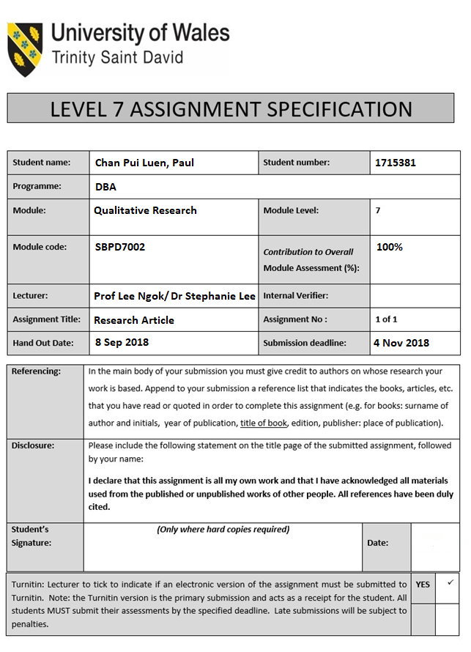



Module:
Qualitative Research (SBPD7002)

Lecturer: Dr Stephanie Lee

Part 1 Topic:
Evaluating the Qualitative Methodology Research

by

Student Name: Chan Pui Luen, Paul
Student Number: 1715381

Word Count: 2,929 words
14 October 2018

Content
Introduction
The Philosophy and Theoretical Perspective
The Methodology and the Data Collection Method
- The Engagement Survey
- The Performance Data
- The Interview Data
- The Research Dairy
A Critique of the Methods Use
- The Participant Section and the Sample Size
- The Data Collection and the Recording Process
- The Researcher Bias
- The Data Analysis Method
Strengths and Limitations
Conclusions
References
Appendix

Introduction
This assignment is to evaluate a top journal for using a qualitative methodology related to the writer proposed research field in employee performance in Banking. The writer has found the related research paper and the topic is “Interplay between performance measurement and management, employee engagement and performance” by Dr Marisa Smith of University of Strathclyde, Glasgow, UK and Mr. Umit Sezer Bititci of Heriot Watt University, Edinburgh, UK are the researchers. This research paper was published in International Journal of Operations & Production Management in 2017 (Appendix) and this journal covers the subject area in the technology and innovation strategy and management for business, management and accounting management in United Kingdom. The journal ranking in Scimago Journal Rank (‘SJR’) has ranked 2.05 since 2017 and the H index was 112 as of 18 September 2018. Both are relatively high ranking, so that overall consider this journal is one of the top ranking journals.
The action approach of the qualitative research is applied on this research paper. It provides an empirically studies on these research concept and topic in two operations departments of a UK bank (‘The UK Bank’). There have three contributions in this research study. First, it based on the organisational control theory to introduce a new theoretical framework and this basis can provide for future research. Second, there have a causal relationship established between the measurement and management of performance, the engagement and performance of employee. Third, it is being managed the process to identify a gap in knowledge to concern the organisational controls design.

The Philosophy and Theoretical Perspective
The research study is to quote the important on the interplay relationship between the performance measurement and management, the employee engagement and performance to suggest there have the direct impact on the relationship between the employee engagement and the performance of the organisation. (Chiva and Alegre 2009, Tregaskis et al. 2013) The theoretical perspective is focus on the intervention to the measurement and management of the performance in resulted on the employee engagement and the employee performance.
The research has developed the theoretical framework with characteristics that typify the technical controls and the social controls, that the mentioned framework compared the factors in the technical controls and the social controls, the performance measurement and the performance management. Refer to this theoretical framework (Figure 1), there have two separate organisational controls in the technical controls and the social controls. These controls are either direct or indirect linked to the employee engagement and the employee performance. (Smith and Bititci 2017)

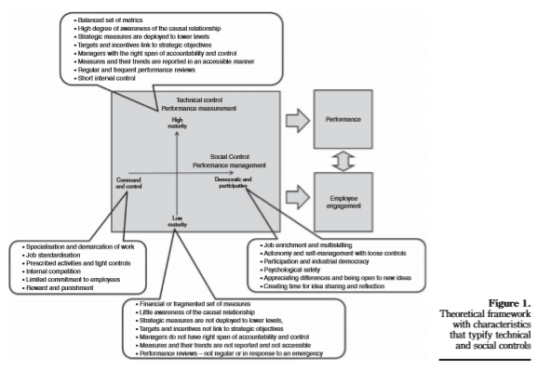
The performance measurement is in term of technical controls. The metrics developments, setting target, performance information collection, analysis and reporting, performance differentials assessment are the activities on the performance measurement. There have some models are formalized (Van Aken et al. 2005, Garengo 2009) to describe the maturity levels of various performance measurements from the ad hoc range, then through grow and develop to mature. (Wettstein and Kueng 2002) In other models of maturity, it contained the performance measurement systems for technical maturity. (Speckbacher et al. 2003)
The performance management is in term of social controls, which are the cultural and behavioural routines. The social controls manage the organisation performance by using the performance measurement system. The control management is including limited commitment to the employees, rewards and punishment, specialisation and standardisation of work. (Podsakoff and Todor 1985, Chenhall 2003, Powley et al. 2004, Mohamed et al. 2004) The democratic and participative management is including communications with the idea sharing and the idea reflection, job enrichment and multiskilling, loose controls and self-management, psychological safety. (Poole et al. 2001, Carson et al. 2007, Wood and Wall 2007, Carmeli et al. 2009)
The UK Bank has implemented the Balance Scorecard (‘BSD’) in 2001. The organisation strategy goals are deployed to each level of department, team and individual. BSD has four perspectives proposed includes the Financial perspective, the Customer perspective, the Internal business processes perspective and the Learning and growth perspective. (Kaplan et al. 1992, Kopia et al. 2017) The scorecards are based on individual and department performance, which presented to the annual reviews and the incentives together with the overall performance of the UK Bank.
The theoretical framework can develop a number of propositions. Therefore, the proposition that strengthen the research is an intervention made on the social controls lead to the democratic and participative management might have three effects:
- The close interrelation between technical controls and social controls, that expects to see the change in the technical controls.
- Expect the observation on the improvement in the elements of employee engagement in both organisational engagement and job engagement.
- The result in improved levels of employee engagement, that expects to observe improvement in employee performance.

The Methodology and the Data Collection Method
The methodology of the research is applied the qualitative research and it was adopted by an action research approach to explore a phenomenon. The research analysis is compared the impact from the action in the social control interplay effect on the technical controls, the employee engagement and the performance to two departments in the UK Bank. The data collection method of the research is used the engagement survey, the performance data, the interview data and the research dairy. The data analysis is used the interview data to analyse through qualitative techniques for the research findings. The research study achieve the triangulation from the data analysis through interviews, survey data, performance data and the observations.

The Engagement Survey
The employee engagement approach was assessed on the research. The engagement survey data were collected at the project kick starting and eight months right after the implementation. The employee engagement and organisational engagement are two main components to use in the engagement survey to associate with statements in positive and negative. (Saks 2006) The five-point Likert scale provided to the participants to rate their agreement from the range strongly agree to strongly disagree. Each employee gave the engagement profiles that refer to their positive, neutral and negative engagement scores. The group engagement profiles are developed by these data collection.

The Performance Data
The individual and department levels of performance data was used the UK Bank existing performance information to assess the effect of the intervention on the performance. The performance information at pilot group and control group was able to collect for the UK Bank. The performance data are included the productivity, the quality errors and the customer satisfaction metrics. The research collected and analysed the performance data “before” interaction and carried on “after” intervention to show the changing of the performance between the pilot groups and the control groups.

The Interview Data
The formal interviews were conducted with the pilot groups team members and taken at the project kick starting and eight months right after the implementation. The interviews were conducted by three to four people in group and taking approximate one hour. The team members were asked about the felt of their jobs and the felt of their engagement of the organisation in the initial interviews. The interviews were asked the six team leaders to think influenced employee engagement on their perception of the performance measurement and the management procedure. The formal interviews were conducted in the same format and the team leaders and the members to use the same questions to perform the comparative analysis. There formal interviews were recorded by the digital recorder over 18 hour hours.

The Research Diary
The pilot team were contacted with the research team constantly over the ten-month period. They were through informal conversations and observations to collect the data and recorded over 260 pages in the research diary.

A Critique of the Methods Use

The Participant Section and the Sample Size
The participant selection process is clearly described. This research paper was provided an empirical study this interplay through the qualitative action research approach to two departments in the UK Bank. Each department has the pilot group and the control group. The analysis compares the impact of the intervention between the pilot and control groups in the departments for the social controls effect on the technical controls, the employee engagement and performance.
The sample size was determined as two cycles of action research for planning, action, monitoring and reflection on the intervention in four months. However, there only have two separate departments with the pilot group and the control group in each department. There have a total 4 teams in 15 AMS and 12 MS staff members of the Bank. The academic team was facilitated two pilot groups in 8 AMS and 6 MS staff members. The pilot groups have no intervention by the management, therefore, more democratic and participative management by the effect in change of the social controls. Overall the process of the research, the academic team was contacted with the pilot groups constantly but the control groups in 7 AMS and 6 MS staff members had no interaction.

The Data Collection and the Recording Process
The data collection and recording process is completed but not fully presented in the research paper because of this qualitative research has the very large amount of data to be collected for analysing data from the engagement survey, performance data, interview data and research diary.
The formal interviews were conducted with the pilot groups team members and taken at the project kick starting and eight months right after the implementation. The interviews were conducted by three to four people in group and taking approximate one hour. The team members were asked about the felt of their jobs and the felt of their engagement of the organisation in the initial interviews. The interviews were asked the six team leaders to think influenced employee engagement on their perception of the performance measurement and the management procedure. The formal interviews were conducted in the same format and the team leaders and the members to use the same questions to perform the comparative analysis. The formal interviews were recorded by the digital recorder over 18 hour hours.
Furthermore, the pilot teams were contacted with the research team constantly over ten months. They were through informal conversations and observations to collect the data and recorded over 260 pages in the research diary.

The Researcher Bias
The researcher bias was not clearly avoided. The researchers were the academic team in the research study and they had an existing relationship with the senior management of the UK Bank. The employee engagement was the bank strategic initiative for analysing two departments in 2010. The researchers thought the Bank approach to performance measurement was having a negative impact on the employee engagement levels. Overall, it based on the pilot team and the senior management of the UK Bank discussions from the review and refine on the theme and concept maps. The bias could come from the staff members of two departments that they know the academic team will report their department research result to the senior management in employee engagement and performance. Then it might be affected the employee performance result and other research result in the research study.

The Data Analysis Method
The data analysis method is consistent with the study’s purpose and approach. The research was used the qualitative techniques to analyse the interview data. The research study identified the common themes by using the manual coded recordings and research notes. The data were developed the first-order codes emerging. The concept maps developed to establish the interaction between the changes and the emerging themes. It based on the review discussion with the pilot team and the senior management of the UK Bank to refine on the themes and concept maps. The comparison of the codes and the themes emerging form the initial interview to the final interview and the observation of the whole process, it found the social controls intervention to get resulted in changes of the technical controls.

Strengths and Limitations

Strengths
This qualitative research has the very large amount of data to be collected for analyzing data from the engagement survey, performance data, interview data and research diary. The research findings come from the above analyzing data. The research was applied the action research approach to explore a phenomenon. This research approach was conducted by two departments in the UK Bank. Each department has the pilot group and the control group. The research study achieved the triangulation through interviews, survey data, performance data and the observations.

Limitations
The limitations of the research, the theoretical framework of the research was built by the majority of the literature. The research study is based on the empirical findings from commercial organisations running in the economy of the western countries. The findings are only relevant to similar organisations running in similar operations. The findings and conclusions are limited by the sample size, that only have two cases from one UK Bank.
The key theoretical can apply for the future research into the performance measurement and management. The consideration on the future research will be the interaction and relationship between these research concepts. There are having demonstrated the complex nature of the interplay. It probably will fail and provide the incomplete insights and potentially conflicting results.

Conclusions
This research paper conducted the action approach of the qualitative research method. The research has developed the Theoretical framework with characteristics that typify technical and social controls to compare the factors in the performance measurement and the performance management, the technical controls and the social controls.
The contribution of the research is to develop the theory on the measurement of performance and provides insights to enhance the employee engagement and performance by designing the performance measurement systems. The social controls intervention was resulted in changes in technical controls of the performance measurement system. The research result was shown the significant improvement in the employee engagement and performance.

References
Barratt, M., Choi, T.Y. and Li, M. 2011, “Qualitative case studies in operations management: trends, research outcomes, and future research implications”, Journal of Operations Management, Vol. 29 No. 4, pp. 329-342.

Carmeli, A., Brueller, D. and Dutton, J.E. 2009, “Learning behaviours in the workplace: the role of high-quality interpersonal relationships and psychological safety”, Systems Research and Behavioral Science, Vol. 26 No. 1, pp. 81-98.

Carson, J.B., Tesluk, P.E. and Marrone, J.A. 2007, “Shared leadership in teams: an investigation of antecedent conditions and performance”, Academy of Management Journal, Vol. 50 No. 5, pp. 1217-1234.

Chenhall, R.H. 2003, “Management control systems design within its organizational context: findings from contingency-based research and directions for the future”, Accounting Organizations and Society, Vol. 28 No. 2, pp. 127-168.

Chiva, R. and Alegre, J. 2009, “Organizational learning capability and Job satisfaction: an empirical assessment in the ceramic tile industry”, British Journal of Management, Vol. 20 No. 3, pp. 323-340.

Garengo, P. 2009, “A performance measurement system for SMEs taking part in quality award programmes”, Total Quality Management, Vol. 20 No. 1, pp. 91-105.

Kaplan, Robert, S., & Norton, D. P. 1992, “The Balanced Scorecard – Measures That Drive Performance”, Harvard Business Review, January-February, pp. 71-79.

Kopia, J., Kompalla, A., Buchuller, M. and Heinemann, B. 2017, “PERFORMANCE MEASUREMENT OF MANAGEMENT SYSTEM STANDARDS USING THE BALANCED SCORECARD”, Amfiteatru Economic, Vol. 19 No. 11, pp. 981-1002.

Mohamed, M., Stankosky, M. and Murray, A. 2004, “Applying knowledge management principles to enhance cross-functional team performance”, Journal of Knowledge Management, Vol. 8 No. 3, pp. 127-142.

Podsakoff, P.M. and Todor, W.D. 1985, “Relationships between leader reward and punishment behaviour and group processes and productivity”, Journal of Management, Vol. 11 No. 1, pp. 55-73.

Poole, M., Lansbury, R. and Wailes, N. 2001, “A comparative analysis of developments in industrial democracy”, Industrial Relations: A Journal of Economy and Society, Vol. 40 No. 3, pp. 490-525.

Powley, E.H., Fry, R.E., Barrett, F.J. and Bright, D.S. 2004, “Dialogic democracy meets command and control: transformation through the appreciative inquiry summit”, The Academy of Management Executive, Vol. 18 No. 3, pp. 67-80.

Saks, A.M. 2006, “Antecedents and consequences of employee engagement”, Journal of Managerial Psychology, Vol. 21 No. 7, pp. 600-619.

Smith, M. and Bititci, U.S. 2017, “Interplay between performance measurement and management, employee engagement and performance”, International Journal of Operations & Production Management, Vol. 37 No. 9, pp. 1207-1228.

Speckbacher, G., Bischof, J. and Pfeiffer, T. 2003, “A descriptive analysis on the implementation of balance scorecards in German-speaking countries”, Management Accounting Research, Vol. 14 No. 4, pp. 361-388.

Tregaskis, O., Daniels, K. Glover, L., Butler, P. and Meyer, M. 2013, “High performance work practices and firm performance: a longitudinal case study”, British Journal of Management, Vol. 24 No. 2, pp. 225-244.

Van Aken, E.M., Letens, G., Coleman, G.D., Farris, J. and Van Goubergen, D. 2005, “Assessing maturity and effectiveness of enterprise performance measurement system”, International Journal of Productivity and Performance Management, Vol. 54 No. 5/6, pp. 400-418.

Wettstein, T. and Kueng, P. 2002, “A maturity model for performance measurement systems”, Management Information Systems, Vol. 26, pp. 113-122.

Wood, S.J. and Wall, T.D. 2007, “Work enrichment and employee voice in human resource management-performance studies”, The International Journal of Human Resource Management, Vol. 18 No. 7, pp. 1335-1372.

Appendix
Evaluating the Qualitative Methodology Research Paper.


