FOR THE AMAZON COMPANY THE EXPIRATION DATE IS
20 JUNE 2025
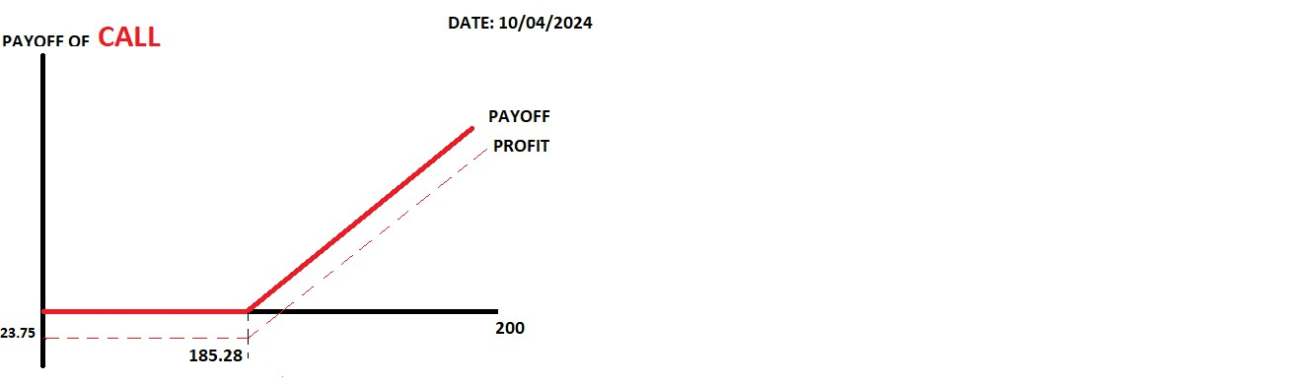

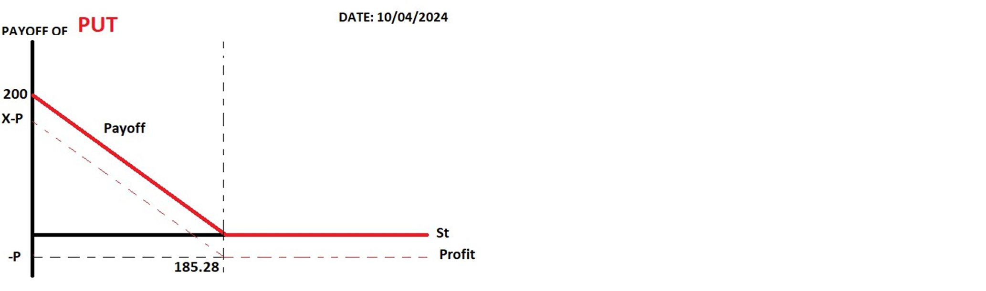
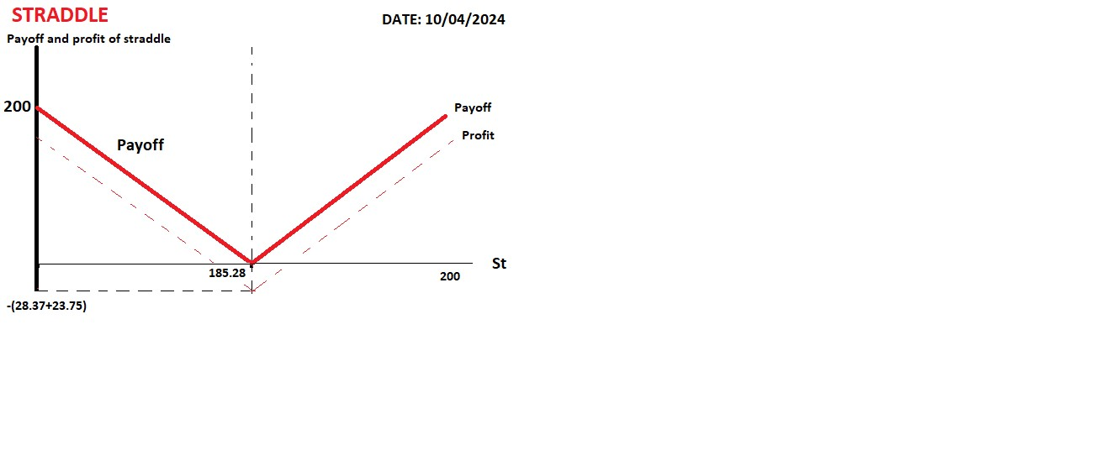
MANAL TALHARCHET
MBA BANKING AND FINANCE
DRAFT PART C

