UNIVERSITY OF WALES TRINITY SAINT DAVID
MSc Cybersecurity and Digital Forensics
Module: Cloud Engineering Principles and Practice
Title:
Docker Containerisation and Cloud Infrastructure Implementation

Student Name: LATCHIARAJAN PARTHASARTHY
Student ID: 2531979
Programme: MSc Cybersecurity and Digital Forensics
Module Code: ACCA7027
Lecturer: Renuga Jayakumar
Internal Verifier: Nathan Morgan
Submission Date: 28 April 2026

2026

Table of Contents
Table of Contents 1
Video Demonstration 1
Docker Practical Demonstration Video 1
1. Introduction 1
2. Principles of Virtualisation 1
3. Docker and Containerisation Architecture 1
4. Practical Docker Implementation 1
4.1 Project Setup and Dockerfile 1
4.2 Building the Image 1
4.3 Running the Container 1
4.4 Publishing to Docker Hub 1
4.5 Reflection on DevOps Practice 1
5. Docker Volumes and Persistent Storage 1
6. Docker Networking 1
7. Cloud Infrastructure Concepts 1
7.1 Load Balancing 1
7.2 Scalability 1
7.3 Application Gateways 1
8. Driving Forces Behind Cloud Computing Growth 1
9. Critical Discussion 1
9.1 Container Use Cases 1
9.2 Serverless Use Cases 1
9.3 Future Trends 1
10. Conclusion 1
References 1

Video Demonstration

My Docker Practical Demonstration Video
YouTube Link: youtube.com/watch?feature=shared&v=fVcHDVZ_cuM

1. Introduction
The role of technology infrastructure is changing radically with the arrival of cloud computing; a technology infrastructure that only a few years ago involved a huge number of physical servers may now be set up in minutes via a web browser [1]. However this was not an immediate switch, but rather the outcome of many years of frustration from companies and developers about traditional on-premises infrastructure where hardware has to be purchased months in advance of needing it, thus allowing valuable resources and capital to go to waste sitting idle and generating money [1]. In the 1960s systems were introduced allowing multiple users to access the same computing resources and then around the start of the millennium the spread of broadband internet and virtualisation allowed for cloud computing to become a real commercial product. Armbrust et al. [2] gave an effective description of what cloud computing is: companies now treat computing as a utility just like the electricity grid where they only pay for what they use.
There is another frustration with the old infrastructure: an application run from one server never behaves the same as an application run on another. Developers waste hours in debugging only to discover the fault is a minor version difference between operating system libraries and so containerization came to the rescue [3]. Containers ship applications with all the dependencies required to run the application so that when the application is moved to another machine it will be guaranteed to perform as expected. Docker was released to the public in 2013 and has become a dominant force in the containerization market, it has provided a standardized way to build run and share containers, it now sits in the middle of deployment pipelines across the world and closely integrates with Amazon Web Services, Microsoft Azure and Google Cloud Platform. This report covers how Docker functions, how the module used Docker as part of its implementation, how it fits into the overall realm of cloud infrastructure and the factors compelling organisations to move towards this new technology [4].

2. Principles of Virtualisation
Even before the existence of containers, the primary method to enhance utilisation was through virtualisation. The concept is in essence, quite simple; instead of running one server for each application, a component of software called a hypervisor acts between the hardware and multiple operating systems so a single machine resource can be utilised for multiple machines [5].
Two types of hypervisors are worth knowing about. A Type 1 hypervisor runs directly on top of the hardware; there is no host OS. Type 1 hypervisors include VMware ESXi, Microsoft Hyper-V and Xen (which is used by AWS). Type 1 hypervisors generally perform better than Type 2 hypervisors and are the primary choice for production environments due to their reduced intermediary layers. A Type 2 hypervisor runs on top of an already installed host OS (like Windows or MAC OS); VirtualBox and VMware Workstation are common Type 2 hypervisors and are often considered appropriate for development/testing [6].
Virtual Machines, generated using a hypervisor, consist of a full copy of an OS. Each VM will have its own kernel, its own system libraries, and its own device drivers. The system is well-isolated; if one VM crashes it doesn’t take the rest of the system down with it. The cost is completeness. Typical VM images take up several gigabytes and can take many minutes to boot up. In a space and time sensitive environment these figures represent an expensive commodity [7].
Containers offer a solution to this issue. Instead of virtualising the hardware they virtually slice and dice the operating system itself. All the containers on a host can share the same kernel. Only the application itself and its libraries are isolated from each other. This means that containers are far more lightweight than VMs. Containers are often hundreds of megabytes rather than gigabytes and will boot up in milliseconds. The price for this increase in density is a reduction in the level of isolation compared to a VM. Two separate processes will be running on the same kernel, so a major kernel-level vulnerability would pose a threat to all containers on a host. In most scenarios, this level of isolation is, however, sufficient [8].
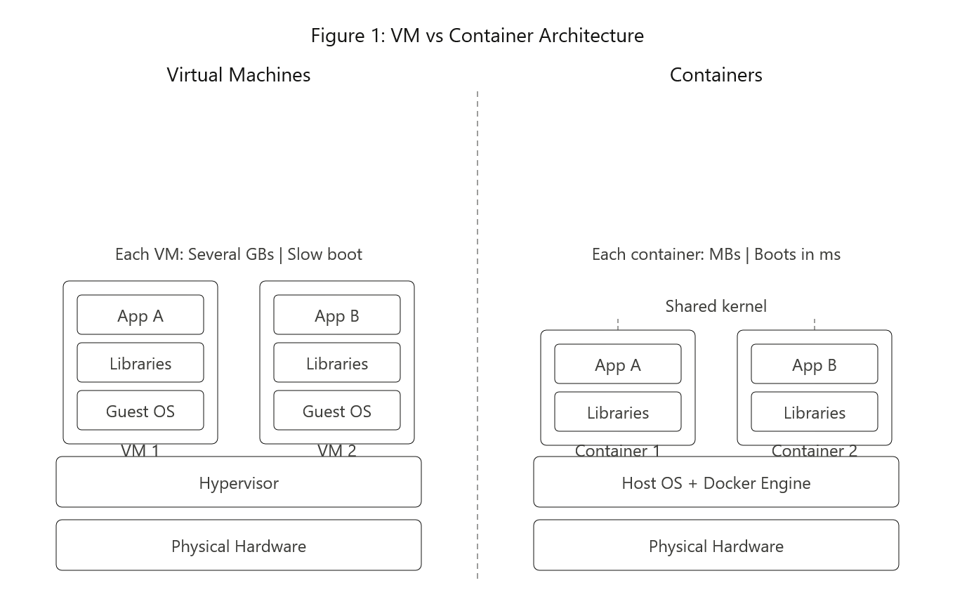

3. Docker and Containerisation Architecture
It uses two Linux kernel features namely Namespaces and Control Groups, often referred to as cgroups to isolate containers from each other. Namespaces give containers their own view of the system. From within a container, it appears that the container has its own process list, network interfaces, and filesystems; there is no leakage out, nor leakage in. Resource allocation to prevent any one container from using too much CPU, memory or disks on the host is controlled by cgroups [9].
The Docker Engine consists of three main components, which is made up of the daemon (called dockerd), a background process that does all the heavy lifting, it’s responsible for storing and processing images, containers, networks and volumes. The Docker client is the command-line interface that users interact with; it communicates with the daemon via REST API [4]. The registry where images are stored and shared, with Docker Hub being the most widely used one.
Images can be viewed as the template to create containers. They are built up by a series of layers with each instruction within a Dockerfile adding a new layer on top of the existing layers, these layers are immutable, read-only, and are stored using content-addressable storage—that means each layer is stored in a separate directory with a hash that uniquely identifies its contents. Images have been designed to share layers between each other, so if two images contain a base layer which is identical, that layer would only be stored once on disk [10].
When you run an image in practice Docker starts a container. This container has a thin writable layer on top of all those read-only layers of the image. Any writes that happens while the container is running are placed on the container’s writable layer and as long as the container remains in existence this data can only be found within that container (this is where the concepts of volume management come in but we can’t cover them all here). The result is that it is possible to run a hundred containers from the same image, all in parallel, without affecting each other [11].
The practical consequences of this are substantial performance increases. A container will provide density of 3 to 5 times what an equal VM set up can offer since each container doesn’t have a fully blown up operating system. The lead time from creation of application to live deploy decreases from minutes to seconds. And since the entire application stack including its environment is packaged into an image ‘it works on my machine’ stops being a valid excuse [3].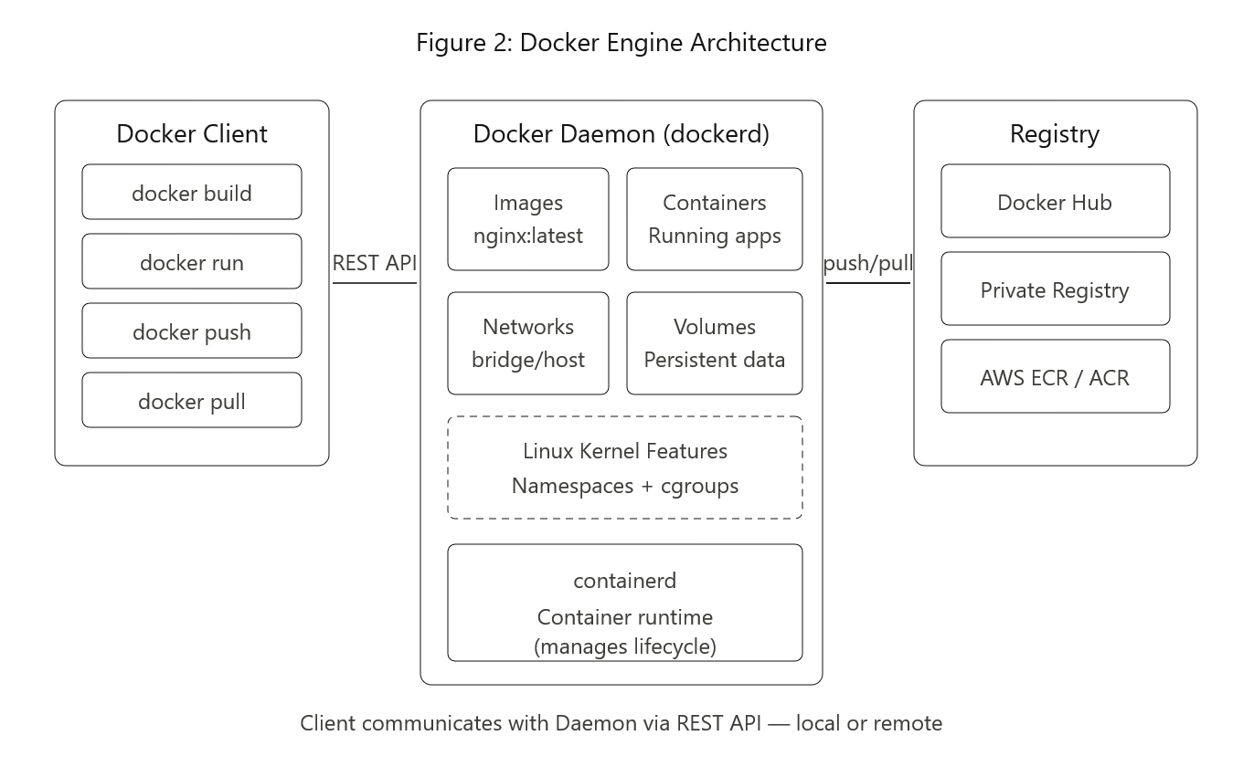

4. Practical Docker Implementation

4.1 Project Setup and Dockerfile
For this practical, a simple web application was created using an HTML file served through an Nginx web server. The project folder was set up in Visual Studio Code with just two files: the index.html page and a Dockerfile. Keeping things minimal made it easier to focus on understanding how Docker works rather than getting distracted by application logic.
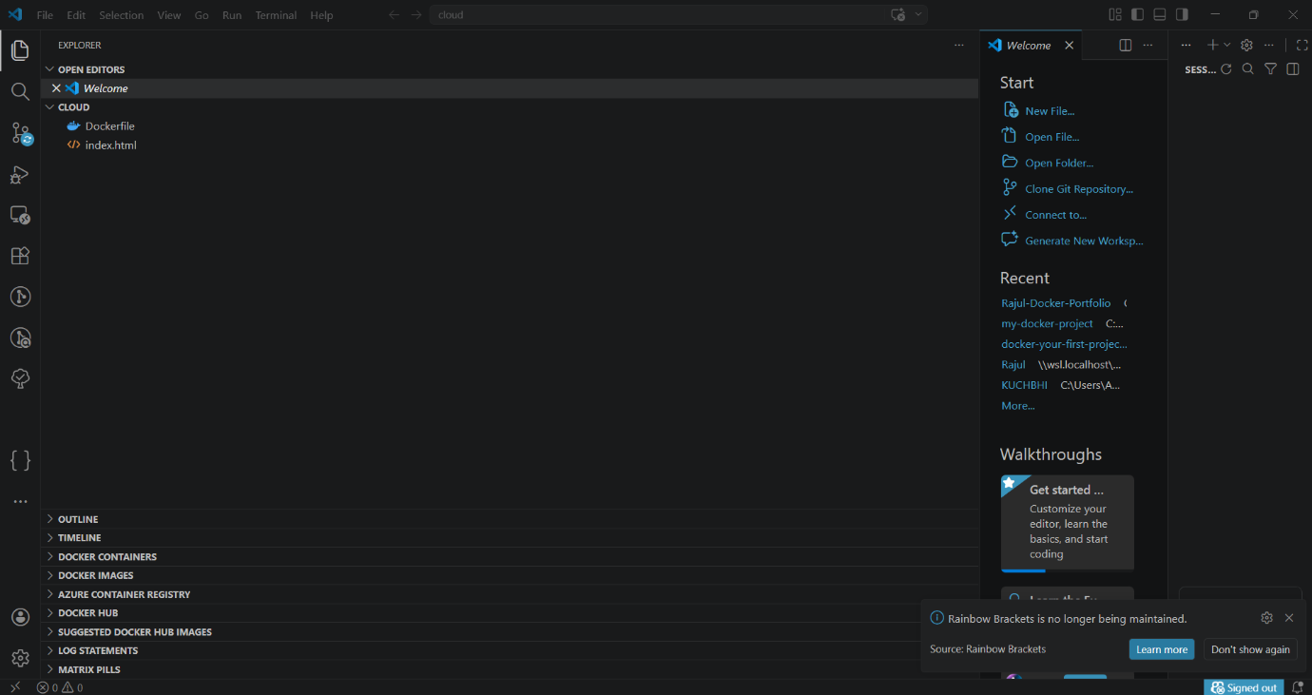
Screenshot 1: Project folder structure shown in Visual Studio Code
A Dockerfile is like a set of instructions for creating the image, each line is a step for Docker to follow. The FROM line at the top of the Dockerfile indicates the initial image that the new image is being built on. Nginx:latest was the image used, which is a basic nginx server without any setup required. The copy line copies the HTML file from the current project folder and places it into the container under Nginx’s path for the webpage. Lastly, the EXPOSE command informs that an application within the container is listening on port 80 [9].
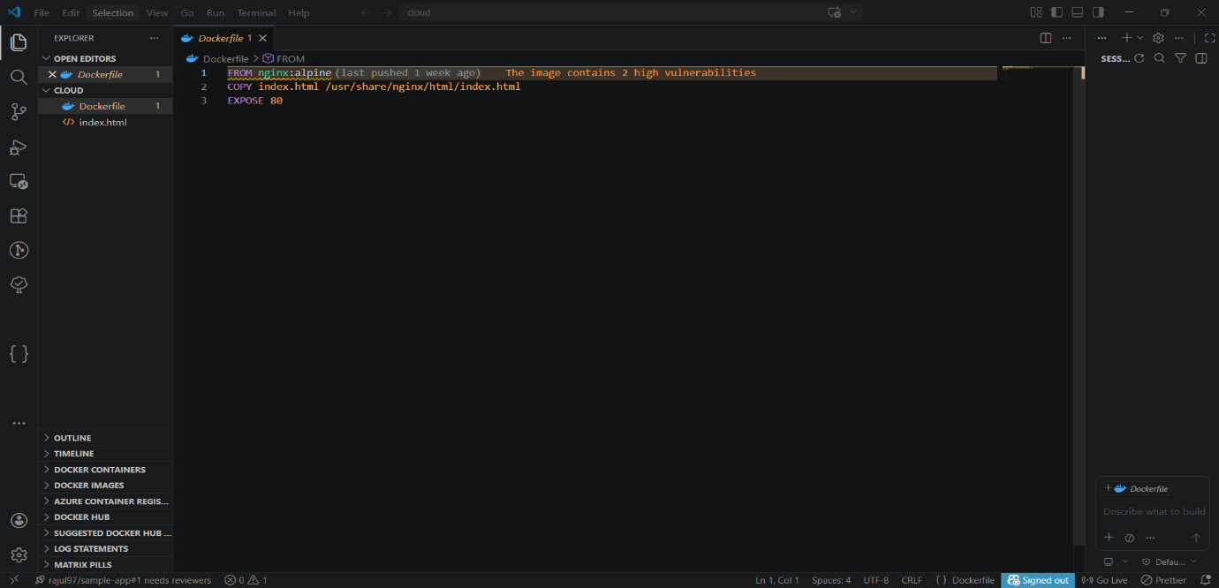
Screenshot 2: Dockerfile with FROM, COPY and EXPOSE instructions

4.2 Building the Image
The image is built once we have created our Dockerfile. This is achieved with the command below, run in the terminal:
docker build -t cloud-assignment .
The –t flag tells docker what name (or tag) to give the image. A dot is specified at the end of the command telling docker that the Dockerfile is located in the current directory. The build process of a Dockerfile consists of going through it line by line. At each line docker will then check whether it already has an image layer that matches the command on that line in its cache and if it does then it reuses that layer without rebuilding the image layer [12]. This caching mechanism is one reason why incremental development is extremely fast. It takes approximately one minute to download the base image the first time you build, however for all subsequent builds after the application code has been modified the build takes milliseconds [12].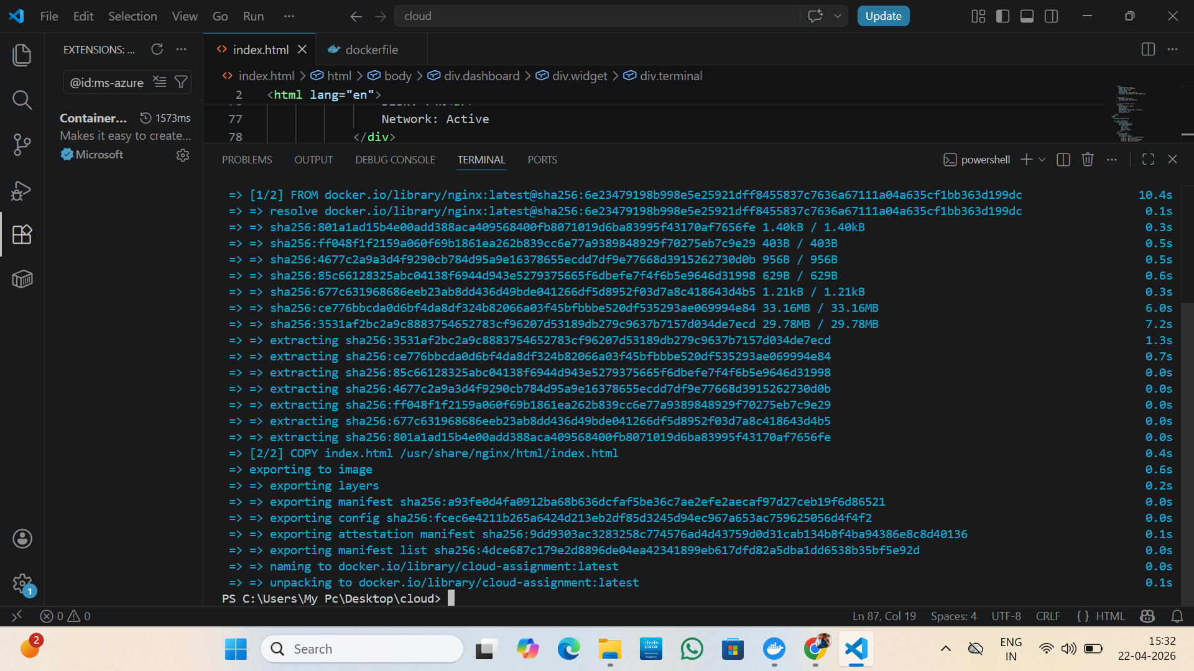
Screenshot 3: Terminal output showing successful image build with layer caching

4.3 Running the Container
After the image has been created the container can be run from it using this command:
docker run -d -p 8080:80 --name my-cloud-site cloud-assignment
Breaking this command down, the -d means that it is run detached, so it continues running in the background, and doesn’t lock up the command terminal. The -p part is the port mapping. This is in the form of -p host-port:container-port so -p 8080:80 translates to any traffic coming in on host port 8080 being forwarded on port 80 on the container, which is needed as the container runs in its own network namespace, therefore isn’t directly available to the outside world. Finally, name my-cloud-site makes the container easy to access, as stated in [9].
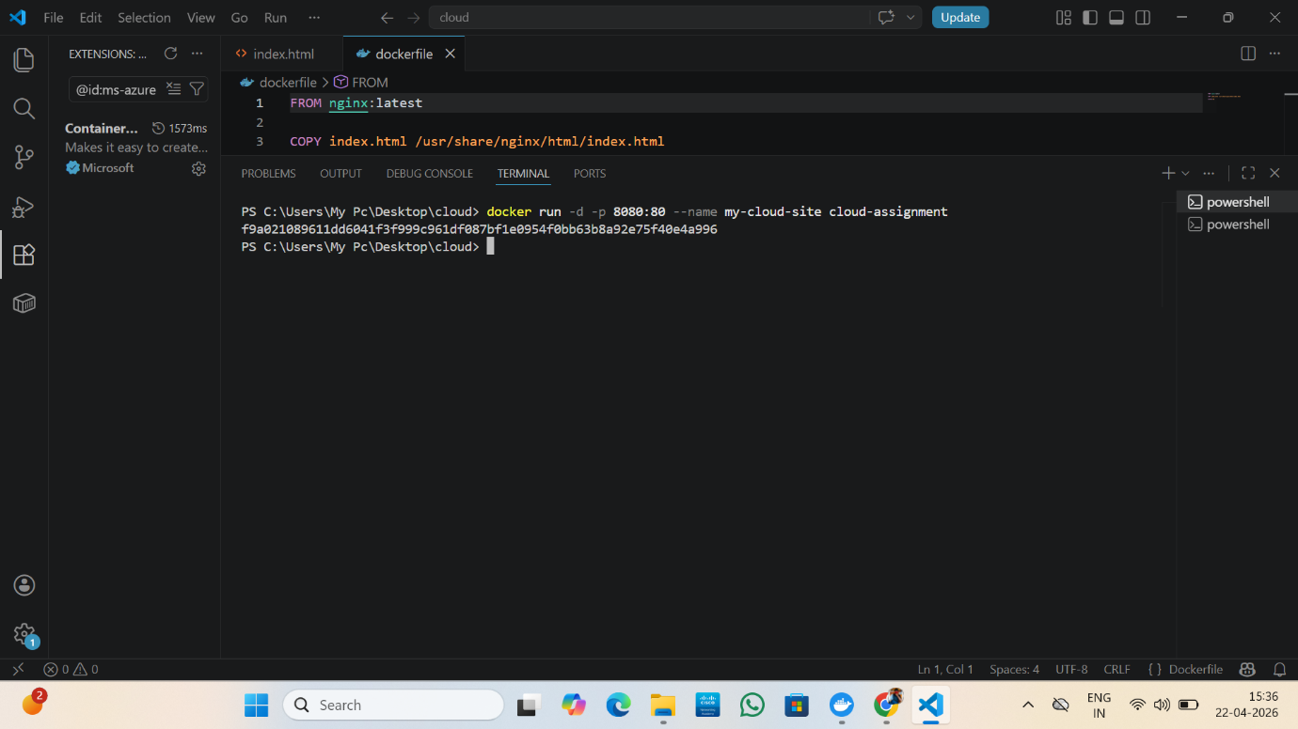
Screenshot 4: Docker run command with port mapping and detached mode
After running the command, opening a browser and visiting http://localhost:8080 confirms that the web server inside the container is working correctly and serving the HTML page.
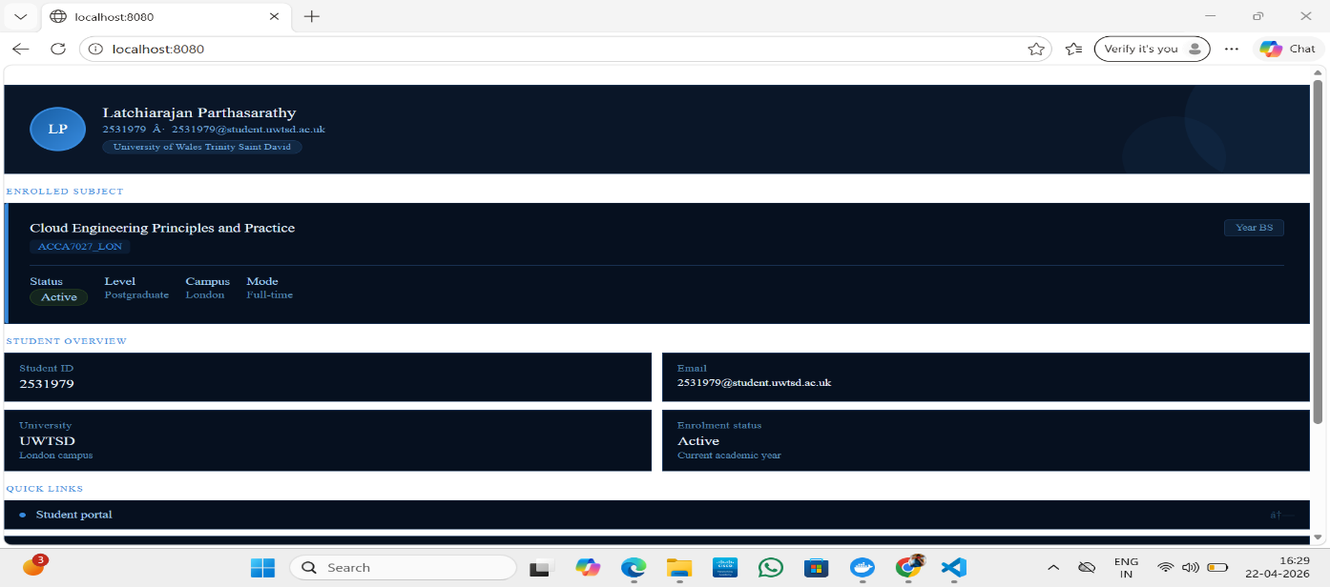
Screenshot 5: HTML page displayed in the browser from the running container

4.4 Publishing to Docker Hub
Sharing the image with others, or deploying it to a cloud environment, requires pushing it to a registry. Docker Hub is the default public registry and is free to use for public repositories. The process involves three commands.
First, log in to Docker Hub:
docker login

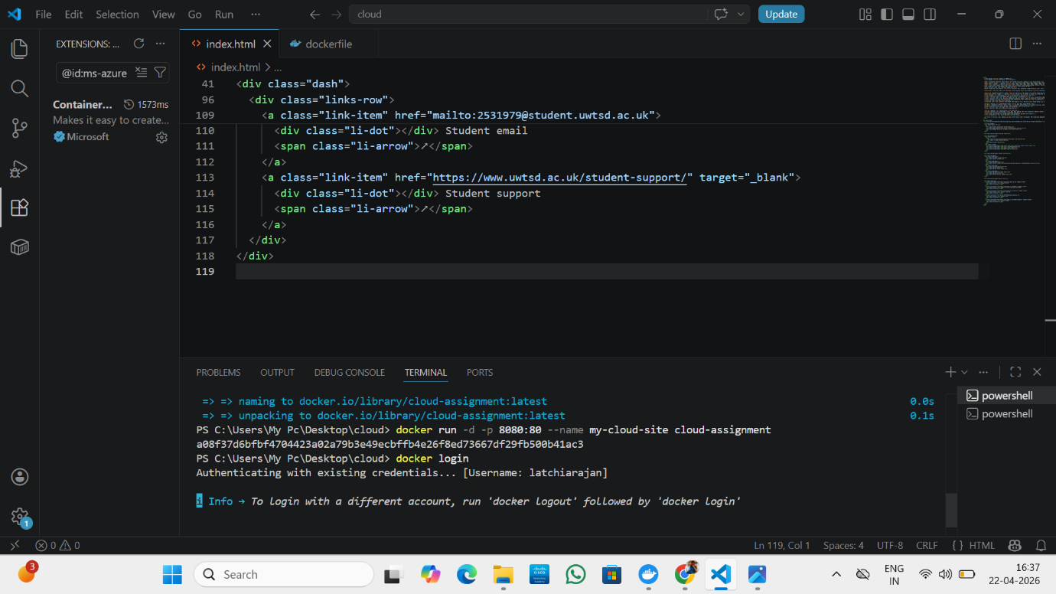
Screenshot 7: docker login authentication with Docker Hub credentials

Next, tag the image with your Docker Hub username and repository name:
docker tag cloud-assignment latchiarajan/cloud-assignment

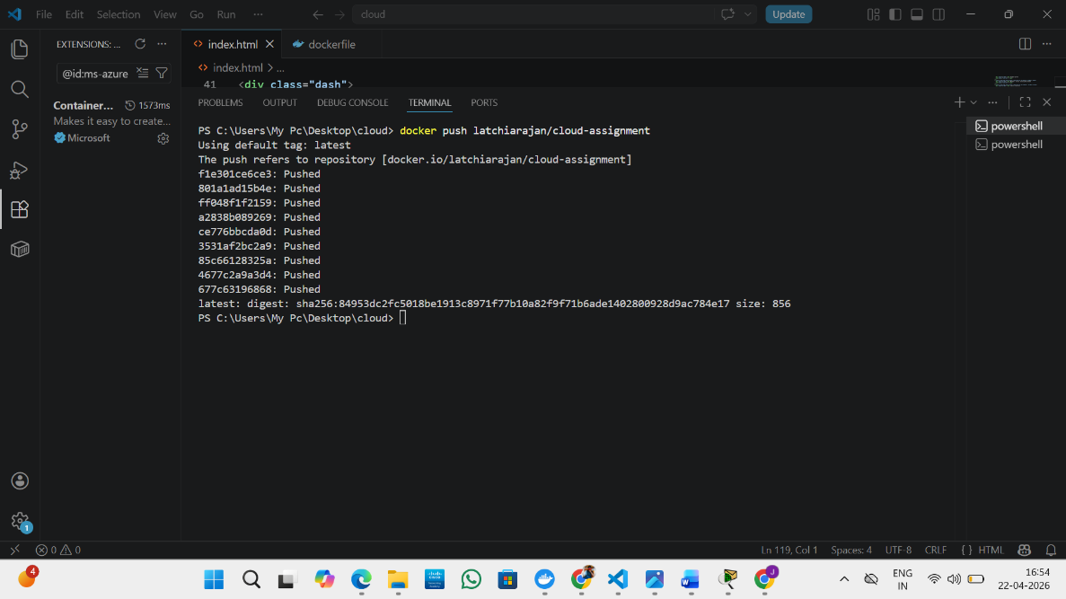
Screenshot 8: docker tag and push commands executed in terminal

Then push it:
docker push latchiarajan/cloud-assignment

The tag command does not create a new copy of the image. It simply adds an additional label that includes the registry destination. When you push, Docker uploads each layer that the registry does not already have. Common base layers, like the Nginx image, are almost always already present in Docker Hub, so they do not need to be uploaded again. This makes pushes for derivative images very fast [4].
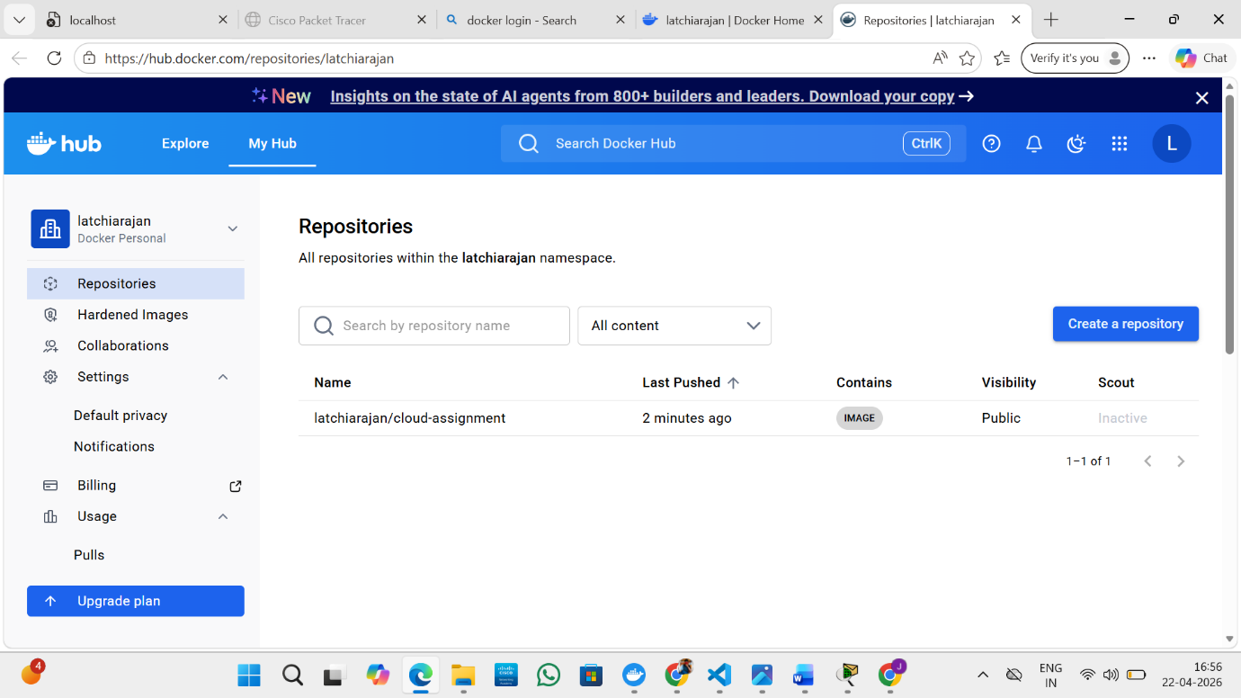
Screenshot 9: Published image visible in Docker Hub repository

4.5 Reflection on DevOps Practice
All that was demonstrated in this hands-on is the essence of modern software delivery. On a real production team all the previously mentioned steps would be automated. A developer pushes the code to the Git repository; the CI/CD pipeline gets that new commit, the tests run, a new image gets built, the image is scanned for any security vulnerabilities, and then the image is pushed to the registry. The deployment platform (such as Kubernetes, AWS ECS, or others) would then get the new image and deploy it to the production cluster with zero down-time. These manual steps performed above are exactly the tasks happening behind the scenes of such pipelines [13].

5. Docker Volumes and Persistent Storage
Another one of the first things people struggle with on Docker is the fact that containers do not persist their data. If you kill a container, anything that has been written to the container during its lifetime is deleted. This is acceptable for a stateless web server just serving static files, however, it is a catastrophic problem for a database or an application where users are uploading documents to [14].
Docker volumes provide a solution to this problem. Volumes are storage entities provided by Docker that exist outside the container’s filesystem. When you mount a volume to a container, anything written to the mounted path is stored on the volume, not on the container’s writable layer, and will persist even after the container is killed. You can then mount that volume to a different container and the state will be exactly as you left it.
Creating and using a volume looks like this:
docker volume create myvolume
docker volume ls
docker run -d -p 8081:80 --name volume-site -v myvolume:/usr/share/nginx/html cloud-assignment

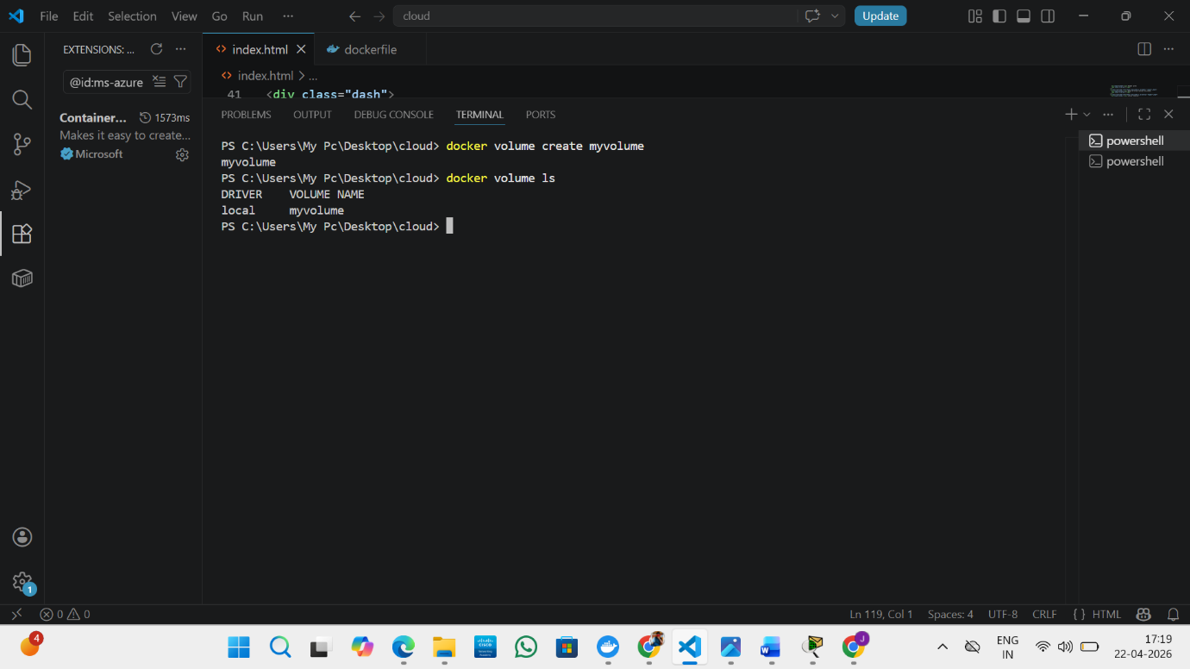
Screenshot 10: docker volume create and docker volume ls commands

The -v flag will mount the volume. Its format is volume-name:container-path. In this case, we have the volume mounted to the directory where Nginx serves its files from, so whatever file you upload into this volume will be served. When you look at http://localhost:8081, you should see that container is running and has its volume mounted [14].
Bind mounts is another option. This is simply where you will map a directory on the host machine into a path within the container. This is really useful in development because if you edit any file in the directory on your laptop it will also edit it within the container. But bind mounts makes your container rely on a directory in your hosts filesystem, thus it’s less portable, where a named volume works with the same result regardless of the host machine and so is better suited for production.
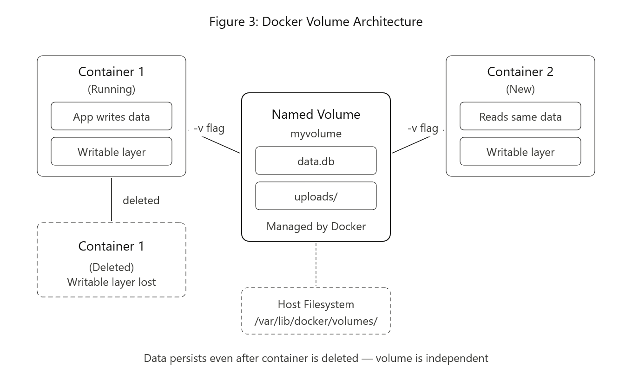

6. Docker Networking
Docker Networking seems difficult to understand when first looking into it. However, at the core, there is not a lot that needs to be learned to work it out. All containers created are given their own network namespace; each container therefore has its own IP address and in order for one container to talk to another, they must exist on the same network. There are many network modes that are provided to allow control over how the containers can access each other and external systems [9].
The default network mode is a bridge network. This is created when docker is installed. Containers in the bridge network can only reach each other via their IP address. User defined bridge networks offer benefits to this, through built in DNS, containers can talk to other containers by their name, as oppose to the IP address. This is useful for things such as talking to a database on a web application.
Setting up a custom network and running containers on it is done like this:
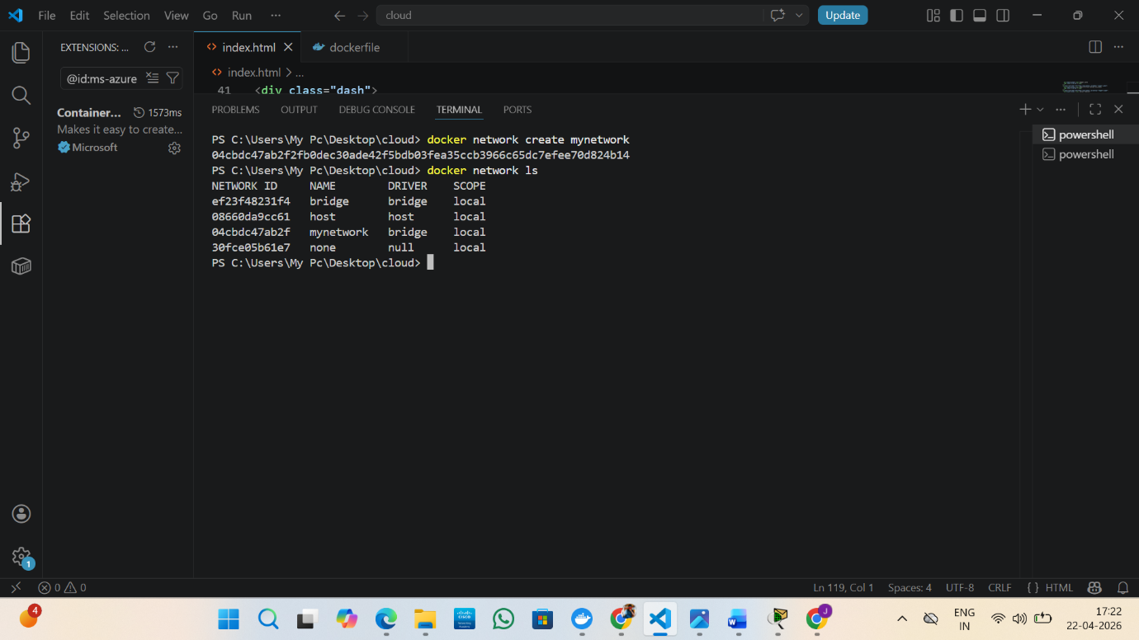
Screenshot 11: docker network create mynetwork and docker network ls output
docker network create mynetwork
docker network ls
docker run -d --name site1 --network mynetwork cloud-assignment
docker run -d --name site2 --network mynetwork cloud-assignment
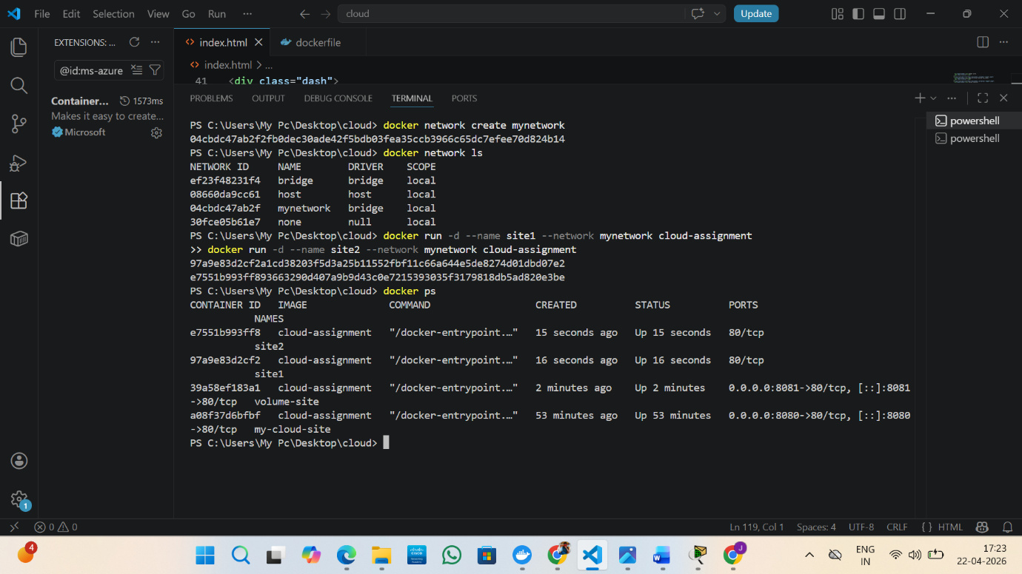

Screenshot 12: site1 and site2 containers running on mynetwork confirmed with docker ps

Both site1 and site2 are now on mynetwork. They can reach each other using their names, which Docker resolves through its internal DNS service. Running docker ps confirms both containers are active. This kind of setup mirrors real-world microservices architectures where separate services need to communicate reliably without exposing themselves to the public internet [15].
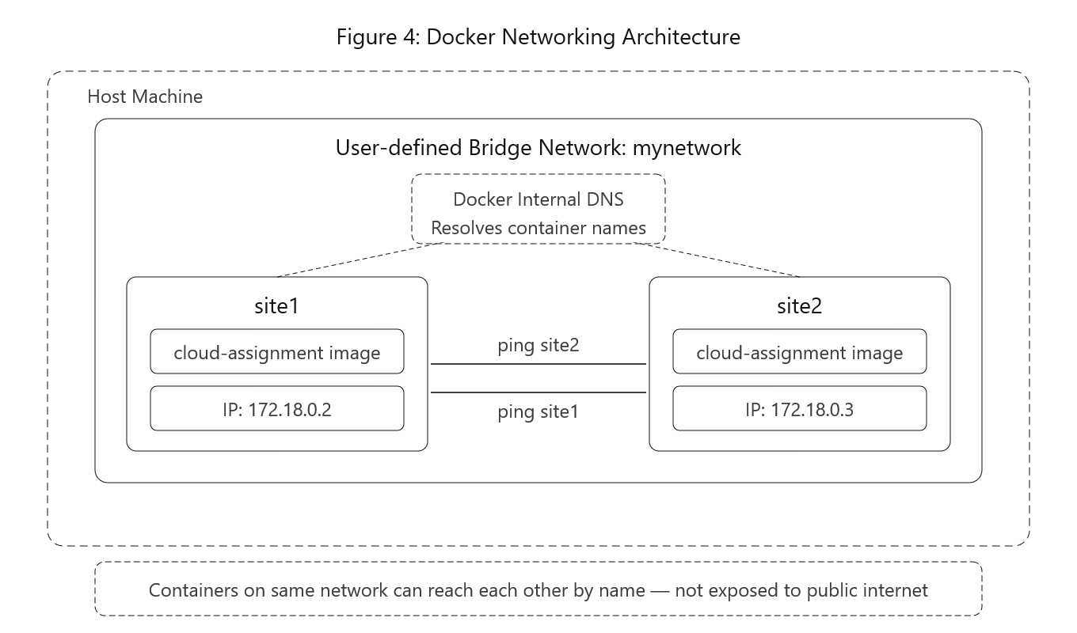

7. Cloud Infrastructure Concepts

7.1 Load Balancing
Once a web application starts gaining popularity, one server can only cope with so much traffic before it crashes under the strain. This problem can be resolved with load balancing, which distributes the incoming network traffic amongst several servers (or multiple container instances within the case of containerized applications). No one instance receives an unreasonable load and if an instance fails the load balancer simply passes traffic onto another available instance [16]. AWS uses the Elastic Load Balancing service to perform load balancing, there are three types of load balancer; the Application Load Balancer operates at HTTP layer and distributes traffic at the request level, meaning you can route traffic to different microservices using different URLs, the Network Load Balancer operates at TCP layer and handles high throughput and low latency applications, while the Gateway Load Balancer operates at network layer to work with network appliances. Similar services are provided by Azure Load Balancer and Application Gateway. Google Cloud uses Cloud Load Balancing that additionally has the ability to utilize Google’s anycast technology to route users to the nearest healthy server, significantly reducing potential latency [16]. A key function of any cloud load balancer is health checking; the load balancer regularly sends test requests to the back end services and if a back end fails to respond to these requests, it no longer directs any traffic towards it, effectively making itself self-healing.

7.2 Scalability
Scalability is the measure of how well a system can cope with increasing load. There are two methods of scaling. Firstly there is Vertical Scaling which is increasing the resources on the server such as increasing CPU and Memory. This method is physically limited and can lead to server downtime. Secondly there is Horizontal Scaling, which means adding more servers to share the load, this can be achieved rapidly by using Cloud platforms which can spin up instances in a matter of seconds [17].
AWS Auto Scaling Groups uses monitoring from CloudWatch. When a defined CPU usage threshold is reached a new EC2 instance or ECS task is created and then registered with the load balancer. When the CPU usage is less than the threshold they are terminated to save costs. Virtual Machine Scale Sets in Azure and Managed Instance Groups in Google operate in a similar manner.
This is why load balancing and scalability go hand-in-hand. Scaling ensures you can achieve additional capacity, and a load balancer ensures this extra capacity is accessible to users.
Why Load Balancing and Scalability are Complementary
Scale-out provides the capacity, but without a load balancer, traffic is still sent to the original instance, the new instances are unseen [17]. Conversely, load balancer alone does not prevent overwhelming the servers when a spike in traffic occurs, and load balancing, no matter how equal, has no means of overcoming a shortage in server capacity [16].
Combined they form a closed loop. As CPU demand increases, new container instances are launched via Auto Scaling and added to the load balancer instantly, traffic spreads to all containers within seconds. Traffic falls and containers are terminated and deleted reducing cost [17].

7.3 Application Gateways
An application gateway is a more intelligent load balancer that exists at layer 7 of the network stack, i.e. Can make routing decisions based upon the contents of the actual HTTP request, rather than just splitting traffic evenly. This makes them much more powerful for modern web architectures than standard load balancers [16]. In AWS the Application Load Balancer (ALB) is the cloud provider’s application gateway solution. The ALB is able to route requests based on path—a request for ‘/api/orders’ could be routed to a specific microservice, while ‘/api/users’ could be routed to an entirely different container cluster all behind a single public endpoint. The ALB can also route requests based on host, allowing for the serving of multiple domain names from the same application gateway. Azure has a similar service called the Azure Application Gateway. The Azure Application Gateway is also unique as it includes a built-in Web Application Firewall (WAF) that can parse traffic, and attempt to identify common threats such as SQL injection and cross-site scripting before the request even reaches the application [16]. An extremely useful application gateway feature is the ability to terminate SSL/TLS connections. Rather than having the computational overhead of encrypting and decrypting each individual web server/container handle the work of handling the HTTPS requests, a single application gateway handles this work, and communicates to the servers/containers via unencrypted HTTP. This centralizes certificate management, and reduces work load of the individual services. Google cloud combines these functions into the Cloud Load Balancing service, and is additionally able to route traffic using anycast, so requests from users go to the closest healthy backend across Google’s global network [20].
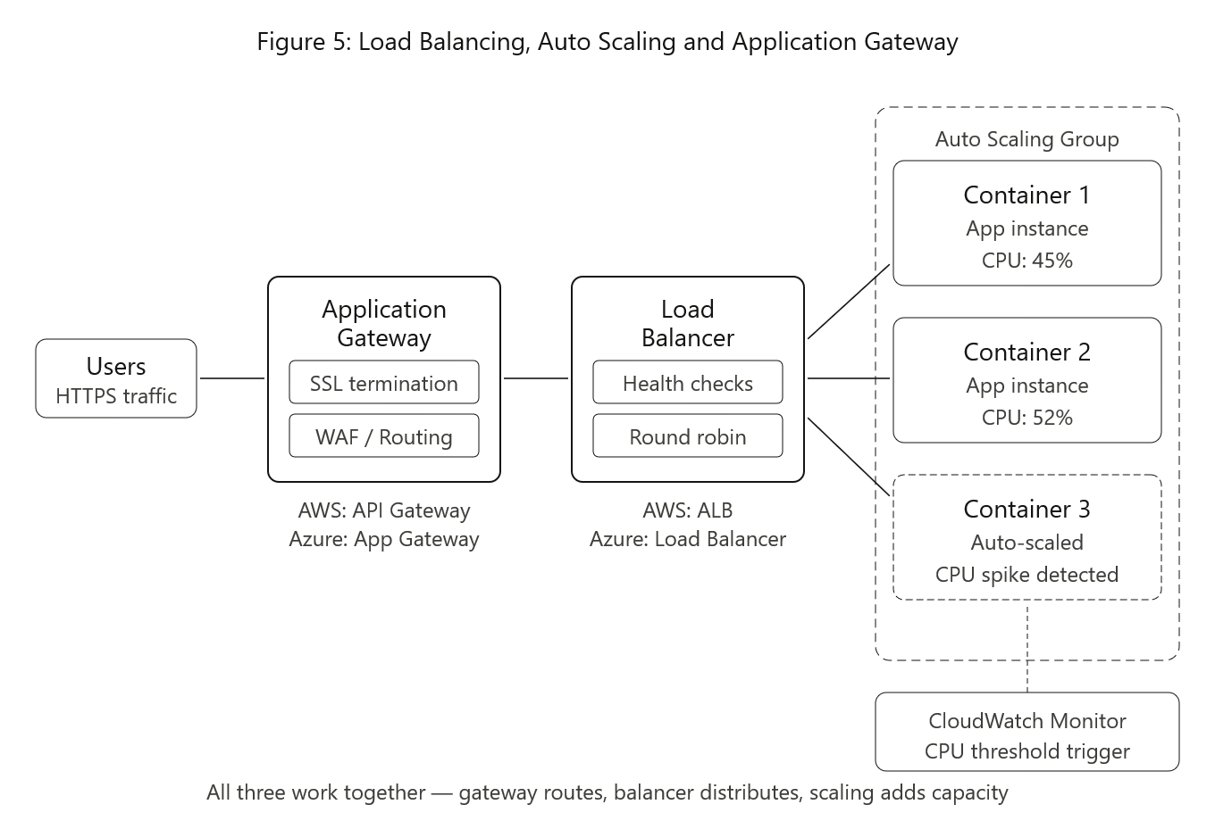7.4 Benefits of Combining Load Balancing, Scalability, and Application Gateways
As an example we take an e-commerce platform sale. The application gateway is the only entry point which correctly routs requests, the product browser one would hit the catalogue microservice and the checkout one would hit the payment microservice, while the internal WAF intercepts requests to prevent malicious requests reaching the application [16]. In the background the auto-scaling is watching the CPU level and if there’s more activity than one container can handle then new containers will be provisioned immediately and registered with the load balancer immediately too. If load decreases over time these containers will automatically be de-provisioned thus minimizing cost [17]. The load balancer will correctly route traffic to all containers with health checks running on all containers at all times to detect crashes and reroute the user with zero downtime [16].

8. Driving Forces Behind Cloud Computing Growth
If you ask an IT manager why their organisation is moving to the cloud they usually give the cost savings as their answer. With traditional IT there is a significant amount of capex incurred before you run the first piece of code in production: servers, storage, networking gear, power, cooling, physical security and people to manage all of that is expensive [18]. Most of that switches to an operational expense billed on a monthly basis with the bill depending on how much you use and this means that a small start-up company can have as much compute power as a huge organisation and they dont have to raise hundreds of thousands of pounds for their data centre.
But cost is not enough to explain why the cloud is adopted at this speed. Time is a big factor too. Whereas in traditional IT a team might have to wait six to eight weeks for hardware to be delivered, a full production environment can be built in an hour. That means that the development model changes – teams are encouraged to try more things, build quicker, react faster to feedback in days rather than months. The speed that the availability of a managed service (database, machine learning service, messaging queue etc.) enables developers, is immense as they no longer have to worry about building and maintaining base components.
Another benefit which is very hard to replicate privately is worldwide coverage. AWS runs over 30 geographic regions in the world and Azure and Google Cloud have a similar worldwide coverage. This allows an organisation to deploy applications nearer to their users in order to minimize the latency and meet the data sovereignty requirements that could only be otherwise met by owning or leasing data centers across many different countries.
Serverless computing is yet another step on the progression of the cloud model. AWS Lambda, Azure Functions etc allow a developer to deploy only a function — a small piece of code executed as a reaction to an event, without the need to actually own any servers. A Lambda function could be triggered by a call on API Gateway, a file being placed on S3, or on a scheduled timer. You pay only per invocation and per millisecond the function is executing which can be extremely cost efficient on burstable workloads compared to having a server, a container, a VM running all the time [19].
While containers provide portability and a good deal of control, serverless abstracts the concerns further to achieve the fundamental business advantages that drive cloud migration. A Lambda function costs far less than a continually executing container and is only charged when it runs [19], additionally serverless requires no managing of infrastructure (e.g. A Dockerfile or base image). Containers are however a better solution for stateful or long running operations. An ML inference service is not practical to implement as a Lambda function because of the cost overhead in starting up new containers but can be efficiently hosted as a container [3]. These are therefore complements, and in most architectures there is a mix of containerized services and serverless services for handling event driven processes like image processing or batch tasks [19].
Table 1: Containers versus Serverless Computing
Aspect | Containers (Docker) | Serverless (Lambda / Functions)
Unit of deployment | Application or service packaged as an image | Individual function triggered by an event
Startup time | Milliseconds for a warm container | Milliseconds to a few seconds on cold start
Resource control | Developer sets CPU and memory limits | Provider manages resources automatically
State handling | Supports state via volumes or external databases | Stateless by design; no local persistence
Pricing model | Charged per second of container runtime | Charged per invocation and execution duration
Portability | High; runs on any OCI-compliant runtime | Low; tied to provider-specific runtimes
Operational effort | Requires orchestration tooling | Near zero; provider handles all scaling
Best suited for | Long-running services, complex workloads | Event-driven tasks, short-lived operations
Figure 6: Docker container lifecycle vs serverless function lifecycle

9. Critical Discussion

9.1 Container Use Cases
However, neither containers nor serverless represents the ultimate solution. Each is more suited to certain types of workload. You should probably use containers if you need a lot of control over the execution environment, if you have long-running processes or if you’re trying to migrate an application to the cloud and can’t easily refactor it in terms of isolated functions (an ML inference service loading a large model will be a poor serverless candidate, due to cold starts and execution limits; containerization will be a far better option here).

9.2 Serverless Use Cases
Serverless is better suited for event-driven applications where traffic fluctuates widely. A webhook that only triggers a few thousand times a day or a batch job that only runs hourly is probably going to be both cheaper and easier to run as a Lambda function than as an always-running container. As already alluded to, the operational ease that serverless provides (no servers to manage, no Docker images to build/push) cannot be understated, and for small teams is a huge win.

9.3 Future Trends
Looking forward, the distinction between these two paradigms is beginning to blur. Platforms such as Google Cloud Run and AWS App Runner now enable you to run containers, but also have them scale down to zero at idle. This provides the portability benefits of Docker images, coupled with the cost advantages of serverless billing. A potential third option is to run code within Web Assembly runtimes such as WASMtime, which should provide much faster start-ups than containers, whilst still offering sandboxing benefits. Whatever the exact form factor, the trend within cloud native computing is clearly toward more abstraction and away from operational overhead [20].

10. Conclusion
This report has discussed the theory and practice of Docker containerization as part of the wider realm of cloud engineering. Starting with basic concepts in virtualisation, building to practical demonstration, data volumes, networking, and cloud infrastructure concepts, it has been the objective of this report to not only demonstrate how Docker functions but also why it is significant.
The practical labs allowed for an exploration of the entire lifecycle of a container: building a Dockerfile, building an image, running a container with port-forwarding, persistently storing data with volumes, linking containers using a user-defined network, and finally publishing an image to Docker Hub. Every one of these actions has direct relevance to current production operations on the internet.
Combined with cloud infrastructure such as load-balancing, auto-scaling, application gateways, and serverless functions, containerization appears to be central to the group of tools and technologies currently allowing the creation of high-availability, scalable services without the burdens of maintaining physical servers. Factors such as lower costs, accelerated deployment times, global reach and ease of maintenance are driving the shift to the cloud and will not be abating as technologies continue to evolve. Understanding of containerization has become a basic requirement in the current world of cloud engineering.

References
[1] P. Mell and T. Grance, “The NIST definition of cloud computing,” National Institute of Standards and Technology, Special Publication 800-145, 2011.
[2] M. Armbrust et al., “A view of cloud computing,” Communications of the ACM, vol. 53, no. 4, pp. 50–58, Apr. 2010.
[3] W. Felter, A. Ferreira, R. Rajamony, and J. Rubio, “An updated performance comparison of virtual machines and Linux containers,” in Proc. IEEE Int. Symp. Performance Analysis of Systems and Software (ISPASS), 2015, pp. 171–172.
[4] Docker Inc., “Docker overview,” Docker Documentation, 2024. [Online]. Available: https://docs.docker.com/get-started/overview/. [Accessed: Apr. 2026].
[5] J. E. Smith and R. Nair, “The architecture of virtual machines,” IEEE Computer, vol. 38, no. 5, pp. 32–38, May 2005.
[6] R. Buyya, C. S. Yeo, S. Venugopal, J. Broberg, and I. Brandic, “Cloud computing and emerging IT platforms: Vision, hype, and reality for delivering computing as the 5th utility,” Future Generation Computer Systems, vol. 25, no. 6, pp. 599–616, Jun. 2009.
[7] L. A. Barroso, J. Clidaras, and U. Holzle, The Datacenter as a Computer: Designing Warehouse-Scale Machines, 3rd ed. Morgan & Claypool Publishers, 2018.
[8] G. J. Popek and R. P. Goldberg, “Formal requirements for virtualizable third generation architectures,” Communications of the ACM, vol. 17, no. 7, pp. 412–421, Jul. 1974.
[9] D. J. Barrett, Docker: Up & Running: Shipping Reliable Containers in Production, 3rd ed. O’Reilly Media, 2023.
[10] A. Mouat, Using Docker: Developing and Deploying Software with Containers. O’Reilly Media, 2016.
[11] C. Anderson, “Docker,” IEEE Software, vol. 32, no. 3, pp. 102–104, May–Jun. 2015.
[12] Amazon Web Services, “Amazon Elastic Container Service Developer Guide,” AWS Documentation, 2024. [Online]. Available: https://docs.aws.amazon.com/AmazonECS/latest/developerguide/. [Accessed: Apr. 2026].
[13] J. Kim, G. Humble, P. Debois, and J. Willis, The DevOps Handbook, 2nd ed. IT Revolution Press, 2021.
[14] Docker Inc., “Manage data in Docker,” Docker Documentation, 2024. [Online]. Available: https://docs.docker.com/storage/. [Accessed: Apr. 2026].
[15] Docker Inc., “Networking overview,” Docker Documentation, 2024. [Online]. Available: https://docs.docker.com/network/. [Accessed: Apr. 2026].
[16] Microsoft Azure, “What is Azure Application Gateway?” Azure Documentation, 2024. [Online]. Available: https://learn.microsoft.com/en-us/azure/application-gateway/overview. [Accessed: Apr. 2026].
[17] N. Dragoni et al., “Microservices: Yesterday, today, and tomorrow,” in Present and Ulterior Software Engineering. Springer, 2017, pp. 195–216.
[18] T. Erl, R. Puttini, and Z. Mahmood, Cloud Computing: Concepts, Technology and Architecture. Prentice Hall, 2013.
[19] Amazon Web Services, “AWS Lambda developer guide,” AWS Documentation, 2024. [Online]. Available: https://docs.aws.amazon.com/lambda/latest/dg/welcome.html. [Accessed: Apr. 2026].
[20] Google Cloud, “Cloud Load Balancing overview,” Google Cloud Documentation, 2024. [Online]. Available: https://cloud.google.com/load-balancing/docs/load-balancing-overview. [Accessed: Apr. 2026].

