

BA International Hotel Management
Module: Marketing Essentials
Module code: BMIH4005
Lecturer: Chris Wilkin, Ruth Taylor-Davies, Gayathri Mudiyanselage, Luciana Suardi

A comparison of the marketing methods of two multinational hotel brands.

Student Name: Dimitar Spasov
Student number: 2226186
Word Count: 2008

Introduction
The rapid advancement of worldwide economic integration and globalization has resulted in significant changes in the hotel business. This study is focused on the findings on the different methods used by the selected company to market its service and the application of STP analysis on the company. And all of these studies will be conducted by picking two specific global hotel chain, in this case Six Senses and Moxy, which operate in a competitive business environment and has pursued numerous marketing routes based on different scenarios in the past.

A comparison of the marketing methods of Six Senses and Moxy hotel brands
Six Senses hotel is a renowned hotel on the international stage in the hospitality sector for its luxurious services. It started in 1995 and now is operating in nations like Japan, the United Kingdom, Germany, India, France, Brazil, Australia, and others through the effective application of marketing strategies and widespread adoption of contemporary technologies. Six Senses have now 21 properties spread-out in 17 countries with more than 1000 employees (Au, 2021). On the other hand, Moxy is a is considered to be high quality hotel service brand with stylish and playful environment. It has almost 60 hotels in many across Europe, Asia Pacific, and North America (Marriott International Newscenter, 2021).
Since its inception, the Six Senses Hotels establishes itself in places with scenic beauty as well as close to airports and popular tourist spots (Au, 2021). Additionally, it has produced a productive and committed workforce, as well as a diverse workplace, to function in that cutthroat commercial environment. Additionally, it improved the methods for succeeding in international marketplaces and determined an effective plan for entering the market. To set itself apart from its rivals, Six Senses Hotels uses a strategy of product and service differentiation. Moxy also uses service differentiation strategy. The positioning strategy of the Six Senses Hotel is to charge considerably higher costs and offer better services than competitors. But Moxy is less costly compared to Six Senses Hotel. That’s why it can be said that it follows more for less strategy. The Six Senses Hotel employs a value-based pricing method for determining the cost of its many service kinds (Thrassou, 2014). That indicates that the corporation bases the pricing of its services on how valuable it views its clients. But Moxy follows competitive pricing strategy.
Many models have been created by academics to assess the state of the market today (Wilson and Post, 2013). The Porter’s Five Forces Model, however, will be more appropriate to use in the situation of the Six Senses Hotel.
Potential of new entrants into the industry: In the hotel business, where Six Senses Hotel and Moxy both operate, the danger of new entrants is modest. Because both belong to a higher class part of the hospitality business, it is difficult for a new firm to deliver service like Six Senses Hotel and develop client loyalty in a short period of time.
Threat of substitute product: The threat of substitute products is also minimal in the hotel business since the services supplied by members of the hospitality industry, such as Six Senses Hotels, are particularly distinctive. As a result, other firm cannot completely replace their services.
Bargaining Power of Buyer: Buyers of these hotel have many possibilities to switch in the present market because there is various hotel available to them.
Bargaining Power of Suppliers: Both of the hotel’s suppliers now have strong bargaining power. Several vendors have shifted to different sectors as a result of the COVID-19 outbreak. As a result, critical service supplies have become limited, strengthening providers’ bargaining power.
Competitive Rivalry: In the hotel sector, there is a lot of fierce rivalry. Numerous international hotel companies, such as Hyatt, and Holiday Inn, face difficulties ensuring the long-term viability of their properties.

Since starting out as a hotel in 1995, Six Senses has succeeded by utilizing unique marketing techniques at every level of its growth. Six Senses provide services to their customers in environment that are very environment-friendly and socially responsible (Au, 2021). Six Senses Hotel did not have to pay for infrastructure of other capital expenditures historically rather those are instead borne by developers. On the other hand, Moxy has highly invested in its infrastructure development and expanded its operation in different parts of the United Kingdom and many parts of Europe and Asia. Since then, it has expanded its operations to many countries worldwide. Moxy hotel is still looking for innovative methods and ways to profit on the growing demand for hotel services in current global economy. To operate in different parts of the world, these corporations must hire personnel from all over the world, each with their own set of beliefs, values, and habits. Before allocation any duty to any employee, Six Senses Hotel always analyses their standards and regulations.
The aspect of marketing mix or 7Ps assists the firm in understanding the demands of potential clients. Product, pricing, place/distribution, promotion/informing, people, physical proof, and procedure are examples of these factors (Khan M.T., 2014).
Product refers to all items and services that are capable of meeting the needs of target clients. It begins with developing a solid product/service strategy, which includes gathering appropriate information about the target client and then providing them with products/services that better serve them (Colledani et al., 2016). For example, the product of Six Senses, one of the most elegant hotel brands in the world, is its magnificent hotel rooms and high quality services. Then there’s pricing, which related to the charges a consumer incurs in order to receive the service/product. A variety of factors impact product pricing decisions. Because of the ambiguity, it is considerably more problematic in the case of services. Six Senses, for example, establishes price by knowing the value perceived by its consumers. They charge a premium for spacious accommodations or rooms with city views. Placement and distribution imply that the items should be conveniently accessible to clients when and when they require them. Products should be present in both online and offline channels in today’s environment. In the instance of Six Senses, they place their hotels in strategic places such as tourist attractions, business hubs, or huge city regions so that their target clients can readily enjoy their services. Promotion target clients refer to the various methods in which organizations communicate, market, and describe their product/service. Businesses refer to all the individuals directly or indirectly involved in the process of delivering products/services from the time of creation by the components of people and process. In the case of Six Senses, this comprises managers, receptionists, and other staff members from the start of the relationship between company and consumer. Finally, Physical Evidence refers to any actual aspects for providing service that aid the delivery process.
The product of Moxy, one of the most opulent hotel brand in the UK, is its spacious hotel rooms and top-notch services. In order to set its prices, Moxy must comprehend the value that its clients perceive. They place their hotels in strategic sites, such as popular tourist destinations, commercial canters, or huge urban areas, so that their target clients can readily take use of their services. They employ the marketing 7Ps to make sure they are giving their clients good value while also assuring profitability, and this involves managers, receptionists, and other staff members from the very beginning of the relationship between business and customer.
Segmentation, targeting, and positioning strategies are very important for successfully delivering the products or services to the customers and presenting them the products or services in the most attractive and useful way. At first, in case of segmentation, the total market is divided or segmented into different small segments based on different characteristics of the customers. Both hotels use geographic segmentation to some degree and place themselves into tourist spots, hilly areas or near-by airport to capture their target customers. It also follows demographic segmentation and targets only those customers who want to enjoy high luxury and have certain level of income. It positions itself as premium quality brand among the market and serves those customers who want to avail that.
In the globally connected environment of today, marketing is done in relation to every aspect of the business. The Six Senses Hotel offers hotel, transportation, and communication services. They place a high priority on branding in their marketing initiatives to provide their clients a clear idea of their services and hospitality (Wirtz, 2012). On the other hand, Moxy always gives a clear message to their customers that customers’ satisfaction is the highest priority of the company. As a result, customers may compare them to others and comprehend the differences in services and hospitality immediately (Santaolalla Lorenzo, 2016). This is circumstance helps us better understand how globalization has affected hotel marketing strategy. Companies like Six Senses Hotel always tries to utilise the opportunities in the most useful way to ensure highest customers’ satisfaction. Recent events like Russia-Ukraine war has significantly impacted the hotel business operating in Russian Federation, Ukraine, and all over the Europe. Due to economic inflation and recession-like situation, the market share of all the major hotel businesses has dropped at various degrees. Even through it is not operating inside Russia, it has also faced huge economic loss due to the negative economic impact of the war. Six Senses Hotel industry also acknowledges the rising need of competent human resource management. It understands that without it, the firm will be unable to fulfil its diverse consumer base, since nearly half of its profit currently originates from other nations or the worldwide market. As result, employees and other personnel are taught in the proper rules, procedures, and customs that apply to a wide and distinct customer base.

Conclusion
This study examined the position of companies on the hotel business, especially Six Senses and Moxy hotels. It has been discovered that the Six Senses and Moxy hotels have successfully altered its marketing methods to fight the changing business situation. Despite fierce competition, these firms have consistently built a significant global footprint and are corporate titan in the hotel industry. Due to the efficient use of technology and professional labour, Six Senses Hotels has surpassed the majority of its rivals and aspire to become the largest hotel chain in the world.

Appendices
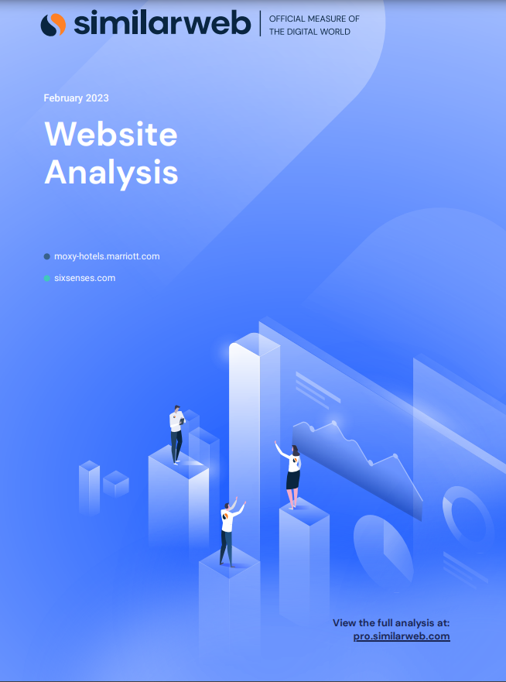
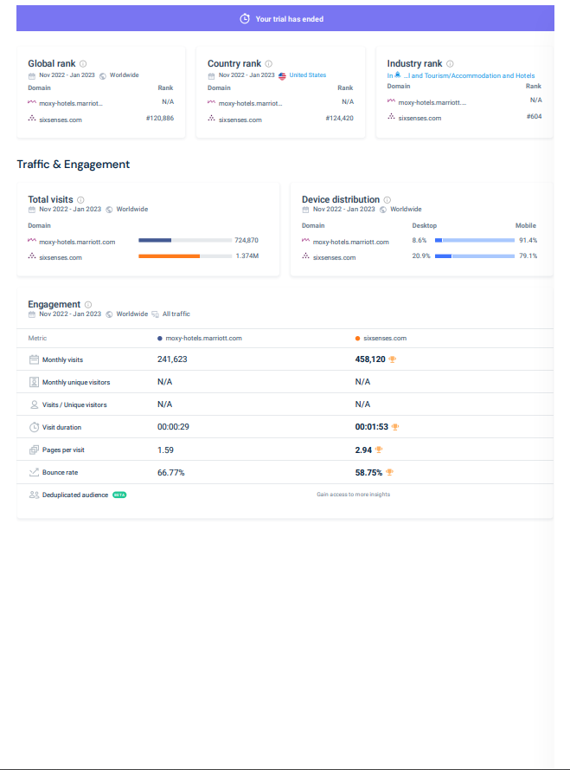
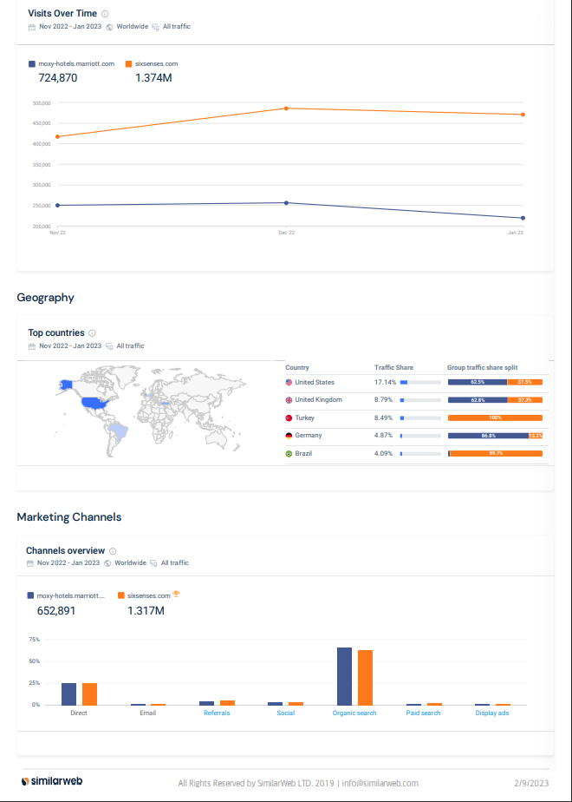

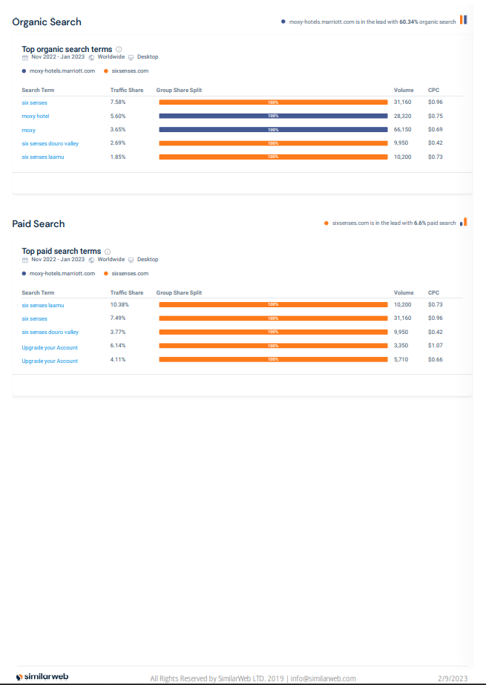
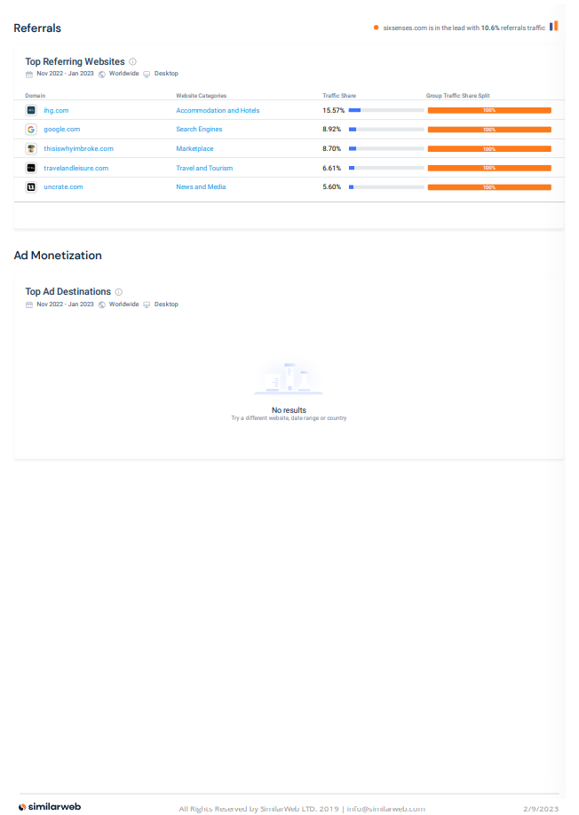

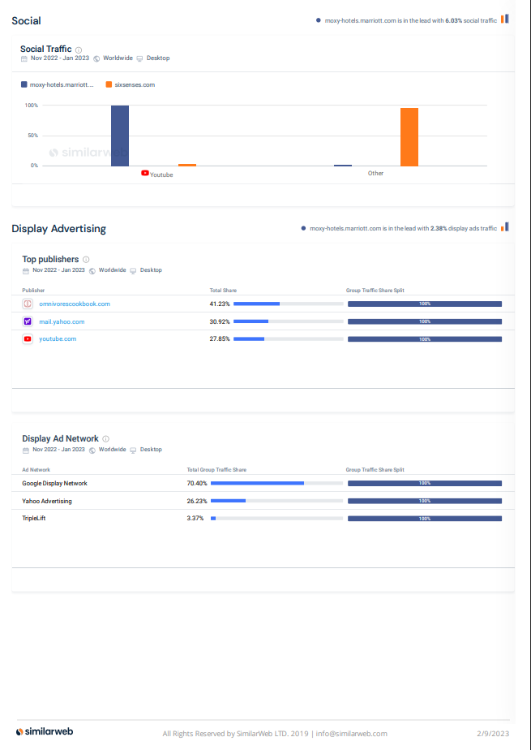

References
Au, S. (2021). The 11 Best Six Senses Hotels & Resorts in the World. [online] UpgradedPoints.com. Available at: https://upgradedpoints.com/travel/hotels/best-six-senses-hotels-resorts/#:~:text=Six%20Senses%20is%20one%20of.
Colledani, M., Silipo, L., Yemane, A., Lanza, G., Bürgin, J., Hochdörffer, J., Georgoulias, K., Mourtzis, D., Bitte, F., Bernard, A. and Belkadi, F., 2016. Technology-based product-services for supporting frugal innovation. Procedia CIRP, 47, pp.126-131.
Gröschl, S., (2011). Diversity management strategies of global hotel groups: A corporate web site based exploration. International Journal of Contemporary Hospitality Management.
Hsieh, Y.C.J., (2012). Hotel companies' environmental policies and practices: a content analysis of their web pages. International journal of contemporary hospitality management.
Ling, L., Dong, Y., Guo, X. and Liang, L., (2015). Availability management of hotel rooms under cooperation with online travel agencies. International Journal of Hospitality Management, 50, pp.145-152.
Marriott International Newscenter (US). (2021). Moxy Hotels | Marriott News Center. [online] Available at: https://news.marriott.com/brands/moxy-hotels/#:~:text=Moxy%20is%20a%20playful%2C%20affordable.
Santaolalla Lorenzo, L., (2016). NH Hotel Group and the challenges of the hotel sector in Spain: economic and financial analysis of the company and its major competitor in the sector.
Thrassou, A., Vrontis, D. and Bresciani, S., (2014). Strategic reflexivity in the hotel industry–a value-based analysis. World Review of Entrepreneurship, Management and Sustainable Development, 10(1-2), pp.352-371.
Wheelen, T.L. and Hunger, J.D., (2011). Concepts in strategic management and business policy. Pearson Education India.
Wilson, F. and Post, J.E., (2013). Business models for people, planet (& profits): exploring the phenomena of social business, a market-based approach to social value creation. Small Business Economics, 40(3), pp.715-737.
Wirtz, J., (2012). Essentials of services marketing. FT Press.

