

Assessment 1 – Reading Task Template
PART 1: Upload your photo of your A3 in-class notes here:
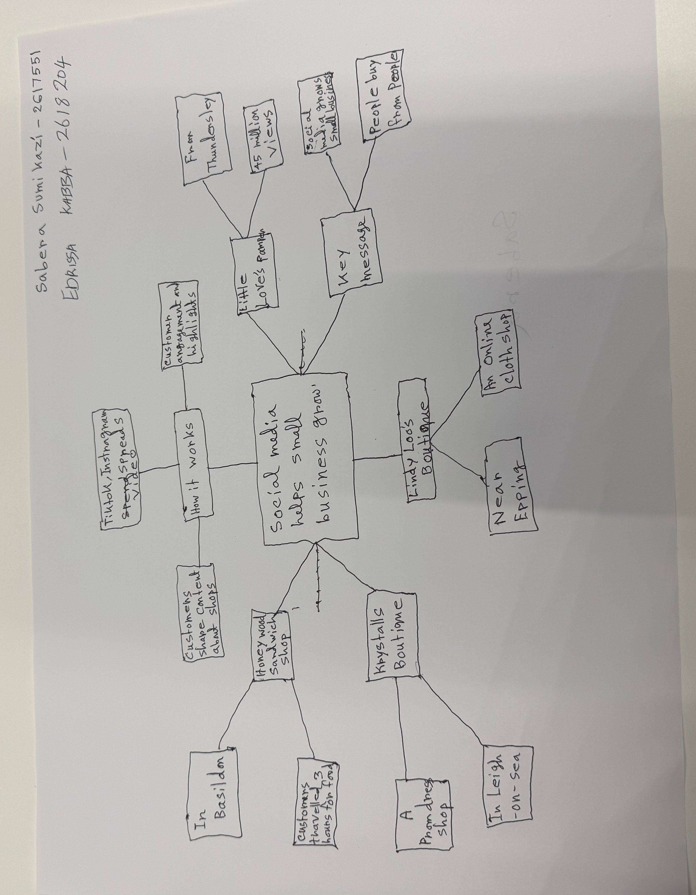

PART 2:
- Answer every question below in 1-3 full sentences.
- Use your own words. Do not use generative AI to answer these questions.
- Include a specific detail from the text when asked.
REMINDER
- The main idea is the overall message of the whole text.
- A key point helps to explain the main idea.
- A specific detail or example from the text shows that the key point is true.

- What is the main idea of the whole text?

The main idea of the text is that social media helps small business become successful. Social media platforms such as TikTok, Facebook and Instagram help small business gain recognition among people quickly. These platforms have made it easier than ever to get noticed by the world.

- What is one key point that supports the main idea, and which specific example from the text shows this?

One key point is that social media helps businesses attract customers from far away. One example from the text is that customers travelled three hours to buy chicken burgers from Murat Mutlu’s Honeywood Sandwich Shop after it became popular online.

- What is a different key point that supports the main idea, and which specific example from the text shows this?

Social media can help business owners expand their business online. The 62-year-old woman, Linda Hunter better known online as Lindy Loo, runs an online clothing business based in Epping. She moved her clothing business online and gained around 320,000 followers across Facebook and Instagram. Her shops moved the business fully online and now ships outfits across the UK and even to Australia.

- Which part of the text do you think is most important, and why?

I think the most important part of the text is that ‘People buy from people’ because social media has made it easier for businesses to reach new customers. People know what an advert is and they do not like being pressured to buy something. This shows that natural and honest posts can help businesses gain customers’ trust and increase sales.

Reflection:
- What did you find difficult in this task (including in-class components), and why was it difficult?

I found it difficult to identify the main points because the article had a lot of information and different examples.

- What helped you with this difficulty, and how did it help you?

Reading the article again and focusing on each paragraph separately helped me understand the information. This made is easier to work out the main points.

