

Program: Master of Business Administration
(INTERNATIONAL BUSINESS)

Module: International Business Concepts
Program code: LCMB7034
Student Name: Amaan Allauddin Sayyed
Student ID number: 2437446

Word Count: 5437

Table of Contents
Section 1: Report 3
1. Introduction to the report 3
2. Industry and Country Overview 3
a. Consumer Electronics Industry in South Korea 3
b. Size, Scope and Economic Importance of the Industry 5
c. Major Firms and Relative Competitive Positioning 6
3. Porter’s Diamond Analysis of South Korea’s Consumer Electronics Industry 8
3.1 Factor Conditions 9
3.2 Demand Conditions 10
3.3 Related and Supporting Industries 10
3.4 Firm Strategy, Structure and Rivalry 10
3.5 Government and Chance 11
3.6 Overall Evaluation 11
4. Analysis on the MNC, critical evaluation on the impacting factor & market’s overall attractiveness 12
4.1 Apple Inc. as the Selected Foreign Multinational 12
4.2 Factors Affecting Apple’s Operational Success in South Korea 13
4.2.1 Market and Economic Conditions 13
4.2.2 Political, Legal and Regulatory Environment 15
4.2.3 Cultural and Competitive Fit 15
4.3 Market Attractiveness of South Korea: PESTLE and Hofstede Analysis 16
4.3.1 Political Factors: Political-Risk Assessment 16
4.3.2 Economic Factors: Growth, Purchasing Power and Financial Risk 17
4.3.3 Legal Factors: Competition, Data and Technology Regulation 18
4.3.4 Cultural Factors: Hofstede’s Dimensions 19
5.0 Conclusion 20
Section 2: Reflective Account Using Kolb’s Reflective Cycle 21
2.1 Concrete Experience 21
2.2 Reflective Observation 22
2.3 Abstract Conceptualisation 23
2.4 Active Experimentation 23
Reference 25

List of Figures
Figure 01: South Korea Consumer Electronics Market Size & Outlook 4
Figure 02: South Korea exports hit record high in 2025 5
Figure 03: Samsung dominates South Korea smartphone market 7
Figure 04: Republic of Korea ranks 4th 9
Figure 05: Annual revenue change 12
Figure 06: South Korea December retail sales decline 14

Section 1: Report

1. Introduction to the report
Consumer electronics market in South Korea is very competitive and yet appealing due to its high level of digital infrastructure, technology ability to innovate, high-order of consumers and robust semiconductor, display and telecommunications ecosystem. The analysis concludes that these national benefits enhance product development, quality of manufacturing and export competitiveness. Nevertheless, key constraints to the market are also present, such as maturity, reliance on part of foreign technologies, reliance on global demand cycles and rising competition in China. The strong competitive pressure faced by foreign companies in Samsung is especially high due to its dominant position in the domestic market. In the case of Apple, South Korea provides opportunities due to well-to-do, technology-sensitive consumers, high-end devices and robust ecosystem attachment. However, the success of Apple is limited by the regulatory demands, localisation issues, the pressure of exchange rates, domestic debt and poor usage of some of its services like Apple Pay. On the whole, the paper concludes that South Korea is a favourable and challenging market, in which further localisation, adaptation to regulations, and further differentiation are the keys to the long-term success of Apple.

2. Industry and Country Overview

a. Consumer Electronics Industry in South Korea
According to Han et al., (2025), the consumer electronics sector of South Korea is a sector that functions in one of the best developed digital and manufacturing economies in the world. It encompasses smartphones, televisions, computers, wearables, audio devices and connected-home items that are underpinned by robust semiconductor, display, battery and telecommunications. The figure suggests a continued growth in the market up to 2033, which proves that South Korea is still a commercial destination even in the maturity of its electronics market and the high level of competition in the industry. In the year 2025, the national consumer electronics market had revenue generation of about US$80.93 billion of which the smartphone was the biggest revenue generating segment (Grandview Research, 2026).
For consistency, this report treats consumer electronics as the focal industry. Smartphones are analysed as one important product segment, while semiconductors, displays, batteries and telecommunications are examined only where they support consumer-electronics competitiveness. Such industry boundaries are important because international business analysis should distinguish the focal market from the upstream activities that enable it (Peng and Meyer, 2023).
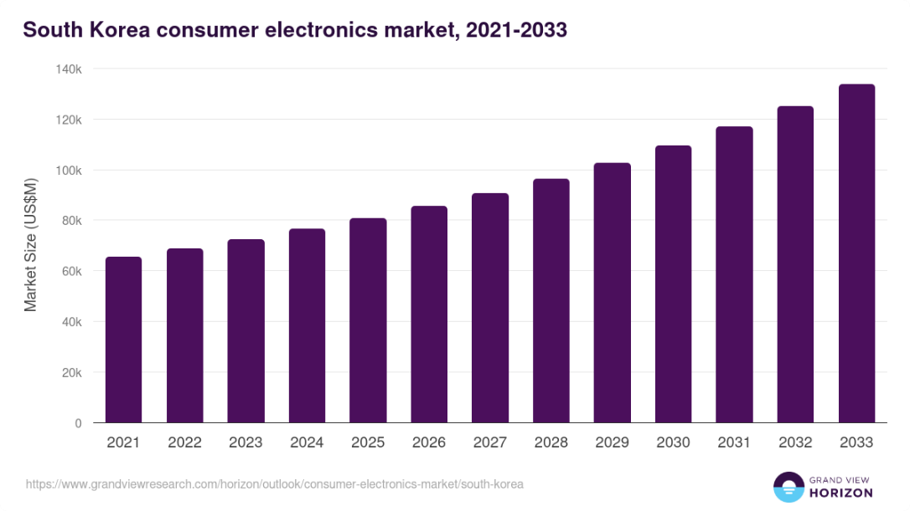
Figure 01: South Korea Consumer Electronics Market Size & Outlook
Source: (Grandview Research, 2026)
South Korea also invested KRW24.8 trillion in large-scale research and development programmes in 2025, bolstering the technological platform on which electronics companies create high-quality and AI-enhanced products (Msit.go.kr, 2025).
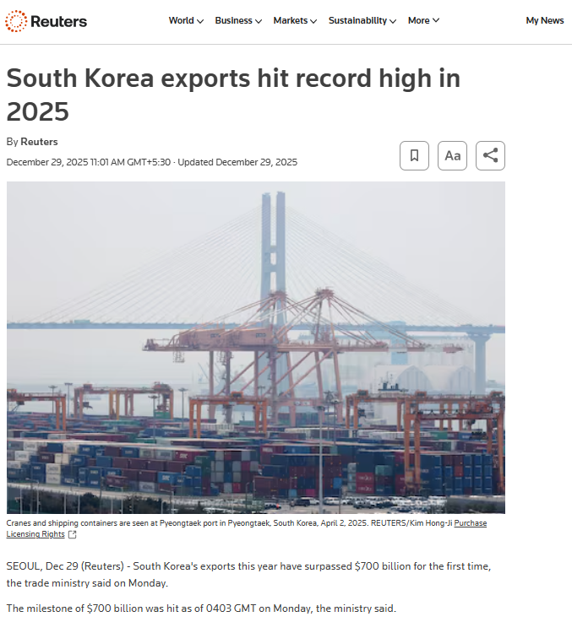
Figure 02: South Korea exports hit record high in 2025
Source: (Reuters, 2025)
The export performance in records shows the high competitiveness of South Korea in the world market and also validates the significance of the technology-related industries in the export-oriented economy of South Korea. The export orientation of South Korea is also an advantage to the industry internationally: national exports reached over $700 billion in 2025 the first time in the history of the country, with the technological products being at the centre of trade results (Reuters, 2025b).

b. Size, Scope and Economic Importance of the Industry
Market Size and Growth
South Korea is a large consumer electronics market with high household connectivity, high product replacement and high demand of high-quality digital products. It has a domestic market that will bring in around US$80.93 billion revenue in 2025 and is predicted to grow to US 133.79 billion by 2033 with an annual growth of about 6.6 percent between 2026 and 2033 (Grandview Research, 2026).
Industry Scope
The industry engages the smartphone, computers, televisions, audio equipment and so on. It also extends its area of support to other related industries like semiconductors, displays, batteries, telecommunications networks, software and digital services. This inter-connected ecosystem allows companies to integrate physical equipment with artificial intelligence, cloud connectivity and pay-as-you-use services (Hazelwood and Pecht, 2021). The well-established manufacturing base and high digital infrastructure in South Korea thus facilitate domestic consumption as well as involvement into global electronics value chains.
Economic Importance
The consumer electronics impact South Korean economy by generating output, export, research and development, skilled workers and development of suppliers (Frederick and Lee, 2022). Consumer electronics benefits from South Korea’s wider technology value chain, but upstream component performance should not be confused with final consumer-electronics performance. Semiconductor capacity is strategically important because disruptions to chip supply can restrict downstream electronics production (Naumann and Schnitzer, 2024).

c. Major Firms and Relative Competitive Positioning
Samsung Electronics: Domestic Market Leader
Samsung Electronics has the most overall position due to its competition in smartphones, televisions, tablets, wearables, computers, audio equipment and smart-home appliances (Abraham, 2022). Samsung managed to dominate nearly all of South Korea in the third quarter of 2025 with nearly 81% of the smartphone market in the country and as this shows the benefits of domestic brand recognition, a strong distribution network, and close ties with local telecommunications firms (Ahn Shang-hee, 2025). Its strategy integrates a wide coverage of products and differentiation with Galaxy AI, foldable smartphones, premium displays and connected devices ecosystem, SmartThings. During 2025, Samsung registered an overall revenue of KRW 333.6 trillion, with operating profit of around KRW 43.6trillion. It also recorded KRW 37.7 trillion of investment on R&D, which improved the ability towards incorporating AI in products (Samsung Newsroom, 2026). However, its fourth-quarter revenue in its Division of Device eXperience decreased by 8% due to competition and less robust new-product launch impacts, which means that the leadership does not eliminate demand pressures.
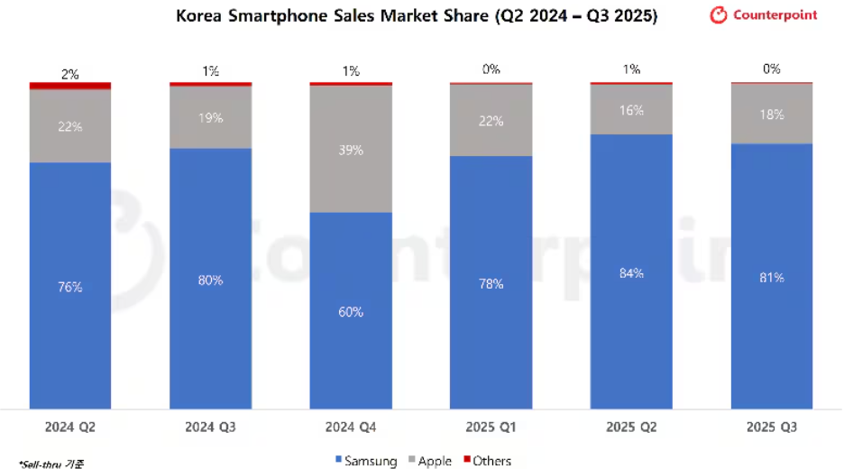
Figure 03: Samsung dominates South Korea smartphone market
Source: (Ahn Shang-hee, 2025)
The close to 81% smartphone market share of Samsung shows the extreme competitive pressure that Apple is experiencing due to the strong brand loyalty domestically, distribution and ecosystem advantages.
LG Electronics: Home and Entertainment Specialist
LG Electronics has helped in differentiating the position on the basis of home applications, OLED televisions and smart-home products. During 2025, the company has also registered all the consolidated revenue of KRW89.2 trillion in its financial books. Its Home Appliance Solution unit earned KRW26.13 trillion that was backed by high-quality appliances, optimisation of production, and subscription services (LG global, 2026). The subscription revenue of LG grew by 29% to almost KRW2.5 trillion indicating its shift away in the one-time hardware sales to recurrent customer relationship-based relationships. Nevertheless, its Media Entertainment Solution segment posted a KRW750.9 billion operating loss although its revenue stood at KRW19.43 trillion due to the stiff competition on display and slow recovery in the market (Manila Standard, 2025). LG is thus well positioned in technology in the OLED and appliances but not as profitable in the highly competitive television segments.
Multinational Competitors
Xiaomi started operating officially in South Korea in January 2025 with Xiaomi 14T and Redmi Note 14 Pro 5G, and afterwards televisions, wearables and robotic vacuum cleaners (Yonhap, 2025). It focuses on high specification at relatively affordable prices, and it competes head-on with local companies in price sensitive markets.
Competitive analysis should therefore concentrate on firms directly shaping South Korean consumer-electronics rivalry. Smartphone evidence may illustrate one important segment, but it should not be interpreted as representing the complete consumer-electronics market (Cavusgil, Knight and Riesenberger, 2024).
Comparative Positioning
Samsung, in general, dominates in terms of the breadth of its ecosystem, the strength of the brand and its investment in technology, whereas LG is more specialised in high-end appliances, OLED displays and subscriptions (Putra et al., 2023). Xiaomi is the most formidable low cost-performance threat, and the focus of Lenovo, HP and Dell is on consumer and business computing. Due to this, the domestic companies are left with the best positioning, yet multinational counterparts raise the prices, the pressure of innovation and product-differentiation.

3. Porter’s Diamond Analysis of South Korea’s Consumer Electronics Industry
The Diamond Model of Porter explains the national competitiveness as a result of factor conditions, demand conditions, related and supporting industries, and firm strategy, structure and rivalry (Kharub and Sharma, 2021). These determinants can be enhanced or diminished by government policy and external events. The model is suitable as global competitiveness is not determined by company capabilities but national resources, industrial cluster, value-chain relationships and competitive pressures.

3.1 Factor Conditions
South Korea has superior factors of production, such as digital infrastructure, engineering skills, research facilities and specialised semiconductor and display facilities. The nation was number 4 out of 139 economies in the 2025 Global Innovation Index, the best it had ever been (Wipo, 2025). It was also the highest in the world in terms of research and development done by businesses and the number of researchers working in businesses.
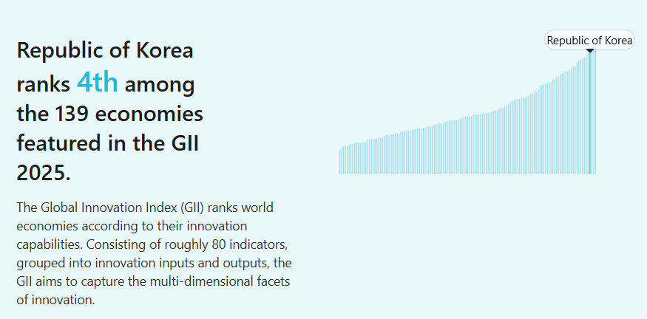
Figure 04: Republic of Korea ranks 4th
Source: (Wipo, 2025)
The fourth-place ranking on innovation strengthens the good factor conditions found in South Korea especially research potentials, human resource and technological infrastructure that has been supportive in the competitiveness of electronics.
South Korea’s technological and research capabilities strengthen consumer-electronics production through skills, innovation and sophisticated supporting industries. However, strong upstream capabilities do not automatically guarantee downstream competitiveness. Lane (2025) demonstrates that South Korean industrial policy can generate benefits across production networks, meaning its value should be assessed through its contribution to final industries rather than semiconductor output alone.

3.2 Demand Conditions
Domestic demand is advanced technologically and promotes fast product development. In January 2025, South Korea had 50.4 million internet users, and an internet penetration rate of 97.4%. The country also had almost 37 million 5G subscribers by March 2025 (DataReportal, 2025).
The high level of connectivity is leading to a high demand of premium smartphones, wearables, smart televisions, connected appliances and AI-enabled products. The willingness of consumers to embrace new technologies offers manufacturers with a good testing ground before they roll out products to other countries (Shang, 2024). South Korea, however, is a mature market that has a low population growth. The longer replacement cycles may thus undermine the growth of domestic sales, i.e. the sophisticated demand enhances the quality of products but it is unable to sustain the industry production levels on its own (Kim, 2025).

3.3 Related and Supporting Industries
The main strength of South Korea is its networked electronics industry. The domestic semiconductor, OLED display, battery, telecommunications and precision-manufacturing businesses are beneficial to the consumer-electronics manufacturers. Industrial clustering facilitates knowledge transfer, coordination with suppliers, economies of scale and innovation (Jeong, 2024).
Semiconductors, displays, batteries and telecommunications should be treated as supporting industries rather than the focal market. Their importance arises from supplying essential inputs, technology and knowledge to downstream electronics producers. Nevertheless, dependence on concentrated global component networks also creates disruption and geopolitical risks (Bu, 2024).

3.4 Firm Strategy, Structure and Rivalry
Rivalry should primarily be evaluated among consumer-electronics competitors such as Samsung, LG, Apple and relevant foreign brands. SK Hynix is more appropriately treated as part of the supporting semiconductor ecosystem. This distinction prevents upstream component competition from being confused with competition for final consumers (Peng and Meyer, 2023). The domestic rivalry engages smartphones, displays televisions, semi-conductors and so on. This stress enhances quality in manufacturing as well as reinforcing international positioning.
The global product of this innovation and competition was shown in South Korean ICT exports of record US264 billion in 2025 (Korea.net, 2026). However, the pre-eminence of big conglomerates might limit the access of small businesses to finance, human capital and distribution channels. South Korea is also losing its technological advantage to Chinese competitors. Geopolitical competition in semiconductors remains relevant only as an external supply-chain risk for consumer electronics. Restrictions, trade tensions and concentrated supply networks may increase component costs or availability risks for downstream manufacturers (Bu, 2024).

3.5 Government and Chance
The Diamond is supported by government investment, export support and strategic technology policies. Public incentives could support planned investment of KRW65 trillion in the private sector in AI over 2024-2027, which may boost demand of advanced chips and AI-enabled electronics (Dig.watch, 2026). Nevertheless, technology controls by US and China, exchange rate fluctuations, shortage of materials and political interference are external threats. Exports constitute approximately 40% of the South Korean GDP, therefore, any alterations in the global demand can have a tremendous impact on the performance of the industry (Hua Chai and Hyeryoun Kim, 2025).

3.6 Overall Evaluation
Overall, South Korea’s consumer-electronics competitiveness depends on combining innovation, sophisticated demand and strong supporting industries while improving supply-chain resilience and maintaining differentiation in final products. Strong global-value-chain linkages create advantages, but they also increase exposure to external production and trade shocks (Jiang, Kim and Liu, 2026).

4. Analysis on the MNC, critical evaluation on the impacting factor & market’s overall attractiveness

4.1 Apple Inc. as the Selected Foreign Multinational
The selected foreign MNE for this study is Apple Inc, an American Electronics/Technology company, which broadly operates in the South Korean’s consumer electronics (Forbes, 2025). The organisation is situated in Cupertino as well as sells different devices like phones, tables and so on.
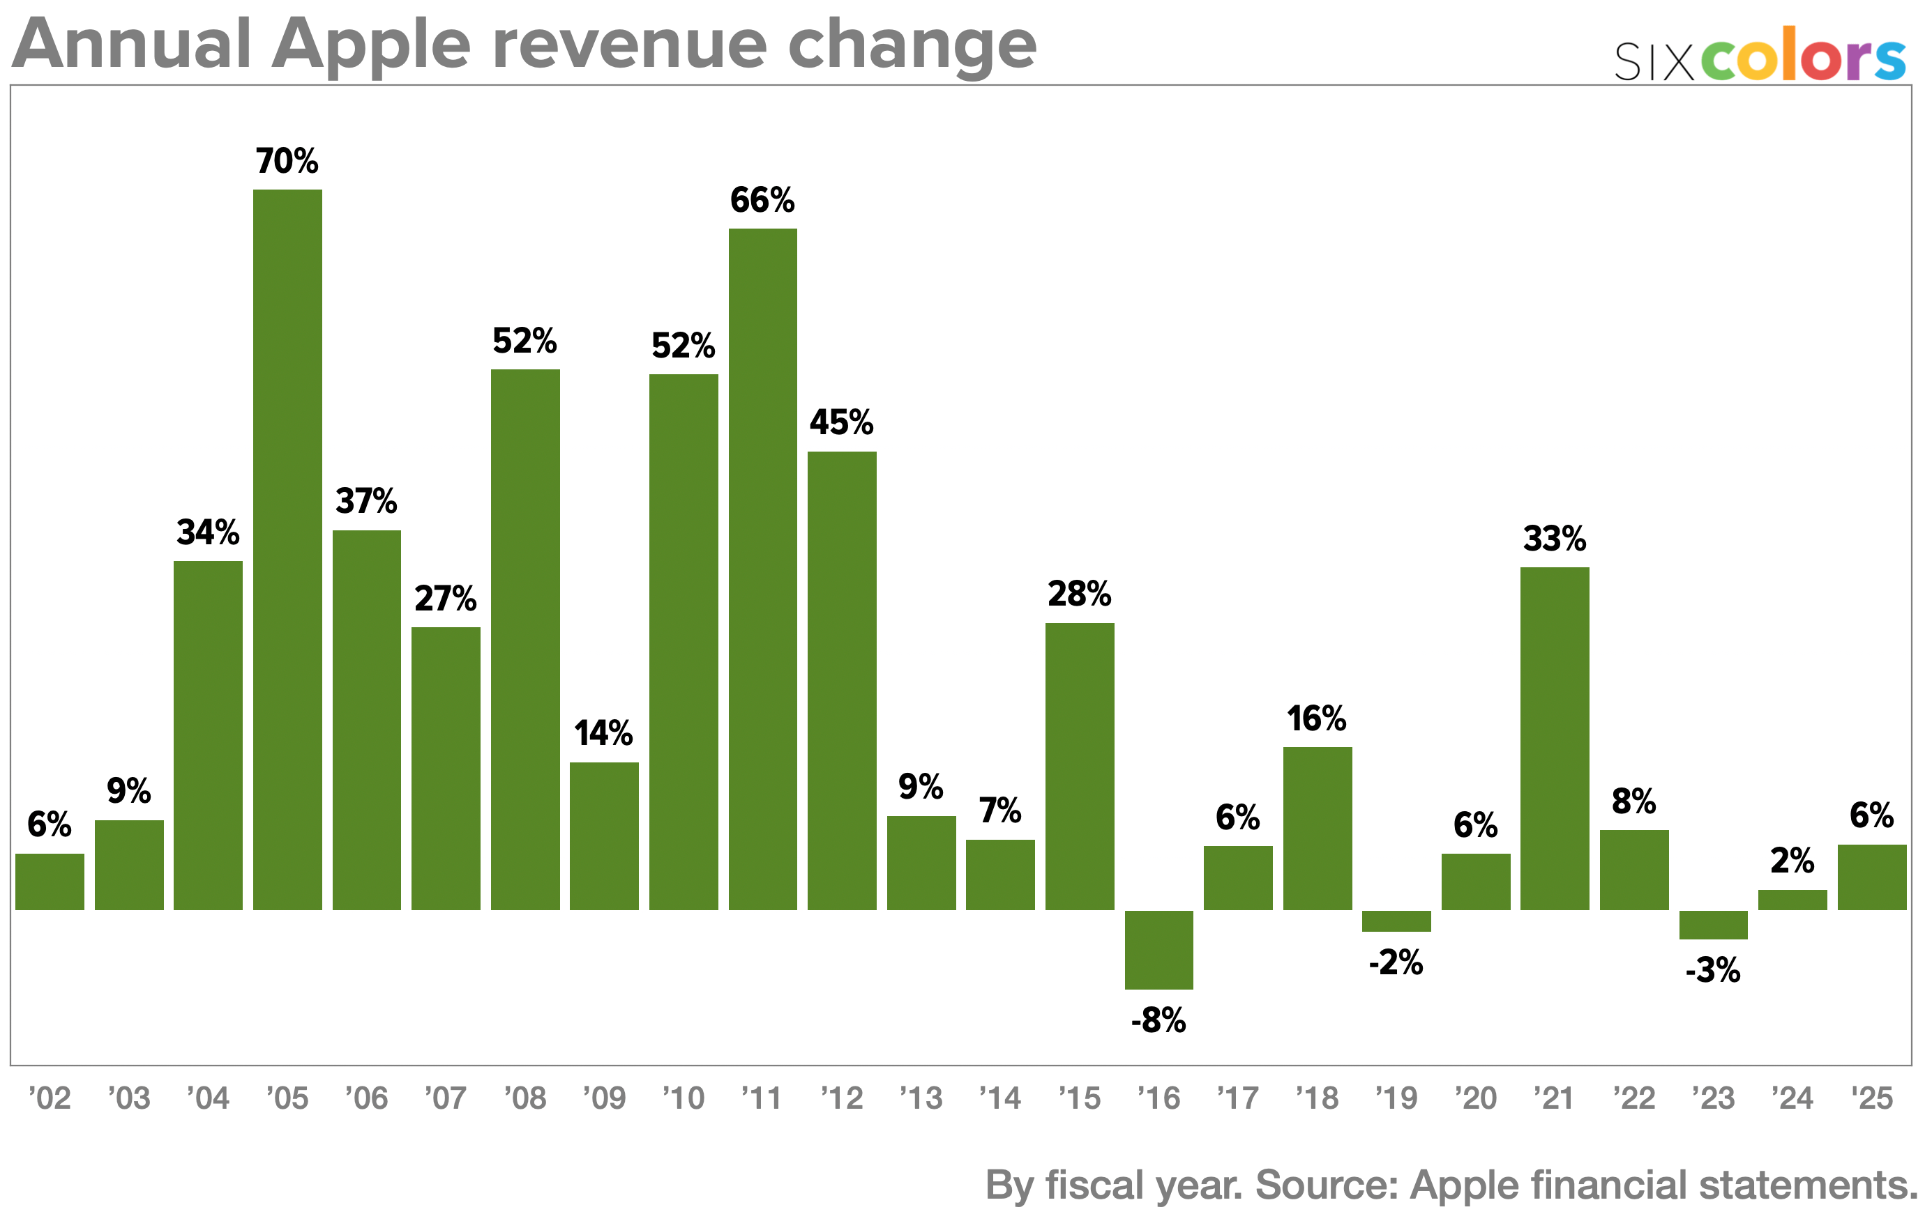
Figure 05: Annual revenue change
Source: (Six Colors, 2025)
Apple is therefore evaluated as a consumer-electronics MNC across smartphones, computers, tablets, wearables and associated services. The iPhone receives particular attention because smartphones represent an important competitive segment, but smartphone performance is not treated as equivalent to the performance of the entire consumer-electronics industry.
The size of Apple offers tremendous financial and technological capabilities to compete in South Korea. The company achieved US$416.16 billion net sales in the financial year ending 27 September 2025, which is a growth of 6% per annum and a net income of US 112.01 billion (Six Colors, 2025). The iPhone was its biggest category with revenue of US209.59 billion and services revenue grew by 14% to US109.16 billion (Sparks, 2026). The research and development in Apple also were US34.55billion to facilitate product integration, proprietary chips, software development and artificial-intelligence facilities.
In South Korea, Apple is poised in the high-end market as opposed to competing in all price segments (Tian and Wang, 2022). The joint 28% market of different iPhone variants share indicates that there is a significant demand of Apple high quality devices even in the presence of stiff competition by the local manufacturers (Counterpoint Research, 2026). The competitive advantages of Apple are thus based on brand value, product differentiation, ecosystem integration, customer loyalty and control of the hardware and software.

4.2 Factors Affecting Apple’s Operational Success in South Korea
The success of Apple relies on the ability to balance between the commercial advantages of South Korea and operating cost and risks associated with the country (Shao et al., 2022). The market offers technologically advanced consumers and modern infrastructure, yet Apple has stiff domestic competition, tight control of platforms and demands of locally compatible services (Tandel et al., 2025).

4.2.1 Market and Economic Conditions
South Korea is a good country due to the fact that consumers are quick to adopt premium technologies and thus, the country has been a significant test market in trying out new devices (Al-Shamsi, 2022). The move by Apple to incorporate South Korea in the first-wave releases of the iPhone 16 and iPhone 17 enhanced the availability of the products.
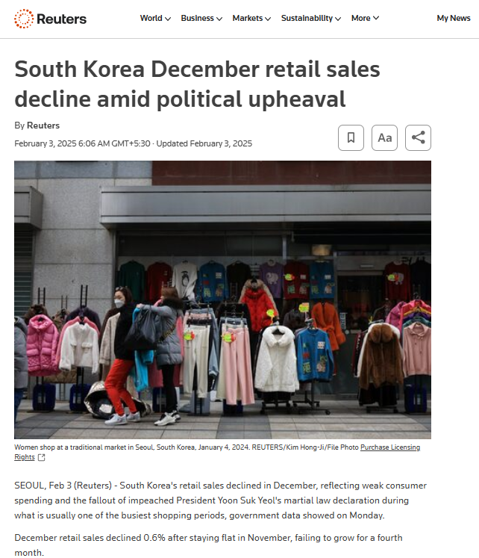
Figure 06: South Korea December retail sales decline
Source: (Reuters, 2025a)
Affordability is also affected by macroeconomic conditions. The retail sales in South Korea dropped 0.6% in December 2024 and car and home appliance sales decreased 4.1% as political disturbance undermined consumer confidence (Reuters, 2025a). In February 2026, the won was about KRW1,451.5 against a US dollar and the rate of inflation was 2%. A weak won may either widen the Korean retail prices of Apple or decrease margins since a significant portion of its global value chain is dollar-based. Apple should thus facilitate high-end positioning by trade-ins, carrier payments and divergent services (Kang, 2026).

4.2.2 Political, Legal and Regulatory Environment
The authorities in South Korea activity gets into the market over the digital platform. For example, in 2021, based on the Telecommunications Business Act, which was embedded, this outlawed practising the developers to utilised proprietary payment systems (Yang, 2021). This was followed by the Korea Communications Commission accusing Apple of foisting specific payment systems, slowing the processing of applications and levying discriminatory fees against Korean developers. The regulator suggested a fine of up to KRW20.5 billion to Apple, but Apple challenged the results and argued that the alterations it made did not violate the legislation (Lee, 2023).
These demands may jeopardize the services-based controlled ecosystem and strategy of Apple. Alternative-payment systems can decrease commission revenues, restrict the ability to control transactions with customers and raise compliance costs (Paweł Bryła and Shokir Abdusattarov, 2025). Nevertheless, opposition to changing the regulation might hurt the relationships between Apple and Korean developers, consumers, and the government. Regulatory adaptation should thus be viewed as a way of enhancing local legitimacy as opposed to the mere loss of operational control that Apple is currently experiencing (Cowls et al., 2023). Political instability poses another threat since the late-2024 crisis disrupted spending and catapulted the won to a 15-year low. However, the fact that the set regulations are still enforced shows that compliance risk is more important than random government intervention.

4.2.3 Cultural and Competitive Fit
Korean consumers are technologically savvy, fashionable and extremely demanding. A survey of consumers in 2025 found that 40% of Korean consumers were active brand switchers, with another 31% being insensitive, which was significantly higher than the global average of 18%. This presents opportunities in instances where Apple offers better design, privacy or ecosystem advantages (Gyu-lee, 2025). Apple has countered this by previous product releases, the Korean-language Apple Intelligence and the locally-available Find My features.
Weaknesses in localisation may however undermine the value of Apple ecosystem. Apple Pay transactions amounted to about KRW2 trillion in 2024, and only 1.1 percent of the total volume of transactions at Hyundai Card. The card providers in Korea can also make payments to Apple of up to 0.15% per transaction, which does not encourage it to be used more widely. Apple Pay is still strategically valued since teenagers and consumers aged between 20s years are some of the most loyal users of iPhone (Yeon-woo, 2025). Yet, limited card and merchant acceptability means that it cannot compete with well-established domestic services. In sum, long-term success entails competitive pricing, strengthened local relationships, regulatory collusion and quicker acculturation to the Korean practice of payments and digital utilization.

4.3 Market Attractiveness of South Korea: PESTLE and Hofstede Analysis
The political, economic, legal and socio-cultural elements of PESTLE analysis can be used to evaluate the attractiveness of South Korea to Apple (Küng, 2023). The factors are to be considered based on the direction of the effect they have on the health condition, the degree of significance and the probable persistence. The dimensions introduced by Hofstede offer further insights into the potential influence of national values on consumer behaviour and business practices (Sağlam and Abdullahi, 2021). The balance of benefits, costs and risks of operation in the country has to be held in the final judgement.

4.3.1 Political Factors: Political-Risk Assessment
Systemic Risk
South Korea is a democratically-driven economy, whose institutions are well established, but the political crisis that erupted in December 2024 with the martial-law announcement temporarily raised the systemic uncertainty (Yeo and Foreman, 2026). In June 2025, President Lee Jae-myung assumed office and vowed to reestablish democratic stability, invest heavily in research and investment in artificial intelligence. The strength of his party in parliament can enhance the government in implementing the industrial policy but on the other hand it might bring about quick changes in the regulations that would impact the multinational technology firms (Reuters Staff, 2025).
One of the opportunities is government support of technology. In June 2026, South Korea announced a planned US$576 billion AI and semiconductor development programme, including significant investments in fabrics, packaging and data-centres. This is capable of bolstering the local supplier network where Apple obtains memory chips, displays and other parts (Ahn et al., 2023). But, the major portion of the programme focuses on local companies, especially Samsung Electronics and SK Hynix. Stronger suppliers might have an indirect positive effect on Apple, but might not offer policy benefits as much as locally headquartered firms.
Procedural and Catastrophic Risk
Procedural risk is also quite average since the regulations are formally implemented, yet foreign digital enterprises are subject to thorough approval, data and competition demands. There is low catastrophic risk, but the tensions between the two countries with North Korea persist (Folorunso et al., 2024). North Korea condemned South Korea on 17 July 2026, in its involvement in a US-led maritime exercise and threatened to escalate the situation (Thomson Reuters, 2026). These developments do not often disrupt usual retail business, yet they pose an ongoing geopolitical threat to logistics, investment confidence and foreign workers.

4.3.2 Economic Factors: Growth, Purchasing Power and Financial Risk
Economic Growth and Consumer Demand
South Korea is a rich and technologically advanced customer base. Due to the AI-chip boom, growth in investment and exports, the government raised its economic-growth outlook to 3.0% in 2026 (as compared to growth of about 1.1% in 2025). OECD forecasted a 2.6% growth in 2026 which is marginally more optimistic, indicating that the future is bright but not clear (OECD, 2026). The restoration of consumption and greater technology sector profits can serve the needs of the luxury smartphones, computers, wearables and digital services.
Inflation, Interest Rates and Household Debt
Affordability pressures are also brought about by the economic environment. In June 2026, the consumer-price inflation was 3.2%, in part due to energy prices and currency depreciation. The Bank of Korea raised its policy rate by 2.75% on 16 July 2026; the first rate rise since 2023 (Jie, 2026). Increased interest rates may lower the amount of disposable income and escalate the price of credit-card instalments that are often payment on more costly devices.
In FY 2025, the household debt for this country was less than 90% in consideration of GDP but still settled in the top rank within the OECD countries. This is a significant medium-term risk since households with high debt levels might delay upgrades or choose less expensive equipment. This can be overcome by trade-in programmes, instalment partnerships and an increased variety of device prices.

4.3.3 Legal Factors: Competition, Data and Technology Regulation
Competition and Platform Regulation
The South Koreans are offering good protection of contracts and intellectual property. However, they are also exposing world-style technology platforms to intense surveillance. This raises compliance expenses and may even result in more equal relationships with local developers and consumers (Ji-min, 2024). Apple should make sure that its App Store, subscription, pricing and developer policy agree with the Korean telecommunications and competition regulations instead of merely translating US practices into the market. This requirement in the country-level adaptation lies in the heart of international operations.
Personal Information Protection
According to the Personal Information Protection Act, the foreign companies are obligated to adhere to certain steps in order to transfer the information of Korean users overseas (Lim and Oh, 2025). The businesses are required to have the privacy policy disclosed, seek guardian consent when processing information of children below 14, report data breaches in time and honour the rights of access, deletion and suspension of processing. The privacy positioning of Apple is a strategic advantage, yet, iCloud, Siri, Apple Intelligence and App Store operations demand the careful management of cross-border data flows. In case of breach of requirements, regulatory authorities may suspend the overseas transfers.
Artificial Intelligence and Location Data
The AI Basic Act became effective in January 2026. It demands generative AI transparency and human monitoring to designated high-impact systems, and potential fines of KRW30 million on the failure, including poor AI-content labelling (Matamis, 2026). These regulations can raise the localisation and compliance expenses of Apple Intelligence, but the one-year minimum grace period will enable it to adapt.
Another challenge is location-data restrictions. In February 2026, South Korea agreed to export finely detailed mapping information, at a scale of 1:5,000, to Google conditionally, with years of restrictions (Shim, 2026). The authorization necessitated local compliance control, extraction of sensitive data and domestic processing. This implies more transparency but does not necessarily grant Apple the same access. There might be still some approvals or alliances required by Apple to enhance Maps and location-based services.

4.3.4 Cultural Factors: Hofstede’s Dimensions
Power Distance and Relationship Management
It is noted that South Korean is currently rated as 60 in power-distance highlighting that it is tolerant moderately regarding the seniority (The Culture Factor Group, 2026). Apple ought to then employ well-defined authority, local leadership skilled in the area and respectful communication with regulators, telecommunications companies and distributors (Jan et al., 2022). But younger consumers might not be as strongly influenced by traditional hierarchy, and national averages ought not to be assumed as homogenous behaviour.
Uncertainty Avoidance
The score of uncertainty-avoidance regarding South Korean is around 85, which defines that the country is majorly associated with rules, low ambiguity, as well as rule. This would help the company Apple, whenever it concentrates over warranties, securities and product quality (Taylor et al., 2021). On the other hand, vague AI operations, localisation or service constraints can deter adoption.
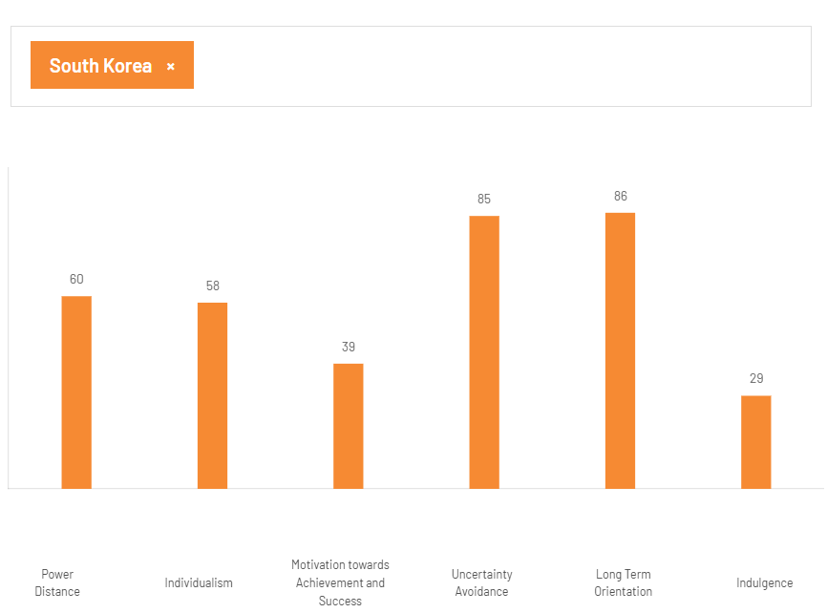
Figure 07: Hofsted Cultural Dimension
Source: (The Culture Factor Group, 2026)
Long-Term Orientation and Restraint
The long-term orientation is 86 and the indulgence is 29 which means perseverance, future oriented decision making and restrained consumption. This can be leveraged by the integrated ecosystem of Apple since consumers can appreciate gadgets that can serve a number of years without failure or incompatibility (The Culture Factor Group, 2026). Automatic growth is however capped by restrained consumption and demographic pressures. In 2025, the fertility rate rose to 0.80 after which death remained higher than births in South Korea. Apple must thus cater to younger premium users as well as older consumers where health, accessibility and safety is needed.

5.0 Conclusion
Thus, having a proper analysis, it can be concluded that consumer electronics business is highly competitive and challenging in South Korea. The industrial analysis has been created through the developed digital infrastructure, high quality labour force, capability to innovate and the developed demand and strong semiconductor, display and telecommunications industries. These mutually reinforcing conditions as exposed by the Diamond Model of Porter helped to improve product development, manufacturing quality and performance in the export markets. Nevertheless, reliance on the chosen foreign technologies, saturation of the market, stiff competition and susceptibility to the global economic cycles are still the major weaknesses.
In this regard, Apple enjoys a strong financial foundation, technology, premium brand positioning and integrated hardware ecosystem and services. The high-end smartphones, computers, wearables and digital services have an opportunity with the wealthy digitally-savvy consumers in South Korea. Nevertheless, Apple bears a major responsibility of both established domestic competitors (particularly Samsung) and localisation requirements, changing consumer preferences, and a low uptake of some enabling services.
The political, economic, legal and cultural analysis revealed that the overall benefit cost risk analysis of the market will still be favourable. Political institutions and investment in technology can support long-term operations and economic recovery can promote consumer demand. Household debt, circulation of currency, tough platform regulation, data-protection standards, and cultural anticipations, however, introduce complexity to operations.

Section 2: Reflective Account Using Kolb’s Reflective Cycle

2.1 Concrete Experience
The assignment involved me coming up with an international business report looking at the consumer electronics business in South Korea and how Apple operates in that market. I have first broken down the assessment into its key requirements: industry overview, competitor comparison, national competitiveness, the position of Apple and its appeal on the market overall (Villarroel Henríquez et al., 2025). This helped the report not to be a general description of the company.
I gathered recent quantitative data of government bodies, company reports, international organisations and well-established newspapers. I have given precedence to 2025 and 2026 information since market shares, regulations, exchange rates and technology investment are rapidly changed. I also disaggregated industry level evidence to firm level evidence in order that Apple does not control the sections that are meant to evaluate the consumer electronics industry of South Korea.
The most challenging choice was the choice of frameworks that would not overcrowd the analysis. National competitiveness has been evaluated using Porters Diamond Model. PESTLE, political-risk categories, Hofstede’s cultural dimensions and the benefit–cost–risk approach were then used to evaluate market attractiveness. PESTLE came in handy since it enabled each factor to be addressed based on its impact being positive or negative, vital or minimal, and short- or long-term.

2.2 Reflective Observation
Consequently, I was able to improve my process over time as I had to shift away to general country research in favour of evidence actually related to every requirement. To begin with, I struggled to draw the line between evidence that South Korea was globally competitive and evidence that it was attractive to Apple (Lee, 2023). As an example, semiconductor capability boosted the national electronics cluster, which did not necessarily imply that Apple would experience a market share against strong domestic firms. Being able to identify this difference enhanced the topicality of my analysis.
I also got to know that recent statistics do not necessarily compare. The sources occasionally employed varied categories of products, time and measurements. The shipments of Smartphones, retail sales and consumer-electronics revenue could not be considered as similar indicators. I thus gave more importance on official statistics and audited company results and relied on newspaper reporting to more or less explain the current political, regulatory and competitive changes.
My initial writing was also descriptive. Recording infrastructure, market growth and regulation was not a critical evaluation. I enhanced this by relating all the significant benefits to a drawback. Powerful information technology infrastructure facilitated high-level products, and market maturity impeded volume expansion. It helped to regulate both consumers and developers but made Apple compliance more expensive. Innovation enthusiasm towards technology favoured high-end equipment, yet the strength of domestic brands and localisation requirements decreased the market penetration ease. This moderation rendered the report more believable.

2.3 Abstract Conceptualisation
This process has helped me to grow in the knowledge that the success of international business is determined by the interplay of firm specific strengths and host country conditions. The multinational is allowed to have monetary assets, brand strength and technology, but these virtues cannot be detached of local regulation, rivalry, culture and economic factors. The international operation is more complicated as the political, legal, economic, behavioural and competitive situation varies on different countries.
The Diamond Model by Porter enabled me to think of national competitiveness as a system. The skilled labour force, picky consumers, semiconductor, and display industries of South Korea, and the high domestic competition strengthen each other. Nonetheless, the model also made me discover my weaknesses such as reliance on some foreign technologies, concentration on big corporations and sensitivity to global demand cycles.
PESTLE and political-risk analysis helped me to be more judgmental about the market appeal, whereas the dimensions of Hofstede were a systematic approach to take into account the cultural inclination. However, I got to know that national scores cannot be used as precise accounts of all consumers. Market behaviour should be coupled with cultural analysis since there are generational and social differences in the country. Another aspect that the cultural framework brought to light was the dangers of basing on old information, general averages and ethnocentric presumptions.
The overarching conceptual learning was that analysis must have causality. It was inadequate to say that there was inflation, regulation or uncertainty avoidance. I had to clarify the ways that each of the factors might impact pricing, demand, compliance, localisation, partnerships, profitability or positioning.

2.4 Active Experimentation
In the future, to prevent drafting an evidence matrix, I will do it. It will note the assessment requirement, the element of the framework, statistic, date, the quality of the source, relevance and critical implication. This will help avoid redundancy and there is less chance that evidence will be tagged with an inappropriate heading. I shall also use an evidence hierarchy, where official institutions and audited disclosures will be given first priority over industry estimates and newspaper reports.
I will implement a standard paragraph format: I will identify the factor, evidence, business impact of this factor, limitation and conclusion. In cases where the estimates vary, I will compare the definitions of the estimates, instead of picking up the most convenient number. I will also make a clear difference between shipments, sales, users, revenue and market value.
Lastly, I will do word count prior to writing and leave more room to evaluation than background description. This method will result in a narrower report, where the different frameworks directly lead to the overall decision regarding the competitiveness of the South Korean industries and the future of Apple in its operation.

Reference
Abraham, C. (2022). SAMSUNG INNOVATION AND TECHNOLOGY. [online] ResearchGate. Available at: https://www.researchgate.net/publication/343721698_SAMSUNG_INNOVATION_AND_TECHNOLOGY [Accessed 17 July 2026].
Ahn Shang-hee (2025). Samsung dominates South Korea smartphone market with 81% share. [online] Biz.chosun.com. Available at: https://biz.chosun.com/en/en-it/2025/12/12/SNYXR7NR55FBXOXPKMBEQEXZEA/ [Accessed 14 July 2026].
Ahn, S., Kim, J. and Lee, K.-H. (2023). Government Policy Support and the Performance of Technology-Based Start-Ups: Evidence from South Korea. Hong Kong Journal of Social Sciences, [online] 61. DOI: https://doi.org/10.55463/hkjss.issn.1021-3619.61.6.
Al-Shamsi, M.A.S. (2022). Review of Korean Imitation and Innovation in the Last 60 Years. Sustainability, 14(6), p.3396. DOI: https://doi.org/10.3390/su14063396.
Bu, Q. (2024). ‘Can de-risking avert supply chain precarity in the face of China-U.S. geopolitical tensions? From sanctions to semiconductor resilience and national security’, International Cybersecurity Law Review, 5, pp.413–442. DOI: https://doi.org/10.1365/s43439-024-00125-1.
Cavusgil, S.T., Knight, G. and Riesenberger, J.R. (2024). International Business: The New Realities, Global Edition. 6th edn. Harlow: Pearson.
Counterpoint Research (2026). Top 5 Smartphone Models Share For 8 Countries. [online] Counterpoint Research. Available at: https://counterpointresearch.com/en/insights/top-5-smartphone-model-share-8-countries [Accessed 17 July 2026].
Cowls, J., Morley, J. and Floridi, L. (2023). App store governance: Implications, limitations, and regulatory responses. Telecommunications Policy, 47(1), article 102460. DOI: https://doi.org/10.1016/j.telpol.2022.102460.
DataReportal (2025). DataReportal – Global Digital Insights. [online] DataReportal. Available at: https://datareportal.com/reports/digital-2025-south-korea [Accessed 17 July 2026].
Dig.watch (2026). South Korea prioritises AI and semiconductor investment in the 2027 budget | Digital Watch Observatory. [online] Digital Watch Observatory. Available at: https://dig.watch/updates/south-korea-ai-semiconductors-2027-budget [Accessed 17 July 2026].
Folorunso, A., Wada, I., Samuel, B. and Mohammed, V. (2024). Security compliance and its implication for cybersecurity. World Journal of Advanced Research and Reviews, [online] 24(01), pp.2105–2121. DOI: https://doi.org/10.30574/wjarr.2024.24.1.3170.
Forbes (2025). Apple on the Forbes America’s best employers list. Forbes. [online] Available at: https://www.forbes.com/companies/apple/ [Accessed 17 July 2026].
Frederick, S. and Lee, J. (2022). Korea and the Electronics Global Value Chain. [online] DOI: https://doi.org/10.13140/RG.2.2.31485.63204.
Grandview Research (2026). South Korea Consumer Electronics Market Size & Outlook. [online] Grandview Research. Available at: https://www.grandviewresearch.com/horizon/outlook/consumer-electronics-market/south-korea [Accessed 14 July 2026].
Gyu-lee, L. (2025). Apple seeks to chip away Galaxy’s share with early launch of iPhone 17. [online] Koreatimes.co.kr. Available at: https://www.koreatimes.co.kr/business/tech-science/20250824/apple-seeks-to-chip-away-galaxys-share-with-early-launch-of-iphone-17 [Accessed 17 July 2026].
Han, J., Ma, Y. and Liu, Z. (2025). Measuring the Position of China, Japan, and South Korea in the Global Value Chain of Digital Product Manufacturing and a Comparative Analysis of Their Competitiveness. Modern Economy, [online] 16(10), pp.1699–1725. DOI: https://doi.org/10.4236/me.2025.1610078.
Hazelwood, D.A. and Pecht, M.G. (2021). Life Extension of Electronic Products: A Case Study of Smartphones. IEEE Access, 9, pp.144726–144739. DOI: https://doi.org/10.1109/ACCESS.2021.3121733.
Hua Chai and Hyeryoun Kim (2025). Korea in a Changing Global Trade Landscape – Korea. [online] Available at: https://www.elibrary.imf.org/view/journals/018/2025/014/article-A001-en.xml.
Jan, J., Alshare, K.A. and Lane, P.L. (2024). Hofstede’s cultural dimensions in technology acceptance models: a meta-analysis. Universal Access in the Information Society, 23, pp.717–741. DOI: https://doi.org/10.1007/s10209-022-00930-7.
Jeong, H.-G. (2024). Analyzing South Korea’s Semiconductor Industry: Trade Dynamics and Global Position. SSRN Electronic Journal. [online] DOI: https://doi.org/10.2139/ssrn.4854445.
Jiang, M., Kim, E. and Liu, H. (2026). ‘Global value chain participation: a sub-national analysis of regional backward and forward linkages in China, Japan, and South Korea’, International Economics and Economic Policy, 23, article 6. DOI: https://doi.org/10.1007/s10368-025-00700-9.
Jie, L.H. (2026). Bank of Korea raises rates to 2.75% in first hike in over three years. [online] CNBC. Available at: https://www.cnbc.com/2026/07/16/bok-interest-rate-monetary-policy-markets-kospi-skhynix.html [Accessed 17 July 2026].
Ji-min, H. (2024). Influence of Intellectual Property Laws on Innovation in the Technology Sector in South Korea. International Journal of Law and Policy, 9(2), pp.15–27. DOI: https://doi.org/10.47604/ijlp.2704.
Kang, H. (2026). Can Monetary Tightening Defend the Korean Won? Evidence from Rate Differentials and Policy Surprises. [online] DOI: https://doi.org/10.2139/ssrn.6999344.
Kharub, M. and Sharma, R. (2021). Comparative analyses of competitive advantage using Porter diamond model (the case of MSMEs in Himachal Pradesh). Competitiveness Review, [online] 27(2), pp.132–160. DOI: https://doi.org/10.1108/CR-02-2016-0007.
Kim, J. (2025). Probabilistic Projections of South Korea’s Population Decline and Subnational Dynamics. Forecasting, [online] 7(3), p.40. DOI: https://doi.org/10.3390/forecast7030040.
Korea.net (2026). ICT exports in 2025 hit record USD 264B led by AI-driven chips. [online] Available at: https://www.korea.net/NewsFocus/Business/view?articleId=285850 [Accessed 14 July 2026].
Küng, W. (2023). Using the PESTEL Analysis to Determine the Effectiveness of New Digital Media Strategies. Advances in Economics Management and Political Sciences, 5(1), pp.19–25. DOI: https://doi.org/10.54254/2754-1169/5/20220054.
Lane, N. (2025). ‘Manufacturing Revolutions: Industrial Policy and Industrialization in South Korea’, The Quarterly Journal of Economics, 140(3), pp.1683–1741. DOI: https://doi.org/10.1093/qje/qjaf025.
Lee, J. (2023). South Korea warns Google, Apple of possible fines over apps marketing. Reuters. [online] 6 October. Available at: https://www.reuters.com/technology/skorea-considers-505-mln-fine-against-google-apple-over-app-market-practices-2023-10-06/ [Accessed 17 July 2026].
LG Global (2026). LG Electronics Releases Fourth-Quarter and Full-Year 2025 Financial Results. [online] LG Global. Available at: https://www.lg.com/global/newsroom/news/corporate/lg-electronics-releases-fourth-quarter-and-full-year-2025-financial-results/ [Accessed 17 July 2026].
Lim, S. and Oh, J. (2025). Navigating Privacy: A Global Comparative Analysis of Data Protection Laws. IET Information Security, 2025(1). DOI: https://doi.org/10.1049/ise2/5536763.
Manila Standard (2025). LG announces consolidated revenue of KRW 20.74 trillion, operating profit of KRW 639.4 billion in second-quarter ’25. Available at: https://manilastandard.net/tech/314621567/lg-announces-consolidated-revenue-of-krw-20-74-trillion-operating-profit-of-krw-639-4-billion-in-second-quarter-25.html.
Matamis, J. (2026). South Korea’s AI Basic Act: Seeking Balance Between Industry Innovation and Social Risk. [online] Stimson Center. Available at: https://www.stimson.org/2026/south-koreas-ai-basic-act-seeking-balance-between-industry-innovation-and-social-risk/ [Accessed 17 July 2026].
Msit.go.kr (2025). Major R&D Budget for 2025 Set to Be KRW 24.8 Trillion, the Largest in History. [online] Msit.go.kr. Available at: https://www.msit.go.kr/eng/bbs/view.do?bbsSeqNo=42&mId=4&mPid=2&nttSeqNo=1018&pageIndex=&sCode=eng [Accessed 17 July 2026].
Naumann, F. and Schnitzer, M. (2024). ‘Rationales for Industrial Policy in the Semiconductor Industry’, Intereconomics, 59(5), pp.262–266. DOI: https://doi.org/10.2478/ie-2024-0053.
OECD (2026). Global economic outlook weakens amid energy shock and rising inflationary pressures. [online] OECD. Available at: https://www.oecd.org/en/about/news/press-releases/2026/06/global-economic-outlook-weakens-amid-energy-shock-and-rising-inflationary-pressures.html [Accessed 17 July 2026].
Paweł Bryła and Shokir Abdusattarov (2025). Apple’s Strategy Success Factors and Challenges in Europe: A Case Study of Apple’s Business Model and International Marketing. Annales Universitatis Mariae Curie-Skłodowska, sectio H – Oeconomia, [online] 59(5), pp.7–30. DOI: https://doi.org/10.17951/h.2025.59.5.7-30.
Peng, M.W. and Meyer, K.E. (2023). International Business. 4th edn. Andover: Cengage Learning EMEA.
Putra, E.Y., Putri, I.M., Mahendra, R.A., Sibagariang, M.I.B.A., Mey, N.A., Kusumo, P. and Hutagalung, R.M. (2023). Analysis of Samsung’s Strategy in Dealing With Global Market Competition in International Business. Journal of Management Analytical and Solution (JoMAS), 3(3), pp.111–117. DOI: https://doi.org/10.32734/jomas.v3i3.12167.
Reuters (2025a). South Korea December retail sales decline amid political upheaval. Reuters. [online] 3 February. Available at: https://www.reuters.com/markets/asia/south-korea-dec-retail-sales-decline-amid-political-upheaval-2025-02-03/ [Accessed 17 July 2026].
Reuters (2025b). South Korea exports hit record high in 2025. Reuters. [online] 29 December. Available at: https://www.reuters.com/world/asia-pacific/south-korea-exports-hit-record-high-2025-2025-12-29/ [Accessed 17 July 2026].
Reuters Staff (2025). South Korean presidential frontrunner Lee Jae-myung’s policy pledges. Reuters. [online] 13 May. Available at: https://www.reuters.com/world/asia-pacific/south-korean-presidential-frontrunner-lee-jae-myungs-policy-pledges-2025-05-13/ [Accessed 17 July 2026].
Sağlam, M. and Abdullahi, M.D. (2021). The Impact of Hofstede’s Cultural Dimensions on Consumer Behaviour Intentions. [online] ResearchGate. Available at: https://www.researchgate.net/publication/356894559_The_Impact_of_Hofstede [Accessed 17 July 2026].
Samsung Newsroom (2026). Samsung Electronics Announces Fourth Quarter and FY 2025 Results. [online] Samsung Global Newsroom. Available at: https://news.samsung.com/global/samsung-electronics-announces-fourth-quarter-and-fy-2025-results [Accessed 17 July 2026].
Shang, X. (2024). The Current Status and Future Trends of Wearable Devices. Applied and Computational Engineering, 120(1), pp.98–104. DOI: https://doi.org/10.54254/2755-2721/2025.18829.
Shim, K.-S. (2026). South Korea launches landmark laws to regulate AI, startups warn of compliance burdens. Reuters. [online] 22 January. Available at: https://www.reuters.com/world/asia-pacific/south-korea-launches-landmark-laws-regulate-ai-startups-warn-compliance-burdens-2026-01-22/ [Accessed 17 July 2026].
Six Colors (2025). Apple’s fiscal 2025 in charts. [online] Six Colors. Available at: https://sixcolors.com/post/2025/11/apples-fiscal-2025-in-charts/ [Accessed 17 July 2026].
Sparks, D. (2026). Apple’s Services Business Was a Major Catalyst Last Year, and 2026 Will Likely Be Even Better. [online] Yahoo Finance. Available at: https://finance.yahoo.com/news/apples-services-business-major-catalyst-182600661.html [Accessed 17 July 2026].
Tandel, K., Mahalaxmi and Sreeramana Aithal (2025). Technological Strategy of Apple in India: Business Challenges and Growth Opportunities. [online] 2(2), pp.259–291. DOI: https://doi.org/10.5281/zenodo.17174706.
Taylor, K., Zarb, S. and Jeschke, N. (2021). Ambiguity, Uncertainty and Implementation. International Review of Public Policy, 3(1). DOI: https://doi.org/10.4000/irpp.1638.
The Culture Factor Group (2026). Country comparison tool. [online] The Culture Factor. Available at: https://www.theculturefactor.com/country-comparison-tool?countries=south+korea [Accessed 17 July 2026].
Thomson Reuters (2026). North Korea calls Seoul a ‘puppet’ for its role in US maritime exercise. [online] WTVB. Available at: https://wtvbam.com/2026/07/16/north-korea-calls-seoul-a-puppet-for-its-role-in-us-maritime-exercise/ [Accessed 17 July 2026].
Tian, W. and Wang, M. (2022). The Core Competentness of Apple Inc. [online] Atlantis Press. DOI: https://doi.org/10.2991/aebmr.k.220307.116.
Villarroel Henríquez, V., Castillo Rabanal, I. and Santana Abásolo, J. (2025). Applying Kolb’s experiential learning cycle for deep learning: A systematic literature review. Social Sciences & Humanities Open, [online] 12, p.102096. DOI: https://doi.org/10.1016/j.ssaho.2025.102096.
Weihong Justin Jiang, Li, R. and Shao, W. (2022). Research About Apple’s Marketing Strategy and Consumer Behavior. [online] DOI: https://doi.org/10.54691/bcpbm.v20i.917.
WIPO (2025). Global Innovation Index 2025: Innovation at a Crossroads. WIPO. [online] DOI: https://doi.org/10.34667/tind.58864.
Yang, H. (2021). South Korea set to curb Google, Apple commission dominance. Reuters. [online] 24 August. Available at: https://www.reuters.com/technology/skorea-set-curb-google-apple-commission-dominance-2021-08-24/ [Accessed 17 July 2026].
Yeo, A. and Foreman, H. (2026). From martial law to democratic renewal in South Korea. [online] Brookings. Available at: https://www.brookings.edu/articles/south-korea-democratic-resilience/ [Accessed 17 July 2026].
Yeon-woo, L. (2025). Two years in, Apple Pay struggles to gain foothold in Korea. [online] Koreatimes.co.kr. Available at: https://www.koreatimes.co.kr/business/banking-finance/20250314/two-years-in-apple-pay-struggles-to-gain-foothold-in-korea [Accessed 17 July 2026].
Yonhap (2025). Xiaomi begins operations in Korea with official product launch. [online] Koreatimes.co.kr. Available at: https://www.koreatimes.co.kr/business/companies/20250115/xiaomi-starts-operations-in-south-korea-with-official-product-launch [Accessed 17 July 2026].

