University of Wales Trinity Saint David



Program: Certificate of Higher Education Skills for the Workplace (Health and Social Care)
Title: Written Assignment
Module Code: LCHS 4003 – Component 2
Module: Introduction to Health and Social Care
Name of Student: Rizwana Adeel
Student ID: 2504702
Lecturer Name: Mumtaz Goolam

Table of Contents
1. Introduction 3
2. Importance of Effective Communication in Mr. Ahmed’s care 3
I. Equality Act 2010 4
3. Importance of Administrative and record keeping skills in Mr. Ahmed’s care 5
I. Data Protection Act 2018 6
4. Importance of Collaborative Working in Mr. Ahmed’s care 7
5. Conclusion 8
6. References 9

Introduction
The report discusses the nursing requirements of Mr Ahmed, a 68-year-old male patient who is undergoing the domiciliary care support at home after suffering a stroke. The issues encountered by Mr Ahmed include language barrier, dependency on a multitude of healthcare workers and a delayed care visit by him which led to late medication. This raises the need to communicate effectively, implement proper practices in the administration department and work together in a health and social care environment. This report is aimed at examining the influence of these three essential areas communication, administration skills and multi-agency collaboration on the quality and safety of care offered to Mr Ahmed. It will look into how workers are able to effectively communicate with Mr Ahmed and his family without violating the law like the Equality Act 2010. It will further explain the relevance of proper record keeping under Data Protection Act 2018 as well as how working together in healthcare professionals contributes to coordinated and person-centred care.
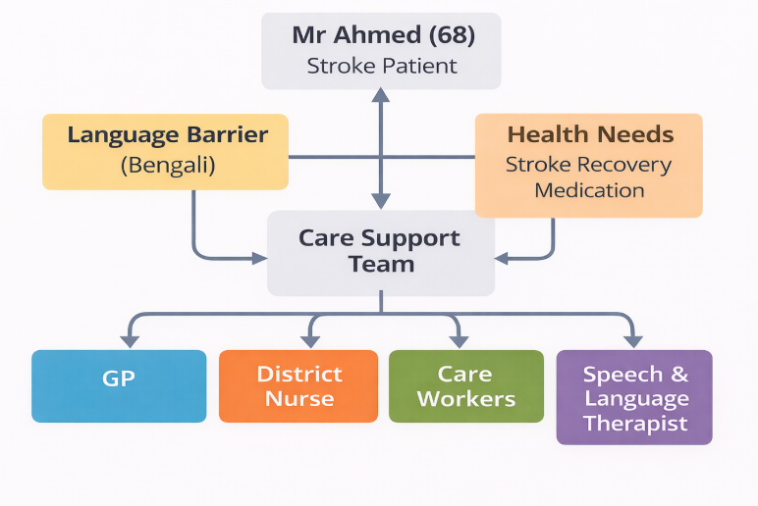
Fig. 1: Mr. Ahmed’s Care Team

Importance of Effective Communication in Mr. Ahmed’s care
It is important that effective communication is a vital aspect in providing safe and person-centred care especially in the case of Mr Ahmed given that he has language barriers and complicated health needs. Mr Ahmed speaks Bengali as his first language and though he has some knowledge of the English language, he has difficulties in complex conversations. This poses a threat of misinterpreting medical directives, and this may have adverse consequences on his recovery and safety. Healthcare professionals should change their communication strategies in order to be effective communicators. This incorporates the use of plain language, articulation and confirming the understanding using methods like repetition or teach back. Professional interpreters should be employed to achieve proper communication and not family members alone.

Equality Act 2010
The equality act 2010 is an important factor in making sure that people such as Mr Ahmed are not at a disadvantage because of language barriers. The Act encourages the equality of access to services and the need to make reasonable accommodations in order to meet the needs of an individual. In this regard, the interpreter services and culturally sensitive care would make sure that Mr Ahmed gets equitable treatment. The communication model that can be useful in this context is Shannon-Weaver Model which emphasizes the significance of a clear transmission of messages and the possibility of noise (facilitating factors) including differences in language. Language in the case of Mr Ahmed is noise, which can corrupt understanding. This barrier can be decreased by means of interpreters and visual aids, this way the communication will become more effective. It is also important in non-verbal communication. Facial expressions and gestures and visual aids can help to enhance comprehension especially to patients who had suffered a stroke and cannot talk or comprehend. Also, engaging Mr Ahmed in the decision-making process encourages dignity and respect which form important values of person-centred care. Good communication is also spread to the family members.
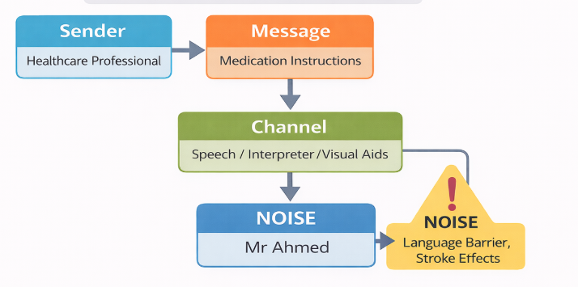
Fig.2: Communication process (Shannon Weaver model)
The role of the wife of Mr Ahmed is crucial to his care and the professionals ought to consider including her in the discussion and at the same time leave Mr Ahmed to exercise his autonomy. Effective communication among professionals and family leads to the establishment of trust and continuity of care. To conclude, communication in the case of Mr Ahmed needs to be adapted, culturally sensitive and legal. Through correct communication strategies, models, healthcare professionals are able to enhance the level of understanding, reduce risks and overall care outcomes.

Importance of Administrative and record keeping skills in Mr. Ahmed’s care
This is because safe and good care delivery requires good administrative skills and maintenance of accurate records. In the case of Mr Ahmed, the absence of a domiciliary care visit and timely medication indicates the dangers posed by ineffective documentation and lack of communication. Proper documentation should make sure that the relevant healthcare professionals that worked with Mr Ahmed can access updated information. This contains information on medication, care plans and any alteration of his condition. Continuity of care is facilitated by proper documentation which aids in avoiding errors including missed visits or wrong medication administration.
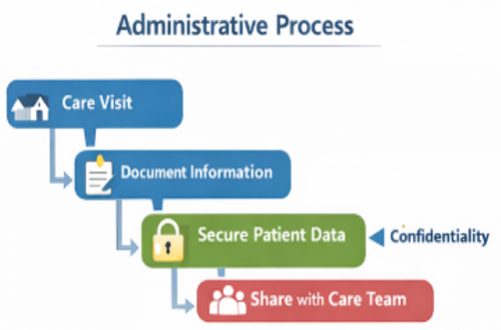
Fig. 3: Administrative Process

Data Protection Act 2018
The Data Protection Act 2018 regulates the process of managing personal data within health and social care. It demands that information must be handled legally, safely and it cannot be disclosed to unauthorised persons. In the case of Mr Ahmed, the personal and medical details of the patient should be secure and yet accessible to the concerned professionals taking care of him. Caldicott Principles also highlight the significance of confidentiality and sharing of information. These principles make sure that the information about the patients is not shared in situations that are not required and in the best interest of the patient. In the case of Mr Ahmed, it will be a matter of deciding between confidentiality and the desire to have good working communication within the multidisciplinary team.
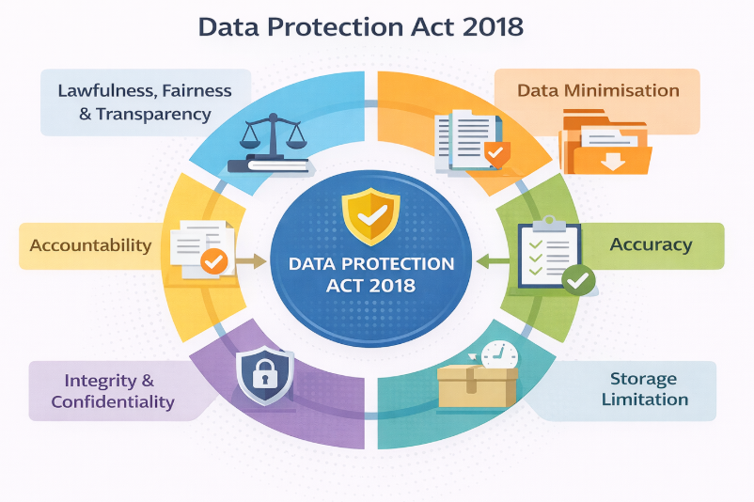
Fig. 4: Data Protection Act 2018

Record keeping may have severe implications such as medication errors, safeguarding complications and lowered quality care due to poor record keeping. The omission of visit in the case of Mr Ahmed could have been caused by lack of proper scheduling systems or lack of updating care records. This underscores proper documentation and proper administration systems. Professional guidelines like the NMC Code and the standards of CQC emphasize the need to ensure that the records are clear, accurate and timely. The healthcare providers must record care operations, report events and be accountable in their practice. Digital record systems are able to enhance efficiency and minimize mistakes through the provision of real-time updates and sharing of information. Nevertheless, the employees should also be trained to operate these systems in order to be accurate and meet the law. Conclusively, administration skills and good record keeping are essential in provision of safe and co-ordinated care to Mr Ahmed. When legal frameworks and professional standards are followed, healthcare providers are able to reduce risks and improve communication and patient outcomes.

Importance of Collaborative Working in Mr. Ahmed’s care
Teamwork is also critical in holistic and integrated care, which is particularly needed by a person with complicated needs like Mr Ahmed. His care includes several professionals this includes GP, district nurse, domiciliary care workers and a speech and language therapist. A good working relationship will make sure that every part of his care is taken care of and in a safe manner. The collaboration of agencies enables professionals to exchange information, organize their programs and offer all-inclusive guidance. The district nurse would, for instance, be overseeing Mr Ahmed on physical health whereas the speech and language therapist would handle communication and swallowing problems. Through collaborating, these professionals can create a mutualized care plan, which is responsive to the needs of Mr Ahmed. Collaboration is possible only through effective communication. Care and regular meetings, shared care plan and documentation are some of the methods that can be used to ensure that every team member is updated on the condition and care needs of Mr Ahmed. The information sharing and the enhancement of coordination can also be facilitated with the help of digital systems. Nevertheless, there may be some difficulties in the work of the multi-agency, including the breakdown of communication, the absence of roles and the lack of professional attitude. The case in Mr Ahmed where he missed a care visit might be due to inadequacy in coordination or communication of team members.
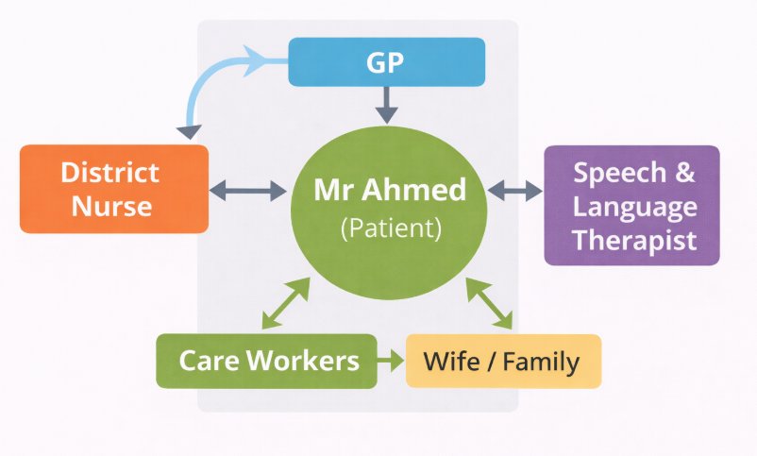
Fig. 5: Collaborative Care Team
Strategies that are necessary to overcome these challenges include identification of roles, frequent team meetings and good leadership. Developing mutual respect and understanding between the professionals is also a way to encourage teamwork and better outcome. Collaborative working should not lose focus on person-centred care. Including Mr Ahmed and his wife in the process of care planning would mean that their preferences and needs would be considered. This is an effective method that improves satisfaction and encourages improved health achievements. Overall, teamwork plays a critical role in providing Mr Ahmed with safe, quality and coordinated care. Healthcare professionals are able to enhance the quality of care that they provide by managing issues and encouraging collaboration.

Conclusion
It is important to emphasise the pivotal role of effective communication, good administration practices and working together in health and social care as it is evident in the case of Mr Ahmed. Communication is essential in the system of breaking the language barrier and the need to make Mr Ahmed comprehend his treatment and care. Person centred and inclusive communication is backed by such legal frameworks as Equality Act 2010. Proper record keeping and administrative act are also essential in ensuring proper and safe care. The missed care visit indicates the risks that can be posed by inadequate documentation and coordination. The professional standards and the Data Protection Act 2018 guarantee accountability and confidentiality. Lastly, professional working is crucial in holistic care provision by healthcare professionals. Through collaborative efforts in overcoming problems, the professionals could make sure that Mr Ahmed is provided with high-quality and regular assistance. On the whole, these three elements are crucial to enhancing patient outcomes and safe care delivery.

References

- Department of Health (2018) Data Protection Act 2018.
- Equality Act (2010) UK Government Legislation.
- Nursing and Midwifery Council (2018) The Code.
- Care Quality Commission (2021) Fundamental Standards.
- Shannon, C. and Weaver, W. (1949) The Mathematical Theory of Communication.
- Glasby, J. and Dickinson, H. (2014) Partnership Working in Health and Social Care.

