Gower College Tycoch

Programme:
Electrical and Electronic Engineering

Final Report
Assessment Component 2

Group Project:
Smart White Cane Prototype

Lecturer:
Lintao Zhang

Student:
Jairo Fabricio David Sanchez

Date:
25/05/2026

Table of Contents

- Introduction | 3
- Updated Research and Design Rationale | 4
- Hardware Component Specifications | 4
2.2 System Design and Circuit Mechanics | 4
2.3 Power Distribution and System Operation | 5
2.4 Parallel Motor System and H-Bridge Driver | 6
- Final Design and Collaborative Hardware Integration | 6
3.1 Structural Modification of the Cane | 6
3.2 External Enclosure Final Assembly | 6
3.3 Wiring and Power Integration | 6
3.4 Internal Component Distribution | 7
3.5 Vibration System Integration | 7
- Evaluation | 7
4.1 Vibration Energy Loss | 8
4.2 Large Hardware Size | 8
4.3 Fixed Sensor Position | 8
4.4 Mechanical Stress Problems | 8
- Cost Summary | 8
- Recommendations | 9
6.1 Smaller Sensors | 9
6.2 Custom PCB Design | 9
6.3 Improved Vibration Feedback | 9
6.4 Better Battery Design | 9
- Conclusion | 10
- Journal Reflection (Gibbs Reflective Cycle) | 10
- References | 11-12
- Appendix | 13-14
10.1 Project Development Journal | 15-16
10.2 Prototype Development Photographs | 17-21
10.3 Online Meetings Recordings Gantt Chart | 22

- Introduction

An important step toward improving the safety and independence of blind and visually impaired individuals is the creation of Electronic Travel Aids (ETAs) (Cardillo and Caddemi, 2019). The conventional white canes can detect ground level obstacles through tactile feedback; however, they cannot effectively identify overhead or suspended objects that may create risks for the user (Yao et al., 2025).

Therefore, the following report presents the development and hardware evaluation of a smart white cane prototype, proposed and designed to improve obstacle detection and give the user awareness. For this, the design of the system combines ultrasonic sensors, an Arduino Nano microcontroller, and a vibrotactile feedback system using ERM vibration motors controlled through an H-bridge driver (Choi and Kuchenbecker, 2013).

In addition, this report discusses the hardware architecture, power distribution system, structural integration, and the main limitations identified during testing, to finally, several recommendations for future improvements are proposed to develop a more compact and reliable assistive device (Hersh and Johnson, 2018).

- Updated Research and Design Rationale
2.1 Hardware Component Specifications and Definitions
The following table presents the Bill of Materials (BOM) and explains the function of each component in the hardware system; each component used in the component is identified by its technical name and primary working characteristics.

Table 1.

2.3 Power Distribution and System Operation
The prototype uses a centralized power system supplied by portable power bank which converts the battery voltage into a stable 5 V DC output to power the electronic components. The positive voltage line passes through the metal switch, which works as the main ON/OFF control for the entire circuit. The negative line is connected as the common ground shared by all components in the system.
To verify the 24-hour operating time observed during laboratory testing, the system power consumption was analysed mathematically, and the total current consumption of the system is calculated by, adding the current used by the microcontroller, sensors, and vibration motors, that consume variable current because they operate using PWM control signals generated by the Arduino Nano (Arduino, 2026; Kazi, Limu and Md., Rakibuzzaman, 2023).
The system current consumption was divided into different electronic components:
- Microcontroller current: IMCU = 19 mA
- Ultrasonic sensors current: Isensor = 30 mA
- H-Bridge driver current: Idriver = 10 mA
- LED switch current: ILED = 15 mA
The vibration motors use the highest amount of current in the system. The prototype uses five ERM vibration motors connected in parallel.
According to Kirchhoff’s Current Law, the total current in a parallel circuit is equal to the sum of the current in each branc, for this each vibration motor consumes approximately 80 mA at 5 V.
Therefore, the maximum motor current is:
$$I_{motors_max}=5×80 mA=400 mA$$
During normal operation, the motors do not work continuously. The system uses a duty cycle of 15%, meaning the motors are active only part of the time during obstacle detection.
The total average current consumption of the system is calculated as:
$$I_{total}=19 mA+30 mA+10 mA+15 mA+(0.15×400 mA)=134 mA$$
To obtain an estimate of the real battery runtime, the efficiency of the DC-DC converter must be considered and the power bank has a nominal capacity of 10,000 mAh and an efficiency of 85%.
The effective battery capacity is calculated as:
$$C_{effective}=\frac{\left(10000 mAh × 3.7 V × 0.85\right)}{5.0 V}=6290 mAh$$
Finally, the theoretical operating time of the prototype is:
$$T=\frac{6290 mAh}{134 mA}≈46.94 hours$$
This result shows that the 10,000 mAh power bank can provide more than 24 hours of operation.
The system has enough energy capacity to maintain stable performance even when the vibration motors are activated for long periods during obstacle detection and navigation.
2.4 Parallel Motor System and H-Bridge Driver
The tactile feedback system uses one H-bridge driver to control the five ERM vibration motors at the same time, and all of them are connected in parallel to the same output terminals of the driver (Arduino, 2026; Choi and Kuchenbecker, 2013).
This means that all motors receive the same voltage:
$$Vmotor1=Vmotor2=Vmotor3=Vmotor4=Vmotor5$$
One advantage of this design is its simplicity, since a single and small driver can power all the motors together without overloading the Arduino output pins, the Arduino sends a PWM signal, the H-bridge allows current to flow through the motors, causing them to vibrate and provide tactile feedback to the user. However, this design also has an important limitation, since all motors are connected together, the system cannot control each motor separately, and as a result, all motors vibrate at the same time, no matter if the obstacle is above or below the user, which means the user cannot know the exact location of the obstacle only through vibration (Choi and Kuchenbecker, 2013).

- Final Design and Collaborative Hardware integration (Details)

3.1 Structural modification of the cane
Upon obtaining the components, the original cane was excessively narrow and slender; the primary objective was to conceal all components to integrate the electronics while preserving the cane's weight distribution. The battery was overly large, so the frame could not accommodate the components handle of the cane was severed to create space. A drill was subsequently employed to create inside openings and accommodate the battery box and components box.

3.2 External Enclosure Final Assembly
Prioritizing the placement of the battery box and electrical component box allowed for the cane to remain balanced; the 10,000 mAh battery was housed in the specially designed 3D printed batery enclosure or holder, and an external electrical junction box with safety IP55 protection (London Electrical Distributors, 2026). The cane framework was fastened to the boxes with a high-tensile exterior glue that is resistant to mechanical shocks and temperature changes.

3.3 Wiring and Power Integration
The electrical connections began with the power system integration, the open push button was permanently installed on the external enclosure, the USB Type-B cable was shortened to fit the available internal space, and the wire ends were reconnected using tin soldering, the positive wire coming from the battery was connected to one terminal of the push button, while the second terminal was connected to the Arduino Nano power input pin. this configuration allowed the button to operate as a standard ON/OFF switch by opening and closing the electrical circuit.

3.4 Internal Component Distribution
Inside the outdoor electrical enclosure, the Arduino Nano, the two electronic controller modules belonging to the ultrasonic car sensors, and the H-Bridge driver responsible for motor power control were physically arranged and fixed in position, and the push button remained externally accessible for user interaction.

3.5 Vibration System Integration
The positive and negative wires from the H-Bridge driver were routed to the upper handle section of the cane, where the ERM micro vibration motors were installed to provide haptic feedback during obstacle detection.

Due to budget limitations, only one H-Bridge driver module was available, for this reason both motors were electrically connected in parallel to the same driver output so that simultaneous vibration feedback could be generated during system activation.

- Evaluation

  - Vibration Energy Loss
During testing, it was discovered that the tactile feedback is not very good. The aluminium cane is lightweight and strong, but it does not transfer vibrations very well. The ERM motors are not securely fastened inside the cane, so part of the vibration energy is lost as sound instead of being felt by the user. As a result, there is a buzzing sound, which can be particularly distracting in noisy outdoor settings where the user might miss the vibration warnings.

4.2 Large Hardware Size
Due to the following, the present prototype is both heavier and larger than intended:
- The ultrasonic sensors are big sensors used in automobiles.
- It will need an additional processing board for every sensor.
- The connection box and external batteries increase the overall weight, and over time, this causes more weariness in the wrists.

  - Fixed Sensor Position
The upper sensor is fixed at about 35° to detect obstacles above the user, while the lower sensor detects ground obstacles. However, the user may hold the cane at different angles while walking, If the angle changes too much, the sensors may not detect obstacles correctly, finally it can cause false alarms or missed obstacles.

4.4 Mechanical Stress Problems
The cane combines aluminium, adhesive material, and plastic parts together, if the cane hits the ground repeatedly, shocks travel through the structure. Over time, this may damage the adhesive and weaken the connection between the cane and the electronics box. Eventually, the enclosure may lose its waterproof protection or separate from the cane.

- Cost Summary

Bill of Materials (BOM)
Item | Model / Specification | Function | Justification | Qty | Price (Each) | Link
Arduino Nano | ATmega328P | Central controller | Small, low-power, and easy to program. | 1 | £14.32 | Amazon
Vibration Motors | 3V, 44000rpm | Spins rapidly to create vibrations | Small, compact, and cheap. | 1 | £9.32 | Amazon
Driver Board | DRV2605L | Controls speed and power of motors | Allows better distance detection via motors. | 1 | £6.99 | Amazon
Sensors | JSN-SR04T | Detects distances | Comes waterproofed, relatively cheap, and reliable. | 2 | £8.99 | Amazon
Battery | 10000mAh | Powers components/ devices | Rechargeable and stores large charge. | 1 | £12.49 | Amazon
Button | 4 Pin DC 5V SPDT | Allows/ stops flow of electricity. | Cheap, simple, allows power saving. | 1 | £7.49 | Amazon
Cane | Telescopic Blind Stick | Assists the blind with navigation | Provides a solid base to build off. | 1 | £17.19 | Amazon
Reflective Material | 1cm x 8000cm Red Reflective Tape | Reflects lights in a noticeable manner | Passive, cheap, easy to apply. | 1 | £1.49 | Amazon
 |  |  |  |  | £87.27

The project was developed using low-cost commercially available electronic components to remain within the planned budget, the existing tools and materials were also reused during the construction process to reduce manufacturing costs. Despite some hardware limitations, the final prototype was completed successfully within the expected development schedule.

- Recommendations

  - Smaller Sensors
The large ultrasonic sensors should be replaced with smaller ToF laser sensors, which are smaller, lighter, and include internal signal processing, this modification can improve the portability and overall ergonomics of the prototype.

6.2 Custom PCB Design
The Arduino Nano, H bridge, and sensor circuits should be combined into one custom PCB board. This would reduce the system size and improve the internal organisation of the electronic components inside the cane structure (Gibson et al., 2020).

6.3 Improved Vibration Feedback
The vibration motors should be placed inside a custom ergonomic handle with tighter mounting, and the motors should also be separated into different groups to provide directional feedback:
- Upper motors for overhead obstacles.
- Lower motors for ground obstacles.
- This would improve users navigation.
  - Better Battery Design
The large external power bank should be replaced with a smaller Li-Po battery (Kazi et al., 2023)., to fit inside the cane, making the device lighter and easier to use

- Conclusion
The smart white cane prototype effectively demonstrated the implementation of integrated electronics, obstacle detection sensors, and vibrotactile feedback into an assistive mobility aid for individuals with visual impairments, the system identifies and delivers sensory notifications via vibration motors, confirming the technical viability of the concept.
Additionally, it offered a significant practical expertise in hardware integration, circuit design, structural modification, and testing methodologies, it was a meaningful professional learning as a team, as it gave us the opportunity in embedded systems engineering and assistive technology development collaboratively.

- Journal Reflection (Gibbs Reflective Cycle)
During this project I learned a lot of technical and professional skills on embedded systems, hardware integration and teamwork. The main goal at the beginning of the project was to create a smart white cane prototype which can help visually impaired users to detect obstacles by means of sensors and vibration feedback.
One of the biggest challenges was in the virtual simulation stage in Tinkercad. I had some short circuits at first because of wrong mixture of different voltage sources in motor driver circuit, This was frustrating at first, as the system kept on failing. However, on studying the pin configuration of the driver chip and analysing the electrical connections carefully, I managed to solve the problem successfully. This experience broadened my understanding of how power is dispersed, grounded and protected with a circuit.
The physical modification and integration of the cane was another important learning experience. Much smaller than expected was the internal space of the cane and many components did not fit inside, as a team we discussed different possible solutions and decided to use external boxes and a custom 3D printed battery holder and the design improved greatly.
Overall, I believe the project showed promising results, as the prototype was able to detect the obstacles and trigger the vibration system properly, the project taught me the importance of testing, planning, component selection and mechanical design in real engineering context.
For future projects I would pay more attention to miniaturisation and internal organization of the hardware components in order to create a more compact and ergonomic design, this project increased my confidence in practical engineering work and showed me how technical challenges can be solved through research, testing, and teamwork.

- References
Arduino (2026) Arduino® Nano, ARDUINO DOCS. Available at: https://docs.arduino.cc/resources/datasheets/A000005-datasheet.pdf (Accessed: 22 May 2026).
Cardillo, E. and Caddemi, A. (2019) ‘Insight on Electronic Travel Aids for Visually Impaired People: A Review on the Electromagnetic Technology’, Electronics, 8(11), p. 1281. doi: https://doi.org/10.3390/electronics8111281.
Choi, S. and Kuchenbecker, K.J. (2013) ‘Vibrotactile Display: Perception, Technology, and Applications’, Proceedings of the IEEE, 101(9), pp. 2093–2104. doi: https://doi.org/10.1109/jproc.2012.2221071.
ElecFreaks (2026) Ultrasonic Ranging Module HC -SR04, https://cdn.sparkfun.com/datasheets/Sensors/Proximity/HCSR04.pdf, p. 3 Available at: https://cdn.sparkfun.com (Accessed: 24 May 2026).
Gibson, I. et al. (2020) ‘Design for Additive Manufacturing’, Additive Manufacturing Technologies, 4(2), pp. 555–607. doi:https://doi.org/10.1007/978-3-030-56127-7_19.
Hersh, M.A. and Johnson, M.A. (2008) Assistive Technology for Visually Impaired and Blind People. London: Springer London doi: https://doi.org/10.1007/978-1-84628-867-8.
Kazi, W., Limu, T.J and Md Rakibuzzaman (2023) ‘Smart Cane: A Low-Cost Assistive Device for the Visually Impaired’, EAI Endorsed Transactions on Internet of Things, 8(4), p. e5 doi: https://doi.org/10.4108/eetiot.v8i4.1707.
London Electrical Distributors (2026) IP Rating Chart UK - Complete IEC 60529 Guide, Londonelectricaldistributors.co.uk Available at: https://londonelectricaldistributors.co.uk/tools/ip-rating-guide (Accessed: 24 May 2026).
meganburroughs (2021) AB-003: Driving Linear Resonance Vibration Actuators - Precision Microdrives, Precision Microdrives. Available at: https://www.precisionmicrodrives.com/ab-003?utm_source (Accessed: 24 May 2026).
Mustufa Haider Abidi et al. (2024) ‘A Comprehensive Review of Navigation Systems for Visually Impaired Individuals’, Heliyon, 10(11), pp e31825–e31825. doi: https://doi.org/10.1016/j.heliyon.2024.e31825.
Panazan, C.-E. and Dulf, E.-H. (2024) ‘Intelligent Cane for Assisting the Visually Impaired’, Technologies, 12(6), p 75. doi: https://doi.org/10.3390/technologies12060075.
Standford University (2016) Arduino: a technical reference: a handbook for technicians, engineers, and makers in SearchWorks catalog, Stanford.edu. Available at: https://searchworks.stanford.edu/view/13211639.
Tinkercad (2019) Tinkercad, Tinkercad. Available at: https://www.tinkercad.com/.
Yao, F., Zhou, W. and Hu, H (2025) A Review of Vision-Based Assistive Systems for Visually Impaired People: Technologies, Applications, and Future Directions, p. 16.

- Appendix

  - Prototype Development Journal

Research and Planning

1.1 Brainstorming and Project Evaluation
The idea started in a Project class. Our lecturers told us to make a project that would benefit society and test our skills from previous class. The project idea was brainstormed and decided by the team independently. To create a smart white cane prototype capable of helping visually impaired users detect obstacles through sensors and vibration feedback. The plan has been reviewed and supported by the teachers. Then the BOM was made for the purchase of the components.

1.2 Developing the First Components
A Tinkercad account was created to create a virtual electronic prototype and test the project idea. Several parts of the simulator were tested, but they were not the same as the final prototype. Tinkercad had only Arduino UNO, HC-SR04 ultrasonic sensors and DC motors. The simulator used a 16-pin motor control chip instead of a commercial H-Driver module. For the hardware, they chose an Arduino Nano, 10,000 mAh battery, two automotive proximity sensors with controller modules, ERM vibration micromotors, H-Driver motor module, and a normally open push button.

Virtual Simulation, Circuit Verification

2.1 Design Tinkercad prototypes
The original prototype used a 9-volt battery for the motors and simulator electricity straight to the Arduino. The 16-pin control chip kept shorting out because the battery’s direct current (DC) voltage was being mixed with the Arduino power source and causing all sorts of problems.

2.2 Troubleshooting Short Circuits
The voltage, operation, and ground ( GND ) connections had to be checked on each of the 16 pins of the chip to find the short circuits . It was also important to learn how to connect the battery to the breadboard to be able to power components. Once we corrected the pin connections, the prototype worked with the battery and the simulator at the same time. At this point the switch was added to the virtual design.

Circuit Simplification and Structural modification of Cane

After repairing the circuit, the teacher saw the prototype. He had a simpler idea that did away with the 9-volt battery to power the actual system. The team investigated this criticism and agreed to remove the battery to optimise the design.
The circuit was built in a new Tinkercad workspace from scratch. The second prototype powered all components from the simulator’s Arduino source, emulating the real system’s single power input.
This simplified the design and removed voltage conflicts on the first prototype. The second prototype showed that the project idea worked. The hardware operation was validated by a simple baseline code.

External Enclosure and Mechanical Integration

Internal Space Restrictions
When the physical parts finally arrived the first cane was way too narrow and had no room inside. The design called for all the parts to be contained within the cane, to keep it neat and light. “The battery was too big so the parts did not fit into the cane.

Modification of Mechanical Cane and Installation of External Casing
When the physical pieces arrived, the cane was too narrow and there was no space inside. The battery was too big. All the components were supposed to fit inside the cane and make for a clean, balanced design.
To remedy this the top of the cane was cut off near the handle. Holes and openings were drilled into the interior for the battery box and the components box.

Wiring and Initial Internal Hardware Integration

Power System and Internal Layout of Components
The first true electrical hookups were in the power system. A typically open push button was added on the external box and the USB Type-B cable shortened and soldered to fit. The battery was wired to the push button and Arduino Nano power input to create a system on/off switch.
The push button was accessible from the outside and the Arduino Nano, two automobile sensor controller modules and H-Driver motor module were fixed inside the electrical box.

Integration of Vibration
The H-Driver positive and negative wires were connected to the top of the cane, where ERM vibration motors provided input when an impediment was detected. Because of budget limitations we only had a single H-Driver module, so both motors were wired in parallel to the same driver output to vibrate simultaneously.

Final Validation and Evaluation

Power Tests
Before the final program was used, several tests were run to make sure that the physical connections were working. I verified that the Arduino turned on when the switch was pressed by connecting the 10,000 mAh battery to the Arduino Nano with the modified USB Type-B cable and soldered push button.

Validation of Sensors
Hardware testing was performed with a simple base code from a software teammate. The two automobile sensors and controller modules were directly connected to the Arduino Nano to test their power and obstruction recognition.

Test of Vibration and Actuator
Finally, the alert system was tested in isolation. The motors were wired in parallel and the H-Driver was hooked up to the Arduino Nano. The test base code confirmed the connections worked and the micromotors vibrated the cane handle confirming the hardware system.

Final Stage

Rehearsals
Prototype demonstrations
Final Project Presentation
Final Report

  - Prototype Development Photographs

Figure A1. Initial Arduino and Sensor Layout and motors
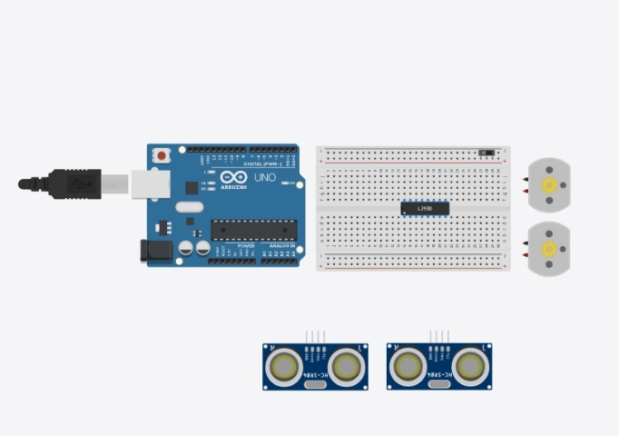

Source: Authors’ own word (2026)

Figure A2. Early Circuit Validation and Wiring Development
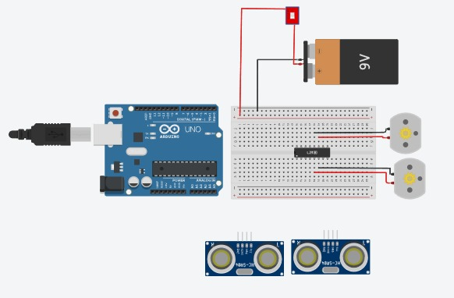

Source: Authors’ own word (2026)
Figure A3. Circuit Troubleshooting and Pin Verification
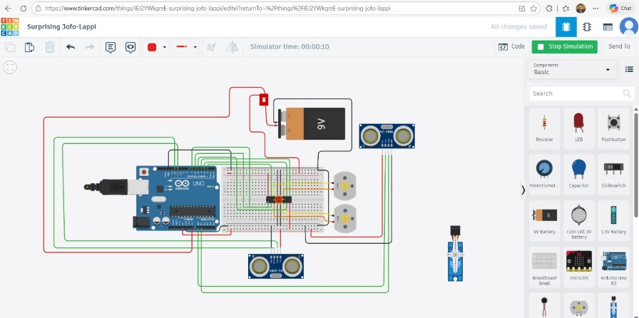
Source: Authors’ own word (2026)
Figure A4. First Complete Tinkercad Prototype with Battery Integration
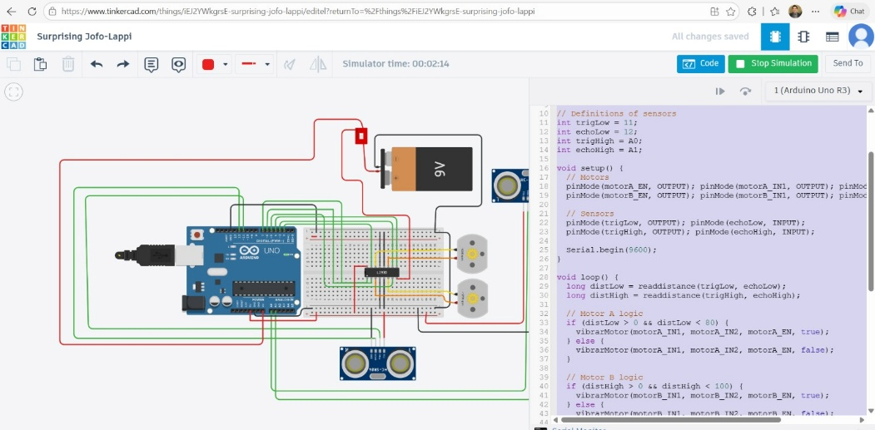
Source: Authors’ own word (2026)

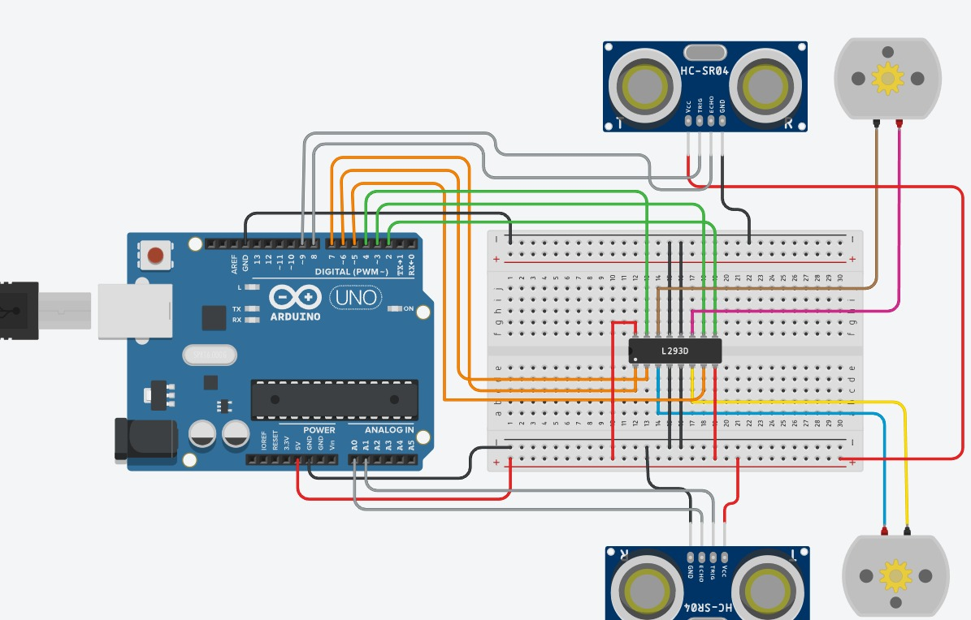
Figure A5. Validated Tinkercad Simulation Before Hardware Construction

Source: Authors’ own word (2026)

  - Hardware Construction
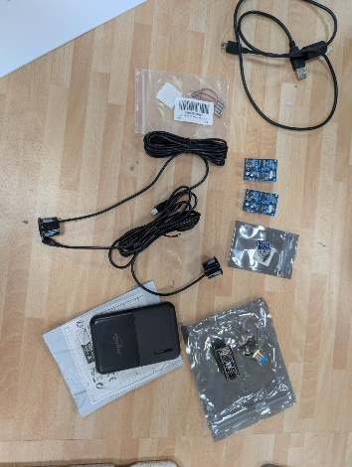
Figure A1. Electronic Components and Initial Hardware Preparation

Source: Group project work (2026).
Figure A2. Mechanical Modification of the Cane Structure
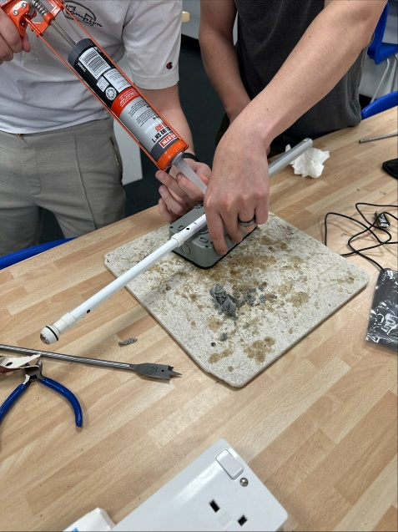

Source: Group project work (2026).

Figure A3. Initial External Enclosure Integration
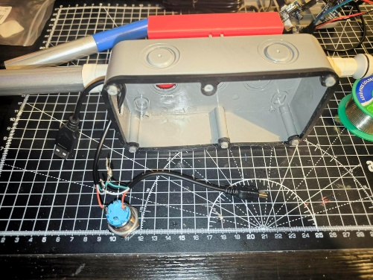

Source: Group project work (2026).
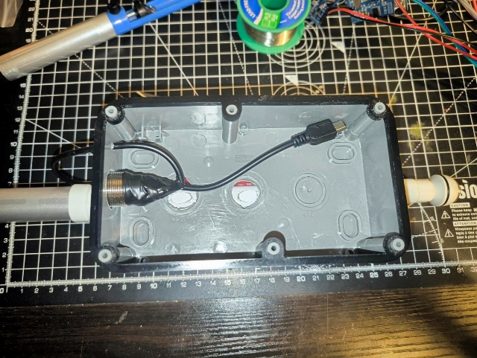
Figure A4. Internal Wiring and Component Installation

Source: Group project work (2026).

Figure A5. Custom 3D-Printed Battery Enclosure
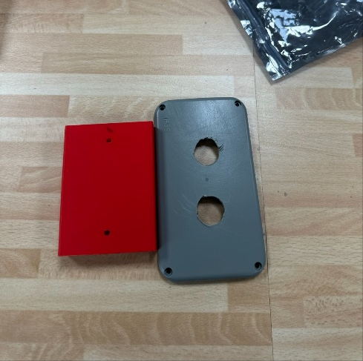

Source: Group project work (2026).

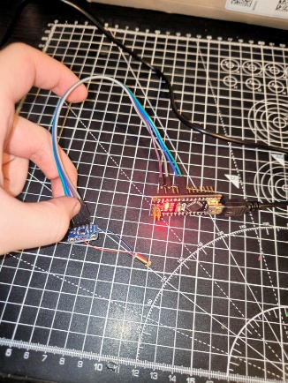
Figure A6. Preliminary Circuit Testing and LED Validation

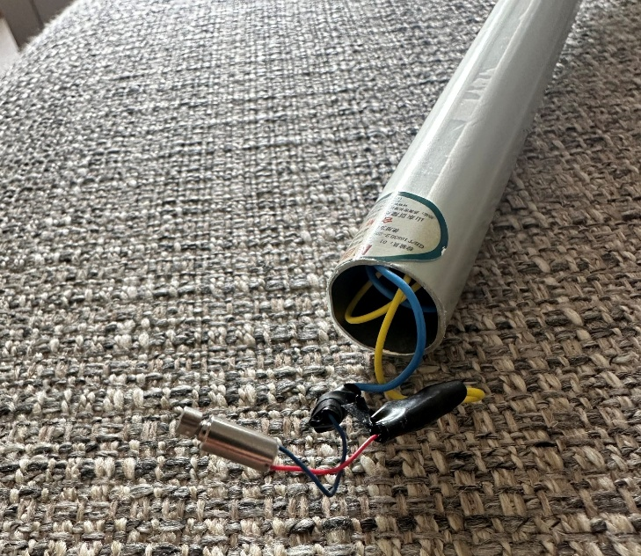
Figure A7. Internal Cable Routing and Vibration Motor Wiring

Source: Group project work (2026).

Figure A8. External Hardware Assembly and Structural Integration
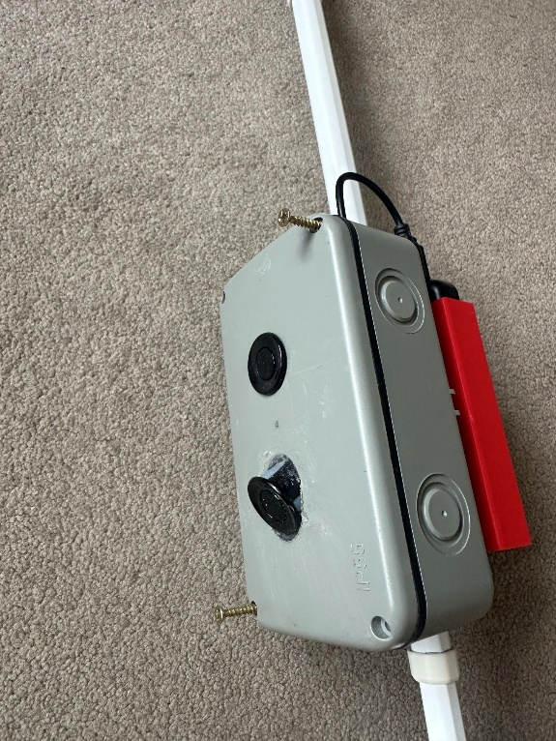

Source: Group project work (2026).

Figure A9. Installation of the External Battery System
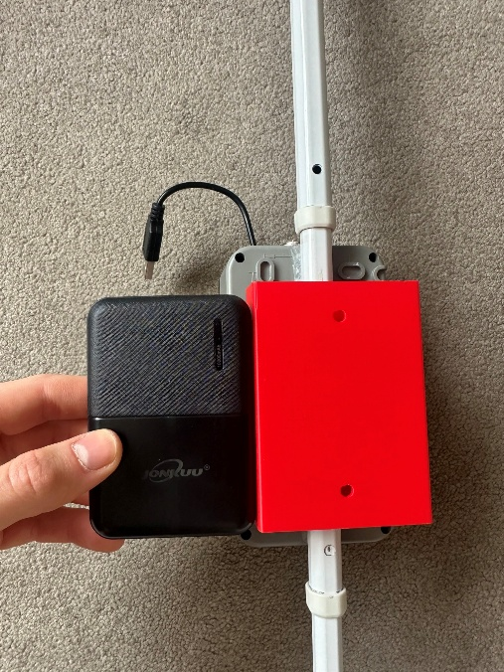

Source: Group project work (2026).

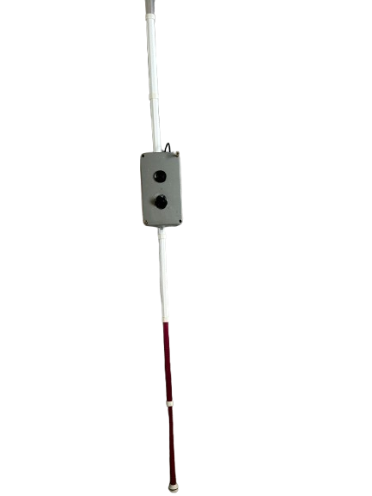
Figure 10. Final Smart White Cane Prototype

Source: Group project work (2026).

10.3 Online Meetings Recordings and



