Essential Academic and Employment Skills
Ethan Anderson

I. MOTIVATION

Motivation is concerned with goal-based behaviour [1]. The ability to motivate and discipline one’s self builds a stable foundation for which any further academic and professional skills can be built upon. It is acknowledged by Ramadanty and Martinus that “every company is not just expecting employees who are able, competent, and skilled in their work, but the most important is their eagerness to work hard and achieve optimal result” [2]. It is, therefore, crucial for anyone who wishes to exceed in a professional environment to possess a source of independent motivation.

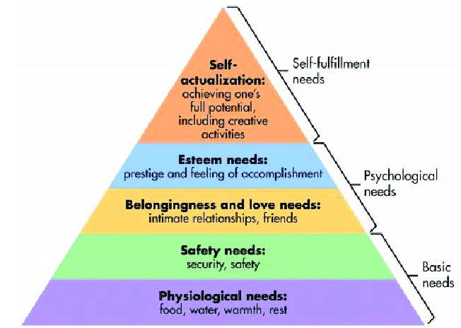
For students and academia it is motivation which is the primary driver of academic proficiency and success, to which other essential skills can be developed and refined. Tohidi and Jabbari discuss the concept of motivation forming the foundation for the development of other essential skills [3] and how students cannot expect to enhance other behaviours without a source of intrinsic motivation “driven by an interest or enjoyment in the task itself” [3]. The importance of a source of intrinsic motivation is illustrated in Figure 1. [4].

Figure 1: Maslow's hierarchy of needs [4]

II. SELF-DISCIPLINE

Self-discipline builds the framework through which one can channel a foundation of intrinsic motivation into actions which progress academic and professional performance [5]. In an academic context in particular, the utilisation of strong self-discipline to evenly distribute the allocation of time and effort to set tasks is crucial to reduce the compaction of workload into narrow, intense and often ineffective periods of study.

References

[1] | P. Gorman, in Motivation and Emotion, London, Routledge, 2004, p. 1.
[2] | S. Ramadanty and H. Martinus, "Organizational Communication: Communication and Motivation in The Workplace," HUMANIORA, vol. 7, no. 1, 2016.
[3] | H. Tohidi and J. M. Mohammad, "The effects of motivation in education," Procedia - Social and Behavioral Sciences, vol. 31, pp. 820-824, 2012.
[4] | Z. Parincu, "Berkely Well-Being Institute," [Online]. Available: https://www.berkeleywellbeing.com/self-discipline.html. [Accessed 04 11 2022].
[5] | M. Haque, B. Z. Zulkifli, S. Haque and Z. Kamal, "Professionalism Perspectives Among Medical Students Of A Novel Medical Graduate School In Malaysia," in Chinese University Medical Education Conference 2018, Hong Kong, 2013.

