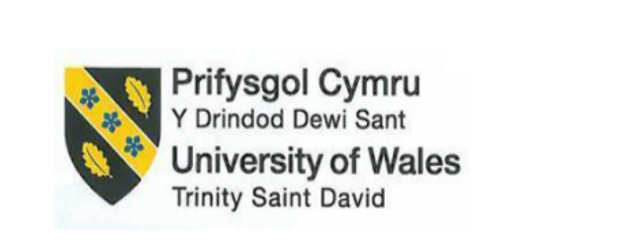
BA INTERNATIONAL HOTEL MANAGEMENT
LEVEL 5
Foreign Languages and Cultural Awareness
BMIH5003
Lecturer name: Giulia Chifari, Antoinette Milne
Student name : Constantin Dragos Nenciu
Word count: 2009

Portfolio 4 Components

Table of Contents
Component 1- Professional Reflection 3
Component 2- Training Plan 4
Component 3- Student Self-Reflection 5
Component 4- Training Presentation 7
References 10

Component 1- Professional Reflection
Scenario
I am an F&B employee at Kraft Heinz food and beverage restaurant which is located in the United Kingdom. When I am busy serving breakfast to my customers, a Japanese customer comes in and asks for a cup of coffee. Refilling each other's cups is customary in Japanese culture and it acts as a show of courtesy and consideration (Pramudibyanto, 2023). On the other hand, it is customary in Western culture and it is also particularly in crowded settings in restaurants. The patrons have the responsibility to provide help themselves so that they can serve food and it is also the responsibility of servers so that they can provide new cups upon request.
Explanation of Cultural Misunderstanding
As I am a serving employee at Kraft Heinz which is a food and beverage company in the United Kingdom, I might not be conscious about the differences between various cultures of different countries. I notice the gesture of the customer they are leaving their cup empty when I am serving them to the other tables and it is an indication of displeasure or rudeness. On the other hand, if I do not aggressively refill their cup as they would anticipate in their cultural context and as a result of this the guest can feel overlooked or undervalued.
Thinking Back on Capability and Behavioural Shifts
After facing such cultural misunderstandings, I need to become more sensitive to and competent in other cultures so that I can be able to avoid miscommunications in terms of these in the future. I also need to think about the following abilities and behavioural adjustments:
Cultural Awareness: I need to focus on learning about various cultures and also should familiarise myself with the customs of many cultures. I need to focus particularly on those cultures that I mostly pertain to handling the clients I serve. I have decided to take a three-month course regarding various cultures of different countries so that I can learn more about various cultures. After knowing all cultures I can give equal respect to all cultures. I can learn about various cultures with the help of reading about different cultures, going to cultural training programmes as well as making an effort by which I can comprehend the viewpoints of individuals from different origins.
Communication Skills: An F&B employee needs to have effective communication skills by which he can interact with various customers (ARICA and Sabbağ, 2020). As I am a server at a hotel restaurant, I need to learn more effective communication skills so that I can speak with visitors, particularly in the moment when there is a language barrier. I also need to put in an effort so that I can learn more languages and make a clear community. It can be helpful to bridge the gap and demonstrate respect for their culture so that I can learn some simple phrases in the languages that my guests frequently speak terms as “May I refill your coffee?” in Japanese. After improving my communication skills I can be polite and communicate with others in a very soft tone.
Observation and Adaptation: Observation and adaptation an essential skills that are required to understand the requirements of guests (Mitsea et al., 2021). I also need to develop my observation and adaptation power so that I can easily understand the preferences and requirements of visitors. I also should be alert to their cues in terms of body language and gestures.

Component 2- Training Plan
The purpose of creating a training plan is to give all hotel employees especially those who have the role and responsibility in food and beverage in terms of maintaining cultural competence and awareness. These are required for the provision of serving guidance to guests from a variety of backgrounds with ease as well as the employees can avoid cultural misunderstanding.
Components of the Training Plan
There are various components by which the employees can learn about various cultures and can make interactions easily are given below:
Sessions for Cultural Awareness
The F&B employees should provide a session of interactive workshops regarding cultural awareness so that the company can teach its staff members about various habits as well as norms regarding various cultures (Christiansen et al., 2020). The company also needs to emphasize those particular issues that are relevant to the clients of the hotel. The employees also should get easy access to various resources in terms of case studies, online videos and articles so that they can get benefits from these resources by which they can better comprehend cultural differences (Maheshkar and Sharma, 2018). The organisation also needs to focus on the creation of a welcoming learning environment so that it can promote candid conventions and inquiries.
Intercultural Communication Competence (ICC) Model: A strong emphasis can be placed by this model on the capacity by which people can engage and communicate with other people who have various cultures (Munezane, 2021). Intercultural communication competence can be developed in employees through components of training plans by which cultural sensitivity, improvement of communication skills as well as enhancement of the need for empathy and respect can be done.
Bennett's Developmental Model of Intercultural Sensitivity: The stages by which people can go through because they become interculturally competent and these can be described by this model (Lou and Bosley, 2023). There are various activities and conversations by which the progression of staff members can be assisted and it also takes part in the development of staff members. Cultural sensitivity and acceptance of the staff members can be increased with the help of this model.
Hofsted's Cultural Dimensions Theory: Six cultural dimensions are included in this theory (Escandon-Barbosa et al., 2022). The cultural dimensions are power distance and individualism vs collectivism and behaviour across cultural boundaries can be impacted by this.
Enhance Communication Skills
The staff members of Kraft Heinz should provide language instruction or materials so that the staff members can pick up the fundamentals in languages that visitors frequently speak. The staff members should be engaged in effective communication with the help of using various strategies in terms of clear verbal and nonverbal communication, active listening as well as clear communication. The staff members also need to practice proper reactions through role-playing scenarios which take place in making duplicate interactions with guests from various cultural backgrounds.
Exercises in Monitoring and Modification
The F&B employees who are well-trained need to be aware of cues and behaviours in terms of body language and gestures so that the employees can better comprehend the preferences and requirements of the visitors (Ngoepe, 2021). They also should provide advice on the methods of modification of services and styles focusing on cultural variances while upholding professionalism and standards of excellence. The company can utilise case studies and real-world examples by which they can highlight the importance of making adjustments to guest interactions to cultural variations.
Stress the Value of Empathy and Respect
The employees face stress when they interact with guests irrespective of their cultural background. As a result, the employees can understand the value of empathy and respect. The employees should include talks and activities by which they can go into the idea of empathy and the importance of providing outstanding services to the customers (Abramson and Moran, 2018). They should learn the importance of empathic behaviour and it plays an essential role in the improvement of guest experiences as well as reduced cultural differences.
Implementation and Evaluation
After learning various components of employee training, I can understand the methods of implementing my skills. As an employee of Kraft Heinz, I need to use a combination of in-person instruction, online courses as well as continuous reinforcement exercises by which I can carry out the training strategy. The efficiency of training should be assessed by using pre- and post-training questionnaires, comments from visitors as well as observations of staff performance. I also need to review and adapt the training programme regularly so that I can take into account new cultural trends and employees and input from visitors.

Component 3- Student Self-Reflection
Self-reflection is performed by using the Gibbs Reflective model.
Description
When starting my job as an F&B employee in the hotel Kraft Heinz, I did not know more about cultural sensitivity in the hospitality sector. The value of offering excellent services needs to be understood by visitors who come from various backgrounds and have different cultures (Tien et al., 2021). I did not have any knowledge or idea of how to treat a guest from different cultures and how to provide polite gestures to the guests. I did not even know the complexity of cultural variations, their importance and the methods by which interactions with other customers can be affected. Sometimes, I need to handle guests from China, Japan, and Spain and all have different cultures, customs and expectations about hospitality services.
Feeling
As soon as time passed, I saw various instances in the hospitality sector because various experiences have grown. I saw how cultural disparity had a huge impact on the impressions and experiences of the visitors. When I joined my job as a F&B employee at Kraft Heinz, I was not sure about my ability and I was nervous about my successful negotiation of these cultural differences. For example, sometimes, I need to handle such situations when I directly touch a plate of customers and it is a violation of cultural norms and I am unable to do so. I unintentionally violate cultural norms and it can have a direct impact on my service.
Evaluation
As time went on, I came to understand that there is an essential role of cultural sensibility as it takes part in delivering great hospital services and it also has a nice-to-have ability. After sometimes later, it was discovered by me that ignoring cultural differences can cause miscommunication, discontent as well and bad evaluations. For example, I have no idea about the negative impact of the ignorance of cultural norms and it can have a direct impact on the feelings of guests and they can feel uncomfortable or dissatisfied with the experiences.
Analysis
A variety of situations in terms of serving visitors from a wide range of cultural backgrounds and seeing cultural misunderstandings among coworkers are essential (Koc and Ayyildiz, 2021). One example which is remember was when I was clearing the table and then I unintentionally touched a plate of an Indian guest and he saw it as an offence. In that moment as a result of this encounter, I have recognised the importance of observing cultural conventions surrounding dining etiquette and the personal space of someone.
Conclusion
It is concluded that I have come to grasp cultural awareness more deeply so that I can understand the variations of culture and give respect to all cultures. I have a strong understanding of the importance of its overall hospitality experiences as well as client pleasure. For example, giving respect to each cultural norms and preferences can improve the overall experiences of the guests in the hotel industry and I have realised this thought. Cultural awareness is not only just acknowledging differences but is also important for providing empathy, deference and readiness to the customers so that the employees can modify their strategy to suit the cultural preferences of others (A Ramos et al., 2024).
Action Plan
I have the determination to seek out opportunities aggressively for learning and development so that I can take part in further enhancement of my abilities of cultural awareness. I also need to take part in cross-cultural activities, receiving cultural sensitivity, training and regular reviewing so that I can take part in encountering visitors from various backgrounds. I have decided to learn the process of introspection and hands-on training so that I can understand the significance of cultural sensitivity in the hospitality sector.

Component 4- Training Presentation
Slide 1: The Importance of Language Awareness Skills Kraft Heinz Hotel Staff
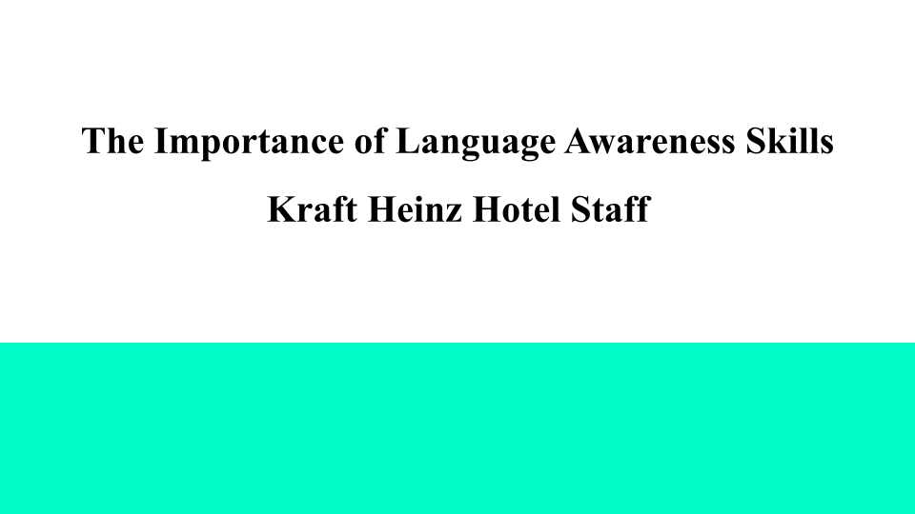
Slide 2: Table of Contents
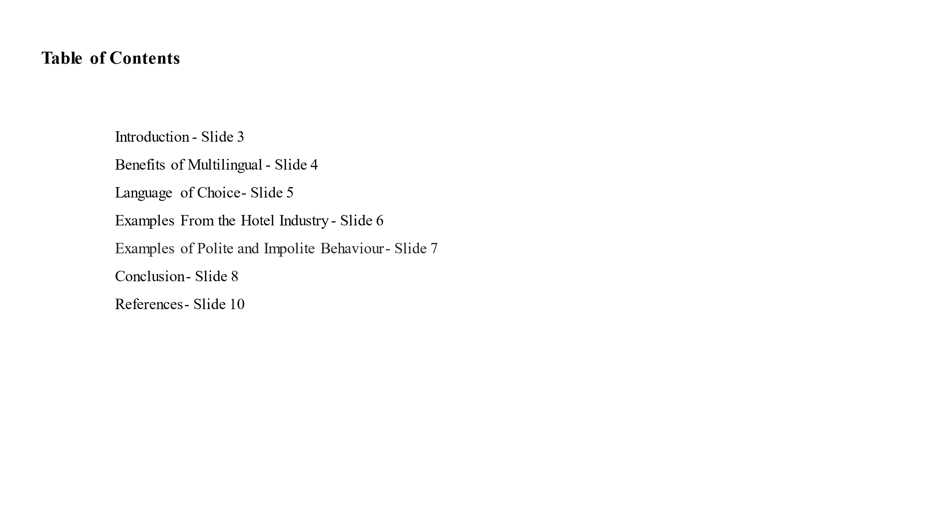
Slide 3: Introduction
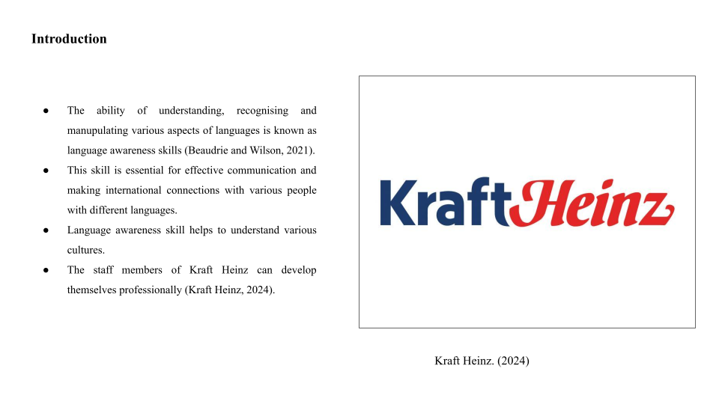
Speaker Notes:
The purpose of writing this presentation is to focus on the importance of language awareness skills of the staff members of Kraft Heinz Hotel. The ability to understand, recognise and manipulate various aspects of languages is known as language awareness skills. This presentation will focus on the benefits of multilingualism and the Spanish language.
Slide 4: Benefits of Multilingualism
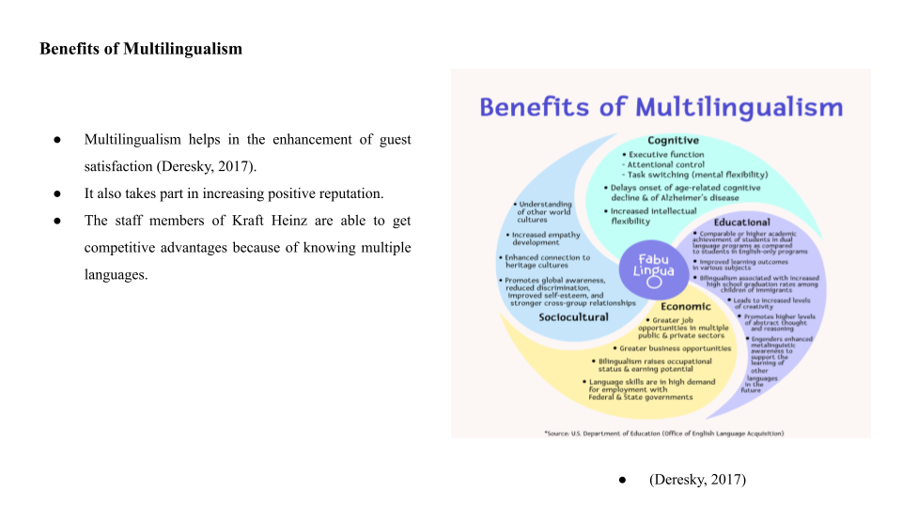
Speaker Notes:
There are several advantages of multilingualism for the hotel industry. First of all, it takes part in making all the visitors of the Kraft Heinz hotel satisfied and happier because it can make them interact with other visitors who come to this hotel in their mother tongue and it also helps in the improvement of their whole experience. Additionally, the hotel can get benefits from its employees who are bilingual and take part in maintaining a favourable reputation by making them seem like a friendly and accommodating place for travellers from all over the world. The employees of this hotel also can able to get a competitive edge in the market after getting the attention of a wider spectrum of visitors and differentiating them from rivals.
Slide 5: Language of Choice
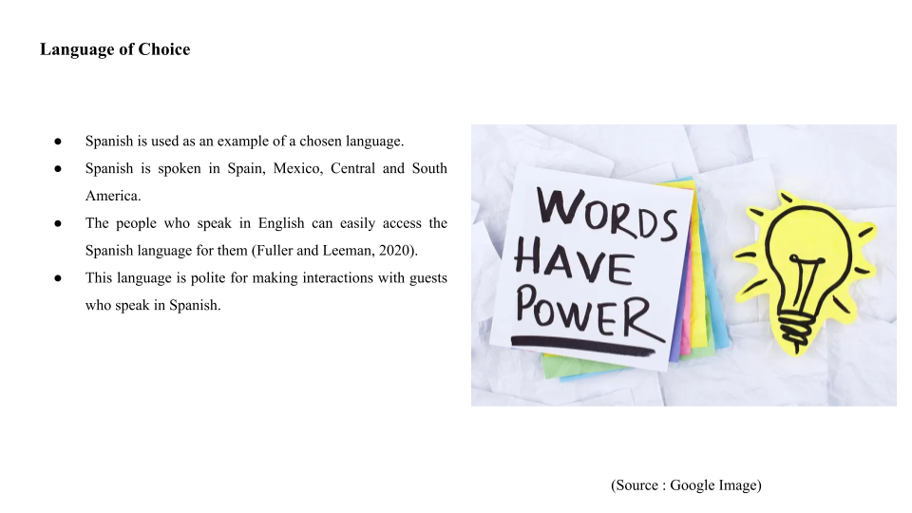
Speaker Notes:
In the context of this portfolio, Spanish language is chosen as an example language. The Spanish language is very much essential for the hotel industry to deal with international clients. This language is widely spread throughout Spain, Mexico, Central and South America and a small portion of the Caribbean. Learning a new language is always difficult and people may face challenges. But, the Spanish language can be accessible for those people who speak in English as it has a phonetic structure.
Slide 6: Examples From the Hotel Industry
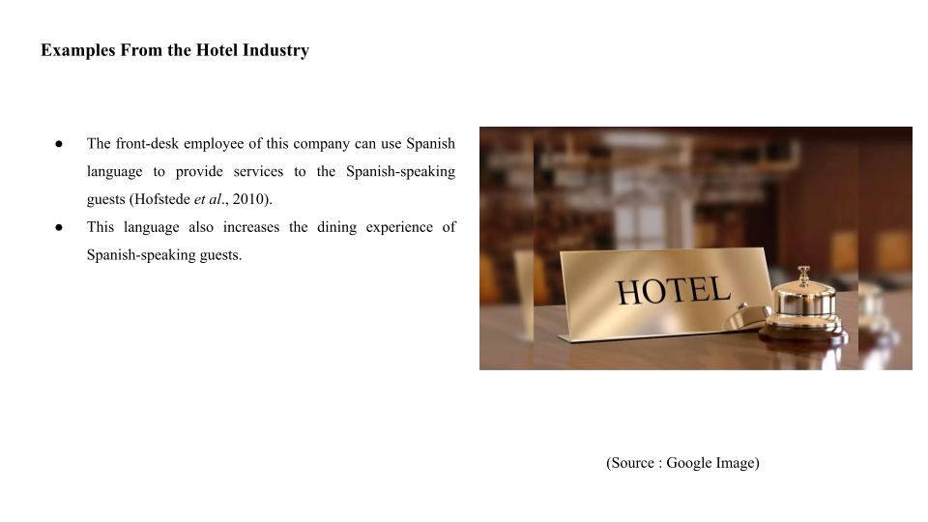
Speaker Notes:
An example of the hotel industry includes a front-desk employee and a group of guests who speak in Spanish and take food and beverages in the restaurant. The front-desk employee of this company can use the Spanish language to provide services to the Spanish-speaking guests. This language also increases the dining experience of Spanish-speaking guests.
Slide 7: Examples of Polite and Impolite Behaviour 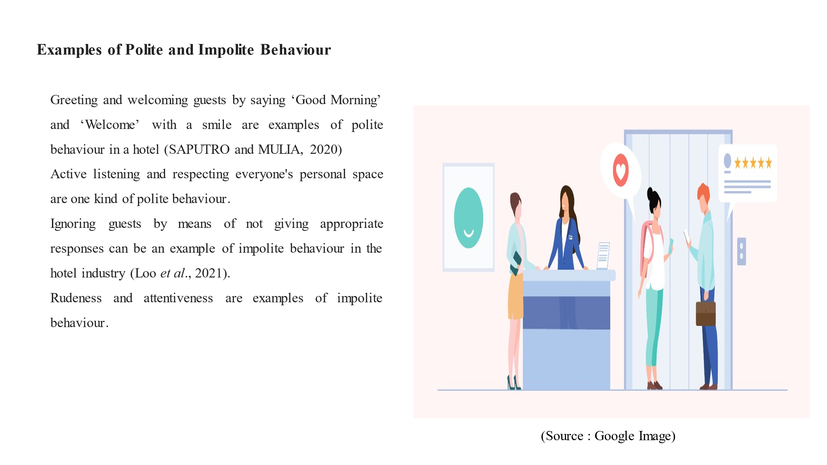
Speaker Notes:
Greeting and welcoming guests by saying ‘Good Morning’ and ‘Welcome’ with a smile are examples of polite behaviour in a hotel. Active listening and respecting everyone's personal space such as giving knocks before entering a guest's room are one kind of polite behaviour. Ignoring guests using not giving appropriate responses can be an example of impolite behaviour in the hotel industry.
Slide 8: Conclusion
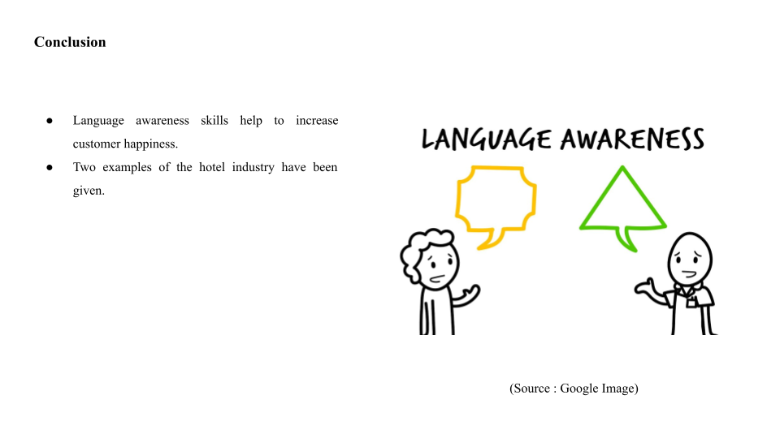

Speaker Notes:
Hence, the presentation has been completed by discussing the importance of language awareness skills and the benefits of multilingualism in the hotel industry such as Kraft Heinz.
References 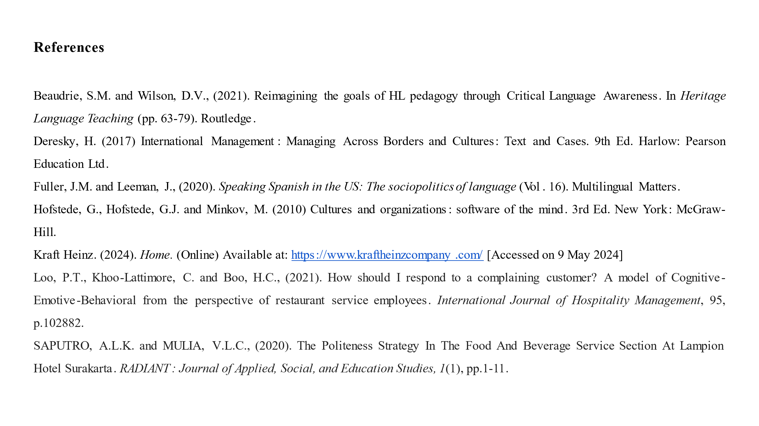

References
Component 1
ARICA, R. and Sabbağ, Ç., (2020). Customer-to-customer information production: the evaluation of customer reviews in Tripadvisor on food and beverage service providers in Adıyaman. Journal of Tourism & Gastronomy Studies, 8(2), pp.729-745.
Mitsea, E., Drigas, A. and Mantas, P., (2021). Soft Skills & Metacognition as Inclusion Amplifiers in the 21st Century. International Journal of Online & Biomedical Engineering, 17(4).
Pramudibyanto, H., (2023). Recognition of Japanese culture in Javanese culture unggah-ungguh through school library brochures. KIRYOKU, 7(1), pp.133-146.
Components 2
Abramson, N.R. and Moran, R. (2018) Managing Cultural Differences: Global Leadership for the 21st Century. 10th Ed. Abingdon: Routledge.
Christiansen, B., Branch, J.D. and Karmowska, J. (2020) Cultural Factors and Performance in 21st Century Businesses. Hershey : IGI Global.
Maheshkar, C. and Sharma, V. (2018) Handbook of Research on Cross-Cultural Business Education. Hershey: IGI Global.
Escandon-Barbosa, D., Ramirez, A. and Salas-Paramo, J., (2022). The effect of cultural orientations on country innovation performance: Hofstede cultural dimensions revisited?. Sustainability, 14(10), p.5851.
Lou, K.H. and Bosley, G.W., (2023). Facilitating intercultural learning abroad: The intentional, targeted intervention model. In Student learning abroad (pp. 335-359). Routledge.
Munezane, Y., (2021). A new model of intercultural communicative competence: bridging language classrooms and intercultural communicative contexts. Studies in Higher Education, 46(8), pp.1664-1681.
Ngoepe, L.L., (2021). Hotel employability of hospitality graduates from private academic institutions (Doctoral dissertation, University of Johannesburg).
Component 3
A Ramos, G., Johnson, W., VanEpps, E. and Graham, J., (2024). When consumer decisions are moral decisions: Moral Foundations Theory and its implications for consumer psychology. Journal of Consumer Psychology.
Koc, E. and Ayyildiz, A.Y., (2021). Culture’s influence on the design and delivery of the marketing mix elements in tourism and hospitality. Sustainability, 13(21), p.11630.
Tien, N.H., Viet, P.Q., Duc, N.M. and Tam, V.T., (2021). Sustainability of tourism development in Vietnam's coastal provinces. World Review of Entrepreneurship, Management and Sustainable Development, 17(5), pp.579-598.
Component 4
Beaudrie, S.M. and Wilson, D.V., (2021). Reimagining the goals of HL pedagogy through Critical Language Awareness. In Heritage Language Teaching (pp. 63-79). Routledge.
Deresky, H. (2017) International Management: Managing Across Borders and Cultures: Text and Cases. 9th Ed. Harlow: Pearson Education Ltd.
Fuller, J.M. and Leeman, J., (2020). Speaking Spanish in the US: The sociopolitics of language (Vol. 16). Multilingual Matters.
Hofstede, G., Hofstede, G.J. and Minkov, M. (2010) Cultures and organizations: software of the mind. 3rd Ed. New York: McGraw-Hill.
Kraft Heinz. (2024). Home. (Online) Available at:https://www.kraftheinzcompany.com/ [Accessed on 9 May 2024]

