MSc Lean & Agile Operations
Extracting Metals from Slag by Induction Atomization
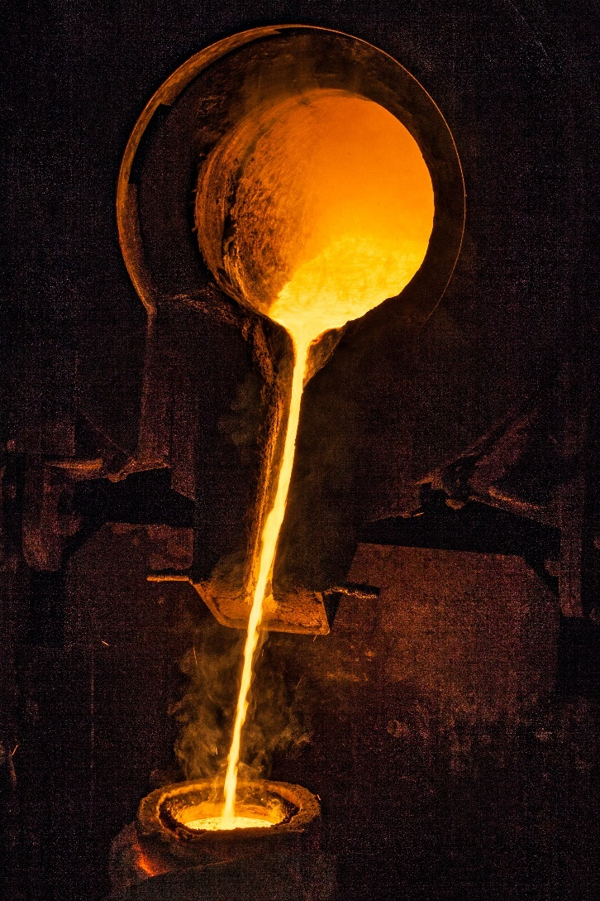

P144082
Jonathan Francis
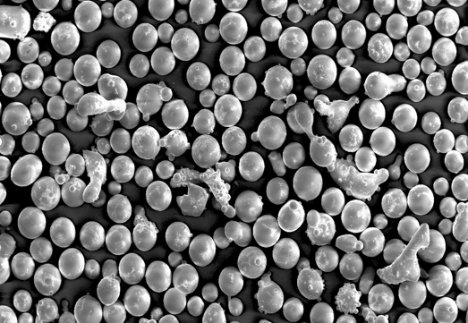


Abstract
LSN is a superalloy manufacturer that specialises in Nickel based and Cobalt based powder metallurgy. Due to rising costs, supply issues and volatility with commodity trading LSN must increase its focus on internal material usages with respect to Cobalt and Nickel.
The aim of the project was to investigate the value lost in disposing of Nickel and Cobalt rich foundry slag and determine how much of this cost could be recovered with existing process technology to ease the burden on raw material purchasing.
The slag waste is a product of the melting process which is typically destined for generic landfill. This waste was collected, sorted using X-ray fluorescence and categorised as nickel rich and cobalt rich waste.
The waste was re-processed in the same fashion as it was generated which was to melt in an induction furnace and convert into a coarse-grained powder using liquid nitrogen atomisation.
Once processed, the resulting yield of metals were around 60% however the value retained is heavily dependent on the chemistry of the resulting alloy.
The Nickel and Cobalt powder products were that of a nature that did not fit specifically, or directly any current saleable product in LSN’s portfolio or customer base however the material recovered was determined to be suitable as an incremental feedstock at a usage rate which would see both waste products consumed within a month.
The process was shown to have minimal environmental impact and would fit within the current limits with respect to water and air pollution. It was determined that the costs of installing and running and dedicated process for this purpose would be outweighed by the value gained from the metals. The continuous processing costs are also negligible in comparison to the potential value recovery.
In the current climate of Nickel and Cobalt price volatility and unreliable supply it is recommended long term that LSN invest into an additional furnace like the 4 current production lines dedicated to an in-house process of continuous material recovery from a material previously destined for landfill.

Contents
Abstract 1
Tables 4
Figures 4
Introduction 5
Company Background 5
Manufacturing Process Overview 6
Induction Melting 7
Slag Formation 8
Material Flow 11
Production Yield 14
Material Value 15
Potential savings 16
Aims 17
Objectives 17
Recovering Value 17
Process 17
Process Feasibility 17
Literature Review 18
Atomisation 18
Commodity Trading 18
Open Pit Mining 19
Environmental Impact 20
Nickel 21
Cobalt 22
Refining 23
Ethical Concerns 24
Waste Management 25
Waste Hierarchy 25
Modern Interpretation 28
Current Recycling of Slag 29
Methods 32
Segregation 32
Atomisation 33
Drying 34
Material Analysis 35
Cost Benefit 35
Results 36
Sorting 36
Atomisation run 1 – Nickel Alloy 37
Physical Analysis 38
Chemical Analysis 39
Atomisation run 2 – Cobalt Alloy 39
Physical Properties 40
Chemical Analysis 41
Discussion 41
Useability of Recycled Material 41
Use In Production 43
Value Gained 48
Environmental Issues 48
Trade Effluent 48
Air Pollution 51
Investing in a Process 52
Equipment required 52
Payback potential & future costs 52
Power 53
Nitrogen 53
Labour 53
Overall process costs 53
War in Europe 54
Recommendations 56
Short term 56
Medium Term 56
Long Term 56
Conclusion 57
Works Cited 58

Tables
Table 1 - Chemical specification of Nickel alloy N580 42
Table 2 - C06 Alloy chemistry specification 44
Table 3-NSR Water discharge permits 47
Table 4 - Trade effluent results 48
Table 5 - Air pollution permits 49
Table 6 - Stack monitoring result 49
Table 7 - Cost of equipment 50

Figures
Figure 1 (Kopeliovich, 2005) Figure 2 - (Mechanical Base, 2022) 7
Figure 3 – Otto Junker, 2021 7
Figure 4 - Plasma weld application of LSN powder 9
Figure 5 - Coated part using plasma welding of LSN powder 9
Figure 6 - Weld cracking 10
Figure 7 – Manual removal of slag Figure 8 - Slag in furnace 10
Figure 9 - Connected processes 11
Figure 10 - Process flow for 1 tonne batch order 12
Figure 11 – Slag stored, awaiting disposal 13
Figure 12 - Powder Sieving locker 14
Figure 13 - locker diagram 15
Figure 14 - Route of DRC Cobalt - (Petavratzi, 2016) 23
Figure 15 - Gulley 2019 23
Figure 16 – DEFRA.gov.uk model of The Waste Hierarchy 26
Figure 17 – Modern view of the Waste hierarchy 29
Figure 18 - (Sun, 2017) 34
Figure 19 37
Figure 20 - Material flow of initial process 41
Figure 21 - New flow of materials including waste recovery 42
Figure 22 - Atomising Process 47
Figure 23 - Settling slurry tank 48
Figure 24 - 2022 Nickel Prices 53

Introduction

Company Background
LSN Diffusion is a super alloy powder metallurgy manufacturer which was conceived in 2012 when senior management from a previous company decided on creating a new business and a manufacturing facility was opened in Llandybie, Wales. The plant began with three atomisation production lines with capability to produce alloy powder via dry gas atomising, water atomising and wet gas atomising in 350kg melt batches, as well as sieving equipment to achieve a range particle size specification. The factory was originally leased from TATA steel however has recently been purchased by the Welsh government who offer favourable terms in return for securing jobs for the area.
In 2020 a fourth atomising line was commissioned due to continued growth, with an 800kg batch capacity – double that of the original furnaces. To accommodate the fourth line significant investment was made to upgrade both electricity supply and liquid nitrogen capacity (atomising medium). Total investment related to atomising line 4 is around £2million.
Ongoing collaborations with customers and further development in powder metallurgy markets such as brake disc coatings have already led to planning of a fifth production line to be installed in the next 2 to 3 years. The Development Bank of Wales has invested into the business from start-up and has built a strong relationship with regards to continued support into research and development which will lead to continued growth.
The core business being powder metallurgy, LSN supply Cobalt, Nickel and Iron based ‘super’ alloys for a wide range of industries such as additive manufacturing, surface coatings, hot isostatic pressing and brazing filler metals. Most sales, approximately, 90% are exported across Europe, East Asia and USA.
Examples of applications vary from heavy engineering such as flame spray coatings on oil drilling equipment, vessel linings for the inside of waste to energy reactors to more delicate applications such as isostatically pressed medical implants. Key characteristics to the powders for customers include alloy chemistry, particle size distribution, morphology (shape) as well as physical properties such as density, flow, and hardness. These various properties are achieved by multiple inputs, e.g., water quenched atomising produces low density, irregular shaped particles (giving a slow flow rate through spray equipment but ideal for pressing into shapes. Conversely dry gas atomising will produce more spherical particles giving higher flow characteristics an increased particle density. Hardness is controlled by chemical means such as the use of tungsten and chrome whereas particle size distribution is manipulated during sieving processes.
There is an extensive catalogue of alloys due to collaborations with customers and continuous technological advances however with respect to carrying elements, most products manufactured at LSN can be broadly categorised into three groups – Iron, Cobalt, and Nickel based alloys. At the time of writings, 2021 sales are around 100 metric tonne of powder per month, this comparable with established competitors in the same market areas – showing that even as a relatively new business there is a strong foothold in the market.

Manufacturing Process Overview
The process of atomisation is essentially to convert solid raw materials into a single alloy in the format of a granular powder.
Firstly, charge chemistry of the desired alloy is theoretically calculated prior to manufacture, and all raw materials are prepared for melting into a single charge loading hopper. From there the metals are loaded into a furnace melted down to a molten liquid state. The temperatures required will depend heavily on the chemical composition of the alloy. During this process the alloy is stirred and homogenised to the point of complete solubility where the viscosity is low enough to be able to pour out of the tilting furnace. Temperatures will regularly exceed the theoretical melting points due to the superheat required for pouring.
The furnace is tilted, and molten metal is poured into a tundish which at the bottom there is a controlled diameter refractory nozzle. The diameter of the nozzle provides control over the flow rate of the metal into the atomising vessel. Upon exiting the nozzle, the molten metal drops into an atomising tank where it is impinged with a high-pressure gas, or high-pressure water jet which provides enough energy to turn the molten metal into fine droplets which then solidify on cooling.
In LSN’s ‘premium’ process - dry gas atomising, droplets are atomised by nitrogen and a collected within a purged tank of nitrogen gas to keep oxygen levels down while the powder settles into a collection pod at the bottom of the tank. The velocity of the atomising gas and the overall gas to metal ratio will affect the shape and overall size distribution of the powder. A high gas to metal ratio will produce a finer distribution of powder.
In a cheaper process, water atomising where oxygen levels are not as critical to the end alloy the droplets are atomised by high pressure water jet and collected in a tank of water at the bottom of the vessel. Like gas atomising, the volume flow rate of hot metal and atomising water will determine the particle size distribution of the finished powder.
LSN also utilise a ‘hybrid’ or ‘wet gas’ method where the metal stream is atomised by nitrogen gas but collected in a water tank to reduce production costs. This method gives a good ‘gas atomised’ powder yet is cheaper to produce than a full, dry gas system due to the cost of liquid nitrogen being far greater than water.
Figure 1 below shows a diagram of water atomising, where water is used to impinge the molten alloy stream and collect the product. Figure 2 (right) is a very similar principle however is a dry system where liquid nitrogen (or argon in some processes) is used as the atomising medium and the powder is collected within the protected atmosphere.
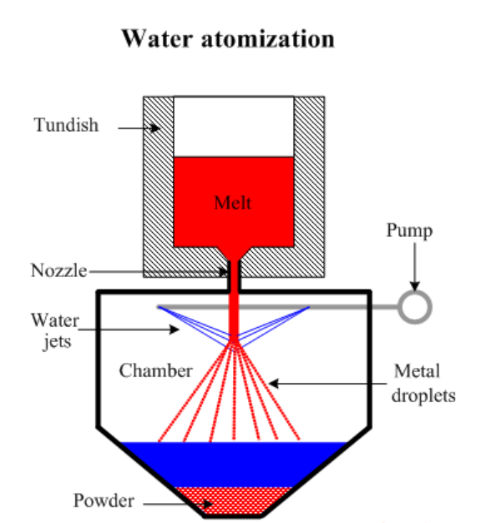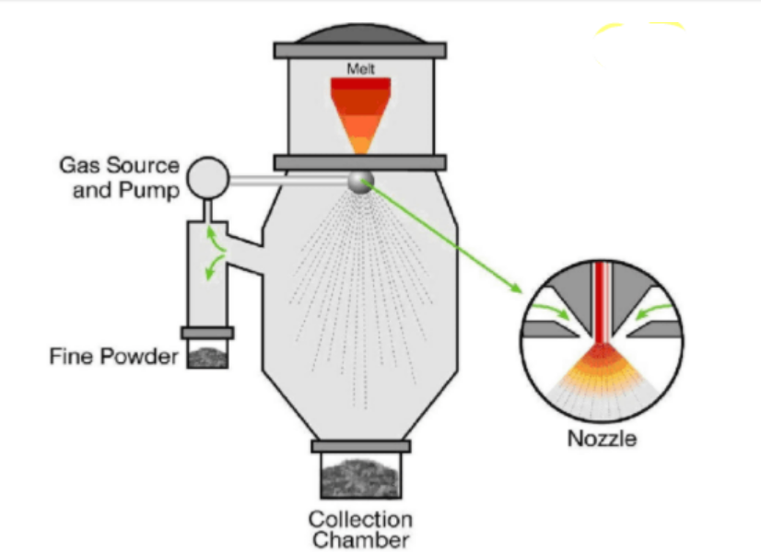
Figure 1 (Kopeliovich, 2005) Figure 2 - (Mechanical Base, 2022)

Induction Melting
Melting and atomising, whilst highly connected can be considered two individual processes. The initial melting of raw materials takes place in an induction furnace much before atomising can begin. The mechanism of induction melting is well researched and is an established industrial process. Many manufactures of induction furnaces have published information on how induction melting works and the benefits over other processes such as cleanliness and uniform heating.
Working on the principal Faradays law, the work piece(s) are placed inside of an electrically conductive coil which produces a magnetic field when an alternating current changes direction. This puts an electrical voltage into the workspace which results in rapid heating due to electrical resistance of the charge materials- the more resistant the material is for current flow the more heat is generated.
Other melting methods such as gas and electric furnaces require direct heat convection and radiation from the outside and are typically inefficient in comparison to induction heating.
An additional benefit due to electro-magnetism is induction stirring. This effect means that molten metal within the furnace can be homogenised which makes it an appropriate method for creating alloys. (Inductotherm, 2021)
Figure 3 below shows a cross section of an induction furnace from manufacture Otto Junker. The section diagram shows the induction coil rammed with refractory protection where molten material is held inside.
Figure 3 – Otto Junker, 2021
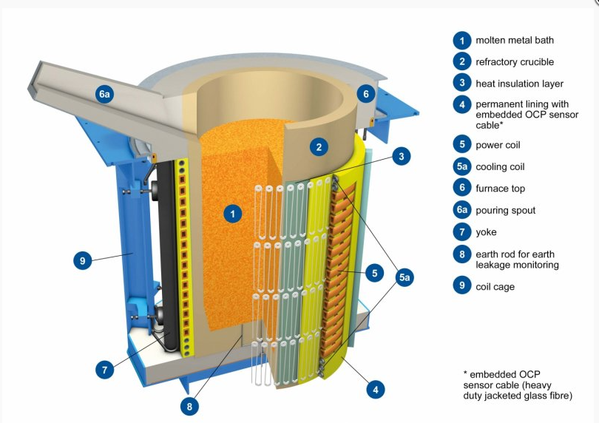

Slag Formation
Open air induction melting takes place within an oxidising environment therefore as impurities and metal oxides are formed from the melt, a slag layer will begin to appear due to the oxidation of the melt pool taking place. The composition of the slag can vary dependent on the original raw material chemistry, fluxes used, and any chemical corrections applied. For example, melting of pig-iron which is a semi-refined material would show a greater amount of slag generated than melting a 99% nickel which has already been refine to a much cleaner format. Oxygen savaging materials such as Aluminium can be added to specifically generate slag and de-oxidise the molten pool. Considered as a waste product of the process with no further use, the slag is discarded and destined for landfill. (Cardoso, 2018)
Another factor to the composition and amount of slag generated is the format and quantity of material in the melt. Most desirable format of metal is solid billets or ingots as these have a better induction within the furnace however a heavily used format is that of previously atomised metal powder. Typically, the larger quantity of powder, the more slag is produced. This is due to powder having a greater surface area than a solid mass and there for will oxidise quicker. Secondary to this is the micron size as the finer the powder the greater the surface area.
LSN regularly re-melt recycled powder and look to maximise the amount of powder per-melt as to remain economical, therefore this issue is unlikely to go away. The powder will react with oxygen, forming a small oxide particle which will become insoluble to the rest of the matrix it is in, from here it will float to the top of the melt in the form of slag and dross.
A key aspect to the process, much before pouring into the vessel is a manual de-slagging procedure where any metal oxides and impurities are removed from the melt in the furnace before the molten metal is atomised. If the melt is not de-slagged properly then any non-metallic, insoluble particles will block the entry nozzle and the production run must be abandoned. There is also the potential for finer sized non-metallic inclusions to enter the atomising vessel and be present within the finished product. As the size will be very similar to that of the metal powder it will be difficult to remove once mixed within the batch.
Any non-metallics in the product will affect melting characteristics and application of the powder – this will reduce quality and potentially deem the powder suitable for application. An example of this is when applying the powder via a frame spray gun or plasma weld onto a substrate. A non-metallic particle sprayed onto the weld will create porosity and therefore weakness, causing the welded coating to crack and or peel away from the substrate.
Figures 4 and 5 below show a plasma weld application. Where the weld appears uniform however any presence of non-metallics and oxidised particles will create cracks as show in figure 6.
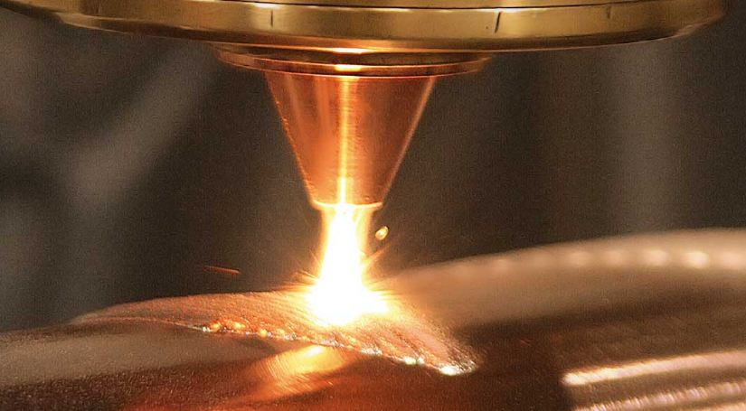
Figure 4 - Plasma weld application of LSN powder
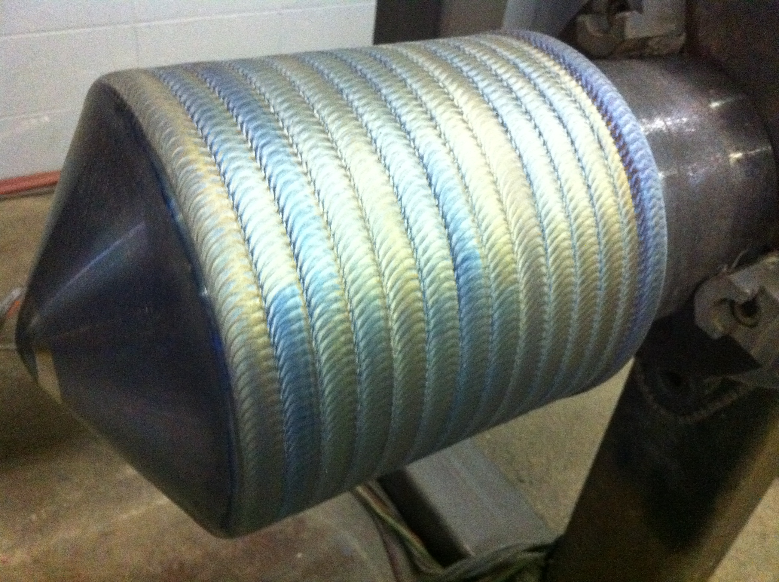
Figure 5 - Coated part using plasma welding of LSN powder
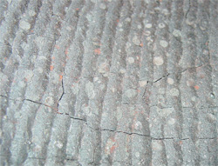
Figure 6 - Weld cracking

As previously mentioned, an inherent effect of induction melting is a stirring process which helps develop a homogenous melt pool. The electromagnetic forces applied on the molten metal area create a constant stirring action in a ‘figure of 8’ motion which aids homogenous alloying but also proves advantageous in slag removal as low-density metal oxides will be pushed and stirred up to the top of the melt pool for easy removal.
Figure 7 below shows a furnace operator de-slagging the top of the melt pool prior to pouring into the atomising vessel, figure 8 shows oxidised impurities sitting on top of a clean melt pool which is to be removed by the operator.
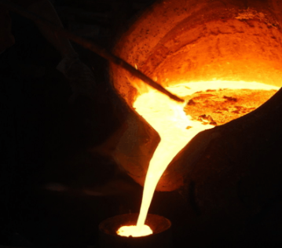
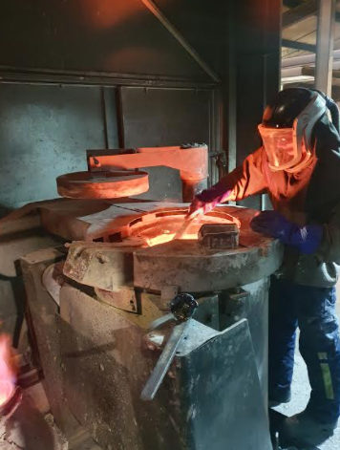
Figure 7 – Manual removal of slag Figure 8 - Slag in furnace
Furnace parameters have a direct effect on the aggressiveness of the stir, for example a low frequency coil will provide a heavy stirring action which is desired for homogenising and refining alloys whereas a high frequency coil will result in a much lighter stirring action which is required when trying to avoid gas inclusion and prolong refractory life. (Keshecki, 2010)

Material Flow
Atomising makes up a portion of the LSN production facility, with other departments preceding and succeeding the melting process. Prior to melting there is charge preparation and after melting is powder finishing in terms of batch blending and screening to size. Each department relies on the functionality of each other. Atomising relies on supply from charge preparation, powder finishing relies on feed stock from atomising and in turn charge preparation rely on receipt of recycled powder from finishing. The illustration below in figure 9 highlights the connectivity between the 3 production areas.
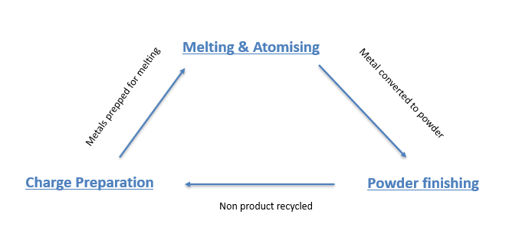
Figure 9 - Connected processes
The process flow chart below in figure 10 uses a typical customer one tonne batch order quantity which would be planned via the larger furnace, utilising the 800kg melt capacity in preference to the smaller 350kg furnaces.
The initial raw material format will use fresh ‘virgin’ metals as purchased from refiners and traders. The format of the virgin metals can vary from highly refined pure pellets of cobalt and nickel to scrap metal, turnings and recycled atomised powder, providing the chemical composition is within specification.
Charge preparation will follow a theoretical recipe of the desired production run and prepare the melt with the required materials before transporting to the atomisation department.
Atomising will then load the material into the furnace before melting and converting the material into powder via the atomising process. The newly atomised powder is sent to the screening department which will pass the material over several sieves to a given specified size. Each smaller batch of powders are then turned in a blender to homogenise into a uniform 1000kg before quality control assess in the laboratory in terms of size, shape and chemistry.

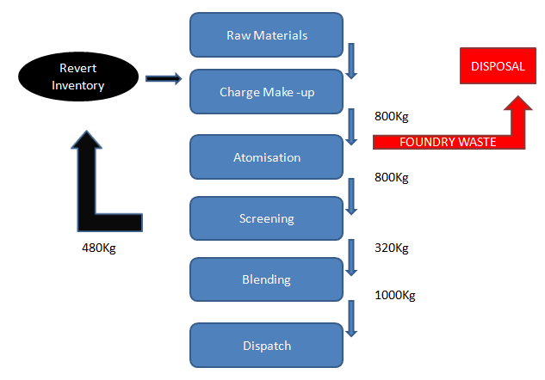

Typical waste 10kg per melt

Figure 10 - Process flow for 1 tonne batch order
At the point of atomisation, slag waste (highlighted by the red arrow on the diagram) is discarded and the quantity per melt is approximated at around 1 to 10kg. Local slag drums are used aside the furnace and once full, the waste is taken to a disposal area.
The only prevention method for slag is to eliminate oxygen and melt under a vacuum, LSN has not invested in vacuum melting technology therefore melting in an oxidising environment is inevitable which in turn will produce slag waste for the foreseeable future.
The manual nature of slag removed often results in some accidental clean metal removal (containing a monetary value,) due to this it is important to find a recycling method of recovering as much metal as possible which can either be utilised back in the process- saving on raw material purchasing or sold as a commodity to generate revenue.
Figure 11 below shows storage of slag waste ready for landfill. The drums of waste are emptied into a general-purpose ceramic skip which gets sorted offsite at a cost per skip load.

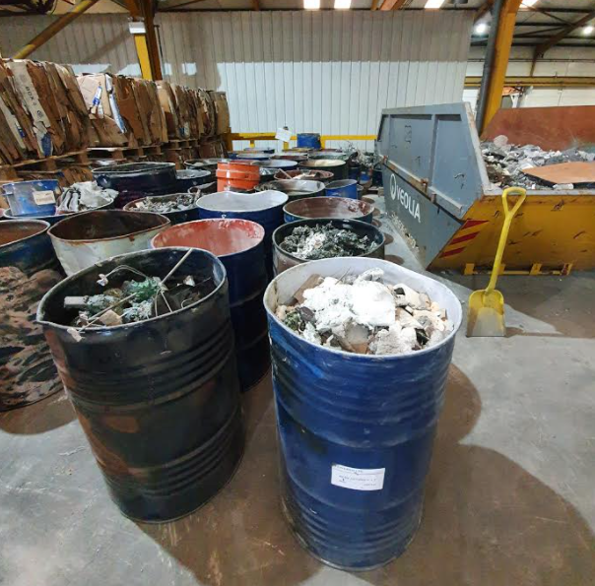
Figure 11 – Slag stored, awaiting disposal
The drums are brought down from the melting area and generically left near the ceramic skip. An employee will spend time to decant these into the skip shown on the right of the image with little attention to the contents and no sorting is done at this point. Once the skip if full it is collected by a recycling company. The company charge around £200 per collection with an additional £1000 penalty if any non-ceramic material must be sorted through. This is a relatively common occurrence as the slag drums often contain metal and other wastes along with the metal oxides and ceramic consumables therefore it is generally £1200 per collection at a frequency of 2 collections per month. Costs could be recovered at this point by simple segregation genuine ceramic consumables such as furnace refractory lining and tundish pots, from metallic oxide slags however this has had little attention to date.

Production Yield
Further to materials flow it is important to understand the inherent low yielding nature of some atomised powders as this puts further emphasis on cost reduction, process efficiency, recycling metal and a low waste process.
A typical product used for flame spray coating applications is required at powder sized between 125µm-45µm. Atomisation produces a nominal powder distribution of 500μm and below therefore screening to this specification will typically yield around 40% of an 800kg melt, meaning only 320kg of the original purchased raw materials is converted to saleable powder. Figure 12 below shows powder sizing equipment. The powder produced from atomising is fed at a controlled rate over two screens sized above and below specification. To avoid screen clogging the powder first passes through an air classifier which extracts ‘superfine powder’ at around 10 microns. This improves the sieving efficiency of the screen themselves. The powder in between the sizes is the desired product.
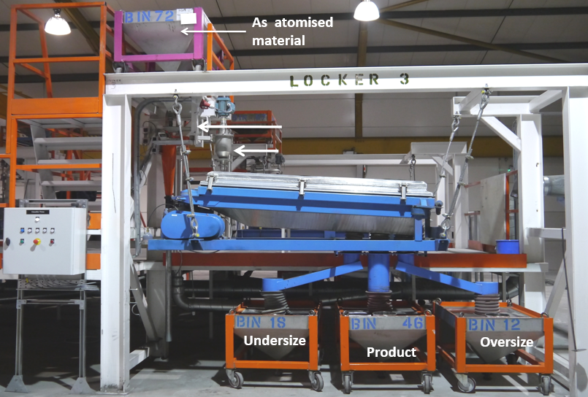
Figure 12 - Powder Sieving locker
Below in figure 13 is a schematic of the locker bed in greater detail, showing placement of multiple screens.
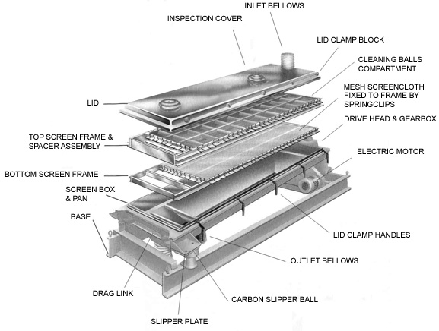
Figure 13 - locker diagram
A critical process parameter in powder sieving is feed rate of powder. Too fast the powder will not be allowed time to fall through the top screen resulting in product not passing through the oversize screen which will show a poor yield. Further to this a slow-moving locker will not create enough energy to keep the powder moving through the screens, potentially resulting in the undersize powder not dropping out of the product range.
Post sieving, the powder which is too fine, or oversize from the customer specification will be chemically analysed and recycled back into melting stock as an ingredient through the campaign in the place of virgin metal to create an economic system.
Referring to the process flow chart above, to achieve a typical batch order of 1000kg product, 3 melts at a yield of 40% will be required before being blended and homogenised into the final batch order. Such is the wide size distribution and poor yield of atomised powder, great emphasis is placed on high utilisation of recycled powder and driving down the amount of raw material charged.
Recovered foundry waste at this point could increase the level of recycled material and further improve the economics of the production run as there would be a secondary stream of metal, to supplement the recycled powder. It would be beneficial to add a secondary supply of recycled material to further reduce raw material purchases. The extraction of useable metals from a from slag would reduce the overall material purchasing as well as adding to the already ‘paid for’ pool of metal on site. Therefore, quantifying the amount, and value of useable metal from slag waste is the focuses of the project.

Material Value
Greater than any processing cost such as labour, electricity and liquid nitrogen, the cost of raw materials makes up around 80% of the overall price of atomised powder for LSN.
As the price of metals is dynamic it is important to keep a low inventory and avoid heavy purchasing of raw materials to avoid financial risks. The most economical way is to purchase metals ‘just in time’, make to order and invoice the customer within a short period of time – this creates some stability in the materials value if the sale is not agreed on a predetermined future price contract.
As briefly mentioned above a heavily used method of keeping inventory low is to re-melt any powder that does not meet the particle size specification, known as revert which can be used in place of fresh virgin metal and has the added benefit of already being paid for when the initial purchase of virgin material was made.
Purchasing of raw materials is a function of sales demands therefore any saving will be a relative measure. If sales are higher, naturally raw material purchasing will increase therefore metal in against metal out by month is a general measure and key performance indicator for accounting purposes.
For accounting purposes and bookkeeping, a more financially accurate process is to account for cobalt and nickel in elemental units, even if alloyed into another metal, for example, a tonne of an alloy containing 75% cobalt sold to a customer would be accounted for as 0.75 of the initial raw material prices. Therefore if 1 tonne of finished product was sold, the cobalt value would be attributed at the equivalent of 750kg pure cobalt at the price when initially purchased. Therefore, any metal recovered as an alloy will retain a high value as the individual elements are accounted for individually.
With respect to a typical customer order size of 1 tonne at 40% production yield, 3 melts of 800kg would be required. Using the common alloy of Nickel-Chrome at 80% Nickel this calculates as 800kg x3 multiplied by 80%, which equates to 1920kg of equivalent Nickel units - valued at £13,000 per tonne, meaning this campaign costs £24,960 worth of Nickel. The combined waste of around 30kg at the same nickel levels would be worth around £300.

Potential savings
Nickel based alloys make up a high proportion of sales for LSN and is one of highest usage materials on site is various formats. The technical specification is typically 99.5% Nickel which limits purchasing to highly refined sources, rather than any ores or intermediary products such as Nickel salts. This is reflected is the prices and at the time of writing, 1000kg is priced at $18,000 USD / £13,000 sterling on the London Metal exchange.
LSN would typically purchase approx. 6 tonnes per week or around 300 Tonnes per annum at a cost of £13,000 per tonne- if purchasing could be reduced by 10% and replaced by recovered metals on site the annual saving is substantial. This calculates at around 30 tonnes less nickel purchasing which at £13,000 per tonne equates to £390,000 savings.
Cobalt usage is much smaller; however, the end applications reflect a much higher price. Compared to Nickel alloys at around £20 per kilogram, LSN cobalt alloys used in dental implants are priced at around £60 per kg, with some higher-grade products up to £80 per kg. Further to this, prices of refined cobalt have risen as electric vehicles and battery technology have increased the demand and volatility in the market. At the time of writing cobalt is valued at $44,000 per tonne which is around £32,000 sterling. LSN purchase around 150 tonne of cobalt per annum and reducing purchasing by 5% would result in a saving of £240,000.

Aims
There are three overall and connected aims of the project which are:
- Recover Nickel and Cobalt value from waste foundry slag.
- Provide additional feedstock with recycled material.
- Determine feasibility of dedicated equipment and recycling process.

Objectives

Recovering Value
1. Segregate Nickel and Cobalt streams to increase the potential value of processed product.

Process
2. Melt and atomise the waste batches into powder form and assess the quality of material produced

Process Feasibility
3. Undertake a cost benefit analysis to determine if investing in a dedicated process would have a viable use and payback

Literature Review

Atomisation
The principle of atomisation is to transfer kinetic energy from high pressure gas into the molten metal. The rapid gas expansion causes the metal to rapidly disintegrate into fine droplets. There are two broadly defined techniques of atomising set-ups used. The first technique is ‘closed couple’ designs where the metal stream is confined through the atomising nozzle and immediately hit with gas on exit. A reason for using this technique is it typically produce finer powder due to the proximity of the gas- provide immediate energy transfer - with the trade-off of a higher chance of metal freezing on the exit point due to gas cooling the nozzle. The second technique of atomisation is a ‘free fall’ method. Molten metal is poured through the nozzle and allowed to fall under its own gravity to a specific distance before being impinged by high pressure gas. The diameter of the nozzle, flow rate of metal, distance it falls, and angle of gas jets will all effect the size, shape and physical properties of the product. Further parameters include atomising head design- i.e., the amount of gas jets and the geometry of these along with gas pressure/ velocity. The temperature of superheat on the metal will affect the viscosity and density of the metal which in turn will alter the shear properties. Gas properties such as temperature and thermal capacity will also affect the properties of the powder. (Urionabarrenetxea, 2021)

Commodity Trading
Much further up the supply chain than manufactured parts are the trading of commodity materials. Commodity trading is critical to the global economy and is the backbone of everyday lives in the form of energy, food, clothing, and many fundamental raw materials. These commodities are typically bought and sold in several different ways, contracts, and complexities. Broadly split into two groups – soft commodities are agricultural stock and ‘grown’ products whereas hard commodities are minerals and metals. Typically, soft commodity trading is far more volatile as the products are subject to environmental conditions such as floods, hurricanes, and earthquakes. Furthermore, many of the products, soybeans for example, have a limited shelf life and quality becomes exponentially worse over time and traders often sell at a low price out of desperation. Hard commodities are also subject to price volatility based on demand and availability. The materials in question are finite and of a limited resource so any surge in demand will see price increases. Some categories of commodities can be interrogated further. For example, in the case of non-renewable energy sources I, e coal, crude oil and natural gas are considered primary products, from these secondary products such as petrol and diesel are made and are traded as a separate entity. All the above are typically priced based on raw quality and branding means very little in comparison to logistical ease. Most of these types of products will be transported in large batches via cargo ship as economies of scale dictates therefore if shipping to a far and potentially difficult to reach area the price will reflect. (Wier, 2016)
With respect to Metals and Minerals as its own commodity category, The London Metal Exchange provides a central area for investors and consumers to trade on a wide variety of materials and contracts. It is used to help mitigate the risk of price fluctuations, provide global price referencing and storage of physical goods. (Watkins, 2006). History of the exchange can be traced back to the 1500s however when the Suez Canal was opened in 1869 it allowed mass cargo ships to transport metals from the east in comparable times to that of the Americas and a global volume of trading increased. Post war the LME continue to grow and is now the world’s central hub for trading ferrous and nonferrous metals, as well as one of the biggest commodity traders worldwide. (Hayes, 2021).
Initially trading in copper, tin and pig iron the LME has grown to deal in Nickel, cobalt and precious metals. There are records from 1877 which show one of the early forms of contract agreements which stated the delivery lead times of copper coming from Chile. The Chinese industrial revolution in the 21st century saw more trade routes open, a higher demand for materials and increased market volatility. (Wier, 2016)
Metals and minerals are bought and sold as any other commodity and therefore are subject to volatile pricing. All commodities are massively affected by supply and demand -, food, fuel, livestock and metals are all example of commodity trading that are considered high risk investments. Cobalt for example has been affected by advancing technology of electric vehicles – currently the mining & refining are just about balanced with supply however it is predicated that there will be a supply deficit of around 36,000 metric tonnes by 2025 which will create price rises. (Holman, 2021)
This risk and volatility can often result in less trading; less production and even further volatility of prices as business choose to be cautious. Trading on long term contracts is a popular way to mitigate price volatility as it provides a security to the price based on a pre-determined cost, however, should prices fall drastically towards the end of the contract the consumer would have benefited more from short term investment. (Rodeck, 2020).
Purchasing metals is typically negotiated on a future contract basis as other aspects such as payment terms, delivery details and consignment stocks can put in place, along with the pricing. This limits the ‘gambling’ on value as there is a hedging element as it decreases the volatility and secures short to medium term protection against the purchase value. The contractual obligation from the seller to deliver the physical goods puts greater emphasis on price stability. These future contracts are where a buyer and a seller will agree to trade a given quantity at a set price, within a specified timeframe. An example would be to agree to purchase 10tonne of cobalt in 6 months at a price of £40,000. This is done to lower the risk of devaluation but will also provide lesser rewards should the price rise. Other ways of trading include straight cash purchases at the ‘spot’ current market price or to investment into stocks of the producers of these commodities. (Hartill, 2021)

Open Pit Mining
Mining for minerals is commonly carried out in an open-pit format. This shallow, wide shape mine is an unfortunate consequence of companies driving down costs as it offers much more efficiency over deep shaft mining as it enables use of much larger vehicles, equipment and therefore a higher production output per day. As well as reduced production costs, labour and transport is also cheaper compared to underground mining with the added benefit of utilising explosives for quick material removal. Further to this is eliminates many dangers of underground mining such as gas poisoning and cave collapses. There is significant impact to the environment caused by mining operations as well as the left behind physical mine structure which can pose a threat if left abandoned after operations have ceased. Landslides and sinkholes are common around old access points. (Sharma, 2020)
Mining operators have an obligation to undertake post-mining rehabilitation. Mines can be filled in to re-flatten the land and treated with clay to recorrect ph. levels. Soil is placed on as a top layer to re-absorb any leached elements. This top layer of vegetation will die slowly in the process but will provide an additional barrier to the surrounding areas. (AngloAmerican, 2021)

Environmental Impact
There are concerns over the environmental impact of nickel ore mining and the inconsistent controls within lesser developed countries. Canada and Australia for example have shown to abide by strict environmental procedures yet two countries with a high natural nickel reserve, Philippines and Indonesia have been accused of damaging river systems, rice fields and 17 mines were forced shut on environmental restrictions. (Kumi, 2021)
Despite supplying a ‘clean’ technology in electric vehicles, mining and refining of nickel ores comes with significant environmental impact. Russian nickel producer Norilsk Nickel was forced to close its facility after 74 years if production due to campaigners highlighting the negative influence of nickel production within the town. It was reported that the factory produced 350,000 tonnes of sulphur dioxide each year and water filtration issues caused the local rivers to turn red. Norilsk town has been labelled the worlds most polluted city and has attracted much attention from activists and Russian official internally. Russian president Vladimir Putin has threated increased fines and Norilsk has agreed to invest £3.5blilion into modernising its manufacturing which included closure of its Nickel plant. Further to this the initial mining operation, transport, handling all creates a significant environmental impact which is driving battery manufacturers into recycling a higher percentage than ever before. (Opray, 2017) Further to this a study in New Caledonia investigated local river streams found a high value of dissolved Chrome in the water as a result of nickel mining sediment leaching. (Gunkel-Grillon, 2020)
A major concern is the actual percentage of Nickel that is extracted by weight. Whilst mining for nickel he vast majority of material removed from the earth is considered waste, and the disposal of the waste is an environmental issue. Producers in Indonesia – one of the world largest suppliers, have announced that to save costs on waste processing and storage, deep sea disposal will be used. Not exporting to Europe there is little pressure to change this. (Mining.com, 2020)
Most of the nickel supply is currently from mining, with recycling rates still at a low point. When compared to recycling, mining fresh nickel still proves cheaper for producers which is proving detrimental to the environment due to the shallow yet wide nature of the mining requirement. (Mudd, 2010)
Indonesian open pit mining has shown to leave reduced soil fertility and high PH levels in the surrounding grounds following mining activities. Some re-vegetations have been attempted however the recovery takes decades to implement as the removal of topsoil and unfavourable, acidic ground that is left behind is difficult to overcome. (Prematuri, 2020)

Nickel
In 2020 the overall market volume for nickel was estimated to be just over 2million tonne, with a further 5% increase predicted by 2026. An increased demand for high-end stainless steels is driving the demand with around 60% serving this application with increased focus on corrosion resistance and toughness being the main drivers. Other demands include battery technology, solar panel and other energy solutions. In terms of Geography, Asia is seen to be the largest consumer of nickel as there is significant stainless steel and battery manufacturing in the east, with China being the world leader in electric vehicle manufacturing. Chinese policies to promote electric vehicle usage will further push the battery sector and therefore the demand for nickel should follow. (Mordor Intelligence, 2021).
It is predicted that the continuous growth of ‘clean technology’ will see Nickel demand increase as much as 500% by 2050 as nickel minerals are key in these applications as a lower carbon footprint is targeted. Current global resources are estimated at around 300 million tonnes with more than half coming from Russia, Canada, Australia and South Africa. With respect to mining the traditional bias is towards Sulphide ores however in recent years this is equalling out as the operating costs of processing laterite ores have reduced. (Horizon Minerals, 2021).
Further battery demand for nickel cathodes within the electrical vehicle sector have seen car manufacturers secure long-term contracts and push nickel ore mining further in Europe, Australia and Asia, with new production facilities evolving to manage the global capacity of the supply chain. Still around 70% of global nickel demand is within the stainless-steel industry but this remains relatively flat. The battery sector is set for continued growth, and this is shown to affect the volatility of pricing. (Mulcahy, 2021)
A review into supply chains carried out by the US government revealed that ‘class 1 nickel’ used in battery technology is not currently considered a critical mineral due to prioritising lithium technology however nickel has been identified as a key supply chain risk as there is limited nickel processing in the United States and there is an opportunity for growth to catch up with Chinese dominance. The report identified that there is limited recycling of nickel and therefore ‘new’ nickel demand will continue to outgrow current circulation. Another factor of rising nickel demand is the attempt to reduce the mining of cobalt as it has significant ethical concerns from mining in the Democratic Republic of Congo. (Home, 2021)
Like cobalt, nickel supply is being effect by battery development in electric vehicles. Historical volatility in nickel prices have been largely attributed to demand of stainless steel however as the electrical vehicle revolution continues the balance is shifting. A combined demand for stainless steel as well as increasing demand from electric vehicles could see the nickel supply go from an 85000-tonne surplus into an 18,000-tonne deficit. (Treadgold, 2021)
Nickel resides naturally in 2 common ores. Sulphides, which are formed from volcanic geology and Laterite which is formed closer to the surface in humid climates. Laterite by weight is the most abundant in comparison to sulphides with around a 60/40% balance. Historically most of the Nickel has been derived from sulphides due to ease of processing compared with laterite however increased demand in recent years has meant that laterite is now also heavily mined and thus extraction methods are developing. Sulphides are typically processed via smelting or floatation whereas Laterites require more complex chemical leaching techniques. (Mudd, 2010)
Nickel sulphide ores are crushed and ground down to fine sediment before a wet floatation process. During this the bath is pulsed with air which causes the nickel rich minerals to float and be collected. This material will contain around 12% Nickel which then requires further processing via smelting. The concentrate from the floatation is dried and heated to around 1400C to produce a ‘matte’ of around 45% Nickel with the balance containing iron and sulphur. Further oxidation and fluxing will refine the matte to around 75% Nickel. Nickel matte can be processed further in a variety of way however a widely used process to gain pure Nickel is to dissolve and electro-plate onto cathodes and anodes (Wise, 2013).
Nickel laterite ores require much larger batch quantities when smelting and re quire considerable processing to remove moisture. The moisture can be around 40% and therefore are processed through rotary drying equipment. Once dried the ore is reduced in large electric furnaces at around 1600C. This process typically produces Ferro nickel, which is a discrete product, however sulphur can be added to the smelting process to give a nickel matte which can be refined the same way as sulphide. (Wise, 2013)

Cobalt
Cobalt is not a naturally occurring element and is typically a by-product from copper and nickel mining. Typically, it is found within sedimentary copper deposits, within nickel laterite and volcanic copper rich minerals. Over two thirds of global cobalt resource is found within copper sedimentary material hence why there is great attention towards the African copper belt regions in the search for cobalt. Global resource is reported to be 25 to 26 million tonnes with the majority to be found in the Democratic Republic of Congo. (Petavratzi, 2016)
Cobalt is typically mined by two destructive methods, underground and open pit mining which carry their own ethical and environmental stigma. Cobalt is typically a by-product of Nickel and copper deposits which is reflected in the natural deposit where it is found. Nickel laterites and Nickel / copper magmatic ores are a frequently mined for cobalt however the highest quantity mined is within sediment copper minerals at around 60%. Cobalt is highly sought after in many forms, from ores, impure metal and even partly processed cobalt salts
Geographically, cobalt containing ores are naturally found in different areas. Canada 2200 tonne, Russia 250,000 tonne, Philippines 260,000 tonne, Cuba 500,000, and Australia with 1.4 million all have considerable resources however the Democratic Republic of Congo have most cobalt reserves with 3.6 million tonnes. (NS Energy, 2021)
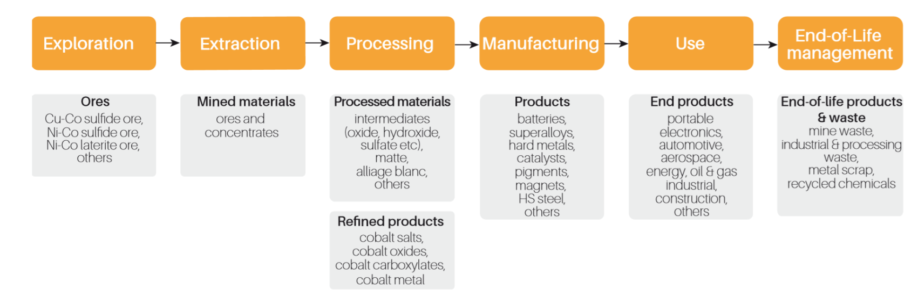
The supply chain for cobalt is illustrated below in figure 14 based upon ores mined in the Democratic Republic of Congo. (Frankel, 2016)

Figure 14 - Route of DRC Cobalt - (Petavratzi, 2016)
Global demand in 2020 was approximately 115,000 tonnes and is set to rise by an additional 9% by 2026 to around 190,000 tonnes. Continued usage in battery technology and electric vehicle advances is the primary outlet for cobalt at 41% of the market. Other applications are superalloys and specialist tool materials. Geographically, major markets are held in every continent however Chinese dominance is becoming more evident. (Expert Market Research, 2020)
China owns around 50% market share for refined cobalt metal, and this is also represented by Chinese ownership of DRC mines. (Gulley, 2019) Illustrates below in figure 15 Chinese dominance against the rest of the world with respect to refined cobalt supply. The graph shows a small percentage of DRC Chinese owned mines, yet influence grows as production shifts to intermediate materials and fully refined cobalt. This relationship means that Chinese influence within the DRC will continue to grow as production rates of refined cobalt increase, therefore a stable relationship is
required between the two countries and is exemplified if the case of a Chinese loan of $5 billion in 2007 to the DRC in exchange for access to raw materials including cobalt (BBC, 2007).
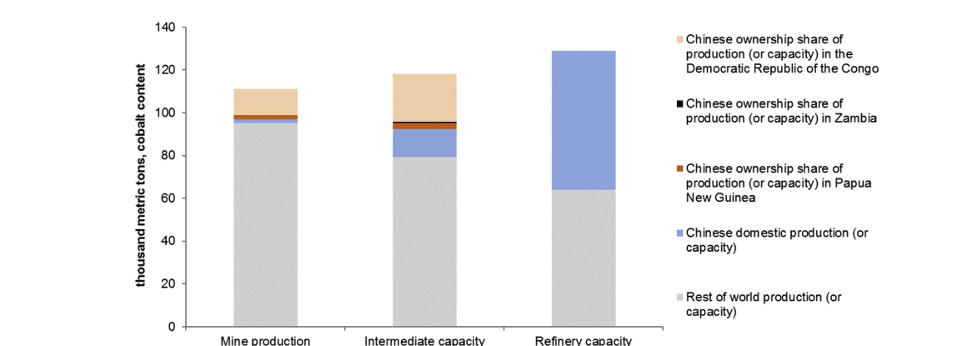

Figure 15 - Gulley 2019
These statistics represent that global supply of refined cobalt metal is heavily influenced by China and their relationships between other countries which is a potential risk to cobalt supply for European organisations.
Furthermore, it is reported that due to Chinese dominance in controlling global cobalt supply, European companies such as Volkswagen and BMW are looking directly to the DRC which due to taxes is causing major cobalt companies to stockpile and delay supply to other areas. (Mining Technology, 2018)

Refining
In order to achieve pure cobalt metal there are similarities with nickel refining where processes such as smelting, and electrolysis are used. With smelting the ores are reduced to a nickel/cobalt alloy before being separated by electrolytic means. Where appropriate, flotation is also used to produce a ‘matte’ concentrate which goes into further treatments of smelting and electrolysis. (Petavratzi, 2016). The raw materials are agitated mechanically and by pneumatics until air bubbles in the bath carry the refined product to the surface. Dependent on whether copper or cobalt is preferred, the bath solution can be adjusted so the floatation process has a bias to what materials are attracted to the bubbles. At this stage the ‘cobalt’ rich material is around 15% purity and will move onto a thermal and electrolysis method for increased purification. In the case of copper-cobalt material, the process is to melt and oxidised the cobalt into a slag above and iron melt, from here the slag is re-melted via electric arc furnace and reduced using carbon to a iron-cobalt alloy. In Nickel rich minerals the preferred method is electrolysis and other methods such as ammonia pressure leaching and solvent extraction. (Taylor, 2021)
Refining by electrolysis produces cobalt of purity greater than 99% which achieved by dissolving raw material and electroplating pure metal onto a cathode. Typically, a cobalt salt such as cobalt chloride is placed in an electrolytic bath and circulated across a cobalt cathode where pure metal is deposited. Process conditions such as chemical additives, temperature, electrical current and pH levels in the bath determine the efficiency and quality of the product. (Manilevich, 2013)

Ethical Concerns
According to the DRC government around 20% to 40% of exported ores are mined from small independent ‘artisanal’ mines. This type of mining does not have any sophisticated equipment and often involves hard manual labour to dig and extract the ores before being sold to larger organisations. This supply is unreliable and can be affected by several factors such as land ownership disputes, sickness, disease, and strict regulatory restrictions. Constant political pressure with regards to ethical sourcing, sustainability along with health and safety and well as human rights and child labour claims has resulted in restriction of mining in the DRC. The restrictions for example include registration of workers to prove they are over 18 years old, structured, agreed extraction zones and physical restrictions such as max vertical depth are common which limits the amount of extraction possible from that area. This together with political unrest and poverty give potential risk to the cobalt supply which results in less ore extracted and therefore less refined cobalt metal. (Faber, 2017)
Despite outside influence the improve the situation, local workers continue to mine as a means of earning a living. Thousands of locals, including children dig by hand and sleep in the underground mines to find cobalt minerals and provide for their families. It is reported that around 100,000. The government in the Congo admit they are aware of the conditions and that children are being used to mine however with the likes of tech giants Apple benefitting from the supply, this is unlikely to change. Child labour is difficult to avoid as there are a lack of schools in the country and officials say, “we have no solutions”. The Washington post reports that pay is based on mineral discovery and averages around £3 per day. Furthermore, these miners are in continuous danger of cave collapses and deaths are common. In September 2015 thirteen miners were killed following a cave collapse and another 15 a few months later in an underground fire. A local worker was interview and was quoted “they don’t care” in reference to bigger organisations prioritising profits over health and safety.

Waste Management
Environmental pressures over the last 40-50 years have pushed the agenda of waste reduction to the point where industry is actively seeking solutions such as reduced packaging, products designed for recyclability, and even specific recycling targets. Despite this and other factors such as ethics and increased focus on sustainability, industry still generates a vast amount of solid waste. Using material from the waste stream back into manufacturing is a highly effective of reducing waste and increasing recycling as-well as providing an economic cost saving benefit. For example, within ceramic manufacturing it is a well-practised method where waste products from mining are of similar composition to and compatible with the desirable raw materials. Recycling of waste is an effective way of reducing landfill and pollution however a more cost effective and preferred method is to reduce at source. Focusing on re-use or prevention at source minimises waste streams and prevents any further processes need for recycling such as heat and chemical treatments where investment into equipment and technology is required. (Menezes, 2012)

Waste Hierarchy
Within the subject of waste management, a waste hierarchy can be discussed. The hierarchy lists the most desirable solution of waste prevention, to the least environmentally friendly solution of non-recoverable landfill. Figure 5 below is taken from a UK DEFRA document which can be applied to manufacturing.
Waste Hierarchy Model
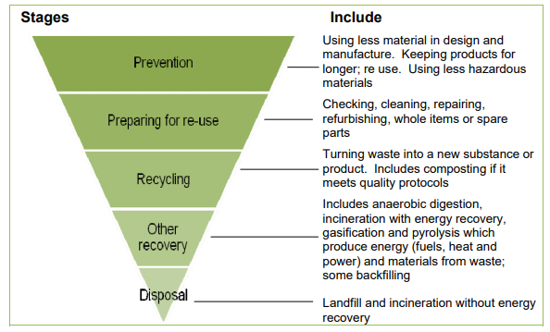
Figure 16 – DEFRA.gov.uk model of The Waste Hierarchy

Prevention
In terms of waste prevention, it could be argued that this warrants its own discussion and should not be part of the waste hierarchy as concentrating on this area would be the most effective tactic in working towards environmental goals. However, when considered linked to the other categories its is an essential activity as preventing waste at source will eliminate any necessity for the following tiers (Cooper, 2014)

Re-use
Where waste prevention is not possible the 2nd tier of preferred solutions is to actively repair, refurbish and eliminate single use items. An example being shopping bags and re-usable coffee cups. This solution effectively challenges the ‘throw away culture’ that has developed into most people’s lives. (ISM Waste and Recycling, 2021)

Recycle
Recycle is not actually as desirable as one might think. Whilst preventing landfill and incineration, recycling can often be a labour and energy intensive process. Recycling scrap paper for example uses significant water and electricity supplies. Quality of recycled products is often reduced in comparison to the brand-new equivalent products. For recycling to be effective it takes mass participation, organisations will require investment into dedicated recycling points and a solid on-site infrastructure to manage materials with respect to segregation and collection, all of which can take significant resource. Curb side recycling has shown to be quite effective however many continue to dispose recyclable materials within general waste. (WhatPlastic, 2021)

Recovery
Recovery references energy recovery rather than material. It is a single use activity where toe material cannot be re-used. Anaerobic digestion where food waste and other organics are digested into a slurry, methane recovery from landfill where gas is collected and converted and incineration where waste is burned into ash are all examples of waste to energy processing where waste material is prevented from landfill and will generate electricity as a product. Whilst reducing landfill tonnage there is environmental concerns regarding some of these processes and can often be detrimental in the forms of emissions and the ‘new’ waste left behind. (Health and Safety Executive, 2021)

Disposal
Disposal is the final and least desirable activity. This adds to already vast landfill sites with no end use for the waste. Environmental issues with landfill sites are well documented with the amount of methane released into the atmosphere regularly reported to be adding to climate change. Other concerns are over the physical land damager in terms of space, as well as toxins leaching into the surround ecosystem effecting both wildlife and vegetation fertility. To counteract some of these concerns there are significant costs associated to landfill such as groundwater treatments and strict environmental permissions. (SL Recycling, 2021)

Criticisms
There are some criticisms of the waste hierarchy from an economical cost -benefit point of view. If the cost of recycling outweighs the profitability of the manufacturing the company would cease to trade. A study of this issue was undertaken by Volleberg and Dijkgraaf found that disposal (least desirable) was cheaper in costs than processing costs of waste to energy solution which would normally sit above in the hierarchy. (Environmental Assesment Institute, 2005)
With further reference to glass and ceramics the hierarchy is to prevent, prepare for re-use then recycling within a re-melt process before moving onto energy recovery and final disposal.
Within the steel industry high iron slags are fed back in as a feedstock to the process however there is still an ultimate waste product that serves no purpose in steelmaking. From here the majority is used in the construction industry as sub-base and ground down into cement formulas. Whilst providing a relatively easy outlet the investment required in granulation factories it is not the optimal solution overall, hence the high amount of re-use at source within the steel industry.
When applying the hierarchy to slag formation in induction air melting it is difficult to appraise prevention methods. A chemical reaction with the surrounding environment is what causes slag formation and is only avoidable by implementing vacuum technology which thus far hasn’t been explored by LSN. The next method down is re-use, which again is difficult as the primary slag must be removed from the melt to pour into the atomising vessel and is also in small quantities of around 1-2kg per melt. Therefore, the focus will be on how to recycle the waste by using an economic batch size for a full furnace run and extracting any secondary slag before atomising the remaining metal.
From here a secondary waste slag will have been generated and will require another outlet. Further recycling is possible within construction and insulation industries before moving further down the waste hierarchy where slag is used in waste to energy recovery and least preferable landfill.
Further to slag, there are other wastes applicable to induction melting and atomisation. Excess electricity and melting at excessive temperatures will have a high expense and can be prevented easily by increased process control and robust instructions. Atomising an alloy at 1500C will be substantially cheaper than an alloy at 1700C with respect to both energy and furnace refractory. Further into the process, using a high flow nitrogen set-up (traditionally for fine sized powders) where only a coarse powder is required can be considered a large waste as there will be over-engineered material with a higher amount of nitrogen units used that required. Again, this can be prevented by establishing robust process instructions.

Modern Interpretation
A modern model of the waste hierarchy puts greater emphasis on prevention at source with respect to design the problem out. A culture change with respect to influencing consumption habits, commercial business strategy and value retention as the model cascades.
The hierarchy contains further detail and additional steps. The new seven step model driven by Zero Waste Management puts further emphasis on the equipment and resources required to undertake to activities of each process. The model is shown below in figure 7 and begins with a Redesign of business models and commercial activities with respect to a zero-waste culture. An example of this is eliminating single use items such as coffee cups and introducing re-useable items. This philosophy should lead to a systematic reduction of waste at source but is heavily focused on business, operational and commercial decisions.
As per the traditional model, the second step is focused on Re-use. The major difference of the newer model is rather than finding outlets for re-use items there is a drive to increase the market and demand of re-useable products. This is done by limiting the production of wasteful products and increasing the value of reusable components by actively sourcing outlets for these items.
Tier 3 is related to the previous with respect of re-use. The focus of this level is the Preparation of the items to increase re-use. An example is refurbishment of washing machines and refrigerators which requires a resource before the item is fit for purpose.
The next level down the model is Recycling. Like the traditional model this tier is predominately aimed at turning waste products into a new useable material. Added attention is given to separating waste streams and increasing the quality of the final produced material. E.g., converting cardboard and paper into high quality packaging rather than a waste to energy solution.
Further down the model is Recovery. This process is typically where waste streams have been mixed and separation has been poor. An undesirable level when compared to the previous tiers of the model due to energy and resources required however the focus is still on extracting valuable good where possible and adding newly separated waste back into its original stream of material. For example, a chemical or recovery of plastics is possible on the condition the correct plastics are used in the feedstock. Any incineration or energetic recovery at this point is where the system has failed.
Residual Management, the last but one level of the model puts focus onto safe landfill. Landfill should be avoided if the previous steps are successful however any residual waste at this point must be safely discarded. An example of this is where harmful wastes are neutralised to an eco-friendlier alternative. The space is still required however the environmental damage is reduced.
The final and least desirable tier is classed as Unacceptable Waste. To be avoided where possible this category is reserved for non-sorted and non-stabilised landfill. Also, in the category is incineration which is an environmentally damaging process. (Simon, 2019)

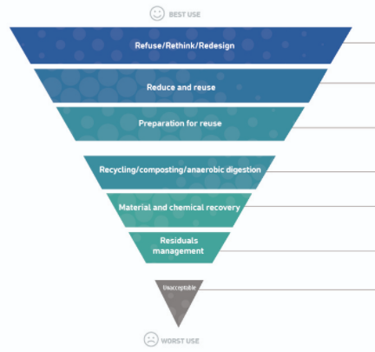
Figure 17 – Modern view of the Waste hierarchy

Current Recycling of Slag
There is extensive literature on the use of slags within construction with respect to technical information such as chemical make-up and its effects on the final product, for example water absorption and abrasive resistance when used in cement. There is less information available on the quantities and economy of scale as a global, environmental issue however it is clear that the issue of slag generation is common across many different processes both ferrous and nonferrous melting. Industry is less forthcoming with releasing technical ‘in-house’ recovery methods and process information with regards to processing slag and recovering metals however there are some standard general practices available such as granulation, mainly related to the steel industry and more specifically blast furnace processing of pig iron where slag is reduced back to a usable iron concentrate.
Globally, approximately 500kg of slag is produced for every 1 tonne of rolled steel, which in 2016 would equate to around 1 billion tonne of steel slag to be managed. Simply, landfill costs are rising and therefore an alternative option such as recycling or conversion to a usable forum is desired. A widely used outlet for ferrous slag is the construction industry in the form of road sub-base, embankments, pavements, and concrete additives. Sand can also be produced from iron slag once granulated and screened down to a specific size and has been shown to give similar characteristics as commercially sourced sand. An alternative based on recovery is to use slag as a direct iron feedstock source as it will contain approx. 20% iron but will require a treatment such as acid leeching prior to this to further boost the iron content and remove impurities. (Zhang, 2019)
In basic oxygen steel making pig iron is processed through a blast furnace. A by-product from this process is alumina, silica and calcium-based impurities in the form of glassy slag material. When cooled the slag can be granulated and used in construction industries as ingredients in cement. The desired properties of the final product will dictate the amount of slag that can be utilised as it can influence mechanical related properties such as compressive and tensile strength, shrinkage properties, permeability, and chemical properties such as corrosion resistance. To ensure no metals are left within the slag the ground material is de-magnified and from there can be used as a binder material. Previous studies have shown that the inclusion of slag within cements increased the strength, improved rheology, and workability of the final product due to less water absorption when compared to other additive such as lime as well as reducing overall unit costs per kg. (Ozbay, 2016).
Despite some high usage within cements, there is an industry concern with regards with alkaline reactions between the slag and the cement that are potentially detrimental to the overall application with respect to corrosion resistant and more research is required into this area. (Cardoso, 2018)
Refining of nonferrous metals will also produce slag. Copper extraction for example is reported to produce around 2 tonnes of slag for every 1 tonne of copper therefore an economical outlet for by-products is critical. Like steel industry, copper slags are granulated and used within cement due to properties such as low water absorption when compared to other aggregates. High iron content means the material is often used as a replacement for iron powder itself (a process material in copper refining) at a lower cost, whilst being able maintain environmental metal leaching restrictions. (Shi, 2008)
Further reasons for the use of slag in construction are that it provides a greater hardness and therefore stronger roads, better friction characteristics and performs stronger in load bearing situations than materials such as natural rock. (Steiniger, 2014)
Thermofisher reports that other common uses for slags are agricultural to improve crop yields, insulations for buildings and ships as well as marine structures such as sea walls. This wide range of applications provides an economic and environmentally friendly solution to a product that is potentially destined for landfill. (Dietz, 2014)
With respect to selling slag as a waste outlet, many of the applications require slag to be processed first, either mechanically or chemically. Chemical processing will be to purify the chemistry or to extract valuable metals, for example slag generated by lead smelting will require reduction of lead levels before being used in soil applications. Initial chemical analysis is required and typically followed by treatment such as acid leaching to adjust the chemistry closer to the end products. Mechanical processing will include sorting, crushing, grinding, and screening, all these processes can be financially unviable, and some companies will just dispose of as landfill. (Ettler, 2004)
Taking just steeling making as an example, processing blast furnace iron alone produces around 300kg per tonne of metal a year equalling to 345 million tonne of slag which emphasises the economic impact across all industry in terms of finding an outlet for this un-wanted by product (Tan, 2018)
Slag, by weight accounts for around 70% of steel making solid wastes – together with increasing pressure on industry to fulfil environmental obligations has meant that slag recycling and usage has increased. In China specifically, there is an increasing demand on improving building quality. Fire proofing, sound insulation as well as thermal retention for example are driving up the demand for slag-based fibre insulation. (Yongli, 2011)
Insulation manufacturers use a large proportion of slag to create fibrous strands of ceramic material. Slag is melted down and either put through a spinning process or drawn. The slag containing mainly aluminium and silicon oxides can show excellent insulating as well as high temperature properties when mixed with small quantities of other raw material. (CCEWOOL, 2015)
Market leader in insulation production Knauf Insulation has recently invested in a new manufacturing facility in Luxembourg as well as plans to further upgrade existing facilities in Serbia and Slovakia. The new facility will enable an additional capacity of 110,000 tonnes of slag wool for 2019 – this will contain approximately 40% blast furnace slag. (Knauf Insulation, 2017)
Slag granulation is a widely used technique in industry as multiple outlets for the products are available. For example, fine dust can be used in cements and fibres in insulation. Both are often produced in the same process or via combined centrifugal and air blowing technique. Processing parameters such as rotary speed of the centrifuge will show a bias towards one or the other- higher centrifugal forces will produce more fibres. (Tan, 2018)
Slag wool has shown to be produced when using up to 80% slag content which suggests a highly economical outlet for waste. A level 60% slag content has shown to be optimal with respect to mechanical and thermal properties of the final wool which would still provide an economical outlet. (Zhao, 2014)
A typical rock, glass, slag or mineral insulation fibre will begin at melting down in a cupola furnace where it can be heated in coke. Acting oppositely to blast furnace, the molten slag material is the product, and any iron is removed for recycling. Once molten, the material is poured onto a spinning line and injected with air. The centrifugal force will split the material down into strands whereas the air will allow stretching into a desired length. To create a finished roll or ‘fleece’, binders are added, and additional processes are required in terms of collection, forming, and cutting. (Knauf Insulation, 2017)

Methods

Segregation
To tackle the first aim of recovering value there are multiple elements. Initially the objective is to qualitatively analyse and pre-sort 800kg batches of waste slag into ‘high Nickel’ and ‘high Cobalt’ batches. Sorting at this stage is highly beneficial as it will keep the two major metals of highest value separate. Alloying Cobalt and Nickel together would reduce the costs on sale or reduce usability in the process as these are considered two different product streams.
Once sorted the batches will be loaded into an induction furnace and melted. This process will allow oxides to be removed before the metal is poured into the atomising vessel and converted into a coarse grain powder, aiming for a particle size distribution of 1µm-500µm. The atomising medium will be nitrogen gas and the powder collected in water. The wet slurry will be dried, homogenised and analysed. The powder will be characterised using ICP to determine the alloy composition to 0.1% and therefore the percentage of Nickel and Cobalt recovered. Further to these physical properties such as hardness (Rockwell), morphology (optical microscopy) and particle size (laser diffraction) will be determined to give a full profile of the ‘product’.
Each batch will be weighed to determine a process start datum for mass balance. Waste will be sorted into ‘high Cobalt’ and high’ Nickel batches using a handheld XRF analyser. Positives of using such a device include ease of use, speed of results as well as relatively accurate figures. A downside to the instrument is the resolution accuracy and in particular certain elements, such as Boron cannot be detected by XRF which is typically contained within most LSN alloys. For sorting purposes of major base- metal, the elements Nickel and Cobalt detectable and the accuracy is not critical as the segregation is based on the major element in the matrix at around 75%.
From here both batches will be loaded into the furnace and melted to a liquid state. Any further oxides and slag will be removed from the melt before being atomised into a powder.
Weights will be recorded at each stage of the process to determine yields at each gateway.
Based on the above objective, the chemical analysis will determine how ‘useable’ the metal will be as a feedstock for LSN alloys. A typical Nickel and Cobalt alloy will be selected from LSN’s portfolio, and a theoretical formulation will be undertaken to determine how much of the recycled material can be used.

Atomisation
The atomising method to be used is a ‘wet gas’ method. The molten stream will be impinged using nitrogen and collected in water. Justification for this over a full water/water process is that gas atomising produces more spherical particles, and the material will be easier to handle once processed. Water atomised powder produced irregular powder with poor flow characteristics which would potentially cause unnecessary issues with respect to handling the material through any equipment further down the line.
The wet gas ‘hybrid’ method has the benefit of using water as a collection medium rather than filling the vessel with nitrogen -this keeps costs very low when in comparison to dry gas atomising where inert gas is required to pre-purge the tank, atomise the powder and protect the powder while cooling.
Within gas atomising there are two common set-up/ process styles. Close couple atomising and free fall atomising. Closed couple atomising is traditionally used for finer powders less than 45µm however that would be over engineering for these exercises as particle size is not critical. Essentially closed couple atomising relies on a gas flow around the nozzle and venturi effect or ‘suction’ to draw the metal through the die before being atomised instantly upon exit. Nitrogen jets immediately hitting the exit of the nozzle can result in premature freezing of the metal and has a higher rate of blockages. Due to the high oxygen content of the slag material, it is expected that the viscosity will be higher, and a more difficult process is expected, therefore using a free-fall method will be more forgiving
Free fall atomising will allow the melt to fall under its own gravity and will help prevent any blocking should the melt pool be particularly viscous. Rather than molten metal traveling out of the ceramic nozzle and being directly impinged by gas jets, the metal is allowed to fall a certain distance and is gently guided by a primary shielding gas. Not atomising instantly will allow temperatures to remain high around the exit of the die. Once the molten metal is allowed to fall approx. 20mm it is then atomised with a secondary gas supply and typically gives a powder distribution of 50-500µm.
Figure 18 below shows free fall atomising (left) where the metal flows much lower from the tundish before being atomised. The gas is directed at a downward angle. Closed couple (right) shows gas jets hitting the exits nozzle directly horizontal which creates a venturi tunnel at gas flows down the sides of the exit nozzle, at the expense of potential freezing and blockages.

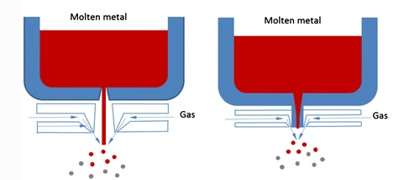
Figure 18 - (Sun, 2017)

Drying
Wet gas uses water as a collection medium therefore powder it is required to go through a drying cycle. The wet powder slurry will be decanted into a large tumble dryer until moisture is removed. This process as the added benefit of homogenising the powder for sampling. The dryer is essentially a large double walled drum which rotates. A hot oil generator circulates oil in between the two walls and keeps the temperature at a set point. The powder slurry will tumble as there is approx. 50% empty space. On contact with the internal surface of the dryer walls water will be driven off and extracted into a steam collector, leaving behind a dry powder. The speed of the dryer rotation will affect the time in contact with the internals walls, rotating too fast will not allow sufficient hot-contact and drying time will be increased. There is a gauge on the hot oil generator which determines when the material is dry. The gauge reads in %power load- at 100% power the material is wet, at approx. 30% power the material will be free from moisture. Figure 19 below shows the dryer equipment. Above the dryer is a platform and a trap door which aids loading the slurry. The pipes on the left of the image are the inlet and exit for the oil flow.
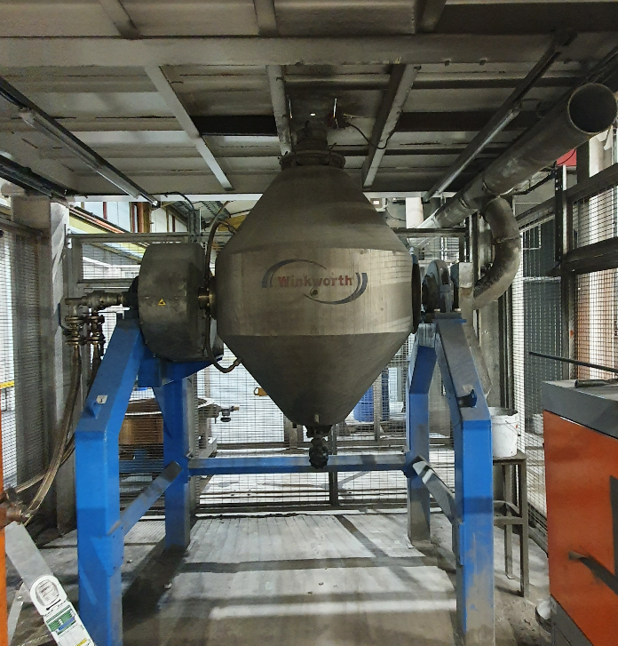

Material Analysis
The powder will be analysed for chemical composition using ICP accurate to 0.01% Particle size distribution whilst not important will also be measure by hand sieve as any customer will require information regarding format of the material. Physical characteristics will also be measured with respect to flow rate, density and morphology as customer will require this detail to determine if their own equipment can process the ‘new’ material.

Cost Benefit
Once it is determined the value recovered the costs of the process with respect to labour, equipment and consumables will be taken into consideration. Further to this, costs required to install a dedicated production line for recycling will be calculated against potential savings in a cost benefit analysis. A significant investment would be required however there will be a buyback time and a business case can be proposed.
Value will be determined by the market prices of Cobalt and Nickel at the time of analysis. This will be calculated on the number of kilograms yielded from the process multiplied by the percentage of the elements in concern. The final value of material will be appraised against the overall processing costs in terms of labour, energy, and capacity. This will determine whether it is commercially beneficial to invest in additional equipment for re processing of waste on site.

Results

Sorting
Using an XRF gun approximately 2 tonnes of waste slag was split into three batches. The batches were identified as the following –
- Nickel content over 25% by weight
- Cobalt content over 10% by weight
- No significant element
As the XRF sorting procedure is based on scanning a small area of a solid mass the sampling is non homogenous and therefore subject to errors and the value is determined on the final product post processing.
The first two batches were loaded into a pre-melting area and batch no.3 was discarded as insignificant value.

Atomisation run 1 – Nickel Alloy
Batch number one of 750kg, identified as ‘unclassified alloy - contains Nickel’ was loaded into the induction furnace manually by an operator. Around 30kg of material was initially loaded to determine how difficult the melt would be and to establish a molten pool before loading the remaining material in intervals. The material is loaded in intervals to maintain a molten pool throughout the process and any chances of ‘bridging’ the melt.
Once fully loaded and molten- approximately 45 minutes, the operator turned the furnace off and allowed the slag to float to the top surface and removed accordingly. This was repeated once more to ensure any secondary oxides were removed. Once all slag was removed a temperature lance was used to record the temperature and reading of 1705°C was taken. A typical Nickel alloy would reach a liquid state by 1500°C however the high oxide nature of the waste material required a higher energy input to reach a suitable viscosity for pouring.
The atomising set-up selected was a free-fall design with a relatively low atomising gas pressure of 110 PSI. The gateway nozzle chosen was 8mm in order to give a low- gas to metal ratio and therefore a coarse grain powder. The liquid metal was poured into the atomising vessel and took 19 minutes until completion. The furnace power was reduced in incremental portions as the thermal mass in the furnace reduced over the production run which helped retain the temperature around the required 1700°C. The atomising head was stripped after the run and some spray-back frozen metal was evident which suggest a small freezing range of the ‘alloy’ which is evident by the elevated temperature required. Figure 19 below shows spray back frozen metal on the underside of the atomising die.
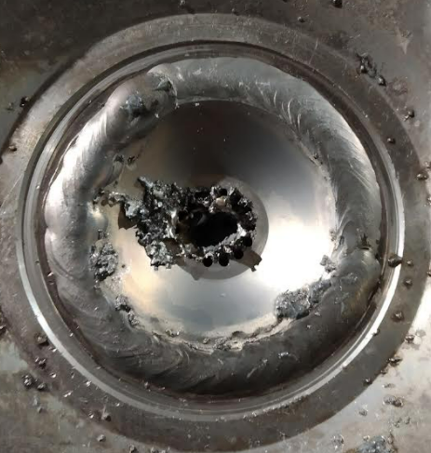
Figure 19
Atomising operator reported the melt visually looked higher viscosity than normal which suggest a ‘dirty’ alloy containing oxidation. The powder was allowed to settle in the water tank for around 20 minutes before the wet slurry was loaded into the tumble dryer. The dryer was heated to 200°C and the steam extracted until all moisture was removed – taking around 90 minutes. The powder was decanted into a tared bin and weighed. The final weight of the batch was 575kg, meaning a melting loss of 175kgs and a yield of 77%. Losses are attributed to slag removal. Typical this would only be around 15kg however the re-melting of slag will inherently have more slag to remove than that of a virgin metal melt.

Physical Analysis
During melting small cast coin was taken and used for hardness checks. This will give an idea of application potential and usability with respect to blending into other products. Using Rockwell hardness C, the cast coin recorded a hardness value of 55HRC. 55 hardness is at the higher end of any application use and would only be suitable for a crude flame spray coating for abrasive protection.
The particle size distribution was measured on a 100g sample using calibrated hand sieves with the following results:

Micron Size | %Retained
250 | 13.5
180 | 9.5
150 | 4.5
125 | 4.5
106 | 6.5
90 | 3.5
75 | 8.5
63 | 8.5
53 | 6.5
45 | 7.5
38 | 3.5
20 | 9.5
<20 | 14

Chemical Analysis
A 0.1g sample was dissolved in hydrofluoric acid and composition was test on an ICP spectrometer. The composition was measured as follows:
Al | 0.09
B | 0.89
Co | 7.35
Cr | 12.68
Cu | 0.1
Fe | 19.66
Mn | 0.31
Mo | 1.25
Nb | 0.13
Ni | 52.11
P | 1.21
Si | 2.79
Ti | 1.42
W | 0.01
Zr | x
C | x
S | x
N | x
O | x
V | x
Ca | x

The analytical program and elements selected to analyse were identical to what is used in normal production. This gives a comparison to how ‘saleable’ the alloy might be.
The Nickel content was measured at 52% which represents considerable recovery. As an alloy the trailing elements such as the 12% chrome and high iron content (20%) mean the alloy is not suitable for current customer applications within LSN’s portfolio. For accounting purposes, the material could be valued in terms of Nickel units i.e., 575kgs x 52% x current price - £14 per kilogram. This would mean a recovered value of £4186. The value however would decrease significantly should the material be sold. Scrap metal traders buy based on the alloy composition and this non-classified, mixed alloy would typically generate around £2 per kilo on sale – a total of £1150. In this scenario the metal is worth a higher value to hold than to sell and an this could be fed into other products at a rate of X kilograms per batch to utilise the material. Each element cannot be individually reclaimed therefore the usage of the Alloy as a whole at a yet to be determined rate is where the value is gained.

Atomisation run 2 – Cobalt Alloy
Following the nickel alloy through production would mean a higher level of nickel as it would pick up from the furnace lining and the drying equipment despite an effort to clean down. Therefore a ‘normal’ nickel alloy campaign was programmed for the remaining week before revisiting the cobalt containing waste after a complete re-lining of the furnace refractory.
The material was loaded by hand as per run 1 with a quantity of 500kg. Due to lessons learned on run 1 regarding increased temperatures the furnace was charged at full power from the beginning to melt the material quicker which saw the material become fluid after a shorter time of 30 minutes. The smaller batch quantity also helped progress of the melt as the furnace power could easily cope with the reduced payload. Once molten the furnace was powdered off to enable slag to float and removed until the melt was visually clean. The smaller batch means the top of the melt pool was lower in the furnace and de-slagging was more difficult for the operator. The furnace was tilted slightly to allow accessible slag removal before being returned to a vertical position.
Like the previous melt the metal was shown to have a viscous consistency even at 1700°C. The atomising set up was identical to the nickel material. The initial atomising run was abandoned after 10 mins where a ‘blowback’ event took place. This is caused by turbulent gas and hot metal splash backs which results in a gas flow upwards into the tundish. The tundish, die and nozzle were replaced while the melt temperature was retained at a consistent level. The 2nd run was atomised successfully without any blockages, taking and additional 15 minutes to pour. Once atomised and dried the final weight was recorded as 300kg, with a yield of 60%.

Physical Properties
The hardness coin was tested with a Rockwell machine as recorded a value of 60Hrc, slightly harder than the nickel material. The chemical composition has the biggest effect on hardness as elements such as Chrome, Boron, Tungsten, Carbon, Cobalt itself have all shown to create hardness in alloys.
With reference to the base metal, pure nickel has a hardness of around 50HRC, with cobalt typically measuring around 70 HRC (MetalMart International, 2012)
Particle size distribution was also measured as the below:

Micron Size | %Retained
250 | 15.5
180 | 8.5
150 | 5.5
125 | 6.5
106 | 5.5
90 | 3.5
75 | 7.5
63 | 9.5
53 | 6.5
45 | 7.5
38 | 3.5
20 | 9.5
<20 | 12

The size distribution resulted in a similar profile to the nickel run ( same process conditions used so this is expected) but with some slight higher percentage of >250µm particles.

Chemical Analysis

Al | 0.15
B | 0.04
Co | 49.77
Cr | 23.72
Cu | 0.1
Fe | 10.32
Mn | 0.41
Mo | 3.15
Nb | 0.18
Ni | 6.00
P | x
Si | 1.08
Ti | X
W | 4.49
Zr | X
C | 0.69
S | X
N | X
O | x
V | x
Ca | x

The Cobalt content was measured at 49% which would be considered a high value recovery. Like the Nickel alloy, the chemistry ‘as is’ does not fit any alloy within the LSN portfolio. The materials can be valued in Cobalt units as the followed: 500kgs x 49% x current price - £50 per kilogram. This would mean a recovered value of £25,000. Like the previous Nickel alloy, selling this metal would lose significant value as to cobalt units would be alloyed amongst other less desirable metal therefore it is beneficial to retain the material and drip feed into production at a rate to be determined.

Discussion

Useability of Recycled Material
In the chapters titled, ‘Material Flow’ a diagram, repeated below in figure 20 shows the flow of materials through the process at LSN. It is shown that after initial atomising and sieving, the powders that are under and over size from the product specification are fed back into the process to reduce material costs and keep the price of the process competitive.
The reprocessed powder is used in place of additional ‘virgin’ metal at a rate typically of around 60% powder, 40% virgin - the missing 40% being the yielded product from the first process. Before considering additional material recovery such as slag melting, this is the only recycled material and the slag waste in red is disposed.

.
Figure 20 - Material flow of initial process

Bringing in the processed slag and associated metal that is recovered, the previously disposed material is now represented by the green loop in figure 21 as an additional source of melting stock to go with the reverted powder and virgin metal.

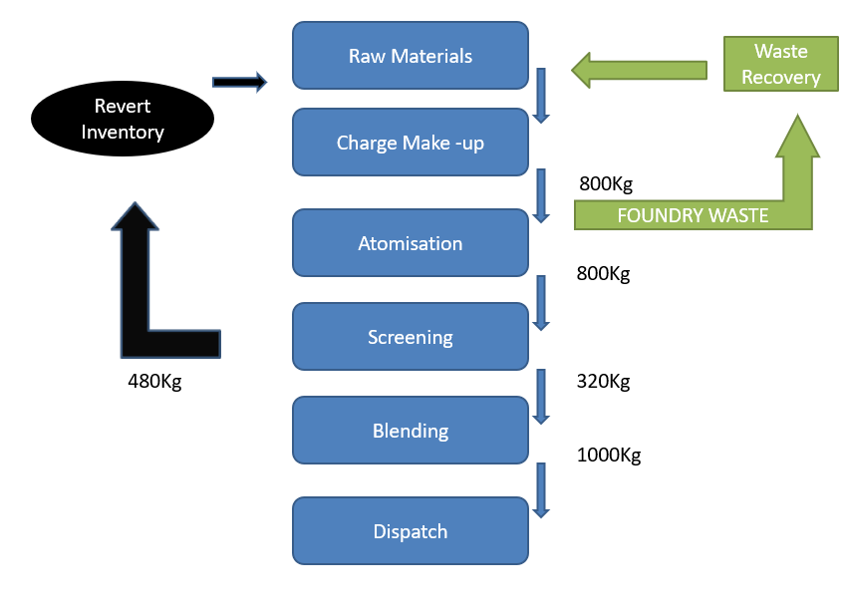
Figure 21 - New flow of materials including waste recovery

Use In Production
The quantity and rate of usage of both alloys will be limited by the alloy specification it is being fed into. A simulated melt run can be undertaken to determine approximately the usage ratio of recycled material to ‘normal material.
A software package titled Alloy Blending Software is used to theoretically calculate a given melt chemistry. The specification of the target alloy is input along with the chemical analysis of each material on the system. The software will determine the optimal recipe for the melt by selecting several materials from Virgin and revert powder along with the newly entered ‘Unclassified’ material.
Firstly, a common and high running Nickel alloy N580 is formulated to determine how much of the recycled material is selected. The N580 desired chemical constraints are as show in table 1 below:
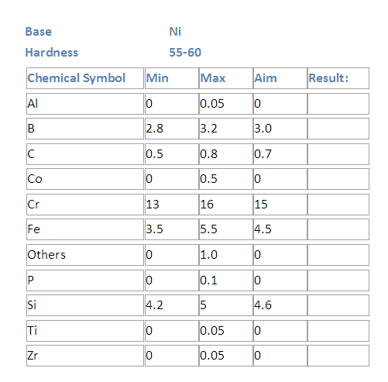
Table 1 - Chemical specification of Nickel alloy N580

Inputting these constraints into the Alloy Blending Software generated the following recipe:
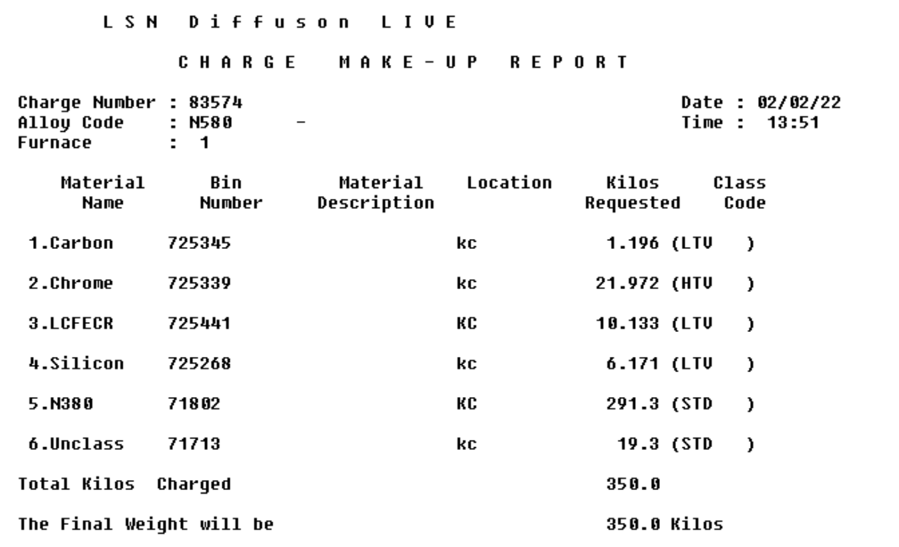
The overall level of recycled material is relatively high. Line number 5, ‘N380’ is a previously manufactured alloy, where the oversized powder is returned after sieving. N380 is a higher quality material and therefore ‘cleaner’ than N580 with respect to lower levels of chrome. This means that the software will instinctively select it as a suitable ingredient and 291kg is used to make up most Nickel units, with no virgin nickel required.
Some other virgin material such as carbon and chrome are added to fine tune the melt composition from the N380 more into N580, whereas the use of silicon aids the pouring process as it reduces the melt viscosity (despite not being essential to the product chemistry.
Under the given chemistry constraints there is 19kg of the newly recycled ‘unclassified’. To utilise the full quantity of 575kg a total of 31 furnace melts would be required. This could be reduced by increasing the amount of virgin Nickel to dilute to recovered material however this is counterproductive to the goal of the project.
Customer demand for this alloy at a particle seize of 125µm to 45µm is 3000kg finished product per month, which at a 40% yield of a furnace load represents 7500kg of metal, or approximately 20 melts. Therefore, it would be possible to use the recycled material within a month of production.

Second to the Nickel based simulation, a high running cobalt-based alloy, C06 was selected as an outlet for the recovered unclassified cobalt material. This product is again a high running material and typical of LSN production. The chemical specification of C06 is shown below in table 2.
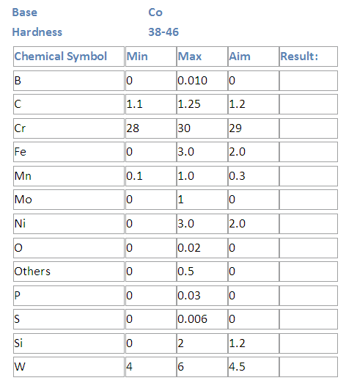
Table 2 - C06 Alloy chemistry specification

Inputting the chemistry of the C06 specification to the alloy software generated the following recipe :
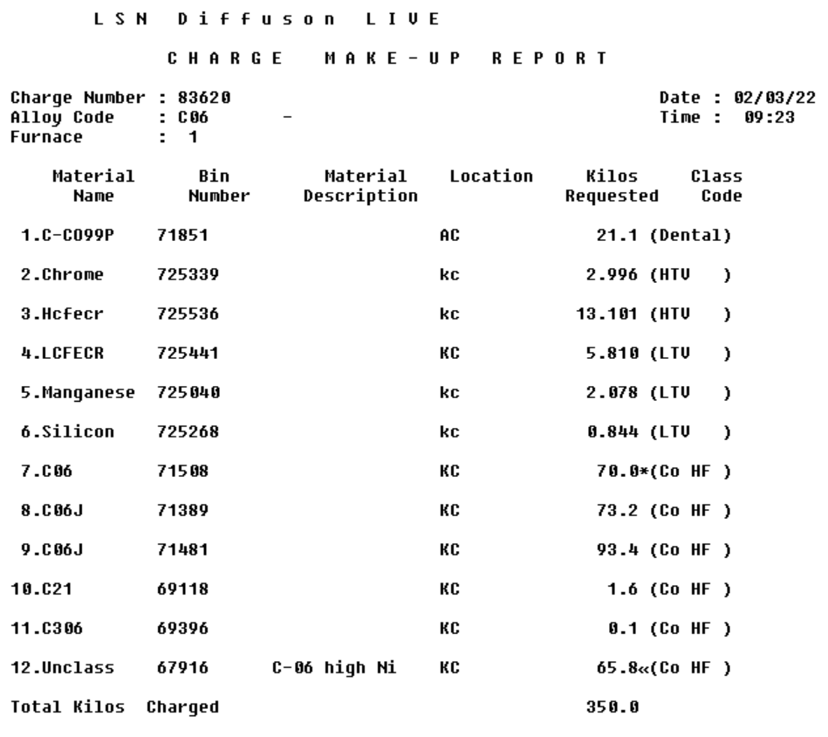
Similar to the Nickel simulation, utilising previously manufactured powders has reduced the requirement for virgin Cobalt, with only minor metals required to adjust the chemistry. 66kg of the ‘unclassified’ recycled slag is selected on line 12 which equates to 18.5% of the composition.
Monthly demand for this alloy is approximately 2 tonnes of finished product at a size of 180µm – 45µm. The particle size distribution is wider the nickel product therefore will be natural higher yield. Average yield is around 45% therefore to generate 2tonne of finished product 4500kg of inventory is required which equals 13 furnace runs. To use the full quantity of recovered slag of 500kg, at rate of 65kg the material would be used by the 8th production run.

Value Gained
Both Nickel and Cobalt streams recovered for waste have both showed high potential in terms of utilisation in main production and there would be a justification to further explore this method of manufacturing. A total of 575kg of waste was used in place of virgin Nickel- at the time of writing the price of Nickel is £17,000 per tonne, resulting in a saving of £9775.
The saving on cobalt, 500kg will result in a saving of £25,000 – with today price around £50,000 per metric tonne.
The savings will be analysed with respect to the processing costs and capital investment to determine the feasibility of investing in a dedicated process.

Environmental Issues

Trade Effluent
Once the furnace payload has been atomised into a powder, the product is collected in the atomising vessel where it settles to the bottom of the water tank. Once the powder is settled the excess water is pumped out into a secondary ‘wastewater’ tank. From here the water is filtered and discarded as waste. There are environment issues with this effluent as it will contain some suspended solids smaller than the micron size of the filter and some dissolved elements. There are environmental restrictions governed by the local authority.
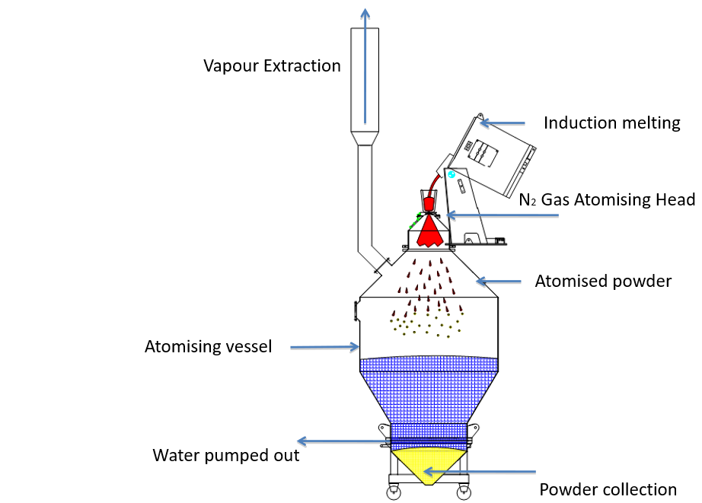
Figure 22 below shows an overview of the atomising process, water is decanted at the bottom of the vessel which enables maximum powder collection.

Figure 22 - Atomising Process

Once the water has been pumped out it is held in another tank as an intermediate wet waste recovery prior to being released as trade effluent. The waste tank is allowed settling time to let any residual solids sink before the water is discharged. Figure 23 below shows the settling tank where any solids are collected as a slurry in waste recovery effort, whereas ‘clean’ water is decanted to the sewerage system.

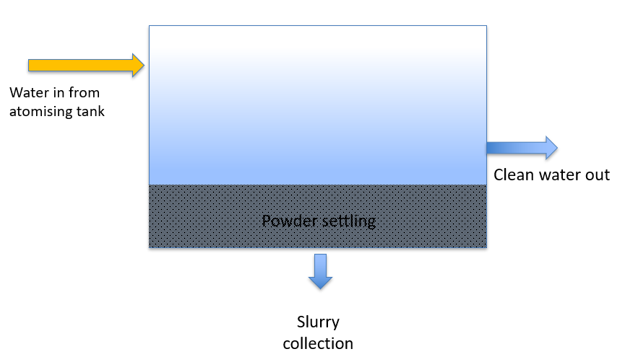
Figure 23 - Settling slurry tank

The discharged water is subject to environmental testing where the following permits are given by Natural Resources Wales and listed below in table 3:
Condition | Level Permitted
pH | 6.0-10.0
Suspended Solids | 250mg/l
Nickel | 2mg/l
Chrome | 2mg/l
Iron | 2mg/l
Phosphorus | 2mg/l
Copper | 2mg/l
Boron | 2mg/l
Molybdenum | 2mg/l
Tungsten | 2mg/l
Cobalt | 2mg/l
Total Non-Ferrous Metals | 5mg/l
Oxygen | 500mg/l
Discharge Rate | 20m3 / 24hr

Table 3-NSR Water discharge permits
A sample was taken from the discharge point and measured to the following values shown below in table 4:
Condition | Measured
pH | 8.0
Suspended Solids | 49
Nickel | 2.9
Chrome | 0.1
Iron | 0.1
Phosphorus | 0.1
Copper | 0.1
Boron | 0.6
Molybdenum | 0.1
Tungsten | 0.1
Cobalt | 0.1
Total Non-Ferrous Metals | 3.6 mg/l
Oxygen | 300mg/l
Discharge Rate | n/a

Table 4 - Trade effluent results
The analysis shows that all elements are sufficiently controlled baring Nickel. Nickel is the typical based alloy in most products made so it makes sense that of all elements, Nickel content would be the highest. An action to reduce the amount of nickel in the discharged water would be to increase the size of the waste tank and therefore the dilution and allow greater settling time so as much nickel dust suspended in solution would be allowed to fall to the bottom before water is discharged.
Further to this the discharge sample was dried on a hot plate to extract any suspended solids. The solids were measured for size by laser detraction which showed that approximately 60% of the sample was between 10 - 5µm, with the remaining being less than 5µm. Therefore, fitting a 5µm filter before the discharge point would eliminate 60% of the solids and potential bring the Nickel value into the permitted levels.

Air Pollution
Along with water waste any steam and vapour from the furnace during the melting process is extracted by local ventilation and discharges via a stack. This is also monitored with respect to air pollution. Further into the process – at the atomising stage exhaust gases are extracted are emitted via an extraction point high in the tower, this serves 2 purposes- extracting atomising nitrogen directly from the process (to maintain a positive insert atmosphere in the tank) and to extract steam generated when the hot metal is quenched in the water tank. Not purging and subsequently extracting the nitrogen would allow oxygen ingress and not extracting steam would result in unsafe pressured environment. The gasses are vented out via an external stack and are subject to the following environmental limits shown in table 5:
Table 5 - Air pollution permits
Condition | Level Permitted
Nickel | 5mg/m3
Cobalt | 5mg/m3
Chromium | 5mg/m3
Iron | 5mg/m3
Copper | 5mg/m3
Total Particulates | 20mg/m3

Recent stack monitoring result showed that LSN were within limits with the following results as shown in table 6.
Table 6 - Stack monitoring result
Condition | Result
Nickel | 1 mg/m3
Cobalt | 1 mg/m3
Chromium | 1 mg/m3
Iron | 1.5 mg/m3
Copper | 0.5 mg/m3
Total Particulates | 10 mg/m3

Iron values were shown to be greater as the production line manufactured iron-based alloys prior to the emissions testing. The results show that most emitted gasses are water vapour / steam driven off from water quenching hot metal.

Investing in a Process
With regards to capital expenditure in equipment, investing in a dedicated furnace could be cheaper than commissioning a like-for like design of current atomising facilities. Converting solids into atomised powder requires a 2-3 story atomising vessel, dedicated platform, steel work, gantry etc as well atomisation equipment such as high-pressure gas lines and collection equipment. To re-melt slag and recover the metal it would be cheaper to cast the molten material into brick sized ingots which will avoid the necessity for a large part of the process with regards to creating a wet slurry and tumble drying. A simple set up of a floor mounted tilting furnace with casting capability would be fit for purpose. A downside to this would be limitations to castings whereas another atomising line could also create substantial production capacity, should waste recovery is not prioritised.
Using a smaller batch quantity would be beneficial. Rather than using a convenience yet economic large melt capacity furnace it would pay greater rewards to emphasise segregation of waste streams. Keeping as much Cobalt and Nickel waste apart and melting in more concentrated efforts would potentially produce cleaner, higher quality waste which is in line with the modern philosophy of the waste hierarchy.

Equipment required
The furnace size will be specified at the same capacity as LSN’s ‘smaller’ furnaces at 350kg. This will give more frequent, yet greater segregated melt loads rather than a much larger ‘generic’ recovery.
Cost can be broken down as the following shown in table 7:
Table 7 - Cost of equipment
Equipment | Est. Cost | Purpose
Induction Furnace | £100,000 | Main furnace body for melting slag
Water cooler / heat exchanger for induction coil | £20,000 | Heat exchanger for keeping induction coil cool
5 Tonne electric loading hoist | £5,000 | Assisted lifting for casting ingots
Ingot preheater | £5,000 | Preheat ingot moulds
Extraction Unit | £6,000 | Extraction of superfine dust and fume during melting
HMI Instrument panel | £4,000 | Interface for controlling furnace power

Payback potential & future costs
The total estimated cost of equipment is £140,000 of capital investment. The savings previously calculated were a total of £35000 per month in metal purchasing, therefore the initial investment would have a pay back of around 4 months.
Further to this, processing overheads need to be considered. Factors such as electricity, nitrogen, water, and labour will all play a part in the economics of the ‘new’ process going forward as the value from each material recovery will deteriorate should these costs increase or should the value of the recovered metal decline.

Power
Electricity is estimated around £80 per melt for the induction furnace. Remaining power for the tumble dryer and hot oil generator will take the price of power to around £100 per batch, assuming the melt time remains approximately 30 mins and drying time around 1 hour.

Nitrogen
The amount of nitrogen used is heavily depended on the atomising time. The flow rate per minute can be calculated based on the pressure used and the atomising jet selection. The free fall head used in these runs was a ‘24x4’ configuration. Meaning there are 24 holes, at 4mm diameters. Based on this the equivalent single hole orifice would have a total area of 301mm². At 110PSI this give a volume flow rate of 1558NM³ per hour, meaning a 20-minute run would use 520 NM³. Priced at 15p per unit this would equate to approximately £80 per batch of atomising gas.

Labour
An operator would be required full time to undertake waste segregation at around a full 8-hour day per batch, costing approximately £15 per hour this would add a cost of £120 per run. Further to this a furnace operator would cost £20 per hour but this run would only take around 1 hour. Second to this would be another lower skill operator to decant the wet slurry and operator the tumble dryer, also around £15 per hour for 90 minutes. A total estimate labour cost per batch of recycled material would be £155.

Overall process costs
Adding all the above would result is a total process costs of approximately £335 per run which is relatively insignificant when considering the potential gains in metal value, given the inflated prices of Nickel and Cobalt in particular.

War in Europe
During the time of writing Russia has invaded Ukraine which has led to war in Eastern Europe. Western countries have sanctioned Russia with harsh economic penalties with an increased focus on western supply of materials. Due to the unrest and uncertain supply, Nickel trading (much of which is of Russian origin) has become extremely volatile. The LME suspended trading for 24 hours following a price rise which saw Nickel rise from $50,000 to $100,000 and then back down to $80,000. Following this contracts and current supply deals were cancelled. The LME described prices as “disorderly” and not representative of the physical market. (Reuters, 2022).
The LME considered a multi-day suspension as the physical disruption in Russian supply has caused many traders to panic and cover their previous investments which in turn caused a squeeze on supply. Similar issues have been raised in Aluminium and Oil industries. The graphs below illustrates the rapid spike in prices around March 2022 which coincides with the Russian invasion of Ukraine. (Journal, 2022)
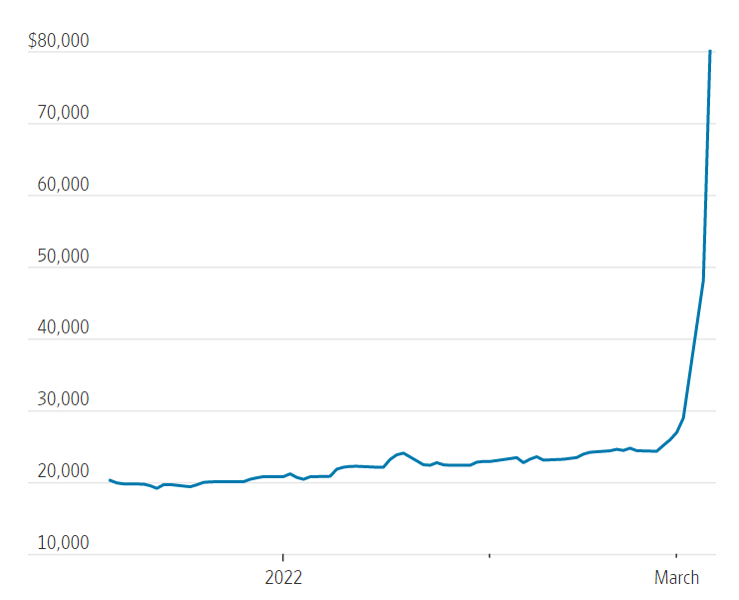
Figure 24 - 2022 Nickel Prices

This volatility has cascaded down to many Nickel suppliers demanding on the spot cash purchases and much reduced payment terms. LSN previously delt with 90-day payment deals for Nickel however many suppliers now demand a maximum of 30 days. This has led to a much greater emphasis on sale for LSN as the company now is required to dispatch sale before committing to further raw materials purchases, all within the same 30-day time frame. Some of these costs can be transferred onto the customer as LSN powder prices are often quoted as ‘metal plus conversion costs’ however some sales would have been pre agreed at a given £ per kilo and any metal cost in between the agreement would have to be absorbed by LSN. Going forward, the sale cost can carry a premium however this is already leading customers to source alternative products, such as Iron and steel which is cheaper than Nickel or Cobalt. Customers are beginning to trial surface coatings with iron materials to assess performance compared with Nickel as they are actively seeking to reduce their own purchasing costs.
Despite the economic climate, this presents some potential growth for LSN. Many customers are within the American oil and gas industry, which due to less Russian oil supply will naturally increase. Existing customers usage rates of LSN powders will increase as more oil is mined and refined in North America in the coming months. Longer term there is potential for a downturn in business, not just due to metals but also the rising increase of energy could see customers production rates decrease as they begin to cut costs themselves by reducing production output. LSN is still within a growth period as a business therefore as existing customers may see a downturn this is largely offset with new business opportunities.

Recommendations

Short term
It is recommended that in the immediate future of 3 to 6 months, LSN put increased effort into waste segregation at source, i.e., during the melting process. Operators should be made aware of the potential value they are throwing away when considering slag as generic waste. LSN could look to colour code slag bins as Nickel and Cobalt containing waste and use the appropriate contains when the melt campaign is taking place. Putting emphasis on this would reduce the amount of sorting required and increase the quality of the wate at source before any processing is required. Mixing both Nickel and Cobalt slag in generic drums requires a labour-intensive sorting process and the potential for both streams to mix, giving an undesirable chemistry. Focusing on value retention using specific waste containers for Cobalt and Nickel slag during the melt process should see a cleaner and higher value product once recovered in line with the waste hierarchy aims of keeping a higher quality grade material prior to processing. LSN should retain the separated waste as material ‘to be recovered’, which whilst this would result in an increased inventory, the potential value held within the previously considered waste is difficult to ignore. The cost implications of this would be negligible as much of LSN delivery’s come in varying drum colours and would be an instant implementation. The biggest challenge is culture and change management of the operators in understand the importance and money within the waste product streams.

Medium Term
In the medium term, 6 months to a year LSN could look to recreate the trial batches on existing equipment during any production downtime. Often, production can be halted while waiting for raw material delivery and/or any shortfall in sales. This redundant capacity could be used to process slag waste initially separated at source and waiting to be processed. Using empty space and utilising the equipment would provide a slow trickle of additional melt stock. There would be no investment required to undertake this process as the equipment and facilities are already in place. Production planning would have to determine specific times where capacity was redundant and suitable batches of waste could be processed. The processing cost would be comparable to a ‘normal’ atomising process and significantly cheaper if the metal was simply cast into ingots rather than converted into a powder- saving on nitrogen gas and water.

Long Term
On the assumption that the test batches would be representative alloy chemistry’s, it is recommended that LSN puts serious consideration into installing an additional a furnace to specifically to recover foundry slag. The nature of the process and non-vacuum melting technology will lead to continuous supply of Nickel and Cobalt rich slag for the foreseeable future therefore an on-site process for recovering metal is seen as a highly economical investment. There is no need to manufacture a full powder atomisation line and a melt to ingot caster would see the same benefits of material recovery, without the requirement for atomising technology. The total capital investment, previously calculated around £140,000 would see payback at around 4 months should the line at a ‘normal’ production rate.

Conclusion
In conclusion, the volatile prices and vulnerability in supply of commodities will put greater emphasis on any ‘in house’ methods of saving material. The costs of a dedicated production line for this purpose are far outweighed by the usability of the recovered waste as both test batches were shown to be consumable within a month’s production.
An atomisation tank is not required as the recovered metal could be cast into usable ingots which would aid handling, rather than going through the expense of atomisation. A benefit of ingots over powder is that solid formats are typically more desirable when sold as scrap as suppliers do not require powder handing equipment and many metal traders are unfamiliar with powdered alloys. The downside of this is that should an ingot have a desirable chemistry for LSN to use internally, it would then have to be remelted a second time and atomised to a powder.
The cost of a dedicated waste recovery line would need up front capital investment and ongoing overhead costs however the continual gains of valuable material, along with increased price volatility in raw metal should push the investment and see payback within a short period of time and make LSN remain competitive in the powder metallurgy market.

Works Cited
Aitch, S., 2017. Rapidly Solidified Rare-Earth Permanent Magnets: Processing, Properties, and Performance. In: Advances in Magnetic Materials. s.l.:s.n., pp. 453-508.
AngloAmerican, 2021. OPEN-PIT MINING DEFINITION. [Online]
Available at: https://www.angloamerican.com/futuresmart/stories/our-industry/mining-explained/mining-terms-explained-a-to-z/open-pit-mining-definition
[Accessed 02 December 2021].
BBC, 2007. China opens coffers for minerals. [Online]
Available at: http://news.bbc.co.uk/1/hi/world/africa/7000925.stm
[Accessed 02 March 2020].
Cardoso, C., 2018. Using foundry slag of ferrous metals as fine aggregate for concrete. Resources, Conservation and Recycling, pp. 130-141.
CCEWOOL, 2015. Ceramicfibre.com. [Online]
Available at: https://www.ceceramicfiber.com/Article/ProductionProcessofC_1.html
[Accessed 10 03 2021].
Cooper, J., 2014. Waste hierarchy: challenges and opportunities, s.l.: ISWA.
Dietz, S., 2014. Slag: From By-product to Valuable Construction Material, s.l.: ThermoFisher.
Environmental Assesment Institute, 2005. Rethinking the Waste Hierachy, Copenhagen: Environmental Assessment Institute.
Ettler, V., 2004. Leaching of lead metallurgical slag in citric solutions--implications for disposal and weathering in soil environments, s.l.: Chemosphere.
Expert Market Research, 2020. Global Cobalt Market Outlook, s.l.: Expert Market Research.
Faber, B., 2017. Artisinal Mining Cobalt in the DRC, s.l.: Cega.org.
Frankel, T., 2016. Tracing the path from deadly hand-dug mines in Congo to consumers’ phones and laptops. [Online]
Available at: https://www.washingtonpost.com/graphics/business/batteries/congo-cobalt-mining-for-lithium-ion-battery/
[Accessed 03 December 2021].
Gulley, A., 2019. China's domestic and foreign influence in global supply chain. Resources Policy, pp. 317-323.
Gunkel-Grillon, P., 2020. Toxic chromium release from nickel mining sediments in, New Caledonia: HAL.
Hartill, R., 2021. Commodities Trading: What Is It?. [Online]
Available at: https://www.fool.com/investing/how-to-invest/stocks/commodity-trading/
Hayes, A., 2021. London Metal Exchange (LME). [Online]
Available at: https://www.investopedia.com/terms/l/londonmetalexchange.asp
Health and Safety Executive, 2021. Disposal and Energy Recovery. [Online]
Available at: https://www.hse.gov.uk/waste/disposal.htm
[Accessed 07 December 2021].
Holman, J., 2021. Cobalt prices to rise as demand-supply deficit widens: analysts. [Online]
Available at: https://www.spglobal.com/platts/en/market-insights/latest-news/metals/051821-cobalt-prices-to-rise-as-demand-supply-deficit-widens-analysts
[Accessed 03 July 2021].
Home, A., 2021. Column: A nickel refinery tops U.S. battery metals wish list: Andy Home. [Online]
Available at: https://www.reuters.com/business/energy/nickel-refinery-tops-us-battery-metals-wish-list-andy-home-2021-06-14/
Horizon Minerals, 2021. The Nickel Market. [Online]
Available at: https://horizonteminerals.com/uk/en/nickel/
Inductotherm, 2021. What is Induction?. [Online]
Available at: https://inductotherm.co.uk/what-is-induction/
[Accessed 01 Febuary 2021].
ISM Waste and Recycling, 2021. What is the Waste Hierarchy?. [Online]
Available at: https://ismwaste.co.uk/help/what-is-the-waste-hierarchy
[Accessed 07 December 21021].
Journal, T. W. S., 2022. Nickel Prices Sent on Wild Ride by Russia-Ukraine War. [Online]
Available at: https://www.wsj.com/livecoverage/russia-ukraine-latest-news-2022-03-08/card/nickel-market-sent-on-wild-ride-by-russia-concerns-oepHo6J9PSoxNNoOCbZf
[Accessed 26 March 2022].
Keshecki, R., 2010. Better Productivity, Metal Quality with Natural Induction Stirring. Foundy Management & Technology, pp. 12-13.
Knauf Insulation, 2017. Knauf Insulation announces major Rock Mineral Wool investment plan. [Online]
Available at: https://www.knaufinsulation.com/news/knauf-insulation-announces-major-rock-mineral-wool-investment-plan
[Accessed 13 March 2021].
Kopeliovich, D., 2005. https://www.substech.com/dokuwiki/doku.php?id=powder_preparation. [Online]
Available at: https://www.substech.com/dokuwiki/doku.php?id=powder_preparation
[Accessed 18 Feb 2022].
Kumi, 2021. Lithium and Nickel: the forgotten elements in the battery supply chain?. [Online]
Available at: https://kumi.consulting/news-and-views/lithium-and-nickel-the-forgotten-elements-in-the-battery-supply-chain
Manilevich, F. D., 2013. Improvement of the Effi ciency of Electrochemical Refining Cobalt, Ukraine: National Academy of Sciences of Ukraine.
Mechanical Base, 2022. Metal Powder Production; Gas Atomization And Other Methods. [Online]
Available at: https://mechanicalbase.com/metal-powder-production-gas-atomization-and-other-methods/
[Accessed 18 Feb 2022].
Menezes, R. R., 2012. Recycling of Mine Wastes as Ceramic Raw Materials: An Alternative to Avoid Environmental Contamination. Environmental Contamination.
MetalMart International, 2012. Approximate Hardness Conversion Numbers. [Online]
Available at: http://www.metalmart.com/tools/hardness-conversions/nickel/
[Accessed 26 March 2022].
Mining Technology, 2018. Inside China’s move to monopolise cobalt, s.l.: Mining Technology.
Mining.com, 2020. As demand for nickel grows, so do environmental concerns – report. [Online]
Available at: https://www.mining.com/as-demand-for-nickel-grows-so-do-environmental-concerns-report/
Mordor Intelligence, 2021. NICKEL MARKET - GROWTH, TRENDS, COVID-19 IMPACT, AND FORECASTS (2021 - 2026). [Online]
Available at: https://www.mordorintelligence.com/industry-reports/nickel-market
Mudd, G., 2010. Global trends and environmental issues in nickel mining: Sulfides versus laterites. Ore Geology Reviews, pp. 9-26.
Mulcahy, J., 2021. Nickel sulfate supply chain dynamics in focus. [Online]
Available at: https://www.metalbulletin.com/Article/3982015/Nickel-sulfate-supply-chain-dynamics-in-focus.html
NS Energy, 2021. Profiling the six largest cobalt reserves in the world by country. [Online]
Available at: https://www.nsenergybusiness.com/features/largest-cobalt-reserves-country/
[Accessed December December 2021].
Opray, M., 2017. Nickel mining: the hidden environmental cost of electric cars. [Online]
Available at: https://www.theguardian.com/sustainable-business/2017/aug/24/nickel-mining-hidden-environmental-cost-electric-cars-batteries
Ozbay, E., 2016. Utilization and efficiency of ground granulated blast furnace slag on concrete properties – A review. Construction and Building Materials, pp. 423-434.
Petavratzi, E., 2016. BGS Commodity Review - Cobalt, s.l.: British Geological Survey.
Prematuri, R., 2020. The Impact of Nickel Mining on Soil Properties and Growth. International Journal of Forestry Research, p. 9.
Reuters, 2022. London Metal Exchange defends nickel suspension after 'disorderly' trade. [Online]
Available at: https://www.reuters.com/business/london-metal-exchange-defends-nickel-suspension-after-disorderly-trade-2022-03-11/
[Accessed 26 March 2022].
Rodeck, D., 2020. Investing Basics: Commodities Trading Guide. [Online]
Available at: https://www.forbes.com/advisor/investing/commodities-trading/
[Accessed 03 July 2021].
Sharma, P. D., 2020. Coal and Metal Surface and Underground Mining Overview, s.l.: Mining and Blasting.
Shi, C., 2008. Utilization of copper slag in cement and concrete. Resources, Conservation and Recycling, pp. 1115-1120.
Simon, J. M., 2019. A Zero Waste hierarchy for Europe. [Online]
Available at: https://zerowasteeurope.eu/2019/05/a-zero-waste-hierarchy-for-europe/
[Accessed 31 Jan 2022].
Singh, D., 2001. Study of free fall gas atomisation of liquid metals to produce powder. Powder Mettalurgy, 44(2), p. 177.
SL Recycling, 2021. What are the Negative Effects of Landfill?. [Online]
Available at: https://www.slrecyclingltd.co.uk/what-are-the-negative-effects-of-landfill/
[Accessed 07 December 2021].
Steiniger, V., 2014. The use and advantages of slag, s.l.: Voestalpine.
Sun, P., 2017. Review of the Methods for Production of Spherical Ti and Ti Alloy Powder. Journal of Minerals & Metals, Volume 69, p. 1853–1860.
Tan, Y., 2018. Granulation characteristics of molten blast furnace slag by hybrid centrifugal-air blast technique. Powder Technology, pp. 176-185.
Taylor, J., 2021. Cobalt Processing, s.l.: Britannica.
Treadgold, T., 2021. Nickel Soars And Could Keep Flying As Demand Rises And Supply Falls. [Online]
Available at: https://www.forbes.com/sites/timtreadgold/2021/01/14/nickel-soars-and-could-keep-flying-as-demand-rises-and-supply-falls/?sh=4af25dd375ba
[Accessed 03 07 2021].
Urionabarrenetxea, E., 2021. Experimental study of the influence of operational and geometricvariables on the powders produced by close-coupled gas atomisation. Material And Design, p. 199.
Watkins, C., 2006. Pricing of non-ferrous metals futures on the London Metal Exchange. Applied Financial Economics, pp. 853-880.
WhatPlastic, 2021. The Waste Hierachy. [Online]
Available at: https://whatplastic.co.uk/blogs/blog/the-waste-hierarchy
[Accessed 07 December 2021].
Wier, J., 2016. Commodities Demistified, s.l.: Trafigura.
Wise, E., 2013. Nickel Processing. [Online]
Available at: https://www.britannica.com/technology/nickel-processing#ref81471
[Accessed 09 08 2021].
Yongli, X., 2011. Status and development of mineral wool made from molten blast furnace slag. Baosteel Technical Research, pp. 3-8.
Zhang, X., 2019. The potential utilization of slag generated from iron- and steelmaking industries: a review, s.l.: Environ Geochem Health.

