

Student name:​ Krisztina Szegvari

Student ID: ​1908223

Module name: ​Community Care and Development

Module code: (BMHP6022_LON)

Lecturer name: ​Chizoba Esio-Bassey

Assignment title: Written Assignment

Word count: 2000 words

Date: 22. 08. 2022

Table of content:

Introduction..................................................................................................................3
Background..................................................................................................................3
Population………………………....................................................................................3
Employment rate……………………………………………………………………..………4
Education………………………………………………………………………….………….4
Health………………………………………………………………………………….………4
Social Care………………………………………………………………………..………….5
Crime…………………………………………………………………………..…………...…5
Legislations……………………………………………………………………………...……6
Theory……………………………………………………………………………..…………..7
Modern technology and social media...........................................................................7
Distinct development in the Croydon community.........................................................8
Recommendations………………………………………………………………………….10
Conclusion………………………………………………………………………………..…10
References List……………………………………………………………………………..11

Written Assignment

1.0 Introduction:
This assignment will write about the Croydon borough. Describe where it is located and when it was registered as a city and how the population how many people live here, how high unemployment is and why it is so high. Health is what diseases occur. What kind of help do social services give to the elderly and the young. Then will describe the crime, how high the highest violations of the law are, and then the laws that protect people from discrimination. Then the theory can help to suppress and prevent crime. Then how social media and modern technology are developing here and what role do they play in the life of the city. In the end, the two development efforts are two separate projects that can help advance the city's situation in terms of health and safety and well-being.

1.1 Background:
Community is when the people who live in the same neighbourhood and they have the common same interest, social groups or nationality(Community, 2022).
Croydon is an outer London borough in England. Croydon is located in the southernmost part of London. It did not always belong to London, historically it was part of Wallington in the county of Surrey. When it was discovered in 1086, it had 365 inhabitants. It is very quickly and steadily becoming a neighbourhood in England(Murray and Murray, 2019).

1.2 Population:
The total population of Croydon is 390,800. Of this population, 187,800 are men and 203,000 are women. The long-term international migration and 21.5% of the population are made up of non-UK-born residents. Croydon is predominantly white (55.1%), with non-white minorities representing the remaining 44.9% of the population(Croydon Observatory – Population, 2021).
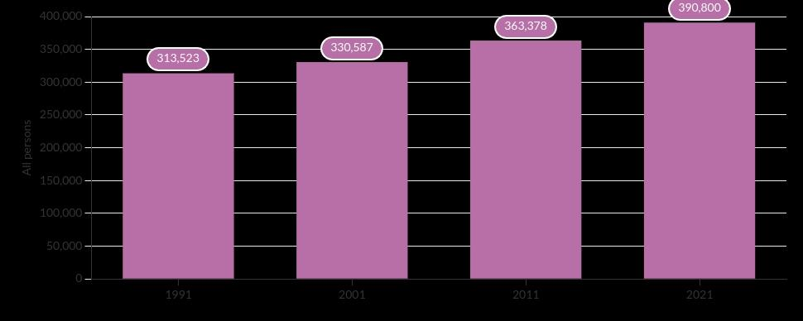
Croydon population from 1991 – 2021 by Census

Source: Croydon Observatory – Population, 2021

  - Empoyment rate:
Croydon has one of the highest proportions of unemployment benefit claimants in the country. The UK unemployment rate was 4.8% in 2021. Men were 4.6% more likely to be unemployed than women 3.8%(Aru, 2018).

  - Education
The proportion of pupils who achieved grades 9-4 in Croydon is only 70.4%, below the average of 75.6% across boroughs. Many people in the city do not have any education and do not even speak the English language so that is why they cannot get a job or find a job(Schools and education, 2022).

  - Health:
People's health in Croydon varies compared to England. 16.1% (12,685) of children live in low-income families. Like men, both women's life expectancy is higher than the English average. 24.5% of children are obese in their 6th year, this is much worse than the average in England. 24.7% of 10-11-year-olds are obese. Among 18-year-olds, there are many who struggle with alcohol problems. During breastfeeding during pregnancy, the number of pregnant women who smoke is very high. The number of sexually transmitted diseases is high. 1100 children are born into poverty every year in Croydon(Local Authority Health Profile 2019, 2020).
People living in deprived neighbourhoods are more likely to experience multiple disadvantages, die earlier, and have more years of long-term ill health.Teenage conception rates in Croydon are 55.4 per 1,000 women under 18, above both the London (44.5) and England (40.5) averages. Over the last 3 years of estimation, the rate of dementia diagnosis in Croydon has been increasing. Diabetes in Croydon has been slightly higher than the regional and national averages over the last 10 years with the trend showing a very slight(Local Authority Health Profile 2019, 2020).

  - Social services:
The National Health Services (NHS) provides healthcare services to all Croydon residents. These include dentists, general practitioners, medical visits, district care and hospital care. Most services are free on the NHS at access points. Croydon Council provides most of the social services in the town(Crouch and Osborne, 2022).
Services for the elderly – Nursing home, residential care home, day care.
Services for children – Early help(Crouch and Osborne, 2022).

  - Crime:
Croydon is among the top 20 most dangerous boroughs in London. The overall crime rate in Croydon in 2021 was 82 crimes per 1,000 people. In January 2022 there were 2,826 crimes recorded in the borough of Croydon with violence against the person (994) the highest type of offence, followed by (424) theft(Croydon Borough Profile, 2021).

The safety of residents in the city is important to the community. Most of the time there are group crimes, violent crimes, knife crimes, hate crimes, domestic violence, sexual violence, anti-social behaviour,drugs and bicycle theft. Serious youth violence includes committing a crime or violence. It happens a lot as it has the largest young population here(Croydon Borough Profile, 2021).

Croydon crime statistics: Most crimes, 12.9k crimes were violent crimes which are 28.4% of all crimes committed in the area. The violent crime rate is at 100% of the national crime rate. Theft from the person crime was the fastest growing crime and it increased by 65.2% over the last twelve months. Knife crime is still a concern with nearly 40% of incidents resulting in injury or death(Molyneaux, 2022).

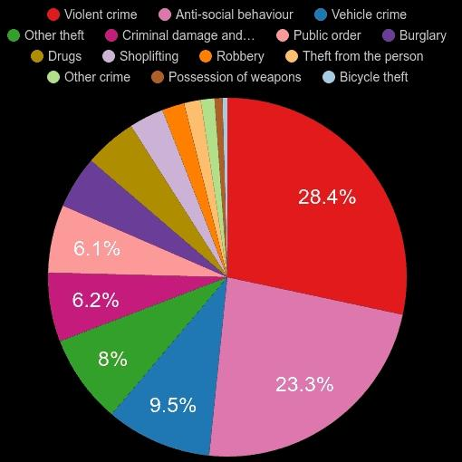
Source: Croydon crime statistics comparison., 2022.

2.0 Legislations:
Equality Act 2010 must take into account the following needs: elimination of discrimination, harassment and victimization, advancement of equal opportunities, and other crimes must be taken into account. It promotes good relations between different parts of the community. The city of Croydon is committed to equality, their goal is to be a stronger, just place where no community is held back. The council ensures that staff, residents and people who use the service are treated equally and treated with fairness and dignity, age or disability or race, nationality or gender. Community leadership is important and using this equality to promote dignity and community achievement and to improve the social and economic environment of the neighbourhood. Their goal is to ensure the highest level of equality and inclusion, thereby eliminating any kind of discrimination and creating a safe place for people(Equality in Croydon, 2022).

Human Right Act:
Human Rights Act is a fundamental right that everyone can have free and cannot be restricted. The right to a fair trial. The right to life. If anyone lives in the UK but is a foreign citizen who is kept in a hospital or prison, are also protected by this right. The Human Rights Act is important because it defines how the government should treat it. It ensures that their work is in line with the respect to their fundamental rights, no matter which workplace or even in an NHS hospital(Equality in Croydon, 2022).

3.0 Theory:
That model is very helpful for this city because they have a lot of different crimes and if they have belief and they use that model with enough and the right support they are able to make a good change (Brookes, 2021).

Theory of Planned Behaviour:
Three variables determined his intentions:
Personal attitudes: A person's attitude toward a particular behaviour.
Subjective norms: To take into account how others view his particular behaviour.
Perceived behavioural control: The situation when the individual believes that the person can control his behaviour(Brookes, 2021).

4.0 Modern technology and social media:
According to our latest research, Croydon has the UK’s fastest growing economy as it increasingly becomes a leading business hub for technology companies. The council help the people who are living in poverty to reach modern technology and gives enough support to connect with social media. Social media is famous here as well, such as Facebook, Instagram, and Twitter. They used to connect with families, and friends. They use the technology to do advertisements in the street or on the road or recommend different products to pay attention to them(Croydon Digital Strategy, 2019 - 2024).

- Digital Strategy for a truly digital Council and borough 2019-2024.

Their strategy is to realize how the internet has changed their lives and to deliver better outcomes for the people of Croydon. Modern technology is not about techniques, but about changing the way people live and connect and work. The strategy is about how they will implement their services and the infrastructure the population needs to thrive, live happily or live a healthy life in city. The residents will have access to an enhanced digital skills offering, helping them gain confidence in areas ranging from basic computer skills to the professional skills they need for the jobs of the future. Croydon residents, visiting students and businesses can enjoy faster broadband connections in digitally enhanced public spaces. Wi-fi or digital route finder information. Croydon has a thriving digital business sector which is expanding and establishing businesses and increasing prosperity. They use social media to stop and prevent crime in Croydon(Croydon Digital Strategy, 2019 - 2024).

5.0 Distinct development in the Croydon community:

- Crime:

Community Safety Strategy 2022 to 2024.
Since Croydon has a lot of different types of crime, this is one of the things it is focused on. To make the city as safe as possible for the residents. They have a strategy of partnership with the police, council, fire brigade, health organizations and businesses to help them to make this strategy work effectively. During the time of COVID – 19, the number of crimes increased due to many closings and unemployment. The increase is largely due to an increase in domestic violence and abuse fueled by the closures(Community Safety Strategy, 2022 to 2024).

Several things have been developed:
- A strong evidence base, so that the organizations can use it to predict who and where and why they are more likely to be involved in family violence or aggressive behaviour so that they can be identified.
- Periods are examined before violence can be prevented. It is influenced by a person's well of life, from birth to adulthood, which can increase violent behaviour.
- Community-based support: recognizes the community voluntary sector and puts them at the centre of Croydon's public health approach to reducing violence:
- Targeted and intensive intervention(Community Safety Strategy, 2022 to 2024).

Priorities for the Community Safety Strategy for 2022-2024:

1. Tackle domestic abuse
2. Protect young people from violence and exploitation
3. Tackle disproportionality in the criminal justice system
4. Strengthen community resilience, offer trauma-informed services, focusing
on Hate Crime, and build trust in the partnership
5. Focus on high-priority neighbourhoods(Community Safety Strategy, 2022 to 2024).

- Health:

CROYDON HEALTH AND WELLBEING STRATEGY:
That strategy, they developed a health and mental well-being strategy, which is about how to work together to create the best conditions for people to live fulfilling lives. It is necessary to communicate effectively with the population, partners and the public in order to be able to change things. Croydon has a lot of obese children, people with alcohol problems, people who use drugs, sexually transmitted diseases, or people with long-term illnesses. It is important to draw attention to these in order to achieve change in the community. The majority of early death in the city is the result of the impact of interactions between a number of complex circumstances such as poverty, poor housing, having a learning or psychical disability, isolation and lack of opportunities(Croydon Health and Wellbeing Strategy, 2022).

How they will achieve this:
It reduces inequalities by helping those in the worst health and improving their health so that they have the opportunity to live a long and happy life.
They focus on prevention, everyone has their own role in the prevention of mental and physical injuries caused by inequalities, individual characteristics, health behaviour and environmental factors.
Increased integration, health and care services that are centred on the decision-making of the family, their friends or neighbours and the community(Croydon Health and Wellbeing Strategy, 2022).

- Priority 1. - A better start in life.
- Priority 2. - Strong, engaged, inclusive and well-connected communities.
- Priority 3.- Housing and the environment enable all people of Croydon to be healthy.
- Priority 4.- Mental health well-being and good mental health are seen as a driver of health.
- Priority 5.- A strong local economy with quality, local jobs.
- Priority 6.- Get more people more active, more often.
- Priority 7.- A stronger focus on prevention.
- Priority 8.- The right people, in the right place, at the right time(Croydon Health and Wellbeing Strategy, 2022).

6.0 Recommendations:
Two major problems in the city were identified for the development of the community. An unhealthy lifestyle that leads to obesity and other diseases or addictions, drugs or alcohol. The Croydon Health and Wellbeing Strategy used for this is my recommendation that the community should be involved much more in the project, drawing attention to it is important, and how important it is for people to change. Communicate via the Internet, using advertisements involving various websites and social media, and create training so that people are aware of how unhealthy or incorrect the lifestyle they are following is. The second thing that is important is to project a crime, since crime is high in this city, there is a lot of violence, theft, carnage, and drug use. The Community Safety Strategy is applied to this project. My recommendation is that people take various types of crime or violence seriously, dare to talk about it and ask for help within the community. The community must unite and report violations of the law, thus protecting the safety of the community and children.

7.0 Conclusion:
Croydon has a very high crime rate, which includes any form of violence, abuse, theft or drug possession. The population is growing very fast and with it the number of various diseases. The number of unemployed people is high because many people do not speak English and many people do not have any profession. There are a lot of obese people in this city, there are many sexually transmitted diseases, alcohol problems, smoking and long-term illnesses. There are two types of laws that protect people against discrimination and prevent it. One is the Equality Act 2010 and the Human Rights Act. The Theory of the Planned Behaviour model helps to solve various crimes if people believe in it and receive the appropriate support, they are able to change. Modern technology and social media are developing very quickly in the city. The two halves of the project, which support the change in healthcare and crime, play an important role for the people there to live a better and healthy life.

8.0 References List:
Aru, D., 2018. Croydon has one of the highest proportion of unemployment benefit claimants in the country. [online] https://www.croydonadvertiser.co.uk/. Available at: <https://www.croydonadvertiser.co.uk/news/croydon-news/croydon-one-highest-proportion-unemployment-1570578> [Accessed 17 July 2022].
Brookes, E., 2021. The Theory of Planned Behaviour. [online] Simplypsychology.org. Available at: <https://www.simplypsychology.org/theory-of-planned-behavior.html> [Accessed 17 July 2022].
Dictionary.cambridge.org. 2022. community. [online] Available at: <https://dictionary.cambridge.org/dictionary/english/community> [Accessed 18 July 2022]
Crouch, S. and Osborne, D., 2022. Croydon joint strategic needs assessment. [online] Croydonobservatory.org. Available at: <https://www.croydonobservatory.org/wp-content/uploads/2016/11/JSNA-Chapter-Overview-of-Health-and-Wellbeing-2011-12.pdf> [Accessed 17 July 2022].
Croydon.gov.uk. 2019. Croydon Digital Strategy 2019 - 2024. [online] Available at: <https://www.croydon.gov.uk/sites/default/files/Croydon%20Digital%20Strategy%202019%20-2024_0.pdf> [Accessed 17 July 2022].
Croydon Council. 2022. Schools and education. [online] Available at: <https://www.croydon.gov.uk/schools-and-education> [Accessed 17 July 2022].
Croydon Council. 2022. Equality in Croydon. [online] Available at: <https://www.croydon.gov.uk/community-and-safety/equality-and-diversity/equality-croydon> [Accessed 17 July 2022].
Croydonobservatory.org. 2021. Croydon Observatory – Population. [online] Available at: <https://www.croydonobservatory.org/population/#/view-report/63aeddf1d7fc44b8b4dffcd868e84eac/___iaFirstFeature/G3> [Accessed 17 July 2022].
Croydonobservatory.org. 2021. Croydon Borough Profile. [online] Available at: <https://www.croydonobservatory.org/wp-content/uploads/2021/06/BOROUGH-PROFILE_JUN2021-1.pdf> [Accessed 17 July 2022].
Democracy.croydon.gov.uk. 2022. Community Safety Strategy 2022 to 2024. [online] Available at: <https://democracy.croydon.gov.uk/documents/s33700/05a%20Appendix%201%20-%20Community%20Safety%20Strategy.pdf> [Accessed 17 July 2022].
Democracy.croydon.gov.uk. 2022. Croydon Health and Wellbeing Strategy. [online] Available at: <https://democracy.croydon.gov.uk/documents/s13992/Health%20and%20Wellbeing%20Strategy%20-%20Final.pdf> [Accessed 17 July 2022].
Fingertips.phe.org.uk. 2020. Local Authority Health Profile 2019. [online] Available at:https://fingertips.phe.org.uk/static-reports/health-profiles/2019/e09000008.html?area-name=croydon> [Accessed 17 July 2022].
Murray, R. and Murray, R., 2019. A Brief Inside Look Into Croydon Borough’s History — South London Club. [online] South London Club. Available at: <https://www.southlondonclub.co.uk/blog/a-brief-inside-look-into-croydon-boroughs-history> [Accessed 17 July 2022].
Molyneaux, I., 2022. The 'most dangerous' places to live in Croydon, according to latest police stats. [online] MyLondon. Available at: <https://www.mylondon.news/news/south-london-news/most-dangerous-places-live-croydon-23371155> [Accessed 17 July 2022].
Plumplot.co.uk. 2022. Croydon crime statistics comparison.. [online] Available at: <https://www.plumplot.co.uk/Croydon-crime-stats.html> [Accessed 17 July 2022].

