BMIH6007
NAME- MIHAELA CALIN
STUDENT NUMBER-2226828
PLANNING AND DELIVERING AN INTERNATIONAL MEETING/EVENT.
INTERNATIONAL MEETINGS
MANAGEMENT BMIH6007
LECTURER’S NAME- Kathryn Flynn
Assignemnt 2
Theme – “Equality, Diversity and Inclusion within Industry”

I confirm that I have not used any AI tools in the research and creation of this assignment. I confirm that I have not presented any AI generated materials as my own work. I confirm I have copies of my drafts, notes, and other resources I used, which I may be asked to provide in evidence.
Table of Contents
Introduction 3
The event cycle 3
Event concept 4
Aim and objective of the meeting/event 5
Event management 5
Event budget 6
Industry trends/issues/impacts 7
Situation and cultural considerations 7
References 10

Introduction
The event will be organised on the international women's Day and the theme of the event must be focused on equality, diversity, and inclusion within the industry. Based on this particular area the discussion within the conference or the event will be managed by offering an effective focus on women's rights. Therefore, the debate in the conference will cover various areas such as equal pay, gender-based violence, and others. Furthermore, the overall event or the conference will be organised in the Plaisterers' Hall of London. The target market of the event will be the women in the UK as they are facing discrimination and gender-based violence in every aspect of their daily life. For this, the selection of that particular topic of women's rights is managed as the maintenance of clear discussion regarding this area must help in creating awareness among people about this cruel practice of society. Thus, it also can help to manage fair practices in social structure to support women for getting their rights based on the reduction of gender pay gaps in the organisations and gender-based violence in the community.

The event cycle
The event cycle consists of different ways that are associated with the organisation of a successful event. The use of this specific cycle supports the organisations to announce the time and agenda of the event to the target audience for attracting their attention to the event for ensuring their participation (Wang, 2021). Engagement in an event cycle must be performed to organise the overall event or conference in a successful way. All the stages of the event cycle that must be applied to the event are listed below:
Announce
This is the first stage of an event cycle. In the announcement stage the creation of hype about the event is managed (Rogers and Wynn-Moylan, 2022). At the time of organising the conference, the announcement about the event will be performed. Thus, the maintenance of proper announcements will be managed through the usage of posters, leaflets, and advertising by using broad hoardings. Within this stage, a description of the event along with the topic area also will be presented. It must support creating interest among the participants to manage their active participation in the event.
Presale
This stage is focusing on the presentation of abilities to individuals for buying tickets within a specific time (Bowdin et al., 2023). At the time of performing this stage, the setting process of a particular time for buying tickets to participate in the conference will be managed. In that case, the organisers will send emails to different social workers and also will produce free passes for them. This initiative will be taken by the organisers to ensure the participation of the people who are working to protect women's rights in the society. Sending the process of personal emails must help to add value.
Onsale
This stage of the event cycle is focusing on the presentation of tickets to the general people. During the organisation process of the event on International Women's Day, the organisers will show a sense of urgency to manage the high purchasing of tickets among the general public (Allen et al., 2022). In that case, within the advertisements usage of phrases like "Buy tickets now, don't miss the opportunity" will be engaged. It must support them to create general excitement among the general public to manage their participation in the conference. For this, maintenance of this stage, social posts will be scheduled by the organisers and must help to support the general public to know about the last date for buying tickets for the event.
Maintenance period
It is a lengthy phase as within this stage the engagement of updated content, performance-related videos, and other areas are managed by the organisers to keep people interested in the event (Rogers and Wynn-Moylan, 2022). At the time of organising the conference on women's rights, the organisers will run evidence-based content and that must support them to reach a larger audience. In that case, the organisers also will make sure about the fact that the opportunity of buying tickets must be listed in the advertisements.
Closing
This phase is dependent on the nature of the event. Generally, this stage is managed two weeks before the event (Bowdin et al., 2023). The closing period for booking tickets for the conference on women's rights will be 3 weeks before the event date. It must support in gathering data about the interest of the audience and organise a successful conference.

Event concept
Delegates or the guests who Will attend the conference will get exclusive experiences. In that case, it can be added that the delegates will have found support, empowerment, and opportunities to form and run a new relationship with others. It must help them to get support from their new relationships to manage protests against the current practices of society related to the gender pay gap and gender-based violence. Through this process, the strengthening of existing connections with different people associated with the protests for establishing women's rights must be managed. Not only that with the active participation in the event, guests also will have felt affirmative regarding their perspectives, and that must help them to offer support to women who became victims of the gender pay gap and gender-based violence in the community. Therefore, the event also will help to form meeting panels and working groups. Those panels and groups will work to protect the rights of women in society. Not only that but the event also will offer opportunities for the guests to manage learning, research sharing, and networking in a better way.

Aim and objective of the meeting/event
Aim
The aim of the event is to have proper discussion to protect women's rights by resolving gender pay gaps or gender-based violence.
Objectives
First objective
To achieve gender equality by eliminating discrimination in the organisational structure.
M-Safeguarding human rights of women.
A-Reduced differentiation in different areas of the community.
R-Support women's empowerment in different areas of life.
T-Manage gender equality in the workplace within 1 year.
Second objective.
To offer effective support to women for managing their participation within the society.
M-Give credit to women for their best work.
Establish institutions to support women.
R-Reduce poverty by updating women by educating them.
Achieve all those areas within 5 years.

Event management
Interpersonal skills
Management of an event requires interpersonal skills (NAWANGSARI et al., 2023). The availability of this skill must help the event organisers to manage a friendly attitude at the time of interacting with clients, vendors, staff, and guests. Maintenance of this soft skill must support the organisers in establishing a strong connection with all the stakeholders of the conference (Cavusoglu et al., 2023).
Communication skill
It is the other important skill that is helping in communicating with all the people related to an event (White et al., 2022). At the time of organising the conference on women's rights, the maintenance of this skill must help in promoting collaboration among the teammates. The process will result in the achievement of success within the project. Not only that but effective communication also will help to reduce misunderstanding and that must result in a healthy working culture (O’Toole, 2011).
Time management
Management of time is a necessary aspect to organise an event in a successful format (Pooch and Wall, 2024). For this maintenance of this skill, the organisers will allocate all the tasks related to the conference within a specific timetable. It must support them in managing all the work in a proper way without facing any challenges. Thus, the engagement of this also will help the organisers to manage strategic prioritisation of activities for managing its completion in a proper format (Smith, 2012).
Marketing
It is an effective resource that is necessary to organise an event (Beridze et al., 2023). At the time of organising the conference on women's rights, the organisers will focus on managing marketing operations in a successful format. In that case, different social media platforms will be engaged to promote the event in front of a large number of people. Not only that but the usage of posters, and leaflets also will be managed as it must help to offer a clear idea about the event to the targeted audience (North et al., 2021). Therefore, influencers also will be engaged within the marketing area. Thus, the engagement of influencers must help the organisers to grab the attention of people towards the conference and it also will manage the participation of a large number of people in the event (Fox et al., 2014).

Event budget
Areas of investment | Cost
Venue | £978 per hour
Conference event app | £1290
Food and beverage | £150 per person
Staff | £67140
Equipment | £1780
Others | £4520
Table 1:Expenditure table
(Source: Self-created)
The upper head table is analysing the overall expenditure that will be assured with the conference that must be organised for International Women's Day. In the table, the overall resources of the event are allocated in various sections. Within this respect, it can be added that the collection of funding to organise the conference must be managed by involving private investors. Therefore, crowdfunding and sponsorship also will be included in the event to get funding to organise the event in a successful way. Equality financing also can be engaged within the event to manage findings and in that case, agile investors will be engaged within the event to manage the adoption of funding. The selling of tickets for the event will help to generate revenues from the conference or the event. Furthermore, the introduction of affiliated marketing and brand activation also will support in generating revenues from the event.

Industry trends/issues/impacts
Current trends
In the present context of event management, it is noticed that the majority of the events in the UK are following basic trends of improving proper planning. Therefore, the recent events are also focused on maintaining personalisation within the content of the event. For this, the incorporation of wellness elements is performed within the events. Therefore, the event organisers also focus on utilising updated technologies within their operational area to manage the success of the event. Not only that but currently event organisers are putting effective focus on managing the accessibility of people to the event and that fosters the engagement level of guests within the event. In addition, it can be stated that data privacy is also taken into consideration within the events (Akinsowon et al., 2025).
Issues and impact
Understanding about guests want
The adoption of clear information about the wants of the delegates is identified as the major issue in the case of organising an event or conference. In that case, it can be added that the lack of presentation of services according to the wants of the guests might cause failure to the event. The process also creates demotivation among them to show their willingness to participate in the event in a proper way to ensure success. For this, it is necessary to acquire in-depth knowledge about the wants of the guests in case of participating in an event. It paves paths to manage engagement of guests in the event (Rogers and Wynn-Moylan, 2022).
Lack of availability of skilled staff
Therefore, the unavailability of skilled staff is another issue that affects the overall performance of the event. Thus, due to a lack of engagement of skilled staff, the event organisers face hurdles in presenting proper assistance to the guests. It causes dissatisfaction among guests or delegates about the event. Not only that but the unavailability of sufficient as well as skilled staff at the event also cause mismanagement in the event location. In that case, guests face hurdles in the parking area, and the delivery of effective services to the guests is not performed in a proper way (Bladen et al., 2022).

Situation and cultural considerations
PESTLE analysis
Political
Within the context of the UK, there is the presence of political stability. Thus, the government of this country is offering support to the organisations for managing multiple activities in a proper way. In that case, it can be added that the availability of effective support from the government must help in organising the conference on the International Women's Day. Therefore, due to a stable political situation, the event organisations might not face any political barriers to ensure the success of the event (Walters et al., 2021).
Economical
In the UK, there is the presence of a stable economy and the economic rebounding was observed in 2023. Thus, the GDP of this country has increased by approximately 0.7% (BBC, 2025). The presence of stable economic conditions is allowing people of this country to manage their participation in conferences by purchasing tickets. The process must support the event to attract more people to manage the success of the conference for fighting against the gender pay gap and gender-based violence.
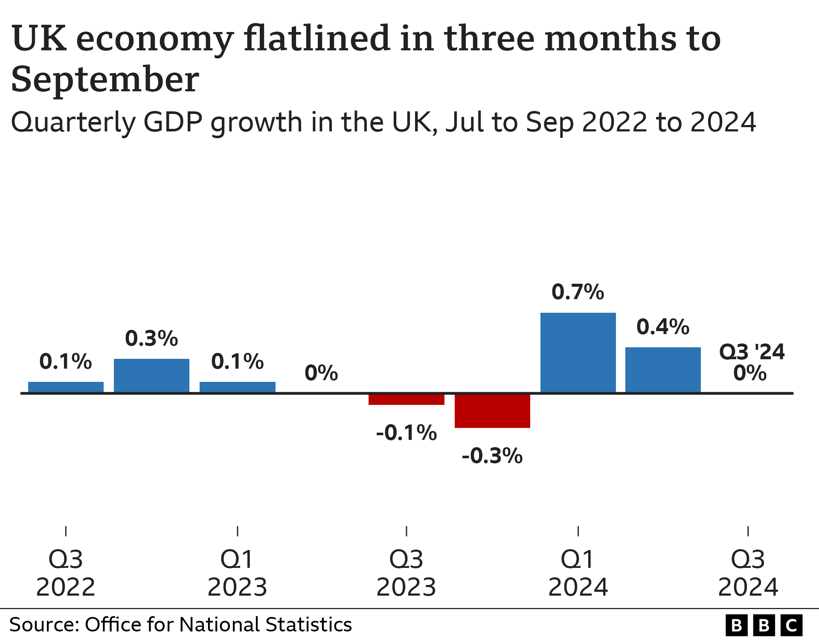
(Source : BBC, 2025)
Social
With the development of time, among the people in the UK, there is a growing concern to protect women's rights in society. Thus, among all the people in the UK, approximately 43% of people are focusing on promoting equality for women in every aspect of society. In that case, approximately 53% of men are showing a positive response to this matter (King’s College London, 2023). It clearly denoted that the protection of the rights of women in the community become a major concern for people in this nation. It will pave potential paths for the event organisers to ensure success due to the introduction of the basic theme of women's rights.
Technological
Within the context of the UK, there is the presence of technological developments. It supports the organisations to engage updated technologies such as AI, blockchain, automation, and others (Gov.uk, 2025). Based on the availability of advanced technologies, the event organisers will get a chance to manage digital transformation within the overall activities of the event. It must support them to manage entire operations with efficiency. Through this process, the management of data rejected to the event also will be maintained in a clear format for its successful usage.
Legal
At the time of organising the conference, the event organisers must need to focus on following different legal obligations. In that case, the Equality Act 2010 must be taken into consideration at the time of lectures at the conference (Wong et al., 2021). It must help to set strategies to protect women's rights. Therefore, the Sex Discrimination Act 1975 also should be included in the discussion of the conference (Hussain et al., 2022). It will support the guests to get an idea about the areas that need to be followed to reduce discrimination against women in the society.
Environmental
In the UK there is increasing concern among people towards the maintenance of environmental sustainability. For this, events with the maintenance of environmental cancers attract people most in this nation. On this note, at the time of organising the event, the organisers must follow Environmental Protection Act 1990 (Green et al., 2021). It must support them to manage fundamental structure in the overall event to protect the environment by reducing waste and also by reducing emission rate from the event.

References
Akinsowon, V. et al. (2025) 9 event trends that will shape 2025 CVENT, Cvent Blog. Available at: https://www.cvent.com/uk/blog/events/event-trends (Accessed: 13 February 2025).
Allen, J., Harris, R. and Jago, L., (2022). Festival & special event management. John Wiley & Sons.https://books.google.com/books?hl=en&lr=&id=fbIxEAAAQBAJ&oi=fnd&pg=PR3&dq=+stages+of+an++event+cycle+to+arrange+a+conference+&ots=yU802TbpZp&sig=PCooIeXEp6LnCTFmNN6ZM9Ncf5Q
BBC (2025) How fast is the UK’s economy growing and what is GDP?, BBC News. Available at: https://www.bbc.com/news/business-13200758#:~:text=What%20is%20happening%20to%20the,growth%20has%20slowed%20since%20then. (Accessed: 13 February 2025).
Beridze, N., Beridze, T. and Tsetskhladze, T., (2023). THE ROLE OF STRATEGIC EVENT MANAGEMENT IN DESTINATION MARKETING. Innovative economics and management, 10(3), pp.93-100.https://iem.ge/ojs/index.php/journal/article/view/166
Bladen, C., Kennell, J., Abson, E. and Wilde, N., (2022). Events management: An introduction. Routledge.https://www.taylorfrancis.com/books/mono/10.4324/9781003102878/events-management-charles-bladen-nick-wilde-james-kennell-emma-abson
Bowdin, G.A., Allen, J., Harris, R., Jago, L., O'toole, W. and McDonnell, I., (2023). Events management. Routledge.https://www.taylorfrancis.com/books/mono/10.4324/9781003044963/events-management-glenn-bowdin-ian-mcdonnell-rob-harris-william-toole-johnny-allen-leo-jago
Cavusoglu, M., Dogan, S., Kirant Yozcu, O., Hsu, M.J. and Cobanoglu, C., (2023). A conjoint analysis of attributes influencing attendance of academic conferences. International Journal of Contemporary Hospitality Management, 35(9), pp.3263-3284. https://www.emerald.com/insight/content/doi/10.1108/IJCHM-10-2020-1184/full/html
Fox, D. et al. (2014) Doing events research: from theory to practice. Routledge: Oxford
Gov.uk (2025) Technology article great.gov.uk international, article great.gov.uk international. Available at: https://www.great.gov.uk/international/investment/sectors/technology/ (Accessed: 13 February 2025).
Green, A.E., Unsworth, R.K., Chadwick, M.A. and Jones, P.J., (2021). Historical analysis exposes catastrophic seagrass loss for the United Kingdom. Frontiers in plant science, 12, p.629962.https://www.frontiersin.org/articles/10.3389/fpls.2021.629962/full?ref=inkcapjournal.co.uk
Hussain, Z., Rizvi, L.J. and Sheikh, H., (2022). The Equality Act (2010)-pre-and post-pandemic historic development on equality and discrimination issues for employers: review of literature. International Journal of Law and Management, 64(2), pp.168-183.https://www.emerald.com/insight/content/doi/10.1108/IJLMA-03-2021-0067/full/html
King’s College London (2023) Britons increasingly scared to speak out on women’s rights, Data Shows, King’s College London. Available at: https://www.kcl.ac.uk/news/britons-increasingly-scared-to-speak-out-on-womens-rights-data-shows#:~:text=And%20a%20large%20minority%20of,third%20of%20women%20(33%25). (Accessed: 13 February 2025).
NAWANGSARI, L.C., SISWANTI, I. and SOELTON, M., (2023), November. Human Resources Management Strategy For Business Sustainability In Msmes. In ICCD (Vol. 5, No. 1, pp. 514-518).http://iccd.asia/ojs/index.php/iccd/article/view/599
North, J., Callary, B., Dieffenbach, K., Galatti, L., Lara-Bercial, S., Nash, C. and O’Connor, D., (2021). A reflection on the state of sport coaching research, its community, and representation: The 2020 International council for coaching excellence research committee consultation. International Sport Coaching Journal, 8(3), pp.405-413. https://journals.humankinetics.com/view/journals/iscj/8/3/article-p405.xml
O’Toole, W. (2011) Events feasibility and development: from strategy to operations. Elsevier: Oxford
Pooch, U.W. and Wall, J.A., (2024). Discrete event simulation: a practical approach. CRC press.https://books.google.com/books?hl=en&lr=&id=5lgsEQAAQBAJ&oi=fnd&pg=PP1&dq=Time+management++skills+required+for+an+event&ots=8XfsvLZzNs&sig=68VJJfBq59EvIIqqyCyKVJusppo
Rogers, T. and Wynn-Moylan, P., (2022). Conferences and conventions: A global industry. Routledge.https://www.taylorfrancis.com/books/mono/10.4324/9781003298953/conferences-conventions-tony-rogers-peter-wynn-moylan
Rogers, T. and Wynn-Moylan, P., (2022). Conferences and conventions: A global industry. Routledge.https://www.taylorfrancis.com/books/mono/10.4324/9781003298953/conferences-conventions-tony-rogers-peter-wynn-moylan
Smith, A. (2012) Events and urban regeneration: the strategic use of events to revitalise cities. Routledge: Oxford
Walters, T., Stadler, R. and Jepson, A.S., (2021). Positive power: Events as temporary sites of power which “empower” marginalised groups. International Journal of Contemporary Hospitality Management, 33(7), pp.2391-2409. https://www.emerald.com/insight/content/doi/10.1108/IJCHM-08-2020-0935/full/html
Wang, Z., (2021). Regulation of cell cycle progression by growth factor-induced cell signaling. Cells, 10(12), p.3327.https://www.mdpi.com/2073-4409/10/12/3327
White, A.A., King, A.M., D’Addario, A.E., Brigham, K.B., Dintzis, S., Fay, E.E., Gallagher, T.H. and Mazor, K.M., (2022). Effects of Practicing With and Obtaining Crowdsourced Feedback From the Video-Based Communication Assessment App on Resident Physicians’ Adverse Event Communication Skills: Pre-post Trial. JMIR Medical Education, 8(4), p.e40758.https://mededu.jmir.org/2022/4/e40758
Wong, B., Elmorally, R., Copsey-Blake, M., Highwood, E. and Singarayer, J., (2021). Is race still relevant? Student perceptions and experiences of racism in higher education. Cambridge Journal of Education, 51(3), pp.359-375.https://www.tandfonline.com/doi/abs/10.1080/0305764X.2020.1831441

