Dissertation- Proposal

by Lilija Tconeva

Dissertation Proposal
Module code: LCBB6000
Word count: 3423
Submission date: 18/12/2023
Table of Contents

Introduction 4
Rationale of the study 5
Research aim 5
Objectives 5
Research questions 6
Literature review 6
Introduction 6
Transformational leadership style 7
Reality of performance management 7
Transformational leadership style at Inditex Inc. 9
Research methods and methodology 10
Research philosophy 11
Research paradigm 12
Research approach 12
Research strategy 13
Techniques 13
Types of investigation 14
Choices 14
Time horizon 15
Data collection 15
Analysis of data 15
Data sampling 16
Ethical consideration 16
Expected outcomes 16
Gantt chart 17
Conclusion 17
References

Topic: challenges of transformational leadership style on productivity at Inditex company

Introduction

Businesses today experience a variety of challenges in the environment they operate that necessitate effective leadership styles that guide employees and improve productivity. Transformational leadership style is the approach that managers embrace to make significant changes in the behaviour of their followers to achieve the leader’s vision and goals. This type of leaders are inspiring and motivating, able to generate trust, loyalty and respect from their subordinates who are willing to work harder than previously expected to foster positive transformation in the company. Transformational leaders have three main roles: recognising the need for a change, creating new vision and institutionalising change (Armstrong, 2016).

Inditex (Industria de Diseno Textil) is one of the largest clothing companies in the world operating on a quick turnover of stock with clothes moving quickly from design to shops. It is a global organisation consisting of many well-known brands such as Zara, Bershka, Pull&Bear and Massimo Dutti. Inditex has a network of factories in China, turkey, Morocco, Bangladesh, India and Spain. In 2022, the company revenue reached 32.6bn euro, consistently increasing every year. Most sales came from Europe with Zara responsible for 70% of the sales worldwide (Statista, 2023). Inditex combines seven brands under one purpose to put their customers first through a variety of categories and points in the most responsible way possible (Inditex, 2023). It was founded by Amancio Ortega in 1975 in Spain, Oscar Meceiraz is the current CEO and Marta Ortega, the new chairwoman (Inditex, 2023).

Amancio Ortega embraced transformational leadership style, following customer- centric approach to build an empire. He was able to differentiate the company by emphasising on the market change responsiveness, quality products and reasonable prices. He is decisive, prioritizing objectives that position the company competitively (Ali, 2013). He established a culture of innovation and excellence in the fashion sector. However, this strategy brings challenges associated with over-reliance on the leadership persona, unrealistic expectations of productivity and resistance to change.

Rationale of the study

Exploring the challenges of transformational leadership style is important to provide a comprehensive analysis that can be compared with other leadership styles to ensuring productivity. The proposed study is motivated by the necessity to offer insights into the challenges of transformational leadership at Inditex Inc., which would guide managers in the fashion sector to navigate the issues of this kind of leadership style to improve productivity. Thus, this systematic review focuses on enriching and contributing to the body of literature by providing unique aspects of the transformational leadership style, especially its challenges, which are currently limited in various studies.

Research aim

The proposed study focuses on investigating the challenges of transformational leadership style on productivity at Inditex company in the UK.

Objectives

- To examine the impacts of over-reliance on the leader for productivity at Inditex company

- To explore the impacts of unrealistic expectations on productivity at Inditex company

- To investigate the impacts of resistance to change on productivity at Inditex company

Research questions

- What are the impacts of over-reliance on leadership persona on productivity at Inditex company?

- What are the impacts of unrealistic expectations on productivity at Inditex company?

- What are the impacts of resistance to change on productivity at Inditex company?

Literature review

Introduction

One major area that is not given enough consideration is how leadership style impacts productivity in an organisation through values, behaviours, ability to create sustainable performance enhancing culture. The level of productivity depends mainly on the senior leadership team, however, in many organisations the accountability for productivity is given to the middle management. It’s often considered part of the management process rather than leadership. Even at places where it is recognised as a leadership responsibility, the focus is usually on conditions outside of the business such as market conditions, interest rates, capital investment. Leadership style has a huge impact on the employees’ performance and the effort people are willing to put into their work when treated right is staggering. Furthermore, the productivity improvement can be sustainable if the behaviours and values of the leadership are genuine, connected to the organisational goals and not only for the benefit of the owners. By identifying gaps in the literature, this review creates an opportunity for deeper examination of how transformational leadership influences productivity.
This literature review explores the performance challenges, origin and application of transformational leadership style with a focus on Inditex Inc.
Transformational leadership style

James MacGregor Burns developed a transformational leadership concept which was further explained by Bernard Bass who explored the psychological concept underpinning a transformational leader. Bernard, instead of using the transforming aspect of leadership embraced the term transformational because of the four constitutive aspects it consists of: idealised influence, the intellectual stimulation, the inspirational motivation, and the individualised consideration (Abadia, 2022).

Contemporary premises embrace transformational leadership style because they lay their vision and purpose on change. They also consider the disruptive aspects brought by technology, the urge for innovation and creativity to stay ahead in the competitive market. In such cases, leaders focus on vertical integration, sustainability, and data analytics to find solutions and meet the needs of consumers.

The reality of performance management

Leadership is a complicated process that contains numerous subcategories and subtleties but at its core leadership is defined as a process that persuades followers to achieve common organisational goals (Armstrong, 2016). Nevertheless, different leadership styles have distinctive aspects and represent different ideas. The connection between leadership style and productivity may be crucial for overcoming challenges produced by bad leadership.

An organisation formal approach to performance management combines sets of procedures- planning, monitoring, reviewing, evaluating and reporting on the results. Ideally the system works as a continuous and self-renewing cycle, shown on Figure 1. However, in reality, the system doesn’t work according to plan due to four problems: (Armstrong, 2021)

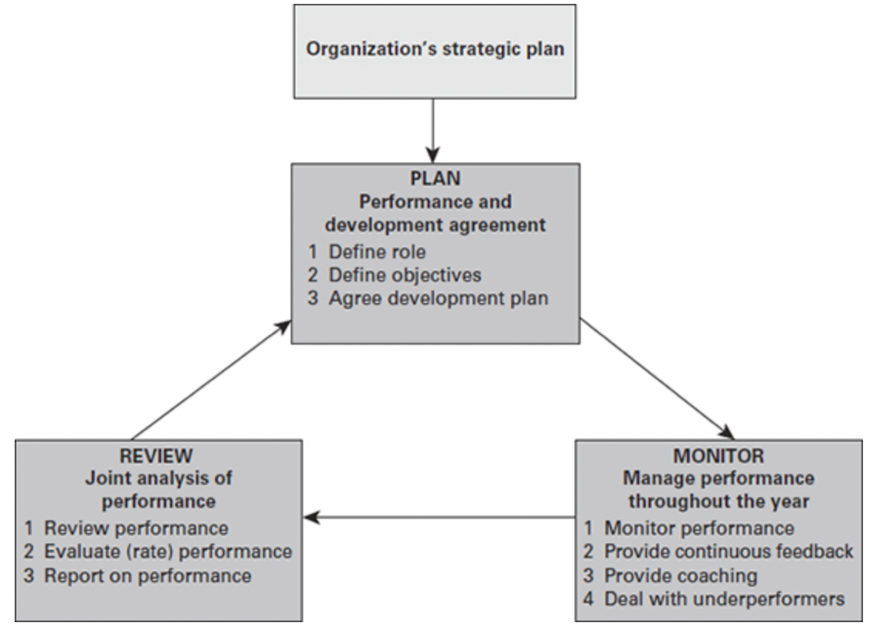
Figure 1: performance management cycle (Armstrong, 2021)

- The system indicates steady progression difficult to achieve mainly because managers tend to compartmentalize activities and don’t appreciate how they are connected or what they should do to for the smooth work of the cycle (Armstrong, 2021).

- Over-elaborate approach which managers are even more reluctant to perform due to the various procedures (Armstrong, 2021).

- Lining organisational goals to individuals’ objectives is more difficult than it sounds mainly due to unclear definition of strategic goals (Armstrong, 2021).

- The successful application of performance management model depends on the context it operates. The contextual factors include organisational culture, structure and type (Armstrong, 2021).

In summary, effective management performance is more about effective leadership performance than conforming to the requirements of a system (Armstrong, 2021).

Transformational leadership style at Inditex Inc.

The implementation of a transformational leadership style at Inditex Inc. improved the company but brought a few challenges. The over-reliance on the leadership persona of Marta Ortega at Inditex Inc. is concerning regarding the productivity of the enterprise. Although the company had record sales in 2022, some shareholders and investors question and pressure for more insight into Marta Ortega’s leadership style (Pons and Reid, 2023). This dependence could hinder the success of Inditex. The association of transformational leadership with the productivity of the workers is an area that requires more exploration because limited information exists. Accordingly, enterprises experience reduced productivity because of over-reliance on leadership persona, unrealistic expectations from the workers, and the resistance that workers bring against the change. Comprehension of such challenges is important for the establishment of strategies that can implement the positive attributes of transformational leadership style avoiding issues.

The focus of the transformational leadership style at Inditex is about driving a positive change in the lives of people and teams, packed with goals, continuous inspiration and opportunities. The company strives to be the idyllic enterprise for the curious, passionate, entrepreneurial, motivated people by fostering growth, creativity and innovation (Inditex Inc., 2022).

These elements were brought by the founder A. Ortega whose ideology was passed to the new team and became a reference point of overreliance on it. Overreliance on one source of decision slows down the decision-making process, establishes inconsistent leadership and uncertainty among stakeholders that impede the agility needed for the fast-paced fashion sector. As a result, the integration of new ideas and aspects are brought to limit, because of employees are accustomed to one leadership style and resist change initiatives which negatively impacts creativity and innovation (Pons and Raid, 2023).
Research Methods and Methodology

According to Saunders, Lewis and Thornhill (2019), the research design is the general plan of how the research should be conducted, taking into account all the elements and methods to be used.

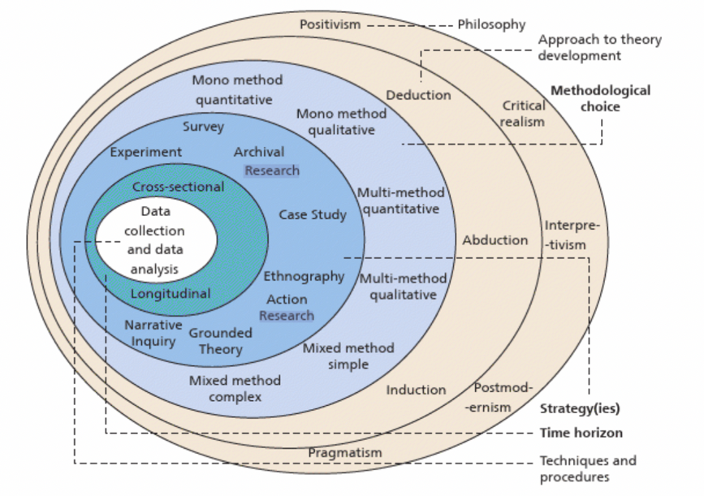
Figure 2: Research onion (Saunders, Lewis and Thornhill, 2019)

The research ‘onion’ (Figure 2) illustrates the steps a researcher should follow in order to build effective research. It describes six layers which must be peeled one by one before arriving at the core- data collection and analysis (Saunders, 2019).

This study focuses on qualitative information, embracing a systematic review of existing studies on transformational leadership style at enterprises located in the UK. Moreover, this proposal embraces thematic analysis for the identified themes for discussion as it will follow a qualitative research approach. Qualitative research gives an insight of communicative knowledge. It enables the necessary exploration and critical analysis of social systems and uncovers inevitable assumptions which shape social behaviour, interaction and empower change (Wang, 2021). It also allows for the development and testing of hypotheses and to derive generalisation of the findings.

Accordingly, the researcher will use Honeycomb research methodology framework to simplify the systematic process, visualizing the strategies and steps for clarity during the research process.
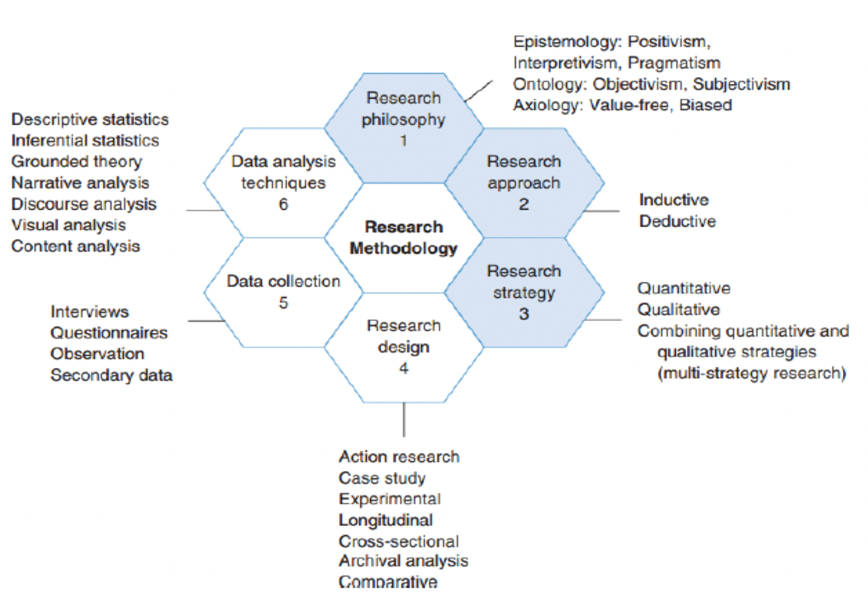

Figure 3: The Honeycomb model (Wilson, 2013)

Research Philosophy

Philosophy consists of believes and assumptions regarding the research development and nature of knowledge (Saunders, Lewis and Thornhill, 2019). It enables the researcher to develop new knowledge such as finding explanations through scientific data and information, in order to accept or reject the research hypothesis.

In studying the challenges of the Inditex transformational leadership style on the productivity of the company, the pivotal research philosophy aligns with epistemology. Epistemology refers to the assumptions about knowledge, what constitutes valid, legitimate and acceptable knowledge and how it is communicated to others (Saunders, Lewis and Thornhill, 2019). It emphasises on knowledge acquisition, validation and application – the process of understanding how insights about challenges of transformational leadership style and productivity at Inditex are gained and authenticated.

Research paradigm

Mertens (2023) defines research paradigms as a way of looking at the world. It is composed by four philosophical assumptions that guide, direct thinking and action by framing our ability to conduct ethical practice in the research.
The most appropriate research paradigm to investigate the challenges of transformational leadership style at Inditex company and the complex relationship between leadership style and productivity is pragmatic. It prioritizes pragmatism over philosophical adherence therefore, it allows researchers to choose the methods or combination of methods that work best for addressing their research questions. The pragmatic paradigm considers the complex nature of the research and uses some positivists techniques. It is also compatible with qualitative/ quantitative methods (Mertens, 2023). This paradigm is well suited for this research as it emphasises on actual behaviour “lines of action”, the believes that stand behind those actions and the consequences that are likely to follow from different behaviours (Mertens, 2023). Furthermore, the pragmatic method is appropriate to produce practical recommendations that aim to improve productivity at Inditex.

Research approach

In the philosophical layer, the research approach is divided into deductive, inductive and abductive. Deductive approach tests a theory, inductive starts with observation to build a theory and abductive is a combination of both (Saunders, Lewis and Thornhill, 2019). This study uses abductive approach. It can start with gathering information on stakeholders’ viewpoints and observations which will create preliminary hypothesis and explanations. These are not determined by existing theories but form as a result from experiences. Then, the collected assumptions are tested and validated. Abductive approach fits with the requirements of this study because it generates new insights based on real world situations.
Research strategy

Strategy layer outlines the plan for the research. Strategy connects the practical and philosophical aspects of the research (Saunders, Lewis and Thornhill, 2019). Interpretive ethnography research is appropriate when investigating the complex topic of the transformational leadership and productivity in terms of understanding employee behaviours. This kind of research focuses on subjective impressions rather than perceived objectivity. It’s appropriate for this study as it gives the researcher more pluralistic approach on understanding meanings with those observed treated as participants rather than subjects (Saunders, Lewis and Thornhill, 2019).

Techniques

The practical techniques are at the innermost layer on the onion (Figure 2) and are used for data collection and analysis. The layers of the onion are interconnected and build on the previous ones. Therefore, the practical techniques layer depends on the strategy and the choices made before that. These choices, on the other hand, should be related to the objectives in the study to contribute to its overall consistency and accuracy (Saunders, Lewis and Thornhill, 2019)

The researcher will commence the collection of data by identifying the various databases to search for the articles, identifying the specific phrases and terms to guide in searching the articles and developing the criteria for inclusion and exclusion of the articles for the study. Inclusion/ exclusion criteria is important in designing high quality research as it determines the characteristics of the subjects or elements in the study (Connelly, 2020) Inclusion criteria aspects include studies on Inditex conducted in the UK to overcome the issue of variations associated with different locations outside the UK. Exclusion criteria will reject studies conducted outside the UK to curb misinterpretation of information.

Types of investigation

The researcher will use a systematic review underpinned by secondary research methods to respond to the research questions and accomplish the objectives.

Primary research
Primary research represents the original collection of data directly from participants, research subjects. Researchers are directly involved in gathering information through interviews, surveys, experiments or other. The aim of primary research method is to address specific research questions, to fill the gaps in existing knowledge or for the unique needs of researchers (Saunders, Lewis and Thornhill, 2019)

Secondary research
Secondary research analyses existing data of literature that has been already collected and published such as reports, books, databases. Secondary research is efficient and valuable because it applies a wide range of existing knowledge, influencing a more comprehensive understanding of a given issue. Researchers usually conduct secondary research when they need to gain insights from previous studies, support arguments or just build a context.

Choices

Choices refer to the specific decisions made in this research in terms of data collection, sampling and data analysis.

Qualitative research
Qualitative research involves words, descriptions and expressions used to better understand the meanings behind people’s behaviours. It is conducted through observations or interviews where researchers gather more in-depth information about details of a subject (Saunders, Lewis and Thornhill, 2019)

Quantitative research
Quantitative research collects and analyses numerical data to explain, describe and understand phenomena. Quantitative research involves surveys and questionnaires (Saunders, Lewis and Thornhill, 2019)

The researcher is using Mono- method qualitative research method.
It is concerned with the use of a single data collection technique and the corresponding qualitative analytical procedure (Saunders, Lewis and Thornhill, 2019)

Time horizon

Decisions about the time of the study should be taken and this is represented by the Time horizon layer. Time management could be cross sectional that involves data collected at a single point in time or longitudinal- data collected over some time (Saunders, Lewis and Thornhill, 2019) Cross sectional approach is adopted for this study where information is gathered and analysed over 10-week time limit.

Data collection

The researcher focuses on the quantitative and qualitative data identified from the various study articles. The researcher will then provide summaries of the findings, and identify the patterns, and themes for thematic analysis and discussions.
Accordingly, the researcher will use Google Scholar, Google Search Website, online libraries, journals and company reports to extract information. The different keywords and terms that the researcher will use in identifying the articles will include leadership persona, unrealistic expectations, resistance to change, transformational leadership style and impact, work performance, productivity, efficiency, Inditex company.

Analysis of data

A proper selection of the relevant articles for the proposed study requires screening to foster high quality and reliable evidence on the challenges of transformational leadership style on productivity at Inditex Company, UK. The researcher will ensure a transparent process of identifying, evaluating, and selecting articles. The researcher will further read the texts, identify methodologies applied in the various studies, and explore the findings to ensure that the systematic review offers valuable information on the topic and that this study is methodologically relevant.

Data sampling

Qualitative research is likely to use non- probability sampling techniques. The qualitative data collected will be non- standardised and should be classified into categories for analysis (Saunders, Lewis and Thornhill, 2019)

Ethical consideration

Ethical consideration is critical when conducting any kind of research. It involves complying with ethical standards, protecting primary data and participants’ privacy by keeping personal information confidential.
Although systematic review does not require much ethical consideration, the researcher will seek ethical approval from the institutional review board policies and consult all ethical guidelines required for the secondary study process.

Expected outcomes

The researcher anticipates various results from the proposed study. Some of them are leader over- reliance, reduction in productivity, reduced morale of the workers, and possible burnout of workers at Inditex Inc. The researcher expects a decrease in productivity because of high employee turnover and demotivated workers because of unrealistic expectations from transformational leadership. Moreover, the researcher anticipates a reduction in productivity at Inditex company because of change initiatives resisting and improper management performance.

Gantt chart

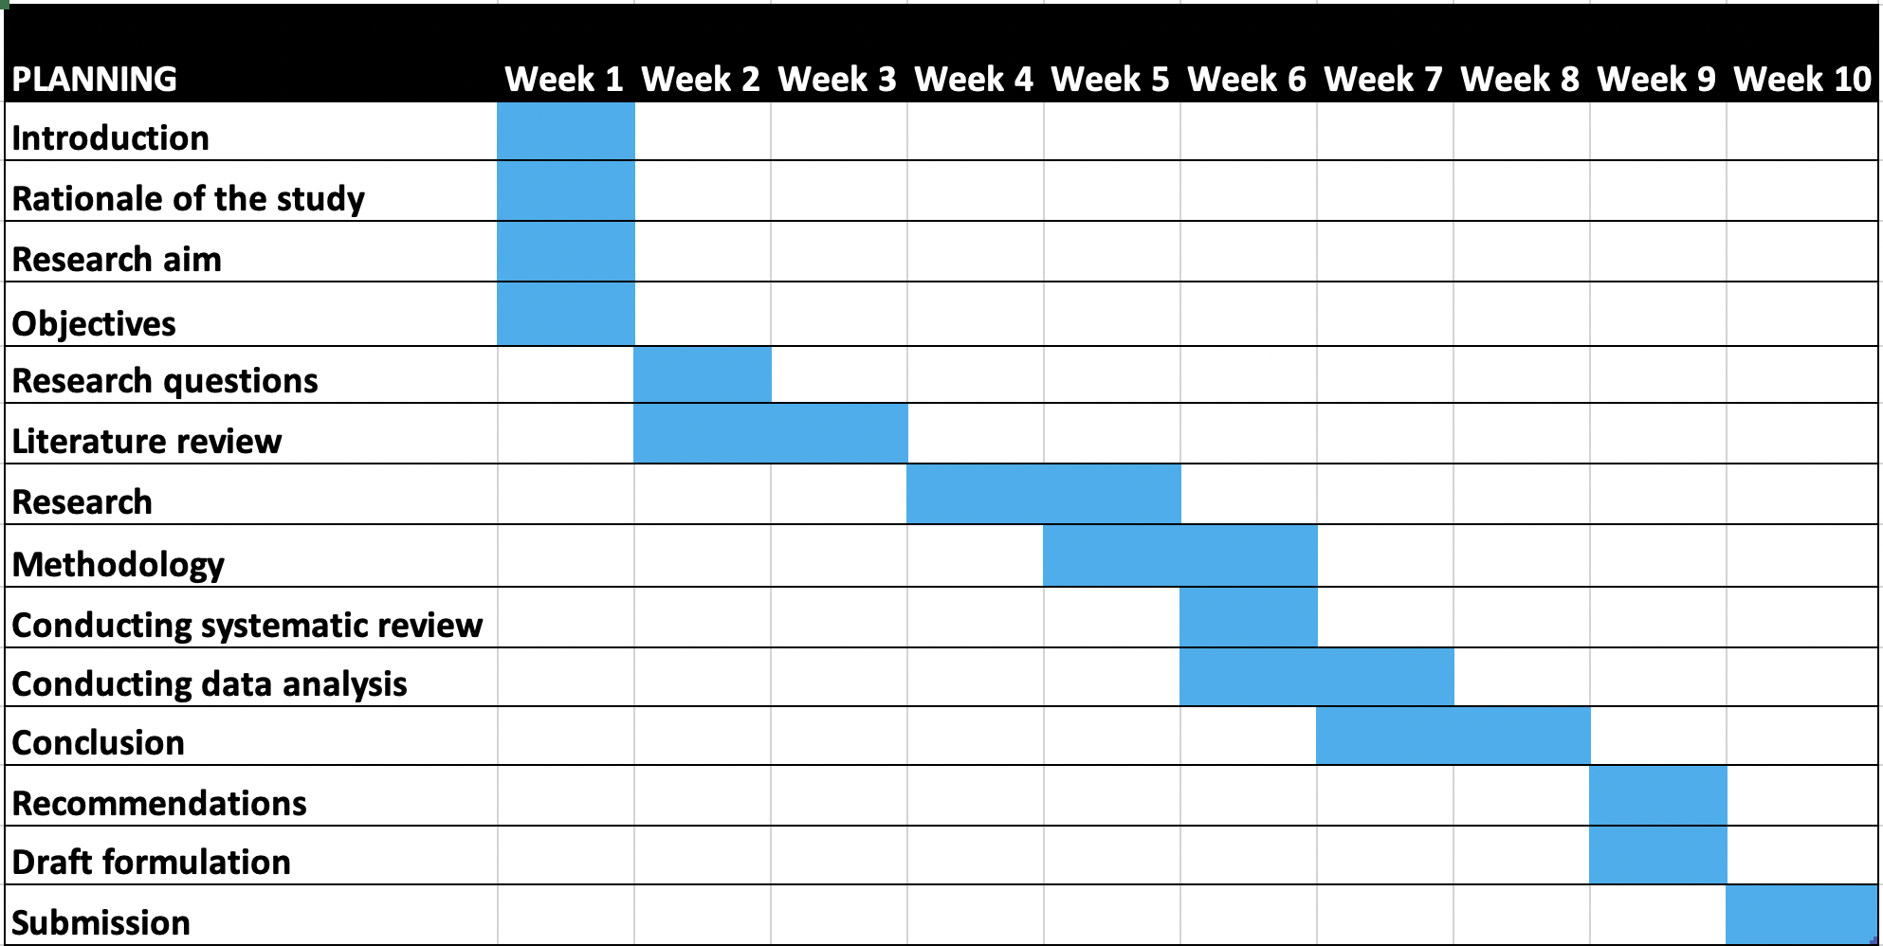

Conclusion

Research is one of the many ways of understanding or knowing. As opposed to other ways of knowing such as insight, inspiration and acceptance of authoritative dictates, research is a process of systematic enquiry designed to collect, analyse, interpret and use data (Mertens, 2020). A variety of reasons exists as to why research is conducted including to understand, describe, predict or control a certain phenomenon or empower people (Mertens, 2020). This research proposal combines different approaches and methods and analyses to provide complete insights into the complex relationship between transformational leadership style and productivity.

REFERENCES

Abadia, A. (2022) Leadership Styles during Disruption: A Multi-Case Study. Leadership- Advancing Great Leaders and Leadership. Available at: https://www.intechopen.com/chapters/84524 (Accessed: 12 December 2023)

Ali, J. (2013), "Strategic positioning and leadership", International journal of commerce and management, Vol. 23 No. 1. Available at: https://www.emerald.com/insight/content/doi/10.1108/ijcoma.2013.34823aaa.002/full/html (Accessed: 05 December 2023)

Armstrong, M. (2021) Armstrong handbook of performance management: an evidence-based guide to performance leadership. 7th Ed. London: Kogan Page

Armstrong, M. (2016) Handbook of management and leadership for HR. 4th Ed. London: Kogan Page

Connelly, L. (2020) “Inclusion and exclusion criteria”. Medsurg Nursing, Vol. 29, No. 2, pp. 125. Available at: https://www.proquest.com/docview/2388933304?parentSessionId=2WIOtIrlGYaxv3fTvPoHyeeIy2FIwl54UYxDKh6Csms%3D&pq-origsite=primo&accountid=130472&sourcetype=Scholarly%20Journals (Accessed: 16 December 2023)

Inditex (2023) Milestones. Available at: https://www.inditex.com/itxcomweb/en/group/history (Accessed: 02 December 2023)

Inditex (2023) Seven brands one purpose. Available at: https://www.inditex.com/itxcomweb/en/brands (Accessed: 02 December 2023)

Inditex Inc. (2022) Inditex Annual Report 2022. Statement on non- financial information. Available at: https://static.inditex.com/annual_report_2022/pdf/PEOPLE.pdf (Accessed: 14 December 2023)

Mertens, D. (2023) Research and evaluation in education and psychology: integrating diversity with qualitative, quantitative and mixed methods. 6th Ed. CA: Sage

Pons, C. and Reid, H. (2023) Focus: in the background Inditex heiress sets the tone for Zara revamp. Available at: https://www.reuters.com/business/retail-consumer/background-inditex-heiress-sets-tone-zara-revamp-2023-03-31/
(Accessed: 04 December 2023)

Saunders, M., Lewis, P. and Thornhill, A. (2019) Research methods for business students. 8th Ed. Harlow: Pearson

Statista (2023) Inditex- Statistics and facts. Available at: https://www.statista.com/topics/10161/inditex/#topicOverview (Accessed: 01 December 2023)

Wang, V. (2021) Promoting qualitative research methods for critical reflection and change. Hershey PA: IGI Global Available at: https://www-igi-global-com.ezproxy.uwtsd.ac.uk/gateway/book/264877 (Accessed: 16 December 2023)

Wilson, J. (2014) Essentials of business research: A guide to doing your research project. Essentials of Business Research. 2nd Ed. CA: Sage

