Mohamed Trissia (1921106).

Organization’s quality systems and customer relationship management.

Understanding and engaging in the customer experience (BMSW 5103_LON)

Lecturer: Dr Nishi Ramsurrun

Table of Contents:

Executive Summary……………………………………………………………………3
Introduction…………………………………………………………………………….3
Main body: ……………………………………………………………………………..4
Apple Inc background…………………………………………………………………4.
SWOT analysis………………………………………………………………………….5
PESTEL analysis……………………………………………………………………….7
CRM models and Marketing theories…………………………………………………9
- Strategic CRM………………………………………………………….10
- Operational CRM………………………………………………………10
- Analytical CRM………………………………………………………...11
- Collaborative CRM…………………………………………………….11
- Maslow’s hierarchy of needs…………………………………………..12
- Marketing Mix………………………………………………………….13
Apple Inc CRM overview………………………………………………………………14
Conclusion……………………………………………………………………………….15
References………………………………………………………………………………..16
Appendices……………………………………………………………………………….18

Executive summary:
This report highlights the importance of implementing quality management systems such as Customer relationship management (CRM) on organizational performance. CRM is the strongest and the most effective approach in acquiring and maintaining relationships with customers (Buttle, 2008). Hence, using CRM help organizations create marketing strategies to enhance customers experience which impact its long-lasting success. To understand how CRM affect organizational achievement, this paper examines Apple’s CRM approach and methods used to create effective marketing strategies. good marketing tactics promote business, sustain its brand image, and help organizations to tackle challenges (Bahrami et al., 2012). Accordingly, this document examines the factors, weaknesses, and threats that may affect Apple’s ability to perform by using SWOT and PESTEL analysis.
Moreover, the report critically explains characteristics and benefits of four CRM models: Strategic, operational. Analytical, and collaborative and highlights two marketing theories: Maslow’s hierarchy of needs, and Marketing Mix. Implementing one or a mixture of these models and theories is paramount for organizational survival. Using Sophisticated CRM systems and executing effective marketing strategy are core principles to improve customer acquisition and loyalty (Freedman, 2021).

Introduction:
Implementing quality management systems (QMS) has become an important aspect of the modern business strategies. A QMS can be defined as set of co-ordinated activities to direct and control an organization to continually improve its performance (Dale et al,. 2016). Similarly, Neyestani (2017) highlights that an effective QMS bring great benefits and improvements to the efficiency and effectiveness of organizations such as reducing costs, anticipating risks, and improving employees’ motivation. A well implemented system helps organizations gain control, confidence and protect their reputation by remaining compliant with the lasted standards and regulations.

In addition, implementing QMS can have great impact on meeting the customers' requirements and enhance customers’ satisfaction and retention (Dale et al,. 2016). By understanding the customers’ demands, organizations use quality management to ensure employees identify their customers’ needs well before making changes to products and services. This helps delivering excellent quality products and improving competitiveness.
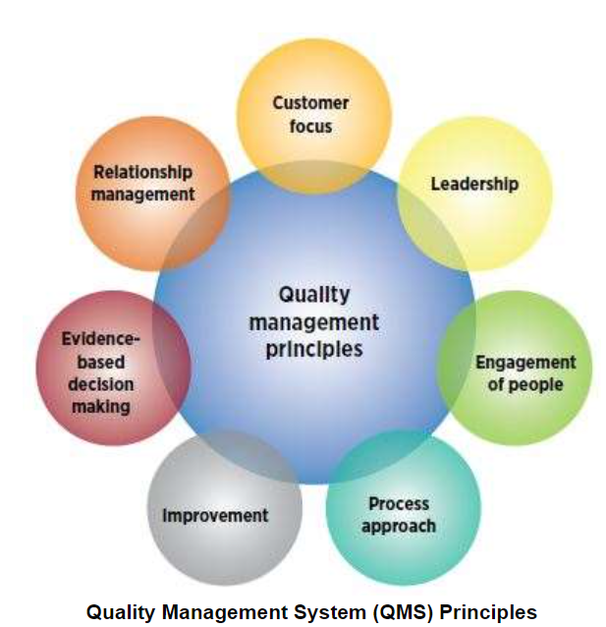
QMS holds several principles, yet Customer Relationship management (CRM) is one of the most essential elements of it (Figure1). CRM refers to the process that organizations use to track and keep strong relationships with their customers (Payne & Frow, 2005). Same authors argue that CRM is about making the best use of customers’ data to identify valuable insights which can facilitate the acquisitions and retention of the customers, as result, turning those insights into successful business decisions.
Figure 1: source: asq.org/quality-resources/quality-management-system.

Several theories strongly argue that using a sophisticated CRM will have amazing benefits not only on customer satisfaction and retention but also organizations’ overall performance. For instance, according to Buttle 2008, developing an excellent CRM system can have significant impact on organizations’ efficiency. He claimed that companies which allocate its assets and implement strategic employees’ appraisal techniques to enhance customer satisfaction tend to grow and expend faster. Similarly, Bahrami et al. (2012) argued that engaging and creating satisfactory experience for customers can have outstanding advantages on organizations’ profitability and market expansion.

For all these reasons, Apple Inc has been developing its CRM to suit customers’’ desires and expectations. Although the company has become one of the most advanced technology companies known by having innovation spirit to achieve excellent outcomes, the real secret to the tech giant’s success is the outstanding CRM strategy that the company has been implementing for decades (Johnson et al, 2012). Apple keeps its billion-strong customer base happy, hungry, and coming back for buying more products and devices by developing a customer centric business culture devoted to satisfying its customers’ requirements and expectations (Johnson et al, 2012). As result, the company has earned the hearts of billions of customers and has become one of the most loved brands in the world. To understand Amazon’s success in acquiring in retaining its customers, it is essential to examine the company’s CRM.
Main Body:

Apple Inc Background:

Apple Inc is an American multinational tech company based in California specialised in electronics, software, and online services (Johnson et al, 2012). It was founded in April 1976 by Steve Jobs, Steve Wozniak and Ronald Wayne as Apple computers Inc who developed the first computer Apple1 then Apple2 which became America’s most sold computer in 1977 (Johnson et al, 2012). Although, Apple 2 was great success, the company struggled with different problems such as products high prices and power between management which led Steve Wozniak to step back and sell his share to Steve Jobs (Wikipedia, 2022).

Since then, Mr Jobs implemented new sophisticated strategies and tactics to increase the organization’s effectiveness and profitability (Johnson et al, 2012). The authors emphasized that workforce diversity and professionalism are among the main factors which allows the company continuously thriving Amazon, 2021). The company’s culture is well known by encouraging employees from different background to join the company to excel their skills and improve creativity. This has helped the company to acquire and continuously develop the most innovative technology (Johnson, 2012).
More importantly, Mr Jobs has changed the company’s main goals and strategies from prioritizing sales and revenues to improving the customer satisfaction (Amazon, 2021). The customers’ relationship is now a essential part of the company’s growth strategy. The company has been implementing CRM for nearly a decade to boost customer service experience for existing and new clients using several touch points either by sending targeted emails or by implementing instore CRM system (Amazon, 2021). In fact, the company focuses more on face-to-face customer relationship as it has developed instore CRM systems to create fast and unique lifestyle experience and to resolve the clients issues the fastest way possible way. This can enhance the customer satisfaction, hence the company growth and success.

Although the company has significantly expanded globally in the last 2 decades, several internal and external factors has impacted the organization’s quality system including customer service management. Therefore, understanding the tech giant broader environment can help identifying key drivers that may affect the organization’s improvement and excellence.

SWOT analysis:
Internal factors refer to the internal environment aspects that can influence organizations strategies and decisions (Khan et al, 2015). These factors can affect both customers’ needs and organizations goals. Hence, using SWOT analysis is the most relevant framework to identify and examine the impact of these factors on Apple’s strategic goals:

- Strengths:
According to Khan et al, 2015, creativity and innovation are considered important forces which can help Apple Inc continuously thrive. The same authors highlight that bringing new changes and features to services and products have various benefits to the organization growth. It can attract new customers and improve the satisfaction and loyalty of the existing ones. For instance, people could queue up for hours to buy the newest products and devices. Binns (2021) argues that customers’ loyalty rates is contently around 89% due to Innovation.

Moreover, the business strategy of Apple is to anticipate the customers’ desires. Because of the sophisticated CRM system that Apple use, the organization has a vigorous understanding of the current and future customers’ expectations (Binns, 2021). Another Apple strength involves the customer service offered by the store agents. Statistics show the majority of customers who visited Apple stores love their experience. the sales agents focus more to deliver an outstanding service and involvement with clients rather than making them purchase. Creating such a culture improves the customer satisfaction and retention.

- Weaknesses:
Weaknesses refer to the obstacles that affect or limit Apple growth and market expansion. for example, Binns (2021) concludes that the organization has limited network of distribution because of its policy distinctiveness. Apple Inc strategy requires a careful selection of the authorized sellers of its products such as iPhone and iMacs. This approach can limit the market reach as the company’s best seller products are not available in all areas.
High pricing strategy is considered as another main weakness of Apple Inc (Binns, 2021). Because of its premium pricing, Apple focus exclusively on high-end market sector. That is to say that Apple high price strategy attracts middle- and high-income consumers and prevents low-income individuals from easily purchasing their products and services.

- Opportunities:
This element of SWOT analysis identifies the major opportunities available for organizations to take in consideration for their strategic direction. In Apple case, the following aspects are highly regarded as significant opportunities:
- The company has the opportunity to widely expand in global market. By changing the distribution network strategy, Apple can reach more consumers worldwide. Also, the high selling prices approach needs to be adjusted.
- Decreasing the products and devices’ price will encourage all income groups for buying.
- Furthermore, the company has the opportunity to explore new product lines to add to existing ones. With further innovation, the business can develop and introduce new products, like what it has already achieved with the Apple Watch. Developing new product lines supports business growth, especially against other technology firms in the international market (Khan et al., 2015).
- Threats:
Threats can be defined as any external factors that can negatively affect organizations performance and limit the business growth. Examples of threat that Apple might have:
- Aggressive competitors:
The competition in technology industry is extremely high (Khan et al., 2015). Apple gas aggressive competitors such as Samsung and Huawei. These firms consider innovation as key element for their business survival. Hence, it is paramount for apple to find best strategies to improve competitive advantages.
- Labour rising costs:
According to Lan (2021), the labour costs are rising in several countries where Apple Inc has production facilities such as China. This can negatively affect the business sales by reducing the profit margins or push the selling prices even higher.
- Covid 19:
As the world came to a full lockdown to help fighting the spread of the pandemic, organizations around the world were bracing for catastrophic consequences that would follow the lockdown (Onyeaka et al., 2021). Governments around the world decided to implement tough restriction to slow the spread of the virus and save lives. For example, businesses were obliged by law to close temporarily their premises and people were restricted to stay at home. all these factors put the global economy in jeopardy (Onyeaka et al., 2021). Food and goods supply chain was significantly impacted and international trade was almost frozen. This triggered a global alarm that world was heading to new financial crisis and recession.
In Apple case, Covid19 impacted the company’s performance and sales revenue. Apple's factories were closed, travel restrictions from heavily impacted areas in China, mandatory quarantines, and low labour return rates led to long delays in production. Also, supply chain crisis has caused long time shipments of few products (Amazon, 2021).

Based on the SWOT analysis, the innovative company has to take in consideration all these factors to anticipate future challenges and to improve its strategic decisions which can develop a strong relationship-based marketing approach.

PESTLE analysis:
Conducting PESTLE analysis is the most appropriate method to identify the macro-environment factors that may impact Apple Inc business outcome. This tool is vital for the organization to understand the market dynamics and to continuously improve its management strategies, hence performance and sales revenue. Accordingly, Apple pestle analysis recognizes the following factors:

Political factors:
The existing political conflict between China and the United States could be a major problem for Apple. According to Johnson et al. (2012), the alarming trade war between the US and China that may impact Apple’s sales profits and market share in China and thus it can create a risk for the company’s potential progression. In 2017 the US government decides to increase taxation on Chinese import into US market. And since China is the main manufacturing country for Apple, this approach can lead to high costs, hence a significant decrease in profitability.

On the other hand, Apple Inc may expand globally due the improvement of free trade agreement between other countries (Khan et al., 2015). The company can benefit from this opportunity to find new distribution market which can help new customers acquisition.

Economic factors:
Global economy recovery is extremely important to Apple. Covid19 pandemic severely demobilised the world’s economy Due the full lockdown implemented by the governments. this had negatively impacted all sort of business industries including tech firms. As result, production level has gone very low and the Economy of many so-called powerful countries are now facing the threat of high inflation and increasing unemployment as a result of lack of productivity.
Moreover, the current Russian-Ukrainian war has impacted the economy worldwide. Oil and gas prices have increased by 30% as the majority of global governments have decided to implement tough sanctions on Russian government to stop the war (Juanino and Millard, 2022). Majority of global organizations has ceased to operate in Russia to show solidarity to Ukraine (NYTimes, 2022). This current conflict put world’s economy in jeopardy, hence Apple Inc should consider the negative effect of this factor and find alternative solutions to cope up with these bad circumstances.

Social factors:
According to Juanino and Millard (2022), consumers behaviours affect all kind of business industries. Nowadays it is imaginable that people can live without mobile phones, smart devices, and tablets. Also, demands on technological systems is continuously rising. Apple Inc can benefit enormously from these socio-cultural trends by increasing its sales revenue. However, some social behaviours may affect Apple business operations. For instance, because of Apple high costs, a rise of external repair services of Apple devices has been observed in few countries such as India and Chine (khan et al, 2015). This behaviour could retrain Apple’ growth.

Technological factors:
Integration of technology is continuously increasing. More business and organizations are switching to innovative systems to improve the customers satisfaction and retention. This behaviour represents a great opportunity for Apple to expend its technology services such as cloud-computing. Yet, many high-value technological products are offered at an affordable price by Apple's competitors which affects the brand image and eventually the financial performance of the company. Therefore, an affordable pricing strategy with most updated technological services is a key for Apple success to acquire and retain new customers.

Legal factors:
Legal factors analysis shows the influence of law and regulations on the company. For Instance, in 2018, FAA announced to banned Apple 15-inch MacBook from the customer due to the fire hazard (Urian, 2021). The company had to recall all the product that sold between September 2015 and February 2017, where products contained the battery that may overheat and pose a safety risk. Similar incidents can result in bad brand image which will affect the company reputation and lead to customers’ disappointments. Also, Apple needs to continuously update their data and privacy regulations on its websites to comply with GDPR legislation. Any misuse of users’ personal information could make the organization vulnerable against lawsuit.

Environmental factors:
Apple Inc has started to implement new eco-friendly strategies to help environment. The company is producing more energy-efficient products like batteries and processes in the recent years. In addition, Apple takes a thorough approach to environment responsibility from reporting the entire carbon footprint to finding ways to reduce it and properly disposes of its electronic equipment at the end of its useful life (Amazon, 2021). on the other hand, Apple assembles the majority of its products in China where environmental side effects are a great concern and can influence manufacturing costs and regulations. Consequently, high costs lead to customers searching for affordable alternatives which could decrease Apple’ sales.
By broadly analysing Apple’ environment, the company needs to focus on more strategic decisions which can improve its weaknesses and maintain its strengths. One way to achieve this goal is by implementing effective marketing strategies.

CRM Models and Marketing theories:
CRM strategy is about making the best use of customers’ data to identify valuable insights which can facilitate the acquisitions and retention of the customers, as result, turning those insights into successful business decisions (Payne and Frow, 2005). The same authors emphasise that CRM systems can be dived into 4 types based on their main characteristics:
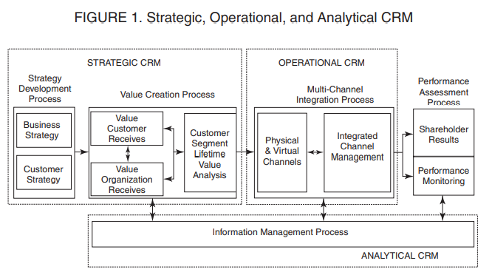
Figure 2: source: Strategic, Operational, and Analytical Customer Relationship Management: At...: EBSCOhost (uwtsd.ac.uk).

- Strategic CRM
According to Buttle (2004), strategic CRM is a model of CRM in which businesses put the winning and retaining of valuable customers first. It acquires, filters, and uses customers and market developments to create an outstanding value to customers. Similarly, Payne and Flow (2005) explained that customers’ feedback is paramount for organizations to understand and fulfil customers’ needs, hence, strategic CRM enable organizations to align their business strategy to enhance customers’ satisfaction. They added that strategic CRM facilitate the understanding of customers behaviours, therefore organizations must consider the implementation of this model in order to keep their customers happy otherwise they may lose market share to competitors which can impact their business sales revenue and growth.
- Operational CRM
Operational CRM is used to integrate and automate workflows in customer service, marketing, and sales (Irina and Buttle, 2007). By using various customers’ touch points and channels via automation systems, the operational CRM helps collecting and making the most of customers information to improve business efficiency and customer satisfaction. This model includes 3 main service automation:
- Sales force automation: it helps organizations to automate and manage the entire sales cycle by identifying new prospects, keeping track on customers’ interactions, forecasting sales’ revenue, and managing sales documents.
- Marketing automation: evaluating and creating effective marketing strategies to accelerate sales profit is the main aspect of this technology. With operational CRM, it is easy to design and create promotions and deals that align perfectly to customers’ needs and desires.
- Service automation: it empowers business to provide the best customer service by improving the speed of resolving customers’ inquiry and issues (Irina and Buttle, 2007). For instance, customers can interact with computers which filter the resolution data base to find the best solution or make automatic call the most relevant employee to reply to the customers’ inquiry.

- Analytical CRM
This model provides detailed analytics and customized reports to develop customer acquisition and retention hence improving organization image and performance (Payne and Flow, 2005). It involves the acquisition, interpretation, segregation, storing, modifying, and processing customers’ data. This process can help organization evaluate customers and markets trends to develop new products and create better value to customers. As reported by Irina and Buttle Analytical systems contain internal business data such as sales data (sales history, bestselling items, etc.), finance data (credit score, payment methods, etc.), and marketing data (promotion rate, loyalty figures, etc).
Moreover, organizations can use analytical CRM to create different promotions for different customers. For example, with the help of loyalty scheme data, valuable customers may have better deals and exclusive services. Therefore, analytical CRM can be beneficial for customers and organization. For the customers, it gives customized and timely solutions to the problems, yet for the business, it gives more projections for sales, and customer acquisition and loyalty.
- Collaborative CRM
Collaborative CRM (CCRM) requires a strong interaction between organization and customers through different communication channels and touch points (Irina and Buttle, 2007). This interaction can be done virtual (chat bots, emails, automated voice response) or physically (store fronts). Also, CCRM can be used by various departments of organization like sales, marketing, finance, and service that share customer information among them to better understand customers’ needs and expectations. For example, information about customers bestselling products could be share with marketing department to create effective marketing strategy.
As discussed earlier in this report, organizations such Apple Inc need to constantly apply different Marketing strategies and theories to better understand market tendencies and fulfil customers and business requirements. According to Molony (2021), six major marketing theories are mostly used to meet the customers desires and motivation and be defined as follows:
- Maslow’s Hierarchy of Needs
- Seven Ps of the Marketing Mix
- SWOT Analysis
- Consumer Decision Making Process
- Porter’s Five Forces
- Market Segmentation
- Wrapping up.
This report will explain the first 2 theories and discuss their importance in creating effective marketing campaigns:
Maslow’s Hierarchy of needs:
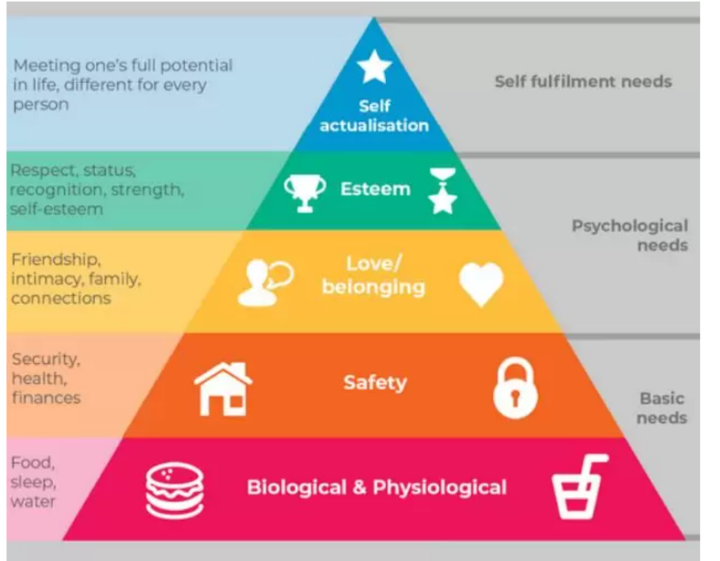
This theory classifies human needs in five levels and states that people need to satisfy basic needs before moving on the higher-level needs. As shown in Figure 3, these levels are: biological, safety, love or belonging, esteem, and self-actualization. To create a successful marketing strategy, it is vital for organization to understand the level of hierarchy that its customer is likely to be when he is interacting with the business. For instance, most Apple consumers use the brand for social media purposes and to stay connected with family and friends. So, it is important for Apple to design and plan a marketing approach to reflect on audience psychological needs.
Figure 3: source: 6 important marketing theories—and how to apply them in social media campaigns - Agility PR Solutions

Marketing’s main focus is engaging with customers by understanding their needs, reactions, and top priorities (Smolianov & Aiyeku, 2009). Before creating any marketing strategies, marketers need to understand the target audience. Thus, Maslow’s hierarchy needs play important part in this process which excel customers experience and improve organization overall performance.

Marketing Mix:
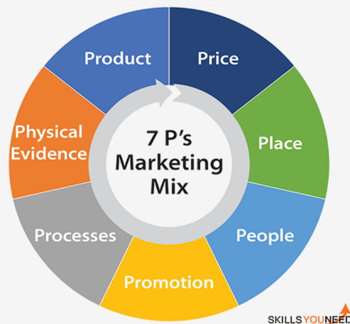
The marketing mix is an element of the market process which aims to help organizations pursue their goals and objectives in the target market (Molony, 2021). This theory was firstly introduced in 1964 by Jerome McCarthy who considered only 4P: product, place, price, and promotion as the main aspect of marketing strategy. Then, Booms and Bitner added 3 more Ps: physical evidence, people, and processes. By implementing this model on Apple, the 7Ps can be defined as follows:
Figure 4: source: The 7 Ps of Marketing Mix | SkillsYouNeed.
- Product: simply refers to the item sold or being designed to meet customers’ needs and desire. Apple has wide range of products such as iPhone, iPad, Wearables (e.g., smart watches), and home accessories (Amazon, 2021).
- Place: Apple has its stores worldwide and online markets places. Also, the company has partnered with different retailers and network providers to sell their products such as Curry’s and EE stores.
- Price: Amazon sells devices from US$29 such as air tags to Mac Pro Computers which have starting price of us$5000 and can reach up to over us$25000 with all-inclusive inputs (Apple, 2021).
- Promotion: The promotion activities help Apple to emphasize its premium image and the quality of its product. The company uses certain methods such as: Advertising, personal selling, sales promotions, and public relations (e.g., Apple events).
- Physical evidence: Apple has significantly expanded its presence in the market by opening more physical stores. The company aims to target the most important and crowded area to acquire more customers. Its logos and symbols are immediately recognized which prove the company’s presence.
- People: Apple users are likely to be loyal to the company’s products and services. As feedbacks and reviews can be found online, this can act as great marketing technique. Also, Apple requires excellent customer service skills in hiring process. The company insists skilful employees can enhance customer satisfaction and improve brad image (Amazon, 2021).
- Process: buying online is different from store purchases. In store customers can accommodate themselves with the products as Amazon use Hands-on strategy for enhancing customer in-store experience. After the purchase, Customer can have support from Amazon if help is needed. They can get support through different channels such as chat session, over the phone or visit the nearest store.

Although CRM models and Marketing theories have different aspects and characteristics, they all aim at similar purposes that is meeting the customers’ expectations to achieve organizations ’excellence. Yet more, implementing those tools have significant benefits which can be broadly summarised in enhancing the quality of customer service, increasing customer satisfaction and retention, and boosting organizational’ profitability.
Apple Inc CRM overview:
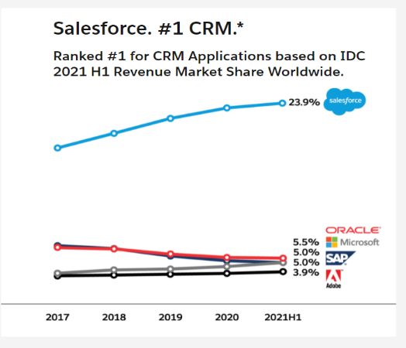
Apple Inc has its own CRM known as iOS, macOS, watchOS and tvOS (Apple.com, 2018). Yet in 2018, Tim Cook, the current CEO of Apple Inc, stated that the company was privileged to collaborate with one of the most sophisticated CRM systems in the world known as Salesforce to improve the software effectiveness and redefine customer experience (Apple, 2018). Similarly, Brooks (2020) argues that over 150.000 organizations are using salesforce and that it has become the leading CRM software in the market. Salesforce gets direct access to Apple features and can work with Apple to implement them in an optimized way. Salesforce can be considered as an operational and analytical CRM. that uses automation (marketing, sales, service) to shape customers data and set organizational standards. This platform has great the advantages of this software are:
Figure 5: source: World's #1 CRM - Salesforce.com.
- Improve the effectiveness of teamwork: Apple software has few collaborative CRM features since Apple representatives can share customer information in real-time. Also, the systems allocate projects, track promotions, and monitor workloads.
- Improve marketing strategy: Easy access to consumers details such as purchase history and deals help in understanding the targeted customers behaviours which can lead to creating effective marketing tactics.
- Enhance customer interaction: receiving tasks notifications and follow-up reminders keep the communication smooth and effective. Contributing to better customer experience.

However, Apple consumers insist that this software has few drawbacks which can be summarised as follows:

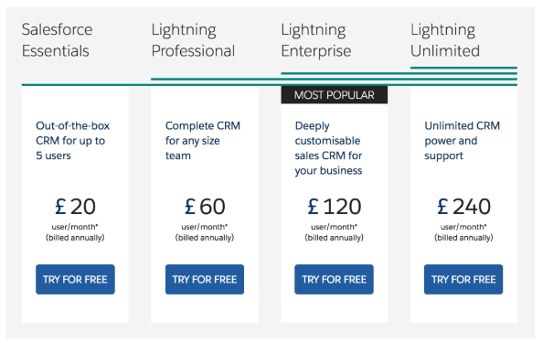
- price: organizations which use apple computers could be paying huge amount of money if they want to implement salesforce CRM. $5000 per year if the average cost of one single salesforce user (Brooks, 2020). So, a business of 10 employees could be paying up to $50000/year.
- Difficult and time-frustrating configuration: consumers complain that Apple systems usually have problems when they install or update them. Besides, the configuration process takes long time to be completed.
Figure 6: World's #1 CRM - Salesforce.com

Another example of operational and analytical CRM is Ovatu software. This is a booking system which allow users to find suitable time slot to make a reservation (Ovatu, 2022). Personally, I use the app to obtain customers information and analyse my monthly finances. Ovatu software has various valuable features. For instance, it indicates customers, spending, attendance, and loyalty points. Customers can book, move their time booking anytime anywhere. Also, business can use the app to set a birthday reminder, highlight customers with allergies and their feedback (see appendices).
Although, Ovatu software is cheap and reasonable to use, the system has certain limitations which need significant improvement. For instance, the customers’ data is accessible to all employees. This can enable the use of sensitive customer information for personal purposes.

Conclusion:
the intensity of business competitiveness and the struggle for consumer loyalty have become the most challenging factors for the majority of organizations today. To achieve excellence, management needs to critically evaluate the external business environment to create effective strategies which can boost profitability and enhance brand image. Developing organization culture which focus on implementing quality management systems such as CRM and marketing theories can significantly impact the organizations’ long-lasting success.

Reference:
Appendix1,2: Apcure. 2022. Available[online]: Ovatu for Android - APK Download (apkpure.com).

Appendix3,4: Ovatu. 2022. Available[online]: Reminders & Marketing | Ovatu Manager.
Apple.com, 2018. Apple and Salesforce bring together the best devices for business and the world’s #1 CRM. Available at [online]: Apple and Salesforce partner to help redefine customer experiences on iOS - Apple (UK).

Binns, R. 2021. Apple CRM case study. Available [online]: Apple CRM Case Study | How to Learn From the Best (expertmarket.co.uk).

Bahrami, M. Ghorbani, M. Arabzad, S.M. (2012). Information Technology (IT) as An Improvement Tool for Customer Relationship Management (CRM). Procedia - Social and Behavioural Sciences. Vol 41, pp59-64. Available[online]: Information Technology (IT) as An Improvement Tool For Customer Relationship Management (CRM) - ScienceDirect.

Dale, B.G. Bamford, D. Van Der Wiele, T. 2016. Managing Quality: An Essential Guide and Resource Gateway. John Wiley & Sons, Incorporated. Available[online]: https://ebookcentral.proquest.com/lib/trinity/reader.action?docID=4562449.

Freedman, M. 2021. CRM models can help you better understand how your company reaches, converts, and retains customers. Available[online]: CRM Models and How to Use Them - businessnewsdaily.com.

Iriana, R. Buttle, F. 2007. Strategic, Operational, and Analytical Customer Relationship Management: Attributes and Measures. Journal of Relationship Marketing (Binghamton, N.Y.), 5(4), 23–42. Available [online]: Strategic, Operational, and Analytical Customer Relationship Management: At...: EBSCOhost (uwtsd.ac.uk).

Johnson, K. Li, Y. Phan, H. Singer, J. The Innovative Success that is Apple, Inc. Theses, Dissertations and Capstones. Paper 418. Available[online]: The Innovative Success that is Apple, Inc. (marshall.edu).

Juanino, P. Millard, S. 2022. What is the Economic Impact of the Russia-Ukraine Conflict?. Available [online]: What is the Economic Impact of the Russia-Ukraine Conflict? - NIESR.

Khan, U.A, Alam, M.N, Alam, S. 2015. A Critical Analysis of Internal and External Environment of Apple Inc. International Journal of Economics, Commerce and Management. Vol 3, Issue 6.

Molony, S. 2021. 6 important marketing theories—and how to apply them in social media campaigns. Available [online]: 6 important marketing theories—and how to apply them in social media campaigns - Agility PR Solutions.

NYTimes. 2022. Here Are Some of the Companies That Have Pledged to Stop Business in Russia. Available [online]: Which Companies Have Pulled Out of Russia? Here’s a List. - The New York Times (nytimes.com)

Onyeaka, H. et al. (2021) ‘COVID-19 pandemic: A review of the global lockdown and its far-reaching effects’, Science Progress. Vol 104, Issue 2, Available [online]: COVID-19 pandemic: A review of the global lockdown and its far-reaching effects - Helen Onyeaka, Christian K Anumudu, Zainab T Al-Sharify, Esther Egele-Godswill, Paul Mbaegbu, 2021 (sagepub.com).

Ovatu. 2022. What is ovatuyou?. Available[online]: What is Ovatu You? | Ovatu Manager.
Customer Relationship Management (weebly.com).

Payne, A. Frow, P. 2005. A Strategic Framework for Customer Relationship Management. Journal of Marketing. Vol69, Issue 4, pp167-176. Available[online]:https://doi.org/10.1509%2Fjmkg.2005.69.4.167.

Urian, B. 2021. FAA Bans Specific Apple MacBook Pro Model on US Flights | Find Out Which Model. Available [online]: FAA Bans Specific Apple MacBook Pro Model on US Flights | Find Out Which Model | Tech Times.

Appendices:

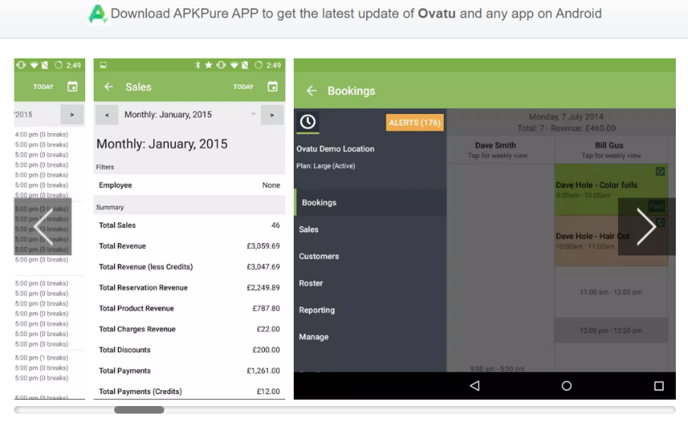

Appendix 1

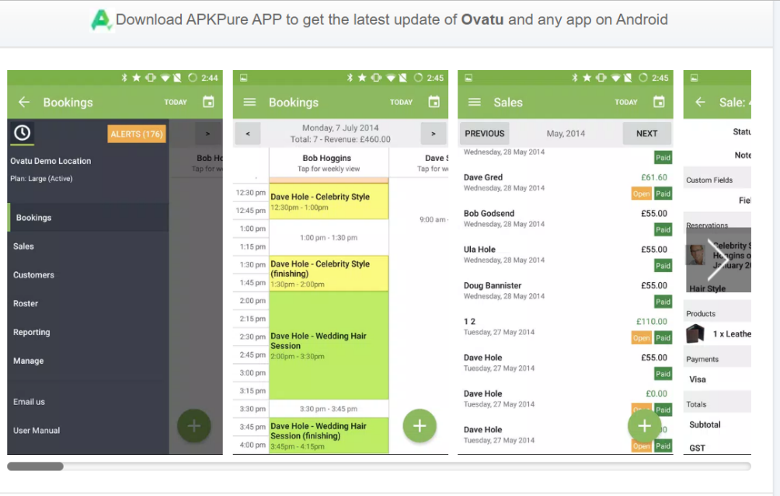
Appendix 2

Appendix 3
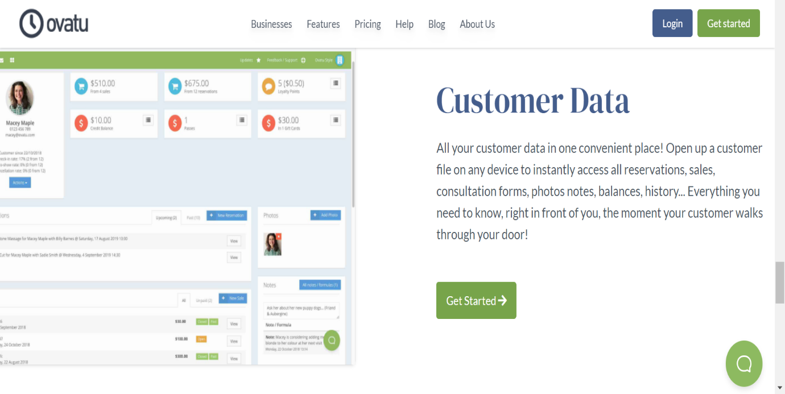

Appendix 4


