Crisis Management- Case Study Review

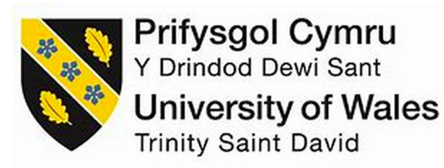

Emma Harper 2012799

Contents Page

3
Introduction
3
Review of Preparation
5
Main Body
7
Conclusion
8
Recommendations
9
Reference List

Introduction

For the academic crisis review, as a crisis manager with the role of the Football Association of Wales within the Bronze Command. There was a duty of understanding practical and interactive real life crisis management Tourism and Events training. This case study review will include a detailed critical review and evaluation of the crisis management of the event and the role played as Football Association of Wales within the Bronze Command. This case study review includes evaluating real life crisis scenarios within the Champions League game in 2017 within Principality Stadium.

Review of Preparation
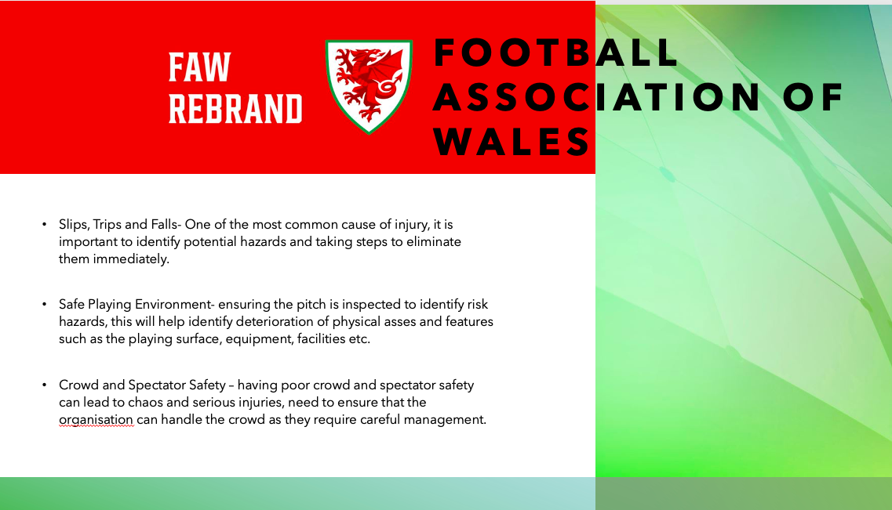

“A culture of continual improvement, a growth mindset that focuses on learning from crises rather than apportioning blame from failings, and careful knowledge management are all necessary for crisis preparedness and resilience in the Tourism Sector” World Travel and Tourism Council 2022
The Welsh national football team and the corresponding women's squad are under the supervision of the Football Association of Wales (FAW), the organisation that oversees association football. Their 2021–2026 strategic goal is to guarantee that Welsh football continues to flourish while becoming more inclusive and accessible. (FAW, 2023) When it comes to Football Association of Wales, there are many risks that FAW need to take into consideration when it comes to a crisis. For example, safe playing environment. FAW role is to take into consideration the risks of an unsafe playing environment, this means they need to ensure the pitch is laid correctly and there are no uneven surfaces which could result in an injury, this could lead to another risk which is slips, trips and falls. Slips, trips, and falls is one of the most common causes of injury, it is crucial to ensure that Football Association of Wales identify potential hazards like an uneven surface and taking steps to eliminate then immediately. Finally, another risk that FAW need to consider is the crowd and spectator safety, having poor crowd and spectator safety can lead to chaos and serious injuries, this is why FAW need to ensure that there are procedures in place to handle the crowd as they require careful management. (FAW Marsh Sport, 2023). As the role of Football Association of Wales, there should have been more research and points made in the PowerPoint Slide as FAW deal with a lot of issues when it comes to a football event.

As the role of Football Association of Wales, it also included being in the Bronze Command group. The Bronze Command has many roles and oversees a variety of issues when it comes to a crisis. For example, the Bronze Command control in the Principality Stadium and outside, transport, CCTV and facial recognition and armed response team. Within the bronze command group, the group communicated about who was in which role within the Bronze Command. Natalie oversaw the stadium, Amy oversaw the fan zone, Eden was transport, Sandra was cordons, Emma was in charge of the city and Sarah was in charge of emergencies. The bronze command communicated effectively within the group to ensure everyone had a role in the lead up to the debate. Bronze Command is an important Command as it is charge of decision making and operational control of the incident, bronze works with Silver Command to inform and update them when it comes to decision making. It is also crucial for Bronze Command to understand Gold and Silver strategic and tactical operational plans. Bronze Command will also implement tactical and operational plans on the ground and have a multi-agency approach. Within the Bronze Command, it was crucial to assign roles as the Bronze Command deal with a lot of issues when it comes to a crisis.

When planning and preparing the crisis scenario, it was crucial to compare it to a real-life event. An event that affected many people was the Manchester Arena attack within the Ariana Grande concert in 2017. Before the crisis occurred, members of the public saw the attacker hiding in the City Room and believed he looked suspicious, they raised concerns about this to security. The security decided not to take any action. (Manchester Arena, 2017) This was an issue as security should have acted straight away to ensure nothing suspicious was going on, even if it was just a simple security check on the person. As the role of Football Association of Wales, it is important to immediately consider the importance of the safety of attendees of an event. Within the research as a crisis manager, it included maps of the Principality Stadium with all of the exits and a map of Cardiff. Having these maps for the case study review helps plan when a crisis occurs in terms of where people should exit if a crisis has occurred.

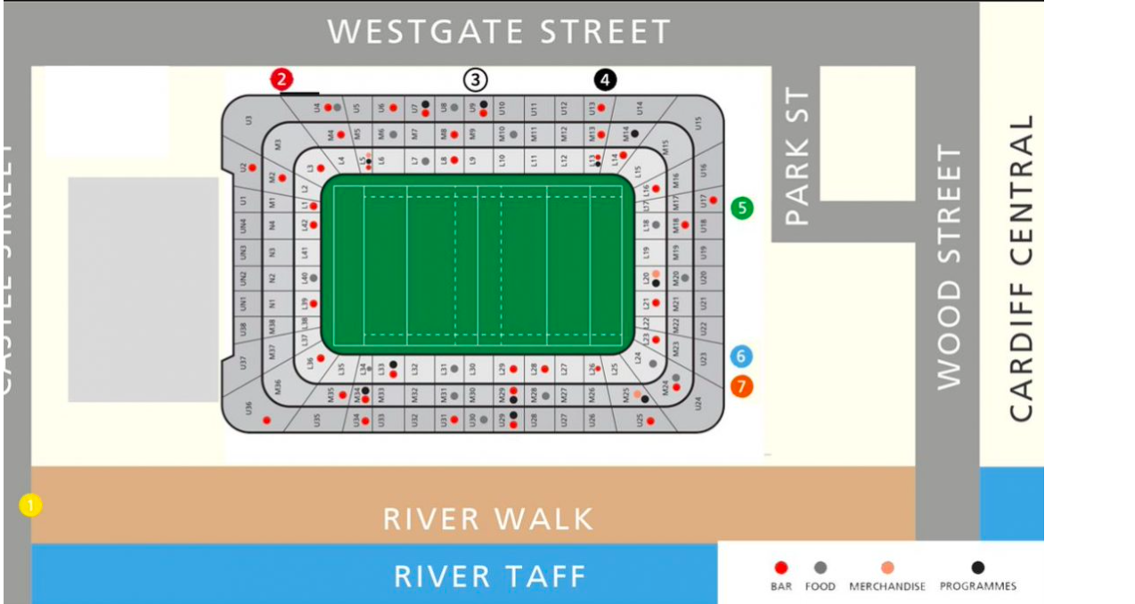
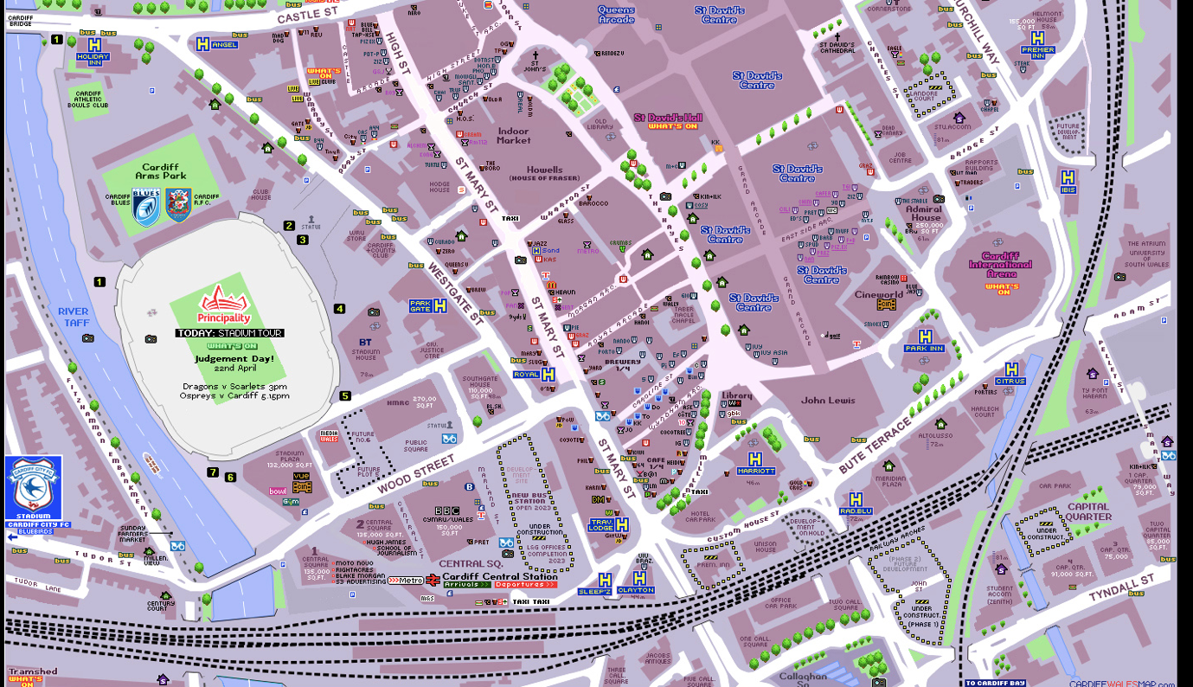

The research contained a lot of information that helped the case study review, although it did not include enough information about a real-life scenario such as, the Manchester Arena attack in 2017. The research also contained different models. For example, Fink (1986) Crisis Management Warnings, this includes 4 steps when dealing with a crisis such as, step 1: prodromal stage, step 2: acute stage, step 3: chronic stage and step 4: resolution stage. By having research on crisis models can help evaluate the crisis and deal with it in a correct manner.

Main Body

The academic crisis review was about the Champions League final in 2017 within Principality Stadium, there was a three-week warning given and that the teams that have qualified for the final were Liverpool and Bayern Munich. The event occurred on the 25th April, the fan zone commenced in Cardiff Bay which included day 1 10am-11pm and day 2 11am-11pm. There was no watching the match except in the Principality Stadium and there was media in the Cardiff Arms Park. As the role of FAW in Bronze Command, this had to include a preparation for the case study review. When preparing for the role it was important to consider that a crisis does inflict harm on the organisation’s reputation because of the negative information it generates about the organisation (Barton, 2001). An organisation would use a two-step procedure to assess the reputational threat of a crisis when handling it. For example, the first step would include assessing the basis crisis type, Coombs and Holladay (2002) had respondents evaluate crisis types based on attributions of crisis responsibility. For example, there would be 13 categories that an organisation would put a crisis in, these can include natural disasters, rumours, workplace violence, preventable crisis etc. (Coombs, 2014). Reviewing the elements that make a crisis more severe in the past and past reputation is the second phase. If an organisation has a history of crises similar to this one or a poor reputation, the threat to its reputation is more significant. (Coombs,2014). Another crisis an organisation could follow is Gonzalez, Herrero & Pratt (1995) Diagnosis, Planning & Adjusting to Change. This involves 3 steps, step 1 is to diagnose the impending trouble, step 2 is to choose an appropriate turnaround strategy and step 3 is to implement the change process and monitor it.

During the crisis review, there was a range of issues given and as a team that the group had to implement what to decide and how to handle the crisis. The first issue included the Royal Family were attending the Champions League final, Prince William, and Kate with their two oldest children. The commands had to come up with a strategy on how to keep them safe throughout the event. The bronze command decided as a team that they would bring in the Royal Family 1 hour before gates open via an underground tunnel, they would have 5 undercover cars when being driven to the event as they believe people would be suspicious if they saw a boat and would draw attention to them, there would also be additional security checks along the VIP boxes where the Royal family would be, they would also leave 2 hours after the game, to ensure they do not clash with the crowd due to not knowing how long the crowd would take to evacuate. Finally, they would leave through Gatland gate and through an underground exit to ensure no suspicions. After discussing this, it was announced that hospitality boxes would not work with the Royal Family as it overlooks the stadium and makes them visible to the crowd, it was beneficial to put them in the function room as it is at the back of the Principality Stadium and it is not as visible to the crowd, this provides extra security for the Royal Family.

The second issue involved Cardiff Castle, there appeared to a bomb planted there. Silver command decided that they would employ sniffer dogs and slowly evacuate people, they would then send bomb disposal team to destroy the bomb on site and then will ask bronze command to announce the crisis. The issue silver command made was not checking if it was a hoax first before making action, this can cause unnecessary stress for the public as they would believe it is something serious. Within the bronze command, they came up as a team to decide that they would investigate if it were a real bomb or just protocol as Principality Stadium would have 7 hoax protocols per match. If it was a real bomb, then the bronze command would lockdown the stadium, evacuate everyone within a mile radius. Check cctv and facial recognition to check if anyone was acting suspicious such as, carrying a bag. It is important to ensure that it is investigated first to see if it is a hoax or not as it is crucial not to scare people, especially VIP’s, ensure it is real before locking down surrounding areas.

Another issue involved a report of flares going off and various anti-social behaviour between the fans down Cardiff Bay, Gold command would ask to slow down alcohol sales to avoid misbehaviour and then contact silver to cctv monitor anti-social behaviour. Silver would then inform Principality Stadium about the misbehaviour as they could be heading towards the stadium, they would ensure extra bag checks are in place to ensure no flares are being brought into the stadium. However, the bronze command would inform silver command that no bags were brought into the stadium, this is the safest option as a bag check might not always be incredibly accurate. They would have emergency services on standby if needed and contact first aider just in case anyone is injured from the flares. Check cctv to see who is letting off the flares, if the people are found then they would ban them and deny entry to the Champions League event.

Having real-life crisis scenarios thrown at each group, helped the groups come together and communicate. However, even though each command such as gold, silver and bronze communicated effectively. There was not much communication going on between the groups, in a real-life crisis it is critical for each command to work and communicate together to ensure the crisis gets resolved quickly and professionally. For example, with the crisis of a bomb being placed in Cardiff Castle, it is crucial for each command to communicate to ensure it is not a hoax, gold command should then communicate with bronze to check cctv and facial recognition to see if anyone or anything looked suspicious around Cardiff Castle. Being able to communicate effectively can help make the crisis be dealt with a lot quicker. For example, with the Manchester Arena attack in 2017, there should have been clear communication about a person looking suspicious after many people complained about the attacker. When evacuating the arena, it should have been done safely and effectively to avoid people stamping on each other and causing even more injuries. “As the attacker made his way to the arena, visibly weighed down by the rucksack on his back, as he waited for the concert to end, he walked amongst the crowds.” (De Simone, 2017). This shows that even though the attacker looked suspicious, the security did not stop or check him even when people claimed the attacker looked suspicious. When dealing with a crisis, it is crucial for security to communicate when something is deemed as suspicious.

Conclusion

Overall, the crisis management scenario was deemed a success. With much preparation and research gone into the role of Football of Association of Wales within the bronze command, it helped prepare for the unexpected crises that occurred. When dealing with many different types of crises within the scenario helped each command quickly communicate on how to deal with the crisis as efficient as possible, on the other hand although the groups each communicated effectively, there was not much crisis management models being discussed. It is crucial as a crisis manager to follow a crisis model to ensure everything goes to plan to ensure bad media or other issues that may follow the crisis. Having the crisis management scenario results in people having a further understanding of a crisis and what to do in the situation, by following crisis models and communicating with the team can help the crisis be resolved quickly and efficiently.

Recommendations

Even though the crisis management scenario was deemed a success, as a crisis manager there are recommendations that have been put forward for future events.

- Ensuring more planning and preparation from each command occurred before the scenario to ensure each command was prepared for every possible crisis that could occur within the event.
- Ensure that each command such as gold, silver and bronze effectively communicate with one another instead of just communicating within the own commands to ensure the crisis is being deal with correctly.

Reference List

Barton, L. (2001). Crisis in organizations II (2nd ed.). Cincinnati, OH: College Divisions South-Western.

Coombs, W. T., & Holladay, S. J. (2002). Helping crisis managers protect reputational assets: Initial tests of the situational crisis communication theory. Management Communication Quarterly, 16, 165-186.

Coombs (2014) Crisis Management and Communications (updated September 2014), Institute for Public Relations. Available at: https://instituteforpr.org/crisis-management-communications/ (Accessed: 03 May 2023).
FAW / security (2023) Security | Cardiff 2017. Available at: https://www.faw.cymru/cardiff2017/local-knowhow/security/ (Accessed: 03 May 2023).
Football association of wales (2023) FAW. Available at: https://faw.marshsport.co.uk/ (Accessed: 03 May 2023).
Fink, S. (1986) Crisis Management. Amacom, New York.

Gonzalez-Herrero, A., & Pratt, C. B. (1995). How to manage a crisis before-or whenever-it hits. Public Relations Quarterly
Manchester Arena (2017) – Manchester Arena Inquiry. Available at: https://manchesterarenainquiry.org.uk/report-volume-one/part-1-missed-opportunities/the-attack/ (Accessed: 03 May 2023).
Simone, D.D. (2020) The road to the Manchester Arena bombing, BBC News. Available at: https://www.bbc.co.uk/news/uk-51908280 (Accessed: 03 May 2023).
UEFA.com (2017) 2017 UEFA champions league final: Guide to cardiff, UEFA.com. Available at: https://www.uefa.com/uefachampionsleague/news/0235-0e95f7479a46-84dce2a2b3c4-1000--2017-uefa-champions-league-final-guide-to-cardiff/ (Accessed: 03 May 2023).
Who are the FAW Trust? (2023) FAW Trust. Available at: https://www.fawtrust.cymru/who-we-are/intro/#:~:text=The%20FAW%20Trust%20is%20a,from%20grassroots%20to%20national%20level.&text=Football%20for%20everyone%2C%20everywhere%20in%20Wales.&text=Transforming%20communities%20through%20football%20for%20all. (Accessed: 03 May 2023).
World Travel & Tourism Council (WTTC): Travel & Tourism Representative Council (2022) World Travel & Tourism Council. Available at: https://wttc.org/ (Accessed: 03 May 2023).

