PROFESSIONAL CAREER DEVELOPMENT
(BMSW4005)

OMOLARA OPEYEMI LAWAL-AKINTOLA
1906883

DR MOLLY JACK

Table of Contents
INTRODUCTION 3
PERSONAL REFLECTION 3
JOHARI WINDOWS 4
UNDERSTANDING OF SKILLS AND KNOWLEDGE 6
SUMMARY AND PARAPHRASING 8
ACTIVE LISTENING 9
TEAMWORK 9
WORK READINESS - AM I READY? 9
STRENGTHS, WEAKNESSES, THREATS AND OPPORTUNITIES (S.W.O.T.) ANALYISIS 10
REFERENCES 14

INTRODUCTION
This is a reflective report of my Personal career development. It will reflect on my skills that I had before I re-entered the university. It will also reflect on skills that I have gained recently on my return to the university. My strengthens and weaknesses will be highlighted. The report will further explain how I will improve upon my weaknesses. The Gibbs Reflective Cycle Model will be used to present this report. The diagram 1.1 below describes Gibbs reflective cycle.

GIBBS REFLECTIVE CYCLE MODEL
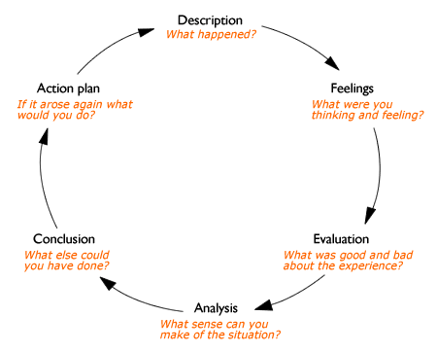
Fig. 1.1. Source: Google Images
I will also discuss my continuous personal career development via the Personal Development Plan.

PERSONAL REFLECTION
I graduated as a degree holder in 1987 with Bachelor's in Business Education in Nigeria. I was gainfully employed as a graduate trainee into the banking industry in June 1988. I worked in the banking industry for several years, where I attended several short courses, seminars, retreats, and inductions. I was able to learn several key skills which were important in the industry such as being able to effective communicate, numeracy skills, Business Mathematics, Team working and skills for operating International Trade such as Letters of Credits and Bills for collection.

In 2001 the Bank went into administration. I was retrenched and I was in the unemployment market till June 2001, I then gained employment again as an Accountant in a Confectionery company, which I worked for until February 2019. I joined the confectionery company at the management level. This exposed me to various management skills such as planning, organising, decision making, delegating of duties and so on. I relocated to the United Kingdom February 2019; I came to look after my grandchildren but after 4 months I got bored, so I decided to get a job. The immediate type of job that was available was a Care Worker. I took the job, because I liked to care for people, it gives me solace, and I have had some experience of being a Carer by caring for my mother in law for about 3 years. This was practised in an unprofessional manner. Some of the skills I developed over the 3 years unprofessionally were being empathetic, patient, observant, reliable and caring. The qualities I just mentioned, I did not know they were skills until I joined the university to improve my job status. Some of these qualities were discovered through a class exercise of the Johari Windows.

JOHARI WINDOWS
The Johari Windows is a model that is used for “self-awareness” it is a tool that processes information. The model is a quadrant where each window symbolizes information that is internal or related to an individual or group. Such information could be feelings, experience, views, knowledge, attitudes, skills, intensions, motivations and so on ( Luft and Ingham, 1961). From the Johari Windows exercise I was able to discover some qualities that I did not know I possessed such qualities of being bold and confident. It is also a medium of disclosure and feedback. It is an information processing tool (Saxena, 2015).
One of the areas of the quadrants is the Open area/ Arena where information in this area is known by both self and others. There is the Blind area/spot information in this area is known by others but not by self. There is the Hidden area which is information known by self but not by others. Lastly there is the Unknown which is information that is not known by both self and others. The focus of the quadrant is the Open area, the more the disclosure and feedback from both the hidden area and the Blind spot, the more the free flow of information about self or group. If the exercise is handled the way it should be it exposes to management the importance of interpersonal communication skills, it also promotes creativity and increase understanding (Saxena, 2015).

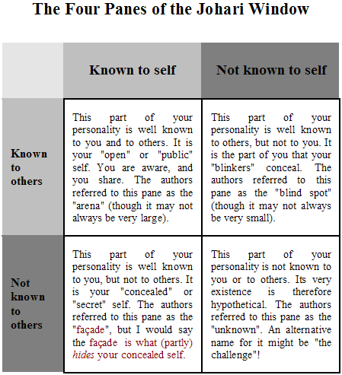
Fig 1.2.
Source: Google Images.
Thus, I chose to study, to have a professional knowledge of both theoretic and practical skills in health and social care.
I was also informed that my certificates were not recognise in the United Kingdom, this is another reason why I return to the university, especially the University of Wales Trinity Saint David, where I can study skills for the workplace as well as academics in Health and Social care, it will also give me a locus standi within the environment in which I find myself, transitioning from being an Accountant to becoming a Health care worker.

UNDERSTANDING OF SKILLS AND KNOWLEDGE
  - COMMUNICATION
Being able to communicate effectively is a key skill. Communication is essential to be able to work effectively. I have been able to reflect on the knowledge and skills learnt in all my modules so far. I have learnt a lot in such a short time.
Communication can be defined as the exchange of views, ideas opinions, thoughts or feelings between a sender and receiver by verbal or nonverbal means (Genc, 2016). Verbal meaning the use of words, there is written and oral communication as well as non-verbal or body language. Oral Communication is the exchange of information by spoken words, while Written Communication is the exchange of information by written words (Daft, and Noe, 2001). Oral Communication is used extensively at the workplace by having face to face conversations, Telephone conversations, presentations and so on.
For Communication to be effective, requires a feedback, as reflected by Schramm’s (1955) Model of Communication. His model emphasized that communication is a two-way process, whereby the sender must ensure that the receiver understands the information being communicated as well as receive a feedback (Ma, 2015) It is essential in the workplace that when I exchange information such as an e-mails that I receive the required feedback to signify that the information was understood. Schram’s model indicates that where there is no feedback communication is incomplete and not effective. As a care worker communicating effectively is essential when writing a Daily Log sheet, which is a detailed report of activities that take place during a shift. I apply the principles of 7 C’s of communication (Fig.1.3) to structure my report.

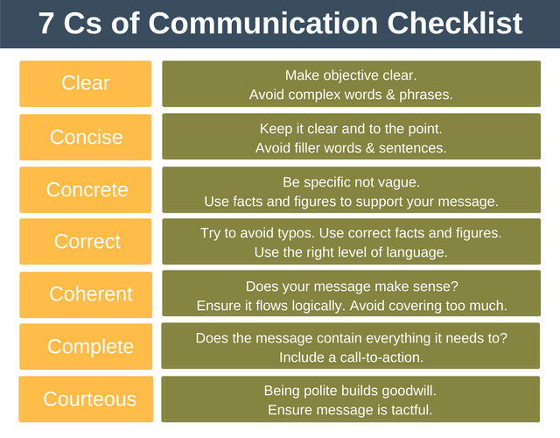
Fig. 1.3 Source: Google Images.
Written communication is used effectively at the workplace via letters, Memos, reports e-mails, notes Office boards, which are used as a medium to exchange information between individuals.
Nonverbal communication is conveying a message without using words or in other terms body language (Daft and Noe, 2001, p. 312). The way individuals perceive body language differs, since nonverbal messages are interpreted generally based on cultural backgrounds and experiences (Daft and Noe, 2001). Staring into an elderly person’s eyes when being spoken to as a younger person for instance, from where I come from its disrespectful, while in the UK it’s a sign of showing keen interest in what is being said. Having the skill to interpret and observe body language as a Health care worker is key to me. With my short experience in dealing with the vulnerable as well as individuals with disability having the skill to interpret nonverbal communication is highly essential to be able to provide a tailor suited support and care to a service user. Gestures from a person's face or body aids communication, these gestures could be intentional or unintentional. The effect of facial expression (body language) compared to spoken words and para-linguistic cues is quite high. Para-linguistic cues is any type of verbal signals that changes or influences the meaning of words of information conveyed (Morgan, 2017, p250). According to Mehrabian’s study, receivers were able to
interpret the facial expression better than other channels (Daft and Noe, 2001). This is also referred to as the 3 Vs – Vocal, Visual and Verbal. See Figure 1.3. below.
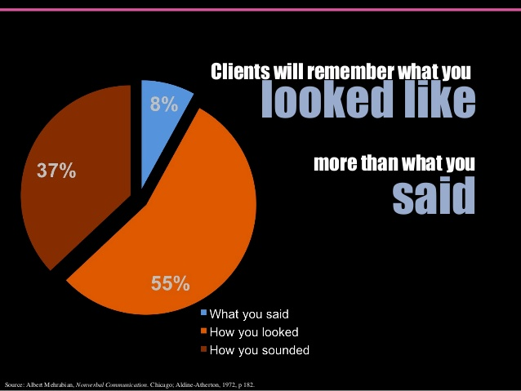
Fig. 1.3.
Source: Albert Mehrabian, Nonverbal Communication.
The Figure 1.3 reflects that facial expressions had a significant impact of 55% on receiver’s interpretation of information conveyed, that is how you looked or the visual. The vocal which is the voice had an impact of 37% this involves the pitch, tone and timbre of the voice, which is represented on the chart as How you sounded. While What you said, which are spoken words had only 8% (Daft and Noe, 2001, p.313).
SUMMARY AND PARAPHRASING
I have learnt how to summarise and paraphrase reports and documents without committing the offence of plagiarism. Summarising of a document or a paragraph is repeating and reducing the key points of a text, that is reducing the passage by 50% (Howard, Serviss, Rodrigue 2010), in my lecturer’s words “cutting the long story short.” Paraphrasing is repeating a text from a source substantially changing the language, although sometimes retaining key words from the text (Howard, Serviss, Rodrigue 2010), Plagiarism is using some else's literature without acknowledging the author (Bailey, 2015). These concepts are essential to me if I want to write an academic report or organise an in-house training at my
workplace in future which requires an idea or an opinion from someone else's literature, the author will need to be cited, that is acknowledged.

ACTIVE LISTENING
Active listening is an important skill in being able to communicate effectively in the workplace. Empirical studies have supported the view that most people do not listen very well (Daft and Noe, 2001, p.325). Active listening is the diligent pursuit of accurate, clear and complete idea of some other person’s communication via explicit explanation of verbal and nonverbal communication (Morgan, 2017, p.266). Active listening is not the same thing as hearing. Hearing is viewed as a passive reception of information, not recognising, and understanding what has been said. It requires much more effort and clarification than just hearing. It requires effort and discipline, and an exact comprehension of the message is required before an appropriate response is made. Active listeners put themselves in the perspective of the speaker. They pay attention to their posture, paraphrase what is heard and scrutinize the in depth meaning of the message (Maund, Schriek and Tinkler, 2017, p.52). Paraphrasing is an influential listening skill, it demonstrates the truth in others, establishes trust and encourages divulgence of information (Maund, Schriek, and Tinkler, 2017, p. 53). In the care setting active listening I have learnt is essential in establishing a bond with others especially vulnerable individuals (Cottrell, 2015, p. 135) listening attentively and observing the individual’s facial expression as well as other body gestures and shows keen interest. Leaning forward within the required distance, having intermittent eye contact as well as paraphrasing what is being said, establishes trust and information disclosure, which in turn enables the individual to develop confidence in you.

TEAMWORK
A Team is a group of collectively devoted individuals who work together to accomplish a common goal (Morgan, 2017 p.204). Whenever an individual joins an organisation the person becomes a member of a large team, where he or she contributes his/her quota to the overall objective of the organisation. Teams are formed depending on the objective that needs to be met, and when and where its’ supposed to be done (Clements, Dault, Priest, nd). Teamwork increases students Learning abilities, assist members to develop dependency on each other, which in turn develops trust between team members. Furthermore, it improves members self-confidence as well as recognise the good qualities in each other.

WORK READINESS - AM I READY?
A Career Development Plan is described by Gysbers (1983) is centred on the development of an instrument and a process. A Care Plan has been described as an implement where
individuals write down their aptitudes, Values, interests and skills they have acquired as well as give a chance to list those they want to improve or acquire. As a process is a career map or shows the way as to how the person can utilize the past and the present to look forward to the future (Kalchik and Oertle, 2011, p.1).
CAREER PATHWAY 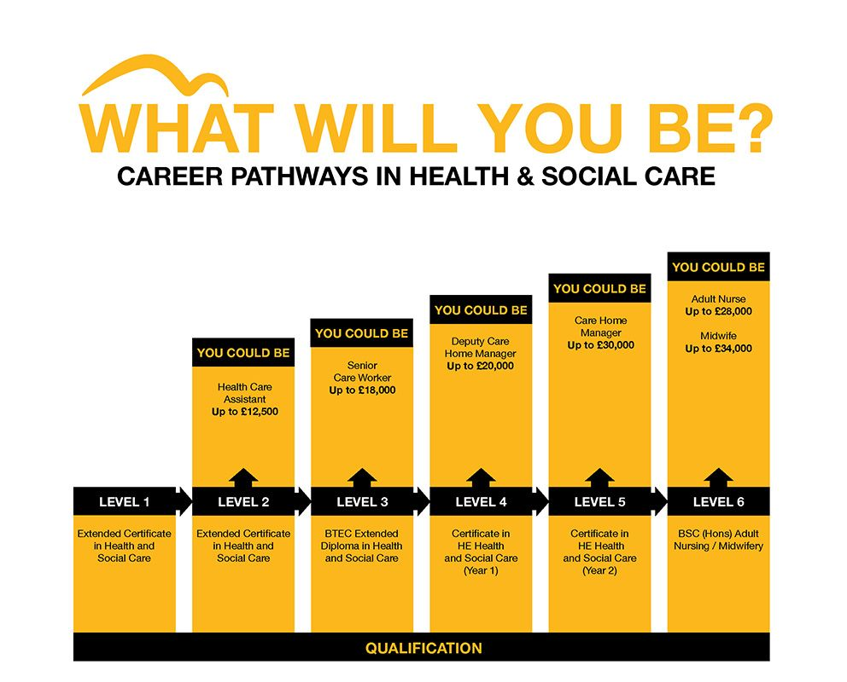

STRENGTHS, WEAKNESSES, THREATS AND OPPORTUNITIES (S.W.O.T.) ANALYISIS
S.W.O.T. Analysis is a management tool used to scrutinize the strengths, weaknesses, threats and opportunities of an organisation’s business “competitive advantage” or research, while for an individual it relates to the person’s career development (Addams and Allred, 2013, pp.43-51). It is an instrument used by an individual or organisation to assess the correlation between an individual’s or organisation’s strengths and weaknesses and their environmental opportunities and threats (Abubakar and Bello, 2013, pp. 83-91). Addams and Allred (2013) further stressed that if the S.W.O.T analysis evaluation is done appropriately individuals can improve their future and continuous personal career development.
SWOT ANALYSIS
STRENGTHS  - I have good communication skills developed over the years as an Accountant.  - I have good Numeracy skills  - I have a positive and calm attitude  - I am hard working  - Team worker  - I have managerial experience  - I have good Interpersonal skills  - I am Empathetic  - I am Caring and Compassionate  - I am Reliable  - I am Resilient | WEAKNESSES  - Often too shy to put ideas across.  - Poor in computer software such as Microsoft word and Excel and the internet - Digital skills.  - Poor Presentation Skills.  - Poor Time Management – procrastinate often.  - Bad in public relations especially when talking to new people  - Slow at Decision making  - Not assertive enough.  - Too helpful – not being able to say ‘NO’.
OPPORTUNITIES  - Government Legislations – On financing individuals who are ready to continue to develop themselves academically or professionally.  - Health and Social care sector – encourage persons to continuously improve professionally.  - Variety of career development opportunities available in Nursing.  - Coming back to the university has given me the opportunity to improve and develop the major and technical skills the I require to be employable in the Health and Social Care sector.  - Shortage of qualified Health personnel as compared to the vulnerable clientele or patient rate. | THREATS  s  - Health Care qualification without the required relevant experience.  - In a digital era, nearly all processing these days are now done on the computer.  Government Legislation – On age limit.

Reflecting on my S.W.O.T. analysis I have been able to use some of my strengths and opportunities to harness some of my weakness and threats to be able to reduce the impact on my career to the barest minimum. One of the opportunities I have is returning to the University and my strengths is being able to communicate effectively which has improved my presentation skills, by reducing my nervousness, knowing that a presentation is not about me, but about the audience, their perspective and being able to put myself in their shoes, impacting upon them to be able to help them to do things differently. Furthermore, I have been able to use the opportunity to get to know some of the government policies that affect me such as student finance, which has enabled me to come back to the university to continue to develop and improve my skills technically and professionally in Health and Social Care sector.
My short-term goal is to be a Lead Adult Care Worker within the next one and a half years, while my long-term goal is to become a Care Nurse in the next 5 years. I am transitioning from being in a world of Numeracy to being in a world full of care and compassion. I have an NVQ level 3 and am currently pursuing a Certificate of Higher Education, Skills for the workplace (Health and Social Care) level 4. The various modules being studied will prepare me to become or be gainfully employed as a Lead Adult Care Worker. Some of the skills required are paying attention to detail, customer service skills, patience and ability to remain calm in stressful situations, ability to work well with others, ability to work on my own, and effective verbal Communication skills. It also requires the following qualities, to be Respectful, Empathetic, Reliable, Observant, Caring and qualified. To be qualified I need a minimum of 1 to 2 ‘A ‘levels plus NVQ 3 or NVQ 4 or 5 plus Experience. Presently I have NVQ 3 which qualifies me to be a Care Worker on the health and social care hierarchy. I have already taken the steps to move to the next level of my career plan by coming back to the University, for a course in Higher Education Skills for the workplace (Health and Social care) which will qualify me to become a Lead Adult Care Worker. I can either do a level 5 diploma in Leadership and Management or a degree in Nursing to go to the next level of my career plan.
Aspiring to be a Care Nurse in the next 5 years will also require some additional skills and qualities such as being diligent, effective interpersonal skills, paying attention to detail and being Empathetic. I will also have to observe the Nursing 6 Cs – Care, Compassion,
Competence, Communication Courage and Commitment. The skill of being courageous also applies to care workers at my current level. It implies that I should speak up for a service user or patient that I feel is in a position of harm or is not safe - to advocate for the individual, especially if the individual is not in the position to do so. Having Empathy for the service user enables me to put myself in the position of the service user and eventually establishes a rapport between the service user and the care provider. There are several Legislations that protect and guide me as to how I should provide care to Vulnerable persons. I have certain duties toward the provision of the care provided. Such as the Duty of Candour which is a legal duty to be open and honest toward the patient if things go wrong or could affect the patient in future (CQC, 2014).

REFERENCES
- Abubakar, Nuru; and Bello Garba Bala (2013) ‘Strengths, weaknesses, Opportunities and Threats (S.W.O,T) Analysis on Gobalcom Ltd., International journal of Information Technology and business management. Vol.16 (1), pp.
- Addams, Lon and Allred Anthony T. (2013) ‘The first step the in proactively Managing students 'careers: Teaching Self – SWOT Analysis’. Academy of Educational Leadership Journal. Vol.17(4) Pp43-51
- Bailey, Stephen; (2015), Academic writing for International students of Business. New York: Routledge 2nd Ed. Pp. 24-26.
- Clements, Dave; (2000) ‘Effective Teamwork in Canada Healthcare: Research and Reality’ Health care papers. Vol.7 Special Issue.
- Cottrell, Stella, (2015), Skills for Success: Personal Development and Employability. 3rd Ed, London: Macmillan Publishers.
- Genc, Ruhet; (2016), ‘The Importance. Of communication in Sustainability and Sustainable Strategies’. 14th Global conference on Sustainable Manufacturing GCSM. 3rd - 5th October, Stellenbosch, South Africa.
- Howard, Moore R; Serviss, Tricia; Rodrigue, Tanya K; (2010) ‘Writing From Sources, Writing from Sentences’ WAP, Vol. 2(2) Pp. 177-192.
- Kalchik, Stephanie; Oertle, Kathleen M (2011), ‘The Relationship of Individual Career Plans to Programs of Study and Career Pathways’. Transition Highlights Vol. 3
- Luft, J and Ingham, H;(1961), The Johari Windows. Human Relations Training News. richerexperiences.com
- Ma, F (2015), ‘Models of Communication’, Information Communication. San Rafael, CA: Morgan and Claypool. Pp. 23-28
- Mehrabian, A (2007), Nonverbal Communication. Chicago: Routledge
- Saxena, P; (2015) Johari Windows: ‘An Effective Model for improving Interpersonal Communication and Managerial Effectiveness’. SIT Journal of Management. Vol. 5(2). Pp 134 – 146.
- Xyrichis, Andreas; Ream, Emma; (2008), ‘Teamwork: a Concept Analysis, Journal of Advanced Nursing, Vol.61(2)

