Module Code & Title: BMHP6030 Health, Wellbeing and Sustainable Development
A Critical Examination of Health, Wellbeing, and Sustainability Policies in the UK: An Analysis of SDG 3 and SDG 13

Joyrul Haque
Student ID: 2131666
Parese Ahmed

Contents
Introduction 3
Section One: SDG 3 – Good Health and Wellbeing 5
Overview of SDG 3 5
Global Policies and Initiatives 6
National Policies and Initiatives in the UK 6
Local Initiatives: London Example 6
Use of Theories and Models 7
Critical Evaluation 7
Recommendations 7
Section Two: SDG 13 – Climate Action 8
Overview of SDG 13 8
Global Policies and Initiatives 8
National and Local Policies in the UK 9
Local Initiatives: London Example 9
Use of Theories and Models 10
Critical Evaluation 10
Recommendations 10
Conclusion 11
References 12

Introduction
Globally, sustainability, wellbeing, and health are being referred to as the key priorities. To ensure high value on these aspects, Sustainable Development Goals (SDGs) are being developed by the UN productively. SDG 3 is being considered as a key and significant goal of SDGs so that addressing of sustainability, wellbeing, and health can be addressed (World Health Organization, 2022). Good health and wellbeing are being considered as the third goal of SDGs and the goal is being developed so that wellbeing and healthy living of individuals can be promoted. Climate action refers to the SDG 13 and the goal is being developed so that impacts and changes of climate can productively be combatted. Due to the influence of these goals effective environment and healthcare will be accessed by the individual which will improve wellbeing of individuals.
Effective policies and procedures are being developed by the UK so that goals of SDGs can be aligned, and key priorities of the world can be addressed. The UK Climate Change Act (2008), PHE, and NHS of the UK are being functioned to ensure the aligned goals. The UK considered these policies and procedures so that the system of health can be sustainable, inequalities in health can be reduced, and resilience can be promoted against the challenges of the society and environment (Department of Health and Social Care, 2021).
SDG 3 and 13 will be comprehensively analysed by the report so that influence of these goals on the UK sustainability, wellbeing, and health can be determined. Diverse national and international policies related to these goals will be analysed comprehensively by the report to ensure a productive knowledge effectively.
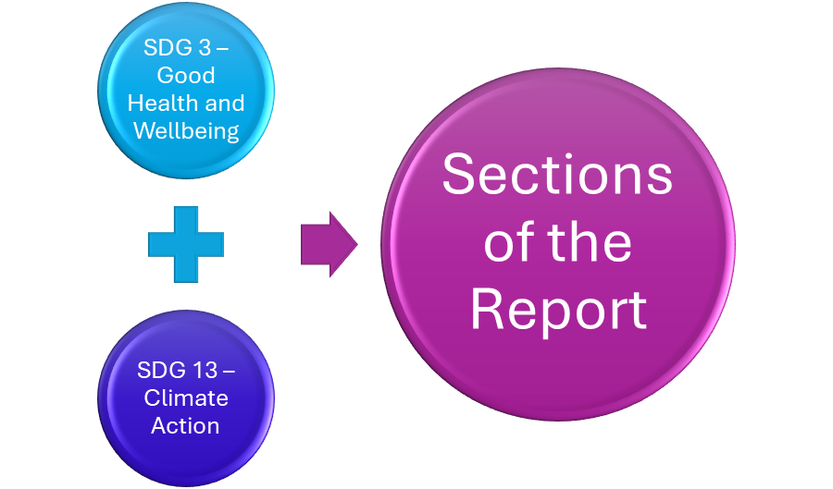
Figure 1: Sections of the Report
Source: Created by Researcher

Section One: SDG 3 – Good Health and Wellbeing

Overview of SDG 3
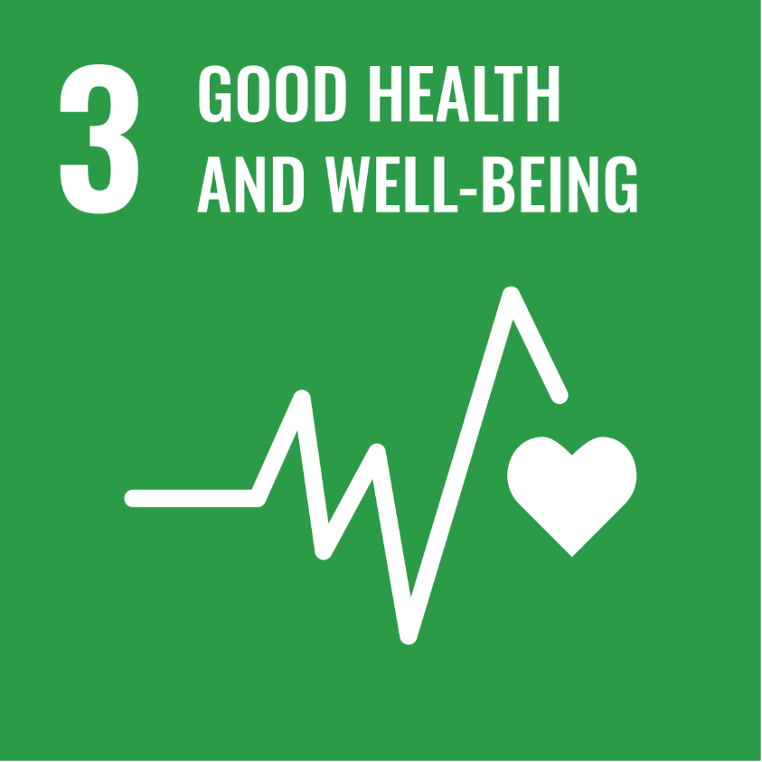
Figure 2: SDG 3
Source: (UN, 2015)
Promotion of healthy living and wellbeing of diverse age groups are being considered as key aims of the goal of SDG 3 (UN, 2015). The primary focus of the goal is being considered as on the reduction of the mortality rate. Additionally, the goal will target to bring an improvement in the accessibility of the services of healthcare. Therefore, non-communicable and communicable diseases will be productive addressed and effective mental health of individuals will be supported. Furthermore, the goal determined and defined that to ensure wellbeing of individual it is not only essential to address issues of health but also to influence factors of economic, environment, and society.
Conditions of the environment, poverty, and healthcare access are being considered as the key global factors which influenced inequalities in the services of healthcare. In 2022, the issue of inequality in the services of healthcare is being faced by 4.5 billion people (WHO, 2023). Therefore, UHC is being targeted by the goal so that addressing of inequality can be ensured and overall wellbeing can be promoted.

Global Policies and Initiatives
To ensure effective coordination in the key factors of the goal of SDG 3, leading contribution is being ensured by the WHO at the global level. Universal Health Coverage Partnership and GHO are being considered as effective initiatives of WHO are being initiated so that system of healthcare of diverse countries can be improved productively (WHO, 2021). Equitability and capacity development are being supported by the program of the Global Strategy on Human Resources for Health so that professional services of healthcare can be enabled for the people of different countries. COVAX is being considered as a key example of global initiative which is being taken by CEPI, Gavi, and WHO so that Covid-19 vaccination can be distributed, and wellbeing of the global people can be promoted (Gavi, 2021).

National Policies and Initiatives in the UK
NHS Long Term Plan (2019) is being considered as a productive policy of the UK which is being developed so that implementation of SDG 3 can be ensured. Digital healthcare, mental health, and prevention are being valued by the policy so that significant transformation can be ensured in the system of healthcare of the UK (NHS England, 2019). The key priorities of the policy are being considered as the prevent the issue of inequality, enhance the quality of care, and integrate services of community and primary.
Healthy People and Healthy Lives are being considered as productive initiatives of the UK which are introduced by the PHE so that social determinants of health can be demonstrated, and productive system of healthcare can be promoted (Marmot et al., 2020).
Furthermore, Mental Health Implementation Plan is being developed by the UK so that services of health can be improved for ensuring effective mental health and integration of psychological therapies can be ensured in the primary care system of the country (NHS, 2021).

Local Initiatives: London Example
Mayor’s Healthier City Programme and London Health Inequalities Strategy are being considered as the initiatives of the local authorities of the city of London so that active lifestyle of individuals can be promoted, and effective support system can be ensured for the community of vulnerable (Greater London Authority, 2021).
Local charities, council, and NHS trust are being collaborated by the local authority of London so that Healthy School London program can be conducted and mental and physical wellbeing of the citizen of the country can be promoted. These are the ways that diverse initiatives are being taken at the local level to ensure effective wellbeing and health.

Use of Theories and Models
The Health Belief Model is being considered as a productive framework which is essential to be demonstrated so that change of behaviour can be supported, and individuals can be motivated in the way of adopting healthy lifestyle (Becker, 2024). This is the reason that optimisation will be ensured in the life quality of an individual and positive impacts will be ensured on the overall wellbeing of an individual comprehensively.

Critical Evaluation
Effective healthcare system is being ensured by the UK. However, diverse inequalities are being determined within the system which ensured negative impacts on the wellbeing and health of individual (Office for National Statistics, 2023). Therefore, consideration of equality policies are essential for the system of healthcare of the UK can be accessibility can be optimised and development of a productive healthcare can be promoted (King’s Fund, 2022).

Recommendations
Different recommendations are showcased below.
- To optimise funding so that preventive healthcare can be ensured.
- Effective collaboration is being required to ensure between local councils and providers of healthcare.
- Productive training is being required to ensure so that equitability can be achieved.
- To ensure targeted intervention enhancement is being required in the process of information acquisition.

Section Two: SDG 13 – Climate Action

Overview of SDG 13
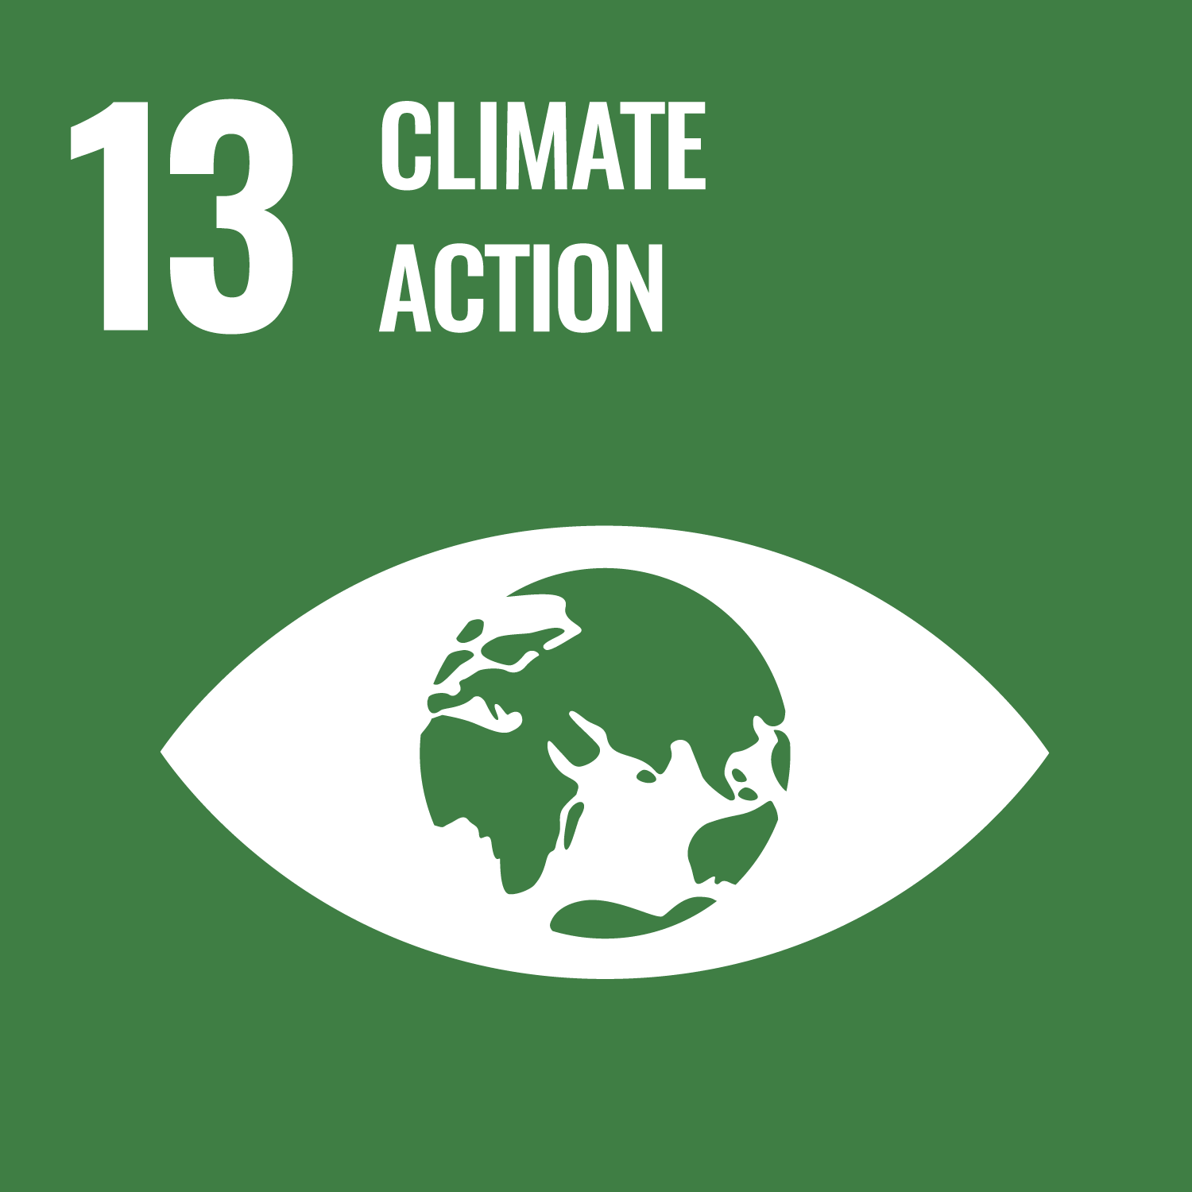
Figure 3: SDG 13
Source: (UN, 2015)
SDG 13 calls for immediate action to mitigate the effects of climate change. It places a strong focus on strengthening adaptive ability, increasing resilience, and incorporating climate measures into national policy (UN, 2015). Extreme weather events, food security, and air quality are all directly impacted by climate change (IPCC, 2022). Climate change is seen as a public health and environmental concern in the UK. Respiratory diseases and death rates have risen due to rising temperatures and air pollution (DEFRA, 2023). Therefore, by safeguarding the health and welfare of the populace, fulfilling SDG 13 advances SDG 3.

Global Policies and Initiatives
The Paris Agreement (2015) is being considered as a global policy which is being developed as to ensure effective climate action. According to the policy, below 2°C different countries of the world are being required to keep the global warming so that positive and productive impacts on the environment can be imposed. COP26 Health Programme is being considered as an effective initiative of the WHO which was being launched so that climate resilient system of health can be developed at the global stage so that not only positive impacts are being imposed on the environment but also on the society and health productively (WHO, 2021).
IPCC is being considered as a global initiative which putted a productive contribution so that scientific evidence can be demonstrated in the way of ensuring comprehensive guidance for the decisions of global policy. Furthermore, UNFCCC is being considered as a global organisation which is being functioned so that climate targets can comprehensively be addressed and positive influences can be promoted on the global environment productively.

National and Local Policies in the UK
The Climate Change Act (2008), which establishes legally enforceable carbon reduction objectives, has made the UK a pioneer in environmental policy. By 2050, net zero greenhouse gas emissions are the goal of the UK Net Zero Strategy (2021) (UK Government, 2021). The Clean Air Strategy (2019) describes steps to lower emissions from industry, transportation, and agriculture in order to lower health risks associated with air pollution (DEFRA, 2019). By enhancing public health, these measures indirectly assist SDG 3 and show a significant relationship with SDG 13. These are the ways that different productive and efficient policies are being generated and implemented by the UK so that climate change impacts can be reduced, and effective environment can be promoted productively. Additionally, the policies of the UK integrated the actions with the health systems so that productive influences can be ensured on the systems of health.

Local Initiatives: London Example
ULEZ is being considered as a productive local initiative of the city of London which was being launched in 2019 so that nitrogen dioxide can be reduced productively from the transportation system of the city and productive impacts can be imposed on the environment of the city (Transport for London, 2023).
London Climate Action Week and Green New Deal Fund is being launched by the local authority of the city so that climate solutions can be enhanced by the citizens and businesses of the city productively. Due to the influence of diverse local programs of the city productive improvement is being ensured in the quality of air. In addition, respiratory diseases are being reduced productively. These are the ways direct impact is being ensured on the health of the citizen effectively.

Use of Theories and Models
Understanding the interactions between social, economic, and environmental systems is made easier by the Sustainability Model and Systems Thinking Approach. These models emphasize the need for cross-sector coordinated effort in order to achieve sustainable solutions (Sterman, 2012). The Ecosocial Theory of Health (Krieger, 2001) explains how housing, work, and pollution affect long-term welfare and links environmental factors to health disparities. These are the ways diverse productive theories can be integrated so that through principles of these theories key goals of the SDG 13 can be addressed and overall performance of the environment can productively be accelerated.

Critical Evaluation
48% reduction is being ensured by the UK in the emissions (BEIS, 2022). However, challenges are being faced by the country to balance protection of the environment and growth of economy (Public Health England, 2020). Different policies are being developed by the country for the improvement of quality of air, while the policies are suffering to ensure zero emissions for the lack of finding. These are being considered as diverse shortcomings which are ensuring negative impacts on the policies of the UK.

Recommendations
Different recommendations are showcased below.
- Funding of the UK in the policies are being required to be accelerated.
- Awareness of public is being required to improve on the connection of health and climate.
- Policies of housing and sustainable transport are being required to be integrated with the strategies of health.

Conclusion
The ways SDG 3 and 13 are being related with sustainability, wellbeing, and health in the context of the UK are being evaluated and showcased by the report comprehensively. The focus of the SDG 3 is being provided on the improvement of the system of health. Additionally, the goal contributed so that social inequalities can be addressed, and mental health of individuals can be promoted productively. On the other hand, climate action and environmental resilience are being demonstrated by the goal of SDG 13. There is an effective interconnection between both the goals so that positive influences can be ensured in the social and health wellbeing of the individual productively.
Climate and health priorities are being required to be integrated by the policies of different countries productively so that sustainable progress can be pursued comprehensively. The integration will ensure a productive support so that protection of the environment. equitable access, and preventive system of healthcare can be focused and promoted productively. Sustainable future can be promoted by the UK through linking the SDG 3 and 13 productively so that overall wellbeing of the individual of the country can be promoted effectively.

References
BBC (2023) ULEZ expansion: London’s air pollution cuts and challenges. London: BBC News.
Becker, M. H. (2024) ‘The Health Belief Model and Personal Health Behavior’, Health Education Monographs, 2(4), pp. 324–473.
BEIS (2022) UK greenhouse gas emissions: Final figures 2022. Department for Business, Energy & Industrial Strategy.
Department for Environment, Food and Rural Affairs (DEFRA) (2019) Clean Air Strategy 2019. London: DEFRA.
Department for Environment, Food and Rural Affairs (DEFRA) (2023) UK Climate Resilience Report. London: DEFRA.
Department of Health and Social Care (2021) Health and Wellbeing Framework. London: DHSC.
Gavi (2021) COVAX: Working for global equitable access to COVID-19 vaccines. Geneva: Gavi.
Greater London Authority (2021) London Health Inequalities Strategy. London: GLA.
IPCC (2022) Climate Change 2022: Impacts, Adaptation and Vulnerability. Geneva: Intergovernmental Panel on Climate Change.
King’s Fund (2022) The state of the NHS in England 2022. London: The King’s Fund.
Krieger, N. (2001) Ecosocial Theory: Health, Society, and Environment. Oxford: Oxford University Press.
Marmot, M. et al. (2020) Health Equity in England: The Marmot Review 10 Years On. London: Institute of Health Equity.
NHS England (2019) The NHS Long Term Plan. London: NHS.
NHS (2021) Mental Health Implementation Plan 2019/20–2023/24. London: NHS.
Office for National Statistics (ONS) (2023) Health inequalities by deprivation in England: 2023. London: ONS.
Public Health England (2020) Review of Disparities in Risks and Outcomes of COVID-19. London: PHE.
Sterman, J. (2012) Sustaining Sustainability: Systems Thinking and Policy Analysis. Cambridge: MIT Press.
Transport for London (2023) ULEZ 2023: Air quality and emissions report. London: TfL.
UK Government (2021) Net Zero Strategy: Build Back Greener. London: HMSO.
United Nations (2015) Transforming Our World: The 2030 Agenda for Sustainable Development. New York: United Nations.
World Health Organization (2021) Universal Health Coverage Partnership Annual Report. Geneva: WHO.
World Health Organization (2022) World Health Statistics 2022. Geneva: WHO.
World Health Organization (2023) Tracking Universal Health Coverage: 2023 Global Monitoring Report. Geneva: WHO.

