Llanllyr House: a Landscape Characterisation

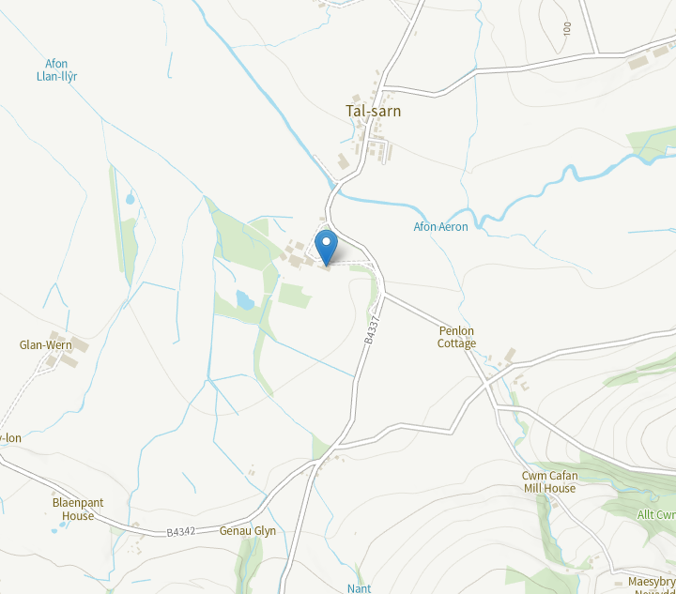
Figure 1: Contemporary map showing Llanllyr and the surrounding area (Royal Commission on the Ancient and Historical Monuments of Wales, 2021)

Today, Llanllyr is a mansion with surrounding farmland and a defunct spring water bottling plant situated within the Aeron valley in Ceredigion nearby the hamlet Talsarn (Royal Commission on the Ancient and Historical Monuments of Wales, 2021; Watson and Pratt’s, no date). The house has transformed greatly over time, and the history of the house encompasses “Celtic Christian saints, Cistercian nuns, Tudor squires, Victorian gentry and today, farmers and entrepreneurs” (Gee, 2010, p. 9).
This landscape characterisation will be about this house, its surrounding area and how it has transformed to what the house is today, specifically focusing on the Georgian period, from John Lewes’ acquisition of the house in 1720 (Gee, 2010, p. 37).

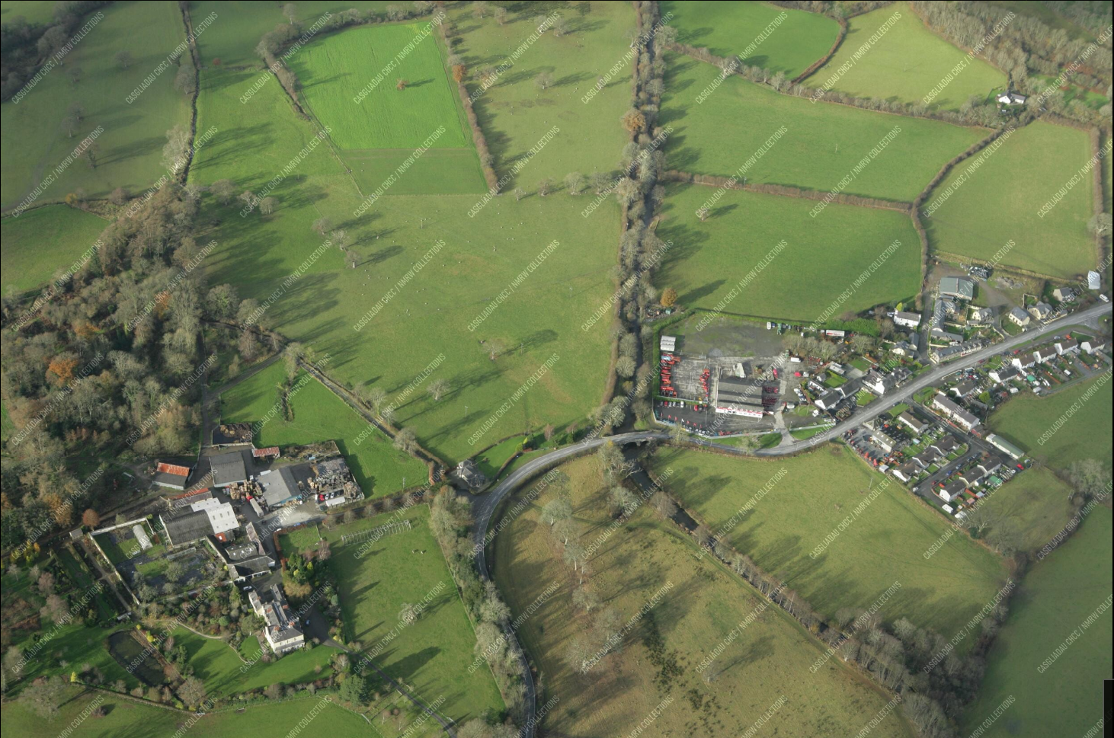
Figure 2: Colour oblique photograph of Llanllyr and Talsarn (Driver, 2007).
Olwig et al. (2016, p. 169) writes that “in any discussion of landscape characterisation the elephant in the room is the question of just what is a landscape?”. Before discussing specifically Llanllyr, it is important to question what is a landscape and what is a landscape characterisation. Landscape is defined as the “social construct of space, containing a bundle of practices, meanings, attitudes and values” (Darvill, 2008), however a simple dictionary definition will not suffice when discussing how to discuss landscape. Historically, discourse has existed between disciplines on how they should. Turner (2007, pp. 41-42) discusses the chasm between one academic tradition of an interest in understanding how societies worked and how they modified their environments and a second tradition that criticised this, arguing that the perception of the landscape is more important. However, the development of the Historic Landscape Characterisation aims to synthesise these ideas, “it recognises that all landscapes are historic and that they all shape and are shaped by the people who dwell on them” (Turner, 2007, p. 43). Perceptions of landscapes are also important, but it is necessary to understand that perceptions are not completely subjective and grow with time and with materiality (ibid.). Furthermore, Simensen et al. (2018, p. 558) discusses how there exists no single method for landscape characterisation, and that the focus of each characterisation is different depending on the subject and the objective. When looking at Llanllyr, the objective of this characterisation, as previously mentioned, is to see how the history of the landscape has shaped the house and the farm today.
A general history of the house begins in the 1180s. Evidence of a Cistercian nunnery at Llanllyr exists from this time, namely an account by Gerald of Wales. The convent for Cistercian nuns was founded around this time by Lord Rhys ap Gruffydd of Dinefwr, Prince of Deheubarth, who placed it under the supervision of the Abbot of Strata Florida, an important Cistercian monastery about thirteen miles from Llanllyr (Gee, 2010, p. 17; Murphy, 2017). It is worth noting that there exists however no medieval buildings or earthworks at Llanllyr, and the existence of the nunnery only exists within “scant documentary sources” (Murphy, 2017).
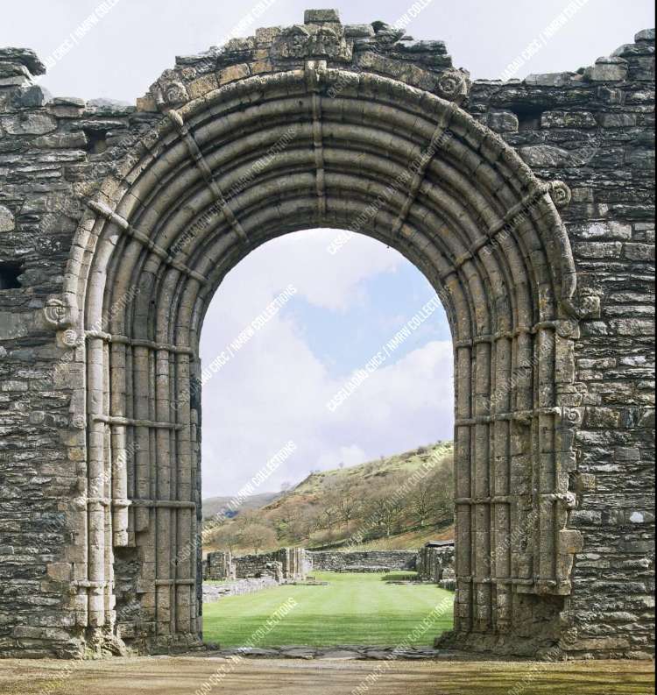
Figure 3: View of Strata Florida Abbey’s west arch (Wright, 2004)
Ownership passed to the Crown when the nunnery was dissolved in February 1537, and by the mid 16th century it was occupied by the Lloyd family (Murphy, 2017). Gee (2010, p. 20), a keen gardener, discusses that there exists evidence of man-made ditches and watercourses at the site of Llanllyr from medieval times, something which she claims as proof of gardening being done at the nunnery. The shaping of the land and the house into what it is today begins early on, and the subsequent large garden that is seen today (figure 4; National Garden Scheme, no date) begins here.

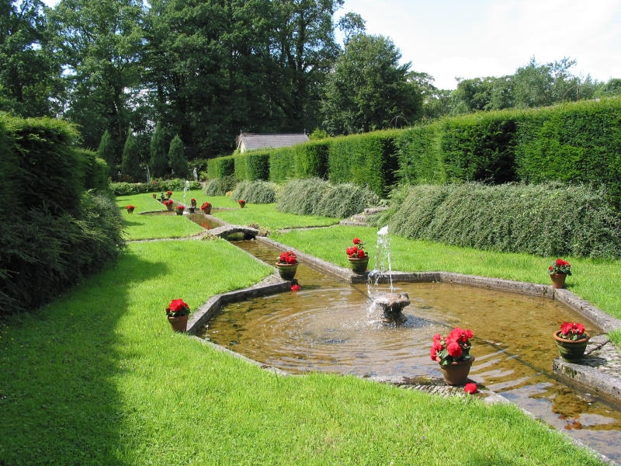
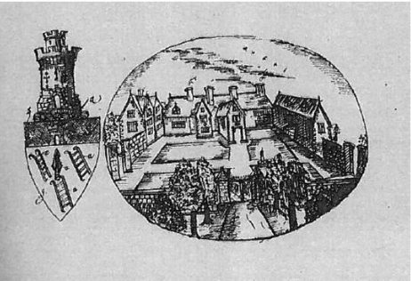
The dissolution of the monastery, which coincided with the Act of Union of Wales with England saw new prosperity and the rise of the Welsh gentry. Llanllyr became particularly gentrified, with the new owners, the Lloyd family, being college educated with distinguished careers such as law and politics (Gee, 2010, pp. 26-27). With the arrival of the Tudors, the gentrification in Wales became even more dramatic. Families such as the Lloyds at Llanllyr wanted to keep up with fashionable architectural trends, with either old houses being demolished or their existing houses seeing extensions and improvements (Gee, 2010, p 29). A 1680s sketch of the house (figure 5) showcases Llanllyr as having a gated entrance with a large courtyard surrounded by buildings.
Figure 4: Llanllyr gardens (National Garden Scheme, no date).
Figure 5: Llanllyr during the Tudor times, circa 1684 (Dineley, 1684, cited in Murphy, 2017)
Gee (2010, p. 31) talks of the garden during this Tudor period as being immensely modern, and that this showcases a family that were a member of the gentry, and were obviously keen gardeners.
The next milestone in the history of the house comes in 1720 with the estate being sold to the Lewes family, particularly John Lewes. 1768 saw an estate map of the area (figure 6) being drawn, the next piece of evidence of Llanllyr after the Dineley drawing (figure 5). Figure 6 also showcases the new buildings and the archaeology that has recently taken place there, showcasing the movement of the house.
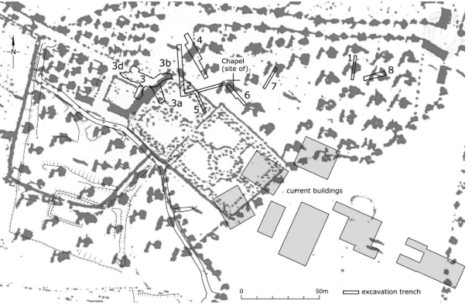
In 1826 the new era for the house began. Architect John Nash was commissioned to design a new house, the one that stands today. Previously working on Llanerchaeron (figure 7), Nash designed the new house box-like, with the main entrance on the north side. This is a similar arrangement to Llanerchaeron (Gee, 2010, p.39).
Figure 6: 1768 estate map of Llanllyr (Murphy, 2017)

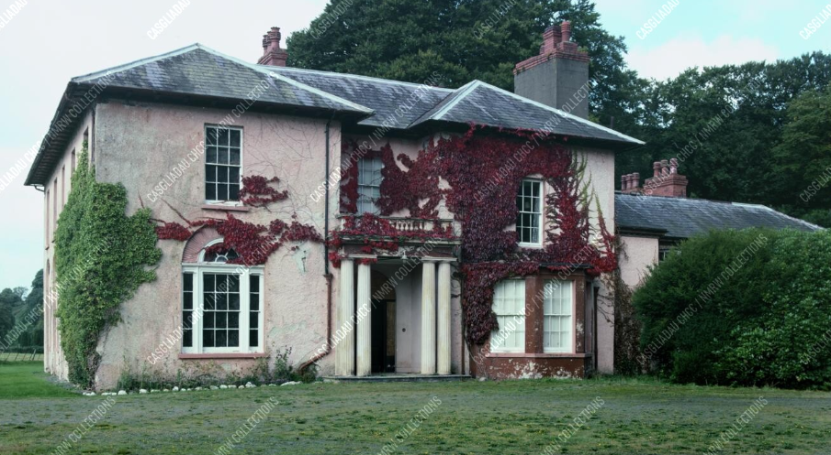
Figure 7: Llanerchaeron house (Wright, 1997).

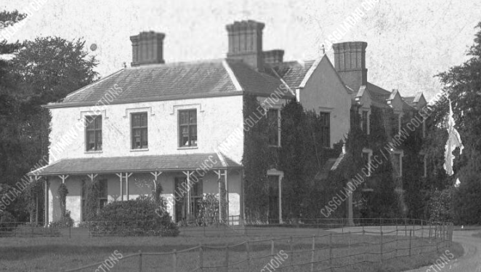
Figure 8: Llanllyr circa 1910 (Lloyd, 1910)
The new John Nash designed house showcases the gentrification of the area even greatly. Nash had famously worked with the royal family on both Regent’s Park and Buckingham Palace (Encyclopedia Britannica, 2024) as well as parts of Wales. As mentioned, he had previously designed the house at Llanerchaeron (National Trust, no date), as well as Golden Grove near Carmarthen, Dolaucothi near Lampeter and Hafod Estate near Aberystwyth (Inglis-Jones, 1950, p. 107).

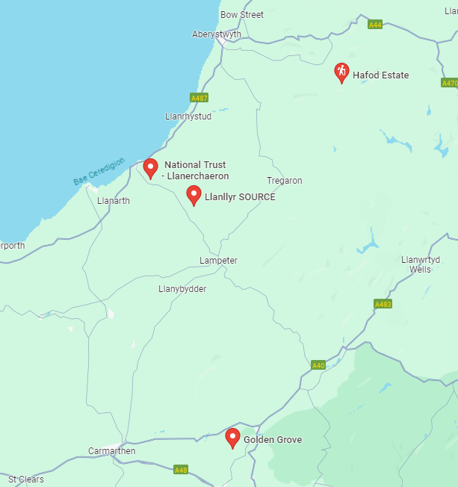
Figure 9: Map showcasing a number of landmarks of John Nash architectural works in West Wales (Google, 2024)

These areas of gentrification are in and around the Aeron valley (figure 9), with a relatively close proximity to one another. But what does this mean for the current landscape today? Today, all of these are to some extent open to the public, some more so than others. Llanerchaeron and Hafod Estate are both owned by the National Trust. This showcases that these areas of gentrification still have a foothold today, with them becoming tourist attractions due to the quality of the landscapes that they are part of. The landscapes were once perceived as being of a higher class due to the generations of families that lived in them, and the perception of them being higher class has not particularly changed over the years, only that they have now become more of a tourist attraction rather than land owning houses.
Llanllyr itself continues to be lived in today. As previously mentioned, Loveday Lewes Gee has continued the tradition of gardening at the house (figure 4), and the Lewes family continues to live there today, where it is still a functioning farm (Gee, 2010, p. 82). The gentrified status, as previously mentioned when talking about all the Nash properties as a whole, still exists, with the lavish gardens and tennis courts being built there within the last one hundred years (Gee, 2010, p. 43).

In conclusion, the landscape at Llanllyr has evolved greatly. Originally considered quite an impoverished nunnery, it was transformed into a home for the wealthy and educated Lloyd family due to the dissolution of the nunnery and the Act of Union of Wales and England. This gentrification of the land increased overtime, with the gardens of the home becoming more lavish overtime and the house going through extensions duringTudor times, to then being redesigned and rebuilt during Georgian times. The house also saw a water bottling plant being built there, one that was branded as being quite artisan and expensive (figure 10). The house today sees attraction for its garden as well, and sees itself as a tourist attraction for gardeners and families alike (National Garden Scheme, no date). Whilst the perception of the house has changed from one of a home to a landowning class to more of a tourist destination, the perception is still of one that is gentrified. The house today still is seen as being of one belonging to a gentry, albeit through the lens of a tourist attraction gazing in rather than less wealthy classes looking up.
Figure 10: Llanllyr Source water bottle (Blas ar Fwyd, no date).

Bibliography

Blas ar Fwyd (no date) Llanllyr Source, Still Water, 75cl. Available at: https://www.blasarfwyd.com/blas-ar-fwydwelsh-and-world-foods/diodydd-drinks/drinks-mixers/llanllyr-source/llanllyr-source-still-water-75cl (Accessed on 12th of May 2024).

Darvill, T. (2008) Oxford Concise Dictionary of Archaeology. 2nd edn. Oxford: Oxford University Press.

Driver, T. (2007) RCAHMW colour oblique photograph of Llanllyr, and Talsarn Village. Available at: https://coflein.gov.uk/en/site/5654/images/ (Accessed on 12th of May 2024).

Encyclopedia Britannica (2024) John Nash. Available at: https://www.britannica.com/biography/John-Nash-British-architect (Accessed on 12th of May 2024)

Gee, L. L. (2010) A Very Small Corner of Paradise: The Story of Llanllyr: a Garden in Wales. Talybont: Y Lolfa.

Google (2024) Map showcasing John Nash locations in West Wales. https://maps.app.goo.gl/t2HEkTAQShpzKv8L9 (Accessed on 12th of May 2024).

Inglis-Jones, E. (1950) Peacocks in Paradise. Unknown publisher.

Lloyd, T. (1910) c1910 postcard view of Llanllyr, Ceredigion. Available at: https://rcahmw.ibase.media/en/view-item?i=31277&WINID=1715540916804 (Accessed on 12th of May 2024)

Murphy, F. (2017) Survey and excavation and Llanllyr Medieval nunnery and post-medieval mansion, Ceredigion. Available at: https://www.dyfedarchaeology.org.uk/wp/wp-content/uploads/llanllyrreport2017.pdf (Accessed on 12th of May 2024).

National Garden Scheme (no date) Llanllyr - Lampeter. Available at: https://ngs.org.uk/gardens/llanllyr-sa48/ (Accessed on 12th of May 2024).

National Trust (no date) Visiting the John Nash villa at Llanerchaeron. Available at: https://www.nationaltrust.org.uk/visit/wales/llanerchaeron/visiting-the-john-nash-villa-at-llanerchaeron (Accessed on 12th of May 2024).

Olwig, K. R., Dalglish, C., Fairclough, G. and Herring, P. (2016) ‘Introduction to a special issue: the future of landscape characterisation, and the future character of landscape - between space, time, history, place and nature’, Landscape Research, 41(2), pp. 169-174. DOI: https://doi.org/10.1080/01426397.2015.1135321

Royal Commission on the Ancient and Historical Monuments of Wales (2021) Llanllyr, Talsarn. Available at: https://coflein.gov.uk/en/site/5654 (Accessed on 12th of May 2024).

Simensen, T., Halvorsen, R., Erikstad, L. (2018) ‘Methods for landscape characterisation and mapping: A systematic review’, Land Use Policy, 75, pp. 557-569. DOI: https://doi.org/10.1016/j.landusepol.2018.04.022.

Turner, S. (2007) ‘Landscape Archaeology for the Past and Future: The Place of Historic Landscape Characterisation’, Landscapes, 8(2), pp. 40-49. DOI: https://doi.org/10.1179/lan.2007.8.2.40

Watson and Pratt’s (no date) Llanllyr Water. Available at: https://www.watsonandpratts.co.uk/d/Llanllyr_Water/e831574cbea74c97bd2fc15b993f4fe5/ (Accessed on 12th of May 2024).

Wright, I. N. (1997) Exterior view of Llanerchaeron. Available at: https://rcahmw.ibase.media/en/view-item?i=131053&WINID=1715540662818 (Accessed on 12th of May 2024).

Wright, I. N. (2004) General View of Strata Florida Abbey. Available at: https://rcahmw.ibase.media/en/view-item?i=133405&WINID=1715536496234 (Accessed on 12th of May 2024).

