Name: ONJON SUTRADHAR
ID no: 2431963
Module: ACCA7022 - Advanced Statistical Programming
Component 1 – Data Manipulation

Part 1: Code Explanation and Section-by-Section Testing

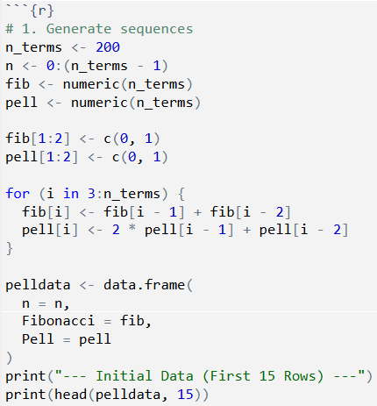
- Generating the Fibonacci and Pell Sequences

The first section of the code sets up two mathematical sequences: the Fibonacci and Pell numbers.
It begins by defining how many terms will be calculated (200). Empty numeric vectors are created to store results for each sequence, and both are given their first two values (0 and 1).
A loop then repeats through the rest of the positions in each vector.
- For Fibonacci, each new term is found by adding the previous two numbers.
- For Pell, each term is calculated by doubling the previous number and then adding the one before it.
After all 200 terms are generated, the values for $n$, Fibonacci, and Pell are combined into one data frame.
After all 200 numbers are created, both sequences are combined into one data frame, which works like a small table. This table has three columns — one for the term number, one for the Fibonacci value, and one for the Pell value.
Finally, the code shows the first 15 rows of the table so you can check that the numbers look correct and that both sequences are working as expected.

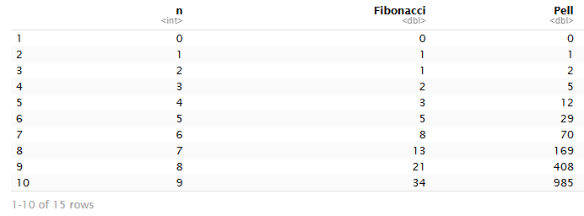
Testing the Sequence Generation

To make sure the loop worked correctly, the first few rows of the data frame were displayed. The numbers matched known Fibonacci values (0, 1, 1, 2, 3, 5…) and Pell values (0, 1, 2, 5, 12, 29…), confirming that both recurrence formulas were implemented correctly. The code also checked that the vectors contained 200 elements each, showing that the full range of terms was produced without errors.
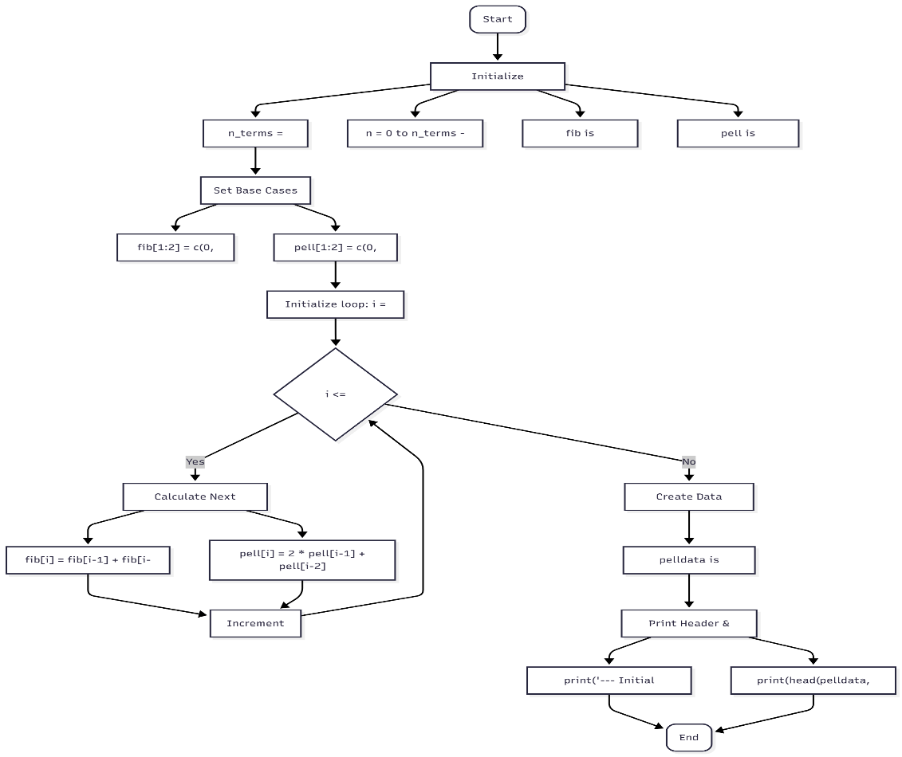
Flowchart:

- Approximating √2 Using the Pell Sequence
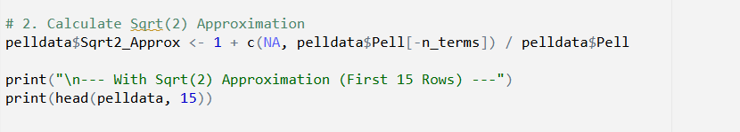

The next section of the program uses the Pell numbers to approximate the value of √2. The mathematical rule behind it is that The code first shifts the Pell sequence down by one position to get the previous value for each term. Then it divides this “previous” value by the current Pell number, adds 1 to the result, and saves it in a new column called Sqrt2_Approx.
The very first row doesn’t have a previous number, so it shows NA instead.
Finally, it displays the first 15 rows of the table again. This lets you see the calculated approximations and check that the new column has been added correctly.
$$\sqrt{2}≈1+\frac{P_{n-1}}{P_{n}}$$
where $P_{n}$is the current Pell number and $P_{n-1}$is the previous one.
In the code, a temporary version of the Pell column is created and shifted down by one place to represent $P_{n-1}$. The ratio of this lagged column to the current Pell column is then calculated and added to 1 to produce an approximation of √2 for every term. A new column called Sqrt2_Approx is added to the data frame to store these results.
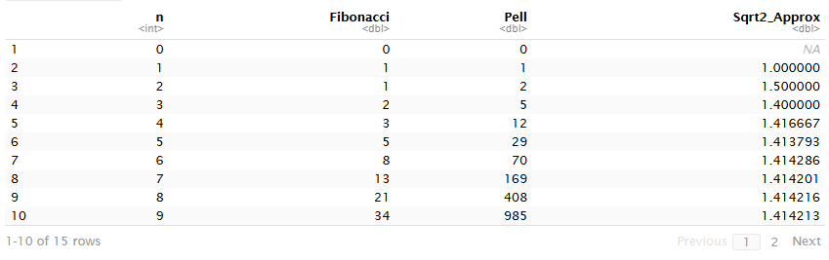
Testing the Approximation

To confirm that this step worked properly, the first several approximations were printed and compared with the real value of √2 (about 1.4142). The results started at 1.5, then 1.4, 1.4167, 1.4138, and so on—values that move steadily closer to the true number. A manual check using the actual Pell values for $P_{3}$and $P_{4}$produced 1 + (5 ÷ 12) = 1.4167, matching the table exactly. This confirmed that the indexing and formula were correct.
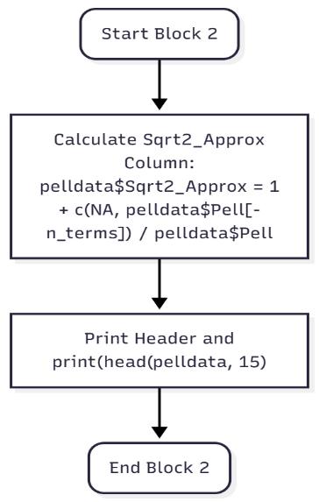
Flowchart:
3. Calculating the Difference from the True √2

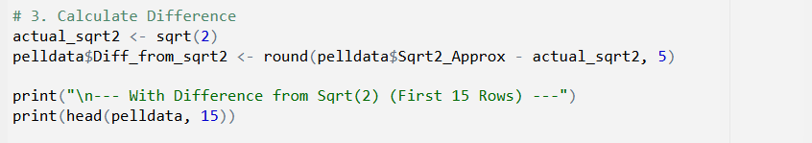
Once the approximations were created, the code measured how far each one was from the real √2. It did this by subtracting the true value (computed with R’s built-in sqrt() function) from each approximation. The result was rounded to five decimal places to make small differences easier to read, and the values were stored in a new column named Diff_from_sqrt2.
This difference shows how close or far each approximation is. Smaller absolute differences mean greater accuracy.
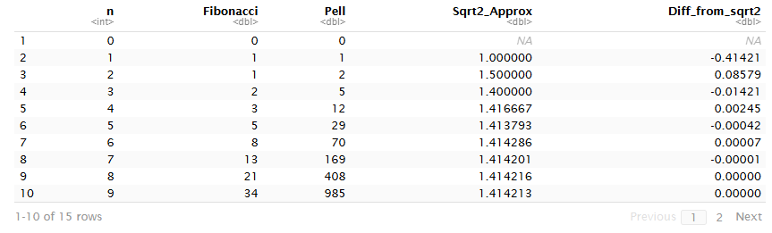
Testing the Difference Calculation
The first 15 results were reviewed to check the pattern. Early terms had larger differences (around ±0.08 or ±0.001), while later terms had values very close to 0. This decreasing error showed that as n grew, the Pell-based approximation converged toward √2. The total number of rows was also checked to ensure no data was lost when new columns were added.
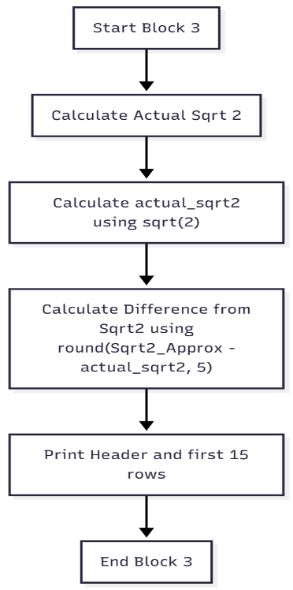
Flowchart:
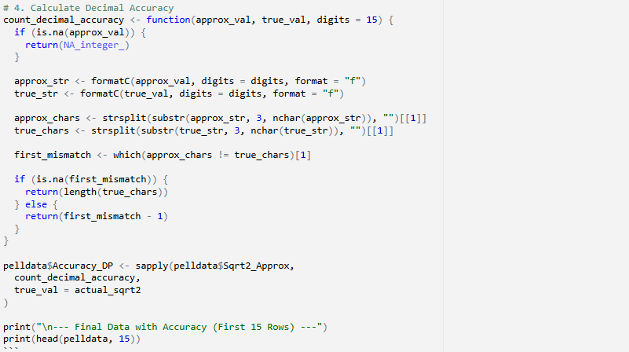
4. Counting Matching Decimal Places

The final stage of the program defines a custom function that measures how many decimal places of the approximation match the true value of √2. Instead of doing this with arithmetic rounding, the function converts both numbers into text strings with 15 digits after the decimal point, then compares the digits one by one until it finds a mismatch. The count of matching digits before that mismatch is returned as the accuracy level.
This function is then applied to every row in the dataset using a vectorised method so that each approximation gets its own accuracy score, stored in a new column called Accuracy_DP.
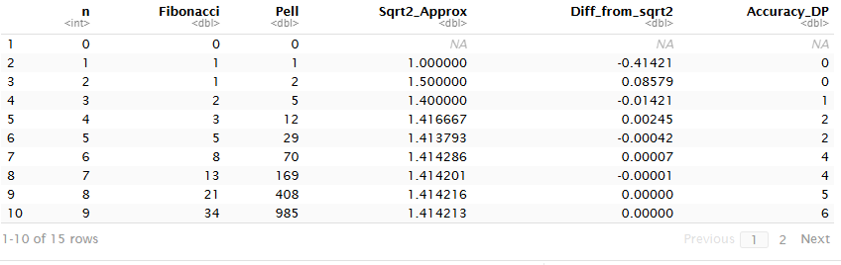
Testing the Decimal Accuracy Function

The function was tested on single values first to make sure it behaved correctly—for example, comparing 1.414213 with the true √2 returned 5 matching decimal places. When applied to the whole data frame, early Pell approximations had only one or two matching digits, while later ones had ten or more. The first row, which lacked a previous Pell number, returned “NA,” confirming that the function handled missing data safely without causing errors.

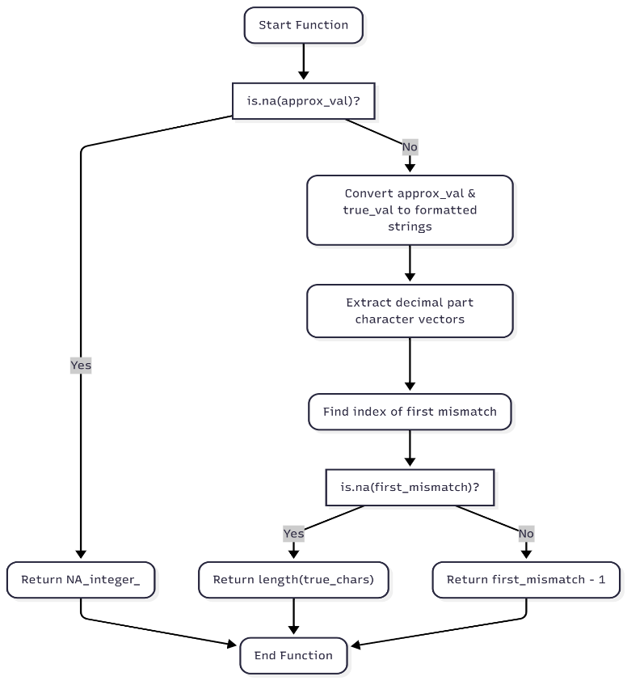
Flowchart:

Part 2: Reflection
This task was more meaningful to me than just writing code. It helped me see how maths and programming can work together to solve real problems. Before this, I only understood formulas on paper, but seeing them work through my own code made it much clearer.
At first, I wasn’t very confident because I thought the maths behind Pell numbers and √2 would be too complex, but once I started coding, it became more interesting. I liked watching how the numbers changed with each step and how the code actually proved a mathematical idea.
I also learned to be patient and keep trying when things didn’t work. Each mistake taught me something new about R and how to think logically. Finishing the task made me feel proud because I built something that worked and made sense. It showed me that programming is not just typing code — it’s about problem-solving and learning from experience. I feel like I’ve grown in both my technical skills and my mindset toward challenges.

What I Found Challenging
The hardest part of the task was building the function that counts matching decimal places. My first attempts gave inconsistent results because of floating-point rounding errors. I learned that comparing decimal digits as strings was a much more reliable method than using mathematical rounding.
It took a few tries to figure that out I kept wondering why my answers didn’t match even when the logic seemed right. Debugging those little errors was frustrating but also satisfying once I understood what was going wrong.
Another challenge was dealing with NA values in the first row when there was no previous Pell number. This initially caused division errors, but I fixed it by adding an NA placeholder in the lagged vector. It was a small fix but taught me the importance of checking for missing data early.
Overall, the challenges made me realise how precise and logical R can be, and that even small details can make a big difference in the final output.

What I Learned
I learned how recursion and loops can be used to create number sequences in R. I also learned how to structure an R Markdown file into clear code chunks, how to create custom functions, and how to apply them efficiently across data using sapply().
At first, I thought this task would be easy, but I faced some problems while writing and testing the code. The hardest part was creating the function that counts how many decimal places match the real value of √2. I first tried using rounding, but it didn’t work because of small errors in decimal precision. I then changed my approach and used text comparison instead, which solved the problem.
I also found it tricky to handle missing values in the data and make sure each column lined up correctly. Another challenge was understanding how the Pell numbers are used to approximate √2 — I had to read about it before I understood the logic. Once I saw the pattern in how they converge, it felt rewarding.
This task helped me understand how the Pell numbers converge toward √2 and how to verify that programmatically. I also practiced data validation, such as checking vector lengths and manually confirming formula results. It made me appreciate how maths, logic, and programming all come together in real analysis work.

What I Would Do Differently
I learned a lot about using loops, functions, and data frames in R. I now understand how recurrence relations like Fibonacci and Pell work and how they can be used to approximate numbers such as √2.
This task also helped me improve how I test and check my results. Instead of just running the code and hoping it worked, I learned to check small parts step by step. I also learned that documenting and explaining code clearly helps me understand it better. Writing everything out properly made the whole process easier to follow later.
If I had more time, I would:
• Add visual plots showing how the approximation converges toward √2.
• Use tidyverse functions like mutate() to simplify my data manipulation.
• Include automated unit tests for the accuracy function to avoid manual checking.
If I did this task again, I would add graphs to show how the approximation gets closer to √2. I would also turn more of the code into functions to make it cleaner and easier to test. Using libraries like dplyr could make the data manipulation simpler too. Finally, I would add some automatic tests to check if the sequences and calculations are correct instead of checking them manually.
I think doing this would make my work look more professional and efficient, and it would also help me learn better coding habits for future projects.

Use of Generative AI
I used a generative AI tool (ChatGPT) mainly for support in writing and explaining my code clearly. I asked it for help structuring the report and for feedback on how to make my explanations clearer. However, I wrote, tested, and debugged all the code myself. The AI helped me check grammar and improve readability.
Sometimes I also asked it to explain concepts like the Pell formula in simpler terms so I could understand the maths before coding it. This helped me connect the theory with what I was actually programming.
I used ChatGPT to help me understand the Pell formula better and to improve how I explain my results. I also used it to make my writing clearer. However, I wrote all the R code myself and tested everything on my own. The AI only helped me learn and write better, not to complete the coding part. I think using AI this way made my work stronger while still keeping it my own effort.

Would you like me to make it a little more academic in tone (for a university report) while still sounding personal and reflective? I can polish the language slightly without losing the student voice.

