
Sports Industry Research Project
Literature Review

Student Name
Thomas Mathew Lloyd

Project Title
Barriers To Participation In Sports And Physical Activity For Males And Females Aged 18-22

Contents Page (use relevant number of pages)
2 – Aims and Objectives
3 – The Sport Journal
4 – When do young adults stop practising a sport?
5 – NIKE’s “Move It” Campaign
6 – Differences between adolescents staying in and dropping out of organized sport
7 – Perceived Barriers Of Young Adults for Participation in Physical Activity
8 – Childhood drop out in football and the effects on participation as a young adult
9 – Literature Conclusion
10 – Reference List
11 – Reference List
12 – Bibliography
13 – Appendices

Aim and Objectives
The aim of this research project is to recognize the barriers on why people in the age range of 18 to 22 do not participate in any kind of sport of physical activity. In this project, I will be analysing the different reasons as to why the people stop participating around this certain age. To ensure that this research project is a success, I have given myself a few objectives. Firstly, I will research the reasons on why people around this age do not participate in sport or physical activity by researching websites, articles and journals that will give me the right information that I will need.
The first objective of mine will be to analyse males and females who do not participate in sport or physical activity between the ages of 18-22, while analysing the people who do not, I will then research the reason behind why they do not participate. I will discover what’s preventing them to participate and getting involved within sport and physical activity and then identify what is able to do to encourage more males and females to participate by showing the benefits of what getting active and fit can do to the human body.
Another objective of mine to make sure the research project is a success is to create a questionnaire and being able to create and attend interviews. By creating questionnaires and attending interviews, I will be able to get the opinions of the participants and their views on participating in sport and physical activity and being able to see if they believe it’s a benefit or not. The participants I will be hoping to interview and give questionnaires out to is the university students that are within the Student Union. I have decided to choose the university students as I believe it would be easy to access the students, that there are many places inside the university that I’ll be able to attend interviews and give out the questionnaires.
From this research project, my main aim is to benefit people who are in the age range of 18-22, to show them the benefits of getting active and why it’s important to keep fit by participating in different kind of sport and physical activity. I have decided to focus on this topic as official statistics show that participating in sport and physical activity in Wales tend to gradually decrease by the age of 18 (Sport Wales), and I will research the main reason why this is.

Literature Review (use relevant number of pages)
The Sport Journal – Athlete Burnout: Is The Type Of Sport A Factor?
This journal suggests how athletes start to begin to feel the burnout and how it decreases performances and negatively impacts them both physically and mentally. The journal shows the negative impacts that could lead to athletes such as chronic stress. (Pines, 1993) noted that burnout is a state of fatigue and emotional exhaustion which is the result of step-by-step process of disillusionment and it quite often found among individual athletes who are highly motivated. Because of this, athletes become more disenchanted with sport participation and stop competing at what should be the pinnacle of their sporting careers, this is a common occurrence.
Many researches have been involved within this journal. Such as, athletes are likely to experience burnout if they are participating in sports for reasons other than the sport attraction. (Coakley, 1992) conducted interviews with high level athletes who had been “burnt out”, it was determined that burnout was directly related to the social organization of intense sport participation.
The journal continues to talk about athletes burning out and the affects it can give. Burnout is labelled as a serious problem that can affect the athlete more than their performances. Burning out has been correlated with various personal dysfunctions such as the inability to sleep, exhausted when being physically active, increasing the use of drugs and alcohol and family/martial problems.
108 athletic females’ participants that were aged between 19 to 24 and played sports such as basketball, cross country, football, softball, tennis, track and field and volleyball were assessed. The results showed that female athletes on the basketball team that had the highest level of burnout. The lowest level of burnout were the volleyball athletes. This indicated that burnout prevention strategies for specific sports are much needed and that they athletes may need to be better prepared for the demands. Also, coaches in the high-risk sports would need to provide interventions to the athletes in form of specialists such as (sport psychologists, counsellors etc), stress awareness and burnout prevention. The coaches should then attend to the possibility of burnout that’s affecting the athletes’ performances and take whatever measures that’s necessary to reduce burnout in the coaches’ players.

Literature Review
When Do Young Adults Stop Practising A Sport? An Event History On The Impact Of Four Major Life Events
This journal investigates the relationship of 4 different major life events that happens that usually stops young adults from participating in sport or physical activity.
The 4 major life events that stops young adults from participating in sport is when they begin and start working. Second life event is when the adult starts to live on your own, for example a brand new house or apartment, the third life event is when the young adult starts to cohabit or gets married and lastly the birth of one’s first child, all of these events has a massive risk on stopping people from participating in sport/physical activity or to end a sports club membership. Dutch SportersMonitor, (2010) used a detailed retrospective life-course data to examine the sport careers and major life events of young adults between the ages of 18-35. The analyses indicated that the risk to stop practising a sport increases when young adults start to work, move out of their house to live on their own, get married or have their first son/daughter. Statistics was able to show that the risk of ending a sports club membership or stop participating in any physical activity is when a young adult starts to live on their own and/or also when they get married.
This journal would be useful for my research project as it shows the main reasons on why young adults decide to stop participating in sport or physical activity. A reliable life-course data was used to examine sport careers and major life events, which shows the accuracy of the reasons on why young adults decide to stop participating.

Literature Review
Nike’s Campaign “MOVE IT”
The journal goes through different problems the Nation is facing when it comes to participation in sport. The first is inactivity as a major public health threat. By naming the problems the Nation has, this journal suggests different ways to overcome it. The first insight is to investment and policy focus on elite and competitive sport, recommendation for this would be a youth-centred policy. For example, place young people at the centre of policy making, re-balance elite and community sport funding’s and leverage digital platforms to help drive behavioural change.
Different statistics and graphs are also shown in the journal. For example, graphs on the weekly recommendations for physical activity by age, a graph on the proportion of children and adults who have participated in active sport, by age. One graph shows that 74.9% of people between the ages of 18-22 compete in sport and physical activity, this was dropped down from 96.7% from the people within the age range of 11-15, the journal suggests that this big drop is due likely because of people leaving school or going to university.
Due to the percentage of the number of people not participating in sport or physical activity, this journal goes through the different reasons that stops people from taking part. The first example is technology. Young people in this century have many ranges of opportunities to avoid being bored without going outside and breaking a sweat, for example staying inside and playing video games, online gaming, computers, television, mobile phones, music are taking over young people’s lives. The second example is transport. The increase in motorised transport has reduced levels of physical activity in relation to travel. According to the journal, one recent study was able to find out that male teenagers cycle only half the distance than they did 20 years ago. Safety is also another reason. For example, an increase within traffic volumes, fear of street crime and high-profile case of child abuse.

Literature Review
Differences Between Adolescents Staying In And Dropping Out Of Organized Sport
This journal suggests that a research shows that participation in organised sport seems especially important in relation to several health factors. Dropout from organized sports increases during adolescence, unfortunately.
This journal shows the benefits of participating in sport and physical activity. For example, a large Norwegian population study suggested that people that participate in organized sport report the following: having more good friends, spending more time out with friends, being more pleased with their parents, being more likely to have plans to achieve a higher education, spending less time looking at computer, tablet or mobile phones, being more satisfied with their own health, having less physical complaints and much more.
The extant literature of this journal has been able to find out that dropping out of participating in sport and physical activity usually contributes around the lack of enjoyment, lack of opportunity to play, poor performances, social pressure, injuries, poor relationships with teammates/coaches and more. (Crane & Temple, 2015; Lagestad & Sorensen, 2018).
According to this journal, all sports comprise movement of the body, for example running, jumping, quick movement of the feet, and because of that it contributes positively to cardiorespiratory fitness. It is reasonable to assert that in most sports, performance will increase with increased cardiorespiratory fitness and, therefore, adolescents with lower levels of cardiorespiratory fitness may exhibit a great possibility to drop out from sport. This is related to the findings of Ommundsen and Vaglum (1997) and Patriksson (1988), who was able to find out that low perceived competence and low performance, respectively, was associated with increased dropping out from sport.
Lastly, this journal was able show that participants that drop out from sport have a lower cardiorespiratory fitness than the participants that continue to participate in organized sport, and that lower levels of cardiorespiratory fitness may be the problem that causes a lot of dropping out from the sport. The fact that significantly fewer participants that drop out from sport report their feeling in relation to sport participation as very good, compared with participants that continue to participate in organized sport, indicates that lower levels of well-being in sport may be the cause of dropping out in sport.

Literature Review
Perceived Barriers Of Young Adults for Participation in Physical Activity
The aim of this journal was to explore the main barriers in college students that do not participate in sport or physical activity. During this study, 8 focus groups discussion was designed for 67 college students in the age of 18 to 24, 48 females and 19 males.
After the group discussions, the participants were able to identify several obstacles to sport and physical activity. The results of the participants showed that they perceived a substantial amount of personal, social and environmental factors as barriers. Examples of these are: Being too tired, stressed, family control, safety issues and much more.
Health professionals and researchers was able to use this information and then design and implement interventions, policies and strategies to promote participation in sport and physical activity. This would further help with the students to deal with the barriers they are facing and can help to instil the habit of regular participation in the later adult years.
This journal goes through different methods on ways to get the reasons behind why people around this age do not or have stopped participation with sports or physical activity. First method is participant and recruitment. As previously stated, college students between the ages of 18-24 were recruited to take part within focus groups, exploring about physical activity and sport and the barriers that are preventing them. Another method is ‘Question Development’. This conceptual domain includes personal, social and environmental barriers to physical activity and sport, which is the focus of this journal. The 3rd method is ‘Focus Group Facilitation’. The focus group would follow a set of semi-structured questions which were then developed to stimulate the open-ended discussion about the participants’ main views on barriers to physical activity and sport. Lastly, the 4th method is “Data Analysis”. The focus groups’ conversations would be audiotaped and then transcribed verbatim into MS Excel.
After the focus groups, it was identified that 32% of the barriers was environmental, 11% social and 57% personal. Example of health-related personal barriers are lack of energy/sleep, stress and physical ailments/discomfort. Examples of non-health-related personal barriers: Time constraints, lack of skills or knowledge, boredom, no self-discipline, lack of self-efficacy and indolence. Another barrier that was mentioned was the lack of social support. Examples of social barriers are family control or discouragement, peer pressure, verbal bullying or intimidation. Lastly, the participants also cite aspects of the environment and neighbourhood as barriers. Examples of environmental barriers are built/physical environment, lack of resources, the weather, financial cost.

Literature Review
Childhood drop out in football and the effects on participation as a young adult
Previous research by (Carroll and Loumidis, 2001; Malina, 2001; Daley, 2002 and Green et al., 2005) focused on the reasons why children stop participating, but this journal is aimed to build on this to identify the affect childhood drop out in sport has on participation as a young adult. An approach was adopted through 7 semi-structured interviews, with all the participants dropping out of football during their childhood years after participating for 2 years. The findings were able to show that childhood drop out affects the participation as a young adult as only two of the participants were playing regularly again. The reason of lack of participation was attributed to; lack of fitness, playing football was not fitting into their routine, the difference between youth and adult football was far too great, for example adult football was too physical, there was too much pressure and it was too competitive. To ensure that there is re-entry into the sport for young adults it was make sure that football providers must be able to create more under 18’s leagues, this would be able to ease the transition from youth football into adult football. Also, small-sided football would need to be made more accessible as the participants still played this version occasionally even if they were not regular eleven-a-side competitors. Because of the big number of drop outs after compulsory schooling (Allender et al., 2006) more research should investigate the options that is available to football players at this time as this study has found the transition into adult football is challenging and it is unlikely that a player will return once they have dropped out.
This purpose of this study was to identify why children drop out of football after participating for a long time, it also explores the consequences of dropping out on participation when being a young adult, to discover the reasons why the participants do not come back and return to playing sports and lastly to highlight the recommendations on how to increase the number of young adults participating in football.

Literature Conclusion

By using all these journals, I will be able to create an informative research project. All 6 journals have different information. Much of the journals discusses the different barriers as to why people around the age of 18-22 do not participate or have stopped participating in sport, with different reasons why. Also, a handful of the journals talks about different recommendations and how to increase the numbers of young adults participating within sport and physical activity. These journals will be able to come together and create a research project that will be able to influence young adults to participate and how to overcome the barriers that is stopping them from getting involved.
These journals will be vital and will need to be used to ensure that the research project is up to the correct standards. Without these journals, I will not be able to complete the work. With the journals I have reviewed, I agree highly with them all, I agree with the different types of barriers that are able to be overcome. During my research, I was able to find key points and findings, such as the 4 main life events that stop young adults from participating in sport and the different strategies that is currently being used to get more people participating.
In future studies, I will research further journals to see if the information I received from the current journals are correct and accurate. By doing this it will extend my work by adding more additional and important information that I may have missed out on.

Reference List (use relevant number of pages)
O’Callaghan, J. (2010). Childhood drop out in football and the effects on participation as a young adult. Cardiffmet.ac.uk. [online] Available at: https://repository.cardiffmet.ac.uk/handle/10369/2608
U.S. Sports Academy (2018). Athlete Burnout: Is the Type of Sport a Factor? [online] The Sport Journal. Available at: http://thesportjournal.org/article/athlete-burnout-is-the-type-of-sport-a-factor/
Uwtsd.ac.uk. (2019). [online] Available at: https://search-proquest-com.ezproxy.uwtsd.ac.uk/docview/2194525430?accountid=130472&rfr_id=info%3Axri%2Fsid%3Aprimo
Eime, RParticipantsochelle, Harvey, Jack, Charity, Melanie, Casey, Meghan, Westerbeek, Hans, and Payne, Warren. Age Profiles of Sport : 1-10. Web.
https://journals.sagepub.com/doi/abs/10.1177/1012690215619204?journalCode=irsb
Anjali and Manisha Sabharwal (2018). Perceived Barriers of Young Adults for Participation in Physical Activity. Current Research in Nutrition and Food Science Journal, [online] 6(2), pp.437–449. Available at: https://www.foodandnutritionjournal.org/volume6number2/perceived-barriers-of-young-adults-for-participation-in-physical-activity/
Kahn, L. and Norman, W. (n.d.). MOVE IT Increasing young people’s participation in sport. [online] Available at: https://youngfoundation.org/wp-content/uploads/2012/10/YOF1716_Nike_report_08_12_web_1.pdf
Barriers to sports participation for women and girls. (n.d.). [online] Available at: https://www.lrsport.org/uploads/barriers-to-sports-participation-for-women-girls-17.pdf.
The challenge of growing youth participation in sport Youth Insights Pack. (2014). [online] Available at: https://www.sportengland.org/media/10113/youth-insight-pack.pdf
SPORTS PARTICIPATION AMONGST 14-21 YEAR OLDS HOW DO WE ENCOURAGE YOUNG PEOPLE TO STAY INVOLVED IN SPORT? Final Report for Sport Wales. (2012). [online] Available at: http://sport.wales/media/1580932/sc0103-00_-_sports_participation_-_final_report_brightpurpose.pdf
The Rationale and Benefits of Sport Participation for Youth of All Abilities : NCHPAD - Building Inclusive Communities (2011). The Rationale and Benefits of Sport Participation for Youth of All Abilities : NCHPAD - Building Inclusive Communities. [online] National Center on Health, Physical Activity and Disability (NCHPAD). Available at: https://www.nchpad.org/397/2171/The~Rationale~and~Benefits~of~Sport~Participation~for~Youth~of~All~Abilities
Drake, A. (2012). Barriers to participation in sport. [online] prezi.com. Available at: https://prezi.com/ygptackmv9u8/barriers-to-participation-in-sport/

Reference List

Bibliography (use relevant number of pages)
Super, S., Wentink, C.Q., Verkooijen, K.T. and Koelen, M.A. (2017). How young adults reflect on the role of sport in their socially vulnerable childhood. Qualitative Research in Sport, Exercise and Health, 11(1), pp.20–34.
Parenting Today Staff (2011). Why Sport is a Great Outlet for Teenagers. [online] Childdevelopmentinfo.com. Available at: https://childdevelopmentinfo.com/ages-stages/teenager-adolescent-development-parenting/teens-sports/#gs.git1xd
FE Sport and Active Lifestyles Survey 2018 State of the Nation. (n.d.). [online] Available at: http://sport.wales/media/1990933/further_education_sport_survey_-_state_of_the_nation_2018_final.pdf
Lse.ac.uk. (2015). Cost is the biggest barrier to young people’s participation in sport because a third live in poverty - 12 - 2015 - News archives - News and media - Website archive - Home. [online] Available at: http://www.lse.ac.uk/website-archive/newsAndMedia/news/archives/2015/12/Cost-is-the-biggest-barrier-to-young-peoples-participation-in-sport-because-a-third-live-in-poverty.aspx
Bailey, R. (2012). Young Adults and Sport: motives and barriers. [online] Blogspot.com. Available at: http://talkingeducationandsport.blogspot.com/2012/01/young-adults-and-sport-motives-barriers.html

Appendices (use relevant number of pages)
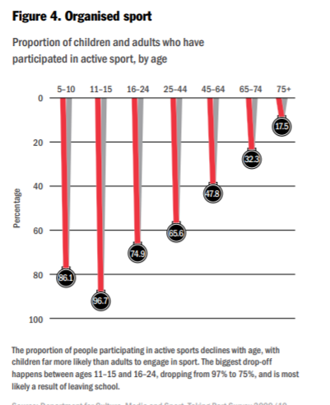
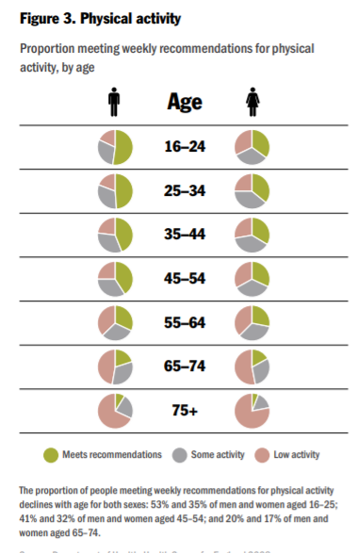

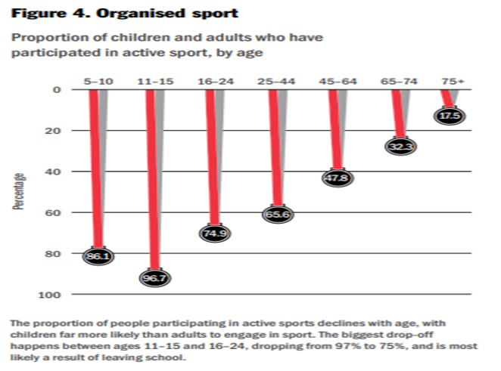
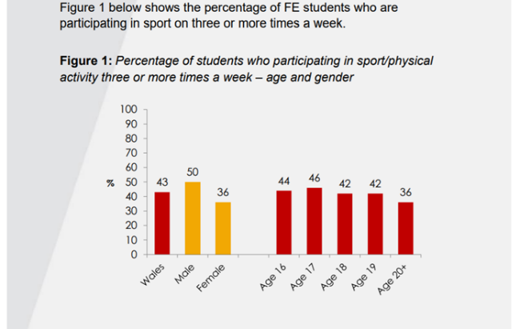
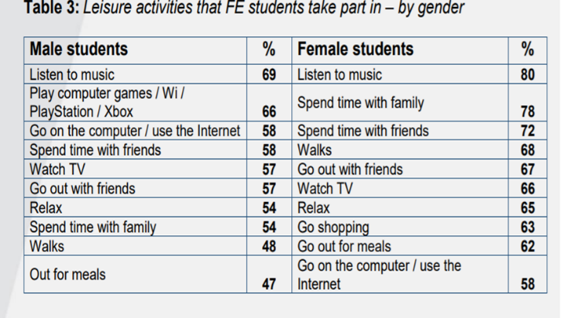



BA Sports Management Portfolio

Literature Review

UWTSDSport

