NetSim Problems & solution:
Problem:
We have installed our license server with the appropriate .lic file. When installing NetSim software on the server, the software obtains the license from port 5053 with no problems. But when trying on other machines connected to the same subnet and local link, we cannot validate the user license, the NetSim square window opens up and there is a progress bar that says Validating User License, but the operation is never successful, it just continues to search (Please see attached).
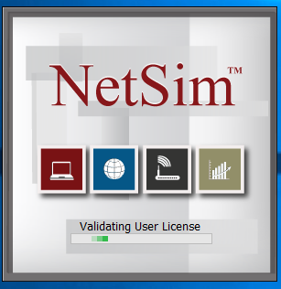

Solution:
We did identify the problem late Friday. Note that the problem occurs when we uninstall Java completely. However we reinstall Java over the existing one we encounter no such problem. If Java is completely uninstall then the NetSim software need to be removed and reinstall to eliminate the problem.

Can you say what need to be done so when the students use their login on the computers that are running the Netsim it does not ask for Administrator username & password when launch said software?

NetSim given solution:
1. You mention"When installing NetSim software on the server, the software obtains the license from port 5053 with no problems" . We would like to reconfirm that you mean NetSim "client" software is running fine in the system where the "license server" is also running. If this is not what you meant, then please install NetSim Software in the system where NetSim license server is running. When prompted for Server IP on startup, provide either the license server system's actual IP or the loop back address (127.0.0.1).

2. Next, install NetSim in a fresh PC. Before installation delete all previously installed versions of java. This can be done by going to control panel->add or remove programs.

3. Check Network connectivity between NetSim License Server and the this fresh system where we will be installing / running NetSim. For this open command prompt in the NetSim license server system and type ping <IP ADDRESS OF THE FRESH SYSTEM> Similarly open command prompt in the fresh system and type ping <IP ADDRESS OF THE NETSIM LICENSE SERVER>. If ping is not successful, disable firewall in both client and server systems (either through control panel or through any antivirus program if installed). Note that successful ping is a necessary condition for NetSim client to be able to access and check out licenses from the server. So if the systems are not able to ping successfully then you have to resolve that issue.

4. If NetSim doesn't run even after this,
Go to NetSim's bin folder (right click on NetSim icon in desktop and select open file location. It should be some thing like C:\Program Files (x86)\NetSim Academic\bin)
Right click on component.dll file
Select edit / choose to open it through Notepad.
It should contain value 255 in the first line and 1 in the second. If the values are different make changes accordingly, save the changes and rerun NetSim.

5. If NetSim still doesn't work, we can setup a online support session at a convenient time on either Tuesday/Wednesday/Thursday via Teamviewer software.
You can download this software from the following link: https://download.teamviewer.com/download/TeamViewer_Setup_en.exe

Support solution:
1. Uninstall the previously installed version of NetSim and all associated third party tools.
2. FTP URL: http://tetcos.com/software-download.html

a. User Name: tetcos1
b. Password: Za9n2km7
3. Click and Download NetSim License Server first. This zip file must be downloaded, unzipped and copied on the PC which you would be using as the license server. This would the PC whose MAC ID has been provided to TETCOS to create the licenses.

4. Download the license file attached with this email. Copy & paste it into the NetSim license server folder (got from step 3). Double click to run the rlm.exe inside this folder, and you would see a command prompt screen. Keep this running. This completes the set-up and running of the license server.

5. Then from the FTP URL http://tetcos.com/software-download.html, click and download NetSim Academic v9,1 (We recommend you use a free download manager like FDM - http://www.freedownloadmanager.org/, rather than via the browser)
6. Install NetSim Academic v9.1 and please ensure that all third party softwares are installed. The installation procedure will take a few minutes.
7. After completing the installation, run NetSim, enter the IP Addresses of the PC where the license server is running, and this would take you into NetSim.

8. Note that for running NetSim, rlm.exe must be running in the license server PC and this license server IP address must be entered correctly at the client. Without running rlm.exe, NetSim won’t run.

9. When viewing Help, turn on bookmarks in Adobe Pdf reader.

10. Videos are available at www.youtube.com/tetcos (Some of the videos are of earlier version of NetSim and may be slightly different from v9.1)

11. A User Manual is available in the menu Help -> User Manual (pdf)

12. An Experiment Manual is available in the menu Help -> NetSim Experiment manual (pdf). This manual is regularly updated with new content and the latest manual would be available in http://tetcos.com/download.html

Minimum system requirements: 32 / 64 Bit Win 7, Win 8 or Win 10 with 512 MB RAM (Min)
Software Dependencies: NetSim requires JRE 1.8, Flash plugin 10.3

Can you say what need to be done so when the students use their login on the computers that are running the Netsim it does not ask for Administrator username & password when launch said software?
Solution:
NetSim asks for administrator previleges during startup because of Microsoft Windows User account controls. This applies not just to NetSim but to all other executables.

One workaround to this would be -

1. Right click on the NetSim shortcut in your desktop and select open file location. This will open NetSim's bin folder.
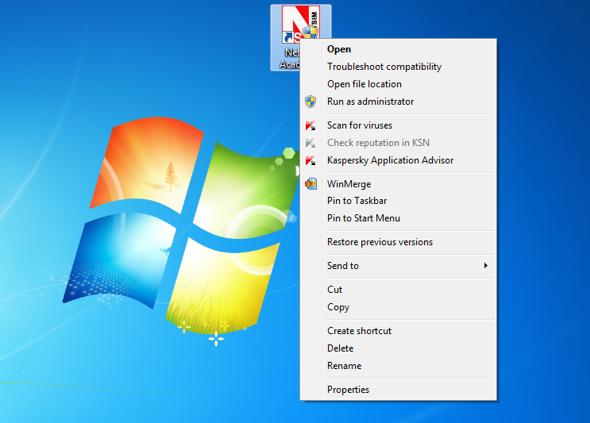

2. Now right click on NetSim.jar and select send to -> Desktop (create shortcut).
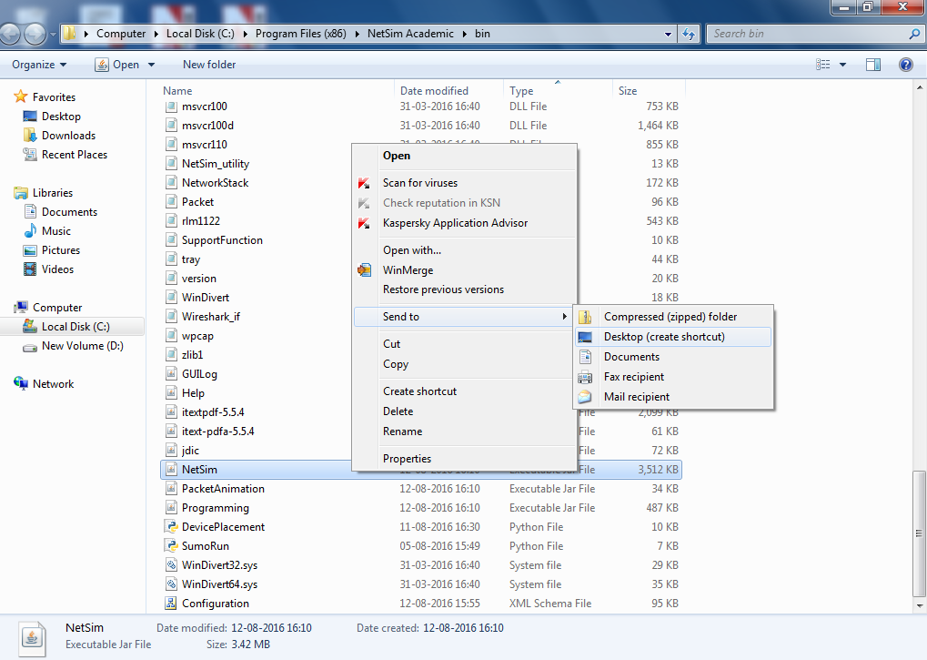

3. Go to desktop and right click on the new NetSim - Shortcut that is created and select properties.
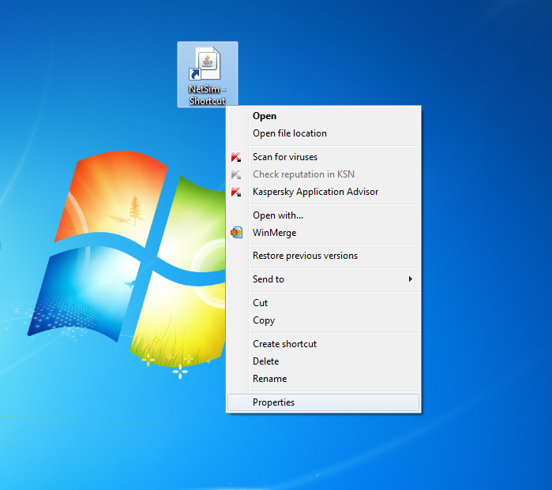

4. In the target text box, before the already existing path add the following:
<path of 32 bit java's bin folder\java.exe> -jar
Eg: After appending the java path the target text box will have contents similar to the following:
"C:\Program Files (x86)\Java\jre8\bin\java.exe" -jar "C:\Program Files (x86)\NetSim Standard\bin\NetSim.jar"
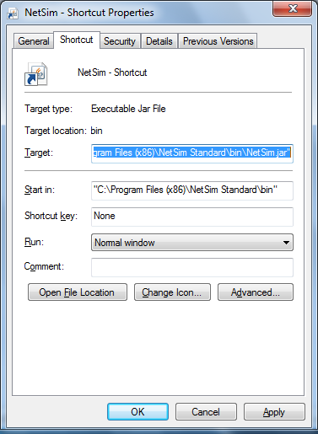

This shortcut can be used to start NetSim instead of the default shortcut that gets created on the desktop after NetSim installation.

Hello Dr. Campbell,

We just checked with our licensing vendors and they have an environment variable for this. My apologies for not having known about this earlier.

The variable is RLM_LICENSE and its value must be of the format port@host. An example screen shot is given below



