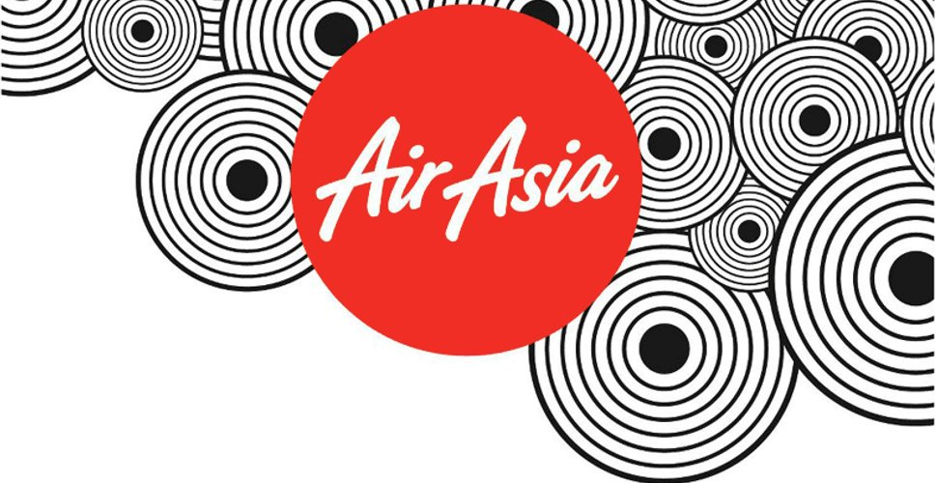

According to Karma (2014), organisational success is defined as the state of achievement, where an organisation accomplishes excellence both in market share and profitability. Elements of success in profit is vital, however consumer relations and employee satisfaction is just as important. This article has critically compared two low-cost airline, Ryanair vs AirAsia, especially on the aspect of women empowerment.
Established in 1993, AirAsia is a Malaysian low-cost airline founded by a government owned conglomerate, DRB-Hicom. In 2001 the airline become heavily in debt and was purchased by Tony Fernandes of Tune Air Sdn Bhd, for a trivial price of one ringgit (RM1). Along with the made purchase, Fernandes acquired the company for RM 40 million worth of debt. Nevertheless under the leadership of Fernandes the Malaysian airline soared in growth and success with a vision of “To be the largest low cost airline in Asia and serving the 3 billion people who are currently underserved with poor connectivity and high fares” (AirAsia, 2018). Through the analysis of AirAsia objectives they have achieved their vision. By creating a globally recognised brand in which have attained low-cost prices, affordable to any consumer and provides customer satisfaction with high quality products and services through the embracement of technology.

‘Work Hard Stay Humble’
AirAsia
VS
‘Always Getting Better’
Ryanair

Billie Morgan
University of Wales Trinity Saint David, Swansea

As for employees of Air Asia, Fernandes has set a primary objective ‘to be the best company to work for whereby employees are treated as part of a big family’(Fernandes, 2018) the treated of employees have triumphed the Air Asian brand, in contrast to other low-cost airlines such as Ryan Air that has been referenced later in the article.
Headquartered in Kuala Lumpur, the AirAsia Group vast operations consist of scheduled, international and domestic flights to more than 165 destinations spanning across 25 countries (AirAsia, 2018).With fleet size of 174 Airbus A320 aircrafts excluding AirAsia X an associate that focuses on long-haul businesses (AirAsia, 2018). Through the accomplishment of their growth in operations the modern-day organisation of AirAsia has delivered a global giant in the region of Asia and its tourism industry. This has led to high returns and valuable income. In 2017, the company made a profit increase of ‘revenue up 8% to RM2.23 billion’ and an ‘Operating profit of RM391 million’ (Press Release, 2017). Additionally, their recent company marketing strategies in promotion has received mass attention. One reason in this gain in popularity that could be related to the huge growth in profit, would be their tactics in mainstream marketing. In 2018/2019 Air Asia will launch free seats for consumers when booking online from 12-18 March 2018, furthermore on September 2018-June 2019 domestic and internationals fares from a low as RM0, of course terms and restrictions apply. Consequently, the continuous low-cost pricing and promotion approaches have led to advancing the progression of passenger numbers. They have achieved to attain mass increase of growth throughout the years. In 2016 ‘56.6 million passengers’ where carried overall (Annual Report AirAsia 2016). In 2017, due to the high demand for air travel “resulting in a 12% year-on-year increase in passengers carried to a further 9.89 million” in contrast to 2016 (AirAsia, 2018 p.1) such strong consumer statistics have retained Air Asia’s legacy and have made hopeful prospects for future success.

I. The success of AirAsia

I. Introduction
According to Farhoud (2017) the Ryanair staff pay £300 for their own uniforms and an additional £2,000 for their training. This has sparked outrage in employees and exposed the poor working conditions within the airline. In comparison AirAsia employees are given free uniforms and paid training by the organisation (AirAsia, 2018). Furthermore, employee dissatisfaction in both pay and working conditions soar as it is believed that the company do not value their employees (Telegraph, 2016).
Showcasing a clear distinction between AirAsia in both leadership style and the success of operations. The Malaysian airline has introduced numerous polices that have benefitted staff such as women empowerment and innovations in employee services, these elements are considered to be one of AirAsia’s key strengths and the reason for being the world’s best airline aside from profit, growth and effectiveness. It is determined that innovations by AirAsia has been the success of the brand and it is recommended that Ryanair deliver in supplying such developments.
III. This is How you Inspire Ryanair
A good working environment means employee satisfaction (Frey & Osterloh, 2001) The advantage of this factor for a company, is described by Foldspang, (2001) it creates high productivity as a positive atmosphere improves performances (Dümke, 2002).
From first-hand experience made by the author, acknowledged from the company headquarters in Kuala Lumpur. AirAsia has supplied this positive working atmosphere, due to the established facilities that are offered and equal treatment which transports high staff morale.

AirAsia HQ, slide for employees to use (13/12/18)
When an organisations introduces initiatives within the workplace, it creates a strong work culture as employees respond positively and actively to facilities that is produced for their use and enjoyment, Bhardwaj (2016).

II. ‘The World’s Best Low-Cost Airline’
AirAsia has been named ‘The World’s best low-cost airline’ for nine consecutive years bestowed by Skytrax World Airline Awards (Yee Xiang Yun, 2017). This has been granted because of numerous strategies that have been performed effectively: such as digital advances, consumer satisfaction and the quality of products and services these factors has induced global recognition of the thriving success of AirAsia.
On the contrary, Ryanair is deemed to be less effective in such aspects in contrast, to AirAsia’s achievements in gaining this award. Ryanair has been under scrutiny for many years as it has been publicized to be ‘worst’ brand for customer service (Telegraph, 2013) in comparison to AirAsia being known as the best globally. There are clear developments and implemented strategies that have set aside differences between both airlines. One that is significant above all is the comparison between AirAsia’s image and Ryanair’s image. AirAsia’s positive brand image has been due to their good customer service. AirAsia CEO believes customer service is the company’s primary goal (MalayMail Online, 2017) whilst Ryanair on the other hand deems to consider profit as their key objective (Telegraph, 2017) thus, clearly identifying distinctive differences of the management of consumers.
One example of AirAsia’s triumph in customer service is their presence on social media. AirAsia’s Facebook goes the extra mile in friendly and instant replies to customer comments, helpful advice and product promotion activities including their current system called AskAirAsia that deal with one million enquiries per month (AirAsia, 2018). Showing evidence in good customer service of AirAsia. In comparison, in, 2015 Ryanair, the low-cost airline was fined £635,000 by the Italian authority (Kim, 2015). Ryanair was not supplying adequate information by providing misleading information to consumers regarding travel insurance. An example of their poor strategies in consumer relations. Additionally, various other issues about the airline has been addressed by the public. According to O’ Callaghan (2016) Ryanair’s CEO Michael O’Leary had admitted to the poor treatment of customers. O’ Leary further commented to say Ryanair has introduced a revamp of their website and mobile platform and to supply overall improved customer service with new routes, technology and service. Has their new approach by the company altered people perceptions? The evidence against the new approach to improve customer service has revealed that Ryanair is still receiving negative press and poor brand image.
In recent years AirAsia has implored facilities to further improve customer information, feedback, cancellation polices and technological enhancement to support a consumer and better their product and services, alternatively Ryanair has produced poor customer service and staff management. For example, in 2017, their mass cancelation crisis in flights further impacted the company’s image as it was exposed another issue regarding the management in Ryanair. Sources reveal that the company produced poor staff treatment and employee dissatisfaction.

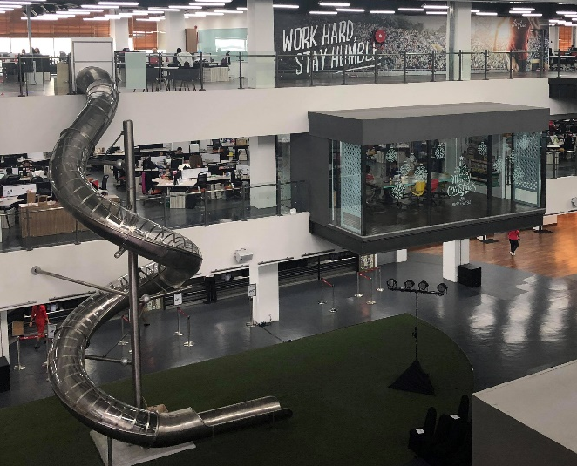

IV. Power to Empowerment
According to Mohamed (2017 p.1) discrimination ‘implies an unfair treatment of two or more persons or subject’. AirAsia’s work environment strategy is against any discrimination in the forms of colour, religion, race, gender, sexual orientation, nationality, marital status, ancestry, socio-economic status or physical disabilities. (AirAsia, 2018). The company have set numerous legislations against these grounds of discrimination, which are clearly detected in their code of conduct (AirAsia, 2018). AirAsia has further capitalizes on its slogan "Now everyone can fly" by introducing more policies on disability, by suppling improved wheelchair access and mobility for customers. Ryanair, however also have many polices on discrimination for employees and customers, according to their website (Ryanair, 2018) yet guilty of disability discrimination (Vanhala, 2010). A passenger was charged ‘£18by Ryanair for a wheelchair’ (Vanhala, 2010 p.222) evident of past history of poor customer care and no new strategies to improve this.
In terms of empowerment, AirAsia has given great recognition of gender equal opportunities as people are based solely on talent and performance. Defined by Michael, Beattie, Martin &Walston (2017 p.1252) Empowerment means ‘the process of becoming stronger and more confident, especially in controlling one's life and claiming one's rights.’ The battle for female equality has been strived for generations. Women continue to occupy disadvantages in contrast to the population of men (Sahay, 1998). The developing modern society women empowerment is growing stronger and action is being taken, especially within the workplace. Polices have been set forward to demand equal rights such as The Equality Act 2010. Due to the response to women taking action against this unbalance, nevertheless rights for women are still in the modern day are below expectable within many organisations around the world. AirAsia is one of the minor large global companies that are have implored the importance of women empowerment and opportunities for their employees.
The company’s employee number by the end of 2017, was approximately 17,000 (AirAsia, 2018). The ratio between men and women are inclining in percentages favouring females, as the company believe in the importance of cumulating women whom are qualified for a role as much as men. The company continuously emphasise the importance for equal opportunities within AirAsia. Fernandez believes “pro-woman” and “pro-equality”; it’s simply good business, and it underscores the company’s broader corporate culture.

This transpires through, AirAsia’s headquarters formerly known as RedFort, now named RedQ. The company in 2016, embarked on a total revamp of the venue to spark inspiration and innovation to employees. The development has transformed the company into a modern, vibrant and interactive facility.
The main focus of the building and employee common area (Primary source 13/12/17).
The six storey revamped building houses 2,000 employees and holds 44 departments (AirAsia, 2018). They have prioritised fun to their workforce by supplying them with a slide for easy and quick access to the ground floor, beanbags on AstroTurf, hair salon, salad bar, restaurant, gym and open spaces to encourage communication. Further creativity continues through themed meeting rooms inspired by destinations of the airlines network, for example such named areas are Manila, Hong Kong and Tokyo. AirAsia facilities aim to stimulate creativity, boost success and productivity. By displaying an engaging and colourful office space it has heavily influenced employee motivation that has helped with company operations and in return employees, gain job satisfaction. The company takes in high regard of employment treatment as explained through there initiations of facilities.
On a personal reflection, AirAsia has named their workforce and each employee to be referred as ‘All-Stars’ as they value them as stars. Each worker from lower positions to top management have direct contact information of Tony Fernandez, as they are encouraged to contact him with any queries, problems or ideas. This creates further career progression opportunities and gives employees respected power. Furthering expressing how AirAsia value their workforce and their policies on empowerment and the importance to develop a heathy organisation. The treated of employees led by Tony Fernandez is the opposite in contrast to Ryanair as this has been shown through Ryanair’s CEO Michael O’Leary leadership style.
Aireen Omar (female), age 43, was appointed as Chief Executive Officer and Non-Independent Executive Director of the Company in 2012. Since then, the importance of women empowerment as soared from strength to strength.
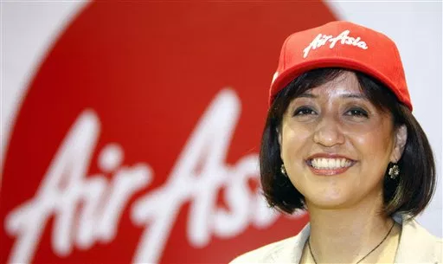
(Aireen Omar, sourced 18/02/18)
Omar has been a dominant influence in the business world. She has been awarded several achievements due to her accomplishments within AirAsia. Masterclass Woman CEO of the Year at the Selangor Excellence Business Awards 2014, named one of Corporate Treasurer’s 25 Most Influential Women in Treasury, and received the Outstanding Achievement Award under the CEO category at the Malaysian Women of Excellence 2014 awards (Pereira, 2017). These awards have been bestowed due to her conscious efforts of equal opportunities regardless of gender, and this has contributed immensely towards creating an environment that encourages creativity and positions of leadership for women (AirAsia, 2018). Stated from an interview with PWC (2013) ‘she mentioned that she is also working hard to maintain the operational effectiveness of the company to maintain its competitive advantages’ focusing on the operations of Malaysia’s AirAsia office and employee empowerment, thus her leadership style has been a great impact to the overall success of the company. Amongst strategies, one campaign that was led to inspire women was named #GirlsCanDoAnything to further support empowerment. This is a significant development for the tourism industry, especially to the next generation of females
V. #GirlsCanDoAnything
The airline has collaborated with the Ministry of Women, Family and Community Development to support the youth of the female generation. The scheme is AirAsia’s largest ploy to accomplish women empowerment. Started in 2016, led by Aireen Omar. The objective features AirAsia female employees from various departments and positions as a real example of girls can do anything, to inspire young females.
Ryanair has a vast ratio of male employees out of their ‘12,438’ in 2017 (Ryanair, 2018). As AriAsia is on the rise of female percentages in the workforce especially through their pilots and engineers, in contrast Ryanair has just one female pilot in operation, Maria Pettersson (Calder, 2017).
As for the policies set to improve women equality, Ryanair has no new agenda to implement empowerment for women. The last strategy performed by Ryanair that involved solely women was the conversional cabin crew calendar. According to the Weinstock (2014) in 2014, the company produced a cabin crew calendar shoot which was judged by the public as demeaning and sexist for women, due to the explicated content and exploitation of the women. This evidence is highly against Ryanair within this subject matter of empowerment, due to lack of strategies the company have not produced to positively impact the women workforce. The researcher has concluded it is highly recommended to improve such areas of treatment in both workforce and customers, in comparison to AirAsia this low-cost airline are progressing for the long-term future by satisfying staff and consumer’s products and services. In regards to women empowerment AirAsia is excelling and embarking of further globally advances of equality that world-wide organisations must achieve.
The implemented action taken by AirAsia to succeed in women equality was to employ women to senior levels. A quote of Fernandez states “Women are good leaders and much more pragmatic than men. A lot of our senior executives are women”. Numerous sourced evidence back up the statement of Fernandez, according to Leon (1993) ‘Women managers control their emotions better than men’. Women leaders has proven to be more empathetic and have greater interpersonal skills whilst being able to boost further employee engagement in comparison to male managers (Hurley & Shumway, 2018). Knowledge of this has been captured by Fernandez, Thus the modern AirAsia’s employee hierarchy represent several women at high senior positions. This is a celebration for women in Asia has many global company’s structure are mostly male dominated. In to comparison to Ryanair their management structure has a significant unbalance of three women are directors out of 13, thus 10 being male (Ryanair, 2018).

AirAsia partnered with Star Media Group (SMG) on a campaign to celebrate women in 2017. Named ‘WOW-Women Do Wonders’ the project highlights women’s contributions and the vital roles they play. In February last year, AirAsia documented Flight AK5110. The flight from Kuala Lumpur to Kota Kinabalu was led by an all women crew (Soon, 2017) this include everyone single member from pilots and cabin crew to the operational control centre, engineers and flight dispatchers. The strategy received mass publicity in social media and the campaign started trending via Twitter and had many positives attention from global outlets. The aim was to show the world that women can achieve the same results as men in the workforce and to further support the empowerment movement and equal rights. It is believed that more campaigns will be established to address issues such as employee treatment, women equality and empowerment within the industry. As the long term benefit of supporting and producing innovations that will thrive to achieve such issues will award companies many advantages from both publicity, consumers and workforce. As from the researcher from a class of nine women with all different backgrounds, each individual captured the vision of AirAsia and was inspired by the company’s operations and achievements made. From the first-hand experience the judgement was made that AirAsia has made success within the tourism industry through their initiatives of empowerment and employee facilities. It was clear sourced information was proof that Ryanair has many differences against AirAsia that was unfavourable, which was a clear distinction in why AirAsia is deemed to be the ‘world best low-cost airline’ and Ryanair is the worst due to several factors previously explained, however it is significant that there are no current strategies that are set empowerment to women by Ryanair. AirAsia has produced a successful campaign in achieve their objectives that the company sets to achieve and it is deemed to be positive to society due to the advancement in their strategies for the women population.
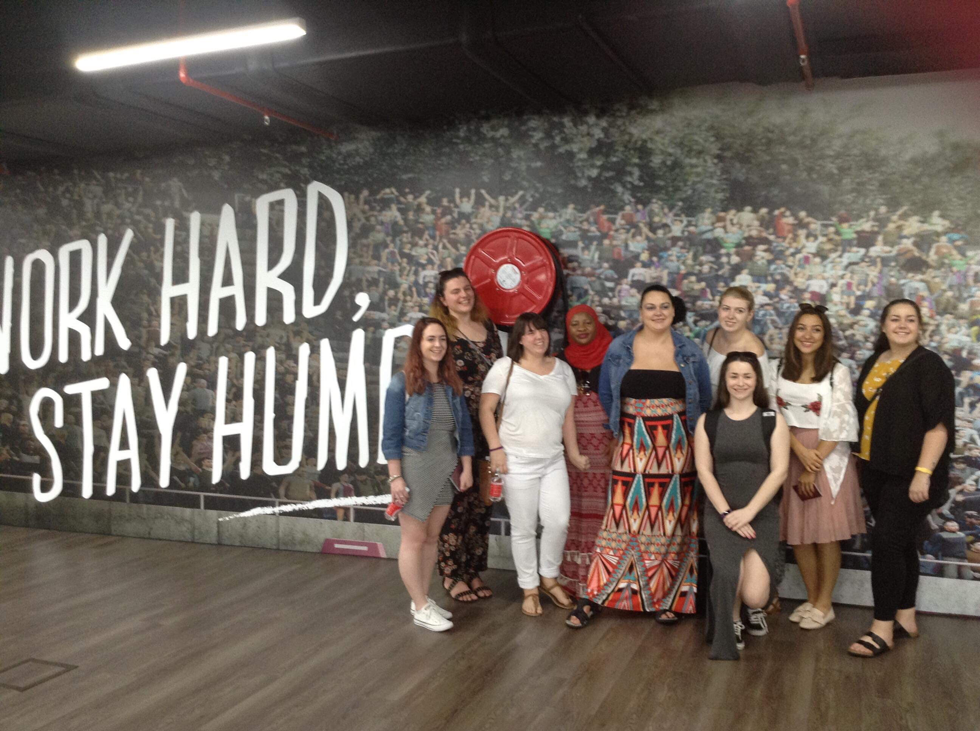
UWTSD MTour student’s visit to AirAsia’s headquarters, an all-female class (Primary source 13/12/17)
Montes (2017) suggests in modern society, the competitive world of business must consider educating and developing leaders is of vital importance. By inspiring the youth of today can greatly benefit an organisation in the long-term. Especially for the female population, as job roles will have equal employee ratios, women have the chance to thrive in male dominated positions, opportunity for progression and a focus on solely on the potential of a person not the gender.
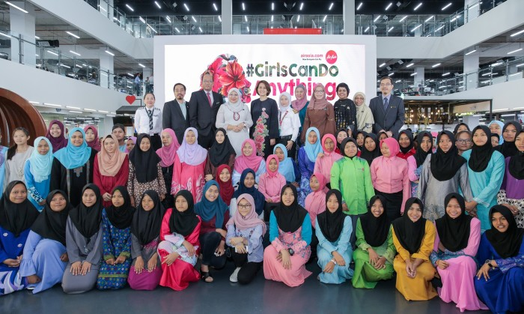
Girls can do anything campaign image. (Sourced 18/02/18)
As part of #GirlsCanDoAnything campaign one strategy introduced in 2017, hosted by the airline in RedQ (Headquarters of AirAsia) invited 84 underprivileged female students for a motivational sharing session with AirAsia’s female pilots, engineers and senior management staff (AirAsia, 2017). The aim to encourage females to work in dominated male fields. Currently the company have 39 women pilots at AirAsia and 15 in AirAsiaX, as well as eight women engineers in AirAsia and one in AirAsiaX (Soon, 2017) campaigns such as this, will aim to further these statistics.
A quote from Aireen Omar, to describe the aim of the event “to inspire them not to limit themselves and dare to choose their desired career paths in any field”. (Press Release AirAsia, 2017). Through this motivational and inspiring sessions of the campaign has received over 400 students that have had the opportunity to interact with many of the successful women at AirAsia, to gain an interest in working and becoming a success of themselves in the industry that they desire to work. The campaign is a truly great example in the progression of large corporations displaying opportunities for the female population. This represents AirAsia’s women empowerment for the public, however success for the women workforce in the company is furthering to great heights. Another campaign to support this movement hosted by the airline embarked on making history.

References
AirAsia (2017) ‘Preliminary Operating Statistics For the 3rd Quarter of the 2017 Financial Year’ https://www.airasia.com/cdn/docs/common-docs/investor-relations/airasia-preliminary-operating-statistics-3q17-final.pdf [Accessed 05/01/18]
AirAsia (2017) ‘AirAsia Mission, Vision & Values’ https://www.airasia.com/my/en/about-us/airasia-mission-vision-values.page [accessed 05/01/2018]
AirAsia (2017) ‘Jumpstart Malaysia’ https://www.airasia.com/common/pdf/JusmStart-Malaysia.pdf [Accessed 06/01/2018]
Frey. B & Osterloh. M (2001) ‘Successful Management by Motivation: Balancing Intrinsic and Extrinsic Incentives’ Switzerland: Springer Science & Business Media p.202
Dumke. R (2002) ‘Corporate Reputation and its Importance for Business Success: A European Perspective and its Implication for Public Relations Consultancies’ Germany: diplom.de p.34
Foldspang. L (2014) ‘Working environment and productivity: A register-based analysis of Nordic enterprises’ Nordic Council of Ministers p.65
Yee Xiang Yun (2017) AirAsia named world's best low-cost airline for 9th consecutive time https://www.thestar.com.my/news/nation/2017/06/21/airasia-named-worlds-best-low-cost-airline/#7DqeZAHDwtcSeeQI.99 [Accessed 07/01/18]
Press Release, AirAsia (2017) AirAsia Berhad First Quarter 2017 Financial Results https://www.airasia.com/cdn/docs/common-docs/investor-relations/press-release-airasia-berhad-1q17-financial-results-25-may-2017.pdf [Accessed 17/01/18]
Annual Report AirAsia (2016) AirAsia
https://www.airasia.com/cdn/docs/common-docs/investor-relations/airasia-annual-report-2016.pdf [Accessed 17/01/18]
Sahay. S (1998) Women and Empowerment: Approaches and Strategies. India: Discovery Publishing House p.1
Soon. I (2017) In this company, #GirlsCanDoAnything https://www.star2.com/living/2017/03/25/in-this-company-girlscandoanything-airasia/ [accessed 02/02/18]
Press Release, AirAsia (2017) Ministry of women, family and community development supports AirAsia’s #GirlsCanDoAnything campaign https://www.airasia.com/ot/en/press-releases/girls-can-do-anything.page [accessed 02/02/18]
Montes. J (2017) Millennial Workforce: Cracking the Code to Generation Y In Your Company Lulu Press, Inc p.1
Karma. U (2014) Asian Business and Management Practices: Trends and Global Considerations: Trends and Global Considerations, Spain: IGI Global p.134
Telegraph (2013) Ryanair 'worst' brand for customer service http://www.telegraph.co.uk/travel/news/ryanair/Ryanair-worst-brand-for-customer-service/ accessed 20/02/2018
Kim. S (2015) Ryanair fined €550k for poor customer service http://www.telegraph.co.uk/travel/news/ryanair/Ryanair-fined-550K-for-poor-customer-service/ accessed 20/02/2018
L. O’callaghan (2016) Exclusive: Ryanair CEO Michael O'Leary admits to THIS huge customer service error https://www.express.co.uk/travel/articles/705812/ryanair-ceo-michael-oleary-admits-customer-service-was-not-good-enough 20/02/2018
Micheal. J, Beattie. L, Martin. F & Walston. J (2017) Oxford Textbook of Geriatric Medicine. 3rd edition, UK Oxford University Press p.1252
Ryanair (2018) Directors https://investor.ryanair.com/governance/directors/ accessed 20/02/18
Hurley. K & Shumway. P (2015) Real Women, Real Leaders: Surviving and Succeeding in the Business World John Wiley & Sons p.5
Mohamed. A (2017) Laws ensure equality in workplace http://www1.nst.com.my/opinion/letters/2017/11/307251/laws-ensure-equality-workplace accessed 20/02/18
AirAsia (2018) Code of Conduct https://www.airasia.com/la/en/about-us/airasia-code-of-conduct.page [accessed 20/02/18]
Vanhala. L (2010) Making Rights a Reality?: Disability Rights Activists and Legal Mobilization UK: Cambridge University Press p.222
Calder. S (2017) The Man Who Pays His Way: Are women-only flight crews anything more than symbolic? http://www.independent.co.uk/travel/news-and-advice/all-female-flight-crew-royal-brunei-easyjet-airlines-outnumber-women-16-to-one-gender-flybe-monarch-a7619841.html [accessed 20/02/18]

