
Skills for the Workplace
Module Assignment Submission
Student Name:
Student Number:
Module No: | BMSK4001
Module Title: | Academic and Employability Skills

Statement of Confirmation of Authenticity
By the act of making this submission, the student declares that this is the work of the student named above. The work has not, in whole or in part, been knowingly presented elsewhere for assessment, or where assessment has been built on a previous assessment, this has been identified. Where materials have been used from other sources it has been properly acknowledged. If this statement is untrue, the student acknowledges that an assessment offence has been committed.
Attention is drawn to the plagiarism and unfair practice policies of both the University and of ILM.

Table of Contents
Introduction 3
Part 1 identify your personal skills-set and knowledge contribution towards the project and general employability skills you have learned or developed during this project. 3
1.0 reflection on group business plan 3
2.0 reflect upon the business and entrepreneurial skills you have explored whilst creating the business plan. 6
2.2 Action Plan for Improvement 7
Conclusion 8
References 9

Introduction
In this reflective cycle im going to take you through the assignment that was set for me and 3 of my team members, we were set a task of making a business and producing a business plan that we could present infront of our coursed tutor. Our business plan was basede on a lawn grass cutting company named TLC (total lawn care) Each of us were given an area of which we needed to cover so that we could all collectively put together for our final plan. I will talk you threw some obstacles we came to and how we managed best to over come them to produce a team effort. And lastly, I will demonstrate what I have learnt in this assignment and the last 12 months of being on this course.

Part 1 identify your personal skills-set and knowledge contribution towards the project and general employability skills you have learned or developed during this project.

1.0 reflection on group business plan

I going to go use the gibbs reflective model to reflect on my assignment
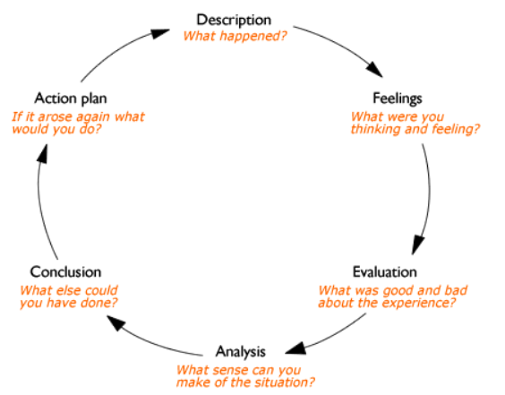
Description (what happened?)
The first weekend of august there was a residential weekend where all students needed to attend a weekend of classes to be given all the information for module bmsk4006, unfortunately due to a family wedding I was unable to attend. So in preparation for my first meeting with team members I studied all the reading material and watched the online tutorials to gather as much information as I could, which I found hard, as I work better and understand things better with face to face class room learning.
Our first meeting was 4 days after the weekend, holly who was our team and she leader gave each person their sections and we came up with our plan for the business idea.
Holly was given introduction, myself was given the section of market and competitors, shannaz was given sales and marketing and Stephen was given operations and financial. And we were given 6 weeks in which to complete the plan and then present it.
My section made me extensively research if there was a market for our tlc ( total lawn care) gardening services, who are competitors were, there costs, prices, market overview, size, trends, basically was there an opening for us in the industry and did we have a future. I also looked into a pest analysis see if our business could be effected, politically, economically, socially, or with technoigical. And I completed a swot analysis. Finally I looked into our customers we would be targeting, age , gender ect. And finally I completed a competitor analysis , to see who we are competing against and what will make us stand out and make people chose us over them.
Feelings (what were you thinking and feeling?)
Its always hard working as a team as u need to take other people feelings and considerations into account, there were a few obstacles we came across but just like being in an office or professional setting these needed too be resolved for this project to run smoothly as possible.it was hard putting work into a project and knowing 1 persons effort could impact the whole outcome of the project when people are giving it 100 percent and some n ot as much. But personally myself I feel I researched the market well and was able to show my findings as well as being able to find pricing and services trends and growth sufficiently, something I would never have been able to do looking back 12 months ago.
Evaluation (what was good and bad about the experience)
from the begging I knew shannaz would be a member that was going to be harder to work with rather than holly or Steve, not because I dislike her in anyway but being in a class room environment with her for the last 12 months I knew that things can sometimes become difficult, but in a professional setting these are obstacles you have to overcome. There was a time that holly the team leader and shannaz had a falling out and refused to speak to each other that being in person or on the group communication page. This made it difficult for me and Steve as we all had a job to do, and we all needed each other’s parts to be able to continue with our own individual parts. I intervened and came up with a solution so that I would meet shannaz personally myself to go over her parts as she was getting confused with what she needed to do as she hadn’t researched or read up on anything from the residential weekend. Shannaz was giving the section of sales and marketing as that what she requested she would like to do as she had previous experience in that field. Even after writing a list of sections she needed to cover we still didn’t get that section completed. Myself I found this assignment a very productive assignment as well as having your own section I now have a better understand of all the details that I would need to be present a business plan if I were to take my idea to investors or lenders. And its given me a lot of confidence. Ive been sat on the fence with weather to continue the course on to the following 2 years to achive my ba(hons) but as each assignment comes back and keep improving from the last score before it and being able to produce the work that we did I think I will be enrolling as of next year.
analysis ( what sense can you make of the situation?)
after a lot of hard work and trying to stick together and helping each other we came together with a plan that everyone was able to update on a dropbox file, their own personal work, and they were visible so that each persons effort was visual. Our business was a 4 way equal partnership with a simple idea so that we didn’t have to get into complicated paper work such as loans from banks. The plan was part time so that we could cover a day each as well as holding down are regular jobs for normal income while we would check the progression in 3 months.
conclusion (what else could you have done?)
I think we could have made more time to sit and help each other understand better each persons role, even though I know we as a team have our own individual sections, for a business or project to work we still need to work as a team.

Action plan (if it arose again what would you do?)
Firsty I would not have missed the residential weekend away as that straight away had me on a back foot and at a disadvantage, classroom learning is when I understand the most. I also think we would have benefited from using the stages of he Tuckman theory better and tried to air any grievances as early on as possible, as it delayed our team assignment dramatically.

2.0 reflect upon the business and entrepreneurial skills you have explored whilst creating the business plan.

From forming this assignment to presenting a business plan I have learnt that the majority of your business has to be knowledge of the market, the competitors and the consumers. You need extensive knowledge of who you are going to be competing against and what will make your company or services stand out from them, u need to know the best way to advertise your services and who u need to target. u need knowledge or the trends and the growth and weather its seasonal or has spikes threw certain months.
Looking back at where I started 12 month ago to where I am now, this assignment has made me
Collobarte with team mates into finding a plan of what to present, and and having an open drop box so that everyone can update there own i9nformation into the live file.
All had to listen and take in other people’s input
Over come problems and build on teamwork
Communicate properly to minimise arguments, putting aside all individual problems for the bigger picture.
This year I have tackled, problem solving and decision making, managing enterprise in the 21st century, academic and employability skills, effective team working and communication, and digital skills, with out any of these skills I wouldn’t have been able to co-produce this plan. 12c months ago I culdnt even turn on a lap top or use a word document .

2.2 Action Plan for Improvement

Objectives | Tasks | Success Criteria | Time Frame | Resources
List your Goals | What do you need to do to achieve these goals? | How will you identify your success? | When do they need to be done by? | Who or what do you need to help you?
To communicate more effectively | Listen better and plan effective communication | Feedback from future assignments | Following year | My self and team members
Not to miss residential weekend | Prioritize education commitments | By completing residential weekend | August 2020 | Myself and family member for child care
To always refrencde sources of informstionj | Take time to source intelligent and correct way to Harvard reference | By feedback from future assignments | Starting feb 2020 | Myself and online research

Conclusion
I have taken you threw my reflective summary of my business plan and shown what skills I needed to undertake the task and also explained what other members of my team did. I also taken you threw the obstacles we came across and how we worked as a team to try and correct them. And lastly I have shown what I have learned in this ;ast 12 months of learning from this course and what I can now do which I couldn’t do 12 months ago

References

Gibbs. model of reflection (1988)

