Commercial Office Installation

hnc electrical and eleCtronic engineering Design of electrical installations
Sian Nunnery

Contents
Section A 2
Question 1 2
Question 2 3
Question 3 4
Section B 5
Question 4 5
Question 5 6
Question 6 11
Question 7 12
Section C 13
Question 8 13
Question 9 14
Question 10 14
Question 11 15
Question 12 16
Reference 17
Bibliography 17

Section A

Question 1

The current usage within the sales office is as follows.
$$6 × 58 = 348 WATTS$$
$$\frac{348}{230} = 1.51 AMPS$$
An upgrade has been requested to replace and increase the number of luminaires within the sales office to substitute the current single luminaires for twin luminaire fittings. As the number of light fittings within the sales office is doubled due to twin lamp fittings being installed the wattage and amperage will increase.
$$12 × 58 = 696 WATTS$$
$$\frac{696}{230} = 3.026 AMPS$$
The total amount of load in the overall office before the twin lamp fittings are installed is as follows.
$$14 × 58 = 812 WATTS$$
$$\frac{812}{230} = 3.53 AMPS$$
Therefore, the overall load in the office would be $812 + 348 = 1160 WATTS$ and $3.53 + 1.51 = 5.04 AMPS$
Due to the description given for this assignment, only assumptions can be made upon the possible impact on the circuit described, therefore the following are only assumptions and not definitive responses to the calculations produced above.
The possible effect of this upgrade within the sales office can have a change in effects upon the current ratings of the circuit cables and protective devices currently installed. This means that the current protective devices currently installed may no longer support the additional six lights. As well as there being a potential need for re-wiring in the office to support the additional six lights due to there being an increase in load on the circuit, meaning that an upgrade to the consumer unit or a need to install a secondary circuit to be able to support the load. The possible impact that the circuit could have on cable sizing would be due to the rating of the size currently installed, as well as considering environmental factors surrounding the cable such as temperature and enclosure conditions. Dependent on these conditions, the size of the cable may need to be increase if the cable is de-rated due to these factors.

Question 2

- The ramifications of relocating the partition wall between the sales managers office and the managers secretary’s office will impact the installations methods chosen by the contractor, the following will have to be considered.
- Adding a junction box, which will allow the joining of the legs of the circuit from the two socket outlets when they are removed.
- Shutdown and isolate the power to the area / isolate the socket outlets.
- Bring new cabling through the new wall that will be constructed.
- Before reinstating the live circuit, test where required.

- The requirements between traders and clients when working in a small area are organisation and communication. Alternative arrangements for the work to commence for either the client and/or contractor may need to be made, as well as taking into consideration when other trades will be commencing work. This could include alternative working arrangement for either the client where they may have to work at a different location whilst work is carried out, or the alternative working hours could be arranged for the client and/or contractor, for example the contractor could work outside of normal working hours.

- To be able to carry out the work required within a small area in the office, organisation and scheduling of the work will need to be carried out between the client, contractors, and other trades to ensure that the work can be carried out in an organised and effective manner. This can be done through the means of meetings, Gantt charts for effective scheduling of where various parts of work will start/end and duration of various tasks will be carried and gives an overall schedule of the work that will be conducted. A critical analysis of communication will also need to be carried out, to attempt to avoid any mis lines of communication between the coordinators of the work that need to be carried out.

Question 3

- The additional cost of upgrading the fluorescent luminaries from a single 1500mm 58W luminaire to a twin lamp fitting to the same dimension and rating is that now there is double the amount of luminaires, therefore meaning that it will be double the price fitting and luminaires to be installed. Other factors may include the need for additional wiring to support the additional lighting load. The current consumer unit may not support the additional load so there might be a requirement to install an alternative consumer unit. Environmental factors must be considered and taken into consideration when carrying out the initial survey.

- Factors to consider whilst calculating costs for removal and replacement of outlets within the partition are dependent on when the contractors can access the office. If it is during normal working hours then consideration must be given to people working in the vicinity. The work between the various contractors such as the electricians, carpenters, builders etc. work will have to be scheduled accordingly. Therefore, the electricians will be working in the office during their allocated period. If this time frame is delayed by other contractors or unforeseen circumstances whilst carrying out the work required, this could add additional costs due to work being delayed. Other costs to consider are the possible additional cost of cable for the outlets within the partition, as well as the cost of the replacement outlets. Once all these additional costs are taken into consideration and totalled, this will likely increase the overall price of the project.

Section B

Question 4

Because of the electrical load for the buliding and high current demand, the supply authority metering equipment is not capable of carrying the level of current which could be drawn by the installation. Therefore, current transformers (CTs) will have to be installed at part of the metering arrangement. The following diagram illustrates how the CTs would be installed at the mains position.
The CTs will reduce the current which runs through the meter while still measuring the kiloWatts consumed per hour.
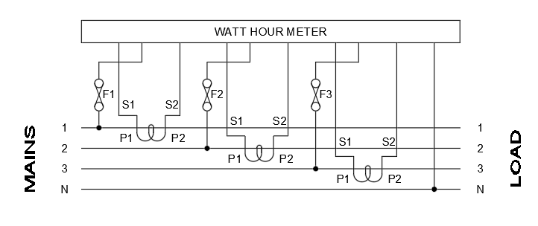

Question 5

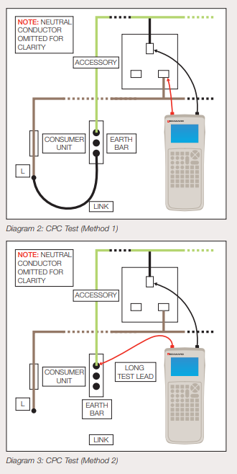
- Testing that will need to be carried out upon completion of the electrical installation is continuity of protective conductors, continuity of ring final circuit conductors, polarity, insulation resistance testing, earth fault loop independence testing, RCD testing and functional testing.
These tests are carried out by…

Continuity of circuit protective conductors (CPC), “the purpose of this test is to verify that the CPC forms a continuous path around the circuit under test.”
(A Guide to 17th Edition Testing, n.d.).
All protective conductors including the earthing conductor, supplementary and main bonding conductors and circuit protective conductors must all be tested to confirm that all conductors have continuity and where appropriate, are connected to the supply earth. The continuity tests of the bonding conductors are carried out by measuring between the main earthing terminal and the end of the bonding conductor. Circuit Protective Conductors continuity is
generally measured using the (R1+R2) method.
Figure 1 - (A Guide to 17th Edition Testing, n.d.)
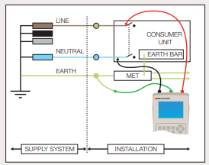
Earth Fault Loop Impedance Testing is given by the following formula Zs = Ze + (R1 + R2), where the value of Zs can be derived by:
- “Measuring the earth fault loop impedance Zs at the furthest point.
- Measuring the earth loop impedance Ze at the incoming supply and adding (R1 + R2)
- Taking the earth fault loop impedance Ze provided by the distributor and adding (R1 + R2).” (A Guide to 17th Edition Testing, n.d.)
Figure 2 - (A Guide to 17th Edition Testing, n.d.)
In preparation for testing the first step is to isolate and lock off the main supply at the consumer unit. To test external earth fault loop impedance (Ze) the earthing conductor must be disconnected from the Main Earthing Terminal (MET). This eliminates any potential parallel earth paths occurring through equipotential bonding which may be present and could affect the reading.
The test procedure consists of firstly selecting the suitable range on the instrument. Secondly, between the incoming line of the main switch and the disconnected end of the main earthing conductor, connect the test leads. Next carry out the measurement. Then the on the testing instrument the value of Ze will appear and can include the value of the PFC, dependent upon the make of test instrument.
It is very important to note that the earthing conductor must be reconnected immediately following this test procedure. If not, the safety of the installation may be compromised.

Functional testing is a procedure that verifies that selected equipment such as a RCD, switchgear, control, etc. all work correctly following installation and commissioning.

Insulation resistance testing. The purpose of this is to test that there are no breaks in the insulation between live and earth conductors. This is carried out by firstly ensuring that all loads are isolated from the supply. On 230V circuits, the test meter ‘injects’ a 500V test voltage. The insulation resistance test will clarify or not that a ‘healthy’ condition exists. If there is any breakdown in insulation, the meter will detect this and give a low reading. Healthy circuits will give a very high resistance reading up to 500MΩ.
“BS 7671 requires that an insulation resistance test is carried out with a test instrument capable of producing the dc test voltages shown in the table below. For single phase domestic installations, a 500V insulation resistance test is required. the PowerPlus 1557 and PowerTest 1557 are capable of such tests. Please see table below”
(A Guide to 17th Edition Testing, n.d.)
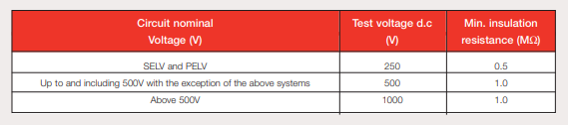
Figure 3 - (A Guide to 17th Edition Testing, n.d.)

RCD testing is a test process of safely ‘tripping’ the RCD, this is to ensure that it operates quickly in case an electrical incident occurs. The RCD is designed to trip / switch off all power to the circuit. Preparation for an RCD test includes disconnecting all power from sub circuit(s) under test and turn the main switch on, so all circuits are live.
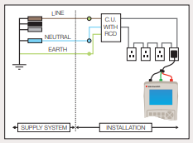
The test procedure for an RCD is as follows:
“1. Select the appropriate test instrument range for the measurement of tripping time (mS).
2. Connect the RCD tester to any accessory point (Use the test lead provided with a 13A plug for socket circuits).
3. Operate the instrument test button and obtain the values of tripping times (at 0.5IΔn, IΔn and 5 IΔn where appropriate).
Figure 4 - (A Guide to 17th Edition Testing, n.d.)
4. Many RCD test instruments have an automatic test sequence which will perform tests at 0.5”
(A Guide to 17th Edition Testing, n.d.)
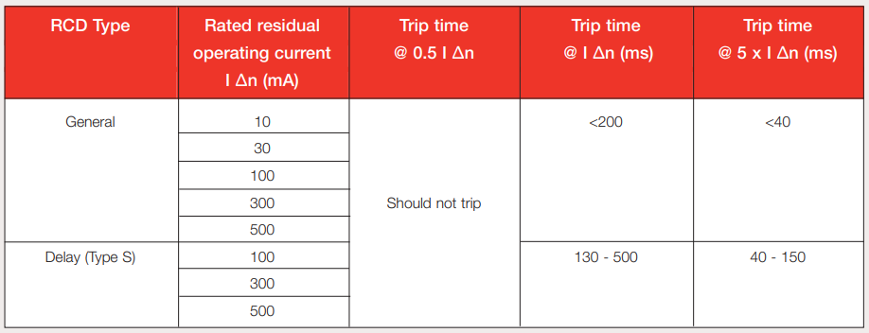
Figure 5 - (A Guide to 17th Edition Testing, n.d.)

- Standards that the test equipment and leads must comply with is BSEN61010 and HSE GS38.
BSEN61010 – Safety requirement for electrical equipment for measurement, control, and laboratory use. This standard is used where there is a requirement to carry out electrical tests using the various types of equipment; equipment test and measurement equipment, electrical industrial process-control equipment, and electrical laboratory equipment. This standard is also in place to reduce various hazards such as electrical shock or burns, spread of fire from the equipment, mechanical hazards, effects of fluids and fluid pressure, excessive temperature, effects pf radiation, including lasers sources and sonic and ultrasonic pressure and liberated gasses, explosion, and implosion.
HSE GS38 Electrical test equipment for use by electricians on low voltage electrical systems, as part of the “Electricity at Work Regulations 1989 require those in control of all or part of an electrical system to ensure it is safe to use ad maintained in a safe condition.” (Electrical test equipment for use on low voltage electrical systems, 2015).
This standard requires electricians to carry out testing and fault finding on electrical equipment and systems, where possible all work is to be carried out with the system dead on.

- The certification forms that need to be completed for the work carried out is a minor work certificate, this certification is carried out where any minor electrical work has been carried out in accordance with the wiring regulations BS7671:2018. This is carried out where there have been any alterations made to any existing circuits but no change to the protection device, and/or any additions made to an existing circuit, such as an additional light fitting or a new outlet socket. An example of the Minor Works Certificate is as follows.
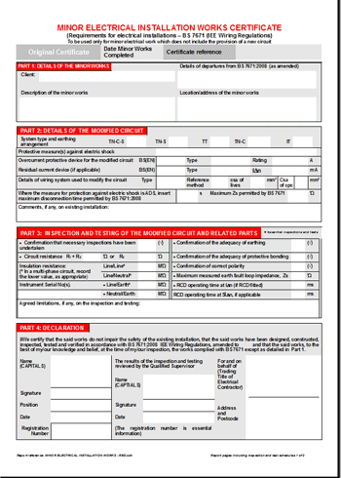
Figure 6 - (The Minor Electrical Installation Works Certificate | SparkyFacts.co.uk, n.d.)

If any further installation work had been involved such as the changing of a distribution board or consumer unit, the contractor would be required to complete a full Electrical Installation Certificate which would include a schedule of test results and a schedule of inspections.

- Upon completion of the work the person who should receive all required inspection and testing certificates and forms would be the customer who ordered the work, therefore the client.

Question 6
The types of test instruments that are used to test electrical installation are as follows
- continuity tests that uses a low resistance ohm meter that has the range of 0-20𝛺
- insulation resistance tester that measure in the range of 0-500m𝛺
- earth fault loop impedance tester that measures in the range of 0-2000𝛺
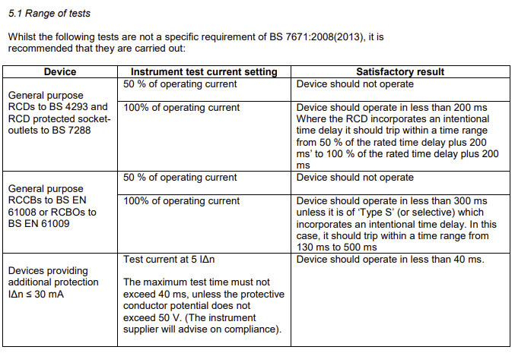
- an Residual Current Device tester this measures disconnection time when a given fault current is applied therefore it is either pass or fail, refer to figure 7 for range guidance
Figure 7 - (Inspection and Testing of Electrical Installations: Residual Current Devices, n.d.)

When testing an RCD there are regulations that need to be followed. To ensure the effectiveness of the RCD, it must be verified by testing under appropriate fault conditions through the means of simulation. “Where an RCD with a rated residual operating current, IΔn, not exceeding 30mA is used to provide additional protection, the operating time must not exceed 40ms at a residual current of 5 x IΔn (see Regulation 415.1.1).”
(Inspection and Testing of Electrical Installations: Residual Current Devices, n.d.)

Question 7

If in the event that an earth loop impedance test at the Visual Display Unit (VDU) switched socket outlet fails to meet the requirement for BS7671:2018, the inspector must initially look for any possible loose connections and/or poor terminations. It may be necessary increase the protective conductor size or install a BSEN60898 miniature circuit breaker. Loose connections or screw clamping can be resolved by re-terminating the connection. In the case of where a break in the circuit has occurred, it will be necessary to repair and re-terminate at that point. Following repair and/ or re-termination, the proprietary tests must be carried out again to verify that the earth fault loop path is of low enough resistance and impedance to ensure the effective operation of protective devices.

Section C

Question 8

The following diagram illustrates an interconnection diagram of the control component within the circuit for an entire light system in the factory area that can be switched by the operation of one key switch located by the front door.
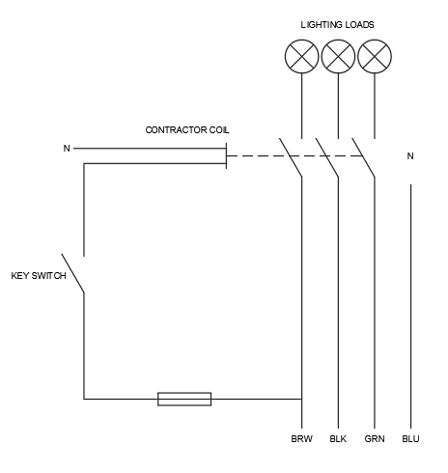
Figure 8 – Interconnection Diagram

Question 9

Possible causes of non-operation of a fluorescent luminaire within the office area could be failure of the lamp (tube), failure of the supply and failure of the starter or ballast. Issues that can arise are that the supply connection can become faulty or loose, breakdown of the florescent tube causing a failure, or a fault causing the florescent luminaire circuit breaker or fuse to disconnect. Ways to rectify these issues are to test and check all connections within the circuit which would hopefully identify any loose terminals. If breakdown of the fluorescent tube occurs then a replacement will need to be installed. Starters and ballasts also fail, particularly in older fittings. In most cases when a ballast has failed, it will be a more effective and cheaper option to replace the whole fitting.

Question 10

Implications of isolating the supply to the office once it has been occupied by the client could mean loss of work time by the client. There are various ways to overcome this which might mean arranging access out of normal working hours, the provision of an uninterrupted power supply (UPS) or requesting that the client arranges a temporary alternative place work. Effective communication between the client and contractors will go a long way towards finding a solution that works for both client and contractor. This will allow the client to give enough notice to their employees or anyone that will be affected by the interruption of the supply. Sufficient notice will allow anyone time to back up and save documentation on computers prior to the interruption of the power supply.

Question 11

The following diagram illustrates how it is possible to provide a 400V, three phase, four wire supply from and 11kV, three phase three wire supply.
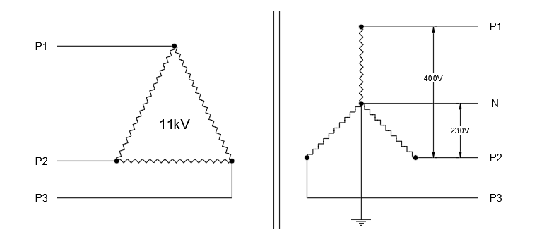
Figure 9 – Supply Diagram

Question 12
The following diagram demonstrates how connection is made on a three phase, four wire TN-S system to provide 230V single phase, 400V three phase and 400V three phase and neutral supplies:
- 230V, single phase
- 400V, three phase, three wire
- 400V, three phase, four wire
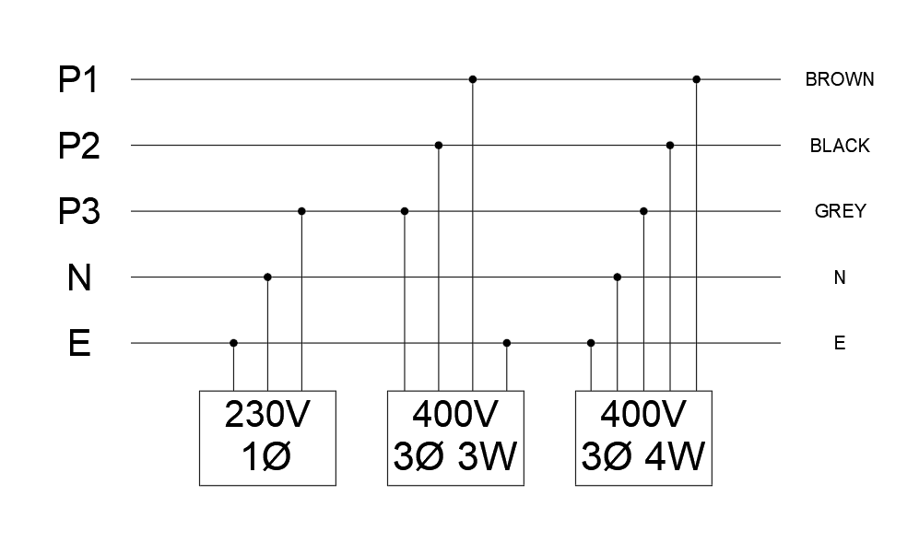
Figure 10 – Phase Diagram

Reference

Seaward.com. n.d. A Guide to 17th Edition Testing. [online] Available at: <https://www.seaward.com/gb/downloads/17th%20Edition%20Testing%20Guide.pdf> [Accessed 7 January 2022].

Hse.gov.uk. 2015. Electrical test equipment for use on low voltage electrical systems. [online] Available at: <https://www.hse.gov.uk/pubns/books/gs38.htm> [Accessed 7 January 2022].

Sparkyfacts.co.uk. n.d. The Minor Electrical Installation Works Certificate | SparkyFacts.co.uk. [online] Available at: <http://www.sparkyfacts.co.uk/The-Minor-Electrical-Installation-Works-Certificate.php> [Accessed 7 January 2022].

Electrical.theiet.org. n.d. Inspection and Testing of Electrical Installations: Residual Current Devices. [online] Available at: <https://electrical.theiet.org/media/1482/rcd.pdf> [Accessed 7 January 2022].

Bibliography

Hse.gov.uk. 2015. Electrical test equipment for use on low voltage electrical systems. [online] Available at: <https://www.hse.gov.uk/pubns/books/gs38.htm> [Accessed 15 November 2021].

Shop.bsigroup.com. n.d. Safety requirements for electrical equipment for measurement, control, and laboratory use - General requirements. [online] Available at: <https://shop.bsigroup.com/products/safety-requirements-for-electrical-equipment-for-measurement-control-and-laboratory-use-general-requirements-1> [Accessed 15 November 2021].

Electrical.theiet.org. n.d. Inspection and Testing of Electrical Installations: Residual Current Devices. [online] Available at: <https://electrical.theiet.org/media/1482/rcd.pdf> [Accessed 15 November 2021].

T. Linsley, 2018. Advanced Electrical Installation Work City and Guilds Edition. Routledge. [Accessed 10 December 2021]

M. Drury, 2018. Electrical Inspection, Testing and Certification Second Edition. Routledge. [Accessed 10 December 2021]

BS 7471: 2018, Requirements of Electrical Installation. IET Wiring Regulations Eighteenth Edition. [Accessed 22 November 2021]

GS38 (Fourth Edition), electrical test equipment for use on low voltage electrical systems. Health and safety Executive. [Accessed 22 November 2021]

BS EN 60898-1 Electrical Accessories. Circuit breakers for overcurrent protection for household and similar installations. [Accessed 22 November 2021]

Marking Comments
Very thorough and accurate responses, Sian.
Your answers are written well and the assignment presentation is excellent.
This assignment is deserving of a good mark. Well done.

Steven Evans

