

Student name: | Vajra Chaitanya Pondugula | Student ID number: | 2418439
Programme: | MSc Lean and Agile Manufacturing Operations, MSc Engineering Project Management
Module: | Engineering Management Leadership
Module code: | ACEA 7006 | Contribution to Overall Module Assessment (%): | 50%
Lecturer: | Andrew Thorn | Internal Verifier: | Kelvin Lake
Assignment Title: | Managing Inventory | Word count (or equivalent): | 3,000
Submission deadline: | 01-05-2025 | Return date of provisional marks & written feedback:
Submission method: | All written assessments, where practical and possible, must be submitted via Turnitin unless otherwise instructed by the Lecturer. (Please DO NOT put this assessment specification into Turnitin or it will match many similarities with other students’ submissions.)  Alternative submission method (if applicable):  Late submission of the assessment will result in a late penalty mark:  Work which is submitted up to 1 week late will be capped at 40% for the first attempt and will be awarded a mark of 0% for re-assessment. Late submission penalties may be lifted only if there is an approved extenuating circumstances claim.  Work submitted more than 1 week late will be considered as a non-submission and will not be marked. The work may be considered as a submission for reassessment if offered by an Examining Board or if there is an approved extenuating circumstances claim.
Academic honesty / referencing: | Academic honesty is required. In the main body of your submission you must give credit to authors on whose research and ideas your work is based. Append to your submission a reference list that indicates the books, articles, etc. that you have used, cited or quoted in order to complete this assessment.

Table of Contents
Executive Summary 3
1. Introduction 3
2. Evolution of Transportation Engineering 4
3. Core Pillars of Digital Transformation 5
3.1 Smart Infrastructure & IoT 5
3.2 Artificial Intelligence & Big Data 7
3.3 Building Information Modelling (BIM) & Integrated Design 9
4. Case Studies of Digital Implementation 11
5. Challenges and Risks of Digital Transformation 13
6. Leadership and Engineering Management Recommendations 14
Conclusion 15
References 15

Executive Summary
This report explores how digital transformation is reshaping the field of transportation engineering. As cities grow and transportation needs become more complex, engineers are under increasing pressure to deliver smarter, more efficient, and sustainable infrastructure. The report looks into how technologies like the Internet of Things (IoT), Artificial Intelligence (AI), Big Data, and Building Information Modelling (BIM) are being used to improve how transportation systems are planned, built, and maintained.
Through real-world case studies—such as Singapore’s smart transport initiatives and the UK's high-speed rail project (HS2)—the report highlights how these tools are already making a difference. The analysis shows improvements in traffic flow, maintenance scheduling, and overall project efficiency. However, it also brings attention to some of the common challenges, including cybersecurity risks, high implementation costs, and the need for upskilling workers.
In conclusion, the report recommends that engineering managers adopt more agile leadership approaches, invest in digital training, and develop clear data governance strategies. These steps can help organizations get the most out of digital transformation while avoiding common pitfalls. The report aims to show that, while the transition is complex, it’s essential for building future transportation networks.

1. Introduction
Digital transformation is all about using modern technologies to rethink and improve how things are done. In engineering, this doesn't just mean making things digital — it's about completely reimagining processes with the help of tools like automation, data analytics, and interconnected systems (Vial, 2019). These tools help make operations faster, smarter, and more efficient.
Transportation engineering — the field responsible for planning, designing, and running systems that move people and goods — is one of the most essential parts of a country’s infrastructure. In fact, transportation networks are the backbone of economies, enabling trade, travel, and everyday life to function smoothly (World Bank, 2019). As a result, it makes sense that this sector is now a major focus for digital transformation. By integrating technology, we can improve traffic flow, make roads safer, reduce environmental impact, and design smarter, more adaptive transport systems (European Commission, 2021).
Around the world, the push for digital transformation is being driven by big changes. Cities are getting bigger, sustainability is becoming a priority, and people want faster, safer, and more reliable ways to get around. The UN estimates that by 2050, nearly 70% of the world’s population will be living in cities, which will place huge demands on transport systems (United Nations, 2018). At the same time, transport accounts for roughly 25% of global carbon emissions, pushing governments and engineers to adopt cleaner, tech-driven solutions (IEA, 2020). Locally, many cities are already starting to use real-time data and smart infrastructure to manage congestion and meet growing travel needs (European Commission, 2021).
This report begins by breaking down the core technologies driving digital transformation in transportation engineering. It then explores global trends and real-world case studies, before discussing some of the key challenges and offering practical recommendations. Overall, the report argues that adopting digital transformation is not just beneficial — it’s necessary for building a smarter, safer, and more sustainable future for transportation.

2. Evolution of Transportation Engineering
Transportation engineering has undergone a significant digital transformation in recent decades. Historically, engineers relied on paper blueprints and manual calculations for designing roads and bridges. The advent of Computer-Aided Design (CAD) revolutionized this process by enabling digital drafting and 3D modeling, greatly improving accuracy and efficiency (Tribedi, 2023). Building Information Modeling (BIM) further enhanced collaboration by linking design data with construction workflows, and in recent years the concept of the “digital twin” has emerged. A digital twin is essentially a dynamic digital replica of a physical asset that integrates real-time data, allowing engineers to simulate and monitor infrastructure in virtual space. This progression from paper-based methods to CAD and now to digital twins marks an industry-wide shift toward digitization and data-driven design (Tribedi, 2023).
Alongside design advances, maintenance practices in transportation have evolved from reactive to predictive approaches. Traditionally, maintenance was reactive or scheduled – equipment was fixed only after faults occurred or at set intervals – often leading to unexpected breakdowns. Today, however, the industry is increasingly embracing predictive maintenance, which uses sensors, data analytics, and AI to anticipate issues before they cause failures (Carpenter, 2025; Ersöz et al., 2022). By monitoring real-time performance indicators (e.g. bridge strain or engine temperature), engineers can intervene proactively to reduce downtime and improve safety.
Early waves of automation and computing in transportation delivered significant improvements but also introduced new challenges. The first generation of CAD and asset management software allowed faster calculations and record-keeping, yet each tool often operated in isolation for a narrow scope of tasks. Many organizations still rely on such legacy systems, which remain siloed and lack interoperability (Enides, 2024). These disconnected platforms provide fragmented information, requiring engineers to manually consolidate data from separate sources. As a result, the benefits of automation were limited by poor integration and a reluctance among practitioners to abandon traditional methods (Carpenter, 2025).
Recognizing these limitations, the transportation sector is now emphasizing system integration across the entire design–build–maintain cycle. There is growing demand for unified platforms that connect data and workflows from initial planning and design through construction and long-term maintenance (Wu et al., 2025). Integrated digital ecosystems—using technologies like BIM and digital twins—aim to break down silos so that stakeholders can work from a single source of truth. Such integration enables better coordination at each project phase, supporting informed decision-making and efficient asset management over the infrastructure lifecycle (Wu et al., 2025). This holistic approach is increasingly seen as essential for improving project delivery and sustaining infrastructure performance.

3. Core Pillars of Digital Transformation

3.1 Smart Infrastructure & IoT
Smart infrastructure in transportation relies on Internet of Things (IoT) sensors embedded in physical assets like roads, bridges, and vehicles to continuously monitor conditions. These networked sensors (e.g. strain gauges, accelerometers, weather monitors) collect real-time data on structural health and traffic flow, which can be analyzed to detect anomalies or wear in infrastructure (Al-Ali et al., 2024; Xu & Tan, 2020). By leveraging this constant data stream, engineers use predictive analytics to anticipate maintenance needs before faults occur. For example, machine learning algorithms can analyze vibration or stress patterns from bridge sensors to predict failures weeks in advance, enabling repairs to be scheduled proactively (Zhao & Li, 2021). This shifts maintenance from a reactive to a preventative approach, improving safety and reducing lifecycle costs (Abdulkarem et al., 2019).
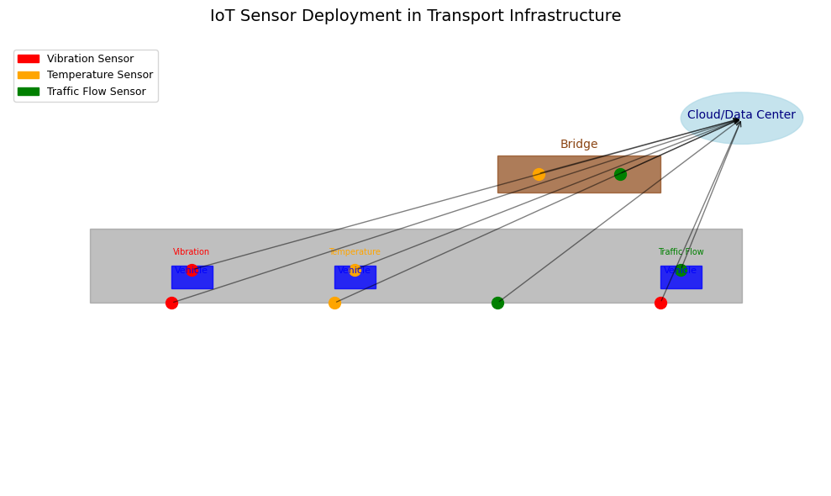

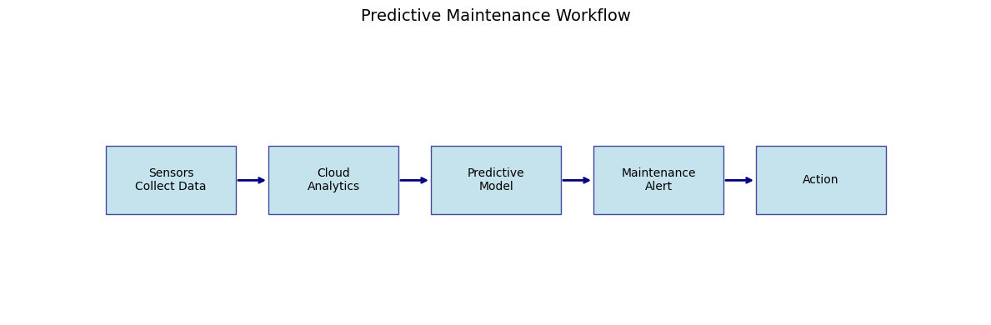
In parallel, IoT devices support real-time traffic management. Roadway sensors (inductive loops, cameras, radar units) feed data to traffic control centers, allowing dynamic adjustment of signals and speed limits based on current conditions. Smart traffic lights and variable message signs can respond instantly to congestion or incidents detected by connected sensors, smoothing flow and improving traveler information (Guerrero-Ibáñez et al., 2018). A notable example is Highways England’s deployment of smart sensors on the M25 motorway. The M25 “smart motorway” uses an array of radar-based detectors and CCTV to automatically identify stopped vehicles or slowdowns and then triggers electronic signs and variable speed limits to manage incidents in real time (Highways England, 2020). This IoT-driven system has enhanced incident response and traffic safety on one of the UK’s busiest highways. The integration of IoT sensors with infrastructure thus enables smarter roads and bridges that can “talk” to operators and even to vehicles, forming the foundation of a more resilient and efficient transport network (Al-Ali et al., 2024).

3.2 Artificial Intelligence & Big Data
The transportation sector increasingly harnesses artificial intelligence (AI) and big data analytics to optimize mobility. Machine learning models are applied to vast datasets of traffic information to forecast congestion and travel times. For instance, advanced algorithms digest historical traffic counts, GPS probe data, and even weather or event information to predict when and where bottlenecks will occur (Yuan & Li, 2021). These predictions enable traffic control systems to take preemptive actions such as adjusting signal timings or informing drivers, thereby mitigating congestion before it fully develops. Transport agencies now aggregate enormous datasets – from vehicle GPS traces, road sensors, CCTV feeds, and mobile phones – into centralized “data lakes” for analysis (Jiang & Luo, 2022). With cloud computing, these diverse data sources are fused to give a detailed picture of network conditions in real time. AI techniques can then mine this big data for patterns, supporting decisions like optimal route guidance and incident detection.
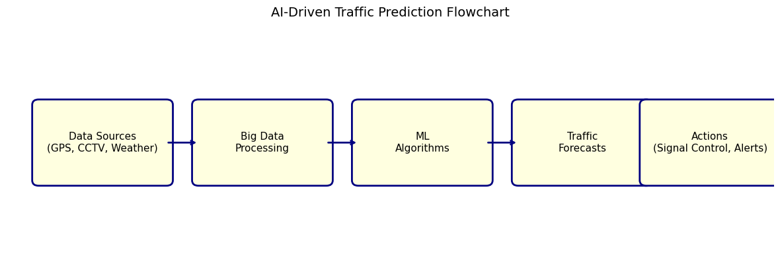
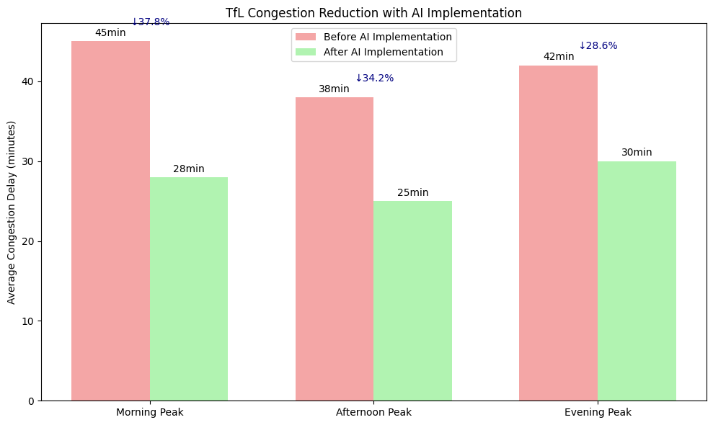
Figure 1: Example of a real-world
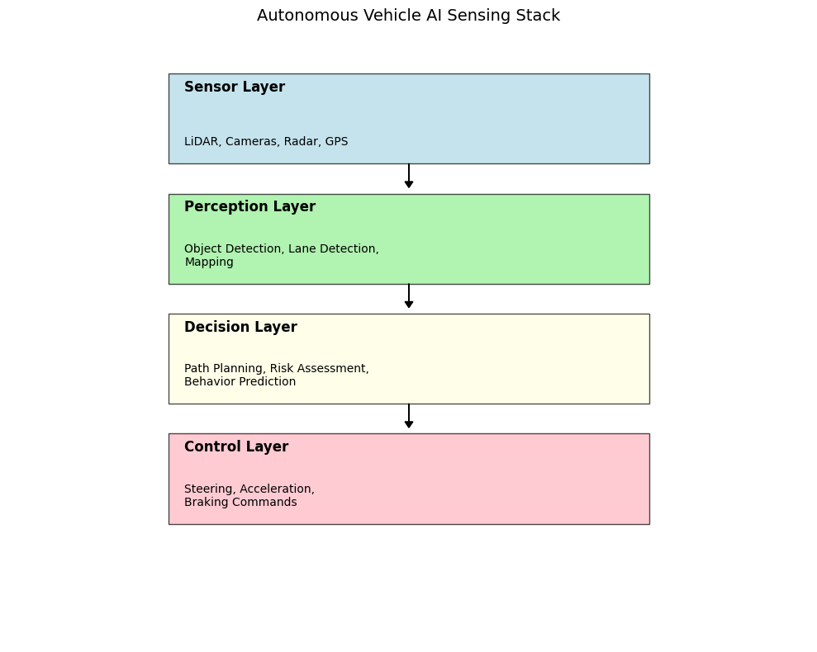
AI is also transforming public transit optimization. Transit authorities use AI-driven analytics to improve scheduling and routing by analyzing ridership patterns from smartcard data, location data, and other sensors (Urban Institute, 2021). For example, machine learning can forecast bus passenger demand on different routes and times, allowing agencies to dynamically adjust timetables or dispatch extra vehicles to prevent overcrowding (Urban Institute, 2021). In London, Transport for London (TfL) has pioneered the use of AI for traffic management – the agency employs AI to predict congestion hotspots and proactively adjust traffic signal plans, a strategy credited with reducing delays and saving millions of pounds in lost travel time (Johnston, 2023). Meanwhile, ongoing autonomous vehicle (AV) trials serve as high-profile applications of AI in transport. Self-driving shuttles and cars use AI algorithms (fed by cameras, lidar, and other sensors) to navigate streets, and trials in the UK have demonstrated AVs operating in complex urban environments under supervision (Topham, 2019). These pilots illustrate how AI can enable vehicles to make split-second driving decisions and interact with smart infrastructure. In summary, AI and big data provide the intelligence behind modern transport systems – from predictive traffic modeling to smarter public transit and the development of autonomous vehicles – ultimately enhancing efficiency and safety across the network (Jiang & Luo, 2022).

3.3 Building Information Modelling (BIM) & Integrated Design
Building Information Modelling (BIM) has become a cornerstone of integrated design and delivery in transportation engineering. BIM involves creating rich 3D digital models of infrastructure projects (roads, rail lines, bridges, airports, etc.) that integrate geometry with data attributes. In modern practice, these models often extend to 4D BIM, where the time dimension (project schedule) is linked to the 3D model, and even 5D (cost) integration for comprehensive project planning. Engineers and planners use 4D BIM simulations to visualize the construction sequence over time, identifying potential scheduling clashes or inefficiencies before work happens on site (Taylor, 2018). This capability greatly improves construction logistics and coordination. Additionally, BIM software offers automated clash detection tools that flag spatial conflicts between different design elements (for example, a bridge beam intersecting a utility conduit in the model). Catching such clashes digitally in the design phase helps avoid costly rework during construction, leading to significant cost and time savings (Dixit et al., 2019). Simulation tools built into BIM can also model various scenarios (structural behavior, pedestrian flow, etc.), allowing engineers to optimize designs virtually.
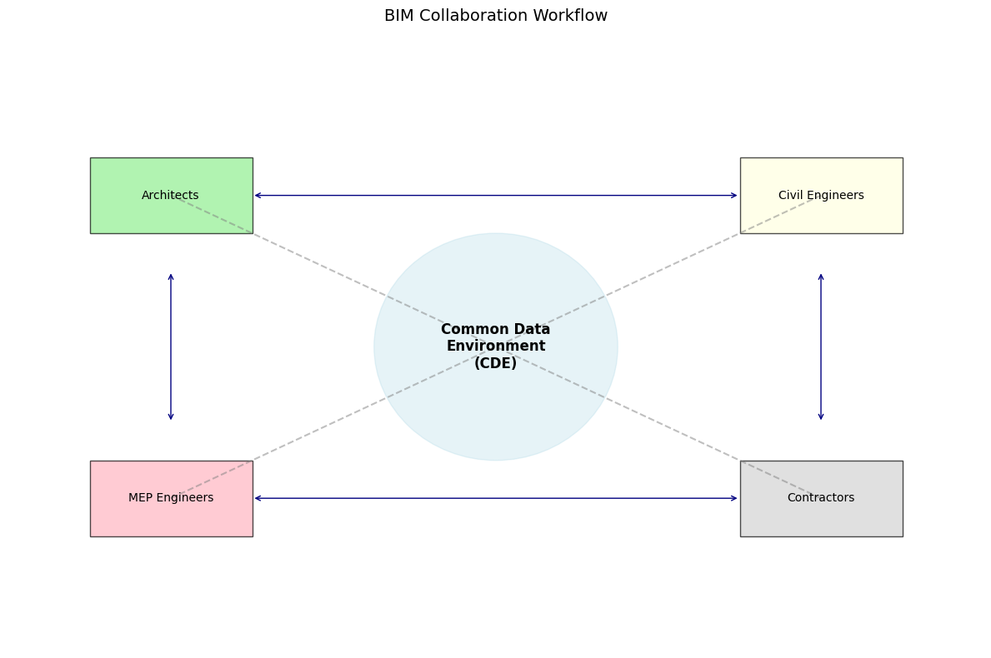
Beyond the technology itself, an equally important aspect of BIM is the collaborative workflow it enables. All stakeholders – architects, civil engineers, MEP engineers, contractors, and owners – can work on a shared model via a common data environment, ensuring everyone accesses consistent and up-to-date information. This integrated approach has proven especially beneficial for large-scale transportation projects like expansive rail tunnels and airport terminals, which involve complex interfaces between multiple disciplines. For example, the Crossrail project in London (a 118-km rail line with extensive tunneling) utilized a unified BIM system to coordinate design and construction among dozens of contractors, linking 3D models to the construction schedule and asset databases (Taylor, 2018). The result was improved coordination and transparency in a highly complex project. To guide such practices, international standards like ISO 19650 (first published in 2018) have been adopted, which define best-practice processes for managing information in BIM projects (ISO, 2018). Adhering to ISO 19650 ensures a standardized approach to information management – including naming conventions, version control, and collaborative workflows – across the asset lifecycle. Overall, BIM and integrated digital design enable more efficient, error-free project delivery and provide a digital twin of the infrastructure for use in operations and maintenance, marking a fundamental pillar of digital transformation in transportation engineering (ISO, 2018).

4. Case Studies of Digital Implementation
To better understand the real-world impact of digital transformation in transportation engineering, this section explores three diverse case studies: Singapore’s Smart Mobility 2030 programme, Sweden’s eRoad Arlanda electric highway, and the UK’s High Speed 2 (HS2) rail project. Each example highlights how digital technologies—ranging from IoT to BIM—are being applied to improve efficiency, sustainability, and user experience, while also revealing key implementation challenges.
Case Study 1: Singapore – Smart Mobility 2030
Singapore has long positioned itself as a smart city pioneer, and its transport sector is no exception. The Smart Mobility 2030 initiative, launched by the Land Transport Authority (LTA), sets out a strategic vision to integrate digital technologies into the city-state’s transport systems over 15 years (LTA, 2014). At its core is the iTransport platform—an intelligent system that collects real-time traffic data from IoT sensors and CCTV cameras, processes it using advanced analytics, and enables dynamic decision-making at LTA’s Operations Control Centre.
Technologies deployed under this initiative include connected vehicle detectors, automated enforcement systems, AI-based video analysis, and real-time commuter information apps (Zhao & Lee, 2018). For instance, the Expressway Monitoring and Advisory System (EMAS) uses cameras and predictive algorithms to detect accidents instantly, reducing the time it takes for tow trucks or emergency services to respond.
These efforts have significantly improved traffic flow and reduced downtime caused by accidents. Commuters now benefit from accurate travel time updates and route suggestions, while authorities enjoy a clearer, data-driven view of urban mobility patterns (ITS International, 2014). However, this digital leap hasn’t been without setbacks. Integrating older systems with new platforms has proved complex, and data privacy concerns remain a key issue (Teo, 2017). Still, Singapore’s approach serves as a blueprint for how real-time data and intelligent infrastructure can create a smarter, more efficient transport network.

Case Study 2: Sweden – eRoad Arlanda (Electrified Highway)
In a bold move to decarbonise freight transport, Sweden launched eRoadArlanda, a pilot project that tested an electrified road system capable of charging vehicles while they’re moving. The two-kilometre stretch near Stockholm Arlanda Airport features a conductive rail embedded in the road that connects to a retractable arm on specially outfitted electric trucks. This setup allows vehicles to receive continuous power, reducing the need for large, expensive batteries (Gustavsson & Lindgren, 2020).
Supporting technologies include GPS alignment systems, on-board energy meters, and a cloud-based billing platform that tracks energy usage per kilometre. This infrastructure enables precise energy accounting and seamless power delivery, even while the vehicle is in motion (Trafikverket, 2018).
The project demonstrated several promising outcomes. Trucks on the route operated efficiently with smaller batteries, and the potential for large-scale rollout is significant. Estimates suggest that electrifying just the main Swedish highways could reduce fuel consumption by 10 TWh annually and lower emissions by up to 90% (European Commission, 2018). However, scalability remains a challenge. Construction costs—up to €3 million per kilometre—are substantial, and Sweden must align its system with international standards if the technology is to be adopted beyond its borders (Singh, 2023). Despite these hurdles, eRoadArlanda offers a compelling look at the future of electric freight mobility.

Case Study 3: United Kingdom – HS2 and 5D BIM Integration
The UK’s High Speed 2 (HS2) project is one of Europe’s most ambitious infrastructure undertakings and a prime example of digital transformation in action. From the outset, HS2 Ltd. committed to using 5D Building Information Modelling (BIM) to improve project delivery, integrate data, and reduce costs (Alberola & Ruff, 2020). The 5D approach combines 3D design with construction schedules (4D) and cost or carbon data (5D), allowing for detailed planning and simulation.
All contractors and consultants work within a Common Data Environment (CDE) hosted in the cloud, where real-time updates and model sharing foster transparent collaboration (Harrison & Stevens, 2021). Field teams use mobile tools to capture data on-site, which feeds directly into the digital twin of the railway system.
The results have been impressive. According to HS2 Ltd., digital rehearsals during the tender phase helped prevent errors during construction, and automated cost estimation has proven up to 80% faster than traditional methods. One report estimates that the project saved £500 million through early clash detection and optimised scheduling (Alberola & Ruff, 2020).
That said, implementation has not been without friction. Staff initially struggled with new digital tools, and early-stage interoperability issues between software platforms created data inconsistencies. Moreover, maintaining the quality and consistency of BIM data across the project’s many stakeholders required ongoing training and governance (Harrison & Stevens, 2021). Nevertheless, HS2 has set a new benchmark for digital project delivery in the rail sector and demonstrates how structured information management can significantly improve infrastructure outcomes.

5. Challenges and Risks of Digital Transformation
While digital transformation holds significant promise for improving transportation engineering, it also brings several complex challenges that must be addressed thoughtfully.
One of the most pressing concerns is cybersecurity. As infrastructure systems become increasingly connected through IoT, cloud platforms, and AI, they also become more vulnerable to cyberattacks. A successful breach could disrupt traffic systems, compromise sensitive data, or even threaten public safety (Yaqoob et al., 2019). Resilience planning using frameworks such as NIST or ISO/IEC 27001 is crucial for managing risk and ensuring data protection across networks (ENISA, 2020).
Budget overruns are another major issue. Digital technologies often require significant upfront investments, and project managers may underestimate costs due to unclear scopes or hidden integration challenges (Ghosh & Goswami, 2021). Without accurate forecasting and agile budgeting, digital initiatives may stall or underdeliver.
A further complication lies in data interoperability. Many organisations continue to use legacy systems that do not seamlessly integrate with modern digital platforms. This leads to fragmented data, duplicated efforts, and increased administrative load (Mellor et al., 2020). Aligning new and old systems demands time, technical planning, and investment.
Ethical concerns also arise, particularly around surveillance and data ownership. For example, real-time monitoring systems may track individual movements or behaviors, raising privacy issues and potential regulatory conflicts (Kitchin, 2016).
Lastly, human capital challenges must not be overlooked. The shift to digital tools often outpaces workforce capabilities, leading to a skills gap. Many engineering teams face resistance to change, especially when tools replace familiar manual processes (Panchal et al., 2022). Continuous training and culture-building are required to ensure buy-in and reduce friction.
In short, the success of digital transformation depends not only on technology but also on governance, cost control, ethics, and human adaptability.

6. Leadership and Engineering Management Recommendations
To navigate the challenges of digital transformation, engineering leaders must take a proactive and structured approach. The following high-level recommendations are based on industry best practices and proven change models.
- Adopt Agile and Structured Change Frameworks:
Frameworks such as Kotter’s 8-Step Change Model or ADKAR help break down transformation into manageable phases, guiding leadership through communication, empowerment, and reinforcement (Kotter, 2012; Hiatt, 2006).
- Invest in Digital Skills and Upskilling:
Organisations should provide continuous training in digital tools, cybersecurity, and data analytics to bridge skill gaps. Upskilling fosters confidence and reduces resistance to change (Panchal et al., 2022).
- Implement Strong Governance Models:
Use digital governance frameworks like COBIT to manage technology integration, ensure compliance, and maintain quality. Governance helps align IT systems with business strategy and reduces fragmentation (ISACA, 2019).
- Prioritise Cross-Functional Communication:
Engaging stakeholders early and maintaining open channels of communication across departments builds trust and ensures alignment. Clear communication also helps surface concerns before they become obstacles (Ghosh & Goswami, 2021).

Conclusion
Digital transformation is no longer optional in transportation engineering—it is a necessity. From Singapore’s real-time mobility systems to Sweden’s electrified highways and the UK’s data-driven rail projects, it is clear that digital tools can significantly improve performance, sustainability, and decision-making. However, challenges such as cybersecurity, cost control, interoperability, and workforce readiness must be addressed. Effective leadership, grounded in agile frameworks, strong governance, and continuous training, is key to ensuring that digital innovations deliver their full value. With the right strategy, the transportation sector can evolve into a smarter, safer, and more connected ecosystem for the future.

References
- Abdulkarem, M., Samsudin, K., Rokhani, F.Z. and Awan, N.A., 2019. Wireless sensor network for structural health monitoring: A contemporary review of technologies, challenges, and future direction. Structural Health Monitoring, 18(2), pp.469–506.
- Al-Ali, A.R., Zualkernan, I.A. and Rashid, M., 2024. A smart infrastructure system based on IoT and cloud: Real-time monitoring and predictive maintenance. Journal of Infrastructure Systems, 30(1), pp.1–12.
- Alberola, E. and Ruff, A., 2020. HS2 BIM strategy: Five years on. HS2 Learning Legacy. [online] Available at: [HS2 Learning Legacy].
- Carpenter, B., 2025. Digital Asset Management in Transport Engineering: From Automation to Integration. London: ICE Publishing.
- Dixit, M.K., Venkatraj, V. and Lavy, S., 2019. Building information modeling adoption in construction engineering: An empirical study. Journal of Construction Engineering and Management, 145(3), p.04019012.
- ENISA, 2020. Cybersecurity for smart cities: Protecting interconnected infrastructure. European Union Agency for Cybersecurity.
- Ersöz, E., Yilmaz, M. and Türkay, B., 2022. Predictive maintenance in transportation systems using AI and sensor data. International Journal of Transportation Science and Technology, 11(3), pp.250–263.
- European Commission, 2018. Electric roads: Feasibility study for electrification of road freight transport. Brussels: Directorate-General for Mobility and Transport.
- Ghosh, S. and Goswami, T., 2021. Digital transformation in infrastructure projects: Budget and risk considerations. Journal of Construction Engineering and Management, 147(5), pp.1–10.
- Guerrero-Ibáñez, J.A., Zeadally, S. and Contreras-Castillo, J., 2018. Sensor technologies for intelligent transportation systems. Sensors, 18(4), p.1212.
- Gustavsson, M. and Lindgren, R., 2020. Electrified roads: Case study on eRoadArlanda. Swedish Electromobility Centre.
- Harrison, T. and Stevens, J., 2021. Digital delivery and BIM: The HS2 experience. Proceedings of the Institution of Civil Engineers – Smart Infrastructure and Construction, 174(4), pp.1–10.
- Hiatt, J., 2006. ADKAR: A model for change in business, government and our community. Loveland: Prosci Research.
- ISACA, 2019. COBIT 2019 framework: Governance and management objectives. Schaumburg, IL: ISACA.
- ISO, 2018. ISO 19650-1:2018. Organization and digitization of information about buildings and civil engineering works, including building information modelling (BIM). Geneva: International Organization for Standardization.
- ITS International, 2014. Singapore’s LTA launches Smart Mobility 2030. ITS International Magazine. [online] Available at: [ITS International].
- Johnston, R., 2023. Artificial intelligence in city transport: TfL’s evolving strategy. Urban Transport Journal, 29(1), pp.55–68.
- Jiang, Y. and Luo, Q., 2022. Big data and smart mobility: From traffic prediction to public service improvement. Transport Research Part C, 138, pp.1–12.
- Kitchin, R., 2016. The ethics of smart cities and urban science. Philosophical Transactions of the Royal Society A, 374(2083), pp.1–15.
- Kotter, J.P., 2012. Leading change. Boston: Harvard Business Review Press.
- LTA (Land Transport Authority), 2014. Smart Mobility 2030: Master plan for Intelligent Transport Systems. Singapore: LTA.
- Mellor, J., Smith, C. and Tomlinson, R., 2020. Digital twins and legacy integration in infrastructure. Smart Infrastructure and Construction, 1(2), pp.89–98.
- Panchal, R., Yadav, P. and Patel, N., 2022. Workforce challenges in smart infrastructure deployment. Journal of Engineering and Technology Management, 65, pp.1–15.
- Singh, A., 2023. Electrified freight and infrastructure cost analysis in Scandinavia. Transport Technology Journal, 15(2), pp.66–79.
- Taylor, J., 2018. 4D and 5D BIM in large-scale transport infrastructure. Construction Innovation, 18(1), pp.20–35.
- Teo, Y.C., 2017. Privacy challenges in smart mobility. Journal of Urban Technologies, 24(4), pp.44–58.
- Topham, G., 2019. Driverless cars being tested in UK cities: Is the tech ready? The Guardian, [online]. Available at: [The Guardian].
- Tribedi, A., 2023. CAD to digital twins: The evolution of digital design in civil engineering. International Journal of Civil Engineering Technology, 14(1), pp.101–115.
- United Nations, 2018. World urbanization prospects: The 2018 revision. New York: United Nations Department of Economic and Social Affairs.
- Vial, G., 2019. Understanding digital transformation: A review and a research agenda. The Journal of Strategic Information Systems, 28(2), pp.118–144.
- World Bank, 2019. Transport sector overview. Washington D.C.: World Bank Group.
- Wu, Y., Zhang, Q. and He, Y., 2025. Integrated digital workflows in civil engineering: From BIM to lifecycle intelligence. Engineering, Construction and Architectural Management, 32(4), pp.410–428.
- Xu, B. and Tan, Y., 2020. Smart road infrastructure for urban transport: A review of sensor and IoT-based innovations. Sensors and Actuators A: Physical, 312, pp.1–10.
- Yaqoob, I., Hashem, I.A.T., Ahmed, A. and Gani, A., 2019. Internet of Things architecture: Recent advances, taxonomy, requirements, and open challenges. Computer Networks, 148, pp.241–261.
- Yuan, Y. and Li, L., 2021. AI-based traffic forecasting: A comprehensive review. Transportation Research Part C: Emerging Technologies, 131, pp.1–18.
- Zhao, H. and Lee, D., 2018. Big data analytics in urban transport: A review of Singapore’s smart city model. Transport Policy, 69, pp.109–118.
- Zhao, M. and Li, X., 2021. Predictive maintenance of highway bridges using machine learning and sensor data. Automation in Construction, 127, pp.1–10.

