Party Hard
By Jacob James-Machin
ID 2304400

INTENDED PLATFORMS | - PC and consoles. For PC mainly using Steam’s digital platform due to it being better for indies [1]

TARGET AGE / DEMOGRAPHIC OF PLAYERS
- Mature target audience – adult content such as stabbing, violence, swearing, drug-taking
- Someone who enjoys games such as Hitman and retro games because the gameplay premise links to hitman the visual style is very reminiscent of retro pixel games.
- A casual game that you can dip into for shorter periods of gameplay – could suit someone who doesn’t play for extended periods at one time.
- Due to the storyline, some players may become invested in the game and feel motivated to keep playing for longer periods.
- There are also links to the horror genre (e.g. one of the main characters, Darius wears a horror-themed mask)

INTENDED PEGI / ESRB RATING
- PEGI – 18 and above [2]
- ESRB – mature, 17+ [3]

CONTRIBUTING TEAM MEMBER: | Jacob James-Machin

Max Payne inspired cover for Party Hard with Darius overlooking a neon city in a blood-soaked mask.
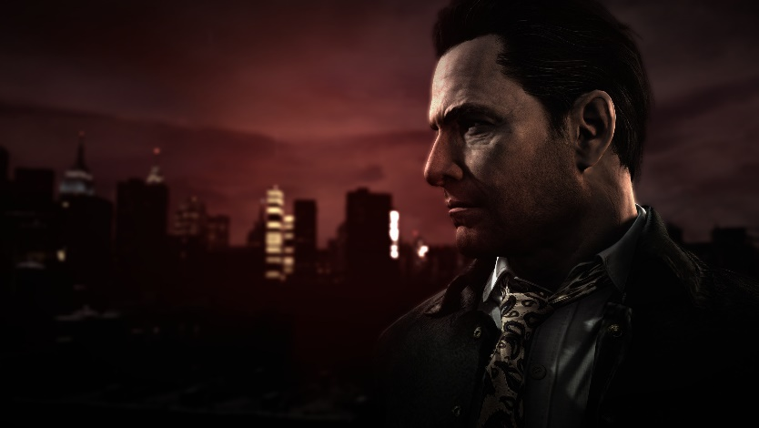
[4]

SECTION 2: GAME OUTLINE

GAME STORY SUMMARY
Taking place in the retro year of 2000. You play as a serial killer, Darius, the default protagonist who got fed up with the noise from a party next-door. His mission now is to kill every partygoer from every party in town. Each level is a different variant of a party (e.g. casino party, beach party etc). Darius kills his victims by stabbing, setting up traps, setting fire to them running them over or by getting them arrested, for example. The player can control the main character, Darius, among other characters unlocked through the gameplay.

GAME FLOW
You are a mass killer named Darius who one day got angry at the noise next door. Which lead to Darius losing his mind and vowing to end all parties from House parties to bus parties and yacht parties.

The gameplay has you finding creative, Machiavellian ways of killing the partygoers, for example.
setting a room on fire, poisoning the partygoers, using the police to take them down.
This game intends to be very violent and pretty over the top however its balanced with a serious crime drama story about a detective trying to hunt you down.

With the 12 levels having a diverse number of challenges it encourages the player to adapt and strategize.

CONTRIBUTING TEAM MEMBER: | Jacob James-Machin

SECTION 3: MAIN CHARACTER(S)
& PLAYER CONTROLS

To create a character, you must envision their personality “Iconic characters are much more than great drawings” [5]

CHARACTER APPEARANCE
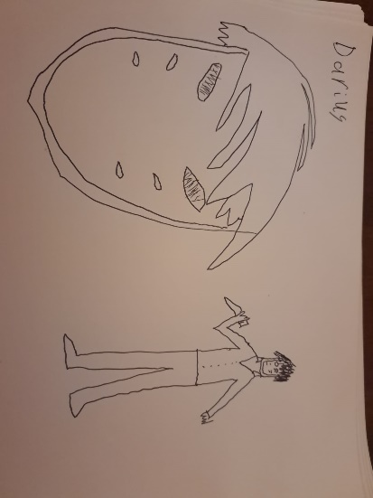

Darius [6]

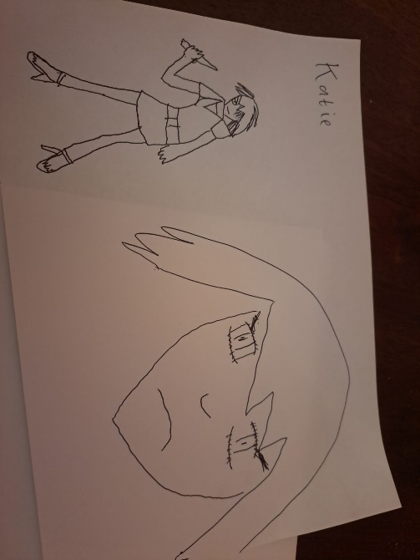

Katie [7]

John West [8]
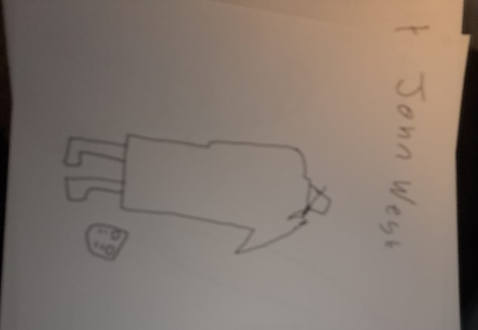
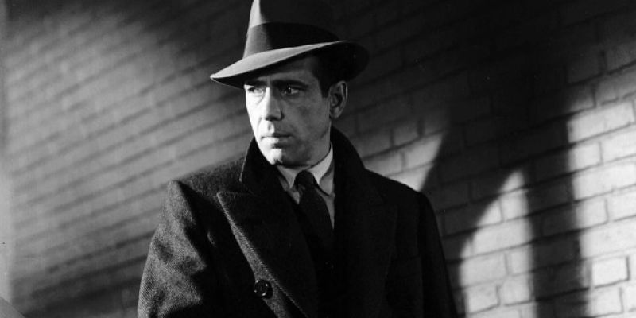

CHARACTER DOSSIER / DETAILS
NAME: | Darius
GENDER: | Male
SPECIES: | Human
AGE: | Unknown
FACTION: | Killers
KNOWN ASSOCIATES: | None – he works alone.
CHARACTER DOSSIER / DETAILS
NAME: | Katie
GENDER: | Female
SPECIES: | Human
AGE: | Early-Mid 20’s
FACTION: | Killers
KNOWN ASSOCIATES: | Darius as she looks up to him
CHARACTER DOSSIER / DETAILS
NAME: | John West
GENDER: | Male
SPECIES: | Human
AGE: | Unknown
FACTION: | Police
KNOWN ASSOCIATES: | Katie his estranged Daughter

CHARACTER’S BACKSTORY
Darius
Darius is just your everyday guy who just got completely fed up with the noise next door and now has made it his mission to end all parties. You will see him being investigated by investigator John West. Possible history of Mental Illness.
Katie
Katie is the 18–20-year-old college student of the Investigator chasing Darious John West. She admires Darius and becomes his partner in Crime.
John West
The grizzled hard-boiled detective that serves as the mediator of the plot. He is investigating Darius and vows revenge against him.

CHARACTER CONTROLS / PLAYER CONTROLS
Fairly standard control scheme. Use the joystick to move around an overhead view with button prompts that can command a specific action.
For instance, gamepad controls are Y to interact, B to pick up bodies, X to attack, R2 to run and R1 to use item.

CONTRIBUTING TEAM MEMBER: | (YOUR NAME HERE)

SECTION 4: GAMEPLAY

SEQUENCE OF PLAY
Party Hard is a level-based game where the main goal would be to eliminate a set number of party goers. Killing them all will unlock the next level and the difficulty will increase as you progress offer new sets of challenges for the player to overcome. The game will encourage players to adapt and play around with differing playstyles.

- Each level is like a story chapter as every time you complete a level you get a cut scene detailing the next part of the story or introducing a new character.
UNIQUE SELLING POINTS (USPs)
- You can add another player for cooperative play.
- Workshop support for new levels, can create your own levels.
- Offer a unique stealth gameplay that allows the player to strategize and sit back while the NPC’s interact with the world.

PLATFORM-SPECIFIC FEATURES
- Gamepad support, keyboard & mouse
- Steam will offer workshop support

CONTRIBUTING TEAM MEMBER: | Jacob James-Machin

SECTION 5: GAME WORLD

GAME WORLD
Each location in the game is based on varying part vendors considering you are playing as a mass killer going to each party to eradicate party goers it makes sense.

These vendors include:

- House Party
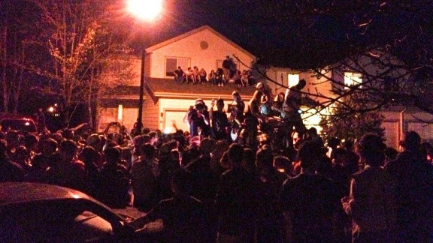
[9]

- Biker Party
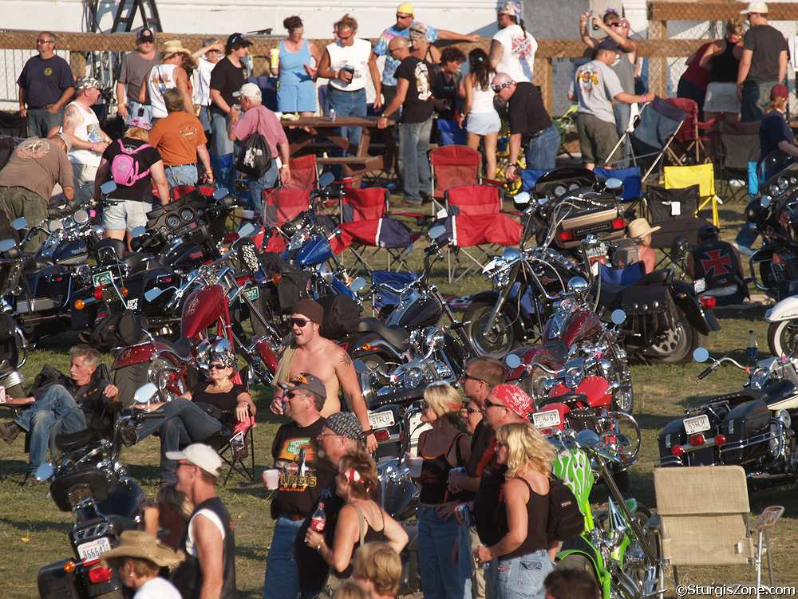

[10]

- Casino Party
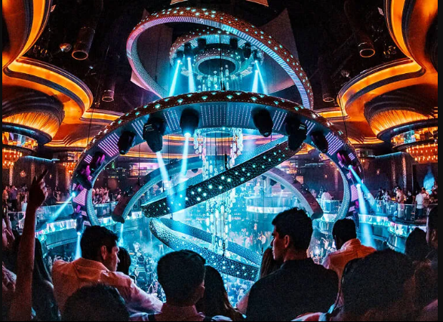

[11]

- Neon top Party
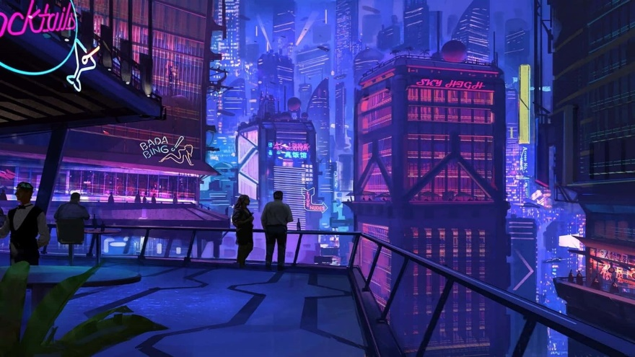

[12]

- Boat Party


[13]

- Miami Party


[14]

- Party Bus (Bonus Level)


[15]

- Open Air (Sawmill Party)


[16]

- Pool Party


[17]

- Halloween Party


[18]

- Campus Party


[19]

- Underground Party
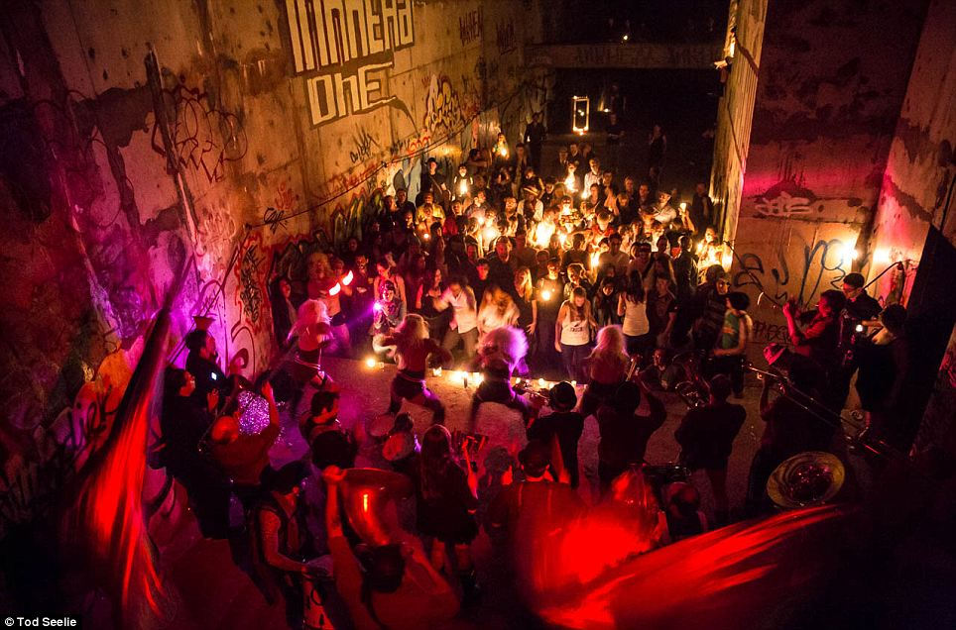

[20]

LOCATION DETAILS
NAME: | Multiple locations across the USA including California, Nevada, Arizona, Texas & Florida
WHAT DOES IT LOOK LIKE? | - Some levels are set indoors, inside the party and other parties take place outside (e.g. on a beach)  - Features and colours can depend on the party setting but there are usually flashing lights, neon lights.  - Fast-paced, busy environment with lots of people
WHAT MOOD IS BEING INVOKED IN THIS LOCATION? | - Fun, party mood to begin with a change to a more sinister mood once the killing begins in each scene – once the killing begins, the partygoers start running around and there is a sense of fear.  - So, consider it a mix of fun retro neon parties with classic thriller tropes
WHAT KIND OF MUSIC WILL BE USED FOR THIS LOCATION? | - The music has a very retro vibe to it, which also fits with the 80s  - theme.  - Use of synthesiser
HOW ARE THE LOCATIONS CONNECTED IN THE GAME WORLD? | - All party-goers must be killed in one party/level before advancing to the next  - The transition involves a cut scene at the end of one level before the next level unlocks

GAME FLOW
To map a game level out as Scott Rogers described in his Level Up book guide on great Game Design that its to imagine the game overhead map as a map of Disneyland with a series of attracts and how to attract the player to certain spots to determine what are the confines and what lives within it [21]
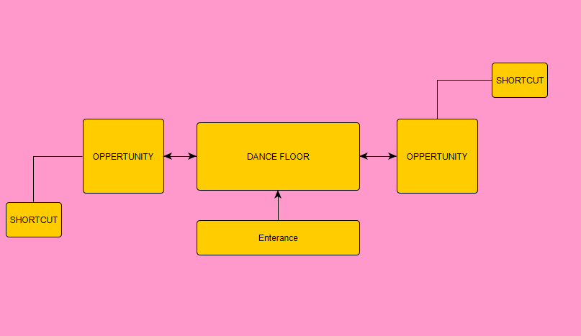

CONTRIBUTING TEAM MEMBER: | Jacob James-Machin

SECTION 6: GAME EXPERIENCE
GAME EXPERIENCE
- Humorous – all the traps you lay in the game are quite ‘over-the-top' which makes it have a comical edge.
- Thrilling – you are a serial killer, killing people through violent means.
- Action & adventure
- Retro with the stylised pixel art.

HOW IS THIS FEELING GOING TO BE PRESENTED TO THE PLAYER?
- Using visual style and music
- The thrill of trying to kill and disposing of a body through the way how NPC’s react to the player.

ARE THERE ANY SPECIAL MODES OR INTERFACES FOR GAMEPLAY?
- You can unlock bonus levels.
- There is a workshop where you can download custom levels.
- There will also be DLC.

WHAT DOES THE PLAYER FIRST SEE WHEN THEY START THE GAME?
- The player first sees the game menu.
- Game will open showing the player the overview of the level.

WHAT EMOTIONS ARE MEANT TO BE INVOKED BY THE GAME?
- Excited – an adrenaline rush
- Strategic planning – I want them to have to think about their gameplay and tactics

HOW ARE MUSIC AND SOUND GOING TO BE USED?
- Use of synths for the soundtrack and party mixes
- Sounds associated with a party, such as loud music, people having fun
- Once the killing begins, sound changes and becomes more frantic – sounds of people screaming, police sirens,

PARTY HARD MENU FLOWCHART
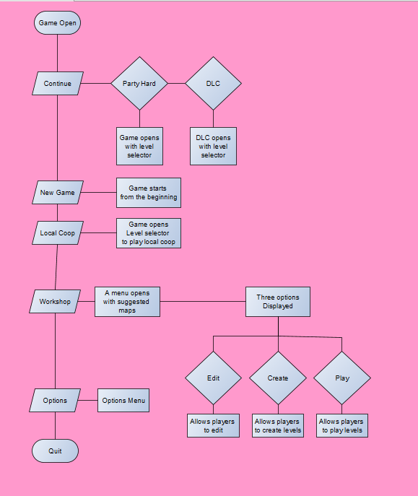

CONTRIBUTING TEAM MEMBER: | Jacob James-Machin

SECTION 7: GAMEPLAY MECHANICS

GAMEPLAY MECHANICS
Party Hard will have diverse Gameplay Mechanics

MECHANIC DETAILS
NAME: | Traps
WHAT DOES IT LOOK LIKE? | Tend to look like normal everyday objects you would typically see in a party like Kool aid, port potties, trees you can cut down on a party, explosive speakers, bear traps, petrol canisters etc.
EFFECT ON PLAYER: | They offer an alternate way to dispose the party goers without directly stabbing them. Since directly stabbing them would be risky. Since stabbing would be quick however if not done in a certain spot you will get spotted. Traps offer a way to kill party goers without being spotted.
WHEN WILL IT FEATURE IN THE GAME? | Each level contains a unique set of traps that are balanced for that area encouraging experimental ways of disposing the enemy

HAZARD DETAILS
NAME: | Some hazards in the game can vary with certain playstyles because the way you play could be a hazard. For example, if you start stabbing people randomly the police would be called and you would be “Busted” or the way you set the traps or use items if done badly could knock or even kill the player.
WHAT DOES IT LOOK LIKE? | Like the mechanics it would vary since its dependant on your playstyle
EFFECT ON PLAYER: | It can either knock the player out, get them arrested or even kill the player.
WHEN WILL IT FEATURE IN THE GAME? | Every level would contain a hazard with how you play it.

POWER-UP DETAILS
NAME: | Events
WHAT DOES IT LOOK LIKE? | Telephones that are located on poles just outside the party.
EFFECT ON PLAYER: | It will let the player phone in help that can take out the party goers quickly or increase the amount of party goers.
WHEN WILL IT FEATURE IN THE GAME? | Each level would have a level specific event while also twitch integration meaning if this game is being live streamed viewers can interact with the game.

COLLECTIBLE ITEMS
Party Hard will have collectable items in the form of briefcases which can be used as Power Ups.

COLLECTIBLE DETAILS
NAME: | Special Items
WHAT DOES IT LOOK LIKE? | Briefcases located within a singular spot on the level.
BENEFIT FOR PLAYER: | Give the player items that can help dispose of the party goers faster or escape the cops (see power up details)
WHEN WILL IT FEATURE IN THE GAME? | Each level would contain a briefcase containing a random item.
CAN IT BE USED AS CURRENCY? | These cannot be used as a currency.
WILL IT EARN PLAYERS AN ACHIEVEMENT? | Can increase a kill count combo which will give an achievement.

SECTION 8: ENEMIES

LIST OF ENEMIES
The List of enemies include:
- Cops- Can be called by the party goers if they see a dead body or see you kill someone.
- Bouncers- Located in certain levels and can chase you down to beat down however they can be avoided easily than cops.
- Zombies- Can be called by the player to eliminate party goers but they attack the player.
- Butcher he may randomly on the campus map during the make a call event and he can kill the player if not careful.
- Alien can abduct anyone including the player showing potential gameplay changes.
- Pest-Control can gas anyone including the player. Can be called in during a “make a call” event.

ENEMY DETAILS
NAME: | Cop
WHAT DOES IT LOOK LIKE? | Police Officer
ATTACKS: | Can chase and arrest the player.
WHEN WILL IT FEATURE IN THE GAME? | If a party goer spots a player committing a crime, they will be called on you. This will indicate by the icon that appears above the player.
HOW DOES THE PLAYER DEFEAT IT? | Run-away far enough they will eventually give up also if done right you can have the cop fall into your trap.
WHAT DOES THE PLAYER EARN FOR DEFEATING THEM? | Allows the player to keep going while also offering a grace period.

ENEMY DETAILS
NAME: | Bouncers
WHAT DOES IT LOOK LIKE? | Typical bouncers
ATTACKS: | Can chase and beat the player down
WHEN WILL IT FEATURE IN THE GAME? | They would appear on certain levels. Most notably the levels that are centred around exclusive clubs. They would be guarding VIP areas.
HOW DOES THE PLAYER DEFEAT IT? | They are very easy to run away from and the player can directly kill them as opposed to the cops.
WHAT DOES THE PLAYER EARN FOR DEFEATING THEM? | Can count towards the overall kill count which would complete the level.

ENEMY DETAILS
NAME: | Zombies
WHAT DOES IT LOOK LIKE? | Undead party goers
ATTACKS: | Can lunge and eat the player.
WHEN WILL IT FEATURE IN THE GAME? | They can be called in during the make a call event. Initiated by the player (see mechanics) to get rid of party goers
HOW DOES THE PLAYER DEFEAT IT? | Stabbing them or having them fall into your trap
WHAT DOES THE PLAYER EARN FOR DEFEATING THEM? | Can count towards the kill count also killing them won’t alert the party goers if they spot you.

ENEMY DETAILS
NAME: | Butcher
WHAT DOES IT LOOK LIKE? | Looks like the movie villain Leatherface. Wearing overalls and holding a chainsaw
ATTACKS: | Can target and kill the player
WHEN WILL IT FEATURE IN THE GAME? | Like the zombies he can show up during the make a call event and can kill party goers and the player
HOW DOES THE PLAYER DEFEAT IT? | Player can stabs or run away from him (ELABORATE)
WHAT DOES THE PLAYER EARN FOR DEFEATING THEM? | Allows the player to keep going while also offering a grace period.

ENEMY DETAILS
NAME: | Aliens
WHAT DOES IT LOOK LIKE? | UFO
ATTACKS: | Can abduct the player
WHEN WILL IT FEATURE IN THE GAME? | During the make a call event initiated by the player.
HOW DOES THE PLAYER DEFEAT IT? | Player cannot attack it directly but just avoid It like the cops
WHAT DOES THE PLAYER EARN FOR DEFEATING THEM? | Allows the player to keep going while also offering a grace period.

ENEMY DETAILS
NAME: | Pest Control
WHAT DOES IT LOOK LIKE? | Wears hazard gear
ATTACKS: | Can potentially gas the player killing them.
WHEN WILL IT FEATURE IN THE GAME? | If a party goer spots a player committing a crime, they will be called on you. This will indicate by the icon that appears above the player.
HOW DOES THE PLAYER DEFEAT IT? | Run away far enough they will eventually give up also if done right you can have the cop fall into your trap.
WHAT DOES THE PLAYER EARN FOR DEFEATING THEM? | Allows the player to keep going while also offering a grace period.

CONTRIBUTING TEAM MEMBER: | Jacob James-Machin

SECTION 9: CUTSCENES

CUTSCENES
The cutscenes within the game are displayed in a way that will evoke an ambience. Pretty much old detective shows with a lot of shadows being used and lighting.

CUTSCENE DETAILS
VISUAL STYLE: | Moody pixel art ambience with a voice over of the detective over scenes of the game levels
BRIEF DESCRIPTION OF SCENE: | Include a scene of the game or the aftermath of a particular event
WHEN WILL IT FEATURE IN THE GAME? | Each Time you beat a level or introduce a new character i.e. Katie.
PURPOSE: | (examples: is this scene included to introduce a new character, ability, plot point, etc.)

CONTRIBUTING TEAM MEMBER: | Jacob James-Machin

SECTION 10: BONUS MATERIALS

BONUS MATERIALS
This game will include DLC. The DLC being “DARK CASTLE” set at a party at a castle and it will have new characters and hazards to overcome.

REPLAY VALUE
To make players come back and revisit the game we let players replay their favourite levels using the different characters they would’ve unlocked throughout the course of the game and let them experiment with new and unique playstyles.

CONTRIBUTING TEAM MEMBER: | Jacob James-Machin

REFERENCES
[1] N (2020) 11 places to publish &amp; release your indie game, Ninichi. Available at: https://ninichimusic.com/blog/2017/9/1/11-places-to-publish-release-your-indie-game (Accessed: 11 December 2023).
[2] All about: Pegi age ratings (no date) Home. Available at: https://www.askaboutgames.com/pegi-age-ratings#:~:text=The%20PEGI%20system%20is%20based,is%20used%20for%20certain%20apps). (Accessed: 11 December 2023).
[3] ESRB ratings guides, categories, content descriptors (2023) ESRB Ratings. Available at: https://www.esrb.org/ratings-guide/ (Accessed: 11 December 2023).
[4] Max Payne 1 main menu in Max Payne 3 by robinolsen2011 on DeviantArt (no date) by RobinOlsen2011 on DeviantArt. Available at: https://www.deviantart.com/robinolsen2011/art/Max-Payne-1-Main-Menu-in-Max-Payne-3-611210001 (Accessed: 11 December 2023).
[5] DeGuzman, K., Kyle DeGuzman Kyle DeGuzman graduated from San Diego State University with a Bachelo and Kyle DeGuzman graduated from San Diego State University with a Bachelor of Science in Television (2023) What is character design - tips on creating iconic characters, StudioBinder. Available at: https://www.studiobinder.com/blog/what-is-character-design-definition/ (Accessed: 11 December 2023).
[6] Jasper, G. (2023) Friday the 13th: When did Jason Voorhees become the hero of his franchise?, Den of Geek. Available at: https://www.denofgeek.com/movies/friday-the-13th-when-jason-voorhees-become-hero-of-franchise/ (Accessed: 11 December 2023).
[7] Monteiro, D. (2017) Photo by Daniel Monteiro on unsplash, Woman holding her head photo – Free Girl Image on Unsplash. Available at: https://unsplash.com/photos/woman-holding-her-head-uGVqeh27EHE (Accessed: 11 December 2023).
[8] Otto&nbsp;Penzler (2018) What is a hard-boiled novel?, CrimeReads. Available at: https://crimereads.com/what-is-a-hard-boiled-novel/ (Accessed: 11 December 2023).
[9] The Rodeo·Features·June 10, 2019, Foster·Interview, T. and Round-Up, T.R. (2019) The three stages of a House Party, The Rodeo Magazine. Available at: https://therodeomag.com/2019/06/10/the-three-stages-of-house-party/ (Accessed: 11 December 2023).
[10] Large party (no date) Big Biker Party. Available at: https://sturgiszone.com/picsphotos/biker/st20071001b.html (Accessed: 11 December 2023).
[11] Dana, L., Wilkinson, J. and Medina, S. (2023) The Best Las Vegas Bachelor Party ideas, Time Out Las Vegas. Available at: https://www.timeout.com/las-vegas/things-to-do/amazing-las-vegas-bachelor-party-ideas (Accessed: 11 December 2023).
[12] Steam workshop::cyberpunk / synthwave - space station 1080p (no date) Steam Workshop::Cyberpunk / Synthwave - Space Station 1080p. Available at: https://steamcommunity.com/sharedfiles/filedetails/?id=1406075299 (Accessed: 11 December 2023).
[13] Yumpa.agency (2023) Boat parties, Summer Rockz. Available at: https://summerrockz.com/boat-parties/ (Accessed: 11 December 2023).
[14] (No date) High Temps and cool beats are guaranteed at summer splash las ... - edm.com. Available at: https://edm.com/events/summer-splash-2018-lineup (Accessed: 11 December 2023).
[15] St Louis Birthday Party Limo &amp; Party Bus Rentals (2023) A Perfect Touch Limo and Party Bus. Available at: https://www.aperfecttouchlimo.com/birthdays/ (Accessed: 11 December 2023).
[16] Barlow, P. by: B. (2023) Milling dimensions: Characteristics of portable sawmill owners and operators, Alabama Cooperative Extension System. Available at: https://www.aces.edu/blog/topics/forestry/milling-dimensions-characteristics-of-portable-sawmill-owners-and-operators/ (Accessed: 11 December 2023).
[17] Meltzer, M. (2014) These are the 10 best pool parties in the world, Thrillist. Available at: https://www.thrillist.com/travel/nation/world-s-best-pool-parties-miami-st-tropez-and-las-vegas-top-our-list (Accessed: 11 December 2023).
[18] Luna, S. (2023) 37 spooky yet simple Halloween party ideas for 2023, Classpop. Available at: https://www.classpop.com/magazine/halloween-party-ideas (Accessed: 11 December 2023).

[19] Hesch, E.F. et al. (2020) 10 ways to dramatically improve your frat party, The Odyssey Online. Available at: https://www.theodysseyonline.com/10-ways-dramatically-improve-frat-party (Accessed: 11 December 2023).
[20] Reporter, D.M. (2013) Going underground: The huge illegal party held in abandoned subway station seven stories below the streets of New York City, Daily Mail Online. Available at: https://www.dailymail.co.uk/news/article-2358630/Pictured-Illegal-party-abandoned-subway-station-seven-stories-streets-New-York-City.html (Accessed: 11 December 2023).
[21] Rogers, S. (2014) Level up!: The guide to great video game design. Hoboken: John Wiley &amp; Sons.

