

The Grand Hotel Budget Planner
Ioana Loredana Dinu
2025758
Lecturer: Dale Clarke
October 26, 2022
University of Wales Trinity Saint David

Executive Summary
Budgets outline organisational objectives, which are then used as metrics for monitoring and gauging success. Businesses need to think about the money coming in and the money going out during this time frame. A well-thought-out budget may serve as a focal point for an organisation, facilitating coordination and control. A firm's income, expenses, cash flow, and capital expenditure may all be managed with the use of a budget. By creating a budget, you may establish company-wide or team-specific financial targets. A Cash Flow Crisis may be prevented with careful budgeting.

Table of Contents
Executive Summary 1
1. Introduction 3
2. 500 words Analysis of Grand hotel budget planner 5
3. Task 2 6
3.1 Importance of budgeting 6
3.2 understanding of incremental budgeting 7
3.3 Activity based 8
3.4 Value proposition based 8
3.5 zero based budgeting 9
3.6 How budgeting control can support sustainability 9
3. Conclusion 9
4. Reference List 10
5. Appendix with Excel Budget planner…………………..……………………………………………………………………11

Introduction
According to Chartered Institute of Management Accountants (2005), budgeting refers to the act of creating and managing an estimate of financial resources (such as revenue and expenditures) for a given time frame. Budgeting is an essential skill for company owners, executives, and managers who want to make sure their companies and teams have the means to carry out their plans and achieve their objectives. The following are some basic procedures that might be taken while creating a budget: budget goals, expected revenue, and expected spending must be discussed and agreed upon before a draught budget can be created, the surplus or deficit can be calculated, and final approval must be obtained. (Davies, T. et al.,2011).

500-words analysis of Grand hotel budget planner

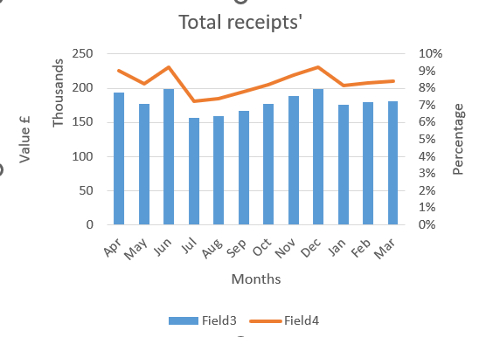

The purpose of this analysis is to evaluate and track Grand Hotel's progress. The Cash Flow forecasts from April 2022 through March 2023 are shown above. The hotel management's past performance and its projections for the future are used to create the budget, which is then created using an incremental approach. Beginning with an April 2022 carry forward balance of £13,500, Grand Hotel ended March 2023 with a carry forward balance of £707,248. Of the entire annual revenue of £2,153,130, $1,915,100 was deposited into the company account, £131,230 was earned on the positive balance, and £106,800 came from the minibar. The largest portion of the budget, £690 000, will go toward wages, followed by the restaurant budget, at £337 900. The entire budget is £1,396,180. For the year, the Net Cashflow is £756,950. Forecasts put the annual amount of the BCF at £1,527,400.
June and December are forecasted to bring in the most money, at over £198 000 each (or 8% of annual revenue). Expenses, however, are forecast to hit a peak of £125 365 in December and a low of £120 565 in February. In the absence of any unforeseen external factors, we anticipate that the firm will end the year with a positive balance and a respectable profit.

Task 2

Importance of budgeting.
To put it simply, a budget is a quantitative description of a strategy for a specified time period. That could include forecasts of resource quantities, liabilities, sales and revenue projections, expenses and costs, assets and cash flows. A well-thought-out budget may serve as a focal point for an organisation, facilitating coordination and control. (Chartered Institute of Management Accountants, 2005). Management is compelled to lay forth its plans for the future in numerical form as part of the budgeting process. It gives people and teams a standard against which they may be evaluated and rewarded. It paves the way for decentralisation of particular responsibilities and powers without compromising the access to crucial data that management needs for exercising control. The firm's income, expenses, cash flow, and capital expenditure may all be managed with the use of a budget. Cost-consciousness is encouraged. It aids in achieving the highest possible Return Of Investment (ROI). (Nugus, S., 2009). The time and work spent on creating a budget and sticking to it are well worth it in the long run. Consider these examples to see why a company budget is so crucial:
- Budgeting's major purpose is to make sure there are enough funds for an organisation to achieve its objectives. Companies may save money and allocate it more wisely to the teams and projects that need it most by doing some forward planning.
- Budgeting in advance might help anticipating other expenses if, for example, someone in the team has to recruit an additional employee to scale operations.
- It is useful for internal goal-setting and reporting. In addition to allocating funds for the next accounting period, budgeting also involves forecasting revenue needs to ensure the achievement of organisational objectives.
- Setting realistic financial objectives is critical for using those objectives to guide other parts of the budget. The goals dictate the costs involved in achieving them, and the other way around. Managers can get their teams in sync for the next stage of growth if they keep tabs on their progress, or lack thereof.
- Budgeting may open up doors for possible financial support. It is crucial to keep detailed financial records if you work for a company or want to seek outside investors. Investors place a premium on a company's historical, current, and projected financial success when making funding decisions. Some potential backers may want a copy of the existing budget in order to gauge the expected performance and choose where their money should go.
- It also allows for a flexible strategy. A budget is a set of guidelines for managing a household's financial resources over a certain time frame, outlining what percentage of income should be allocated to various categories and how much should be spent on those categories.
There are different budgeting methods placing emphasis on various elements of financial management.
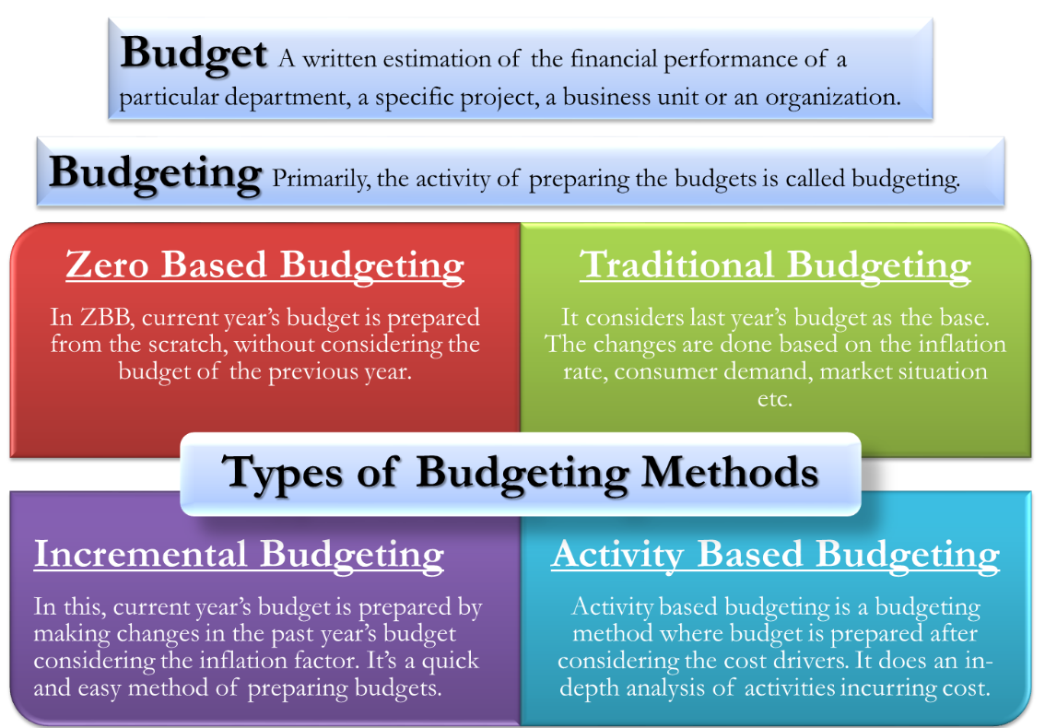
(Efinance Management, 2022)

Understanding of incremental budgeting
If a budget exists from the prior period, incremental budgeting will use that as a starting point, allowing for rapid forecasting if past performance is indicative of the current period. And it does not leave much room for investigation, especially if big shifts are on the horizon for the coming fiscal year. Incremental budgeting is a method of creating an annual spending plan by comparing the prior year's actual outcomes to a target percentage. Because of how straightforward and understandable it is, the household budget is by far the most popular. Assuming the main cost factors remain consistent from one year to the next, the incremental budgeting is a viable option. But there are issues with the method and because of this, inefficiencies are likely to persist. (Weygandt, Keiso & Kimmel, 2008).

Activity based

In order to achieve the desired outcomes, businesses often use a budgeting method called activity-based budgeting, which works from the top down to estimate how much money would be needed for various activities. In activity-based budgeting (ABB), activities are dissected in great detail in order to estimate future expenses. When developing a plan of action, activity-based budgeting does not factor in previous expenditures. In activity-based budgeting, actions are dissected in detail to estimate future expenses. (Corporate Finance Institute, 2022). The activity-based budgeting process comprises three primary actions:
- determining the factors that affect costs,
- forecasting expected output quantity,
- calculating a per-unit price estimate.
Although activity-based budgeting facilitates extensive cost driver analysis, it comes at a hefty price tag for businesses to execute. (Denise Elizabeth P, 2021).
Instead than replacing traditional budgeting methods, activity-based budgeting complements them. (Nugus, S., 2009).

Value proposition based
By analysing and justifying a company's spending habits over a specific fiscal term, value proposition budgeting (also called priority-based budgeting) helps managers make better financial decisions. Value proposition budgeting is a method for determining how much of a return on investment (ROI) a given expenditure provides for a corporation. Instead of using either zero-based budgeting or incremental budgeting, Value Proposition Budgeting finds a middle ground. Expenses may be rationalised with this strategy since it focuses on the benefits received in return. Both zero-based and incremental budgeting have their flaws, but it is possible that incremental budgeting does not look closely enough at individual line items or budget categories, while zero-based budgeting may take a look at everything too closely. (Denise Elizabeth P., 2021). For this reason, the Value Proposition Budgeting approach serves as a middle ground. Leadership teams may profit from this technique since it allows them to zero in on the most useful aspects of a firm and discard those that are not contributing anything to the overarching notion. Creates a distinct selling point for your company by highlighting the strengths that set it apart from the competition and which you may focus on throughout the following reporting period. (Corporate Finance Institute, 2022).

Zero based budgeting
The term "zero-based budgeting" indicates a method of budgeting that prioritises programme necessity and efficiency over budget history. It has attractive opportunities for lowering costs and adding value in the form of operational efficacy, making it a good fit for businesses hoping to expand by freeing up cash via better cost management. (Deloitte Department, 2015). Zero-based budgeting (ZBB) offers managers a framework for operational planning, resource allocation, and financial forecasting, but it is not without its drawbacks. Zero-based budgeting provides benefits despite any doubts about its efficacy, but it is a time-consuming approach. (Maturi, R.J., 2009). For the sake of the company as a whole, Zero-Based Budgeting mandates that every department meticulously map out their anticipated income, expenses, and capital investments. Executives tasked with preparing the budget may make better use of zero-based budgeting if they have a firm grasp on both the cost items that will be incurred and the drivers of these cost elements. When using a zero-based budgeting (ZBB) methodology, as opposed to the more conventional method, management must justify all budgeted expenditures. Clearly, running a ZBB system is more costly than running a standard system, thus a cost-benefit analysis should be performed before committing to it. (Denise Elizabeth P., 2021).

3.6 How budgeting control can support sustainability
According to the Sustainable Development Commission (2011), the expansion that satisfies the demands of the present without sacrificing upcoming peers capacity to do the same is called sustainable development. Development strategies have far-reaching consequences, individual lives will be directly affected by the choices we make as a society. The UK runs the danger of food shortages since its population depends on imports rather than domestic agriculture.) Sustainable development offers a framework for addressing the problems that impact us all and generating more equitable solutions. One way to guarantee that people in new communities have convenient access to medical care and recreational opportunities is to include health plans in their preliminary design. (Weissenberg, A., N. Redington, and D. Kutyla. 2008). Spending plans aid in both short-term and long-term objectives. By anticipating future income and expenses, the financial planner is better able to prepare for the future and attain the set goals. (Bird et al. 2007). The Cash Flow Crisis may be prevented with careful budgeting, an individual, business, or government that effectively prepares for and implements its financial strategy may avert financial crises. While there is a wealth of environmental research in the hotel industry, very little has been done to investigate whether a company's green efforts translate into improved profits, this line of inquiry was suggested by Myung, McCaren, and Li (2012). The companies in the hospitality and tourism sector have a higher average rating for environmental friendliness than those in other industries, lending credence to the idea that these businesses care about their environmental reputation as part of a larger strategy to attract customers of all stripes.

Conclusion
Budgets outline organisational objectives, which are then used as metrics for monitoring and gauging success. Businesses need to think about the money coming in and the money going out during this time frame. A well-thought-out budget may serve as a focal point for an organisation, facilitating coordination and control. A firm's income, expenses, cash flow, and capital expenditure may all be managed with the use of a budget. By creating a budget, you may establish company-wide or team-specific financial targets. A Cash Flow Crisis may be prevented with careful budgeting. Making a business choice is not something that is done on the fly, instead, it is the result of careful analysis (Miles, Covin, and Heeley 2000).

5. Reference List
- Akten, M., Giordano, M. and Scheiffele, M.A., 2009. Just-in-time budgeting for a volatile economy. McKinsey Quarterly
- Arya, A., Fellingham, J.C and Glover, J.C. (1998). Capital Budgeting: Some exceptions to the Net Present Rule, Issues in Accounting Education. Vol. 13
- Atrill, & McLaney (2002). Basic Marketing: A Global Managerial Approach. New York: McGraw-Hill.
- Bird, Ron, Anthony D. Hall, Francesco Momentè, and Francesco Reggiani. 2007. What corporate social responsibility activities are valued by the market?, Journal of Business Ethics
- Brigham, Eugene F., & Micheal, C. Ehrhardt, (2005). Financial Management: Theory and Practice. Ohio: South-Western.
- Chartered Institute of Management Accountants (CIMA) 2005, Budgeting, available at https://www.cimaglobal.com/ accessed on 18/10/2022
- Corporate Finance Institute, (2022), Budgeting and Forecasting ,available at: https://corporatefinanceinstitute.com/course/budgeting-and-forecasting-fpa/, accessed on 18/10/2022
- Corporate Finance Institute, 2022, available at: https://corporatefinanceinstitute.com/resources/knowledge/accounting/activity-based-budgeting/ accessed on 21/10/2022
- Davies, T. et al. (2011) Business accounting and finance. 1st ed. Harlow, England: Pearson.
- Deloitte Development, 2015, Perspective on considering a Zero Based Budgeting (ZBB) planning approach, Deloitte Analysis, available at: https://moodle.uwtsd.ac.uk/pluginfile.php/579373/mod_resource/content/1/Zero%20base%20budgeting-%20Deloitte.pdf, accessed 21/10/2022
- Denise Elizabeth P, 2021, Types of Budgets, available at: https://fundsnetservices.com/types-of-budgets-and-methods, accessed on 19/10/2022
- Finance management, 2022, Budget, available at: https://efinancemanagement.com/budgeting, accessed 22/10/2022
- Kavanagh Shayne, 2011, Zero-Based Budgeting- Modern Experiences and Current Perspectives, available at: http://www.gfoa.org/sites/default/files/ GFOAZeroBasedBudgeting.pdf, accessed 12/10/2022
- Marr, B. (2012). Key Performance Indicators (KPI): The 75 Measures Every Manager Needs to Know. United Kingdom: Pearson Education Limited.
- Miles, Morgan P., Jeffrey G. Covin, and Michael B. Heeley. 2000. The relationship between environmental dynamism and small firm structure, strategy, and performance. Journal of Marketing Theory and Practice
- Orlitzky, Marc, Frank L. Schmidt, and Sara L. Rynes. 2003, Corporate social and financial performance: A meta-analysis, Organization Studies
- Sloan, Philip, Willy Legrand, and Joseph S. Chen. 2013. Sustainability in the hospitality industry: Principles of sustainable operations. Oxon, UK: Routledge.
- Sustainable Development Commission (2011) Making Sustainable Lives Easier: A Priority for governments, business and society. Available at https://www.sd-commission.org.uk/pages/what-is-sustainable-development.html, accessed on 20/10/2022
- Weetman, P. (2013) Financial accounting an introduction. 6th edition. Harlow, England: Pearson.
- Weygandt, Keiso & Kimmel, (2008). Principles of Corporate Finance. Boston: McGraw-Hill/Irwin.

4.Appendix Budget Calculations

