BMSP4004
Generating Business Data and Analysis

Assignment 1
Conference Venue Database and Report

Lisa Roy 1804811
Dr Roisin Mullins
09/01/19



Contents Page

- Introduction
- Rationale for the chosen Venue
- Well-being of Future Generations Act (Wales 2015)
- The Well-Being and Future Generations Act and Celtic Manor Resort
- Roles – End User versus Database Administrator
- Planning and Analysis
- Database Design
- Implementation
- Maintenance
- Comparison between Prosumer file and Venus Database
- Appendices
- Reference page



Introduction/Executive Summary

This report is based on results found in a Microsoft Access spreadsheet created to find out information on 20 possible conference venues in Wales. It explores the reason for a choice of one of these venues as an ideal place to hold a conference for the Carmarthen Business School.
This report will explore what a database is, how it is created and why. It will show how a database stores easily accessible information needed about the chosen Venue.
The Venue which this report is based upon is “The Celtic Manor Resort” in Newport, Wales. It will explain reasons that it is a good choice and how the data is entered and stored in the database about the Resort.

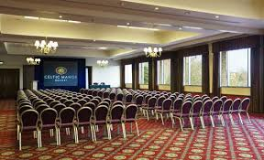(www.celtic-manor.com)

What is a database?
A Database is a collection of Data organised in a manner that allows access, retrieval and use of the Data.
A Database is a system which is Computerised for easy access to select, find and store information. A Database has many purposes for many different scenarios.

Rationale for the Chosen Location

The Assignment task was to create and produce a unique Microsoft Access Database in which 20 possible Venues and important information about those venues was to be entered. These Venues all had to be in various Counties within Wales and a variety of different types of Venues chosen. Within the Database was useful information about the Conference facilities at each particular Venue that would show whether it could be a good choice or not depending on different reasons. The https://www.celtic-manor.com/conference-eventsenue this report is based on is “Celtic Manor Resort”. It is a golf resort in Newport Wales. One such reason was as below
“Welcome to The Celtic Manor Resort, one of Europe’s finest destinations for meetings, conferences and events, voted M&IT ‘Best UK Hotel' seven times in eight years 2011 - 2014, 2016 - 2018, and C&IT ‘Top UK Conference Hotel’ for five consecutive years.
Only two hours from London and with exceptional links from all major UK cities, it is accessible, versatile and offers every possible amenity to meet the needs of companies planning events of all sizes.” (https://www.celtic-manor.com/conference-events, 2018)
This quote from the website shows that it is a good choice and the data on the Microsoft Access Database also shows it to be a very good choice.
On the Database it shows that “Celtic Manor Resort” has good transport links. It is on the M4 in Newport and there is a train station in Newport and is only 30 minutes drive from Cardiff Airport. There is ample parking, in fact 1500 bays including disabled spaces as seen on the database. The cost of parking is £15 for a whole day but the Resort offer a discount on a group booking. The resort offer 13 different conference rooms meaning that there would always be a room suitable for the amount of people to attend the conference being put on. The average room would hold around 100 people. There is a restaurant and a bar at the Resort enabling people to stay all day and be comfortable. At a cost of around £300 for a decent sized conference room that works out at £3 a head of there were 100 people attending. There is good disabled access throughout the resort making it accessible for everyone. There are rooms available overnight for those who may have to travel a fair distance as well. The resort is easily contactable by either phone or email and there is also a link to request a conference brochure on the website.

Well-Being of Future Generations Act (Wales 2015)
The Well-being of Future Generations act was created to encourage public bodies in wales to make long term decisions with thought of the impact. It wants them to work better with and alongside people, communities and each other. It aims to prevent frequent issues such as poverty, climate change and Health inequalities. This is a unique act to Wales and counties across the world have shown interest as it has a huge opportunity to make a positive long-lasting change to future generations. (http://futuregenerations.wales/about-us/future-generations-act/, 2015)
There are 7 different well-being goals within the act, The Act does make it clear that public bodies must aim to achieve all 7 of these. The 7 goals are:
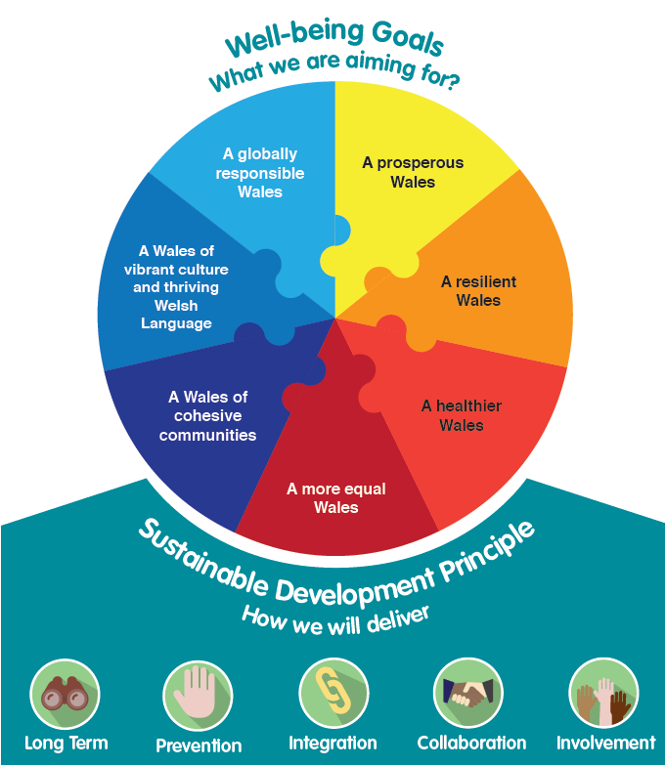 (https://www.publichealthnetwork.cymru/en/topics/policy/well-being-of-future-generations-wales-act-2015/, 2015)

The Well-Being and Future Generations Act and Celtic Manor Resort
The Well-being of Future Generations (Wales) Act is about improving the social, economic, environmental and cultural well-being of Wales through sustainable development. (https://www.monmouthshire.gov.uk/the-well-being-of-future-generations-act, 2018)

The Celtic Manor Resort in Newport is aiming towards these 7 goals. An example of how they are aiming for 2 of these are below:


A Healthier Wales
“A society in which people’s physical and mental well-being is maximised and in which choices and behaviour that benefit future health are understood” (https://futuregenerations.wales/aotp/health/, 2018)
The resort is doing well towards this of the 7 goals as the resort is a golf club with a number of golf courses for all levels of players from beginners to pro players. Guests are encouraged to engage in the sport whether young or old and enjoy participating in it with new people they may have not met before.
The Resort also offer spa breaks and have a fully stocked gym and swimming pool on the site. This allows partners or friends of the golfers to participate in a sport as well if they aren’t interested in Golf.


A Wales of Cohesive Communities
“Attractive, viable, safe and well-connected communities” (https://futuregenerations.wales/aotp/health/, 2018)
“Celtic Manor Resort” offers Golfing holidays and spa breaks for all. There are no age, race, sex, disability or cultural restrictions at all and everyone regardless of these things are encouraged to participate in the sports as well as dine together and meet in the bar in the evenings.

Roles – End User versus Database Administrator

Database design is not just about storing the data but finding a way to get the information out of the database to support decision making by key employees within the business or organisation.

The Database administrator will:

- Physically design the database
- Ensure recovery mechanisms and perform back-ups
- Ensure Access and security of the database
- Monitor the usage of the database
- Monitor the performance of the database
- Acquire any resources needed to complete it
- Solve any problems affectively
- offer training and technical support
The designer of the database will follow these 5 steps: Planning, Analysis, Conceptual Design, Implementation, and maintenance. These things may not necessarily always be in the same order as in designing a database there may be times the design needs editing as it is being created. For example, a new field may need entering that wasn’t previously on there so will need editing therefore going back a step before the data is input into the database.

The database End User will:

- Take the completed database and rename it
- Enter the data that is needed for their organisation
- Create the relationships for the database according to what they need to be joined together
- Create forms
- Customise any readymade forms for their organisation
The end user of a database will take a ready made purposely designed database and make it their own. Edit any fields and tables to the primary keys and the fields that they require the data for. They will enter the data that is required and fill in all the database as best they can.
The difference between the two is that one creates, and one uses the database.

Planning and Analysis

Planning to design a database is very important. Just simply putting data on a piece of paper provides little value. The end goal of any database is not just the data storage but being able to extract the information to support any decision making that may be needed. Database design should be the foundation of a successful information system. The database should promote data integrity and prevent any data redundancies and data anomalies. A database must be efficient in the provision of data access and serve the need of the organisation within the information system.
In Database design there should be a clear storage structure, be able to easily input data into the database and be able to be modified and backed up if necessary. Any problems or anomalies should be identified as soon as possible as these can stop the whole database from working.
In Analysing the database design, the following questions should be asked…
- What is the organisations environment and mission?
- What Is the organisations structure?
Planning and Analysing the database requires the designer to find out the following information:
- What kind of information is needed?
- What queries and reports will the system need to generate?
- Who will use the information?
- How will the information be used?
- Where will the information be found?
- How will they extract the information?
- What data elements are needed?
- What data attributes are needed?
- What relationships are needed?
All of these questions will need answering to build a successful database with all the correct information on it that the organisation can use and find easily.
(https://knowhow.ncvo.org.uk/how-to/planning-a-good-database, n.d.)

Database Design

The 20 Venus Database needed planning to achieve the must functionable design. In it the Database has Tables, Forms and queries, all of which make the data stored within it very retrievable.
Firstly, the Table needed creating. The way this was done was as follows.
First click on the “Create” Tab at the top of the screen, Select Table, press OK and a new table will appear on the database. Give the table a name so that its easier to find the Data in the correct table at a later date. This is done in “Design View”
The Tables in the Database for the 20 venues were named
- County
- Town
- Venue
Once the table was named then it is needed to add in the different Fields across the top where on Fig.1 it is written County Code, County name and so on. This is done by clicking onto View then to Design View
Appendix 1 is an example of the County Table filled in.

Once the field name is filled in then the data type needs filling in. There is a drop-down menu in the box for this. The correct type needs choosing for example of it was a code then you would choose “Short Text, for a phone number then “Number” needs selecting and for a website then “Hyperlink” needs to be selected. This database required a lot of different types of Data to be input. At the bottom there is a box called General and Lookup. The field size needs to be altered depending on the size of the data that is going to be put into the cell. For example, a phone number is around 11 numbers, so you would type in maybe 12. If an address needs entering, then that’s going to need more characters. In the look up box you can alter things such as the width of the columns and rows and if it is a combo box or not.
You can select a primary key from the list of fields. This is done by going into design view and clicking next to the field you would like to use and then selecting Primary key from the drop-down menu. The primary key is the most important bit of data on the table.
To enter the Data into the tables that have been created then Select one of the tables from the left-hand side of the database and click on “Open”. The table appears in a Datasheet view and then the Data can be entered in the correct fields. Each time a Data entry is finished then press enter to move onto the next one or even tab to move across the page. Each time a table is completed then click on the tab for the table and click “Save” and then “Close” before moving onto the next table.
Appendix 2 shows how to save and close the table after filling

To create a relationship

To create a relationship between the tables on the database then the instructions are as follows:
Select relationship from Database tools. Select the Show Table option from the relationship menu. Select the tables from the database and click add on them which need the relationship formed and them boxes will appear on the screen.
Select from the first box the entity that needs a relationship and drag it to the same one on the second box. A box will appear on the screen then with these written in it, Click the box that says Enforce Referential Integrity, then select one to many or one to one on it and click create. Then a line will appear between the 2 or 3 boxes that you selected showing the relationship between them. A one to many relationship means that the first one has 2 or more of the same field in other tables and an one to one relationship means that it is just 2 that have the same.
Appendix 3 shows relationships created on the Database.

To Create a Query

To create a query then click on Create and then onto query design. A tab called Query one will appear. Then the table that you wish to use for the query needs to be selected from the list that is on the page now. Select more than one of needed then click on Add. Next close that box down. Next drag down the fields that you wish to sort into the boxes below. Then click on Sort and there is a drop-down menu there. Its possible to have either descending or ascending. Choose one for each field that has been chosen. Then click Run and save the query.
Appendix 4 shows a query on the database sorted into ascending order.

Implementation
The Implementation is which software that the database is stored on. It is about creating the database and also making sure that the Database runs correctly. (www.google.co.uk/implementation n.d.)
This database is made with Microsoft Access. Microsoft Access allows data to be stored in tables, forms, to run a query to create relationships and is easy to find the information which has been entered. This would be very good for a business to use as all of the information is well laid out and designed for the user.

Maintenance
Maintenance of the database is key to it working well. The term is used to describe a set of tasks used to improve a database. (https://www.officetools.com/knowledgebase/database-maintenance-explained/, 2014)
The Database will require regular maintenance and checks to ensure it is running correctly. Also, there is a chance that additional information may be needed to be added to the database. Maybe the venues will add information that is useful so needs adding onto the tables. Maybe a venue will change a phone number or price and need to be amended. The Database needs to be checked over regularly to ensure that all relevant data is always up to date.

Comparison between Venue Database and Prosumer Database

The Prosumer database was created in Microsoft Excel. This database was already designed with all the required fields entered already. The Venue database was in Microsoft Access. This database needed designing. It was designed and created from scratch in a way that the information that was put into it was a custom design. It enabled us to put in which data we thought would be the most important and the most useful in order to decide which venue would be the best choice for a conference in Wales. There are various similarities between the two databases such as the fact that there are lots of data all In columns that is all easy to find and see. The data is easy to edit and move around. There are also differences between the two database programmes. In Microsoft Access the list of tables and forms show in a lost on the left-hand side and on excel they are at the bottom of the screen. In Access it is possible to create a query very easily, within excel there are not these same options. In Appendix 5 it shows the prosumer database. If you put a large quantity of information into it then the row automatically expands to incorporate all of the data whereas in Microsoft access you have to alter the amount of characters you can enter into a cell.
The Prosumer database being created and requiring the data input only meant that we were the “End users” of the database whereas the Venues Database made us the Database administer.

Appendices
Appendix 1
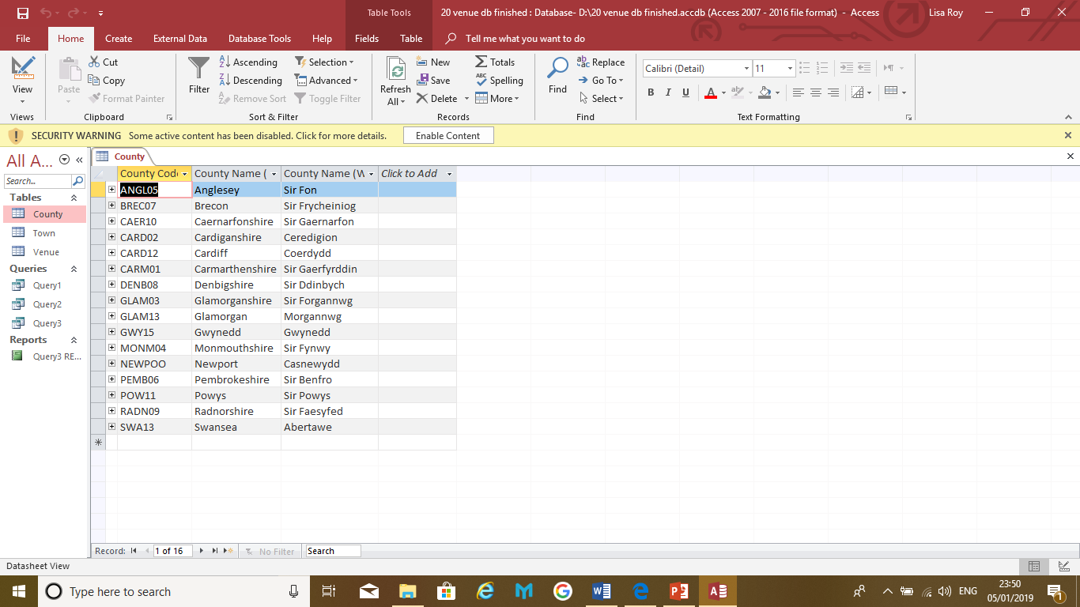

Appendix 2
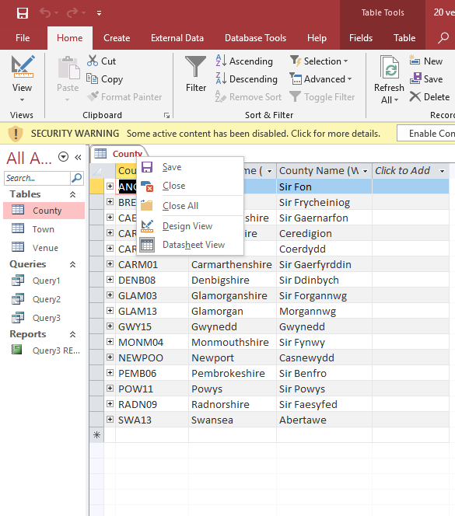

Appendix 3
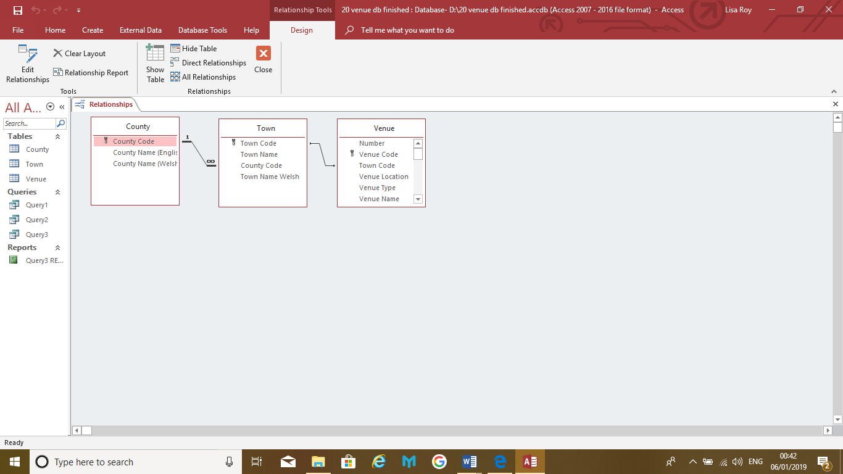

Appendix 4
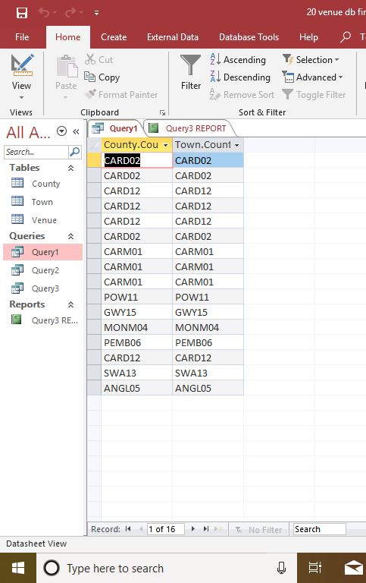

Appendix 5
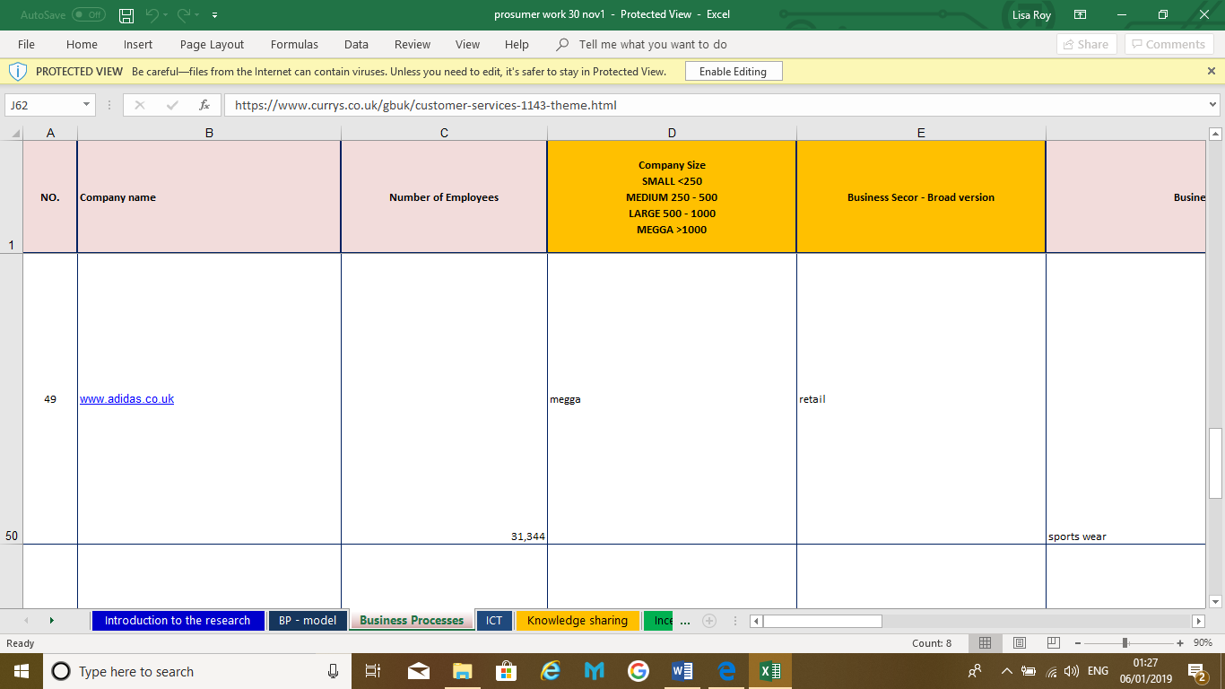

References

Works Cited
(n.d.).
(2018). Retrieved from www.celtic-manor.com.
(2018). Retrieved from https://futuregenerations.wales/aotp/health/.
http://futuregenerations.wales/about-us/future-generations-act/. (2015). Retrieved from FUTUREGENERATIONS.WALES.
https://knowhow.ncvo.org.uk/how-to/planning-a-good-database. (n.d.). Retrieved from knowhow.ncvo.org.uk.
https://raima.com/database-terminology/. (2018). Retrieved from https://raima.com/database-terminology/.
https://www.bbc.com/bitesize/articles/z8yk87h. (2018). Retrieved from www.bbc.com.
https://www.celtic-manor.com/conference-events. (2018). Retrieved from www.celtic-manor.com.
https://www.google.co.uk/url?sa=t&rct=j&q=&esrc=s&source=web&cd=2&cad=rja&uact=8&ved=2ahUKEwiehvbO-tffAhUHmBQKHcVzC4cQFjABegQIBhAE&url=https%3A%2F%2Fmariadb.com%2Fkb%2Fen%2Flibrary%2Fdatabase-design-phase-3-implementation%2F&usg=AOvVaw339wDFtxryXSv4Xs4F7i. (n.d.).
https://www.monmouthshire.gov.uk/the-well-being-of-future-generations-act. (2018, september 20). Retrieved from www.monmouthshire.gov.uk.
https://www.officetools.com/knowledgebase/database-maintenance-explained/. (2014). Retrieved from www.officetools.com.
https://www.publichealthnetwork.cymru/en/topics/policy/well-being-of-future-generations-wales-act-2015/. (2015). Retrieved from WWW.PUBLICHEALTHNETWORK.CYMRU.
https://www.visual-paradigm.com/solution/dbdesign/best-er-diagram-tool/?gclid=EAIaIQobChMI9-CouKzQ3wIVVPhRCh1x1QRlEAAYASAAEgL8-fD_BwE. (n.d.). Retrieved from www.visual-paradigm.com.

