Student Name | Hollie Willmott
Student Number | 2434208
Module Number | BMSK4014
Module Title | Problem Solving And Decision Making

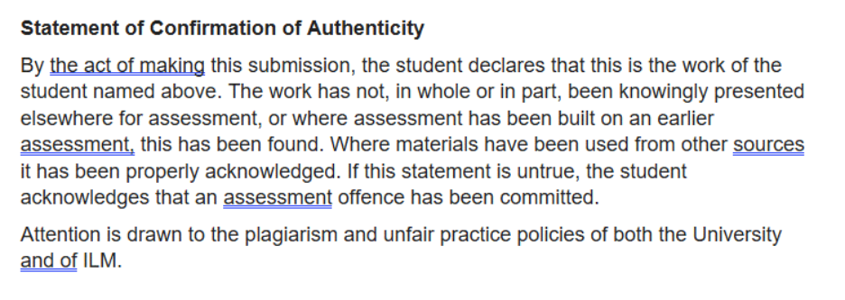

Table Of Contents

Define a Complex Problem in the Workplace, Including its Scope and Impact 2
Analyse Information on the Identified Problem, to Help Inform the Decision-Making Process 3
Propose a Range of Alternative Solutions to the Problem 6
Using a Decision-Making Technique, evaluate a Range of Solutions to Identify the Most Appropriate Option 8
Develop a Detailed Plan for Implementing the Solution 10
Communicate the Plan to Relevant Stakeholders 12
Assess Appropriate Monitoring and Review Techniques to Ensure Successful Implementation of Solution 13
References 15

Define a Complex Problem in the Workplace, Including its Scope and Impact
Effective communication is important within customer service because advisers need correct and current information when responding to customers. Effective internal communication can also support employees’ understanding of organisational information and expectations (CIPD, 2025). The complex problem found within the Maximus customer service department is inconsistent communication and difficulty accessing up-to-date process information.
Customer Service Advisers receive information through different channels, including emails, team messages, meetings, and verbal updates. When processes change, advisers may therefore find it difficult to find the most current guidance. Employees who are absent, on annual leave, or dealing with customers when an update is communicated may also miss valuable information.
Although the issue mainly involves communication, several different factors contribute to it. Information is shared in different ways, employees have different workloads and some updates can be missed because of absence or leave. This means that improving one area alone may not completely solve the problem. The problem affects Customer Service Advisers, Team Managers, customers, and the wider organisation. Complex problems require consideration of different stakeholders and practical solutions before the most appropriate response is selected (Dorner & Funke, 2017).
The impact can extend beyond internal communication. If advisers cannot quickly find current guidance, they may need to ask colleagues or managers for clarification, increasing the time required to deal with an enquiry. Customers could also receive inconsistent information, potentially contributing to repeat contact, complaints, or reduced satisfaction. Advisers may experience reduced confidence if they are uncertain whether the information they are using is current.
However, improving communication involves competing priorities. More meetings could improve understanding but reduce the time advisers are available to support customers. Training could improve knowledge but requires staff time and resources, while introducing modern technology could involve added costs. Continuing to rely on existing emails and messages would be inexpensive but may not address the underlying problem.
This report will focus only on communication within the Maximus customer service department. It will look at how advisers receive and access process information rather than wider communication issues across the organisation.

Analyse Information on the Identified Problem, to Help Inform the Decision-Making Process

To find an appropriate way of improving communication, it is important to look at why advisers sometimes miss updates or have difficulty finding the latest guidance. Choosing a solution without exploring these issues could mean that only part of the problem is addressed. Different problem-solving techniques can help identify possible causes and show how they are connected (Tague, 2005). Brainstorming, mind mapping, fishbone analysis and the 5 whys were therefore used to examine the problem from different perspectives.

Brainstorming
Brainstorming was used to find probable causes from an employee and management perspective. The key issues found were:
- Information is being communicated through several channels.
- Important emails or messages are missed.
- Limited time to read updates during busy periods.
- Verbal updates are not always being recorded.
- Different managers communicate information differently.
- Employees are missing updates because of absence or annual leave.
- Difficulty finding the most recent process guidance.
- Employees relying on colleagues for information.

The advantage of brainstorming is that advisers and managers can contribute examples based on their own experience of receiving workplace updates. This may highlight everyday problems that are not immediately obvious when looking at the communication process. A limitation is that employees may have different opinions about what causes the problem, and more confident members of the group may influence the discussion. For this reason, the ideas identified through brainstorming should be explored further using other problem-solving techniques.

Mind Mapping
A mind map was used to group the identified causes into five themes: people, communication, management, technology, and workload.
People-related issues included various levels of experience and employees missing updates. Communication issues included information being shared through several channels. Management factors included differences in how updates are communicated. Technology related to information being stored in various locations, while workload reflected the limited time advisers may have to review guidance while responding to customers.
The mind map shows that the problem cannot simply be blamed on advisers not reading information. For example, an employee may miss an update because they are dealing with customers rather than because they are unwilling to remain informed. This distinction is important because a solution focused only on employee behaviour would not address problems with how information is organised.
Fishbone Analysis
A Fishbone analysis was then used to examine the root causes in more detail (Ishikawa, 1986).

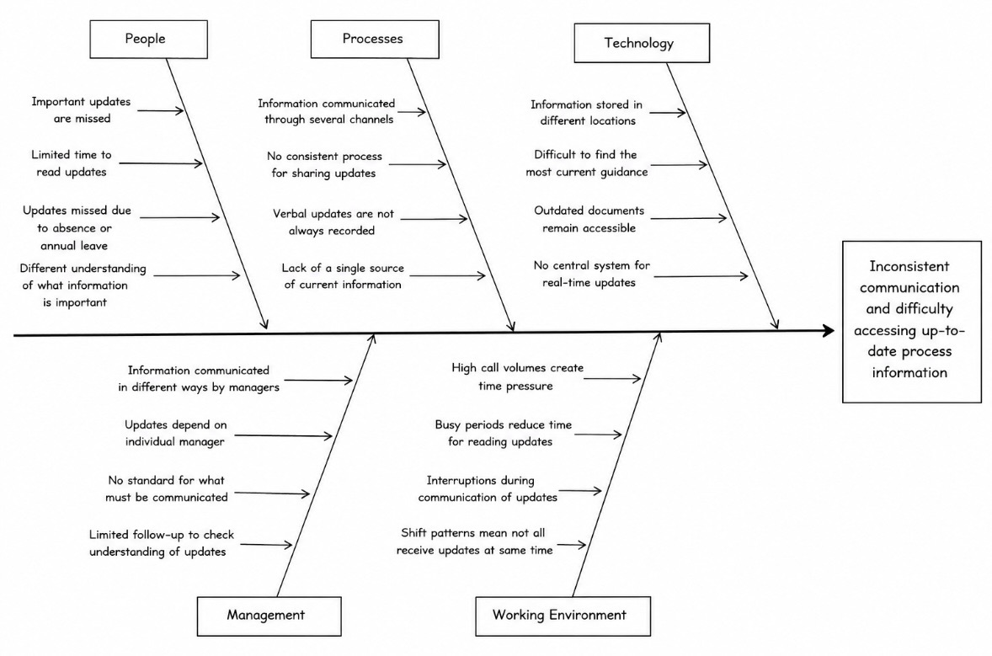

People: Advisers have various levels of knowledge and experience, while absence can result in updates being missed.
Processes: Significant changes may be communicated in separate ways, and there may be no consistent procedure for recording updates.
Technology: Guidance may be stored across various locations, increasing the time required to find the correct information.
Management: Managers may use different approaches when communicating changes, resulting in variation between teams.
Working environment: Customer demand means advisers must balance reading internal information with responding to customers.
Looking at the categories together shows that one issue can make another more difficult. For example, several communication channels may be available but this does not necessarily help if advisers have limited time to check them while dealing with customers. Managers may also communicate an update clearly, but its value is reduced if employees cannot easily locate the information afterwards. The fishbone analysis therefore highlights the need to improve both how information is communicated and how employees access it.

5 Whys Analysis
The 5 Whys technique was used to explore why customers may receive inconsistent information (Serrat, 2017).
1: Why might customers receive different information?
Because advisers may have different knowledge of current processes.
2: Why might advisers have different knowledge?
Because updates can be communicated through different channels.
3: Why does this create inconsistency?
Because employees may miss an update or have difficulty finding it later.
4: Why is information difficult to locate?
Because guidance may be spread across emails, messages, and other documents.
5: Why does this continue?
Because there may be insufficient centralisation and standardisation of important process information.
The 5 Whys therefore suggests that a key root cause is the absence of one clear location where advisers can confirm current guidance. However, this should not be considered the only cause. A central information source would still require regular updating, employee engagement, and sufficient time for advisers to use it.

Findings
Overall, the analysis finds multiple communication channels, difficulty finding current information, workload pressures, and inconsistent communication practices as the main causes.
There are also competing priorities. More meetings could improve understanding but reduce customer-facing time, while added training could improve knowledge without solving the problem of future updates. Therefore, simply increasing the amount of communication is unlikely to provide a sustainable solution.
The findings suggest that the preferred solution should improve the accessibility, consistency, and reliability of information without creating a significant added workload. Potential solutions include an essential information hub, short team updates, standard process guides, refresher training, and a standard communication procedure. These options will require further evaluation before the most appropriate solution is selected.

Propose a Range of Alternative Solutions to the Problem
The earlier analysis identified several areas where the communication process could be improved. Based on these findings, five possible solutions have been considered. The options focus on different parts of the problem, including where information is stored, how updates are communicated and how advisers maintain their knowledge. Each option also has practical advantages and disadvantages that need to be considered before a final decision is made.

1 – Central Information Hub: An essential information hub could provide one location for current process guidance and important updates. This would reduce the need for advisers to search through emails or messages and directly address the difficulty of finding current information. However, the hub would require staff time to set up regular maintenance to prevent information from becoming outdated.
2 – Short Weekly Team Updates: Managers could provide brief weekly updates covering important process changes and allowing advisers to ask questions. This would support two-way communication and would be inexpensive. However, meetings reduce customer-facing time, employees may be absent, and information may still be difficult to find afterwards.
3 – Standard Process Guides: Short guides provide clear instructions for common processes. This may increase consistency and support less experienced advisers. However, creating and regularly updating multiple guides would require staff resources, and too many documents could make information more difficult to manage.
4 – Refresher Training: Regular training could improve advisers’ knowledge and confidence, particularly where processes commonly cause confusion. However, training requires employees to spend time away from customer-facing duties and only reflects guidance available at the time. Further training would be needed when processes change.
5 – Standard Communication Procedure: A standard procedure could provide guidance on how major changes should be communicated and who handles recording them. This could reduce differences between teams and would be inexpensive. However, its effectiveness would depend on managers and employees consistently following the agreed procedure.
The options show that the problem could be approached in several ways rather than relying on one obvious answer. The central information hub appears particularly relevant because it responds directly to the difficulty advisers experience when trying to locate current guidance. A standard communication procedure could also help by creating clearer expectations about how important updates are shared and recorded. However, the most obvious solution may not necessarily be the most practical one when cost, staff time, ease of implementation and long-term use are considered. The five options will therefore be assessed against the same criteria to determine which provides the strongest overall response to the problem.

Using a Decision-Making Technique, evaluate a Range of Solutions to Identify the Most Appropriate Option
Grid analysis was used to compare the five solutions against effectiveness,sustainability, cost, ease of implementation and staff time (Robbins & coulter, 2021 ). Each option was scored from 1 (poor) to 5 (very good) , with higher weightings given to the most important criteria.

Solution | Effectiveness ×5 | Sustainability ×5 | Cost ×4 | Ease ×4 | Staff Time ×3 | Total
Central information hub | 25 | 25 | 16 | 16 | 12 | 94
Weekly team updates | 20 | 15 | 20 | 16 | 9 | 80
Standard process guides | 20 | 20 | 16 | 16 | 9 | 81
Refresher training | 20 | 15 | 12 | 12 | 6 | 65
Standard communication procedure | 20 | 20 | 20 | 20 | 12 | 92

The central information hub achieved the highest score of 94, followed by the standard communication procedure at 92. The hub scored highly because it directly addresses the difficulty advisers experience when finding current information. However, the scores involve judgement and different weightings could change the result. The matrix should therefore support rather than replace management judgement.
Cost-Benefit Analysis
A cost-benefit analysis was used to compare the estimated first year cost of the information hub with its potential benefits. As actual Maximus financial information is unavailable, the figures are estimates and would need to be checked before a real workplace decision.

Estimated Year 1 Costs | £
Staff time to develop and organise the hub | 1,500
Management time reviewing information | 1,000
Staff briefing/familiarisation | 750
Ongoing review and maintenance | 1,250
Total | 4,500

Estimated Year 1 Benefits | £
Reduced adviser time searching for guidance | 5,000
Reduced management time answering repeated queries | 3,000
Reduced repeat work/customer contact | 4,000
Improved efficiency | 3,000
Total | 15,000

The workbook calculates the Benefit-to-Cost Ratio by dividing total benefits by total costs.
Benefit-to-Cost Ratio = £15,000 ÷ £4,500 = 3.33:1
Net Annual Benefit = £15,000 − £4,500 = £10,500
On these assumptions, the solution could therefore generate approximately £3.33 of benefit for every £1 spent. However, benefits such as reduced search time do not necessarily represent direct cash savings, so these estimates should be treated cautiously.
Overall, the central information hub is the preferred solution, supported by a standard communication procedure. Together, these address both where advisers access current guidance and how new information is communicated.

Develop a Detailed Plan for Implementing the Solution
The central information hub, supported by a standard communication procedure, will be introduced over three months. The phased approach will allow staff consultation, development, testing and review while limiting disruption to customer service (Kotter, 2012).

Implementation Action Plan

Action | Responsibility | Timescale | Success Indicator
Discuss proposal and gain approval | Team Manager/Senior management | Week 1 | Approval obtained
Gather adviser feedback | Manager/Advisers | Weeks 1–2 | Feedback collected
Review current guidance | Manager/Selected staff | Weeks 2–3 | Outdated/duplicate information identified
Develop and organise information hub | Manager/Support staff | Weeks 3–5 | Current guidance available centrally
Develop standard communication procedure | Management | Week 5 | Procedure agreed
Pilot with selected advisers | Manager/Advisers | Week 6 | Feedback received
Make changes following pilot | Manager/Support staff | Week 7 | Identified issues addressed
Brief employees | Team Managers | Week 8 | Advisers understand new process
Full implementation | Management | Week 9 | Hub accessible to relevant staff
Monitor and evaluate | Managers/Advisers | Weeks 10–12 | Initial results reviewed

Advisers should be involved in developing and testing the hub because they regularly use process information and can identify practical problems. Employee involvement can also support workplace change (HSE, 2025). Existing approved technology should be used where possible to reduce costs and training requirements.
Current guidance should be reviewed before being added to the hub so outdated or duplicate information is removed. Responsibility should also be assigned for keeping the information current. Feedback from the pilot will be used to make any necessary changes before full implementation.

Communicate the Plan to Relevant Stakeholders
Communication will be needed throughout implementation because each stakeholder has a different role. Customer service advisers need to understand how to use the hub and provide feedback, while team managers will oversee the change. Senior management will need information about costs and results, and IT support staff may assist with technical requirements (Robbins & Judge,2023).
Stakeholder Communication Plan

Stakeholder | Information Required | Method | When | Responsibility
Customer Service Advisers | Purpose, use of hub and feedback process | Team briefing/written guidance | Before pilot and launch | Team Manager
Team Managers | Responsibilities and progress | Meetings/email | Throughout | Project lead
Senior Management | Costs, benefits and results | Report/meeting | Start and review stage | Project lead
IT/Support Staff | Access and technical requirements | Email/meeting | Development and testing | Manager
Pilot Advisers | Testing and feedback requirements | Briefing/feedback form | Pilot stage | Team Manager

Communication should be two-way rather than management simply informing employees about the change. Employee voice is also important during workplace change because it allows employees to contribute their views and experiences (CIPD, 2026). Advisers should have better opportunities to identify difficulties and suggest improvements because they will use the hub regularly. This could also increase employee acceptance of the solution (ACAS, 2026).
Different communication methods are right for different stakeholders. A team briefing allows advisers to ask questions, while written guidance provides information they can refer to later. Senior management needs less operational detail and should instead receive concise information about progress, costs, and outcomes.
Communication should continue throughout implementation rather than ending when the hub is launched (HSE, 2021). If feedback finds confusion or technical problems, managers should communicate any changes made in response. This creates a clear link between stakeholder communication, implementation, and monitoring.

Assess Appropriate Monitoring and Review Techniques to Ensure Successful Implementation of Solution
Once the information hub has been introduced, its effectiveness will need to be reviewed rather than assuming the change has solved the original problem. Monitoring will focus on whether advisers can find current information more easily, whether the hub is being used and whether the new process is working as intended.
The first monitoring technique will be the implementation action plan. Progress can be compared against the planned three-month timescale, with key milestones including completion of staff consultation, development of the hub, pilot testing, employee briefing, and full implementation. Delays should be found early, so responsibilities or timescales can be adjusted where necessary.
However, completing each stage on time does not prove that communication has improved. Key Performance Indicators (KPIs) should therefore be used to measure outcomes. Appropriate measures include the time advisers spend finding process information, the number of repeated process questions raised with managers, employee confidence in finding current guidance and usage of the information hub. Baseline information should be collected before implementation to allow comparison after the change.
Employee feedback will provide an important qualitative measure. A brief survey could be completed approximately four weeks after implementation to assess whether advisers find information easier to find and whether they trust that guidance is current. Feedback is particularly important because high usage of the hub would not necessarily show that employees find the information correct or useful.
The information itself should also be reviewed regularly. One risk found earlier is that guidance could become outdated, causing advisers to lose confidence in the hub. Responsibility should therefore be allocated for reviewing information, initially monthly, and removing or updating outdated guidance.
Reviews will take place around four weeks, three months and six months after implementation. The first will identify any immediate problems with using the hub, the three month review will consider whether it has become part of normal working practice, and the sixth month review will assess whether improvements have continued.
Monitoring also needs to lead to corrective action. For example, if employees continue to struggle to find guidance, the structure of the hub could be simplified. If information becomes outdated, responsibility for keeping it may need to be reconsidered. This shows that monitoring should support continuous improvement rather than simply record whether targets have been achieved.
There are limitations to the proposed measures. Customer service performance can be affected by other factors, including staffing levels, customer demand, and wider process changes. It may therefore be difficult to attribute every improvement directly to the information hub.
Overall, combining progress against the implementation plan, KPIs, employee feedback, and scheduled reviews provides a balanced approach. The solution should be considered successful if advisers can access correct information more easily and consistently without creating significant added workload or cost.

References

Acas. (2026). Consulting employees and representatives. Advisory, Conciliation and Arbitration Service.

CIPD. (2025). Employee communication. Chartered Institute of Personnel and Development.

CIPD. (2026). Employee voice. Chartered Institute of Personnel and Development.

Dörner, D., & Funke, J. (2017). Complex problem solving: What it is and what it is not. Frontiers in Psychology, 8, 1153. https://doi.org/10.3389/fpsyg.2017.01153

Health and Safety Executive. (2021). Management Standards: Change. HSE.

Health and Safety Executive. (2025). How to involve your employees. HSE.

Ishikawa, K. (1986). Guide to quality control (2nd rev. ed.). Asian Productivity Organization.

Kotter, J. P. (2012). Leading change. Harvard Business Review Press.

Robbins, S. P., & Coulter, M. (2021). Management (15th ed.). Pearson.

Robbins, S. P., & Judge, T. A. (2023). Organizational behavior (19th ed.). Pearson.

Serrat, O. (2017). The five whys technique. In Knowledge solutions: Tools, methods, and approaches to drive organizational performance (pp. 307–310). Springer.

Tague, N. R. (2005). The quality toolbox (2nd ed.). ASQ Quality Press.

