University of Wales Trinity Saint David
Electrical and Electronic Principles (ACDA4006 & ACDB4002)

Investigation into RLC circuits when configured in series or parallel

Ryan James Owen
2015048

Abstract

This report is an investigation into the different outputs between a series RLC circuit and a parallel RLC circuit. In order to do this, both circuits were created using Proteus 8 Professional software using the same component values in each. Voltage probes were placed at appropriate locations on each circuit to enable voltage against frequency graphs to be produced. It was determined that in a series RLC circuit the voltage can be amplified far beyond the supply voltage. In a parallel circuit the current has a unique oscillation at resonant frequency.

Introduction

Both of the circuits included in this report consist of the same three basic electronic components. These are a resistor, capacitor, and inductor. A resistor is an electronic component which is used to oppose current flow via its resistance value which is measured in Ohms (Ω). There are three main types of resistors which are carbon, wire wound, and film [1]. A capacitor is made of two conductive plates with a dielectric between them. Its two main attributes are storing charge and producing reactance in an AC circuit. Its capacitance value is measured in Farads (F) [2]. An inductor is simply a coil of wire which is able to hold charge in a magnetic field. It also resists change in current and its inductance is measured in Henrys (H) [3]. All of these components are both passive and linear.

In a series RLC circuit the current can change depending on the frequency of the voltage source, but will remain the same across all of the components. The voltage however, will change across individual components depending on the frequency of the voltage source. The voltage across the resistor will be in phase with the current. The voltage across the inductor will lead the current by 90°, and across the capacitor the voltage will lag behind the current by 90°. This means that the voltage across individual components can be far greater than the supply voltage. This process is known as voltage magnification. Resonant frequency can be calculated when the reactance of the capacitor and inductor are equal and opposite in value and so the circuit becomes entirely resistive. The voltage across the capacitor and inductor also becomes equal and opposite in value, and effectively cancel each other out, leaving the full supply voltage across the resistor. At this point resistance in the circuit is at a minimum, therefore current is at a maximum. An example of where one of these circuits is used is to control the input of an oscillator [4].

A parallel RLC circuit will have the same voltage across the capacitor and inductor, but current will change. At resonant frequency, supply current is at its minimum and as such impedance is at its maximum. Current across the capacitor and inductor will be the same, but in opposite directions. This is because the capacitor will charge itself using current from the inductor, and the inductor will use current from the capacitor to build its magnetic field. If the components were purely capacitive and inductive then this would continue indefinitely. Due to the resistance of the components, heat would be generated and therefore power would dissipate. This type of circuit could be used as a radio transmitter or receiver. [5]

Simulation Setup

Each circuit was produced in Proteus as can be seen in Figure 1 (Series) & Figure 2 (Parallel) below.

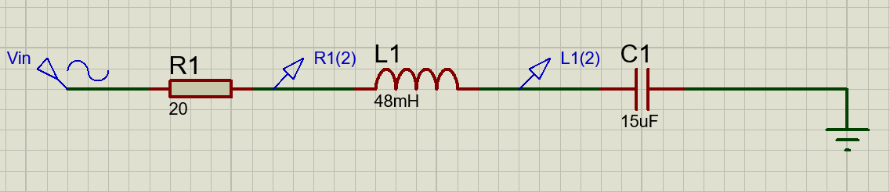
Figure 1 Series RLC Circuit
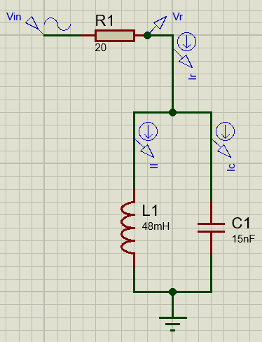
Figure 2 Parallel RLC Circuit
The component values used were assigned by a student number. The first two digits would be the resistor value in ohms, the next two digits would be the capacitor value in microfarads, and the final three digits would be the inductor value in millihenrys. In this case the student number used was 2015048 and therefore the component values were determined as follows:

Component | Value | Units
Resistor | 20 | Ω
Capacitor | 15 | µF
Inductor | 48 | mH

It was instructed that the voltage source, a sine wave generator, be set at 1V peak to peak and at a frequency of 100Hz. The frequency ranges to measure the voltage across the resistor, capacitor and, inductor would be between 100Hz – 20KHz.

Results
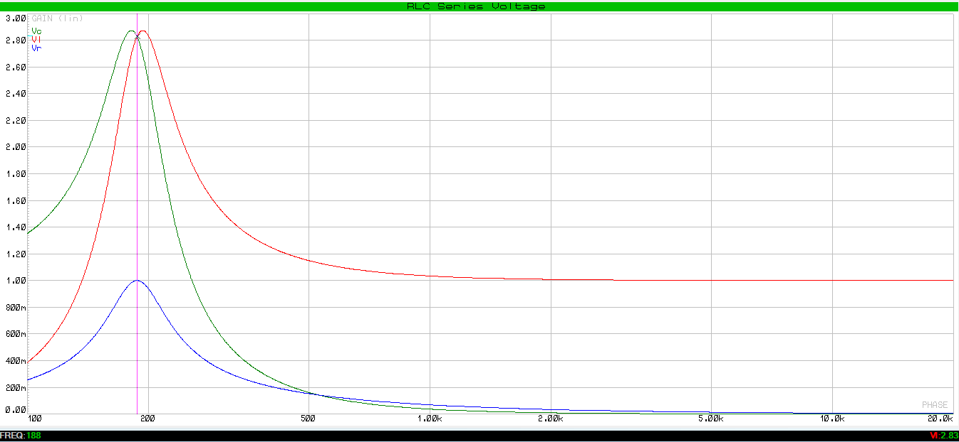
Figure 3 Graph of RLC Series Voltage
Figure 3 shows the voltages across individual components in the series RLC circuit. The blue trace shows voltage across the resistor, the red trace shows voltage across the inductor and the green trace shows voltage across the capacitor. Resonant frequency has been estimated from the graph as 188Hz. Voltage across the inductor and capacitor is approximately 2.8V. The Y axis is voltage in volts and the X axis is frequency in hertz.

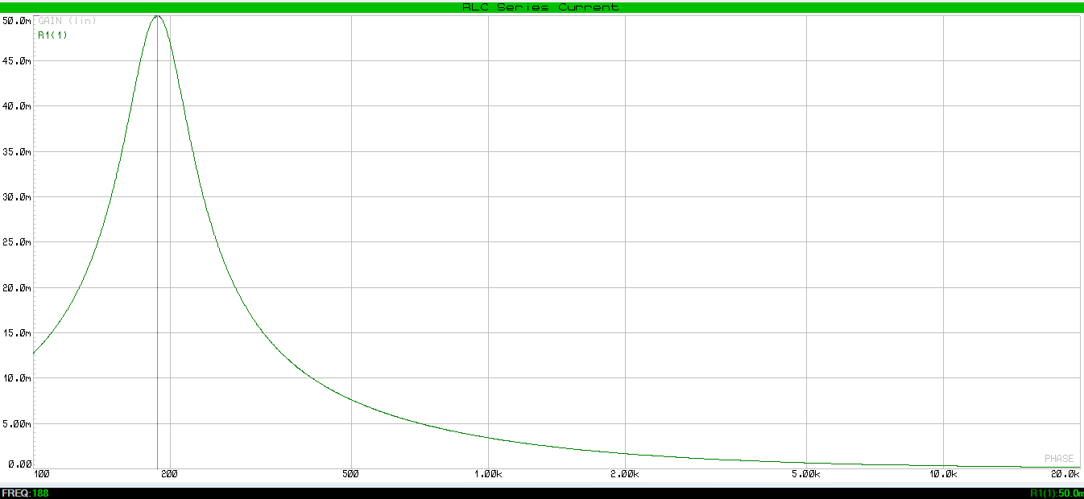
Figure 4 Graph of RLC Series Current
Figure 4 green trace shows the total circuit current as frequency changes for the series circuit. It can be seen that at resonant frequency, current is at its highest, approximately 50mA. The Y axis is current in milliamps and the X axis is frequency in hertz.

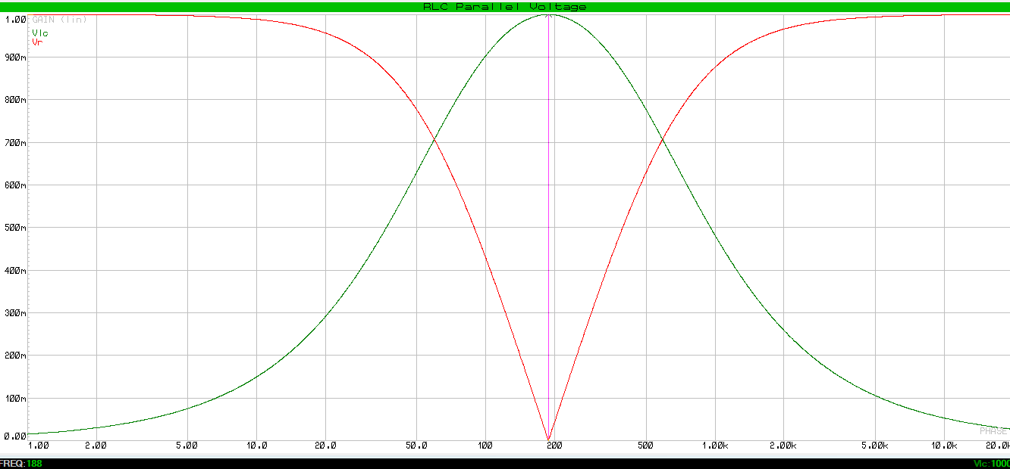
Figure 5 Graph of RLC Parallel Voltage

Figure 5 shows the voltage across the resistor on the red trace and the voltage across the inductor and capacitor on the green trace. It shows that at resonant frequency the voltage across the resistor drops to zero and the voltage across the inductor and capacitor increases to the supply voltage. This graph is of the parallel circuit. The Y axis is voltage in millivolts and the X axis is frequency in hertz.

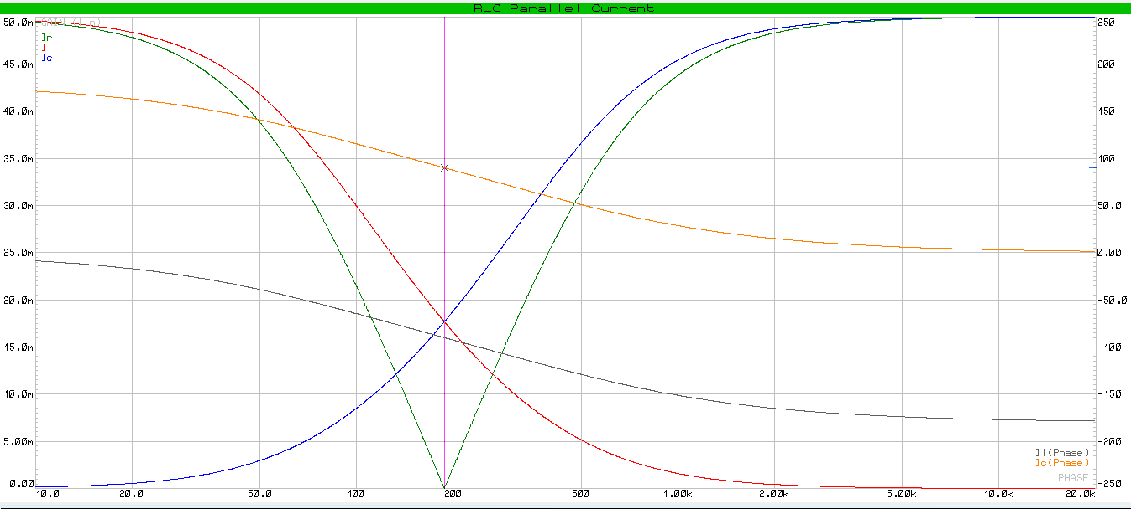
Figure 6 Graph of RLC Parallel Current with Phase Difference
Figure 6 is a graph of current across different components in the parallel circuit. The green trace shows current through the resistor which drops to zero at resonance. The red trace shows current across the inductor and the blue trace shows current across the capacitor, these can be seen intersecting at resonance. The grey and orange traces show the phase difference between the current across the inductor and capacitor against the supply voltage respectively. It can be seen that they are always 180 degrees apart. On the Y axis left hand side is current in mA, the Y axis right hand side is the phase in degrees and the X axis is frequency in hertz.

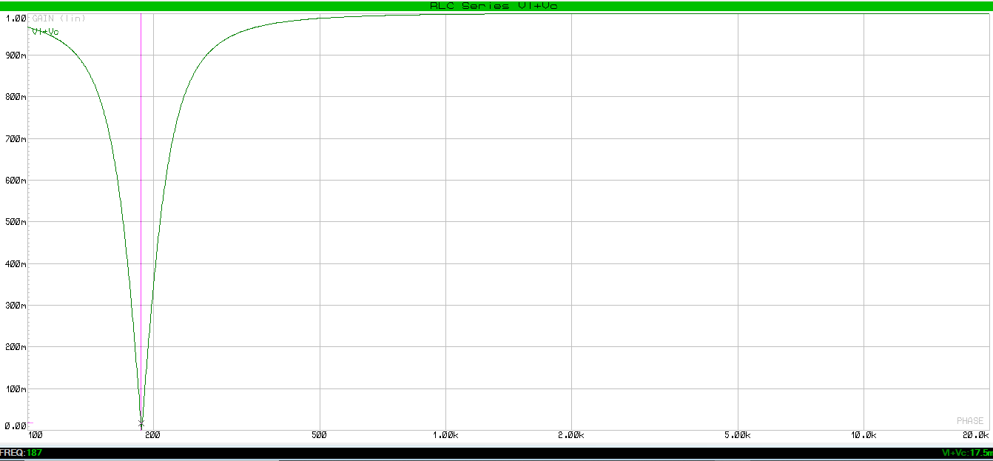
Figure 7 Series RLC Voltage of Capacitor + Inductor
In figure 7 it can be seen that the voltage across both the inductor and capacitor together at resonant frequency drops to zero. The Y axis is voltage in millivolts and the X axis is frequency in herts.

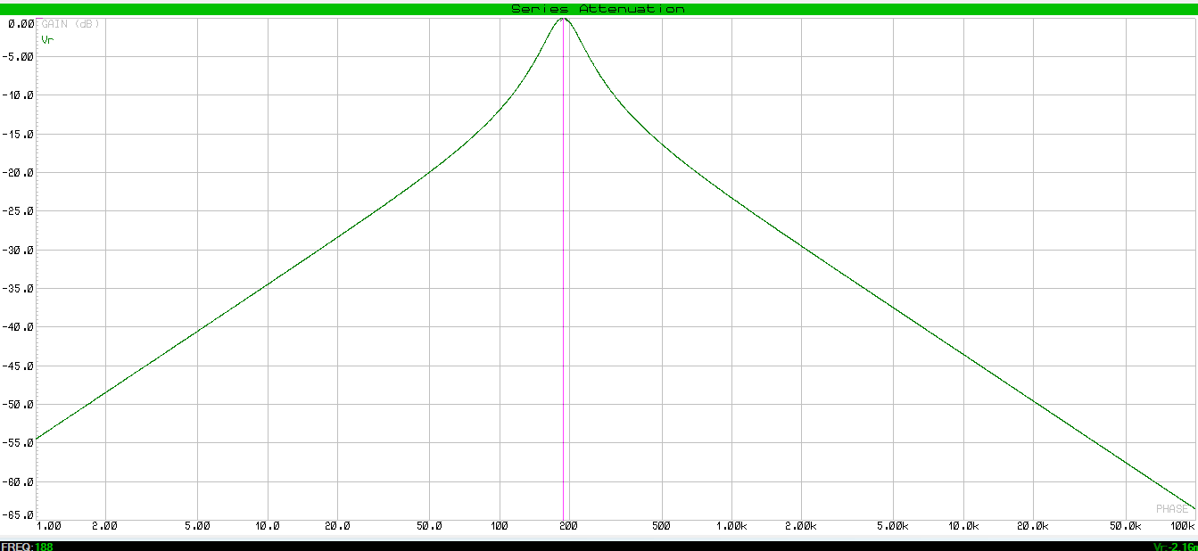
Figure 8 Graph of Series RLC Attenuation
Figure 8 shows the attenuation across the resistor in the series circuit. The Y axis is attenuation in dB and the X axis is frequency in hertz.

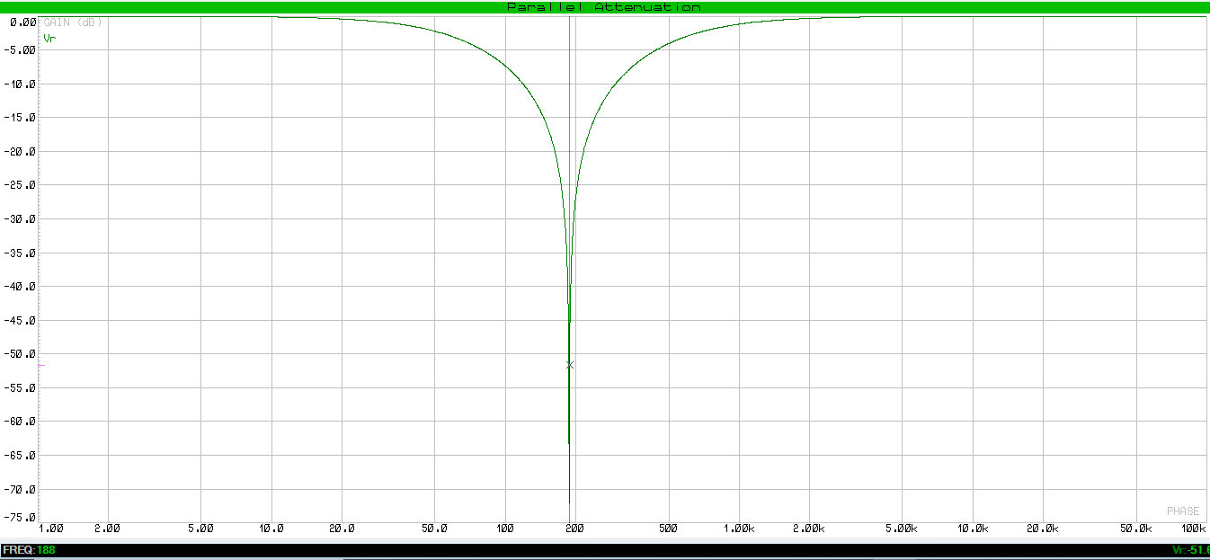
Figure 9 Graph of Parallel RLC Attenuation
Figure 9 shows the attenuation across the resistor in the parallel circuit. The Y axis is attenuation in dB and the X axis is frequency in hertz.

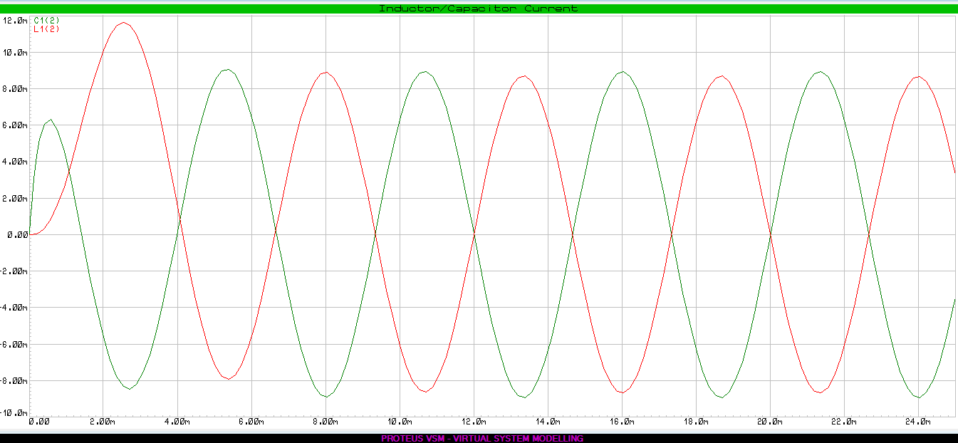
Figure 10 Parallel RLC Oscillation
Figure 10 shows the current oscillation in a parallel RLC circuit at resonant frequency. The Y axis is current measured in mA and the X axis is time in mS.

Discussion

Resonant frequency can be calculated for an RLC circuit using formula (1). The same formula applies for series and parallel circuits.
$f_{Res}= \frac{1}{2π\sqrt{LC}}$ (1)
Where $f_{Res}$ is the resonant frequency in hertz, L is inductance in henrys and C is capacitance in farads. Substituting the values from the set up section gives:
$f_{Res}= \frac{1}{2π\sqrt{48x{10}^{-3} x 15x{10}^{-6}}}$ (2)

$f_{Res}=187.57Hz$ (3)

This value is clearly presented in the graph from figure 1. The point at which the voltage across the capacitor and voltage across the inductor intersect is 188Hz.

The quality factor or Q factor of an RLC circuit is the magnification of the capacitor/inductor compared to the input voltage. As this measurement is a ratio, it has no units. In order to determine Q factor from the graphs, it must be looked at in terms of resonant frequency and bandwidth. Resonant frequency has already been calculated in equation (3) as 187.57Hz. Bandwidth is measured as the frequency difference between 70.7% of the amplitude of the response. Using equation (4) below and figures 3 & 5 Q factor can be worked out from the graph of both the series and parallel circuits respectively. [7]

$Q= \frac{f_{Res}}{BW}$ (4)

For the series circuit, the amplitude was 2.87V. Multiplying this number by 0.707 gave the points to measure frequency at as 2.03V. Using the Proteus software, it was determined that the lower bandwidth frequency was 165Hz and the higher frequency was 245Hz. Subtracting one from the other gave a final bandwidth value of 80Hz. Putting this into equation (4) gives:
$Q_{Series}= \frac{187.57}{80}$ (5)

$Q_{Series}= 2.34$ (6)

Following through the same principle for the parallel circuit, the amplitude in figure 5 was 1V, leaving 0.707V as the points to measure the frequency. The lower bandwidth frequency was 59.5Hz and the upper was 588Hz. Subtracting one from the other gave a bandwidth of 528.5Hz. Entering these numbers into equation (4) gives:
$Q_{Parallel}= \frac{187.57}{528.5}$ (7)

$Q_{Parallel}= 0.35$ (8)
To confirm these results, Q factor can also be worked out mathematically. Equation (9) can be used for series and (10) for parallel. Where R is resistance in ohms.
$Q_{Series}= \frac{1}{R}\sqrt{\frac{L}{C}}$ (9)

$Q_{Parallel}= R\sqrt{\frac{C}{L}}$ (10)

$Q_{Series}= \frac{1}{20}\sqrt{\frac{48x{10}^{-3}}{15x{10}^{-6}}}$ (11)

$Q_{Series}= 2.83$ (12)

$Q_{Parallel}= 20\sqrt{\frac{15x{10}^{-6}}{48x{10}^{-3}}}$ (13)

$Q_{Parallel}= 0.35$ (14)

Taking a closer look at figure 3, it can be seen that the voltage across the inductor and capacitor is nearly three times that of the input voltage. This is a clear display of voltage magnification which is unique to this type of circuit. Before reaching resonant frequency, the graph shows voltage across the capacitor, but not the inductor. In this state the circuit can be described as capacitive. After passing resonant frequency, this switches around and the circuit becomes more inductive than capacitive. The voltage across the resistor reaches the supply voltage at resonant frequency as the circuit becomes purely resistive. This is also proven by figure 4, where the current reaches its maximum at resonant frequency, which can only happen because the circuit is at its lowest impedance. Figure 7 gives slightly more explanation as to what is going on. Even though the voltages across the capacitor and inductor are nearly 3V at resonance, when measuring across both the capacitor and inductor at the same time, voltage drops to zero at resonance. This happens when the reactance of each component becomes equal and opposite in value. This means that in essence they cancel each other out. [6]

$X_{l} =2πFL$ (15)

$X_{c} =\frac{1}{2πFC}$ (16)

$X_{T}= X_{l}- X_{c}$ (17)

Using equations (15), (16), (17) with the numbers from this experiment it can be proven that inductive reactance and capacitive reactance are equal at resonance.

$X_{l} =2π x 187.57 x 48x{10}^{-3}$ (18)

$X_{l} =56.57Ω$ (19)

$X_{c} =\frac{1}{2π x 187.57 x 15x{10}^{-6}}$ (20)

$X_{c} =56.57Ω$ (21)

$X_{T}= 56.57Ω- 56.57Ω$ (22)

$X_{T}= 0Ω$ (23)

Figure 5 is a graph of voltages of the parallel circuit. Since the inductor and capacitor are in parallel the voltage is the same across both components. At resonant frequency this voltage can be seen increasing to the supply voltage and the voltage drop across the resistor drops to zero. At this point, the circuit has its highest impedance and therefore the supply current drops to zero as can be seen by the green trace in figure 6. The current across the capacitor can be seen starting very low and then starting to climb as frequency increases. The current across the inductor does the opposite. This happens because inductive reactance increases as frequency increases which lowers the current across the inductor. The capacitor reactance has an inverse relationship with frequency which means it gets lower as frequency increases. The current across these two components can be seen intersecting at resonance. The right hand scale of figure 6 shows the phase difference of these two components which is measured as 180 degrees apart from each other. Figure 10 gives the current between the inductor and capacitor when set at resonant frequency. In an ideal circuit the supply current could be removed and this oscillation between the two components would last indefinitely. This happens as the capacitor draws current from the inductor to build a charge. The capacitor will then discharge and the inductor will draw the current to build its magnetic field. [6]

Conclusion

In this report it was determined that RLC circuits have many useful characteristics to offer. Resonant frequency was calculated and then compared against the graphs with very accurate results. This gives confidence in the theory used and shows that it is possible to calculate this reliably. A similar process was carried out with the Q factor which also produced good results. The relationship between resonant frequency and bandwidth shows good insight into how these circuits can be used for low/high pass filters.

It was discovered that in series, an RLC circuit can become a powerful voltage amplifier when measured across individual components, but due to the phase of the capacitor and inductor being 180 degrees apart, the voltage would show zero if measured across the both added together. Current is more interesting to observe when looking at the parallel RLC circuit which has unique oscillating properties at resonance.

References

[1] A.Butterfield, and J.Szymanski,
A Dictionary of Electronics and Electrical Engineering (5 ed.),
Oxford University Press, 2018.

[2] R.Rennie, and J.Law,
A Dictionary of Physics (8 ed.),
Oxford University Press, 2019.

[3] M.Brain,
“How inductors work”, Howstuffworks [Online].
Available: https://electronics.howstuffworks.com/inductor.htm
[Accessed 11th April 2021].

[4] I.Hickman,
Analog Electronics (2 ed.),
Newnes, 1990.

[5] A.McHutchon,
RLC Resonant Circuits,
April 20, 2013

[6] S.Mossey,
Electrical Electronic Principles L4
Available: https://moodle.uwtsd.ac.uk/course/view.php?id=2013
[Accessed 23rd April 2021].

[7] S.Mossey
Q Factor
Available: https://moodle.uwtsd.ac.uk/course/view.php?id=2013
[Accessed 23rd April 2021].

