
Student Name: | Thomasina McDaid
Student Number: | 1712027
Module No: | BMSK5006
Module Title: | Knowledge and Information Management Skills for the Workplace
Skills for the Workplace
Module Assignment Submission
Statement of Confirmation of Authenticity
By the act of making this submission, the student declares that this is the work of the student named above. The work has not, in whole or in part, been knowingly presented elsewhere for assessment, or where assessment has been built on a previous assessment, this has been identified. Where materials have been used from other sources it has been properly acknowledged. If this statement is untrue, the student acknowledges that an assessment offence has been committed.
Attention is drawn to the plagiarism and unfair practice policies of both the University and of ILM.
Permission for ILM to use this script
ILM uses learners’ submissions – on an anonymous basis – for assessment standardisation. By submitting, both the centre and the learner agree that ILM may use this script on condition that identifying information is removed. However, if you are unwilling to allow ILM use this script, please refuse by ticking the box: □

Contents
Introduction 3
Management Synopsis 3
The relationship between Data, Information and Knowledge 3
The relationship between Individual Knowledge and Organisational Knowledge 6
Identifying knowledge assets 8
Actual and potential knowledge 9
Requirements to create, store, apply and integrate knowledge 10
Importance of intellectual property rights 11
The contribution that knowledge assets have on the organisation 12
Bibliography 13
References 13

Introduction
The author of this report is Thomasina McDaid, a 29-year-old mum of one, currently working as a Waitress and has worked in the Hospitality Industry for over 15 years. She is currently studying Level 5 Leadership and Management in University of Wales, Trinity St David’s after completing Level 4 Skills for the Workplace.

Management Synopsis
In this report the author reviews knowledge management practices and structures. There are findings of the relationship between data, information and knowledge, the way in which knowledge is developed and managed, the importance of tacit knowledge to obtain success in a business and ways in which businesses collect and store their knowledge.

The relationship between Data, Information and Knowledge
Data, Information and Knowledge have an array of definitions. Davenport and Prusak (2000) state that data is a set of discrete, objective facts about events that are structured records of transactions made, that information is a message sent in various forms of communication to have an impact on judgement and behaviour and that knowledge is a mix of experience, values and expert opinions that provide the framework in order to evaluate and incorporate the new information and experiences.
Data is recorded captured and stored readings of words, numbers, diagrams and images. Data is usually processed and analysed and then turned into information. Information has more understanding and meaning to the person receiving it. It can be used towards making decisions or taking action. That information is then turned into knowledge when it is taken in and understood by the human mind. Knowledge helps to create or increase the value for the organisation. Knowledge retained can then be externalised by being told to others whether verbalised or illustrated and turns back into information. That information can then be captured and turned into data. A continuous cycle of data and information collecting to boost the knowledge and understanding of the organisations wants and needs.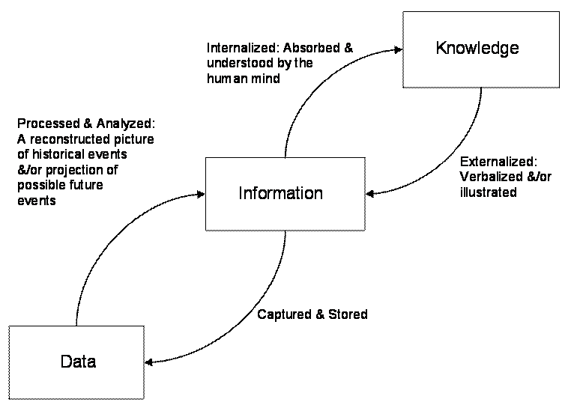
(Lew, 2007)

Big data is a combination of structured and unstructured data that is collected by businesses in which they can dig through for information. According to Rouse’s interpretation of research conducted by an analyst at Meta Group; Gartner in 2001, Big data has become a common component of data management. It’s often split into 3 groups known as the 3V’s. The Volume of data that’s collected, the wide Variety of data that’s been found and the Velocity at which the data is then generated, collected and processed. Big data is important to business as it can help improve operations, help provide better customer service, be able to create promotions more personalised to the customers and ultimately increase financial value (Rouse, 2019)

Data within the hospitality industry can be used for many things, monitoring competitors, tracking potential customers, keeping popular items in stock, the demand for certain products, predicting business income and many more. Having live up to date data is a huge advantage in the hospitality industry as it can help with continuous and frequent improvements to the service. Information is commonly spread through the industry from the menus with product information and pricing, signs that are placed around the restaurant whether its toilet signs, opening times, restaurant rules or information on the fire safety and information is also readily available around the kitchen on how to cook products, temperatures the food should be at etc. Using this data and information collectively ensures that both employee and customers gain the knowledge necessary in order for the business to run successfully.
The author currently works in a restaurant called The Westbourne. It’s an independently run family business that has been running for 15 years. They have several processes in order to collect data from their customers, use the information gathered from it and turn it into valuable knowledge that adds value to the business. They collect statistics and facts about everything ranging from stock control, to what products are their best sellers.
As an example, every Monday morning The Westbourne will collect data on all products sold/used. A stock count will be done collecting the amount they have left of each product. This is beneficial in many ways such as allowing them to know when stock is low, and it also can catch if any stock has gone missing/been wasted in that past week. This data would then develop into the information they need to decide or take an action. This information is converted into knowledge when the restaurant applies the data and information into the decision making and have an understanding of what is needed to be re-ordered along with the quantity. By doing this they have a wisdom in knowing what they need for the upcoming week and to minimalize wastage and therefor adding value to the business.

The relationship between Individual Knowledge and Organisational Knowledge

Individual and Organisational knowledge are both contributing factors towards the success of a business. Individual knowledge is what a person holds to be true, through personal experience or witnessing it first-hand. Organisational knowledge is cumulative knowledge and strengths obtained by the people who work for the business.
Knowledge sharing is fundamental to the success of a business. Workers will naturally pass on their gained knowledge onto the next person through face-to-face conversations and ‘hands on’ methods to share their tacit knowledge with others (Hansen et al, 1999).
Wagner and Sternberg (1987) believe that the skill to obtain and manage tacit knowledge is detrimental to management success, using tacit knowledge from the business employees are big factors in maintaining a loyal and productive work force (Smith, 2000). Businesses that actively encourage their employees to gain and share their tacit knowledge, develop ways to find, sort, use, store, retrieve and share the growing knowledge. Firstly, they learn what knowledge exists, they then filter the knowledge and integrates that into the business making it explicit knowledge (Brown and Dugid, 2000)
The SECI Model (Nonaka, 1994) is widely acknowledged as a landmark and the framework is used and adapted for most knowledge sharing within business. The model (Nonaka and Takeuchi, 1995) considers the creation of knowledge as a continuous process in which the constant communication between tacit and explicit knowledge hatches new knowledge and distributes it into the business.
The SECI Model is made up of 4 conversion modes; Socialisation, Externalisation, Combination and Internalisation which is the process of changing one type of knowledge into another (Nonaka, 1994)
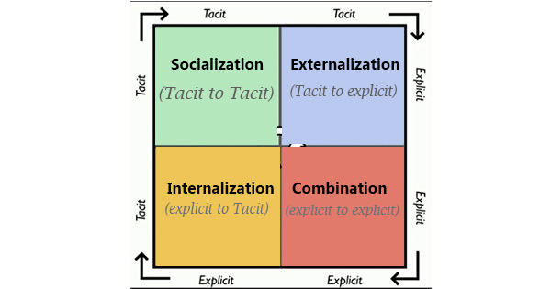
(Nonaka, 1994)

An example of using this structure in the authors workplace is:
Socialisation – The author works on the bar taking orders and has been asked on numerous occasions about a drink that they don’t stock.
Externalisation – Author documents the number of requests they’ve had and shares the data with the management.
Combination – Manager orders in the product and shares the information with all employees including putting up posters advertising their new drink.
Internalisation – Staff upsell the new product and previous customers who wanted the drink can now have access to it in the Westbourne (Author’s place of work)
To summarise, the SECI Model is a standard structure used in many ways to benefit the business and shows there is a constant share of information from individual knowledge and organisational knowledge and that both are important in the success of running a business.

Identifying knowledge assets

To Identify knowledge assets, the author used a couple of modelling techniques. The first model being a SWOT Analysis (Appendix 1). A SWOT analysis identifies the businesses strengths, weaknesses, opportunities and threats. The SWOT analysis was conducted with input from the author, their colleagues, their managers and business owner.
The second model is a PEST analysis, that identifies the external factors that influence a business. The author is examining how her workplace The Westbourne is affected by political, economic, social and technological factors.
There are many political factors within the hospitality industry, one main one being the encouragement to eat healthier and being more conscious of what foods people are eating. The government plays a huge role in advising people to eat healthier and lots of places where you eat now show the calorie count within each product/meal. Showing the calorie count can affect people’s choices of food.
The main economical factor currently going against the hospitality industry is the restrictions due to covid. Restaurants have been closed on and off for over a year now and even when open have many restrictions, limiting customer base and opening times. Recently restaurants/pubs have been able to open but only provide service outside. With the British weather, many days have been ‘rained off’ and they’ve had to close, affecting their income negatively.
Social factors, like mentioned previously have an impact on all businesses. Being a vegetarian or vegan is less of a fad and now more of a lifestyle choice. Both the government and the consumers push for healthier eating (Frue, 2017)
Technology in the workplace can give a competitive edge. With the internet and social media being widely used daily, The Westbourne can advertise on several social media platforms for free and instantly reach tens of thousands of potential customers.

Actual and potential knowledge

Looking at the SWOT Analysis (Appendix 1) the author has identified the strengths and weakness in their workplace in which they believe to be the actual and potential knowledge.
One of the main weaknesses that is affecting The Westbourne currently is the covid restrictions. The restrictions that have been implemented by the government has affected the sales of their food and drink consumption. As they have not been allowed to open for sit in service much of the time, The Westbourne have adapted and made changes to the way in which they serve customers, including delivery service and a pickup option as to not exclude the older generation who don’t tend to use smartphones. If the Westbourne didn’t have the knowledge of the most updated restrictions, they miss out on valuable sales. The Westbourne have lost half their bar staff due to them being students and them students going back to their homes as they can no longer attend university.
Now that the most recent restrictions allow the pub/restaurants to open, many places have lost their most experienced workers. Additionally, Brexit plays a huge factor in losing experienced chefs/managers. More than 30% of hospitality workers are said to have come from Europe, pre-Brexit. With covid restrictions on top, most experienced workers have gone back to their home countries, leaving the industry struggle to replace them with other experienced workers (Butler, 2021)
Luckily for The Westbourne, an independently family run business. The experienced staff in the kitchen are still there and they’ve only had to replace bar staff making their weakness into a strength as they can reopen for customers.

Requirements to create, store, apply and integrate knowledge

Knowledge management needs to be recognised for the value it brings to a business. In a competitive market, for success and long-term survival, it’s essential to not just look at the physical assets of the business but recognise the value of knowledge. A building block approach to implementing knowledge follows three principles:
- Building on existing knowledge.
- Provide an immediate return on investments on knowledge resources.
- Ensure that each step is a building block that provides the foundation for future enhancements.
Within these principles are 7 steps to integrate the knowledge:
- Identify the business problem.
- Prepare for change.
- Create the Knowledge Management team.
- Perform Knowledge Audit and Analysis.
- Define key features to the solution.
- Implement the building blocks for knowledge management.
- Link knowledge to people.
Results have shown that businesses that implement these methods have been very positive. The best practices are shared, experts identified, making cost savings as employees are spending less time reinventing knowledge and more time being productive. These businesses are more affective as the integrate knowledge management practices into the fabric of their business (Dataware Technologies, 1998)
Here is an example of these steps to better knowledge sharing in the authors workplace.
1 – Identifying the business problem – The cleaning schedule in order to keep the restaurant both front of house and back of house is not documented anywhere meaning jobs are forgotten about and no clarity as to when certain jobs have been done.
2 – Preparing for change – Manager understands that jobs are forgotten due to poor knowledge sharing and prepares for change.
3 – Creating the team – Manager holds a team meeting in which all employees attend.
4 – Knowledge Audit – The manager will collect all knowledge from employees regarding what jobs need doing and how they’re done.
5 – Defining key features – A checklist is made of all jobs that need to be done on a weekly, spreading out all jobs over the 7-day week.
6 – Implementing the building blocks – Manager makes use of a smart tablet placed on a wall on the bar which has all the tasks for the day listed that can be checked off as they’re done.
7 – Linking knowledge to people – By having everything documented and listed, nothing can be missed or forgotten about, whoever is on shift knows what needs to be done before close of business on the day. Overall, the productivity of the employees has bettered, and business can run more efficiently.
By using this structure, the authors workplace has identified a problem and taken steps to improve by sharing the knowledge in a more efficient way.

Importance of intellectual property rights

Intellectual Property refers to creations of the mind. Examples being inventions, artistic work, designs, symbols, names and images. Businesses can earn recognition or financial benefit from what they create or invent. The intellectual property is protected by law via copyright, trademarks and patents. The Intellectual property system allows creativity and innovation to thrive (WIPO, 2021)
Below is the Authors workplace sign. As you can see there is a ‘W’ written creatively behind the name of the pub/restaurant. As a well-established business that has been running in the family for over 20 years this ‘W’ is commonly known locally to be used by The Westbourne. The Westbourne have copyrighted this, to ensure that no other business can use their well-known logo.
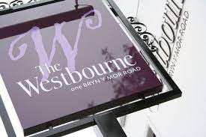

The contribution that knowledge assets have on the organisation

Measuring and managing knowledge assets within business is essential for the success of a business. 3 processes to discuss are knowledge assets identification, knowledge assets mapping and knowledge assets flow. The business needs the ability to gain a competitive advantage in order to master these processes (Schiuma, 2017)
Collecting knowledge in business is not new, training programmes, policies, routines, procedures, reports and manuals have done this for many years. By doing this, businesses reduce the workload for the managers whilst improving the effectiveness and efficiency of its operations (Peter, 1992) The new ways of gaining knowledge is modern information technologies such as the internet, browsers, data warehouses, loyalty cards etc, which helps to collect, store and share knowledge easily throughout the business.
The authors place of work the Westbourne, use a loyalty card scheme where both the business and the customer benefits from. The customer gains 1p for every £1 that they spend whilst the Westbourne are benefitting themselves by gaining the knowledge that is needed to reduce costs and improve efficiency. The Westbourne collect all the data of what products are their best sellers, products that are not so great for sales along with being able to calculate busier times of the day and busier days due to being able to see when the loyalty cards are being used. Having this knowledge is beneficial to the Westbourne as they can reduce waste, manage stock better and staff the business accordingly.

Bibliography
https://hoteltechreport.com/news/big-data-examples
https://www.forbes.com/sites/bernardmarr/2016/01/26/how-big-data-and-analytics-changing-hotels-and-the-hospitality-industry/#27b04b6b1c22
https://www.systems-thinking.org/dikw/dikw.htm

References
Brown, J.S. and Dugid, P. (2000), ``Balancing act: how to capture knowledge without killing it’’, Harvard Business Review, May-June, pp. 73-4, 76, 78-80.
Butler, S., 2021. Quite a challenge’: UK restaurants and pubs face staffing crisis after Brexit. The Guardian, 1 May 2021, Available from: https://www.theguardian.com/business/2021/may/01/uk-restaurants-pubs-brexit-staff-covid [Accessed 9 May 2021].
Dataware Technologies, Inc, 1998. Seven Steps to Implementing Knowledge Management in Your Organization. Dataware. Available from: http://www.systems-thinking.org/kmgmt/km7steps.pdf [Accessed 16 May 2021].
Davenport, T. and Prusak, L., 2000. Working Knowledge: How organisations manage what they know. Harvard Business School Press.
Frue, K, 2017. PEST Analysis Example for the Food Industry. 8 February 2017, Available from: https://pestleanalysis.com/pest-analysis-example-for-the-food-industry/ [Accessed 12 May 2021].
Hansen, M.T., Nohria, N. and Tierney, T. (1999), ``What’s your strategy for managing knowledge?’’, Harvard Business Review, March-April, pp. 106-16
Liew, A., 2007. Understanding Data, Information, Knowledge and Their Inter-Relationships. Knowledge Management Practice, 8 (2), Available from: http://www.tlainc.com/articl134.htm [Accessed 1 May 2021].
Nonaka, I. (1994). A dynamic theory of organizational knowledge creation. Organ. Sci. 5, 14–37.
Nonaka, I., and Takeuchi, K. (1995). The Knowledge Creating Company. New York, NY: Oxford University Press.
Peters, T. (1992), "Knowledge Management Structures I: Taking Knowledge Management Seriously," in Liberation Management, New York, NY: Alfred A. Knopf, New York, pp. 382-439.
Rouse, M., 2019. Big Data. Search Data Management, 1 October 2019, Available from: https://searchdatamanagement.techtarget.com/definition/big-data [Accessed 1 May 2021].
Schiuma, G, 2017. The managerial foundations of knowledge assets dynamics. 19 December 2017, Available from: https://www.tandfonline.com/doi/full/10.1057/kmrp.2009.21 [Accessed 1 June 2021].
Smith, E.A. (2000), ``Applying knowledge-enabling methods in the classroom and in the workplace’’, Journal of Workplace Learning, Vol. 12 No. 6, pp. 236-44.
Wagner, R.K. and Sternberg, R.J. (1987), ``Tacit knowledge in managerial success’’, Journal of Business and Psychology, pp. 303-12.
WIPO, 2021. What is Intellectual Property?. World Intellectual Property Organisation, Available from: https://www.wipo.int/about-ip/en/ [Accessed 13 May 2021].

Appendix

Appendix 1 –
Strengths  - Great location – Near a city centre with lots of foot traffic.  - Independently run business meaning changes can happen instantly.  - Variety of gluten free, dairy free, vegetarian and vegan options.  - Customers enjoy our homemade specials producing repeat and loyal custom.  - Strong values as a family run business. | Weaknesses  - Prices are higher than any other pub/restaurant in the area.  - Zero parking for customers.  - Single location meaning customer base is limited.  - Low advertising budget  - Website needs updating.  - Covid restrictions.  - Brexit.
Opportunities  - More and more people turning vegetarian and vegan.  - Due to covid, space is restricted but the business has lots of space both indoors and outdoors.  - Potential for partnership with a catering company to work local events. | Threats  - Other local pubs in the area are cheaper.  - Covid restrictions continuously changing costs the business money (lack of custom and produce waste)  - Due to covid restrictions, as an independent business they don’t have a major company to take the downfall of income – potentially losing the business and closing down altogether.

