

NAME: MANIBARATHI GOVINDARAJ
STUDENT ID: 2316981
MODULE TITLE: STRATEGIC MANAGEMENT
MODULE CODE: LCMB7003
LECTURER: AMARE DESTA

CONTENTS
Virtual Organization ...........................................................3
Summary...........................................................................12
Précis ...............................................................................17
Presentation slides ...........................................................20
References .......................................................................22

Virtual Organizations
There has been a significant paradigm shift in business operations due to the emergence and rapid rise of virtual organizations (VOs). VOs are virtually existing organizations with all sectors of a physical organization in place and operating. They are characterized by their great reliance on digital platforms and technology to facilitate the coordination of activities among geographically dispersed teams and individual members. This emergence represents a groundbreaking evolution in organizational structure, transcending physical boundaries while encouraging the growth of virtual collaboration and the limitless growth of virtual interconnectedness. An evaluation of virtual organizations involves an examination of their advantages and challenges in the growth of virtual organizations with a detailed view of their strategic management practices, planning, designing, and leadership.
VOs organizations exist in a virtual world where the boundless realm of cyberspace has replaced the physical requirement of traditional organizational office spaces. Cyberspace allows limitless converging of teams from all corners of the world, coming together for a common purpose and enabled by digital connectivity. The emergence of these organizations can be traced back to the emergence of technology epitomized by the proliferation of high-speed internet and collaboration of all related tools that have laid a foundation for borderless connectivity. The current shift in socioeconomic dynamics has also contributed to the shift towards flexibility and decentralization. This shift is a confluence of economic imperatives and technological possibilities. Businesses that have embraced this possibility can remain competitive in the increasingly competitive and global marketplace. Technology has found a way to leverage talent and resources irrespective of their geographical constraints. It has made it possible for businesses to access empowering platforms enabling their performance in a global space. This virtual space is slowly challenging and eliminating the traditional organizational boundaries and rules due to the possibility of virtual collaboration.
Advantages of VOs
The advantages of VOs offer transformative advantages to those who have embraced them. They have reshaped modern business through the inclusion of flexibility and scalability. They generally possess an inherent agility that is not available in traditional organizations. Since they are not bound to the limits of physical infrastructure, VOs can make use of emerging opportunities, adapt to evolving market dynamics, and mitigate risks with precision and speed. This flexibility allows them to expand faster than physical offices and organizations, which may need to re-establish themselves in the newly found market, costing them more time and financial resources. When already in operation in their markets, VOs can respond in a timely manner to market fluctuations such as consumer demands, changes in production processes, and the need to enter emerging markets. They operate in a scalable manner such that they can expand and contract their operations as needed without great changes in their logistics and physical modification needs.
VOs have a great global reach, which means that they can transcend geographical barriers and benefit from a global talent pool. Due to the reliance on technology and functionality of digital platforms and tools, they can collaborate with members and teams worldwide. In addition to the benefits of the global talent pool, the digital ability enables VOs to access diverse markets and customer segments. The digital functionality of VOs supports establishing global partnerships, market research, and timely global delivery of products to international clients.
VOs operate in a cost-efficient manner. Their lack of reliance on physical infrastructure, maintenance, and utilities costs reduces their operational costs, making more finances available for organizational business expansion. The virtual world significantly reduces their operational costs, and through this great reliance, they can streamline their workflow, optimize their resource allocation, and eliminate redundancies in expenditure, leading to greater cost-saving and making more funds available for expansions.
Employees operating with virtual organizations have a greater work-life balance due to the greater flexibility created in the management of organizational schedules. The remote work schedules allow members to plan their workdays in a manner that accommodates their commitments, leading to higher job satisfaction, increased productivity, and less stress. Virtual operation also allows engaged organizations to acquire specialized experts, probably on a project-by-project basis, without the need to engage in long-term employment contracts (Gilson et al., 2021). This allows the organizations to acquire high-performing teams tailored to specific projects or initiatives. The network of freelance professionals allows VOs to maintain a competitive edge in evolving industries where skills are in high demand. The overall operations of VOs place them at a better adaptability to remote work trends. Remote work has been greatly accelerated by emerging global events and pandemics such as COVID-19. Focusing on the placement of this organizational model, with already established remote teams, it can benefit from remote opportunities and attract top talent around the world while saving on operational costs and benefiting from operational efficiencies with remote work arrangements.
Issues in Strategic Management of Virtual Organizations
Amidst all these benefits and advantages of virtual organizations lie great issues that arise and affect their strategic management. These strategic management issues arise concerning planning, designing, and leading toward effectiveness and sustainability in the overall organizational operations. These are the organization's development steps and ought to be tackled with great care, embracing the ethos of continuous evolution, change, and innovation. At the planning stage of a virtual organization, processes are tailored to ensure that the set virtual organization’s goals and objectives are aligned with the achievement of the overall mission and vision. This is made possible through strategic alignment, which prioritizes and establishes performance metrics to measure progress and direction.
Risk management activities are performed at the planning stage. This involves the identification and mitigation of virtual operation-related risks. Some of the risks involved in virtual organizations that must be considered in planning include cybersecurity threats, data breaches, and regulatory compliance issues. Cybersecurity issues, in this case, involve a wide range of possible malicious activities that may threaten and render vulnerable the digital networks and systems of an organization. Possible threats, in this case, include phishing scams, ransomware, and insider threats and attacks (Burrell, 2020). These threats have severe consequences on the VOs, including possible financial losses, loss of organizational reputation, risk to legal liabilities, and loss of customer trust. Once malicious activities happen, they disrupt operations, expose confidential organization information, and compromise sensitive data. Although these issues may cause great losses once they occur, they can be mitigated if proper planning is done during the planning stage. Mitigation strategies may include the implementation of cybersecurity measures that protect against threats. Such strategies include antivirus software, firewall installation, intrusion detection systems, and encryption technologies. Data breaches, on the other hand, cause illegal exposure of organizational information to unauthorized persons who may use it for malicious purposes. This may lead to financial losses, legal penalties, regulatory fines, and damage to organizational reputation. These losses can be mitigated through the installation of data protection measures and systems.
The planning stage should capture possible trust and communication issues that may arise throughout the virtual operations. Due to the remoteness and nature of virtual interactions, there are high cases of communication and trust issues. Trust issues occur due to the lack of face-to-face interaction and the physical presence of members. This denies them a personal connection to build relations that can create trust. It also affects the individual perceptions of accountability and may lead members to be suspicious about their performance and commitment, which may affect team collaboration, cohesion, and effectiveness. Communication issues in virtual organizations occur and may affect operations greatly since they are the core interaction point that facilitates organizational activities (Bagga et al., 2023). Causes of poor communication may be technological barriers where individuals may fail due to total reliance on technological tools and platforms. Technical and connectivity issues on these platforms may paralyze communication and disrupt operations. Communication may also become ineffective due to the lack of nonverbal cues caused by the nature of the interaction. These cues are essential in conveying emotions, nuances, and intentions, and they are lacking in virtual communication, making it a great challenge for the entire organizational operations. Such issues can be mitigated during the planning stage by establishing clear communication channels that promote openness and inclusivity, establishing alternative communication channels, and establishing clear expectations among team members.
During the designing stage of virtual organization development, strategies are put together for developing an organizational structure and technological infrastructure and establishing organizational cultures and values. A flexible and adaptable organizational structure is essential to accommodate all the flexible work operations (Graves & Karabayeva, 2021). Strategic management here ensures an optimal balance between centralized control and decentralized decision-making while taking into consideration the unique and dynamic needs of the virtual teams. Technology infrastructure is built at this step to establish a reliable technological base supporting virtual operations. Technological infrastructure includes communication tools, project management software, and the development of cybersecurity measures. The strategic management measures here must invest in scalable and secure technology that ensures seamless collaboration and protects sensitive information and data.
Virtual organization leaders establish reliable cultures and values that promote organizational progress. They set organizational expectations, behaviors, and rules that create the entire organizational culture. They also create these cultures by defining, communicating, and reinforcing values for all stakeholders through the most effective communication channels or platforms. Organizational values determine how an organization will progress and how members interact among themselves and with outsiders. Organizations can create cultures that promote and encourage collaboration by emphasizing the need for mutual support, shared goals, and collective achievement. Consistent practice of these virtues creates an organizational culture. Strategic management must also ensure to create a sense of belonging and strengthen cohesion among stakeholders while emphasizing the importance of effective communication, transparency, and respect.
Strategic management also takes part in designing leadership issues in virtual organizations. Leadership issues handled through strategic management include leadership development, performance management, and change management. Organizations here invest in leadership development programs through team building, virtual communication and interaction, conflict resolution, and decision-making to foster collaboration and lead toward organizational success. The leadership issues involved here include the development of virtual leadership skills so that leaders have the right competencies to thrive in the virtual space. Leaders aim to acquire competencies in team building, decision-making, and conflict resolution. They are also trained in the unique needs and challenges experienced in virtual space.
Strategic management activities at this point assist in setting clear organizational objectives and goals. This practice ensures the alignment of individual and organizational goals toward accountability and better outcomes.
Strategic management ensures performance management by implementing performance management systems and processes that evaluate the operations of virtual teams. Some of these management systems and processes include setting clear and measurable goals for virtual teams. These goals must be SMART (Specific, Measurable, Achievable, Relevant, and Time-bound) to provide direction to members. These goals should, however, be communicated clearly among members. Another process is utilizing performance metrics, which are set during design. Key performance indicators and tracks are used to track performance and view their alignment with organizational goals. Other systems include conducting system reviews, continuous improvement, and provision of regular feedback.
During the leadership development stage, strategic management operations also ensure change management. Change management is essential for organizations as it ensures all activities are managed and transitioned effectively in the virtual world (Kohntopp & McCann, 2020). It involves addressing all challenges associated with the implementation of organizational changes, transformations, and activities in the virtual workspace. Here, strategic management communicates change, provides support and resources, and involves stakeholders in decision-making processes. Issues that may arise in a virtual organization’s change management include communication issues that are contributed to by communication barriers that affect the timely conveying of information (Lee, 2021). Virtual organizations may also face resistance to change from some members delaying change processes.
Conclusion
Virtual organizations are well placed for competitiveness and progress in the current digital world. They have several advantages over physically established organizations. Such organizations should, therefore, maximize their benefits to thrive. Despite the advantages, several disadvantages challenge progress. In order to thrive, they must adopt strategic management practices to meet the needs of the virtual teams and all market requirements and effectively manage performance and change. Leadership should be critically positioned to handle all issues arising in the virtual world.

Summary
Organizations are currently adopting the use of software in their operations. They are adopting the use of ERP systems that help in easing modern business operations. ERPs offer integrated solutions across various organizational functions. The adoption of ERPs in organizations is part of the business processes that are fundamental building blocks and contribute to organizational success. Information technologies focus on process management and improvement to help organizations improve their competitiveness while fulfilling corporate visions. The aim of the research, as reported, is to understand information Technology usage and adoption in Greece'se local companies as well as a defined context to provide answers to questions on whether SMEs using ERP systems have experienced any differences and whether the system implementation affects them in a positive or negative manner.
Looking at the previous research done on information systems management shows that the development of success models such as the Delone and McLean model, has greatly contributed to an improved understanding of information systems management (Mullins et al., 2011).
International ERP vendors have dominated the Greek market of Enterprise Resource Planning Systems with great significant presence of local software at the SME levels. The adoption rate in Greece was reportedly low in the SMEs which should be researched to understand it more. However, the ERP may be due to the inapplicability of the commercially available ERPs to SMEs. These ERPS do not support SME operations apart from the accounting provision (Mullins et al., 2011). Therefore, they may need to be customized to include the business practices of the SMEs. Since the research intended to define whether SMEs in Greece use SMEs, and there was no valid data collected, it could not be determined.
Their adoption varies widely across regions and cultures. ERPs are promoted by vendors who advocate for the use of global templates to streamline implementations, the templates may not necessarily align with local needs and cultural nuances (Mullins et al., 2011).
These cultural differences play a great role in the adoption of these systems, as some research shows that national culture may impact the success of implementation projects. ERP implementation success is dependent on various factors referred to as critical success factors (CSFs). These CSFs include organizational readiness, top management support, user involvement, and effective change management in an organization (Mullins et al., 2011). These factors must be understood for effective implementation and management of the entire ERP system.
In an empirical research carried out involving Greek SMEs, sample data was collected through surveys and interviews. The research results indicated that the most dominant system was SAP, followed by Microsoft Navision (Mullins et al., 2011). The system implementation occurred in the manufacturing sectors where their advantages were felt. It was discovered that the implementation cost of these systems varied with many companies experiencing significant budget overruns.
Most of these SMEs that adopt ERP systems implement them all at once rather than in a phase-after-phase system. Regardless of the implementation system used, the user experiences varied, with some users getting some level of satisfaction and others dissatisfied with the packaged implementation approach. ERP modules are chosen selectively focusing on specific business processes rather than implementing the entire ERP functionalities (Mullins et al., 2011). There are reported improvements as a result of the ERP implementation in some SMEs. These improvements are reported in the sales, expenses, production, and personnel efficiency sectors. The improvements underscore the potential benefits of ERP systems for businesses despite the challenges faced in implementation.

In the companies that accepted to take part in the survey program, most respondents were CEOs, followed by the head of IT and then the head of accounting. This was quite realistic because CEOs are basically the ones in charge of making organizational decisions and have dominance in company decisions (Mullins et al., 2011). In most SMEs, CEOs are reluctant to delegate decisions regarding the company, and they have all the necessary knowledge concerning the same. CEOs are also primarily responsible for system upgrades. While some firms are owned by family members, they have few employees, thus increasing the probability of having the CEO as the primary decision maker.
There are wide advantages of ERPs and other systems in adopting organizations. Some of these advantages include integrating organizational processes through the processing of a large majority of organizational transactions and managing organizational information (Mullins et al., 2011). They also facilitate communication within the organization and stakeholder collaboration. Systems also assist organizations in the elimination of information asymmetries and provide online and real-time information. There is a reported benefit of these ERPs that they can be purchased in modules, beginning with the most needed ones and having others installed later.
Limitations of these ERPs have been documented to have a negative impact on work and organizational cultures. Researchers suggest the need for intensive technical support prior to the actual ERP use to overcome underlying cultural barriers. Another limitation is that the system takes quite a long time after implementation to see benefits, which is costly to the organization and may discourage SMEs from adopting them. They also find fault in the commission that they should pay to those implementing the system; thus, in most cases, they avoid the entire system.
There is a reported need for further research on SME operations and their adoption of ERPs in Greece. In addition to the limited influence these ERPs have on SMEs, there are also issues of the cost effectiveness of adopting them (Mullins et al., 2011). The cost might be inapplicable to small businesses, considering that the ERP functionalities may be irrelevant. They provide redundant processes for SMEs which increases bureaucracy without a useful management of information. Some other reasons that have held back the use of ERPs in Greece are that most vendors consider software, especially those based on SQL, to be wrong. In an argument, the developers try to bind buyers to their system instead of providing software packages that help the companies as a whole.
In conclusion, there are complexities and challenges associated with ERP implementation in Greece. Cultural and organizational factors are the facts challenges, and thus, there is a need for tailored approaches to meet the needs of vendors in Greece. Although the standard global systems may offer some benefits, they need to be adapted to local needs and cultural contexts. There is also a need for further research in the Greek markets to find out the specific challenges and opportunities that can be explored in Greek vendor markets.

Précis

Title: "An Empirical Study of ERP Implementation in Small and Medium Enterprises in Greece"
Authors: Roisin Mullins, Chatzichristos Christos, Federico Iannacci
This paper dissects the complex process of adopting Enterprise Resource Planning (ERP) systems by Small and Medium-Scale Enterprises (SMEs) operating in Greece. It highlights the need for companies to carefully select the compatible ERP system as well as the numerous challenges that are involved in its implementation. Two primary questions guide the study: firstly, whether the SMEs employing ERP in their daily operations are discriminated specifically in terms of their size compared to the others representing any global business; and secondly, the effects are the outcomes. Both positive or negative implications are objects of exploration.
The core aspect of this research is the insight how the ICT system has been adapted and reused in the Greek SMEs, with the focus on the use of ERP systems. He tries closing the gap in the related investigations in the application of ERP in SMEs in Greece and through them, also presenting useful standpoints for practitioners from the sector and academic investigators. Therefore, this study applies socio-technical method through which a survey-based research is used to collect the empirical data. This technique involves an initial collection of information that is then given for a subsequent analysis by this theory. There are various reasons why the grounded theory is being utilized for the research with regard to Greek SMEs is because it is an innate approach for investigative and explanatory research over the course of time, and of space.

The results of the study reveal that there is a glaring need for more knowledge on how to choose and apply ERP systems by Greek small and medium-sized enterprises. Although a well-planned ERP implementation can be associated with expense issues, the research study finds that most small and medium enterprises that execute this implementation can reap favorable results from this process. Does not only contribute in creation of models, which depict IBM ERP success, but also increases the spectrum of the information systems practical research. The survey outcomes also highlight a pressing need for SMEs in Greece to be educated about ERP systems, as these are becoming more and more strategic component. While there is a definite pattern of early problems and complexities to any ERP implementation, this thesis ends on a more optimistic note: if an ERP project is done the right way, the benefits for SMEs can be counted in the hundreds of thousands and more. ERP systems' transformative potential has the power of streamlining processes as well as raising decision-making abilities in business to an indecently high level. In addition to these implications, other research findings have been ascertained and are now applicable in the study around information systems. Through the uncovering of the ERP factors and the knowledge sharing on the ERP application approaches, the study extends in the current conversation on the ways to implementing ERP successfully in Greek SMEs. It offers the holistic view of the practical issues and benefits of ERP implementation in a selected socio-cultural situation that will, as a result, will make a relevant contribution to the information systems theory.
Overall, this research can be considered as a pioneering study that first investigates the behind implementation of ERP in Greek SMEs. It does this by helping to lift the curtain on the complexities of ERP adoption and use and thus offers valuable information that businesses and individuals can use to inform strategic decisions as they formulate their policies regarding their SMEs, and this is also a key foundation for further scholarly inquiry on this area.

Presentation slides

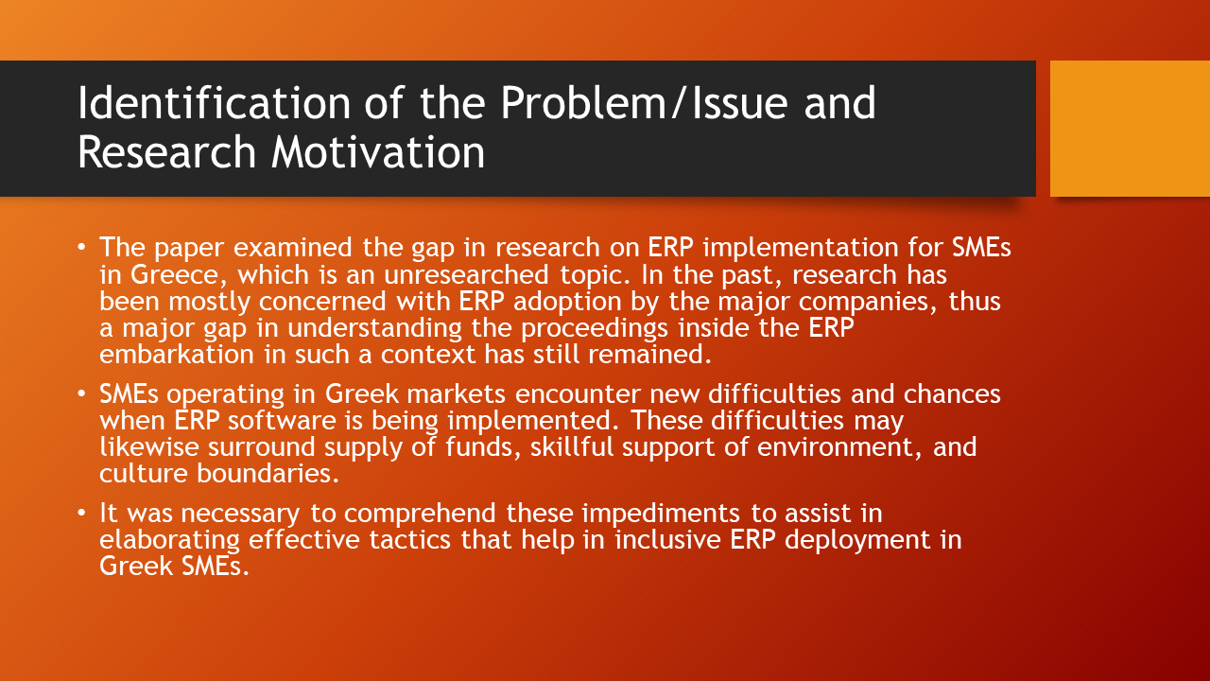

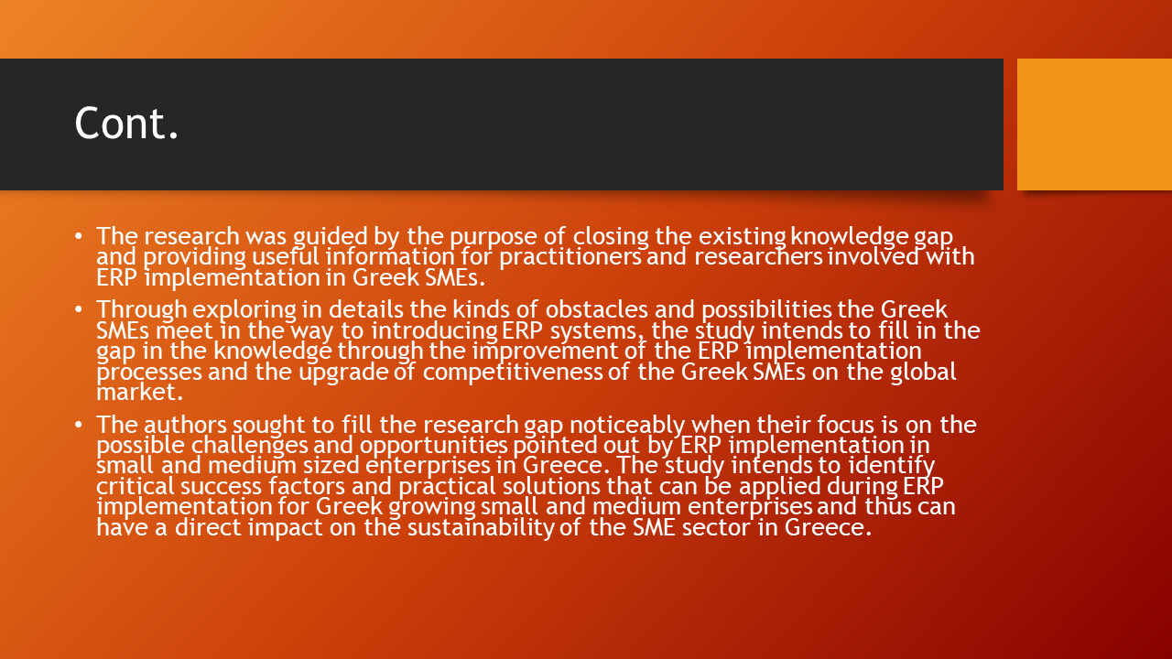

References

Bagga, S.K., Gera, S. and Haque, S.N., 2023. The mediating role of organizational culture: Transformational leadership and change management in virtual teams. Asia Pacific Management Review, 28(2), pp.120-131.
Burrell, D.N., 2020. Understanding the talent management intricacies of remote cybersecurity teams in covid-19 induced telework organizational ecosystems. Land Forces Academy Review, 25(3), pp.232-244.
Gilson, L.L., Costa, P., O’Neill, T.A. and Maynard, M.T., 2021. Putting the “TEAM” back into virtual teams. Organizational Dynamics, 50(1), p.100847.
Graves, L.M. and Karabayeva, A., 2020. Managing virtual workers—strategies for success. IEEE Engineering Management Review, 48(2), pp.166-172.
Kohntopp, T. and McCann, J., 2020. Leadership in virtual organizations: Influence on workplace engagement. The Palgrave handbook of workplace well-being, pp.1-26.
Lee, M.R., 2021. Leading virtual project teams: Adapting leadership theories and communications techniques to 21st century organizations. Auerbach Publications.
Mullins, R., Christos, C. and Lannacci, F., 2011. An Empirical Study of ERP implementation in Small and Medium Enterprises in Greece. In 8th International Conference on Enterprise systems, Accounting and Logistics (8th ICESAL 2011).

