[Date]
Samuel Kargbo (2423977)

ASSIGNMENT 2
Project Management & Innovation

MODULE NAME: cHANGEMAKERS: CREATIVITY AND VALUE CREATION
MODULE CODE: ACCA5033
STUDENT NAME: SAMUEL MOMOH KARGBO
STUDENT ID: 2423977
LECTURER: DR. FAHAD AHMED
UNIVERSITY OF WALES TRINITY SAINTS DAVID LONDON CAMPUS
Table of Contents
Introduction 1
Task 1: Project Management 2
Task 2: Enterprise or Task 2: Innovation 9
T2-Innovation : 9
Task 3: Project Reflection 10
Appendices: Supplementary Information 10

Introduction
Projects Management Play a crucial role in the successful development of contemporary software systems, especially those integrating cutting-edge technologies like artificial intelligence. This project centers on the management, planning, and design of SmartGen Assistant, an AI-driven productivity tools designed to enhance student’s academic organisation and efficiency. As academic demands grow, students often struggle with deadline tracking, time management, and maintaining consistent study routines. The SmartGen Assistant aims to address these challenges by offering an intelligent solution that merges task management with customised study support.
The goal for this assignment (Projects) is to showcase fundamental project management practices, including defining project scope, scheduling tasks, resource allocation, and selecting a suitable development methodology. It also delves into the design processes necessary to translate a conceptual idea into a concrete and actionable systems. By employing established methodologies such as Agile development and utilising visual planning aids like Gantt charts, this project strives to promote and efficient workflow and ensure om-time completion.
Additionally, the assignment (Projects) will include designs artefacts such as requirement specification and system diagrams to demonstrate the SmartGen Assistants functionality from both user-centric viewpoints and technical.
In summary, this project offers practical opportunities to apply theoretical knowledge of project management and software design to a real-world context, emphasising the importance of planning, organisation, and flexibility in the development of an AI-powered application.

Task 1: Project Management

Project Management & Planning
Project Title: SmartGen Assistant- AI Powered Student Productivity and Academic Support System

SmartGen Assistant project aims to create a web-based AI-Powered digital assistant design to help students manages their organised tasks, academic workload, and enhance productivity. It addresses common challenges students face such as handling assignments, deadlines, lecture materials, and revision schedules.
SmartGen Assistant will operate as web-based platforms that leverages AI technologies to support students in managing their academic tasks. Users will be able to upload course materials, track assignments, receive automated reminders and interact with an AI powered chatbot. The solution focuses on developing an intelligent assistant that integrates natural language processing [1] (NLP), task management capabilities, and personalized study recommendation tools. By analyzing user queries, the system will deliver relevant responses and suggestions, helping student efficiently complete their academic works.

Key Systems Features Include:
The key systems features form a comprehensives student support platform design to enhance academic productivity through AI technology. Here’s a concise summary:

Assignment and Deadline Tracker: Helps students keep track of their tasks and important submissions date.
Automated Notification: Sends reminders about approaching deadlines to keep students on schedule
Document and Note Management: Enable organization of lecture notes and academic files in a centralized system
AI Chat Assistant: Provides instant responses to student questions related to coursework and academic topics [2]

Expected Outcome: Development of a functional prototype showcasing the integration of AI to support students academically and boost productivity

Required Technologies and Resource
The development of SmartGen Assistant involves the integration of various software tools, programming technologies, and essential resource to build a scalable and intelligent student assistant system.

Programming Language
Javascript: For frontend development and interactive user interface [3]
Python: For backend development and AI model implementation

Frameworks and Libraries
Pandas: For effective management and manipulation of user data
TensorFlow: To enable AI functionality, including machine learning and natural language processing [4]
React: To build to dynamic and responsive web interface.
Node.js: For backbend service and API development

Development Tools
GitHub: For version control, collaboration, and source code management [5]
Visual studio code: Integrated development environment (IDE) for coding, debugging, and project management.

Resources
Laptop/Pc with internet connection: Required for development, testing and deployment activities.
Cloud Storage: For Secure storage and retrieval of user documents.
Public Datasets: To train and improve AI models.

These technologies and resources collectively enable the creation of a robust, scalable system that provides intelligent support to students.

Project Timeline and Schedule
SmartGen Assistant project will be completed over a period of 12 weeks. Each phase is dedicated to a key development stage as outlined below:
Stage | Activities | Duration
Project Research | Identify requirement and conduct literature review | Week 1-2
System Planning | Define system architecture and design | Week 3
UI/UX Design | Create interface layout and user interaction design | Week 4
Backend Development | Implement database and sever logic | Week 5-7
AI Integration | Develop chatbot and recommendation features | Week 8-9
Testing & Debugging | Test system functionality and performance | Week 10-11
Documentation and Delivery | Prepare final report and presentation | Week 12

Gantt Chart:
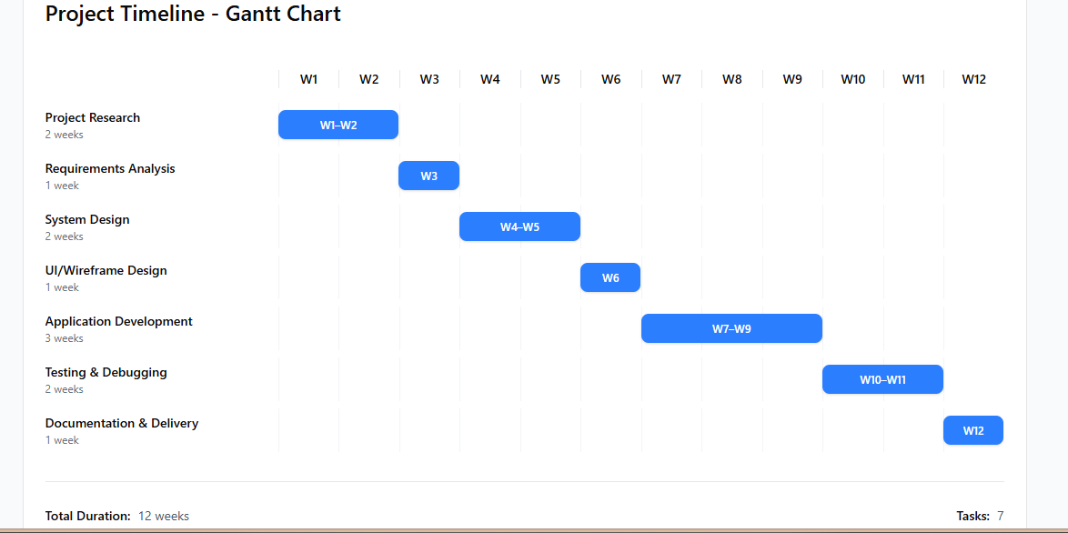

Project Constrains
Several constrains may impacts the development of the SmartGen Assistant:

Development Scope: The project aims to build a functional prototype rather than a fully deployed product system.
Technical Constrain: Limited hardware resources may affect the performance of AI models and the system scalability.
Time Constrain: The project must be completed within a limited academic timeframe, which restricts the complexity and scope of the features implemented.
Data Privacy Concerns: Handling student data necessitates secure storage and strict adherence to data protection measures.

Development Methodology
The project will adopt the Agile development methodology, recognized for its flexibility and iterative nature in Modern software development.

Agile facilitates breaking the project into smaller development cycles, known as sprints, allowing for continuous feedback and incremental improvements throughout the development process.

Key stages of development include:
Planning Phase: it defines project requirements and establish the initial development plan.
Sprint Development: Implement core features such as task management, notification system, and chatbot.
Testing Phase: Assess system functionality and address any identified issues.
Iteration and Improvement: Refine and enhanced features based on testing outcomes.

Requirement Specification
The requirements specification defines the essential functionalities and qualities SmartGen Assistant system must possess to meet user expectations effectively and operate reliably

Functional Requirements
These specify the core features and behaviours the system must support:

User Registration and Login
Enable student to create accounts with necessary credentials
Provide secure authentication mechanisms for user login

AI Chat Assistant
Allow users to asked academic-related questions and receive intelligent responses.
Implement a natural language processing-based chatbot

Task and Assignment Management
Provides tracking features to monitor deadlines and progress
Enable editing and updating of existing assignments
Allow users to create new assignments tasks

Notification System
Automatically send reminders for upcoming deadlines and important tasks

Note: These functionalities collectively empower students to manage their academic responsibilities efficiently and enhance their learning productivity.

Non-Functional Requirements
These describe the quality attribute and system performance criteria:
Usability
Design a user interface that is intuitive and straightforward for students to navigate and use

Performance
Optimize the system to respond swiftly to user queries and tasks operation, minimize latency.

Reliability
Prevent frequent crashes and maintain consistent operation
Ensure the platform is stable and available with minimal errors

Security
Ensure secure storage of user data
Implement robust authentication and authorization protocols to prevent user privacy and data integrity
Note: Adhering to these non-functional requirements will guarantee a secure, responsive, and user-friendly system.

System Design – Flowchart

Wireframes:
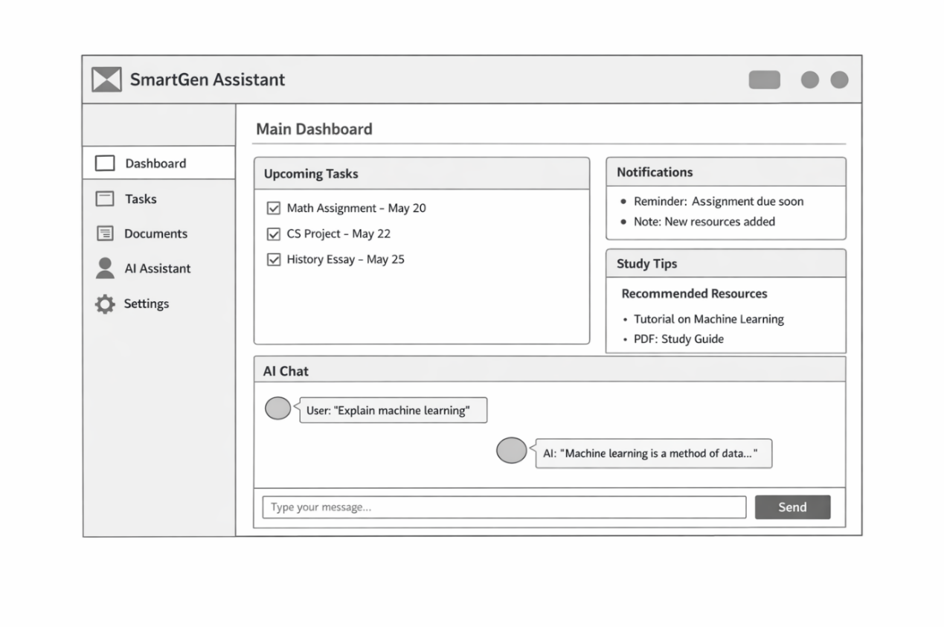

Task 2: Enterprise or Task 2: Innovation

T2-Enterprise: Tech Company Analysis and Start-up Proposal

PEST Analysis-Telsa
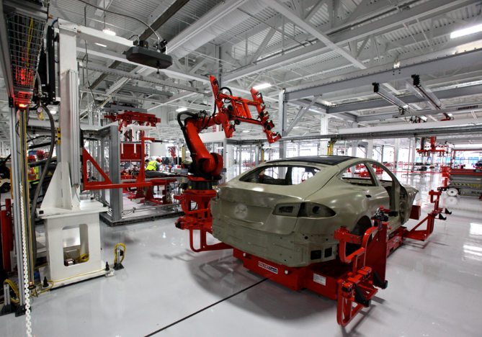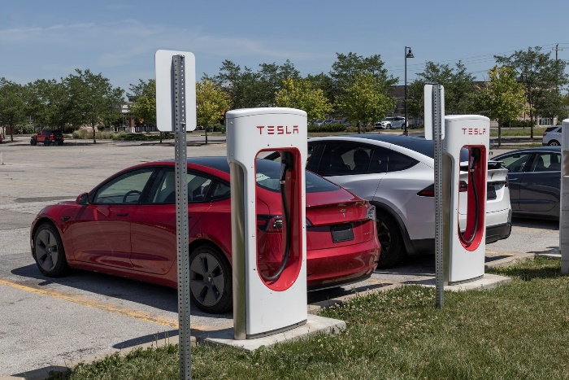
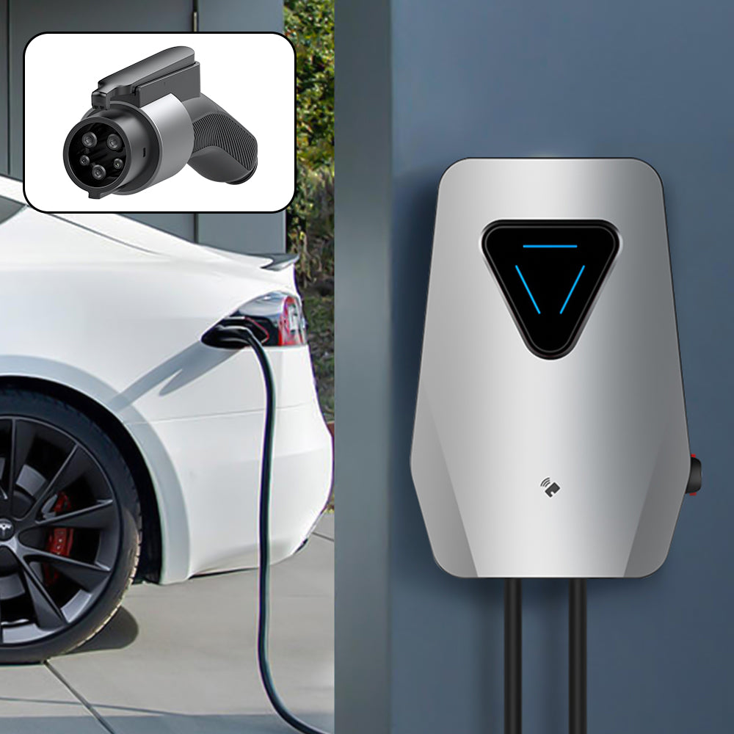
Tesla, Inc. stands as one of the most influential companies in the electric vehicle (EV) and renewable energy sectors, driving significant technological innovation and shaping the future of sustainable transportation. To understand the external environment influencing Tesla’s business, a PEST analysis (Political, Economic, Social, and Technological factors) offers valuable insights. Furthermore, a SWOT analysis highlights Tesla’s internal strengths and weaknesses alongside external opportunities and threats. Additionally, understanding the legal and ethical considerations Tesla face is crucial for its long-term sustainability and public trust.

Political Factors
Tesla’s growth is strongly influenced by government policies worldwide. Many countries promote the adoption of electric vehicles through tax incentives, subsidies, and grants, which encourage consumers and businesses to transition towards cleaner transportation options. These policies not only reduce the cost barrier for EV buyers but also create a more favourable market environment for Tesla’s products. Moreover, increasing regulatory pressure on traditional internal combustion engine vehicles, including stricter carbon emission standards, further benefits Tesla by accelerating the shift to electric mobility.

However, Tesla is also vulnerable to political risks. Changes in government administrations or priorities may lead to the reduction or removal of subsidies, directly impacting demand. Trade policies and tariffs, especially those affecting Tesla’s global supply chains and manufacturing facilities, could increase costs. Geopolitical tensions may also disrupt the availability of critical raw materials or components. Therefore, Tesla must continuously navigate a complex and evolving political landscape.

Economic Factors
Tesla operates in a rapidly expanding EV market, driven by rising environmental awareness and the urgent global need to reduce fossil fuel dependency. However, economic challenges persist. Inflationary pressure increases production and operational costs, while ongoing global supply chain disruption -particularly the semiconductor shortage-have periodically constrained Tesla vehicle production capacity. Economics downturns or recession could reduce consumer spending power, especially for premium-priced electric vehicles like Tesla’s models.

Conversely, rising fuel price and growing concerns about climate change support increasing EV adoption, which bodes well for Tesla’s sales growth. As battery technology improves and economics of scales are realized, Tesla has the opportunity to reduce vehicle costs and attract a broader customer base.

Social Factors
Social trends Favor Tesla’s business model. Consumers are becoming more environmentally conscious, placing higher value on sustainability and green technologies. Tesla’s brand is strongly associated with innovation, clean energy, and futuristic automotive technology, which appeals to environmentally and tech-conscious customers. The increasing popularity of smart technologies and autonomous driving further aligns with Tesla’s strategic focus on AI-based self-driving systems [6]

Nonetheless, consumer trust remains critical, especially concerning the safety of autonomous driving features and the reliability and lifespan of battery technology. Any high-profile safety incidents or battery failures could harm Tesla’s reputation and slow customer adoption.

Technology Factors
Tesla’s competitive advantage heavily relies on cutting-edge technological innovation. The company leads in the development of AI-powered autonomous driving systems, battery chemistry breakthroughs, and over-the-air software updates that continuously improve vehicle performance post-purchase. Rapid innovation in the EV sector demands Tesla invest heavily in research and development to maintain its technological edge over emerging competitors.
Battery technology is central to Tesla’s success, as improvements in energy density, charging speed, and cost reduction directly influence vehicle range and affordability. Tesla’s proprietary software and integrated ecosystem, including its vast Supercharger network, further enhance customer experience and loyalty.

SWOT Analysis
Tesla’s strengths include its strong global brand synonymous with innovation and sustainability, advanced battery and software integration, an extensive charging infrastructure, and visionary leadership under Elon Musk. However, Tesla faces weaknesses such as higher production costs compared to traditional automakers, a relatively limited product range, and dependence on complex supply chains for batteries and rare materials like lithium and cobalt.

The company’s opportunities lie in the expanding global EV market, increasing demand for renewable energy solutions, and potential development of autonomous taxi networks and AI-driven services. On the other hand, Tesla confronts threats from intensifying competition as established automakers enter the EV space, regulatory scrutiny over autonomous driving safety, and volatile raw material prices that could impact production costs.

Legal and Ethical Considerations
Tesla operates under strict legal and ethical frameworks that shape its innovation and operations. Data privacy and cybersecurity are paramount, as autonomous vehicles collect vast amounts of user data. Compliance with data protection laws such as the UK GDPR is essential to safeguard user information and maintain trust.
Safety regulations pose significant challenges, requiring Tesla’s autonomous driving technology to meet rigorous standards before widespread deployment. Any failures or accidents could result in legal liabilities and diminish public confidence.
Environmental responsibility extends beyond emissions reduction. Battery manufacturing and disposal raise concerns about resource extraction, pollution, and recyclability. Tesla must adopt ethical sourcing of raw materials and sustainable manufacturing practices to mitigate these risks.
Finally, workplace ethics are critical. Tesla must ensure fair labour practices, safe working conditions, and transparency throughout its factories and supply chains to uphold its corporate social responsibility commitments.
In conclusion, Tesla’s growth and sustainability depend on successfully navigating political, economic, social, and technological factors while leveraging its strengths and addressing weaknesses. Legal and ethical diligence will continue to be vital as Tesla pushes the boundaries of innovation in the electric vehicle and renewable energy markets.

Start-Up Proposal
Start-Up Name and Logo Concept:

Start-Up Name: VoltNet


Logo Idea:
- Shape: A stylized lightning bolt shaped to also resemble a simplified network diagram. The bolt’s zigzag lines incorporate small circular nodes at key points where the lines bend or intersect, symbolizing network connections.
- Style: Minimalist and geometric, with clean, sharp edges to convey speed and precision. The design should be simple enough to work well at small sizes but distinct enough to be memorable.
- Symbolism:
  - Lightning bolt = fast, powerful energy.
  - Nodes and connecting lines = network, digital connectivity, and smart technology.
  - The integration of both elements reflects VoltNet’s mission to deliver fast, connected energy solutions.

VoltNet: AI-Powered Smart EV Charging Network
Legal Classification:
VoltNet will operate as a Private Limited Company (Ltd) in the UK. This structure limits liability for founders and investors while facilitating access to venture capital funding, making it ideal for a technology-driven start-up.

Start-Up Idea:
VoltNet aims to revolutionize electric vehicle (EV) charging in urban settings by creating an AI-powered smart charging network. The platform will optimize charging station availability, energy demand, and dynamic pricing through advanced machine learning algorithms. Via a user-friendly mobile app, EV drivers can effortlessly locate and reserve the nearest available charging stations. VoltNet’s infrastructure will be powered by renewable energy, reinforcing sustainability goals.
Business Strategy:
VoltNet’s strategy centers on harnessing network effects to build value:
- Platform Development: Create a seamless mobile application connecting EV drivers with real-time information about nearby charging stations.
- Infrastructure Partnerships: Collaborate with city councils, parking providers, and energy companies to deploy smart, AI-enabled chargers in strategic urban locations.
- Data-Driven Optimization: Utilize AI to forecast demand patterns, optimize energy consumption, and reduce waste.
- Subscription Model: Introduce premium memberships offering benefits such as discounted charging rates and route optimization features, enhancing user engagement and revenue.
As more drivers and charging stations join the network, the platform’s utility and value will increase exponentially, fostering growth and market dominance.

Funding Initiatives
VoltNet plans to secure funding through multiple channels to support development and scaling:
- Government grants targeting green technologies and EV infrastructure.
- Venture capital from clean-tech investment funds focused on sustainable innovations.
- Crowdfunding campaigns to engage early adopters and build community support.
- Strategic partnerships with renewable energy providers and automotive manufacturers to leverage industry expertise and resources.
Conclusion:
Employing enterprise analysis frameworks like PEST and SWOT is vital to understanding the dynamic technology landscape and identifying opportunities and challenges. Tesla exemplifies how innovation, sustainability, and technological leadership can disrupt and transform industries. Inspired by such models, VoltNet seeks to lead the smart EV charging sector by integrating AI, renewable energy, and network-based platforms. This approach positions VoltNet to create significant value in the rapidly expanding electric mobility market and contribute to a sustainable future.

Task 3: Project Reflection
This project presents a valuable opportunity to develop both technical and transferable skills essential for my academic and professional growth. My proposed idea focuses on creating a digital solution—such as an app, platform, or service—that addresses a real- world problem. Through this process, I aim to strengthen my abilities in problem-solving, project management, digital literacy, and critical thinking.
Firstly, I plan to acquire new technical skills by engaging with tools and technologies relevant to my project. For example, if my project involves developing a digital platform, I will learn basic programming, user interface design, and data management. These competencies are increasingly important in today’s digital economy, where technological proficiency is a key asset (World Economic Forum, 2020). Alongside technical skills, I will also improve soft skills such as communication, teamwork, and time management. Managing deadlines, planning tasks, and potentially collaborating with others will enhance my organisation and adaptability.
Moreover, this project will foster independent learning. I will need to research solutions, critically evaluate sources, and apply knowledge in a practical context. According to Kolb’s Experiential Learning Theory (Kolb, 1984), learning is most effective when individuals actively engage in real experiences. This project aligns with that approach by encouraging learning through doing, reflecting, and iterative improvement.
In terms of societal impact, my project has the potential to create meaningful value by addressing a specific need or challenge. For instance, if my idea focuses on improving access to education, supporting mental health, or promoting sustainability, it could benefit individuals and communities at scale. Digital solutions, in particular, can reach wide audiences and provide scalable benefits. Research highlights that innovation and skill development are key drivers of social progress and economic growth (OECD, 2019).
Additionally, by developing new skills, I will enhance my employability and my capacity to contribute effectively to the workforce. Skilled individuals are better equipped to solve problems, innovate, and support organisations in achieving their goals. This benefits not only me personally but also society by fostering productivity and innovation.
However, the project entails several risks and challenges. One key challenge is a potential lack of technical knowledge or experience. Difficulties in development could delay progress or affect the quality of the final outcome. To address this, I plan to seek support through online tutorials, learning platforms, and guidance from teachers or peers. Breaking the project into smaller, manageable tasks will also help mitigate complexity.
Time management poses another challenge. Balancing this project alongside other academic responsibilities may be difficult. Poor planning could lead to missed deadlines or incomplete work. To minimise this risk, I will create a clear project timeline with achievable milestones and regularly monitor my progress.
Ensuring the project’s relevance and value to users is also critical. If the solution does not effectively meet user needs, its impact will be limited. To overcome this, I intend to conduct basic research, gather user feedback, and, where possible, test my idea with potential users. This iterative process will refine the project and ensure meaningful value delivery.
Technical or resource limitations, such as access to software or tools, may also arise. To mitigate this, I will explore free or low-cost resources and adapt the project scope if necessary.

Conclusion
In conclusion, this project offers a significant opportunity to develop a diverse set of skills, including technical expertise, organisational abilities, and critical thinking. These competencies will support both my academic success and future career prospects. Moreover, the project has the potential to contribute positively to society by addressing real-world challenges and creating value for others. While risks such as time constraints, limited experience, and resource challenges exist, they can be managed through careful planning, research, and adaptability. Overall, this project promises to be a meaningful learning experience that fosters both personal growth and societal contribution.

References

[1] | J. Doe and A. Smith, “AI-Powered digitals assistans for academic task management,” IEEE Transaction on Learning Technologies , vol. 14, no. 3, pp. 230-240, 2021.
[2] | S. Yang, “AI-Powered educational assistants: Enchancing student productivity through machine learning,” IEEE Transaction on learning Technologies , vol. 12, no. 4, pp. 423-433, 2019.
[3] | React-, “A JavaScript library for building user interfaces,” React Official Website , [Online]. Available: http://reactsjs.org/. [Accessed 10 Jun 2024].
[4] | “TensorFlow: An end-to-end open source machine learning platforms,” TensorFlow Official Website , 10 Jun 2024. [Online]. Available: http://www.tensorflow.org/. [Accessed 10 Jun 2024].
[5] | “GitHub: Where the world builds software,” GitHub Official Website , [Online]. Available: http://github.com. [Accessed 10 Jun 2024].
[6] | A. Smith and J. Lee, “Social drivers behind electric vehicle adoption,” The Tesla Case Journal of Cleaner Production , vol. 275, pp. 122-130, 2020.

Appendices: Supplementary Information

