

Cover Page
Megan Hart
Student Number: 2319198
Lecture: Danielle Dunne
Unit: Building your Personal Brand for Sustainable Employment Component 2

Report: Employability and Professional Development for the Role of Family Support Worker
Introduction
This report evaluates my skills, experience, and areas for development to prepare me for the role of Family Support Worker at Father Hudson’s Caritas. The position is vital in supporting families through challenges, promoting safety, wellbeing, and positive relationships. I am drawn to this role because I want to make a meaningful difference in the lives of children and families, offering practical and emotional support. My degree in Health and Social Care, alongside my experience as a Teaching Assistant in a SEND setting, equips me with essential employability skills such as communication, problem-solving, flexibility, and person-centred care (Skills for Care, 2023; Health Education England, n.d.).
Job Advertisement
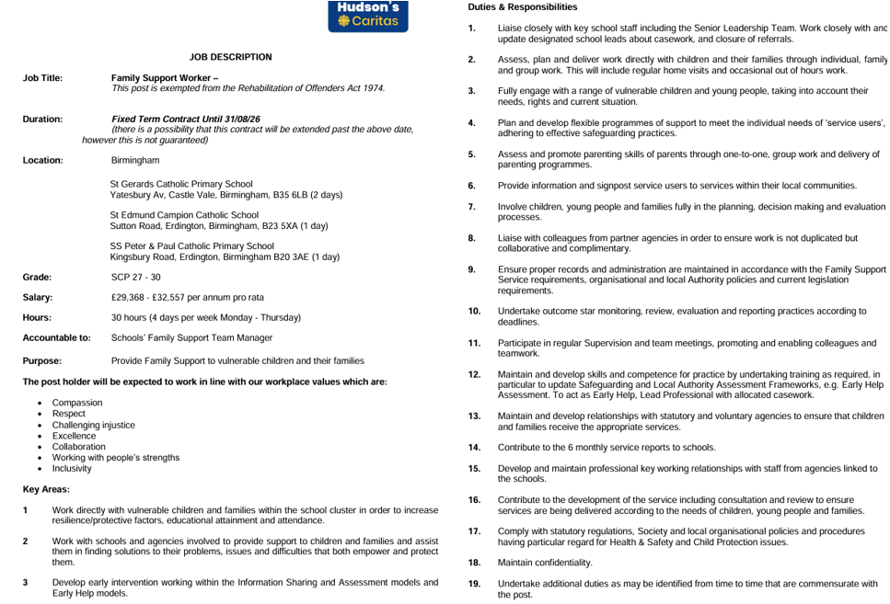

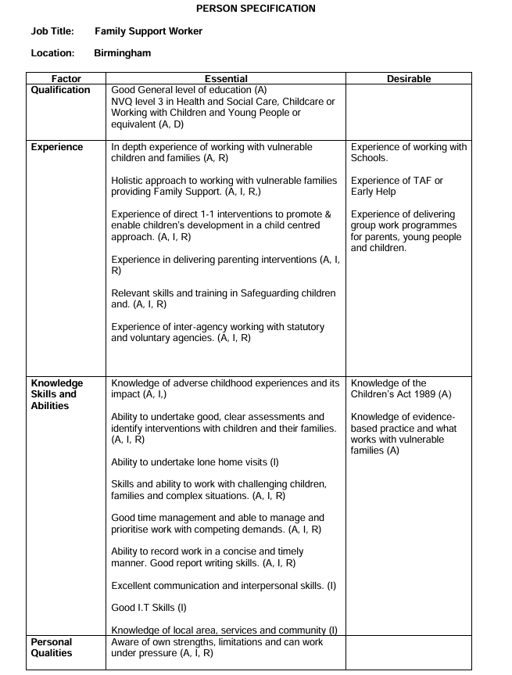
Father Hudson’s Caritas (2024) Family Support Worker – Job Description (P1838). Available at: https://www.fatherhudsons.org.uk/wp-content/uploads/2024/12/P1838-Family-Support-Worker-Job-Description.pdf (Accessed: 10 November 2025).
Job role employability skills
Father Hudson's Caritas offers a fixed-term Family Support Worker position in three schools in Birmingham to assist families and children struggling with social, emotional, or behavioural issues. The role requires accurate case recording, multi-agency collaboration, 1:1 and group interventions and developing relationships with parents and carers. Multi-site responsibilities mean a driver’s license and vehicle access are necessary (Father Hudson’s Caritas, 2024).
The Family Support Worker role demands strong interpersonal and communication skills, alongside problem solving abilities to work effectively with families and professionals. Practitioners who build trusting relationships and communicate effectively are better able to support families and respond to their needs (Bromer and Henly, 2009). Birmingham City Council (2025) also highlights the importance of supporting parents and carers to create a positive and nurturing home learning environment.
Communication skills are particularly essential for discussing sensitive issues, calming tense situations and ensuring support plans are clear and understood. Effective communication supports multi-agency working, ensuring information is shared and children and families are kept safe (Department for Education, 2024). Strong communication increases family engagement, helping interventions succeed and safeguarding children (Broadhurst et al., 2020).
Empathy and emotional intelligence are required to make children and families feel valued. Morrison (2021) argues that empathy improves assessment accuracy and intervention planning by building a positive rapport and increasing family engagement. Statutory safeguarding guidance emphasises that professionals should listen to children, take their views seriously and work collaboratively with families to meet their needs (Department for Education, 2023). According to Salovey & Mayer (1990), emotional intelligence involves the capacity to understand, manage and use emotions in ourselves and others, and when this is lacking, individuals may misinterpret emotional cues and make less effective decisions which can weaken trust, hinder communication and reduce the effectiveness of support.
Compassion and respect are crucial because families share sensitive information. Practitioners must maintain dignity, demonstrate respect for individual differences, and support families in a non-judgemental way, reflecting the Care Act 2014’s focus on wellbeing and treating individuals with respect (HM Government, 2014). Collaboration across schools, health services, and social care agencies is also central, helping to build a full picture of a child or family’s circumstances (Father Hudson’s Caritas, 2024; HM Government, 2023). When respect, collaboration, or information-sharing fails, key concerns may be missed, potentially leading to serious negative outcomes for children (HM Government, 2023).
Personal Evaluation of My Skills and Experience
I have spent six years working as a Teaching Assistant working predominantly with SEND, supporting students with autism, ADHD and complex behavioural needs. My work has included carrying out Education Health and Care Plans, delivering both 1:1 and small-group interventions, and liaising closely with parents, the school SENCO, and other outer reach teams. This experience directly aligns with the Family Support Worker role at Father Hudson’s Caritas, which requires working with children and families facing social and emotional difficulties (Father Hudson’s Caritas, 2024).
My strengths include strong communication, empathy and adaptability. Through my role, I regularly build trust with children who find verbal communication difficult and with parents navigating challenging backgrounds, using active listening and non-judgemental action. Working collaboratively with therapists and external professionals has strengthened my multi-agency working skills, which matches the integrated, coordinated support model required in the Family Support Worker role (K Stuart, 2014).
My organisational skills, including accurate record-keeping and managing unpredictable, high-pressure situations, are essential for effective multi-agency planning and intervention. Keeping clear and accurate records ensures continuity of support and builds trust with partner agencies (NHS England, 2023). Resilience is another key strength I bring. Being able to stay calm and maintain professional judgement under pressure allows me to provide consistent, reliable support to children and families, even in challenging situations (HCPC, 2024).
Areas for Development
As a Family Support Worker, I know the role is much more than just offering emotional support but also involves assessing a family’s needs, managing a caseload, coordinating with multi-agency teams, and writing reports (Prospects, 2025). According to some role profiles, I would also help with practical tasks like parenting guidance, home-management, and attending case conferences or even court.
With experience and training, a Family Support Worker may specialise in working with families facing very challenging issues, such as addiction, incarceration, or financial and relationship difficulties (National Careers Service, n.d). I recognise areas where I need to develop. Using Gibbs’ cycle and a SWOT analysis, I’ve realised I have very little experience in formal case management and in completing detailed assessments. Although I feel confident giving direct support, I’m less sure about producing formal reports or leading complex, coordinated interventions. This kind of coordination is critical, because without effective multi-agency collaboration which Treiber (2012) argues is vital for effective family support or significant problems may be overlooked or misunderstood.
Support to Improve Skills
To address this, I plan to pursue CPD training in trauma-informed practice, family-support frameworks and mental health training, which will enhance my readiness for the Family Support Worker role and align with Father Hudson’s Caritas’ values of collaboration, compassion, and ethical practice (RoleCatcher, 2025).
A SWOT analysis for my skills:
Strengths | Weaknesses
6 years’ SEND experience; communication skills; safeguarding knowledge; collaboration with families | Limited experience of multi-agency case management and formal family intervention reports
Opportunities | Threats
Completion of Health and Social Care BSc; CPD training in mental health and trauma-informed practice | High competition for roles need and flexible hours
These understandings suggest I have the experience to progress into a Family Support Worker role but must continue developing professional confidence in documentation, assessment, and Milti-Agency working.
Action Plan and Timeline for Development
I will use the SMART, Specific, Measurable, Achievable, Relevant, Time-bound framework to guide my professional development plan, ensuring my goals are clear, trackable, and realistic for me (SkillsYouNeed, 2025).
From January to December 2025, I will complete my Level 5 BSc Health and Social Care coursework. Maintaining strong academic performance and reflective practice during this time will provide a solid foundation in family and community support, which is essential for effective practice in this role. From March to June 2026, I plan to undertake a CPD course in trauma-informed practice, such as an online module or Safelives training, to build my capacity to support families with complex emotional and psychological needs.
To gain practical experience, I will volunteer at a local family hub or children’s centre from April to June 2026. This hands on work will allow me to develop key skills, including communication, assessment, and relationship-building, while observing multi-agency collaboration in real family support settings. From May 2026 onwards, I will create and maintain a LinkedIn profile, sharing achievements and networking with professionals to build my online professional identity.
From July 2026 onwards, I will actively apply for Family Support Worker vacancies, tailoring my CV and cover letters to reflect my skills, experience and CPD training. Finally, beginning in September 2026, I aim to start a Family Support Worker role, applying my academic knowledge, practical experience, and training in daily practice.
By structuring this plan with SMART goals, I can track my progress, reflect on learning, and ensure each step is time-bound, achievable, and relevant Islam (2024). Combining structured goal-setting, voluntary experience and relevant training will provide a strong foundation for entering the family support sector as a confident professional.
Using the Gantt-style framework, I have created a one year professional development plan to strengthen my employability for the Family Support Worker role.
Goal/Task | Start Date | End Date | Actions | Expected Outcome
Complete Level 5 BSc Health and Social Care coursework | Jan-25 | Dec-25 | Maintain strong academic performance and reflective practice | Gain theoretical knowledge of family and community support
Undertake CPD course in Trauma-Informed Practice | Mar-26 | Jun-26 | Enrol in online CPD or Safelives training | Enhance understanding of emotional and psychological trauma
Gain Voluntary Experience in Family Support Service | Apr-26 | Jun-26 | Volunteer with local family hub or children’s centre | Develop experience of direct family interventions
Create and maintain LinkedIn profile | May-26 | Ongoing | Upload achievements, network with professionals | Build online professional brand
Apply for Family Support Worker vacancies | Jul-26 | Ongoing | Tailor CV and cover letter for each application | Secure interview opportunities
Start Family Support Worker role | Sep-26 | Ongoing | Continue to use my knowledge of Level 6 studies to support me in my role | Improve professional confidence and self-awareness

Building Personal Brand and Professional Identity
To build my professional identity and career as a Family Support Worker, I will create a detailed Personal Development Plan (PDP) based on SMART goals. A PDP will help me identify my strengths, understand areas for growth and plan practical steps for development (Health Careers, 2025). My first SMART goal is to complete a trauma-informed practice course by March next year, which is specific, measurable, and directly relevant to my future role (Bjerke & Renger, 2017). I will do this by enrolling onto a certified CPD programme and setting aside two hours per week for study.
I will also strengthen my multi-agency working skills by attending at least two professional networking events related to social care and family support within six months. This goal is realistic and builds on my SEND experience though my SENCO at my current position, aligning with the expectations of the Family Support Worker role (Father Hudson’s Caritas, 2024). I will monitor my progress by keeping a log of contacts and key learning points from each event (Civil Service, n.d.).
To support my development, I will use the STAR method (Situation, Task, Action, Result) to reflect on experiences (Van der Bijl et al., 2024). After networking events or volunteering, I will record what happened, what I needed to do, the actions taken, and the results. This will help me recognise my strengths, identify areas for improvement, and most importantly prepare for interviews by giving clear examples of my skills (Indeed Editorial Team, 2025).
Finally, I will review my progress every three months, using feedback from mentors or peers. I am really fortunate to work closely with a Family support worker and SENCO in my current role. Networking through events, LinkedIn groups and voluntary organisations will further expand my professional connections and support future employment opportunities (Week 10 Recap, 2025).
Promoting my professional identity
Effectively promoting your professional identity is vital for standing out to employers. I would tailor my CV and covering letter for each role to highlight my communication, empathy and teamwork through examples such as supporting families, collaborating with education and health services(BASW, 2025).
Maintaining a professional online presence is also important, as it helps to connect with professionals and services safely and responsibly (BASW, 2025). I would also use a structured reflective practice such as Gibbs’ Reflective Cycle to help me to evaluate my experiences, clarify my values and plan practical development steps (Care Learning, 2025). This kind of self-reflection enables me to align my personal values of empathy, patience, and communication with the Family Support Worker role while identifying areas for growth.
Bringing together a tailored CV, cover letter, and online presence will show employers that I am not just experienced, but also thoughtful and intentional about my work. Building my network map via professional social care webinars or peer led groups will demonstrates my commitment to ongoing learning and supporting vulnerable families (Care Learning, 2025).
Building a network for success
Networking is an essential part of progressing within health and social care because it helps practitioners learn from others, access professional support, and stay informed about good practice Skills for Care (2023). Strong professional networks also improve confidence, open opportunities and create links between services that ultimately benefit children and families. According to National Careers Service (n.d) , building professional relationships and connecting with others in the sector is a key part of workforce development, helping practitioners share knowledge and strengthen collaborative working.
I already have a strong foundation in networking through my current role in the academy where the Family Support Worker post is advertised. Multi-academy trust training days give me regular opportunities to connect with staff from other schools, SENCos, pastoral teams, and Family Support Workers. These relationships help me understand how different schools approach early help, intervention and safeguarding, which strengthens my knowledge and gives me a clearer idea of what the role looks like in practice.
Being part of a large academy network also means I have access to potential mentors who can offer advice on professional development, job expectations and ways to progress into family support roles. This puts me in a strong position, as I am already building meaningful professional links that can support my move into this field and guide me as I develop my skills and confidence Indeed Editorial Team (2025).
Conclusion
In conclusion, this report has helped me recognise how much of my current experience and personal strengths already align with the Family Support Worker role at Father Hudson’s Caritas. My six years working in SEND have given me strong communication skills, patience, empathy, and the ability to build trusting relationships with children and families who have a range of needs. These are all qualities that are essential for supporting families effectively. I can also see where I need to grow, particularly around formal case management and leading multi-agency work. Identifying these gaps has been positive, as it gives me a clear focus for my next steps.
My action plan involves the relevant further training goals and commitment to reflective practice show that I am motivated to keep developing and strengthening my professional identity. Networking and learning from others is something I already do regularly through my academy role, and I will continue to support my confidence and understanding of family support work in real settings.
By continuing to build on my experience, completing further training, and reflecting on my practice, I feel I am genuinely preparing myself for the next stage of my career. This report confirms that I am on the right path to becoming a confident, capable Family Support Worker who can make a positive difference to children and families.

References
Aveyard, H. (2014). Doing a Literature Review in Health and Social Care: A Practical Guide (3rd ed.). Open University Press.
BASW (2025) Digital capabilities for social workers. Available at: https://www.basw.co.uk/policy-and-practice/resources/digital-capabilities-social-workers (Accessed: 24 November 2025).
Birmingham City Council (2025). Family support. Birmingham City Council. Available at:https://www.birmingham.gov.uk/info/50295/family_hubs/2810/family_support (Accessed: 15 November 2025)
Bjerke, M.B. & Renger, R. (2017) ‘Being smart about writing SMART objectives’, Evaluation and Program Planning, 61, pp. 125–127. doi: 10.1016/j.evalprogplan.2016.12.009.
BMHP5015 (2025). Week 10 Recap and Module Survey. University of Wales Trinity Saint David Lecture Slides.
BMHP5015 (2025). Week 3: Building Your Personal Brand for Sustainable Employment. University of Wales Trinity Saint David Lecture Slides.
Broadhurst, K., Mason, C., & Bowyer, S. (2020). Family support and child protection: Understanding complex needs. University of Bedfordshire.
Bromer, J. and Henly, J.R. (2009) ‘The work–family support roles of child care providers across settings’, Early Childhood Research Quarterly, 24(3), pp. 271–288. Available at: https://www.sciencedirect.com/science/article/pii/S0885200609000222 (Accessed: 10 November 2025).
Care Learning (2025) Explore models of reflection and the importance of reflective practice. Available at: https://carelearning.org.uk/qualifications/level-5-adult-care/lmac-6a-development/1-6-explore-models-of-reflection-and-the-importance-of-reflective-practice-in-improving-own-and-teams-performance/ (Accessed: 24 November 2025).
Civil Service (no date). Setting SMART Objectives. Available at: https://cdn.learn.civilservice.gov.uk/packages/NgoKaq_VS4yrAWPSSX1mTw/jdVhe-qYR9uo-XNgN4f_EQ/Setting%20SMART%20objectives.pdf (Accessed: 20 November 2025).
Department for Education (2024) Information sharing: Advice for practitioners providing safeguarding services to children, young people, parents and carers. GOV.UK. Available at: https://assets.publishing.service.gov.uk/media/66320b06c084007696fca731/Info_sharing_advice_content_May_2024.pdf (Accessed: 11 November 2025).
Father Hudson’s Caritas, Our Values. Father Hudson’s Caritas. Available at: https://www.fatherhudsons.org.uk/our-values/ (Accessed: 10 November 25)
Gibbs, G. (1988) Learning by Doing: A Guide to Teaching and Learning Methods. Oxford: Oxford Polytechnic.
Gibbs, G. (1988). Learning by Doing: A Guide to Teaching and Learning Methods. Oxford Brookes University.
HCPC (2024) Record keeping under pressure – HCPC standards. Available at: https://www.hcpc-uk.org/covid-19/advice/applying-our-standards/record-keeping-under-pressure/ (Accessed: 14 November 2025).
Health Careers (2025) Personal Development Plans (PDPs). Available at: https://www.healthcareers.nhs.uk/career-planning/personal-development-plan-pdp (Accessed: 24 November 2025).
Health Careers (NHS) (no date) Personal development planning. Available at: https://www.healthcareers.nhs.uk/career-planning/developing-your-health-career/personal-development-planning (Accessed: 20 November 2025).
Health Education England (n.d.) Core skills and how they link into person-centred care. NHS Cancer Communications Resource Hub. Available at: https://www.hee.nhs.uk/our-work/cancer-diagnostics/cancer-communications-resource-hub/patient/core-skills-how-they-link-person-centred-care (Accessed: 10 November 2025).
HM Government (2023) Working Together to Safeguard Children: statutory guidance on multi-agency working to help, protect and promote the welfare of children. Available at: https://assets.publishing.service.gov.uk/media/669e7501ab418ab055592a7b/Working_together_to_safeguard_children_2023.pdf (Accessed: 24 November 2025).
National Careers Service (no date) Networking: tips to help your career. Available at: https://nationalcareers.service.gov.uk/careers-advice/networking (Accessed: 22 November 2025).
NHS Digital. (2022). Digital Inclusion in Health and Social Care. Available at: https://digital.nhs.uk (Accessed 10 November 2025).
NHS England (2023) Safeguarding – Information Governance and Record-Keeping. Available at: https://www.england.nhs.uk/long-read/safeguarding/ (Accessed: 24 November 2025).
RoleCatcher (2025) Family Support Worker. Available at: https://rolecatcher.com/en/careers/technicians/legal-and-social-professionals/legal-social-and-religious-professionals/social-work-professionals/family-support-worker/ (Accessed: 24 November 2025).
Skills for Care. What core skills do I need to work in social care (2023). Skills for Care. Available at: https://www.skillsforcare.org.uk/Documents/Recruitment-and-retention/Careers-in-care/What-core-skills-do-I-need-to-work-in-social-care.pdf (Accessed 11 November 2025)
Stuart, K. (2014) “Collaborative agency to support integrated care for children, young people and families”, Children & Society, 28(6), pp. 512–523. Available at: https://www.ncbi.nlm.nih.gov/pmc/articles/PMC4027932/ (Accessed: 24 November 2025).
Indeed Editorial Team (2025) ‘What is professional networking? (Learn and master it)’, Indeed UK Career Guide, Indeed, 4 March. Available at: https://uk.indeed.com/career-advice/career-development/professional-networking (Accessed: 23 November 2025).
Health Careers (NHS) (no date) Personal development planning. Available at: https://www.healthcareers.nhs.uk/career-planning/developing-your-health-career/personal-development-planning (Accessed: 25 November 2025).
Van der Bijl, C.C., et al. (2024) ‘Mastering job interview skills for family physicians’, PMC Article [online]. Available at: https://pmc.ncbi.nlm.nih.gov/articles/PMC10839229/ (Accessed: 25 November 2025).
Salovey, P. & Mayer, J.D. (1990) ‘Emotional intelligence’, Imagination, Cognition and Personality, 9(3), pp. 185–211. Available at: https://journals.sagepub.com/doi/abs/10.2190/DUGG-P24E-52WK-6CDG (Accessed: 25 November 2025).
Prospects (2025) Family support worker job profile. Available at: https://www.prospects.ac.uk/job-profiles/family-support-worker (Accessed: 22 November 2025)
Treiber, L.A. (2012) ‘The role of “workplace family” support on worker health, exhaustion and pain’, Community, Work & Family, 15(1), pp. 1–27. doi: 10.1080/13668803.2011.580123. (Accessed 21 November 2025)

