Portfolio

ECIE5002

Emily Combe

265650

Contents Page

Video Link - https://www.canva.com/join/shq-mzr-nyv

Pages 4- 5: …………………………………………………………. Essay
Page 6: …………………………………………………………….. Essay (reference list)
Page 7: …….………………………………………………….......... Blog
Page 8: …………………………………………………................... Blog (reference list)
Page 9 - 10: ………………………………………………………… Resource Information Sheet
Page 11: …………………………………………………………..... Resource Information Sheet (reference list)
Page 12: ……………………………………………………………...Video
Page 13-14: ………………………………………………………….Evaluation
Page 15-16: ………………………………………………………….Evaluation (reference list)

Why is Good Numeracy Important?

Numeracy, as defined by the Cambridge Dictionary (2025) is the ability to do basic mathematics. However, numeracy is not just about an individual's ability to perform basic mathematics. It is about understanding number relationships, interpreting data and being able to use mathematical reasoning to make decisions in daily life. Despite its importance, a significant portion of the population does not possess strong numeracy skills and does not wish to improve on them. National Numeracy’s data reveals that adults continue to undervalue the importance of the skills gained through a basic understanding of mathematics (GOV UK, 2019). This essay will be discussing why good numeracy is important by linking it to the wider social and political aspects.

Numeracy affects our lives in many ways, so having an understanding is crucial. Numeracy refers to the understanding and skills needed to meet the mathematical demands of both personal and public life. It enables individuals to engage in society as informed, thoughtful and active members of the public (Geiger et al. 2015). Numeracy allows individuals to make informed decisions in a wide variety of areas. Everyday tasks such as budgeting, shopping, working out interest rates or paying into a retirement scheme all require an understanding of mathematical understanding. Without these skills, individuals are more likely to make poor decisions, which in turn leads to negative financial and ultimately personal outcomes. A lack of numeracy skills has also been linked to lower wages and higher unemployment rates (UK Parliament, 2019). The National Numeracy Charity (2022) highlights that over 54% of the working-age population has low numeracy skills. This can result in poor financial planning and even financial crises in adulthood, showing that individuals with low confidence in numeracy being worse off than those with strong numeracy skills.

Furthermore, numeracy influences an individual's social and political engagement. As Schleicher (2025) states, people with low numeracy are less likely to participate in political discussions, as they may find it difficult to understand or evaluate data on important issues. This then limits their ability to make informed decisions and contributes to their disinterest in political and social issues. In contrast, those with good numeracy skills are better at critically evaluating information and making informed choices when it comes to social and political factors, leading them to make better choices as members of the public. Despite the clear importance of numeracy, many people continue to underestimate its value.
As the Organisation for Economic Co-operation and Development (2025) state, one in four adults have limited numeracy skills, scoring at Level 1 or lower on the Programme for the International Assessment of Adult Competencies numeracy scale. Those at Level 1 can manage basic calculations with money, they understand decimals and can extract simple details from tables or charts but may struggle with more complex tasks. Whereas individuals below Level 1 can only perform basic addition and subtraction with small numbers. On average, just 14 percent of adults in Organisation for Economic Co-operation and Development (OECD) countries achieved Levels 4 or 5 which are the highest levels of numeracy. They can calculate and understand rates, ratios, interpret complex graphs and critically assess data. However, for the lower-level individuals, numeracy does not seem to be a priority.

As National Numeracy (2022) reports, 40% of individuals do not prioritize improving their numeracy skills, even though they acknowledge that basic math is essential in daily life. One reason for this is negative impressions that are formed in childhood, leading individuals to avoid engaging with math altogether. The Cockcroft Report (1982) says that the attitudes and expectations of parents can have a significant impact on children's mathematical development. Parents who dismiss the importance of numeracy or fail to encourage math can contribute to the poor attitudes toward numeracy and math in their children. As a result, individuals may struggle to develop basic skills, which can affect their educational and professional outcomes later in life. Therefore, one of the key solutions to addressing the lack of numeracy skills is to make learning mathematics more engaging and accessible. The Welsh Government (2020) believe that it is essential to create positive and inclusive learning experiences that promotes mathematical resilience in learners. This can be achieved by encouraging education that makes mathematics relevant to real-life situations, helping learners see the practical applications of numeracy in everyday life. Moreover, providing opportunities for adult education and training in numeracy can help individuals improve their skills and overcome the challenges they face in various aspects of life, from managing finances to advancing in their careers.

In conclusion, having good numeracy skills is important as it is a life skill that influences many aspects of daily life. As having these skills helps with the understanding and skills needed to meet the mathematical demands of both personal and public life. From everyday aspects of life for example shopping. Through to managing personal finances and ensuring a secure career with a higher wage. However, a significant portion of the population does struggle with numeracy which is leading to negative consequences. To address this issue, it is important to have engaging and accessible learning experiences that encourage individuals to develop their numeracy skills. By improving numeracy, individuals can make more informed decisions, participate more actively in political and social aspects leading to a greater involvement in society and enhances overall well-being. Governments, educational institutions and communities must work together to ensure that everyone can develop the numeracy skills they need to succeed in today’s increasingly complex world.

Reference List:

Cambridge Dictionary (2025) Numeracy Definition. Available at: https://dictionary.cambridge.org/dictionary/english/numeracy (Accessed: 5th February 2025)

Cockcroft, W. H (1982) The Cockcroft Report. Available at: http://www.educationengland.org.uk/documents/cockcroft/cockcroft1982.html (Accessed: 5th February 2025)

Geiger, V., Goos, M. and Forgasz, H. (2015) A rich interpretation of numeracy for the 21st century: A survey of the state of the field. (47), pp.531-548.

GOV UK (2019) The importance of numeracy as a life skill [blog]. Available at: https://educationhub.blog.gov.uk/2019/05/the-importance-of-numeracy-as-a-life-skill/ (Accessed: 7th February 2025)

GOV. UK (2019) Ways improving your Numeracy skills has become easier. Available at: https://www.gov.uk/government/news/ways-improving-your-numeracy-skills-has-become-easier (Accessed: 6th February 2025)

National Numeracy (2022) New survey shows Brits are not as good at maths as they think. Available at: https://www.nationalnumeracy.org.uk/news/new-survey-uk-numeracy (Accessed: 5th February 2025)
OECD (2025) Adults Numeracy Skills. Available at: https://www.oecd.org/en/topics/sub-issues/adult-numeracy-skills.html (Accessed: 12th February 2025)

Schleicher. A (2025) Why is Numeracy Important? Available at: https://www.nationalnumeracy.org.uk/what-numeracy/why-numeracy-important (Accessed: 5th February 2025)

UK Parliament (2019) Evidence on Adult Skills and Lifelong Learning. Available at: https://committees.parliament.uk/writtenevidence/104394/pdf/ (Accessed: 5th February 2025)

Welsh Government (2020) Mathematics and Numeracy. Available at: https://hwb.gov.wales/curriculum-for-wales/mathematics-and-numeracy/ (Accessed: 5th February 2025)

What Can Schools Do to Encourage Good Numeracy?
https://www.canva.com/design/DAGfcQxXzvc/Hk7Uz-CwA3CNj8TFOxyl-A/edit?utm_content=DAGfcQxXzvc&utm_campaign=designshare&utm_medium=link2&utm_source=sharebutton
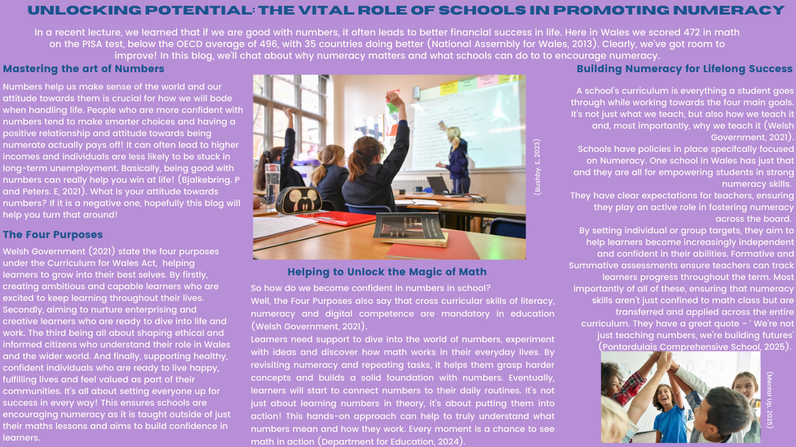

Reference List:

Bjälkebring P, Peters E (2021) ‘Money matters (especially if you are good at math): Numeracy, verbal intelligence, education, and income in satisfaction judgments.’ PLoS ONE 16(11). https://doi.org/10.1371/journal.pone.0259331

Bushby, E. (2023) British pupils’ gains in maths and reading declined following pandemic – study [image]. Available at: https://www.independent.co.uk/news/uk/organisation-for-economic-cooperation-and-development-teenagers-british-hinds-damian-hinds-b2458855.html (Accessed: 10th February 2025)

Department for Education (2024) Why numbers are important. Available at: https://help-for-early-years-providers.education.gov.uk/areas-of-learning/mathematics/numbers (Accessed: 5th February 2025)

Mental Up (2025) How to Get Better at Math: 14 Effective Steps [image]. Available at: https://www.mentalup.co/blog/how-to-get-better-at-math (Accessed: 10th February 2025)

National Assembly for Wales (2013) Literacy and Numeracy in Wales. Available at: https://senedd.wales/media/4tfknvrj/13-039-english.pdf (Accessed: 5th February 2025)

Pontardulais Comprehensive School (2025) Numeracy Policy. Available at: https://pontcomp.co.uk/wp-content/uploads/2022/07/Numeracy-Policy-min.pdf (Accessed: 10th February 2025)

Welsh Government (2021) Developing a vision for curriculum design. Available at: https://hwb.gov.wales/curriculum-for-wales/designing-your-curriculum/developing-a-vision-for-curriculum-design/#curriculum-design-and-the-four-purposes (Accessed: 29th January 2025)

Welsh Government (2021) Introduction to curriculum for Wales Guidance. Available at: https://hwb.gov.wales/curriculum-for-wales/introduction-to-curriculum-for-wales-guidance/ (Accessed: 29th January 2025)

Resource – Information Sheet

Reference List:

HWB (2024) Supporting learner progression: assessment guidance. Available at: https://hwb.gov.wales/curriculum-for-wales/assessment-arrangements/supporting-learner-progression-assessment-guidance (Accessed: 20th February 2025)

Gordan, M. and Krishanan, I.A. (2014) ‘A review of BF Skinner’s Reinforcement Theory of Motivation’. International journal of research in education methodology, 5(3), pp.680-688.

Welsh Government (2021) Curriculum for Wales: Summary of Legislation. Available at: https://hwb.gov.wales/curriculum-for-wales/summary-of-legislation/ (Accessed: 29th January 2025)

Barnet, S. (2019) ‘Application of Vygotsky’s social development theory’ Journal of Education and Practice, 10(35), pp.1-4.

Lees, J. (2024) The Value of Maths Games. Available at: https://www.booktrust.org.uk/news-and-features/features/2024/march/the-value-of-maths-games/ (Accessed: 21st February 2025)

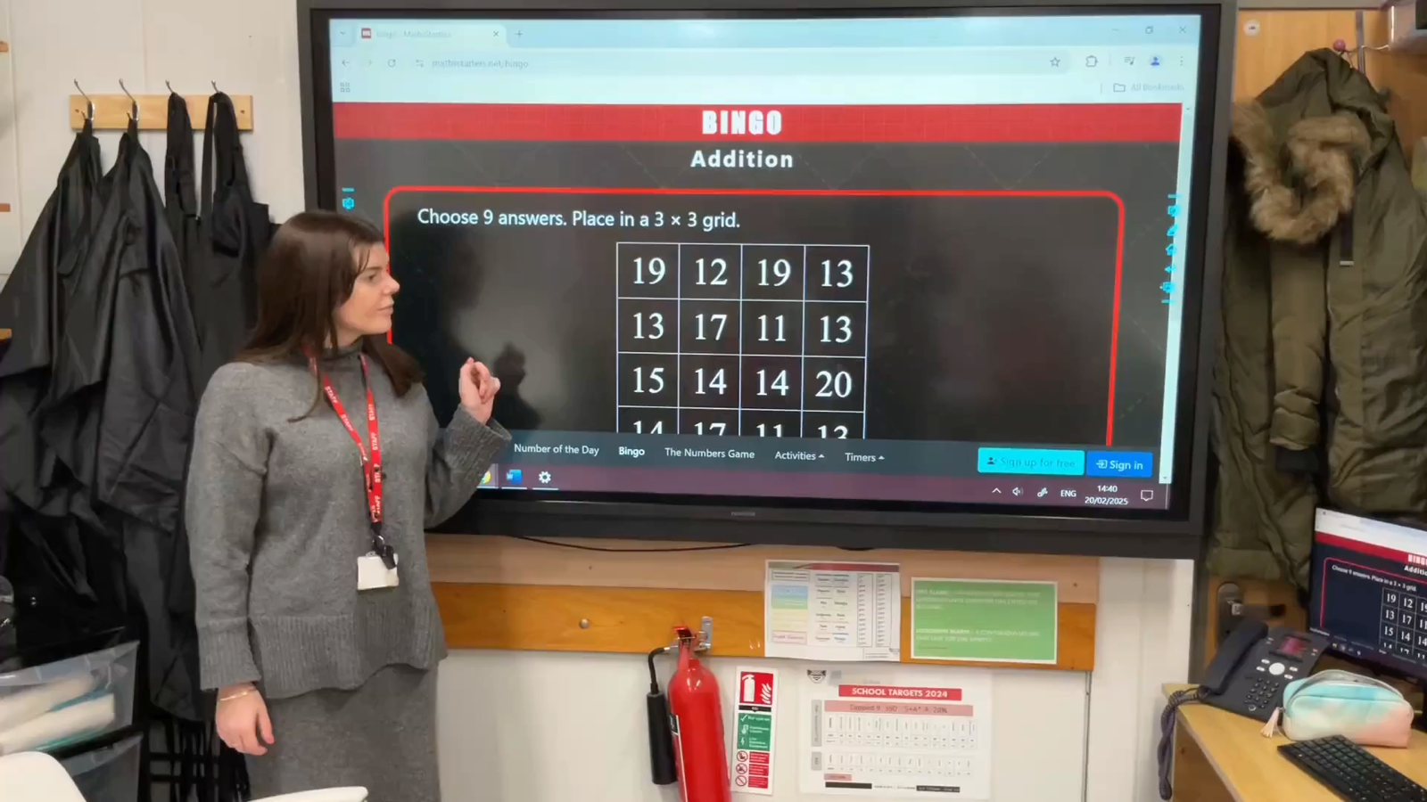
Video of Resource in Action

https://www.canva.com/join/shq-mzr-nyv

Evaluation of Resource

To motivate children to learn math, teachers must create engaging teaching methods that make the subject enjoyable (Strategy Education, 2017). Math Bingo is an educational game used to help students practice and reinforce their mathematical skills in a fun and interactive way. This evaluation will be discussing the effectiveness of this numeracy resource critically, drawing on the numeracy framework, theories of learning and whether progress is made by the learners. Reflecting on the advantages and disadvantages and whether it works for all students.
Numeracy is applying mathematics to solve problems in everyday life. It is essential in our lives and crucial for economic well-being. Therefore, it is important that mathematical and numeracy experiences are made engaging, exciting and accessible for learners (Hwb, 2025). This resource is a numeracy take on the classic Bingo game, with the key difference being that players solve math problems. Using numerical, measurement, geometry and algebra games to play using their self-created bingo grids. This math bingo game is an online resource used to develop learners in numeracy using cross-curricular skills, allowing learners to see how they use numeracy in daily life. The Four Purposes sets out in the Curriculum for Wales (2021) that students should be provided with opportunities throughout the curriculum to apply numerical skills and problem-solving in everyday scenarios. They must also become proficient in using various technologies to function, communicate effectively, and understand the world around them (Welsh Government, 2021). According to the Organisation for Economic Co-operation and Development (OECD), mathematics and numeracy are often seen as challenging worldwide and societal views on the importance of mathematics can impact learners' engagement (Welsh Government, 2023). This resource allows learners to become engaged in numeracy in a positive way.
In a classroom setting, students can become more excited and eager to participate in a math lesson when it involves a game. This excitement not only makes the learning experience enjoyable for learners, but it also helps to reduce some of the stress and anxiety that students may feel when faced with topics within numeracy (Hattie, 2009). The competitive nature of this game can encourage students to stay focused and motivated. Learners compete to be the first to complete a row/ line or a full table/house on their card by solving math problems that come up on the screen correctly. The competitive aspect of this game pushes students to pay attention, think quickly and solve problems more efficiently. The desire to win can inspire students to try their best, which often leads to improved focus and retention of the concepts being practiced (Ryan & Deci, 2000). Another notable benefit of Math Bingo is that it reinforces basic math skills in a fun and engaging way. The game is typically used to practice foundational math concepts such as addition, subtraction, multiplication, division. Alongside measurements, geometry and algebra. These are skills that students need to progress in areas of mathematics and numeracy (Sharma & Kar, 2015). As students continue to play and solve math problems in this resource, they are reinforcing their understanding and recall of concepts they have learnt in their lessons. This repeated practice is essential for developing the speed and accuracy necessary for success in more complex tasks (Siegler, 2009). As learners advance, they become stronger in their learning in social and work-related settings (Welsh Government, 2021). Math Bingo also promotes social interaction and collaborative learning. As the game is typically played in groups, learners can work together, share ideas and discuss math concepts in a relaxed way. This type of interaction can be beneficial in a classroom setting because it allows space for a cooperative learning environment where learners can learn from one another (Education Endowment Foundation, 2025). This collaborative learning can be especially helpful for learners who may feel hesitant to ask questions or seek help from the teacher. By playing together, learners build a sense of community and the social aspect of the game can make learning feel less isolated (Bransford et al., 2000). This can enhance learners' understanding and create a positive learning environment.
While Math Bingo has many advantages, it also has its disadvantages. Math Bingo does not promote deep conceptual understanding or critical thinking about numeracy or mathematical concepts. While students can practice solving math problems, the game does not provide opportunities for students to explore the reasoning behind these topics or to develop problem-solving skills for more complex tasks (Hiebert & Grouws, 2007). In addition, the game is not sufficient for addressing the full range of learning needs in a classroom, especially for learners who have additional learning needs. Students who are struggling with basic skills may find that Math Bingo does not provide enough support. Without a deeper focus on conceptual understanding, students may simply memorize math facts or guess the answers. This lack of conceptual understanding can be detrimental to students’ long-term learning and mathematical development (National Clinic Trials Network, 2000).
In conclusion, Math Bingo is an enjoyable and engaging educational tool that has its benefits, including increased student engagement by making it fun and relatable. It reinforces basic math skills and encourages social interaction and peer learning. It can give learners an environment where they can practice foundational math concepts and gain confidence in their abilities. However, its effectiveness is limited in certain ways, particularly when it comes to learners gaining a deeper understanding. Math Bingo works best as a fun activity, reinforcing basic math facts in an interactive and motivating way. However, it should be used alongside other teaching methods that promote conceptual understanding and problem-solving skills to provide math education. Teachers can make the most of Math Bingo by adapting it to suit the needs of different learners, ensuring that the game remains an effective and engaging tool in the classroom.

Reference List:

Bransford, J. D., Brown, A. L. and Cocking, R. R. (2000) How people learn: Brain, mind, experience, and school. Washington, D.C.: National Academy Press.

Education Endowment Foundation (2025) Collaborative Learning Approaches. Available at: https://educationendowmentfoundation.org.uk/education-evidence/teaching-learning-toolkit/collaborative-learning-approaches (Accessed: 28th February 2025)

Hattie, J. (2009) Visible learning: A synthesis of over 800 meta-analyses relating to achievement. London: Routledge.
Hiebert, J., and Grouws, D. A. (2007) The effects of classroom mathematics teaching on students' learning: Second Handbook of Research on Mathematics Teaching and Learning. Charlotte, NC: Information Age Publishing.
HWB (2025) Mathematics and Numeracy. Available at: https://hwb.gov.wales/curriculum-for-wales/mathematics-and-numeracy (Accessed: 28th February 2025)
National Clinic Trials Network (2000) Principles and standards for school mathematics. Reston, VA: National Council of Teachers of Mathematics.
NCTM (2000) Principles and standards for school mathematics. Reston, VA: National Council of Teachers of Mathematics.
Ryan, R. M. and Deci, E. L. (2000) ‘Self-determination theory and the facilitation of intrinsic motivation, social development, and well-being.’ American Psychologist, 55(1), pp. 68-78.

Sharma, S. and Kar, S. (2015) ‘Reinforcing basic math skills through games and activities.’ Journal of Educational Psychology, 37(3), pp. 150-160.

Siegler, R. S. (2009) ‘How can developmental psychology contribute to understanding and improving mathematics education?’ Developmental Psychology, 45(6), pp. 1436-1444.

Strategy Education (2017) Making Math Fun. Available at: https://strategyeducation.co.uk/making-maths-fun/ (Accessed: 28th February 2025)

Welsh Government (2021) Developing a vision for curriculum design. Available at: https://hwb.gov.wales/curriculum-for-wales/designing-your-curriculum/developing-a-vision-for-curriculum-design/#curriculum-design-and-the-four-purposes (Accessed: 29th January 2025)
Welsh Government (2023) Mathematics and Numeracy Plan 2023. Available at: https://www.gov.wales/mathematics-and-numeracy-plan-2023-html (Accessed 20th February 2025)

