


Owen Willams – 2113039
BEng Mechanical Engineering
Advanced Thermofluid Mechanics
Rob Goodson
Submission Date – 17th June 2024

Design and Analysis of Extended Surfaces

Application and History of Fins
In the field of thermodynamics, fins are a widely used and utilised aspect for engineering purposes. Fins are surfaces that extend from an object which are used as critical components in heat transfer with their job being to enhance the rate at which heat is transferred between surfaces and their surrounding environment.
Optimizing the heat transfer within the engine leads to improved efficiency and power saving. (Kayal & Sur, 2021) explain that different characteristics of the fins such as base temperature, fin tip, fin array are studied to help understand how they affect the efficiency and effectiveness of the fin. This can then all help and contribute to the flexible analysis and design of the fin to be used. Having an understanding of material options along with properties and cost, conductivity of the material will impact on the performance and transfer process of the fins.
Fin efficiency is described as the ratio heat transfer from the actual fin to the heat transfer of an imaginary fin of the same geometry and same conditions but with an infinite conductivity according to (Thorat, 2022). Another way of explaining it would be if the temperature of the entire fin surface was equal to the temperature at the base, therefore the efficiency will always be smaller than 1.
(Thorat, 2022) then goes on to describe fin effectiveness as being the quantity of heat extra heat being given off from the fin. It can also be described as the heat transfer of the fin compared to the heat transfer without a fin. The aim is to keep the overall cost from adding fins to a minimal whilst also having this ratio as large as possible.
It is found that by increasing the surface area of fins will have a direct increase in the heat transfer. Practical examples of fins can be seen in automotive engines and especially high-performance cars and motorbikes. Fins are found mounted on the engine block and are used to increased surface area and therefore dissipate heat generated through combustion (Kadam, 2019). The use of fins is to also extend the lifespan of engines by stopping them from overheating and therefore seizing up. Fins can also be found in car radiators to with the same objective of increasing heat transfer from the coolant to the surrounding air.
Looking at the history and design or fins within automobile engines, it was during 1904 where an engineer in Manchester known as Royce first used a tube-fin radiator. This was an all-aluminium radiator which increased surface area and therefore enhanced the heat exchange, this then became more popular by the end of the decade with notable vehicles such as the Ford Model T using the simple fin design (CBD Autoradiators, 2024).
The development of fins then took an advance during the mid and late 20th century where firstly, material of radiators took a move from copper and brass cores to more lighter materials which provide better heat dissipation. The fins also took a more advanced turn in terms of design, where more sophisticated developments were made such as the louvered fin. This is a fin which includes angled slits or louvers cuts into the fin, this allows for air to be directed across the radiator surface enhancing the heat transfer, overall cooling efficiency and airflow turbulence (Jani, 2024). The late 1900s then saw fins become more efficient by again changing shapes and design meaning they became denser with wave shaped and cross-flow patterns reducing weight and size but having a greater surface area whilst still increasing the cooling efficiency, these can also be known as wavy or corrugated fins. Again, these fins also generate turbulence, this helps to break up the boundary layer of air near the fin surface, further improving heat transfer.
The 21st century now sees fins more efficient and effective than ever with advanced shapes and materials being used. Radiators now use materials like aluminium alloys for sophisticated shapes such as serpentine fins and dimpled fins for better air flow and heat exchange. Hybrid cooling is now seen in car radiators also which includes both liquid and air cooling, fins are used within these systems and a critical role maximising heat transfer (Shareef, 2021).
The advantages of using fins are that it increases the rate of heat transfer whilst being a cheap and easy way of keeping equipment cool, it is also important that it does not increase the amount of maintenance needed on the component. The disadvantage of using fins is that it will cause the weight of the component or machine to increase, the length of the fins may lead to bending if not properly designed which can affect the overall efficiency, this is why it is important to properly research and design and why material such as aluminium alloy is used due to its material properties.
Fins have also become a crucial design feature on micro-processors used on electronic components such as computer processors and amplifiers where high amounts of heat are generated. Here, fins are built and used to help pull the heat away from the processor and therefore prevent the components from suffering thermal damage. After 1993 all processors needed heat sink fins and fans to help cool them due the increase in performance. Early pins would often be straight pins or flat plates angled from the base
With the advancement of micro-processors in them becoming more and more powerful, it has become critical that heat sink fins and cooling processes even including fans are used to allow reasonable air flow and cooling to take place to maximise life span and reduce the chances of overheating issues occurring. The fin has the same principle as that used in different applications such as radiators in car engines, it is designed to maximise heat transfer by increasing its surface area in contact with the surrounding area such as air. The fin transfers the thermal energy from a high temperature area and transfers it to a lower temperature fluid such as air. (Cheung, 2020) states that sometimes, if the heat sink is meant to be a passive-heat sink, the designer may specify that the heat sink be anodized matte black to take advantage of increased black body radiation.
(Magadum, 2015) mentions that during the design of fins for micro-processors, considerations need to be made for thermal resistance, fin efficiency, fin arrangement and optimization and spreading resistance. Research has found that by limiting the constraints on fin pitch and thickness can attribute to allowing turbulent flow. Analysis of the flow through a partially ducted configuration of fins whilst having a fixed approach velocity has shown that an optimum length of fin exists, and therefore thermal resistance improves as fin pitch decreases.
The advancement in design technology such as solidworks designs and computational fluid dynamics (CFD) has allowed for fins to be designed without the use of material and then put under test the analyse the flow of fluid. This means that fins can be designed to perform at their optimum and maximise the rate of heat transfer without spending the money to manufacture it. (Waqas, 2022) states that adopting CFD modelling tools in invention and design saves time and cost when compared to experimental techniques. This then gives designers and companies a better understanding of how their components will perform. This is due to the design tools used allowing for material and geometric properties to be defined. Using this equipment means that fins can simply just be added to the design and then heat flux and transfer can then be calculated and studied. It could be found using this equipment that after a certain amount of fins, no considerable increase in heat flux or decrease in maximum temperature is observed, this allows for no wasted fins to be added which would increase the cost and the effectiveness of the micro-processor.
To conclude, the introduction and development of fins or extended surfaces has allowed for components and machinery to perform at its optimum for longer and to expand the lifespan of the kit. By increasing the surface area of a fin, it allows for the rate of heat transfer by dissipating the heat from a component and more it to its surrounding such as air. The advancement of fins means that designs have developed and therefore fins can be used on more obscure bits of kit with the same goal. From different designs the fins have become more efficient due to factors such as material, thickness and shape, thermal layout, and surrounding environment. Optimizing the design allows for fins to perform at their best in practical applications such as dissipating combustion heat from engines in vehicles and pulling away heat in performance equipment such as micro-processors.

Task B
When designing and using adiabatic fins, also known as fins with an adiabatic tip boundary condition, that it should be considered that the fin parameter known as mL is no greater than 2.65 for the length of an optimum fin. Calculating the optimum length is critical in the design aspects as it can save money and time when it comes to manufacturing and using fins on specific components.
It can be shown that the ratio between rate of heat transfer for a fin with an adiabatic tip ${\dot{Q}}_{finite}$ with the rate of heat transfer for an infinitely long fin ${\dot{Q}}_{∞}$ is equal to tanh(mL). Where tanh is simply the hyperbolic function of tan.
Using this formula of tanh(mL) and increasing the mL parameter in increments of 0.1 from 0 to 4 will show why the mL is typically no greater than 2.65. Using increments of 0.1 between the high and low number gives a clear viewing of how the rate of heat transfer changes from number well above and below the supposed optimum length. Below, is the graph which was plotted using the formula above.

As the above graph indicates, once the mL parameter goes greater than 2.65 there is no significant increase in the rate of heat transfer and so it can be considered that 2.65 in the optimum fin length to use.
Calculating the fins optimum length is a crucial part when designing fins to be used in practical components or systems. This gives an understanding that even though an increase in length or surface area normally has a direct impact in the rate of heat transfer, there is a limit to this. The parameter of mL being 2.65 for an adiabatic fin means that material is not being wasted for increasing the size of the fin, and that to gain maximum rate of heat transfer from the fin, the parameter does not need to be above 2.65, above this the ratio simply is not as effective.
To see the full table of figures used to plot the graph, refer to section 1.1 in appendix.
Task C
1.) The first task asks to find the temperature distribution along the length of 4 rods of different materials. As it is stated as a ‘very long rod’ it can be assumed that it is of infinite length, assuming this the equation below can be used to find the temperature distribution.

$$T\left(x\right)= T_{∞}+ (T_{b}- T_{∞})e^{-mx}$$
Where;
$T_{∞}$ is stated as being the ambient temperature of 20⁰C.
$T_{b}$ is the constant temperature being 120⁰C.
$x$ being the length, so increments of 0.01m all the way up to 0.4m.
$m$ is given as $\sqrt{\frac{hP}{kA_{C}}}$, where P is πd, Ac is πd²/4, h and k are material properties which differ for each rod.
2024 Aluminium Alloy
m = $\sqrt{\frac{30 * π * 0.00476}{186 * 1.7795 * 10-5}}$
m = 11.6421
$$T\left(x\right)= 20+ (120- 20)e^{-11.6421 * x}$$

Brass (70 Cu/30 Zn)
m = $\sqrt{\frac{30 * π * 0.00476}{99 * 1.7795 * 10-5}}$
m = 15.958
$$T\left(x\right)= 20+ (120- 20)e^{-15.958 * x}$$

Copper
m = $\sqrt{\frac{15 * π * 0.00476}{398 * 1.7795 * 10-5}}$
m = 5.638
$$T\left(x\right)= 20+ (120- 20)e^{-5.638 * x}$$
304 Stainless Steel
m = $\sqrt{\frac{7.5 * π * 0.00476}{16 * 1.7795 * 10-5}}$
m = 19.847
$$T\left(x\right)= 20+ (120- 20)e^{-19.847 * x}$$
Using these formulas for each of the materials and increasing ‘x’ by increments of 0.01 each time allowed for the below graph to be plotted to visually represent the temperature distribution along each of the four rods.

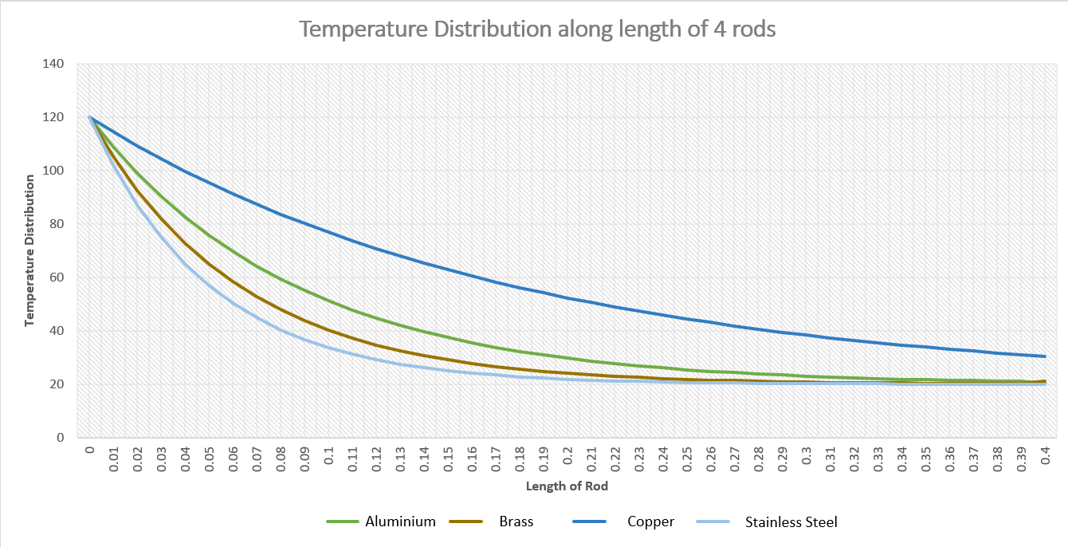
To view the table of figures used, refer to section 1.2 in appendix.

2.) The second task involved determining the corresponding heat loss values for each of the four rods shown above. The equation used to calculate this can be seen below, with each of the letters being directly the same to the corresponding values above.
$$\dot{Q}= \sqrt{hPkA_{c}} \left(T_{b}- T_{∞}\right)$$
Aluminium Alloy
$$\dot{Q}= \sqrt{30*π*0.00476*186*1.7795*10-5} \left(120- 20\right)$$
$$\dot{Q}=3.853W$$
Brass (70 Cu/30 Zn)
$$\dot{Q}= \sqrt{30*π*0.00476*99*1.7795*10-5} \left(120- 20\right)$$
$$\dot{Q}=2.811W$$
Copper
$$\dot{Q}= \sqrt{15*π*0.00476*398*1.7795*10-5} \left(120- 20\right)$$
$$\dot{Q}=3.98W$$
304 Stainless Steel
$$\dot{Q}= \sqrt{7.5*π*0.00476*16*1.7795*10-5} \left(120- 20\right)$$
$$\dot{Q}=0.565W$$
3.) As stated above in the assignment for an adiabatic fin it can be considered that an optimum length would be 2.65. Using this assumption a length can be determined for the four rods as well as the heat loss for each. As it is now considered an adiabatic fin tip the heat loss formula will also change to;
$$\dot{Q}= \sqrt{hPkA_{c}} \left(T_{b}- T_{∞}\right)tanh⁡(mL)$$
Aluminium Alloy
Optimum length can be stated as
$L=\frac{2⋅65}{m}=\frac{2⋅65}{11.6241}$
$$L=0.228m$$
$$\dot{Q}= \sqrt{30*π*0.00476*186*1.7795*10-5} \left(120- 20\right)tanh⁡(11.6421*0.228)$$
$$\dot{Q}=3.815W$$
Brass (Cu 70/30 Zn)
$$L=\frac{2⋅65}{m}=\frac{2⋅65}{15.958}$$
$$L=0.166m$$
$$\dot{Q}= \sqrt{30*π*0.00476*99*1.7795*10-5} \left(120- 20\right)tanh⁡(15.958*0.166)$$
$$\dot{Q}=2.783W$$
Copper
$$L=\frac{2⋅65}{m}=\frac{2⋅65}{5.638}$$
$$L=0.471m$$
$$\dot{Q}= \sqrt{15*π*0.00476*398*1.7795*10-5} \left(120- 20\right)tanh⁡(5.638*0.471)$$
$$\dot{Q}=3.947W$$
304 Stainless Steel
$$L=\frac{2⋅65}{m}=\frac{2⋅65}{19.847}$$
$$L=0.134m$$
$$\dot{Q}= \sqrt{7.5*π*0.00476*16*1.7795*10-5} \left(120- 20\right)tanh⁡(19.847*0.134)$$
$$\dot{Q}=0.559W$$
After finding the optimum length for each of the four rods, and using this result in the adiabatic heat loss formula, the results showed that the corresponding heat loss was not far off what was found with the infinite fin boundary condition. All four results from the different materials shows they are slightly less than calculated in task b, however it also shows that some of the rods do not need to be as long, as what was first calculated, for example, Aluminium Alloy generates a similar heat transfer but having a rod length of just 0.228 metres, saving on materials and costs.
4.) Since the optimum length of the rods have been calculated and the corresponding heat loss values, a temperature distribution graph can be plotted for the four rods and their optimum lengths, this used the formula below, again where ‘x’ is the increasing increments of 0.01.
$$T\left(x\right)= T_{∞}+ (T_{b}- T_{∞})\frac{cosh⁡[m\left(L-x\right)]}{cosh⁡(mL)}$$
Aluminium Alloy
$$T\left(x\right)= 20+ (120- 20)\frac{cosh⁡[11.6421\left(0.228-x\right)]}{cosh⁡(11.6421*0.228)}$$
Brass (Cu 70/30 Zn)
$$T\left(x\right)= 20+ (120- 20)\frac{cosh⁡[15.958\left(0.166-x\right)]}{cosh⁡(15.958*0.166)}$$
Copper
$$T\left(x\right)= 20+ (120- 20)\frac{cosh⁡[5.638\left(0.471-x\right)]}{cosh⁡(5.638*0.471)}$$
304 Stainless Steel
$$T\left(x\right)= 20+ (120- 20)\frac{cosh⁡[19.847\left(0.134-x\right)]}{cosh⁡(19.487*0.134)}$$

Using these formulas allowed for the below graph to be plotted, as you can see the length of the rods are much shorter and it can be seen that the temperature distribution never reaches the temperature of ambient air stated at being 20⁰C.

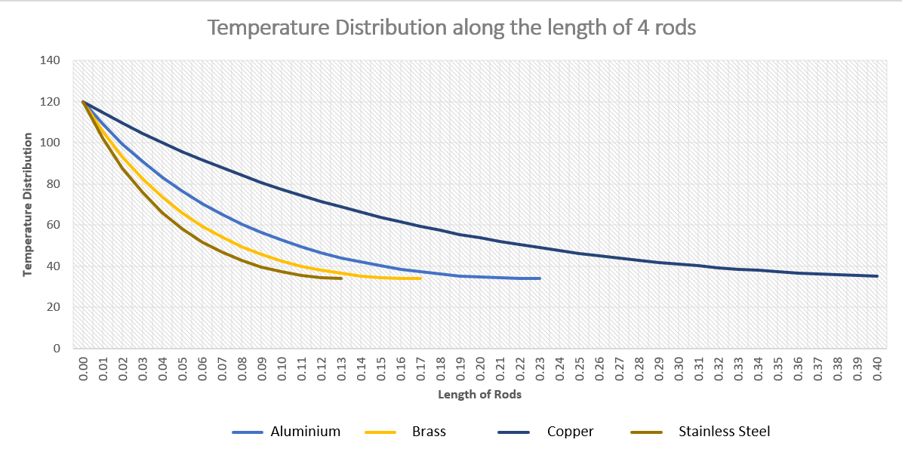
Refer to section 1.3 in appendix to see full table of figures calculated.
5.) To find a more temperature distribution for an infinite fin approximation, mL would need to be larger. Recognising a requirement that the tip temperature is very close to the fluid temperature; it can be shown that $e^{-mL} <0.01$. Using this equation, a more accurate length can be found and therefore a difference in the temperature distribution.
$$e^{-mL} <0.01$$
$$-mL<ln0.01$$
Aluminium Alloy
$$-11.6421 L<-4.6052$$
$$L>\frac{-4⋅6052}{-11⋅6421}$$
$$L=0⋅396$$
Brass (Cu 70/30 Zn)
$$-15.958 L<-4.6052$$
$$L>\frac{-4⋅6052}{-15.958}$$
$$L=0⋅289$$
Copper
$$-5.638 L<-4.6052$$
$$L>\frac{-4⋅6052}{-5.638}$$
$$L=0⋅817$$
304 Stainless Steel
$$-19.847 L<-4.6052$$
$$L>\frac{-4⋅6052}{-19.847}$$
$$L=0⋅232$$

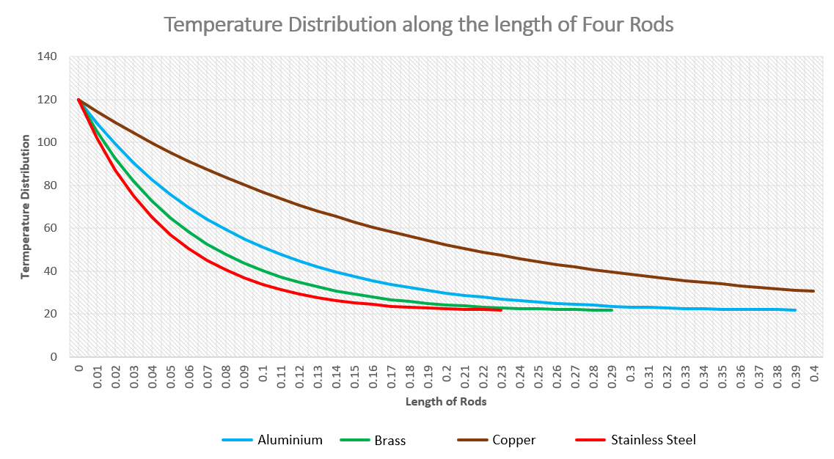
From these more accurate lengths of the rods a new temperature distribution graph was plotted, still only going up to the 0.4 metre length.
Refer to appendix 1.4 for full table of calculated figures.
The graph above differs from the graph in section four as the lengths are slightly longer, a lot longer with copper however it shows the other three materials reaching the ambient temperature of 20⁰C whilst also showing their optimum lengths.
Graph one seen in task one shows infinite length rods which is an idealistic theory, as there must be an eventual end to a fin. The above graph shows the optimum length these fins can be, so the shortest they can be therefore the less material used and less cost whilst also achieving the same temperature distribution and heat transfer. When choosing a material from this, factors would then be considered such as cost, weight, ease of manufacturing and is why aluminium alloy is often used as fins.

References

CBD Autoradiators. (2024). Analysis of the Historical Development of Automobile Radiator. Retrieved from Autoradiators : https://www.autoradiators.com/
Cheung, M. (2020, June). The State of Microprocessor Cooling Systems. Retrieved from Medium : https://medium.com/
Jani, D. K. (2024). Radiator Fin Designs. Retrieved from Techiescience: https://techiescience.com/
Kadam, A. (2019). Design and Thermal analysis of fin with different Geometeries of Engines. International Journal of Scientific & Engineering Research, 150 - 153.
Kayal, A., & Sur, A. (2021). Design and Analysis of Cooling Fins of Engine. International Journal of Engineering Research & Technology (IJERT), 305 - 307.
Magadum, P. (2015). Analysis & Optimization of Processor Cooling . International Journal of Engineering and Innovative Technology (IJEIT) , 90 - 93.
Shareef, M. (2021). Design and thermal analysis of engine cylinder fin body using various fin profiles. Materialstoday: Proceedings.
Thorat, S. (2022). Types Of Cooling Fins | Fin Efficiency, Applications, Advantages. Retrieved from LearnMech: https://learnmech.com/types-of-fins-heat-transfer-equation/
Waqas, H. (2022, May). Thermal transport analysis of six circular microchannel heat sink using nanofluid. Scientific Reports, pp. 9-12.

Appendix
  - – Figures used to plot curve representing optimum length.
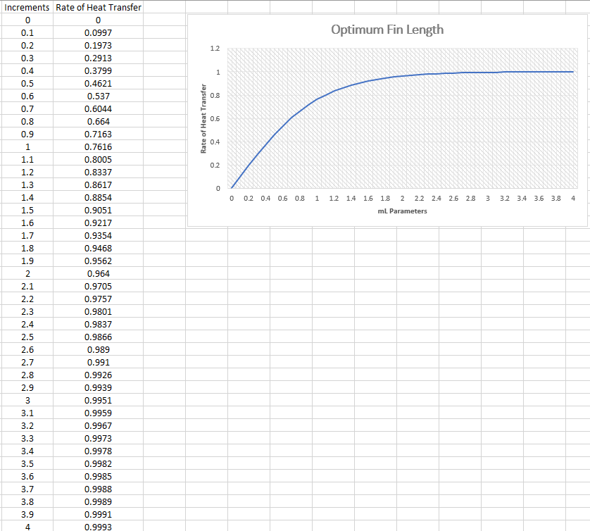

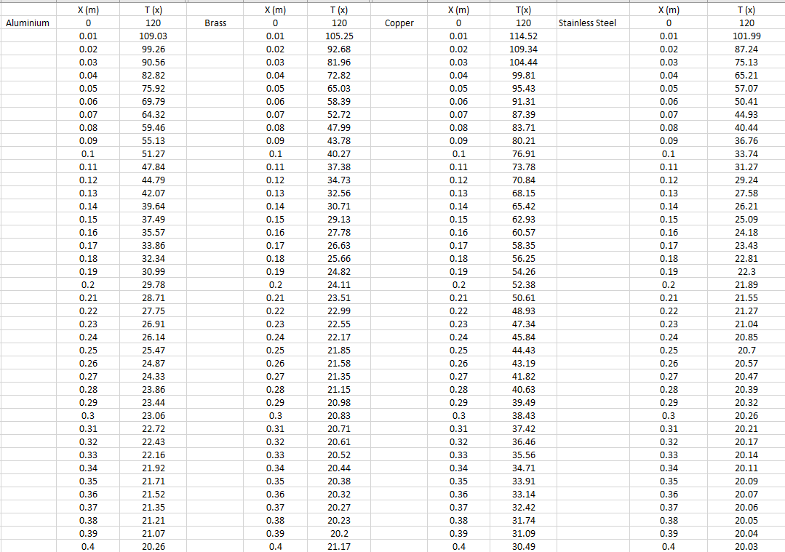
1.2 Full table of data which was used to plot graph for first question.
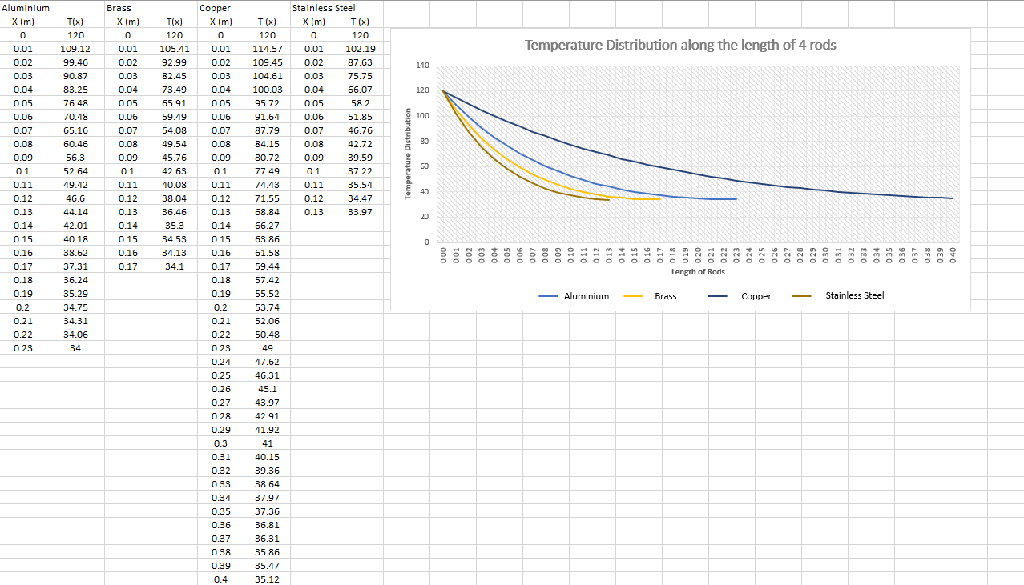
1.3 - Full table of data which was used to plot graph for fourth question in Task C.

1.4 - Full table of data which was used to plot graph for fifth question in Task C.


