University of Wales Trinity Saint David
School of Engineering



L5 Plant Group Industrial Project

ACMA5000
Matthew Frey
1302960
28/10/2024

Abstract
This project addresses the significant inefficiencies of the conventional paper-based Permit-to-Work (PTW) systems currently utilised by Tata Steel UK (TSUK), EnerSys UK, and Dwr Cymru Welsh Water (DWCC). These inefficiencies hinder operational performance, compromise transparency, and increase the likelihood of human errors. This initiative aims to develop a digital Permit to Work (ePTW) system, leveraging the capabilities of the Microsoft Power Platform, which includes tools such as Microsoft Forms, Power BI, Power Automate, and PowerApps. This digital solution enhances permit management, risk assessment, and oversight of employees and contractors.
The ePTW system's implementation allows real-time data tracking and reporting across mobile devices, tablets, and desktops, allowing seamless integration into existing workflows. Addressing the limitations of traditional paper-based systems, the project set clear outcomes aimed at improving efficiency, risk management, and compliance measures while ensuring data accessibility for audits and third-party applications.
A comprehensive literature review established the regulatory context and necessity for effective PTW systems in high-risk industries. The digital transformation from paper to electronic systems is demonstrated to significantly enhance compliance, tracking, and overall efficiency. By utilising cloud-based solutions, the project highlighted the role of technology in modernising safety management processes, ultimately supporting a flexible, responsive work environment.
The hybrid project management methodology combined Agile and Waterfall approaches to balance structured planning with flexible execution, fostering user engagement and continual feedback. This methodology, paired with the user-centric design of the ePTW system, led to a practical solution that meets operational requirements. The project's success was measured through various metrics and validated by stakeholder feedback, affirming its alignment with organisational goals and user needs.
Ultimately, this project represents a substantial advancement in managing operational permits, with the ePTW solution offering improved efficiency, greater accuracy in risk assessments, and enhanced monitoring capabilities. As organisations navigate safety and compliance challenges, this innovative approach lays a solid foundation for improving workplace safety and operational efficacy.

Table of Contents
1 Introduction 1
2 Literature Review 2
2.1 Permit to Work Systems- Regulation 2
2.2 Digital Transformation of Permit-to-Work Systems 2
2.3 Digital Transformation of Permit-to-Work Systems 3
2.4 Organisational and Behavioural Considerations 4
2.5 GDPR Compliance 4
3 Methodology 4
3.1 Hybrid Agile and Waterfall Methodology 4
3.2 Tools 5
3.3 Measurement and Validation of Results 6
4 Results and Discussions 7
4.1 Microsoft Form and Word Template Implementation 7
4.2 Power Automate Flows 10
4.3 Approvals 11
4.4 Power Apps Interface and Dashboard 12
4.5 Power BI Visualisations 12
4.6 Financial Analysis 14
4.7 Feedback 16
5 Conclusion 20
6 Evaluation 21
6.1 Organisational Learnings 21
6.2 Personal and Project Learnings 23
7 References 24

Figure 1: Blank Permit Template (Word) 8
Figure 2: QR Code Example 9
Figure 3: Approval Flow A 10
Figure 4: Closure Flow B 11
Figure 5: MS Teams Approvals 12
Figure 6: Permit Record Database 12
Figure 7: Location Dashboard 13
Figure 8: Active and Overdue Permit Dashboard 13
Figure 9: Task Aspect Dashboard 14
Figure 10: User Feedback 1 16
Figure 11: User Feedback 2 17
Figure 12: User Feedback 3 17
Figure 13: User feedback 5 18
Figure 14: User Feedback 5 18

Table 1: Financial Analysis 14
Table 2: ROI Financial Analysis Comparision 15

Introduction
This project addresses critical inefficiencies within the existing paper-based Permit-to-Work (PTW) systems currently employed at Tata Steel UK (TSUK), EnerSys UK, and Dwr Cymru Welsh Water (DWCC). These inefficiencies erode operational efficiency, reduce process transparency, and significantly increase the risk of human error. This project aims to develop a digital Permit to Work (PTW) system solution that utilises the Microsoft Power Platform (including Microsoft Forms, Power BI, Power Automate and PowerApps) to enhance permit management, risk assessment, and employee and contractor oversight.
This digital system will safeguard data, allowing it to be integrated into an organisation's existing systems and workflows. Real-time data tracking and reporting can be done on both mobile devices like smartphones, tablets or desktops
The project aimed to address the drawbacks of existing paper-based systems, such as legal compliance challenges, safety risks, inefficiency, operational complexity, environmental impact, and increased costs, but setting the following outcomes:
- Improve the efficiency of the existing process by automating the PTW process to remove slow, time-intensive manual administration.

- Improve hazard and risk management in risk assessments,
- Improve employee and contractor monitoring during high-risk situations.
- It ensures data availability for third-party applications and auditing purposes.
Ultimately, this project strives to deliver a comprehensive and robust solution tailored to meet the specific operational requirements of the three named organisations. This solution will streamline operations and significantly mitigate the safety and compliance risks inherent in the current paper-based system, providing a safer and more compliant work environment.

Literature Review

Permit to Work Systems- Regulation
At its core, a PTW is a regulatory requirement – particularly in industries such as TSUK, where much of the work is categorised as high hazard/ risk. The Health and Safety at Work Act 1974 is the underlying regulatory framework, outlining the expectation that organisations will commit to a formal risk management strategy to safeguard employees, contractors and public members associated with the operation of that business (Health & Safety Executive, 2024).
In addition, under the Management of Health and Safety at Work Regulations 1999 (MHSWR), the UK Government (2015) requires employers to undertake comprehensive risk assessments and place safety controls before undertaking dangerous work. The PTW system operationalises these requirements by requiring risk assessments and related authorisations to be documented before work commences.
Finally, within its benchmark guidance document for PTW systems, HSG250, the Health and Safety Executive (2005) states that a permit-to-work system aims to ensure that consideration is given to the risks of a particular job or simultaneous activities at the site. Whether manually or electronically generated, the permit is a detailed document that authorises specific work at a specific site at a specific time and sets out the main precautions needed to complete the job safely.

Digital Transformation of Permit-to-Work Systems
The evolution from traditional paper-based to electronic PTW systems is emblematic of the broader digital transformation within safety management, with digital permit systems offering enhancements in compliance, tracking and efficiency, thus offering improvements over the traditional paper-based PTW. Reddy and Reddy's (2015) work claims that traditional PTW systems are susceptible to errors, delays, and miscommunication, often culminating in safety hazards. The argument is further protracted during an interview with Jones (2024), who claims that paper systems are resource-intensive, involving burdensome physical documentation and manual approval procedures that impede operational effectiveness.
The advantages of ePTW systems are well-documented. Research from Reddy and Reddy (2015) claims a significant reduction in human error, expedited permit issuance, and improved tracking capabilities afforded by automated workflows and digital approval. Furthermore, Tucker (2024), TSUK’s safety compliance lead, agrees that electronic systems bolster compliance by ensuring the sequential completion of all safety checks and approvals, thereby mitigating the risk of oversight.
Given its widespread availability across global organisations and ease of use, the Microsoft Power Platform (MPP) lends itself well to an ePTW solution. MPP enables businesses to fully utilise their data and business processes, regardless of how much digital information they need to handle. The workforce, lacking in programming experience, can thus develop custom solutions, create automated workflows and business processes, and generate reports from raw data without prior training or knowledge (Wang, 2023).

Digital Transformation of Permit-to-Work Systems
Risk management is the cornerstone of any PTW system, and digitalising this process opens new vistas for enhancing safety culture and performance. An effective ePTW system incorporates dynamic risk assessment tools that prompt users to identify, assess, and mitigate risks associated with specific tasks (Reddy & Reddy, 2015). This real-time risk evaluation is vital in high-hazard industries where conditions may change rapidly, and unanticipated risks might emerge during work operations.
The incorporation of data dashboarding within ePTW systems further augments risk management capabilities. Data dashboards allow organisations to monitor permit trends, pinpoint non-compliance areas, and track near-misses or incidents linked to specific permits (Nickell et al., 2023). These insights inform continuous improvement efforts, aiding organisations in refining their safety protocols to reduce the probability of future accidents. As Brinkmann and Voeth (2007) argue, leveraging data for informed decision-making is a crucial advantage of digital systems, furnishing organisations with the tools to manage safety risks proficiently.
Moreover, cloud-based solutions offer scalability and flexibility, enabling organisations to securely store extensive volumes of data while ensuring access from any location with internet connectivity (Nickell et al., 2023). This capability is particularly invaluable for large organisations operating across multiple sites or regions, where centralised data management significantly enhances oversight of safety activities.

Organisational and Behavioural Considerations
Even with the clear benefits of ePTW systems, their successful implementation necessitates carefully considering organisational and behavioural factors. Resistance to change is frequently a significant hurdle when transitioning from analogue to digital systems. Therefore, employees accustomed to traditional processes may be reluctant to embrace new technologies, particularly if perceived as complex or disruptive to established workflows.
Change management strategies, for example, Kotter’s eight-step model (1996), create pathways for organisations to create a vision and sense of urgency. This inclusive approach ensures the system meets practical user requirements and fosters end-user buy-in. User-friendly interfaces, intuitive workflows, and ample support are essential to minimise disruption and maximise the advantages of ePTW systems.

GDPR Compliance
Compliance with the General Data Protection Regulation (GDPR) and ISO/IEC 27001 standards is imperative when managing sensitive data within ePTW systems (GOV.UK, 2022). As organisations depend more on electronic systems for storing and processing data, adopting data protection strategies like encryption and multi-factor authentication is crucial. These strategies help prevent unauthorised access, data leaks, and possible violations of regulations.

Methodology

Hybrid Agile and Waterfall Methodology
The ePTW project was structured around a hybrid project management methodology combining the Waterfall and Agile methods. This allowed for a well-structured planning phase as well as a flexible execution phase.
According to Nieto-Rodriguez (2023), the waterfall model established a broad structure and an orderly way of undertaking work for the first level of the project. This ensured that all the requirements, deliverables, and scope were thoroughly planned and defined to provide a basis for a structuring framework for the following levels of work definition.
Also, sufficiently allocated resources were met, while a risk management framework was developed using both informal and formal approaches (according to ISO 31000). This framework provided a valuable tool to identify, assess, and mitigate the risks that constituted a potential threat to the project and its progress.
With the progression into development and implementation, the project was guided by Agile methodologies, providing additional flexibility to the process. Iterative and incremental development processes informed development, including time-boxed sprints that enabled responsive development and regular re-assessment of project outputs based on user feedback and evolving stakeholder requirements. There was also consistent stakeholder feedback so that features of the system could be adapted through development to meet the evolving needs of its end users.
These were translated into a focus on user needs and making permitted activities easier to understand while making efforts to improve efficiency by facilitating the flow of work (or workflow efficiency). This focus was aided by semi-structured interviews with a cross-section of stakeholders, including safety managers and frontline workers, to generate rich qualitative data that outlined the shortcomings of the old processes and articulated user needs regarding the new system's design. Another important part of the process was an in-depth workflow analysis – it sought to uncover the details of the complex paper-based permit processes that are currently in use, pinpoint the key bottlenecks and inefficiencies, and also provide the basis for the redesign of the workflow to take advantage of the digital capabilities.

Tools
A user-centred design process followed established design best practices to ensure ease of use, clear navigational structures, and consistency to minimise the user's cognitive load. The goal was a clean interface that was as intuitive for a high-energy physicist as it was for a college student in a physics course. Iterative prototyping research and end-user feedback provided valuable data, leading to significant changes. The ultimate result was an interface that met the needs of its diverse and significant end-user community.
The development process drew on the extended feature set offered by the Microsoft Power Platform. Power Apps enabled the development of an intuitive, beautiful interface, enabling rapid prototyping and iterative improvements in responsive design as feedback was gathered from stakeholders. Power Automate streamlined workflow processes, reducing unnecessary and repetitive overhead processes like permit approvals and stakeholder notifications – reducing administration and potential errors. Power BI provided powerful data visualisation capabilities, enabling beautiful interactive dashboards for real-time monitoring and data-driven decision-making as the system improved. Mobility was built in, enabling virtual real-time accessibility. Managers and stakeholders were able to create, review and manage permits from their Android or iOS devices, reducing approval times and improving information flow.
Risk assessment modules, activated automatically as part of the system, were added to aid hazard awareness and mitigation. Users were prompted to consider known hazards associated with a task. By design, the culture of safety would become part of routine operational procedures.
The project reached a successful end by using this framework to balance the Waterfall and Agile methods for developing and implementing the ePTW system in both the plan and execution phases. This framework not only coped with the complexities of modern operational environments but also ensured that the system stayed in tune with the real-world demands of its users. The project delivered a highly innovative and robust ePTW system poised for future horizontal and vertical growth and development by leveraging contemporary technological solutions and an ethos of user-centred design.

Measurement and Validation of Results
The project's success was gauged through precise measurement and validation strategies. Performance metrics were used to assess development efficiency by tracking the completion times of Agile sprints, focusing on the number of tasks finalised per sprint, thus establishing clear efficiency benchmarks. Error reduction was measured by analysing system logs and gathering user feedback, which allowed for quantifiable improvements over previous manual processes. Stakeholder satisfaction was evaluated through post-implementation surveys that gauged user satisfaction, assessing the system's usability and accessibility and whether users' needs and expectations were fulfilled.
Workflow efficiency improvements were measured by comparing process completion times before and after the implementation of the ePTW system. The time taken for permit approvals and task completions was evaluated to measure the impact of automating workflows on operational efficiency. Compliance and safety metrics validated the system's role in enhancing safety and compliance with regulatory standards by assessing the frequency and accuracy of risk assessments conducted via the ePTW system. Incident analysis monitored the frequency and nature of safety incidents and near misses to evaluate improvements in workplace safety following the system's implementation.
Validation of findings was achieved through several means. User Acceptance Testing (UAT) ensured the system's functionality and alignment with user requirements by engaging end-users in realistic scenarios. Throughout the development process, iterative prototyping collected user feedback after each iteration, validating that enhancements and new features met user expectations and operational needs. Post-implementation, stakeholder interviews provided qualitative validation of findings, offering insights into user satisfaction and the system's practical effectiveness. Advanced data analysis tools, such as Power BI, comprehensively analysed operational metrics within the ePTW system, offering data-driven insights and validating system performance improvements. Finally, the effectiveness of risk management processes embedded within the system was reviewed and validated against ISO 31000 standards, ensuring a robust approach to hazard management.
Through these rigorous measurement and validation strategies, the ePTW project effectively demonstrated its efficacy in improving safety, efficiency, and compliance, affirming its alignment with the operational goals and user needs.

Results and Discussions

4.1 Microsoft Form and Word Template Implementation
Microsoft Forms is essential for managing submissions by capturing key information such as the submitter's details, start and end dates, specific work task activities, and environmental conditions—especially high-risk factors like confined spaces, working at heights, and hot work. Using these forms streamlines administrative tasks, significantly reducing the time spent on paperwork.
Once a form is submitted, an automated Word template is generated to create the permit document, incorporating all relevant details from the form. This feature simplifies the permit documentation process, allowing for online storage, emailed permits, or saving PTW documents to local servers.
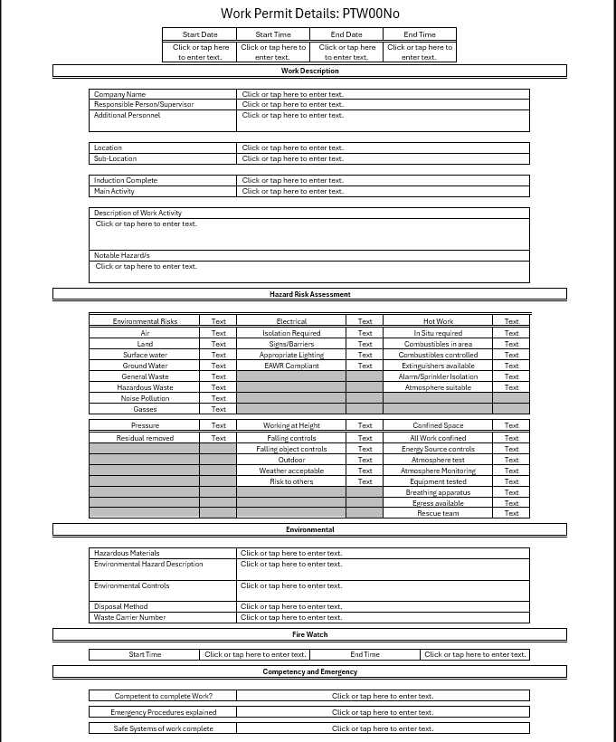
Figure 1: Blank Permit Template (Word)

Additionally, MS Forms provides unique QR code accessibility, which is particularly beneficial in large operational sites like TSUK and DCWW. This feature enables remote access to the ePTW system via mobile devices, enhancing efficiency and significantly reducing process time.


Figure 2: QR Code Example

4.2 Power Automate Flows
The ePTW system utilises a series of Power Automate flows to enhance efficiency. Figure 3 shows Flow A for the submission approval process. Data is transferred from the form to SharePoint, the origin of the permits' initial status. Notifications and approvals are sent through Microsoft Teams, allowing for faster processing.
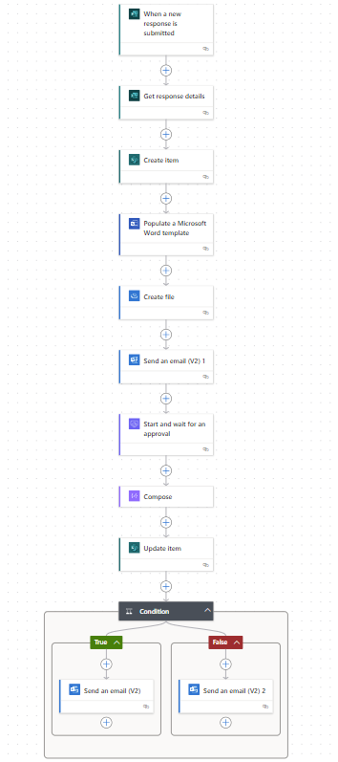
Figure 3: Approval Flow A

Figure 4 illustrates Flow B, which is programmed to activate at specific intervals—3 PM and 6 PM daily. This flow targets open and overdue permits for the closure process. This strategy ensures that all permits are reviewed promptly and addressed appropriately.
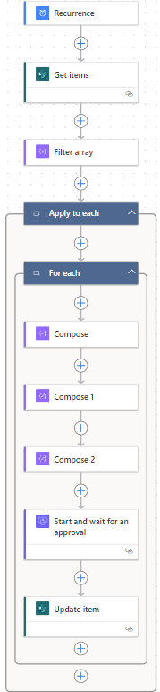
Figure 4: Closure Flow B

4.3 Approvals
The approval process is flexible, assigning approvals to specific individuals or groups. This ability to redistribute requests enhances flexibility, risk management, and monitoring. Approvals are communicated through Microsoft Teams and Microsoft Outlook simultaneously, reflecting the objectives of mobile integration while guaranteeing that the initiation and closure of permits occur in a timely and accurate manner.
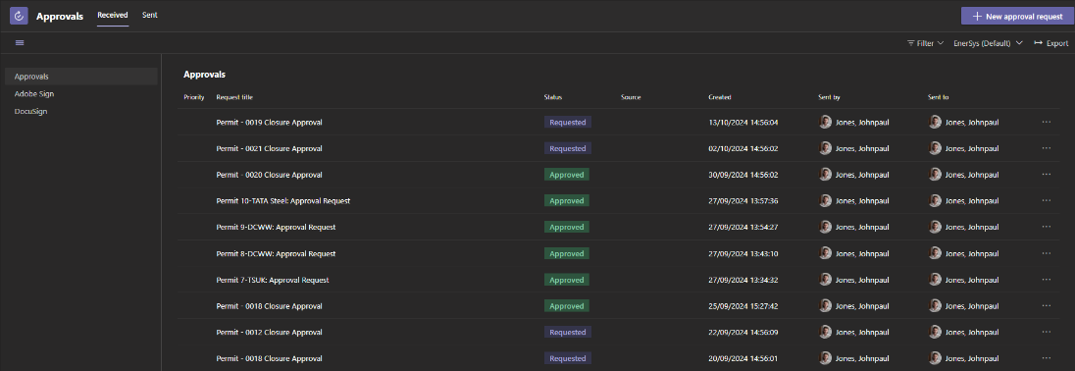
Figure 5: MS Teams Approvals

4.4 Power Apps Interface and Dashboard
The Power Apps application boasts an intuitive user interface showcasing currently open permits and multiple dashboards. These dashboards provide a real-time overview of the total permits and emphasise those linked to high-risk activities. Including searchable records enhances user engagement, facilitating analysis while ensuring compliance with GDPR.
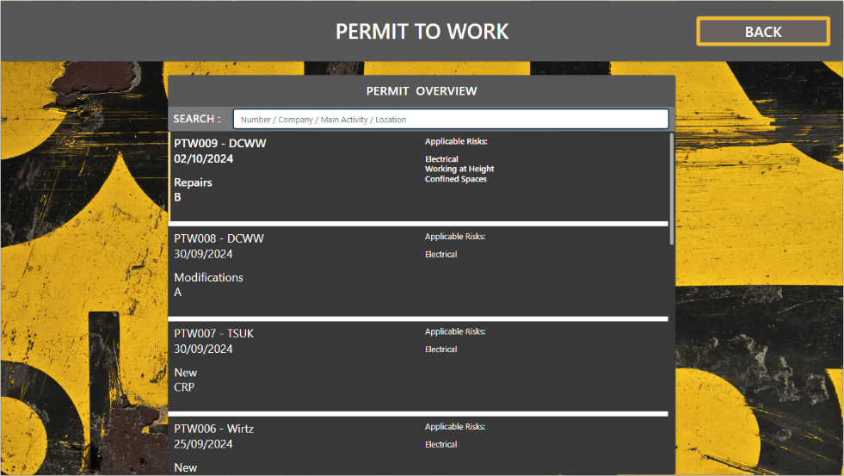
Figure 6: Permit Record Database

4.5 Power BI Visualisations
Linking directly with SharePoint lists, Power BI integration allows for the following effective data visualisation:
Figure X Permits by Location Total: Visualising currently active permits by geographic location facilitates real-time oversight of areas characterised by substantial work activities. This approach enables the systematic monitoring of spatial distributions of permit issuance and corresponding project engagement.
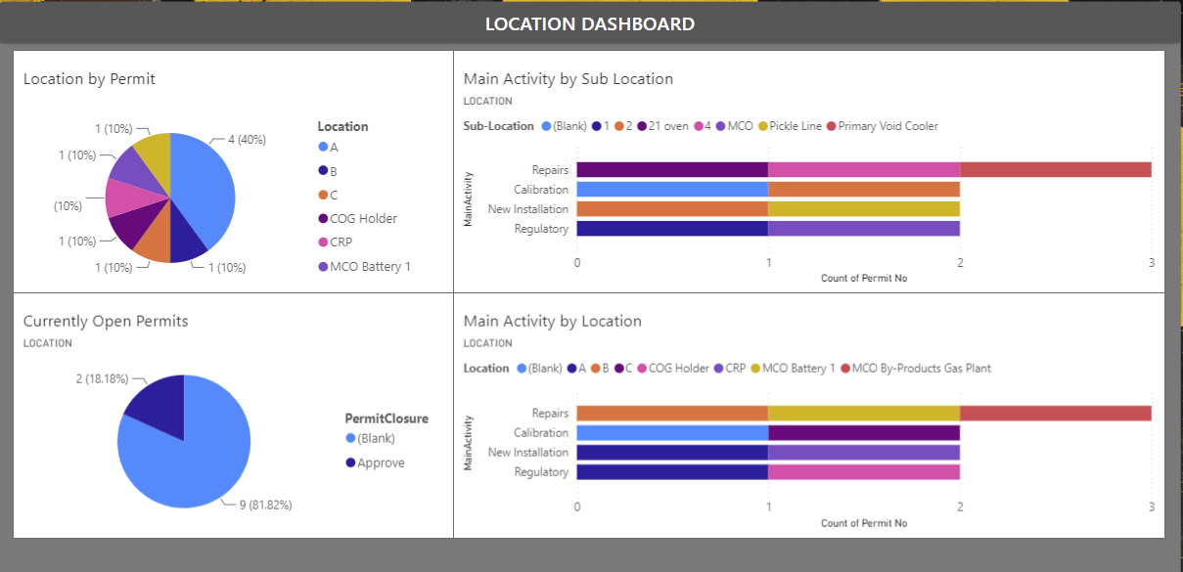
Figure 7: Location Dashboard

This categorisation of currently active permits, including those that are overdue, offers valuable insights into potential areas of risk concentration.
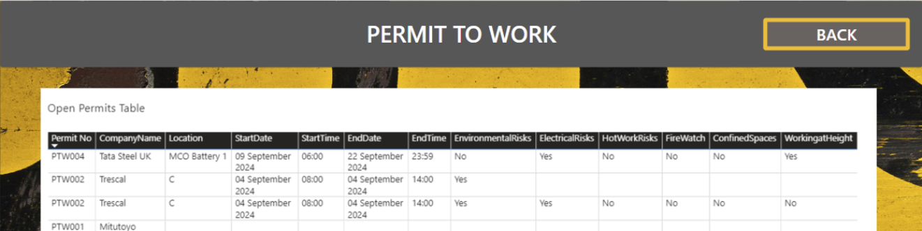
Figure 8: Active and Overdue Permit Dashboard

This system systematically monitors and highlights the most frequently identified activities across diverse locations, thereby facilitating the identification of opportunities for continuous improvement and pinpointing areas where increased auditing is required.
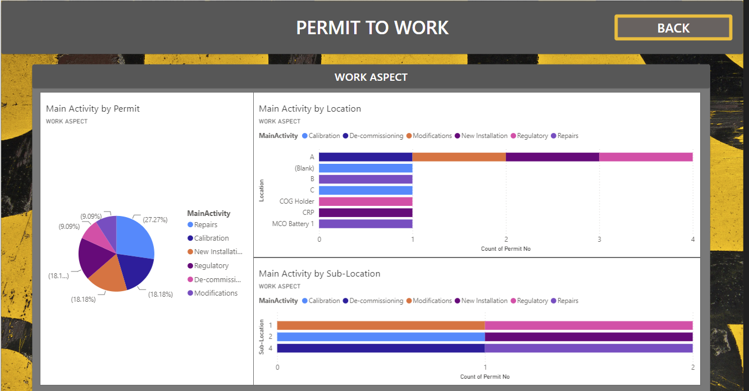
Figure 9: Task Aspect Dashboard

Financial Analysis
Table 1: Financial Analysis
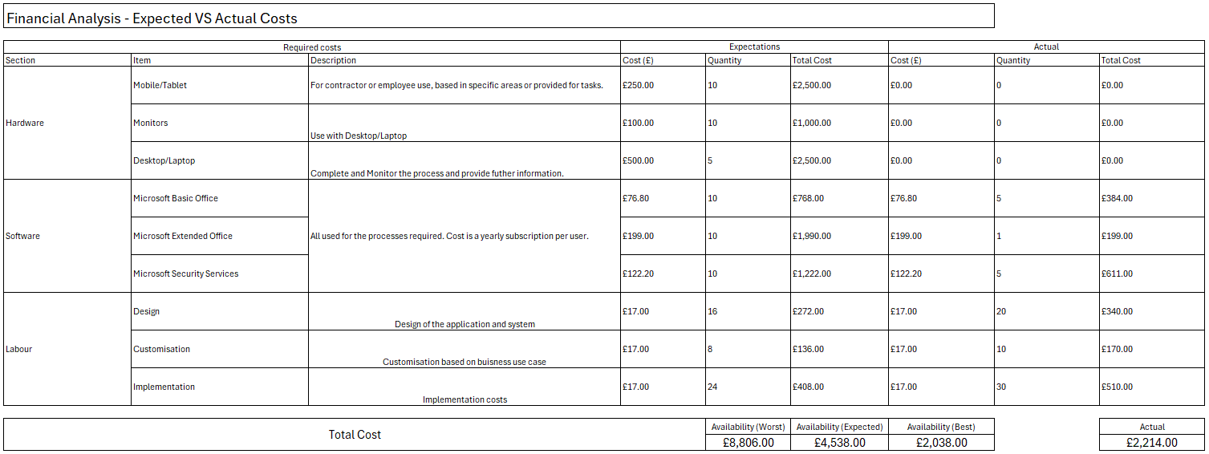

The financial analysis presented in the spreadsheet details the projected versus actual costs associated with the project, broken down into categories such as Hardware, Software, and Labour. This categorisation is essential for evaluating the effectiveness of the initial budgeting and assessing the project's overall success.
Regarding hardware costs, the projections accounted for necessary equipment like mobile devices, tablets, and desktops or laptops required for administrative duties, data management, and remote task execution. Specific budget allocations were made to cover these essential items. On the software front, anticipated expenditures included essentials such as Microsoft Office and Security Services to ensure a robust software infrastructure while maintaining compliance with regulations. The actual costs listed in the analysis reflect the project's ability to adhere to its financial plan or prompt any necessary adjustments.
Labour costs encompass expenses related to Design, Customisation, and Implementation, highlighting the resource investment needed to meet the project's specific deliverables. These figures not only represent financial outlay for labour but also serve as indicators of the project's effectiveness in managing both budget and timelines.
When analysing the financial outcome by comparing projected costs against actual expenditures, the data provides insights into the financial efficiency of the project. For instance, underspending might suggest prudent resource management, yet it could also imply that certain aspects of the project were under-resourced, potentially impacting the quality or timely delivery of project outcomes.

In the context of return on investment (ROI), the analysis reveals that the actual outcomes following the implementation of the new process were more favourable than initially projected. The costs associated with the new process were lower than expected, suggesting effective project management and potentially reflecting earlier underestimations of inefficiencies in the previous process. The actual investment gains and annualised ROI exceeded expectations, more than doubling anticipated figures in the first year, which underscores either conservative initial estimates or the emergence of unexpected benefits from the process change.

Table 2: ROI Financial Analysis Comparision
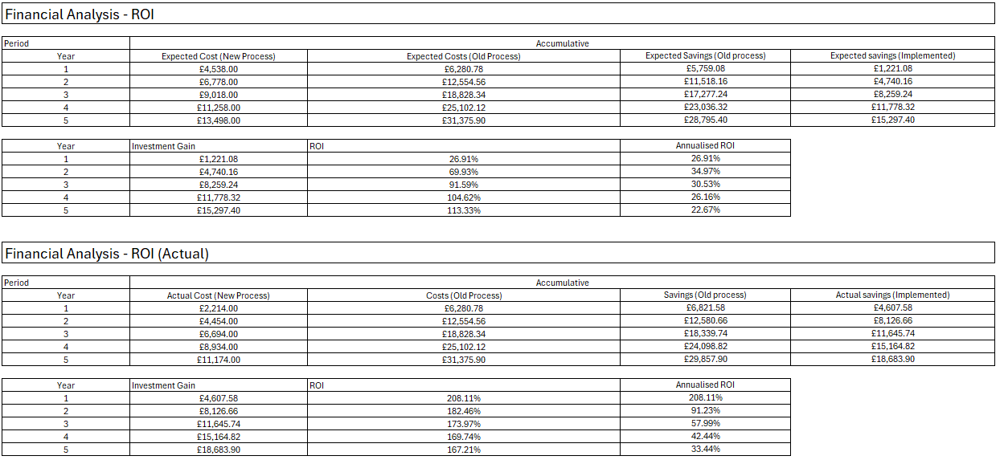
Several factors contributed to this successful financial performance. Introducing new processes led to significant efficiency improvements, reducing costs beyond expectations. The project management team demonstrated adaptability, optimising the new process to surpass initial projections. Additionally, the conservative nature of initial forecasts allowed for a more pronounced demonstration of the improvements brought by the process changes. By comparing expected outcomes with actual results, the analysis provides valuable insights into both the planning and execution phases of the project.

Feedback
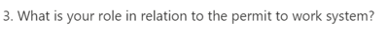
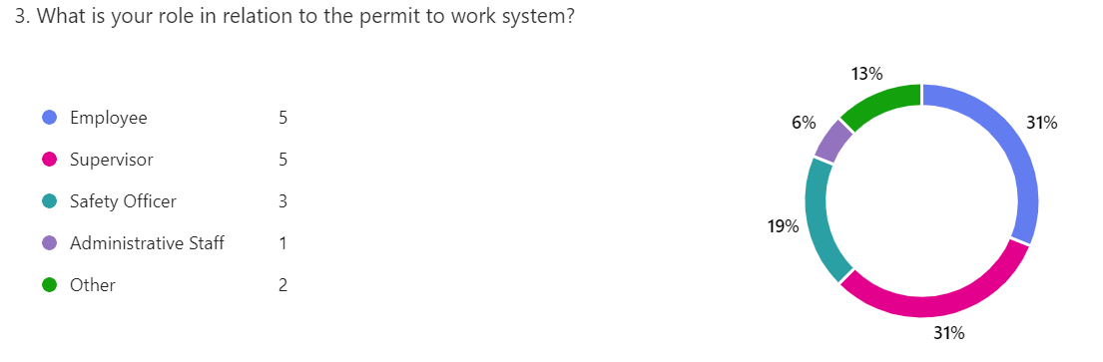
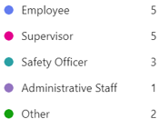
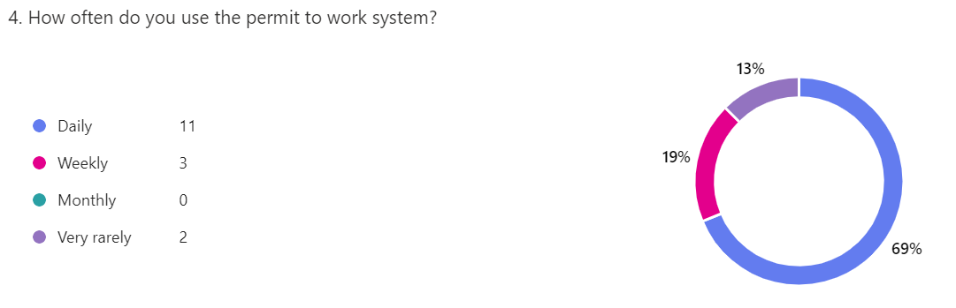
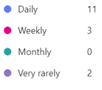
The feedback for the ePTW system provides encouraging insights, demonstrating a strong uptake and generally positive reception among users. Notably, a significant proportion of participants—62% and 69%, respectively—identified as front-end users, indicating robust engagement and suggesting that the system is well-received.
Figure 10: User Feedback 1

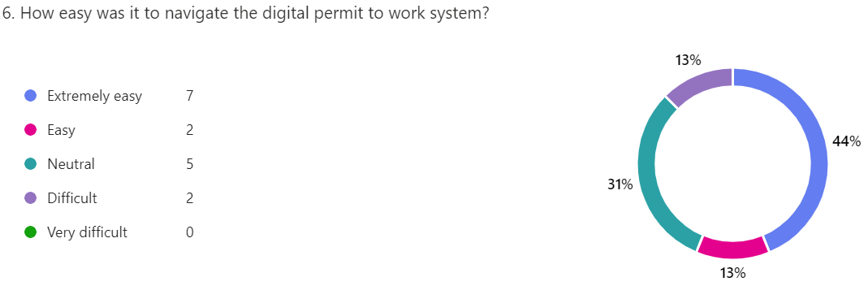
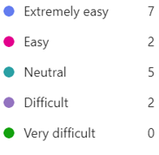
In terms of navigation, 57% of users found the system intuitive and easy to navigate, which points to a positive user experience overall. However, 31% of users remained indifferent, recognising no major difficulties yet not finding the system exceptionally user-friendly. A minor proportion, 13%, did encounter navigation challenges, signifying that while most users managed well, a small segment might still face occasional hurdles.
Figure 11: User Feedback 2

When considering users' familiarity with digital systems, the feedback revealed a varied level of comfort. Half of the participants felt confident in their digital literacy skills, indicating a divide between those proficient in navigating digital environments and those who might benefit from targeted training or additional support.
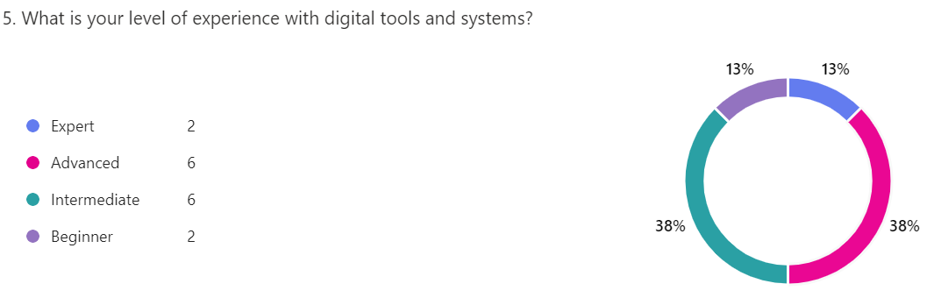

Figure 12: User Feedback 3

The area of permit completion appeared to be a strong point for the ePTW system, with 56% of users completing permits with ease and 25% requiring only minimal assistance. The fact that 68% did not encounter technical issues underscores the system's robust operational design, ease of use and efficiency.

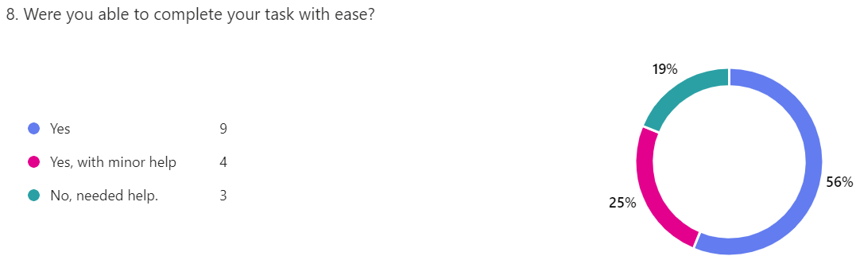
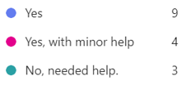
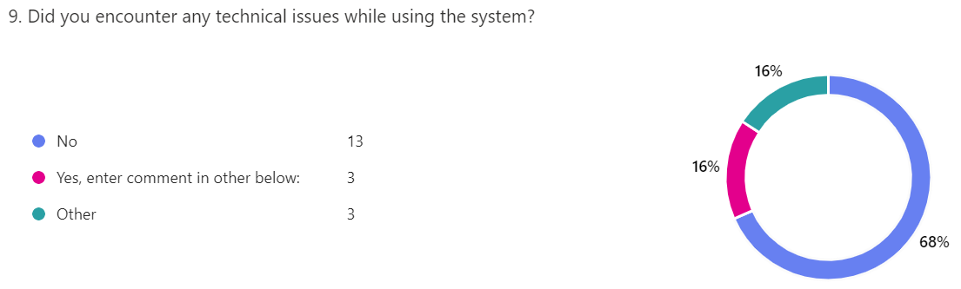
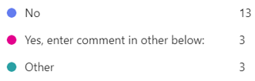
Figure 13: User Feedback 5

Regarding meeting user expectations, 69% of participants expressed that the system effectively met their needs, with 63% satisfied with its functionality. The willingness of 69% of users to recommend the system to colleagues is a testament to the high level of user approval and confidence in the system's capabilities.
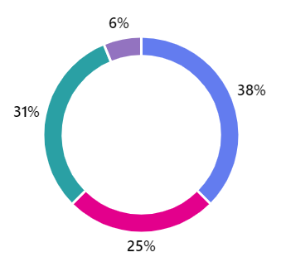
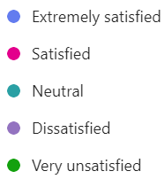
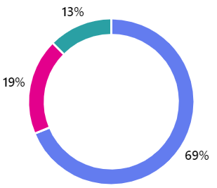

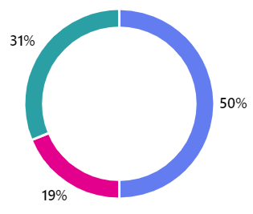
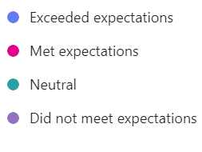
Figure 14: User Feedback 5
13. How would you rate your overall satisfaction with the digital permit-to-work system?

The feedback collected from Welsh Water employees provides a positive assessment of the electronic Permit to Work (ePTW) system, particularly emphasising the tangible benefits of its implementation across Wales. A key advantage highlighted was the ability to manage remote permits centrally, which streamlines the authorisation process and enhances organisational efficiency. This facilitates a unified approach to permit management, ensuring consistent and expedited approvals. Similarly, input from TSUK underscored the critical role of collaboration between those drafting the permits and the contractors executing the tasks. This collaborative element is vital for maintaining clear communication and ensuring that all parties are aligned with the work requirements.
Despite the promising feedback on benefits, the testing survey also surfaced important suggestions for improvement. A significant number of participants indicated a need for additional training to fully capitalise on the system's features. This highlights an area where user support could be bolstered to increase confidence and proficiency. One insightful suggestion involved conducting a trial in a specific area to gauge the system's performance under controlled conditions. Such a trial could offer practical insights and enable preemptive adjustments, facilitating a more seamless transition during the system's broader deployment.
The overall reception of the ePTW system was further validated by the strong endorsement from users, with 68% indicating they would recommend it to their colleagues. This level of support serves as a strong testament to the system's efficacy in meeting user needs. It reflects not only user satisfaction but also their confidence in the system's capacity to improve operational processes. This positive reception, coupled with actionable feedback, provides a solid foundation for refining the system ahead of its comprehensive implementation.

Conclusion
In conclusion, the development and implementation of the electronic Permit to Work (ePTW) system represent a significant advancement in managing operational permits. This project strategically leveraged digital technologies to streamline documentation processes, enhance approval workflows, and integrate dynamic risk assessment tools, largely achieving the primary objectives set out at its inception. Built on Microsoft's expansive suite, including Power Automate, Power Apps, SharePoint, and Power BI, the ePTW system has effectively delivered on its promise to boost permit management efficiency, improve the accuracy of risk assessments, and enable real-time contractor monitoring.
Comparing the project outcomes with its initial aims reveals that the system successfully reduces manual processing times and enhances data reliability through dynamic assessment tools, thus achieving the primary objectives of efficiency and process accuracy. The integration of mobile capabilities for remote approvals marks a considerable improvement in operational flexibility. However, during the project's progression, several deviations from the original scope were identified. These primarily arose during the integration and testing phases, where the complexities of aligning various Microsoft tools were initially underestimated. This led to an extended development timeline and a realisation that a broader scope of user testing was needed to ensure robustness and user-friendliness across diverse operational settings. Despite these deviations, these adjustments were essential for delivering a well-rounded and practical system.
The project's notable successes include significant impacts on permit management processes—reducing manual tasks, and increasing data accuracy. Yet, challenges like initial data integration difficulties highlighted areas needing extra focus, ultimately requiring additional troubleshooting and resources. Moving forward, several enhancements are suggested to refine the system further. These include introducing a more sophisticated risk assessment scoring mechanism, automating high-risk permit notifications, and integrating accident and near-miss processes. Implementing these features could transform the ePTW system into a comprehensive safety monitoring solution, broadening its scope beyond permit management to capture a wider range of safety data and foster continuous improvement.
Continuing to refine the system based on user feedback will ensure it remains responsive to evolving operational needs and capable of handling increased data volumes. Implementing robust security measures, especially in encryption and intrusion detection, will also be crucial in maintaining security against evolving cyber threats. Overall, the ePTW system has not only laid a solid foundation for safe and efficient permit management but has also demonstrated alignment with the project's core objectives and organisational goals, setting the groundwork for future growth and broader applicability.

Evaluation

6.1 Organisational Learnings
Reflecting on the development of the electronic Permit to Work (ePTW) system at Tata Steel UK (TSUK), I have experienced a transformative journey that has revealed the extensive possibilities of digitalising traditional processes. This project aimed primarily to rectify the inefficiencies rooted in the outdated paper-based system, which had previously resulted in a lack of transparency and an increased risk of human error. By focusing on enhancing operational efficiency and reinforcing compliance and safety measures, we sought to create meaningful improvements across the three organisations involved.
Understanding operational efficiency has become integral to optimising organisational performance. Transitioning from cumbersome manual processes to a streamlined digital platform has had a profound impact, particularly highlighted during the successful testing phase of the ePTW system at TSUK. Leveraging Microsoft's Power Platform, we integrated robust tools like Power Automate, Microsoft Forms, and PowerApps, which facilitated the modernisation and acceleration of permit management and risk assessment tasks. The project goals were carefully crafted around these principles, underscoring the vast potential of digital transformation to enhance operational workflows.
The project also highlighted the critical importance of compliance and safety within workplace environments. By integrating automated risk assessments into our workflows, we ensured greater accuracy and responsiveness to potential hazards. This capability is particularly vital under regulatory frameworks, reinforcing the need for proactive safety measures in high-risk industries to avert incidents and maintain compliance.
Additionally, this initiative showcased the transformative power of technology in contemporary work environments. Employing the Microsoft Power Platform to streamline data management and processes demonstrated how technology can effectively tackle practical challenges while enhancing user accessibility. The integration of mobile capabilities further supports a flexible working environment, facilitating remote permit management and approval, which is essential for improving communication and minimising downtime.
Navigating the complexities of organisational dynamics and change management highlighted the importance of engaging stakeholders throughout the implementation of new systems. Resistance to change is a common barrier, but the project's focus on user-centric design and the active incorporation of stakeholder feedback proved crucial in overcoming this challenge. By adapting to the diverse needs of users, we fostered acceptance, ensuring that the system was well aligned with real-world operational requirements.
In evaluating the success of the project, I recognised that effective measurement and validation strategies were essential. We employed performance metrics, user surveys, workflow efficiency analyses, and compliance assessments, creating a comprehensive evaluation framework that ensured alignment with project objectives and stakeholder needs. The integration of data analysis significantly enhanced our capability to monitor and validate the system's impact in real time.
Overall, the ePTW project serves as a compelling case study, illustrating how the integration of advanced technologies with strategic project management approaches can efficiently address longstanding inefficiencies while advancing organisational safety and compliance goals. It reinforces the crucial roles of innovation, adaptability, and stakeholder involvement in the successful execution of digital initiatives.

Personal and Project Learnings
Reflecting on the design and build phases of the ePTW project, I appreciate how we harnessed the capabilities of Microsoft's Power Platform, incorporating essential tools such as Power Automate, Microsoft Forms, and especially Power Apps. Power Apps played a pivotal role as a display and monitoring tool, offering an intuitive interface for visualising task risks and locations using data. Its user-friendly design and familiarity among TSUK employees facilitated a smooth transition to a modern permit management system, promoting engagement across various organisational levels and enhancing usability throughout the testing phases.
However, the complexity of coding within Power Apps posed considerable challenges, especially given my limited prior experience in this area. Initially, the task of creating a functional and user-friendly dashboard felt rather daunting. Yet, this obstacle became an invaluable opportunity for personal growth. By utilising tutorial resources and tapping into the expertise within our project team, I was able to effectively address my knowledge gaps. Collaborating with colleagues who had essential skills was instrumental in overcoming these challenges, ultimately leading to the successful deployment of the Power Apps dashboard. This experience underscored the importance of continuous learning and the power of collaborative problem-solving in technological projects.
During the critical testing phase, our unwavering focus on ensuring the system fulfilled its operational objectives alongside strict compliance and safety regulations proved pivotal. Integrating automated risk assessments into our workflows allowed us to quickly identify and mitigate potential hazards in line with the compliance frameworks established by relevant regulations. This proactive safety management approach emerged as a fundamental success factor for the project, demonstrating the capacity of digital tools to enhance organisational safety standards.

References
Brinkmann, J. & Voeth, M., 2007. An analysis of buying centre decisions through the salesforce. Industrial Marketing Management, 36(7), pp. 998-1009.
GOV.UK, 2022. Data Protection Act 2018. [Online]
Available at: https://www.gov.uk/data-protection
[Accessed 29 May 2024].
Health and Safety Executive, 1974. Health and Safety at Work etc. Act 1974. [Online]
Available at: https://www.legislation.gov.uk/ukpga/1974/37/contents
[Accessed 11 May 2024].
Health and Safety Executive, 2005. HSG 250: Guidance on Permit-to-work Systems, s.l.: s.n.
Jones, D., (2024). Conversation with Matthew Frey [Interview] (08 April 2024).
Kotter, J. P., (1996). Leading Change. Harvard Business Review Press.
Nickell, E. B., Schwebke, J. & Goldwater, P., 2023. An introductory audit data analytics case study: Using Microsoft Power BI and Benford's Law to detect accounting irregularities. Journal of Accounting Education, Volume 100855, p. 64.
Nieto-Rodriguez, A., 2023. It's Time to End the Battle Between Waterfall and Agile. [Online]
Available at: https://hbr.org/2023/10/its-time-to-end-the-battle-between-waterfall-and-agile
[Accessed 26 10 2024].
Reddy, V. & Reddy, I., (2015). Study of Electronic Work Permit System in Oil and Gas. IJISET - International Journal of Innovative Science, Engineering & Technology, 2(4), 533.
Samani, N., (2023). How is IoT Leading to Safer Workplaces? [Online]
Available at: https://www.deskera.com/blog/how-is-iot-leading-to-safer-workplaces/
[Accessed 09 September 2024].
Tucker, S., (2024). Interview with Matthew Frey [Interview] (25 April 2024).
UK Government, (2015). The Management of Health and Safety at Work Regulations 1999. [Online]
Available at: https://www.legislation.gov.uk/uksi/1999/3242/regulation/1/2015-06-01
[Accessed 11 May 2024].
UK Government, (2020). The Control of Substances Hazardous to Health Regulations 2002. [Online]
Available at: https://www.legislation.gov.uk/uksi/2002/2677/regulation/9
[Accessed 12 May 2024].
Wang, X., (2023). Enhancing Business Processes through Dynamics Solutions with Microsoft Power Platform, s.l.: Metropolia University of Applied Sciences.

