The Global Business Environment

Assessment 2

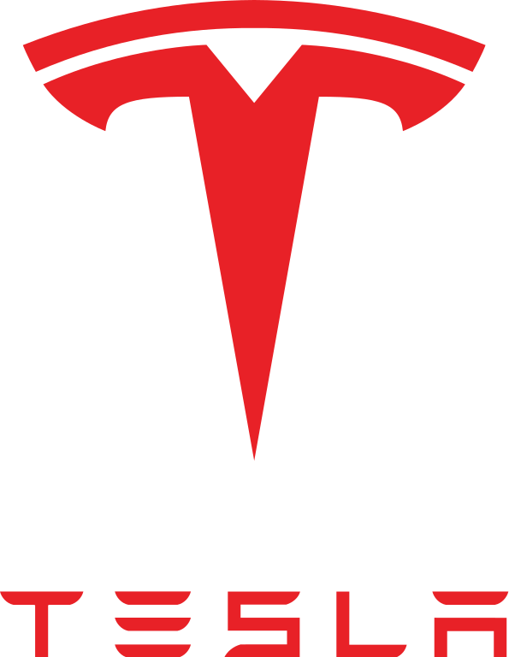

Contents
Introduction 2
PESTLE automotive industry 2
Trends in the automotive industry 4
References 4

Introduction

The impact of COVID-19 has been affected various industries at a global level, including the automotive industry. Beside the economic impact which has been felt all across the world given the numerous lockdowns, furloughs, and incapacity of numerous jobs to be performed, COVID-19 has also created an environment of insecurity and uncertainty which negatively impacted consumer behaviour.

Furthermore, reduction of production and manufacture of certain parts from the automobiles, as well as reduction of cars production as a result of COVID-19 (Deloitte, 2021) also represent a threat on the automotive industry. According to the same study, COVID-19 uncertainty and customer perception of a potential economic crisis, lack of confidence in making a long term investment to buy a car has determined a 71% plunge in automobile sales. McKinsey (2021) enhances the idea of negative impact on automobile sales following the COVID-19 outbreak claiming that Europe has been the most affected with 80% decrease of automotive sales.

Nevertheless, as any other industry that has been affected by COVID – automotive industry has exploited its strengths and opportunities and developed strategies of coping with COVID-19. In order to understand how automotive industry been affected by the pandemic and which strategies have its players applied to overcome the impact, a critical evaluation of the internal and external environment in the current context is necessary, as follows in the next sections of this report. Tesla Motors will be used as case study to provide a better understanding of the megatrends in this industry and how businesses can use the internal resources to overcome the COVID-19 impact.

PESTLE automotive industry

Political and economic factor that mainly impacted the industry following the COVID-19 outbreak is represented by the regulations and restrictions implemented across the world, along the economic impact caused by the pandemic. The governments of nearly 162 nations have imposed stringent border closures, travel restrictions, and lockdown measures in try to flatten the pandemic curve. As a result, the markets of the world's top economies and others are working in fear of global financial market disruption.

As far as current history is concerned, the economic collapse brought on by the pandemic is unparalleled in its scope (Nayak et al, 2021). GDP decreased by 9.7 percent in 2020, the largest decrease since records started in 1948 and, according to unofficial estimates, a decrease comparable to that seen in 1921. (McKinsey, 2021). As a result, both external causes represent a danger to the sector.

Socio-cultural and environmental factor in this context represent a threat for the industry as consumer’s lifestyles and preferences toward travelling have changed due to travelling restrictions and limitations. However, a recent McKinsey (2021) study shows that consumers attitudes toward purchasing a car have recovered after the pandemic, nevertheless they are more inclined towards purchasing an EV. Therefore, once customers become more conscious about the environment and potential negative impact of cars, EV can become an alternative for car buyers and an opportunity for players in the automotive industry.

Technological factor represents an opportunity in the current pandemic context. Whilst human workforce has been affected by the outbreak in various manufacturing and production fields, robots have started to play a critical role in the automobile sector. Working alongside humans, robots do everything from using tools to putting items on an assembly line. By 2027, the Global Automotive Robotics Market would be worth US$ 14.1 billion, according to ReportLinker (2021).

Legal factor

The automobile business is impacted not only by laws and regulations across the world, but also by the question of copyright. Cars may be protected in a variety of ways under intellectual property, trademark, and patent laws. Everything from the branding to the form can be protected. It's uncommon to hear of legal conflicts in the automobile sector, but they do happen. An increasingly serious issue has arisen in recent decades, with Chinese manufacturers blatantly copying designs from their Western counterparts. Consider the case of Geely Motors, a Chinese carmaker that has created some remarkably identical clones of the Rolls-Royce Phantom, resulting in significant criticism. However, there is no denying that this copying has had an influence on the industry as a whole.

Based on the external analysis of the automotive industry, the impact of the pandemic has clearly developed some threats and opportunities that players in this industry must consider when strategically planning at a global level. Within the most important threats is the economic and political changes that COVID-19 implemented around the world, including one of the highest recessions that impact customer behaviour, uncertainty and travelling restrictions. On the other side, human resource was also negatively affected by this pandemic, but technological development and consumer attitudes towards a cleaner planet represent both opportunities, especially for EV development.

Trends in the automotive industry

Virtual buying experience

Given the pandemic context that reduced human interaction and travelling, one of the most actual trend in the automotive industry is the incline towards online shopping. Although online shopping and multichannel use in retail is present in most of the big retail players, the pre-sale customer experience in certain goods including cars plays a very important role in impacting the customer purchasing decision.

It became clear that technology would be critical as dealerships all around the globe scrambled to meet shifting in-person constraints during the outbreak. Customers may only interact with certain dealers through phone, videoconference, or special appointment since several dealers closed their showrooms to the general public during the shutdown. Potential customers could also use websites and apps that supported them in researching and arranging ancillary services, such as financing and insurance, remotely and virtually as part of the car-buying process, which was also accessible (McKinsey, 2021).

Internet of Things (IoT)

IoT is nowadays present in most of the industry and given the current context and the rapidity of the changes occurring on the world, introduction of IoT in the automotive industry was emergent as a European Commission (2021) study confirms. In the automobile sector, the Internet of Things (IoT) refers to cars' ability to link to the surrounding ecosystem in real time. Users will have a pleasant and safe travel thanks to communication with other cars and, for example, road sensors.

In the automobile business, eCall is an example of a short-term IoT trend. This technology notifies police and/or paramedics, allowing them to provide accurate help to road users who have been engaged in crashes. According to European regulations, the eCall system was required for new vehicles starting in 2018. User-Based Insurance (UBI) models are another short-term trend to watch. UBI models identify the amount of risk using data from in-car sensors, and they have shown to be useful in attaining accurate risk-level categorization (Fortune Business Insight, 2021).
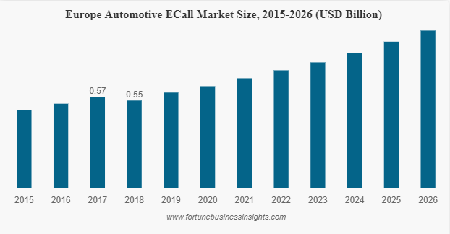
Figure 1: Europe Automotive Ecall market size, 2015-2026, source: Fortune Business Insight (2021)

The evolution of 5G will also have an impact on the utilisation of real-time data in the long run. The use of 5G networks will increase mobile data communication and have an influence on car-to-environment connectivity. In the long run, the concept of Mobility as a Service (MaaS) will alter the concept of ownership. There is also a trend of connecting smart cities with linked automobiles, which builds on the integration of the automotive sector with other developments. This mindset entails coming up with a solution for many improvements, such as urban growth, transportation systems, and emissions reduction, all of which contribute to smart cities.

Raise of usership/subscriptions (rather than ownership)

Affordability and access are two important characteristics car user seek when are looking for a car. Although not perceived as a luxury good, certain car makers such as Tesla Motors are promoting the idea of luxury brand – nevertheless it limits its clientele due to income restrictions. Therefore, the idea of usership or subscriptions to cars has already been introduces by BWM, Audi and Porsche (Forbes, 2018). On the other hand, in order to make car subscription a success, automakers will need to develop a business model that addresses not just the luxury demands of the market, but also delivers economical, price-sensitive models that are easily accessible to the general public. Another thing to think about is include young used automobiles at a reasonable price range, guaranteeing a fleet mix of new and used cars that caters to both ends of the client spectrum. Leasing will be a quick and straightforward way for lease providers to monetize the enormous pool of used automobile assets, particularly off-lease cars.

Electric vehicles (EVs)

A major trend that addresses the customer concern in regard to environmental damage and carbon footprint related to vehicle usage represents the electrical vehicles boom. Although at the moment the costs of a Tesla overcome a medium income yearly salary, development, and innovations in the EV market already make owning an electric car more affordable. Electric cars (EVs) will continue to be mass-produced in large numbers, owing to a combination of stricter pollution restrictions, and altering customer tastes. Automakers will construct modular, scalable specialised EV platform designs in order to capture a piece of the massive potential market for EVs (Forbes, 2021).

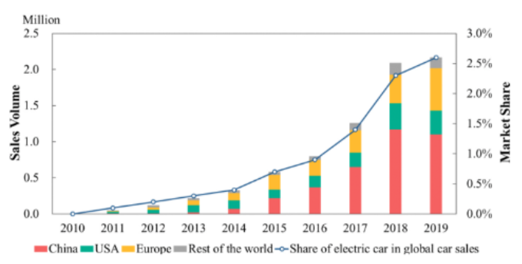
Figure 2: Global sales of electric cars (2010–2019), Source: W. Wen et al. (2021)

The Chinese government has shown a keen interest in the development of electric cars. Electric cars are viewed as a more contemporary and superior technology in China than combustion engines. Some of the most popular plug-in battery variants are made by state-owned companies. Since 2009, businesses have been able to get tens of billions of dollars in subsidies from the Chinese government. Companies have been able to sell new automobiles at a lower cost because to the subsidies. Competition such as Tesla, on the other hand, should boost efficiency and spur new discoveries given the fact has been overcome by other EV manufacturers such as Stellantis, Daimler AG and VW group (EV-Volumes.com, 2021).
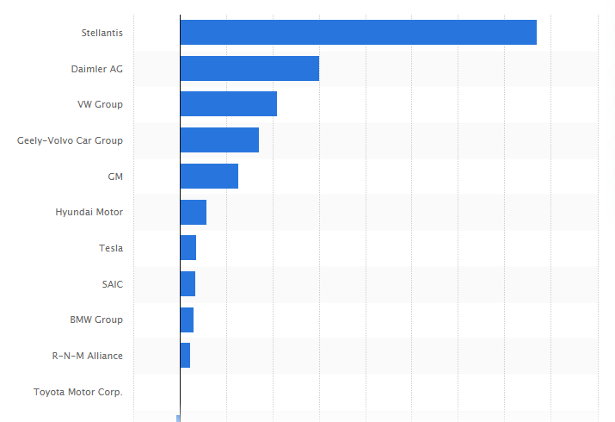
Figure 3: Global plug-in electric vehicle sales growth between 2019 and 2020, by major manufacturer, Source: EV-Volumes.com (2021)
Based on the external analysis of the automotive industry in the current business context, few opportunities and trends can be highlighted: the virtual/online selling experience, EV cars affinity, as well as Internet of Things and robotics. From the previous internal analysis of Tesla’s it was shown that the company has some unique capabilities and resources that provide it with competitive advantage on the EV market. Whereas the company’s resources match the current trends in the industry and provide the company with a sustainable competitive advantage, it will be analysed in the next section of the report.

Sustainability Competitive Advantages | Value | Rarity | Inimitability | Organizational support | Sustainability
Reputation and Brand Awareness | Yes | Yes | Yes | Yes | Yes
Innovative Capabilities | Yes | Yes | Difficult | Yes | Yes
Manufacturing | Yes | Yes | Difficult | Yes | Yes
Stores | Yes | Yes | Difficult | Yes | Yes
Charging Network | Yes | Yes | Difficult | Yes | Yes

Table 1: VRIO analysis, Source: Author’s own work

Tesla Motors strong brand reputation and brand awareness represents a strong opportunity to expand globally, especially in the emergent countries such as China. In accordance to the industry trends, Tesla conducts the majority of its sales entirely online. Because of the high demand for electric vehicles, such as the new Model Y, many buyers order them on the Tesla website and wait impatiently for them to arrive.

Furthermore, Tesla Motors also provide a “touchless test drive” experience which although easily imitable by the other players in the industry, represents an important strategy of adaptability to the new trends on the market. This is also an opportunity for the company to expand its clientele to parts of the world where there are no physical showrooms and the driving experience can only be performed virtually.
Technology and R&D investments are also a difficult to imitate capability of Tesla Motors. Its continuous investment in research and development and technology and its adaptability to the “new normal” given by COVID-19 is also reflected into the last collaboration with an artificial intelligence and software company which are making camper attachments for Tesla Cybertrucks (Business Insider, 2021).

References

Deloitte (2021), Understanding the impact of COVID-19 on the automotive industry, Available online at: Deloitte.com, Accessed 01 January 2022

McKinsey (2021), How the automotive industry is accelerating out of the turn, Available online at:
https://www.mckinsey.com/industries/automotive-and-assembly/our-insights/how-the-automotive-industry-is-accelerating-out-of-the-turn, Accessed 25 December 2021

McKinsey (2021), The Coronavirus effect on global economic sentiment, Available online at: https://www.mckinsey.com/business-functions/strategy-and-corporate-finance/our-insights/the-coronavirus-effect-on-global-economic-sentiment, Accessed 04 January 2022

McKinsey (2021), How consumers behaviour in car buying and mobility changes amid Covid-19, Available online at: https://www.mckinsey.com/business-functions/marketing-and-sales/our-insights/how-consumers-behavior-in-car-buying-and-mobility-changes-amid-covid-19, Accessed 01 January 2022

Nayak, J., Mishra, M., Naik, B., Swapnarekha, H., Cengiz, K. & Shanmuganathan, V. (2021), An impact study of COVID‐19 on six different industries: Automobile, energy and power, agriculture, education, travel and tourism and consumer electronics, Expert System, 2021, Available online at: https://www.ncbi.nlm.nih.gov/pmc/articles/PMC8014102/, Accessed 05 January, 2022

ReportLinker (2021), Automotive Robotics Market, Global Forecast, Impact of Coronavirus, Industry Trends, by Components, Growth, Opportunity Company Analysis, Yahoo Finance, Available online at: https://finance.yahoo.com/news/automotive-robotics-market-global-forecast-155600569.html, Accessed 31 December 2021

European Commission (2021), Short-term and long-term IoT trends within the automotive industry, Available online at:
https://ati.ec.europa.eu/news/short-term-and-long-term-iot-trends-within-automotive-industry, Accessed 31 December 2021

Forbes (2018), Your Next Car Could Be A Flexible Subscription Model, Available online at: https://www.forbes.com/sites/sarwantsingh/2018/07/30/your-next-car-could-be-a-flexible-subscription-model/?sh=68e01f74ffad, Accessed 31 December 2021

EV-Volumes.com. (2021). Global plug-in electric vehicle sales growth between 2019 and 2020, by major manufacturer. Statista. Statista Inc.. Available online at: https://www.statista.com/statistics/976025/global-sales-growth-of-plug-in-electric-vehicle-manufacturers/, Accessed: 05 January 2022.

Business Insider (2021), A $50,000 camper that turns the Tesla Cybertruck into an RV has hit $100 million in preorders, Available online at:
https://www.businessinsider.com/photos-tesla-cybertruck-camper-van-cyberlandrs-tiny-homes-on-wheeks-2021-8?r=US&IR=T, Accessed: 05 January 2022.

