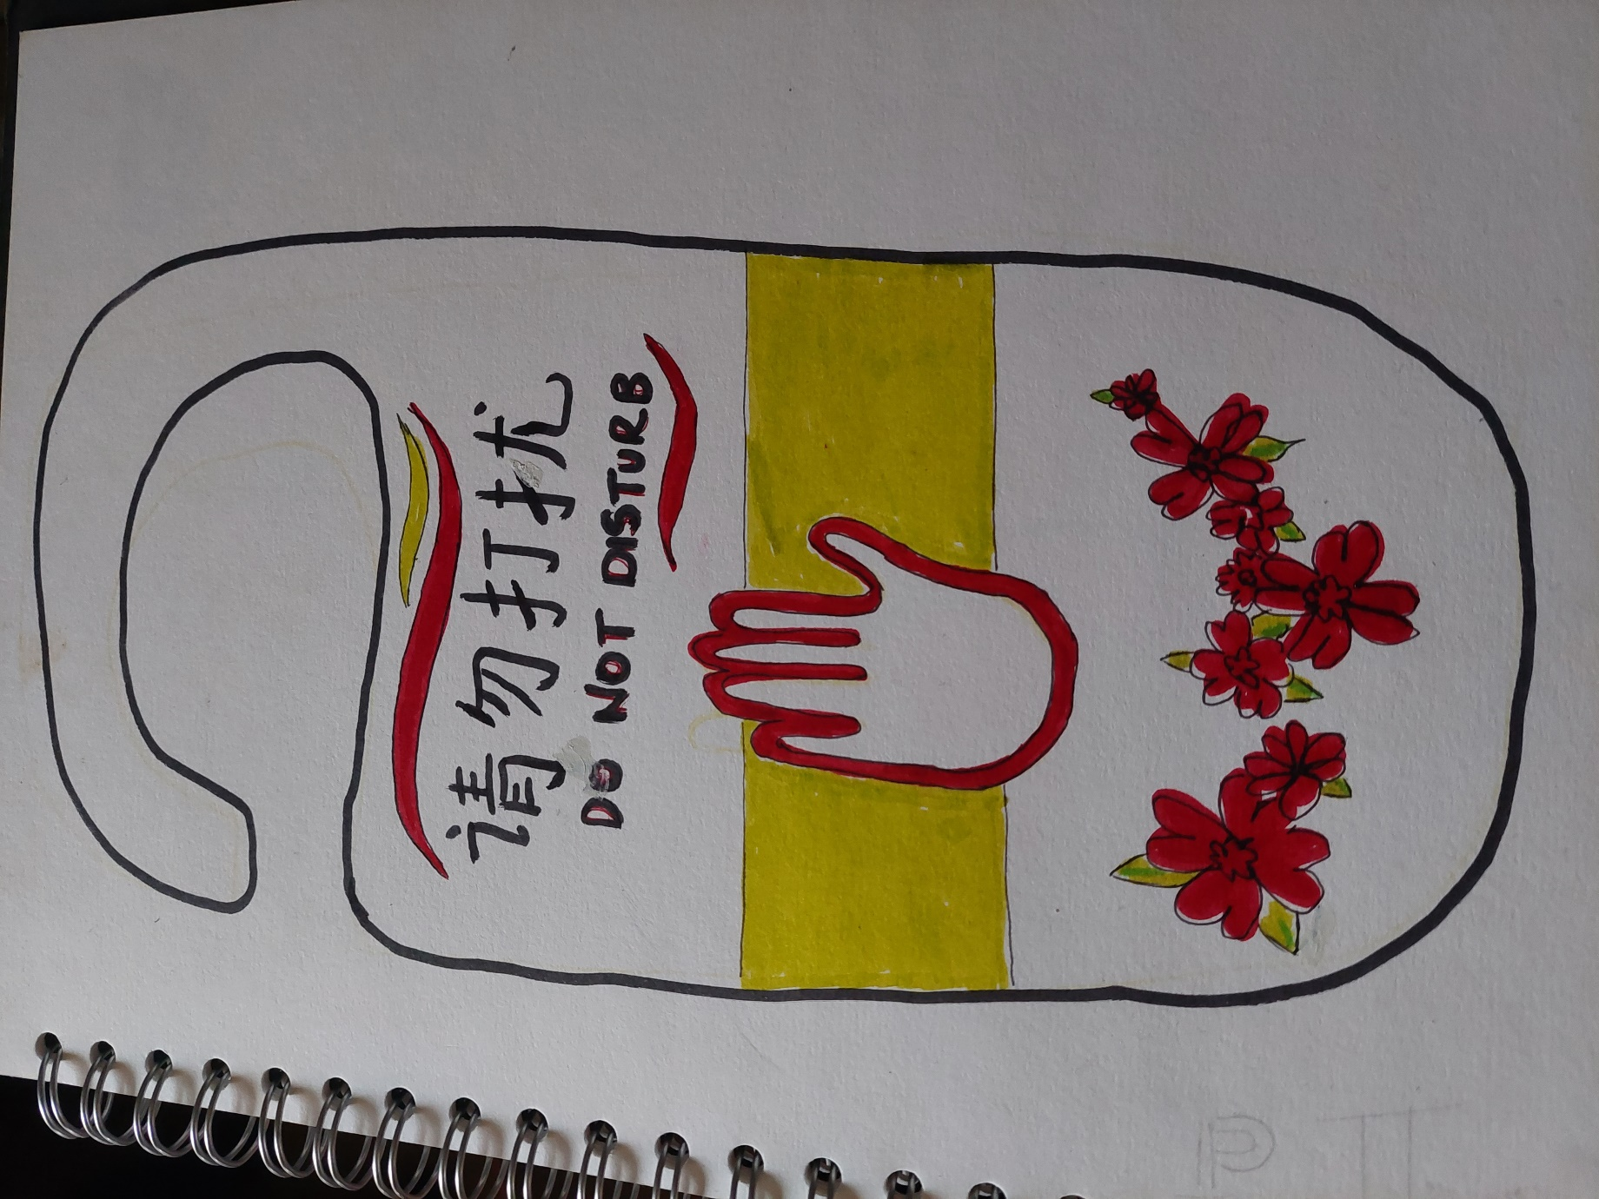
Name: Catrianna Di Muzio Module: Mandarin Course: International Hotel Management
Date: 18th of November 2021
Assignment Number 4: Hotel Danger Sign

