Assessment Form

Module: Preparing for Professional Policing
Student Name: Jacob Cox
Module Tutor (s): Kelly Andrews
Question | 1  Situation | 2  Task | 3.  Action | 4.  Result |  | Total Mark
1 | 4/5 | 2/5 | 14/15 | 3/5 |  | 23/30
2 | 5/5 | 1/5 | 12/15 | 3/5 |  | 21/30
3 | 5/5 | 1/5 | 12/15 | 3/5 |  | 21/30
 |  |  |  |  |  | Total Mark 65 /90
Key
No Reference | Minimum | Satisfactory | Exceptional
0 | 0-4 | 5-10 | 11-15

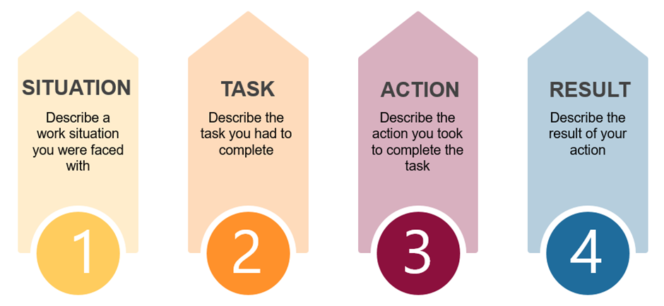

Question | Comments
1 | Q3:  Work example – Steward for the SCS.  I was partnered with someone on their first session – this person was very anxious person – so if there was a lot of noise this person was becoming timid –  I didn’t want to take over – I tried to communicate with her how to deal with this situation. So she could develop skills.  Good detail around why he needed to do this.  Result – she left for another section so not sure what happened with her. But there was a marked improvement.
2 | Q7:  Training in martial arts for 5 years – at the same gym. Lots a people come and go – one person who joined was very critical about females in the gym – it is a male dominated sport.  This person was very critical about them being there. He was not willing to train with them.  He was excluding a portion of the gym. Very detailed answer.  Spoke to him in private.  Found out that this was because he believed women were more fragile. I explained that this is not the case.  Remember to include all elements of STAR – needed a clear task.  Good result; there was some change with him.
3 | Q6:  Gyn example:  People from a wide range of backgrounds attend. I trained for 6 months with someone from South Africa. There was a language barrier. Some elements of the training were lost on him.  He was being excluded by others because of this.  Some of the more aware people including me were trying to include him to achieve his goals.  Had to find a work around – using different words or different examples – so that he could understand and have the same experience as others within the gym.  Result: He had to go back home – over time he became more aware and developed better.  .

.

.

