Understanding the link between individual and organisational performance

On the job training

Health Education & Improvement Wales’ (HEIW) Values Based Performance and Appraisal Development training session is mandatory for all line managers and is provided by our Learning and Development Practitioner. This demonstrates Taylor’ (2016) view that in order for performance management to bring the best out of the workforce, HR and line managers must work collaboratively.

The process has been developed to link in with HEIW’s strategic aims and values and behaviours.
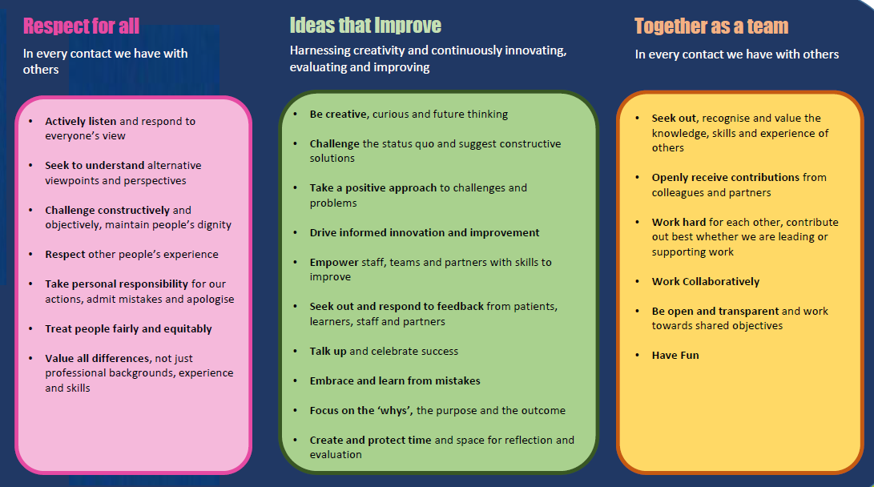
HEIW (2018)
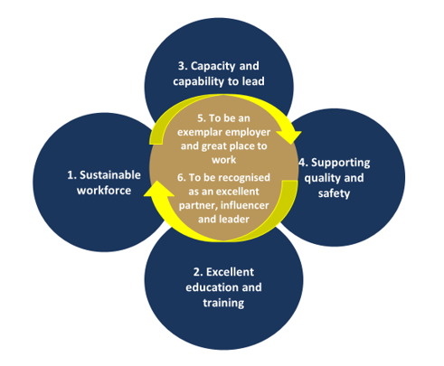
HEIW (2020)
There is also alignment with the Workforce Strategy for Health & Social Care (HEIW & SCW, 2019), which is shortly due to be approved by Welsh Government.
The HEIW process is a two-way process between the employee and the line manager with a focus on communication and mutual trust. It offers motivational factors as outlined by Hertzberg (1987) in that it is an opportunity for recognition of achievements and identifies career progression opportunities. It also incorporates Marin-Garcia & Martinez Tomas’ (2016) AMO theory in that it provides access to learning and development, ensures employees stay motivated by ensuring job satisfaction, they are valued and understand expectations, as well as identifying opportunities, including access to supportive leadership enhanced by the employee-line manager relationship.

Fleetwood & Hesketh (2010) believe the contribution employees give to an organisation is key to its success. HEIW are in agreement with this and supports its staff to be the best they can be, ensuring the right people are recruited in line with its values and behaviours. This ensures that that drive, determination and mutual understanding is instilled from the start of the career journey within HEIW.

The performance management process, until recently was not supported by any financial incentive. However, from April 2019, the process has been linked to staff pay, with employees only being able to move to the next salary increment of the pay scale if they meet their agreed objectives (NHS Wales, 2019). Whilst this has a positive impact on staff within the first five years of their time in a position, once the maximum salary has been reached for the role, there no longer remains a financial incentive for individuals to perform well. Therefore, to keep these individuals motivated and continuing to perform well, other incentives need to be utilised and promoted.

CIPD (2019) state that to ensure effective performance management, there should remain a focus on activities and opportunities that offer employees an opportunity to grow to be the best they can be. This offers the opportunity for career progression to those who wish to progress. This in itself is a driver for high employee performance. If this is done successfully and an employee gains a promotion, the financial incentive is once again activated. The combination of financial benefit along with learning and development support offers the greatest opportunity to get the best out of the workforce.

The HEIW performance management cycle is continuous and is made up of formal and informal stages (HEIW, 2019).

Formal
- Objective setting – These are agreed between the line manager and employee and are set using the SMART theory (Mindtools, 2020).

- Talent conversations – allows the employee to identify and discuss their future career aspirations and how the organisation can support them to realise them. It is also an opportunity to identify potential successors to critical roles.

- Mid year review – An opportunity to formally assess progress against agreed objectives

- Annual review - review outcome of objectives and assess against values and behaviours. Also linked with pay if applicable.

Informal
- 1:1 discussions should be held at least monthly to informally monitor progress and discuss challenges and opportunities.

- Day to day communication - Taylor (2016) describes this as continually seeking to engage and motivate staff on a day to day basis.

The above process ensures individuals are developed to enhance and ensure job satisfaction and also support organisational outcomes and ensures continual two way communication in relation to performance.

It is clear that the performance management process HEIW currently have in place is based around best practice and elements of robust research. This is demonstrated by the positive culture in the organisation and the number of internal candidates that been promoted into more senior roles.

References

CIPD (2019) Performance Management: An Introduction. Available at: https://www.cipd.co.uk/knowledge/fundamentals/people/performance/factsheet (Accessed on: 23 July 2020)

HEIW (2020). Integrated Medium Term Plan (IMTP) 2020-2023. Available at: https://heiw.nhs.wales/files/board-papers/board-papers-january-2020-v2/ (Accessed: 23 July 2020)

HEIW (2018) Values and Behaviours. Available at: https://heiw.nhs.wales/about-us1/values-and-behaviours/ (Accessed on: 23 July 2020).

HEIW (2019a) Values Based Performance Appraisal and Development Policy. Available at: https://heiw.nhs.wales/files/values-based-performance-appraisal-and-development-policy-v2/ (Accessed on: 23 July 2020)

HEIW & SCW (2019) Workforce Strategy for Health and Social Care. Available at: https://heiw.nhs.wales/files/workforce-strategy-for-health-and-social-care/workforce-strategy-for-health-and-social-care-final-draft/ (Accessed on 23 July 2020).

Hertzberg, F (1987) ‘One More Time: How Do You Motivate Employee?’ Harvard Business Review

Marin-Garcia, J., and Martinez Tomas, J (2016) ‘Deconstructing AMO framework: A systematic review’ Intangible Capital 12(4) pp 1040 – 1087

Mindtools (2020) Smart Goals. Available at: https://www.mindtools.com/pages/article/smart-goals.htm (Accessed on 23 July 2020)

NHS Wales (2019) Pay Progression Policy. Available at: https://heiw.nhs.wales/files/all-wales-pay-progression-v2/ (Accessed on: 21 July 2020).

Taylor, S (2016) ‘Improving Organisational Performance’ in Taylor, S. and Woodhams, C. Human Resource Management: People and Organisations (2nd edn). London: CIPD.

