Consultancy Report on ibis Chesterfield Centre - Market Town: Front Office Department
Student Name: Ionela Flavia Lapka
Student Number: 2130481
Premier Hospitality Consultants
Date Report Will Be Delivered to Client: May 31, 2024

List of Figures
Figure 1 PESTEL Analysis 11
Figure 2 SWOT Analysis 12
Figure 3 TOWs Analysis 12

Table of Contents
List of Figures 2
Executive Summary 4
Introduction 7
Analysis 8
Issue Identification 8
Impact on the Hotel 8
Causes of Housekeeping Inefficiency 10
PESTEL Analysis 10
SWOT Analysis 16
Tows Analysis 18
Recommendations 18
Staff Training and Retention 18
Process Optimization 19
Upgrade Equipment 19
Enhance Communication 20
Action Plan 21
Conclusion 22
References 24

Executive Summary
The Problem or Issue at Stake
Customers are not satisfied with the ibis Chesterfield Centre - Market Town because of a major problem with the cleaning staff. This can lead to a loss of income. There is no doubt that the hotel is in a great location and has reasonable prices, but it fails to meet its guests' standards when it comes to cleaning. Because of this organisational failure in the hospitality business, which is very competitive, the hotel's image and bottom line are in danger.
Findings
A lot of people are leaving the cleaning department because they are not getting enough training, which is making the department very frustrated. The level of happiness of guests is affected by these worries, which in turn lowers the moral of staff and causes service quality to vary. Long room changeover times and poor cleanliness standards are results of inefficient cleaning operations, which are marked by bad time management and job assignment. Because of this waste, guests are unsatisfied and leave bad reviews, which also makes the operations less effective. In addition, the housekeeping team is having trouble doing their job because they are using old cleaning tools and cleaning supplies are not always available. As a result of not having access to current tools, the crew finds it difficult to clean as often and effectively as they would like, this has a big effect on the whole experience the guests have. Moreover, communication problems exist between departments, mainly between cleaning, front desk, and maintenance. This is the major reason why problems and concerns from guests are not quickly dealt with and fixed. This detached operation hurts both the hotel's credibility and the level of happiness its customers feel.
Analysis of findings
The results show that the ibis Chesterfield Centre - Market Town's cleaning department is having a lot of problems. As a result, smart action needs to be taken right away. These issues show the inefficient building features that make it challenging for the hotel to meet cleaning standards and guest demands. In the fast-paced hospitality business, the problems that were found also put the hotel's image at risk. The problems with the staff are a high change rate and poor training, lower confidence and make service range. This hurts both the hotel's image and the number of satisfied guests. Inefficient cleaning operations have long room change times and do not meet cleanliness standards because they do not handle time or divide up tasks well. This kind of operational inefficiency directly causes visitors to give bad reviews and costs money to be lost. The housekeeping staff has trouble getting things done because the cleaning supplies are not always easy to find and the cleaning equipment is old. Using old, useless tools makes the staff less productive, which makes guests less satisfied and loyal. As problems mount from not being able to talk to each other between cleaning, the front desk, and repair, guests lose faith in the establishment. In order to deal with these problems, effective measures are needed.
Recommendations
It is important to always want to learn and get better, which is why it is important to have regular feedback sessions and performance reviews. Another thing that needs to be taken care of is to make the process better, the business should carefully analyse the current cleaning methods and think of ways they can be made better. Setting up regular processes and procedures is a great way to get more done and cut down on the time it takes to change places. It is suggested that the business should think about getting cleaning management software or some other kind of technology to make creating schedules and assigning tasks easier. Get fresh cleaning supplies on a regular basis and spend money on the latest cleaning tools. The business is recommended to upgrade its equipment. A cautious repair plan should be made so that the equipment works at its best and lasts as long as possible. Achieve and keep high levels of cleanliness while also making sure that guests are happy by using regular quality checking methods. Improve Communication means setting up a structured way for people to talk to each other that will help different groups work together and solve problems. Holding regular meetings and giving the staff helpful feedback can help them communicate openly and take responsibility for their actions. It is important for the people in charge of cleaning, the front desk, and maintenance to be able to talk to each other so that problems with guests can be fixed quickly.
Conclusion
The hotel needs to fix the problems that have been found in the cleaning area if it wants to stay ahead of the competition, make guests satisfied, and run its business more efficiently. By following the steps that have been given, the ibis Chesterfield Centre - Market Town will be able to get past the problems it is currently facing and set itself up for future success in the hotel business, which is always changing. Implementing these strategies will not only lead to better service overall, but they will also help the business make more money and keep customers loyal.

Introduction
The competition within the hospitality industry is rather intense and that is why the hotel needs to reestablish its unique selling proposition occasionally due to mild fluctuations on the market (Hudson, 2017; Paulose and Shakeel, 2022). Thus, based on the findings of the present research, the selected object is the ibis Chesterfield Centre – Market Town which is 2-star hotel situated in Chesterfield, United Kingdom that offers its guests rather low prices for accommodations, as well as location that may suit the guests who are eager to explore the town (Trip Advisor, 2024). This structure belongs to the organization since year 2000 and it has 86 rooms primarily for businessmen and tourist (Butschle et al., 2024). However, the hotel has many challenges that are established to be effective in denying the establishment an ability to deliver the best experience to the guests and achieve organizational objectives and goals notwithstanding its central location and low prices.
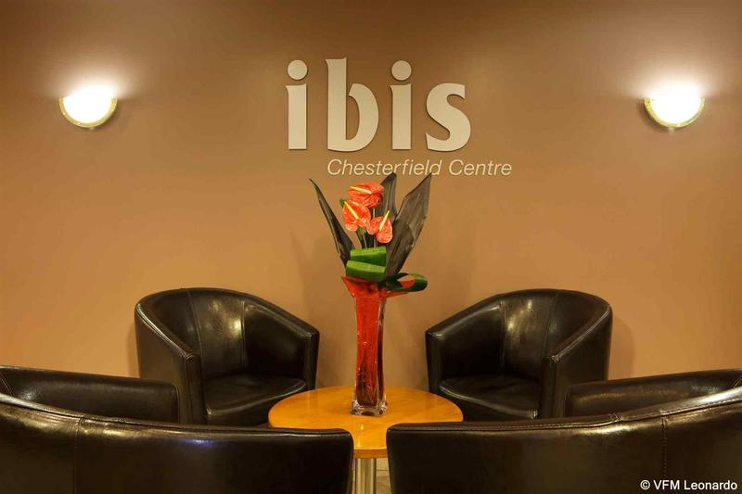
Figure1#: Ibis Chesterfield Centre– Market Town
In this part of the project, the problems affecting ibis Chesterfield Centre – Market Town will be identified from the gathered data and information, and related theories and models will be applied in order to propose different solutions. The following factors in PESTEL analysis will aid in the determination of factors shaping the hotel on the external level: political, economical, social, technological, environmental, and legal. If we try to look for more potential factors influencing the activities of the hotel, it is possible to identify more factors which will put the hotel in general context ( Perchard et al., 2024).
This assessment aims to provide the key responsibilities of the hotel department including front desk officer, housekeeping, maintenance and other departments' work performance ( Ryan et al., 2024). Furthermore, this assessment aims to assess the performance of the consultancy and further investigate the potential improvement areas in the hotel department specifically only the front desk office. However, this assessment involves the job responsibilities of the front desk office, including check-in, check-out, handling guest queries and being involved in other operational activities. However, this assessment also involves the implementation of technological advancement techniques which enhance the performance of hotels (Kamath, 2021).
The guest experience is our top priority at Ibis Chesterfield Centre. The hotel offers guests modern, cosy rooms with all the conveniences they need for a comfortable stay. Moreover, the accommodating team at the hotel is dedicated to giving each visitor individual attention and attending to their requirements as soon as possible (Goldstein et al., 2021). The hotel's prime location also makes it simple to see Chesterfield's attractions, which improves the entire visitor experience. However, providing guests with a flawless experience requires efficient operations. The hotel's front desk employees are skilled in handling reservations, checking guests in and out, and responding to general inquiries, all of which help to ensure efficient operations and happy customers. Additionally, the housekeeping staff keeps the entire property up to date with high standards of hygienic practices, fostering a friendly atmosphere for visitors( Doelman, 2024).
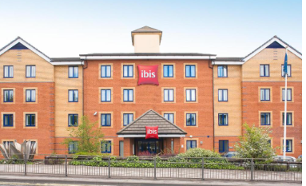
Figure2: Iblis hotel
SWOT analysis will compare the hotel’s current position as the strengths and weaknesses on one hand and the key opportunities and threats that surrounds the hotel on the other. Understanding these factors will be easier using this framework in which high scores represent that the hotel is good in that aspect as opposed to low scores which will depict that the hotel is struggling with the issue. Consequently, the hotel will be placed in a vantage point to contain the perceived strength of the competitor and at the same time eliminate the weaknesses (Zipursky, and Takhshid, 2024).
Also, with the help of TOWS analysis, one aims at figuring out its strategic capabilities of the hotel through the correct matching of its strength and weaknesses with the opportunities and threats identified in the external environment. These are the preeminent discoveries that can be deployed to proactively address the stated challenges and threats and, in turn, optimally capitalize on opportunities and strengths.

Analysis

Issue Identification
The core problem found at ibis Chesterfield Centre – Market Town is that the specific department of housekeeping is clearly overworked and therefore ineffective. Failure in the provision of the necessary supplies results in reduced customer satisfaction, post-trip negative word of mouth, and organizations lose their valued clients. A cleaner hotel is a business goal that is best kept and advance in the rooms department as any spotty cleaning jobs may cost the hotel lots of money in the long run ( Mansfield, K., 2024).

Impact on the Hotel
Lack of adequate cleaning slows up the emptying process, creates unhygienic conditions, and provides a substandard quantity of resources. These problems turn into complaints as guests, and that ends up decreasing the general level of satisfaction. Competition sites like; TripAdvisor, and Google reviews are some of the sites where guests express different concerns about a given hotel and out of all the many contrasting complaints, housekeeping issues dominate.
The impact financial position of the Chesterfield Center includes efficiency in cost management and possible opportunities for savings are shown by looking at cost structures such as labour costs, overhead, and operational expenses (Teresa, and Howell, 2021). Average daily rates (ADR) and occupancy rates provide information on hotel demand and pricing strategy. Furthermore, examining revenue trends over time provides information about the hotel's capacity to generate revenue as well as its sales performance. These financial assessments support the hotel's long-term financial planning as well as strategic decision-making and the optimization of pricing and operational efficiency.
The impact hotel ibis Chesterfield Centre plays a key role in promoting economic growth through a variety of means. First of all, they employ a sizable number of people, providing a variety of work opportunities ranging from entry-level to managerial roles, therefore improving local livelihoods and lowering unemployment rates. According to Pino-Moreno et al., (2021), hotels draw business and leisure travellers as well as attendees of events, bringing in a sizable amount of money for local economies (Armstrong, C.P., 2019). This flood of tourists encourages expenditure in nearby industries like dining, shopping, and transportation, creating a bustling business community (Joshi and Lee, 2019). Additionally, by promoting infrastructure improvements and urban renewal initiatives, hotels frequently catalyze urban development. They support the development of dynamic travel destinations that draw tourists and business visitors alike, enhancing the allure and competitiveness of an area ( Edwards, 2024).
It also gets negative comments and bad ratings from the guests leading to a reduction in the number of people accessing the representations. A steady decline can also lead down in a negative way to occupancy since individuals awaiting to make a decision to book the hotel or travel could end up canceling their booking. As of now, the app was rated as 3/5 stars. 7 stars, this has emphatically highlighted the need to safeguard or pursue this position to enhancing competitiveness in the world market.
The findings showed that low guest satisfaction in combination with reputation loss is detrimental to increases in the hotel’s sales. This will mean that the guests will not be able to revisit the hotel and the hotel has to reduce it’s’s price or offer some incentives in order to attract the clients, thus the reduction of the probable earnings ( Costanzo, 2024).

Causes of Housekeeping Inefficiency
Housekeeping function is faced with the major issue of a relatively high turnover rate of the human resource and therefore a scarcity of competent personnel. This is considered costly since the newly recruited personnel require rigorous training, and it benchmarks time consumption which effects productivity.
The following are some of the possible causes of the above delays; Lack of time may be experienced in cleaning the equipment or there may be poor time management through out the intervals time allocated to cleaning. Shortcomings of the current processes are: this has resulted to rearrangement of staff which is not efficient, and distribution of tasks which also has not been efficient hence more time and resources are consumed ( Ghosh, 2024).
As such, substandard cleaning tools, and irregular supply of cleaning aids diminishes the capacity of the employee in the timely and effective delivery of his or her services. Such consequences may result in negative cleaning quality and lengthy room dwell times.
It was however established that the level of coordination between housekeeping department with other department particularly the front office department and the maintenance department is /are comparatively low. This leads to misconceptions and it takes a long time to attend to the grievances or problems as spelt by the guests or visitors more so concerning any given room (Acito et al., 2024).
However, there may be constituent factors of housekeeping inefficiencies which are therefore necessary to understand and solve at ibis Chesterfield Centre – Market Town. For this analysis, the following frameworks shall be applied: The PESTEL of analysis, The SWOT of analysis, and TOWS of analysis.

PESTEL Analysis
In order to evaluate the external environment and the impact on its operations and performance, the PESTEL analysis of ibis Chesterfield Centre - Market Town is covered. The paper aims at analyzing the PEST factors affecting the hotel with a view of identifying the pertinent Political, Economic, Social, Technological, Environmental and Legal factors.
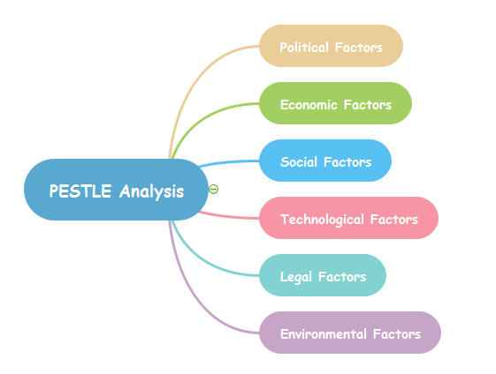
Figure3# PESTEL Analysis
Political
- Hospitals operational cost may be influenced by adjustments in the regulatory policies affecting staffing in the hospitality industry and in labor laws.
- The government initiated a tourism namely VisitBritain which aims to attract customers to enhance their travelling experience with feasibly and flexibility.
- However, UK policies support tourism by prompting the hotel industry and new initiatives.
- The government of the UK enforces legislation aimed at reducing the ecological footprint of enterprises, such as hotels.
- To operate responsibly, hotels must adhere to environmental standards including waste management, carbon emissions, and energy efficiency (Adkins, 2020).
- The accessibility of employment in the lodging industry can be impacted by immigration laws, especially for positions requiring specialized training or seasonal labour.
- The number of employees and hiring processes may be impacted by changes in immigration laws.
- Government organizations including the Food Standards Agency (FSA), local councils, and the Health and Safety Executive (HSE) have requirements that hotels must abide by. These rules address things like food cleanliness, fire safety, well-being specifications, and license conditions (Blake and Cairns, 2020).
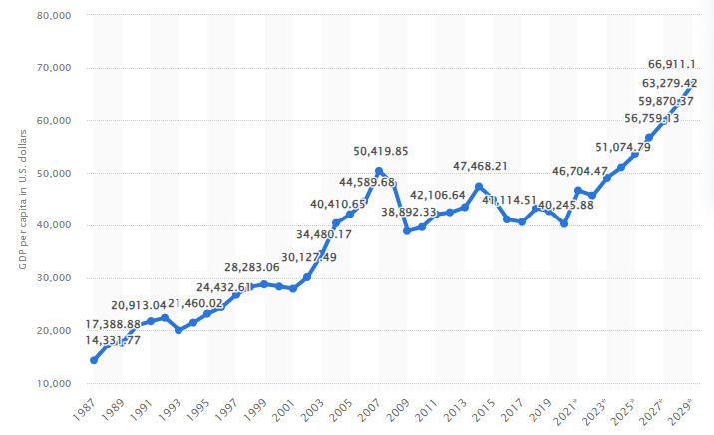
Figure 4: GDP per capita
Source: (Statista, 2024)
Economic
- Consumer spending on travel and lodging is influenced by several economic factors, such as GDP growth, inflation rates, and the rate of joblessness (Grass, 2019).
- Increased demand and higher rates of occupancy for travel are typically associated with a stable economy.
- Changes in currency exchange rates can affect import costs, which can affect the price that the hotel must pay for the goods and services it needs.
- Potential customers' ability to purchase hotel stays is influenced by their income levels. Economic downturns may cause consumers to spend less on leisure travel, which would affect hotel profits.
- Economic fluctuations such as the current recession may lower the traffic causing reduced sales in travelling and room occupancy.
Social
Social factors | Description
Demographics | Changes in age, family structure, and income levels all have an impact on traveller behaviour and lodging preferences. For instance, whereas older generations might place a higher priority on comfort and convenience, millennials and Gen Z visitors frequently seek out unusual experiences and cherish authenticity (Wallerstein et al., 2021).
Cultural diversity | Travelers now come from a wider range of ethnic backgrounds because of globalization, which has increased demand for lodging that can accommodate various dietary needs and cultural preferences. To entice foreign visitors, hotels may provide multilingual services, cultural events, and ethnic consuming alternatives.
Physiographic | There is a growing need for lodging in town centres and industrial areas due to urbanization and population increase. Hotels in metropolitan areas enjoy the advantages of being close to business hubs, tourist destinations, and transit hubs ( Menci, and Valarezo, 2024).

Technological
- Utilizing digital technologies for marketing campaigns, guest services, and reservations boosts operational effectiveness and increases the visitor experience.
- The hotel's credibility and reservation prices are greatly influenced by its social media presence and online reviews. Keeping an eye on and controlling your internet reputation is essential to drawing visitors (Ervits, 2021).
- The hotel may stand out from the competition and draw in tech-savvy guests by implementing technological innovations like virtual concierge services, smartphone check-in/check-out, and smart room services (Zhang et al., 2022).
- Some proposals, such as the adoption of new kinds of cleaning technologies, automation, can increase the efficiency of services, but this is associated with the need for investments.
Legal
- A healthy work environment and the avoidance of legal problems are contingent upon adherence to employment rules and regulations about wages, working hours, and employee rights.
- Respecting health and safety laws, including building rules and food safety requirements, is essential to protecting guests' and employees' health and avoiding legal ramifications.
- Adherence to data protection regulations, like the CCPA or GDPR, is essential for managing visitor data and preserving data security and privacy.
- This is a passion that is paramount to ensure that the company upholds the health and safety standards in the business before conducting the operations and also to ensure that the clients are safe during their stay at the hotels.
Environmental
- Adopting sustainable practices, such as trash minimization, eco-friendly amenities, and energy-efficient operations, shows business commitment and attracts customers who care about the environment (Choi and Won, 2023).
- Extreme weather and natural catastrophes are two risks linked to climate change that could affect the hotel's efficiency and resilience.
- Establishing strong relationships and improving the hotel's reputation is fostered by limiting its environmental impact, supporting local companies, and participating in corporate social responsibility projects that involve people in the area (Klee, 2021).
- Sustainability practices in cleaning (e.g., eco-friendly products) are increasingly demanded by guests.

SWOT Analysis
SWOT analysis of the ibis Chesterfield Centre - Market Town is done in order to identify the factors prevailing within and outside the organisation. The SWOT analysis of the specific hotel provides the information about the business’s strengths, weaknesses, opportunities and threats.
Figure 5 SWOT Analysis

Tows Analysis
Next the TOWS analysis is conducted in order to derive strategic options for the ibis Chesterfield Centre – Market Town based on the findings of the SWOT analysis. This tool assists in the identification and mapping of internal strengths and weaknesses with relative external opportunities and threats with regard to the hotel.
Figure 3 TOWs Analysis
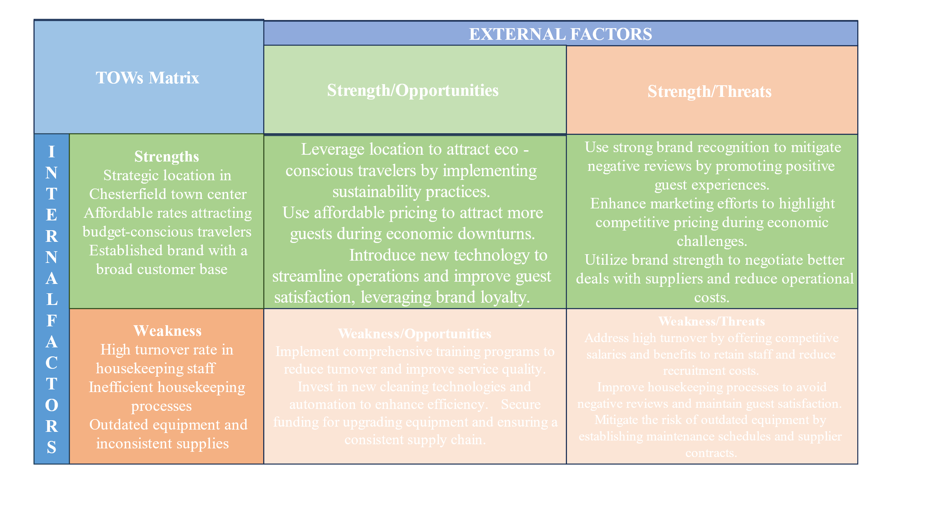

Recommendations

STAFF TRAINING AND RETENTION
Devise a clear training program that would cover both initial training of new employees in the company as well as of any other employees on its list. This policy should elaborate on cleaning approaches, operational hours, and interactivity with clients, and eruption technologies respectively. It may provide corporate career ladder Frame works for Housekeeping department subordinates in order to improve their morale and also reduced staff turnover. This may call for certification, leadership development and or other promotional avenues such as to the next rank. Encourage group meetings and training sessions plus give constructive feedback as a means of emphasizing and bettering the other form of team relationship. Really care about their demands and strive to raise the standard in terms of employees’ satisfaction and employee motivation, and their accomplishments because dissatisfied employees will not look for work with your company.

Figure#6 Training and development
The ibis Chesterfield Center's training course can only work with a well-thought-out plan that focuses on hiring and growth all the time (Thibault et al., 2020). A full training manual should be made that covers everything about how the business works, from how to clean and follow safety rules to opening hours and how to treat guests properly. New employees will go through a full introduction plan that includes classroom learning, hands-on training, and the chance to work alongside more experienced employees to make sure they fully understand the company's culture and how things work. If the hotel really wants to keep its cleaning staff, it should set up a clear way to advertise jobs. The planning chart will show possible career routes, chances to move up, and the steps that need to be taken to get to the next level in one's present job. Through classes on leadership development, licensing programs, and regular reviews of staff’s work, this project can give them a feeling of direction and purpose (Milton, 2024). To keep people motivated and boost mood, there should be a lot of team discussions and feedback sessions. People are able to praise each other, share concerns, and talk about how to improve things during these meetings. Being open for the coworkers to talk about their thoughts and concerns, it can help make the workplace more helpful and positive. Part of managing change is making sure that everyone who is taking part in the training program knows what its goals and benefits are. By getting employees involved in the growing process. One way to get more people to take training classes is to offer rewards, like awards or extra vacation days, for doing so (Buhalis and Moldavska, 2022).

PROCESS OPTIMIZATION
Develop a plan which would indicate how much operations would be performed in one room and how long it would take to go to the next room and start cleaning it. In this case, this implies that use of software tools to assist in managing and performing automated work on these schedules correspondingly is advisable. Develop a program through which supervisors can post subordinates’ schedules with the corresponding work assignments as well as monitor the execution in a virtual sense (Wijayanti et al., 2021). This provision should help in achieving the goal of enhanced more cooperation and timely addressing of problems as they arise.
In order to develop and be able to implement these rules and regulation, ensure that Standard Operation Procedures SOPs are developed and implemented for all housekeeping operations throughout the department to attain superior state in the department. On this note, the above mentioned procedures should reviewed and update more frequently to to reflect the best practices.
It is possible for the ibis Chesterfield Centre to have a cleaner that is better managed and uses more modern technology (O’Connor et al., 2023). A good place to start is with a time-motion study to find out how long it takes to clean different types of rooms on average. When employees' plans are based on what is expected of them, they are less likely to be stressed. Using housework control software is a surefire way to get things done faster and better. This kind of tool make schedules, check on the state of rooms, and give jobs based on availability and importance (Floričić, 2020). With this app, managers can be able to keep an eye on progress and move resources around, which can come in convenient when there are not enough employees or there is a lot of demand. Setting up Standard Operating Procedures (SOPs) and reviewing them on a daily basis can help keep cleaning methods uniform. All staff should be able to access these SOPs because they will lay the groundwork for ongoing training changes (Saide et al., 2024). These steps should be followed often to make sure they are still relevant and follow the most recent industry standards. For change management solutions to work, employees must agree with the new processes and how they are implemented. There is help available during the necessary training classes on the new tools and standard working procedures in case any problems come up (Florescu et al., 2020). Some of these benefits are less work to do and more regular schedules. Set up feedback loops so that problems can be fixed quickly and changes can be made all the time.
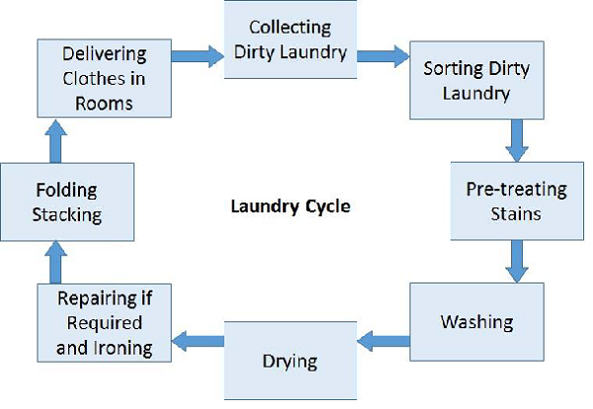
Figure7# housekeeping key responsibilities

A number of key measures will be used to judge how well the tactics work and what results they produce like figuring out how efficient cleaning is to compare the amount of time needed to clean places before and after changes were made (Velayati et al., 2021). This can be measured by comparing the real time it took to clean with the time it was predicted to take in time-motion studies. Reports and reviews can be used to check that standard operating procedures (SOPs) are still relevant and up-to-date when it comes to cleaning methods. The cleaning control software's effectiveness can also be judged by how well the plan works, how many tasks are finished, and how much total output goes up (Weaver et al., 2021). By measuring things like satisfaction, shorter wait times, and better cleaning, feedback from both staff and customers can put light on how well the plans are working (Hassanein and Özgit, 2022). Early costs include buying and setting up the software for cleaning control, teaching staff about new tools and processes, and possibly hiring more people to help with the change. The money saved on running costs and higher output should more than cover these original investments (Diem et al., 2021). The hotel will make sure that its costs are fair and sufficient based on its size and income so that it can get a good return on its investment and keep growing.

UPGRADE EQUIPMENT
Procure equipment for cleaning to ensure that the available equipment minimally requires less effort from the cleaners while effectively supporting cleaning effectiveness (Sann and Lai, 2020). These are some of the tools used in cleaning; there are vacuum cleaners specifically designed to be fitted with HEPA filter, steam cleaners, and automatic floor cleaners. It is advisable to be consistent on the type of cleaning material to buy and establish a time with specific suppliers, this ensures availability of clean materials. Some of the cleaner equipment being used in communities are among the most vital assets and they require regular maintenance to avoid failures. This involves creating a flow chart for the supplies to ensure that there is a constant check on when they are due for restocking (Starski et al., 2023). The ibis Chesterfield Centre can be able to improve its cleaning tools to make them work better and faster. Right away, the business need to get modern hoover cleaners, floor sweepers and steam cleaners with HEPA filters. The cleaning staff can use these tools to do their jobs faster and with less pain. The staff will never run out of good cleaning supplies as long as the business stick to regular buying habits. Customers can always expect a clean and nice environment because the business works with dependable providers and does quality checks on a regular basis (Kim et al., 2022).
Everyone who works for the company will have to go through full training on the new tools so that the switch to new equipment goes smoothly (Vosburgh et al., 2022). The tools will be easy for staff to use after seeing demos and working with them. The cleaning crew's help is needed to fix problems and make changes during this shift. Several key measures can be used to judge how well and how often the methods given work. By measuring how long it took to clean before and after the new equipment was put in, the company can tell if it is faster and better at what it does (Jabeen et al., 2022). The result would be good if there was more cleanliness and less time spent cleaning. Staff surveys and notes may also show how useful and simple the new technologies are to use. The hotel can keep an eye on stocking levels and seller performance to see how well it is doing at keeping a steady supply of cleaning products. By doing regular checks, it can be assured that cleaning supplies are always on hand and quickly fix any problems that come up. Ratings from customers about how clean a business is can be a good quality sign (Zwiegelaar et al., 2022). If these tactics are used, cleaning up, staff happiness, and customer satisfaction can increase. This can lead to more customers staying with the business and more good reviews. The costs that come with the suggestions include the original cost of buying new equipment, the ongoing costs of keeping it in good shape, and the fees for training staff. But given the size and income of the hotel, these fees should be fair and justified (Mitchell, 2020). Customers who are satisfied and buildings that are clean will more than cover the costs of being efficient and effective.

ENHANCE COMMUNICATION
The accommodation division have to establish the necessary communication with the front desk and the cleaning division have to do the same for the maintenance section (Höpken et al., 2020). Information can be passed by using social apps such as instant messaging, the corresponding communication apps. Ensure there is a formal communication system where people from different departments can share ideas through proper meetings where issues, activities and new ideas can be passed around. Ensuring the cooperation of all the stakeholders to such a discussion is also important in improving it. A case on effective management of a reporting process coordination that enables housekeeping staff to report issues and or new solutions. Ensure that feedbacks are used in an encouraging manner and particularly in workplaces, and that any feedback given is attended to within the shortest time possible (Adiba et al., 2021). The people who clean the ibis Chesterfield Centre can improve their speaking skills in a number of ways.

Figure#8 Communication skills
A simple way for the cleaning, front desk, and repair staff to communicate with each other, like an instant message app, can be helpful for everyone. This will let them stay up-to-date and work together in real time. The method must be easy for all staff members to use and get to. The best way to solve problems, share ideas, and combine efforts is for people from different areas to get together on a regular basis. These events should be open to everyone while still being well organised so that everyone can take part and contribute. Problems with operations, future projects, or guest opinions can be up for discussion (Schwepker Jr and Dimitriou, 2021). Potential results of the suggested methods can be judged by a number of important criteria. The hotel can find the time it takes to respond to important problems and how often staff reports are sent among them.
If the hotel wants to know how well group teamwork sessions are working, they can look at how many people show up, how engaged they are, and how many useful ideas they create (Milton, 2024). Two more ways to measure success are the time it takes to deal with problems that have been mentioned and the rate at which solutions are put into place. These tactics can boost working efficiency, employee morale, and guest happiness by making teams work together better and fixing problems faster. Positive comments, repeat business, and higher earnings are all possible if these changes are made. The hotel should make sure to include a list of any costs that come with the suggestions. This is where the costs of teaching staff how to communicate, setting up meetings, and rolling out new tools go. If the hotel wants to stay open and make money, these prices should be fair and match the amount of money the business makes (Cheung et al., 2021).

Action Plan
S.no | Problem | Solution | Desired outcomes | Time frame | Completion date | Planned budget
1. | Housekeeping service not up to the mark resulted in customer dissatisfaction.  Lack of communication skills which leads to operational inefficiency. | Providing training and other sessions to develop communication skills.  Invest in visitor suggestions or feedback this will aid in improving the performance and taking action to enhance the performance. | Enhance customer satisfaction. | 3-6 months | August, 2024 | $30,000
2 | Lack of environmental sustainability | Initiatives towards a sustainable and eco-friendly environment | Enhancing the practices and operations related to sustainability. | 9-12 months | September, 2024 | $ 40,000
3 | Downfall of brand reputation and revenue | Use data analytics to improve hotel rates and inventory management, execute flexible pricing methods based on variations in demand, and maximize income by adding value packages or promotions. | Enhancing revenue management, higher revenue per available room (RevPAR), and maximum profitability. | 6-9 months | March 2025 | $ 65,000

Conclusion
From this consultancy report, the main problem that has been provided is the general problem of ineffectiveness in housekeeping processes at ibis Chesterfield Centre – Market Town. There are various challenges that the housekeeping departments present which affect the guest satisfaction, image of the organization, and sales. By employing PESTEL analysis to the industry and by using SWOT and TOWS tools, potential factors that may lead to the inefficiencies mentioned above were identified as staffing problems, operations, ineffective and outdated technologies, and inadequate communication.
Accomplishing these recommendations will help ibis Chesterfield Centre – Market Town improve guest satisfaction, the center’s ranking, and overall profits? Envisioned approaches will cause an improvement in the housekeeping department’s productivity and efficiency, the outcome of which will benefit the hotel as a whole. Better local training and increased retention levels will guarantee qualified and committed employees while applying operational enablers to increase process efficiency. Upgrading cleaning equipment and materials, guaranteeing their availability will sustain high cleaning quality, Increased communication between the shifts and or departments will help in smoother problem solving. In aggregate, implementing these value-enhancing cost strategies will create the kind of travel lodging demand that will help ibis Chesterfield Centre – Market Town attract guests and become more profitable over time.
In conclusion, this report is based on the Chesterfield centre located in London UK. However, this hotel strong brand image and reputation. To develop this research the core problem was found at ibis Chesterfield Centre Market Town that the specific department of housekeeping is overworked and therefore ineffective. Moreover, Failure in the provision of the necessary supplies results in reduced customer satisfaction, post-trip negative word of mouth, and organizations losing their valued clients. Moreover, the cleanliness of the hotel is a business goal that is best kept and advanced in the rooms department as any spotty cleaning jobs may cost the hotel lots of money in the long run.
Furthermore, this study covers three main body parts firstly a brief introduction, then analysis which includes SWOT, PESTLE and TOWs matrix, these matrices sort out the hotel's strengths, weaknesses, opportunities, future strategies and other political and economic factors which may enhance the credibility of the hotel industry. However, the prime location of Chesterfield Center also makes it simple to see Chesterfield's attractions, which improves the entire visitor experience. However, providing guests with a flawless experience requires efficient operations. Furthermore, enhancement in the business model for efficient operations and customer satisfaction is the main objective and goal of ibis Chesterfield Centre.
Subsequently, the hotel has many challenges that are established to be effective in denying the establishment an ability to deliver the best experience to the guests and achieve organizational objectives and goals notwithstanding its central location and low prices. Through the implementation of technology, personnel development, and sustainability programs, the hotel may enhance its service quality and sustain its competitive advantage within the hospitality sector. With an emphasis on ongoing development, ibis Chesterfield Centre is well-positioned to carry on offering its visitors remarkable experiences while guaranteeing long-term, consistent development and achievement.

References

Acito, M., Varfaj, I., Brighenti, V., Cengiz, E.C., Rondini, T., Fatigoni, C., Russo, C., Pietrella, D., Pellati, F., Bartolini, D. and Sardella, R., 2024. A novel black poplar propolis extract with promising health-promoting properties: focus on its chemical composition, antioxidant, anti-inflammatory, and anti-genotoxic activities. Food & Function.
Adkins, M.E., 2020. Chesterfield Smith, America's Lawyer. University Press of Florida.
Armstrong, C.P., 2019. Ampthill Neighborhood Market Analysis & Community Strengthening Plan.
Blake, D. and Cairns, A.J., 2020. Longevity risk and capital markets: the 2018–19 update. Annals of Actuarial Science, 14(2), pp.219-261.
Buhalis, D. and Moldavska, I., 2022. Voice assistants in hospitality: using artificial intelligence for customer service. Journal of Hospitality and Tourism Technology, 13(3), pp.386-403.
Buhalis, D., O’Connor, P. and Leung, R., 2023. Smart hospitality: from smart cities and smart tourism towards agile business ecosystems in networked destinations. International Journal of Contemporary Hospitality Management, 35(1), pp.369-393.
Butschle, M., Lindner, S., Schackmann, M. and Dam-Johansen, K., 2024. Towards improved antifouling: Exploring xanthan gum hydrogel coatings. Progress in Organic Coatings, 188, p.108197.
Choi, S. and Won, J., 2023. Exploring the Survival Mechanisms of Short-Term Rentals in Virginia: A Comparative Analysis of Rural versus Non-Rural Markets. Sustainability, 15(16), p.12651.
Costanzo, K., 2024. Expanding Equitable Housing Through Rezoning: Strategies for Land Use and Future Development within Richmond.
Doelman, J., 2024. The daring muse of early Stuart funeral elegies.
Edwards, J.R., 2024. Capitalism and the return on capital employed. Some further evidence. The British Accounting Review, p.101320.
Ervits, I., 2021. R&D by US multinationals in China: geography and patterns of co-invention. International Journal of Emerging Markets, 16(8), pp.1525-1555.
Floričić, T., 2020. Sustainable solutions in the hospitality industry and competitiveness context of “green hotels”. Civil Engineering Journal, 6(6), pp.1104-1113.
Foris, D., Florescu, A., Foris, T. and Barabas, S., 2020. Improving the management of tourist destinations: A new approach to strategic management at the DMO level by integrating lean techniques. Sustainability, 12(23), p.10201.
Frasier, R.M., De Oliveira Sergio, T., Starski, P.A., Grippo, A.J. and Hopf, F.W., 2023. Heart rate variability measures indicating sex differences in autonomic regulation during anxiety-like behavior in rats. Frontiers in Psychiatry, 14, p.1244389.
Ghosh, S., 2024. Water management practices in master-planned developments and eco-neighborhoods. Encyclopedia of Sustainable Technologies.
Goldstein, M.R., Bourn, S. and Jacob, A., 2021. Early Osia® 2 bone conduction hearing implant experience: nationwide controlled-market release data and single-centre outcomes. American Journal of Otolaryngology, 42(1), p.102818.
Grass, S., 2019. Autobiography, Sensation, and the Commodification of Identity in Victorian Narrative: Autobiography, Sensation, and the Literary Marketplace (Vol. 121). Cambridge University Press.
Hassanein, F. and Özgit, H., 2022. Sustaining human resources through talent management strategies and employee engagement in the Middle East hotel industry. Sustainability, 14(22), p.15365.
Höpken, W., Fuchs, M., Keil, D. and Lexhagen, M., 2020. Business intelligence for cross-process knowledge extraction at tourism destinations. Information Technology & Tourism, 15, pp.101-130.
Hudson, S., 2017. Marketing for tourism, hospitality & events: a global & digital approach.
Jabeen, F., Al Zaidi, S. and Al Dhaheri, M.H., 2022. Automation and artificial intelligence in hospitality and tourism. Tourism Review, 77(4), pp.1043-1061.
Joshi, K. and Lee, K., 2019. Making an impact in the health-care sector with outsourced information technology services: An interview with Day Veerlapati, President and CEO, Seven Seas Technologies Inc, Chesterfield, USA. Journal of Global Information Technology Management, 22(1), pp.71-74.3.
Kamath, V., 2021. Market Analysis Report for Global Infections 2020 is scheduled in Singapore during 28-29 September 2020. International Journal of Collaborative Research on Internal Medicine & Public Health, 13(1), pp.1041-1042.
Kim, M.K., Kim, T., Choi, J., Joo, Y.E., Park, H., Lee, H., Lee, C., Jang, S., Vasseghian, Y., Joo, S.W. and Lee, J.I., 2022. Analysis of semi-volatile organic compounds in indoor dust and organic thin films by house type in South Korea. Environmental Research, 214, p.113782.
Klee, S.J., 2021. Assembling “The Camp”: Agricultural Labor and the Wartime Carceral State in Chesterfield, Missouri, 1937–1972. Agricultural History, 95(4), pp.633-658.
Knani, M., Echchakoui, S. and Ladhari, R., 2022. Artificial intelligence in tourism and hospitality: Bibliometric analysis and research agenda. International Journal of Hospitality Management, 107, p.103317.
Madyatmadja, E.D., Adiba, C.N.A., Sembiring, D.J.M., Pristinella, D. and Putra, A.M., 2021. The positive impact of implementation business intelligence and big data in hospitality and tourism sector. International Journal of Emerging Technology and Advanced Engineering, 11(6), pp.59-71.
Mansfield, K., 2024. The Complete Short Stories of Katherine Mansfield (Literature Classics Series). Good Press.
Menci, S.P. and Valarezo, O., 2024. Decoding design characteristics of local flexibility markets for congestion management with a multi-layered taxonomy. Applied Energy, 357, p.122203.
Milton, T., 2024. Artificial Intelligence Transforming Hotel Gastronomy: An In-depth Review of AI-driven Innovations in Menu Design, Food Preparation, and Customer Interaction, with a Focus on Sustainability and Future Trends in the Hospitality Industry. International Journal for Multidimensional Research Perspectives, 2(3), pp.47-61.
Milton, T., 2024. Artificial Intelligence Transforming Hotel Gastronomy: An In-depth Review of AI-driven Innovations in Menu Design, Food Preparation, and Customer Interaction, with a Focus on Sustainability and Future Trends in the Hospitality Industry. International Journal for Multidimensional Research Perspectives, 2(3), pp.47-61.
Mitchell, C., 2020. The impact of big data within the tourism and hospitality industry and influence on business intelligence and strategic decision making in the hotel sector.
Nazarian, A., Velayati, R., Foroudi, P., Edirisinghe, D. and Atkinson, P., 2021. Organizational justice in the hotel industry: revisiting GLOBE from a national culture perspective. International Journal of Contemporary Hospitality Management, 33(12), pp.4418-4438.
Paulose, D. and Shakeel, A., 2022. Perceived experience, perceived value and customer satisfaction as antecedents to loyalty among hotel guests. Journal of Quality Assurance in Hospitality & Tourism, 23(2), pp.447-481.
Perchard, A., Gildart, K., Curtis, B. and Millar, G., 2024. Fighting for the soul of coal: Colliery closures and the moral economy of nationalization in Britain, 1947–1994. Enterprise & Society, pp.1-34.
Pino-Moreno, G.C. and Pino-Moreno, G., 2021. Chains of Stability: Building Financial and Cultural Community Sustainability for Latinas in Richmond & Chesterfield, Virginia.
Ratna, S., Saide, S., Putri, A.M., Indrajit, R.E. and Muwardi, D., 2024. Digital transformation in tourism and hospitality industry: a literature review of blockchain, financial technology, and knowledge management. EuroMed Journal of Business, 19(1), pp.84-112.
Ryan, C.D., Henggeler, E., Gilbert, S., Schaul, A.J. and Swarthout, J.T., 2024. Exploring the GMO narrative through labeling: strategies, products, and politics. GM Crops & Food, 15(1), pp.51-66.
Sann, R. and Lai, P.C., 2020. Understanding homophily of service failure within the hotel guest cycle: Applying NLP-aspect-based sentiment analysis to the hospitality industry. International Journal of Hospitality Management, 91, p.102678.
Schwepker Jr, C.H. and Dimitriou, C.K., 2021. Using ethical leadership to reduce job stress and improve performance quality in the hospitality industry. International Journal of Hospitality Management, 94, p.102860.
Sheehan, M.J., Vosburgh, D.J., O’Shaughnessy, P.T., Park, J.H. and Sotelo, C., 2022. Direct-reading instruments for aerosols: A review for occupational health and safety professionals part 2: Applications. Journal of occupational and environmental hygiene, 19(12), pp.706-729.
Shi, F., Shi, D., Weaver, D. and Samaniego Chavez, C.E., 2021. Adapt to not just survive but thrive: resilience strategies of five-star hotels at difficult times. International Journal of Contemporary Hospitality Management, 33(9), pp.2886-2906.
Stylos, N., Zwiegelaar, J. and Buhalis, D., 2021. Big data empowered agility for dynamic, volatile, and time-sensitive service industries: the case of tourism sector. International Journal of Contemporary Hospitality Management, 33(3), pp.1015-1036.
Teresa, B.F. and Howell, K.L., 2021. Eviction and segmented housing markets in Richmond, Virginia. Housing Policy Debate, 31(3-5), pp.627-646.
Thibault, M., Weston, M.A., Ravache, A. and Vidal, E., 2020. Flight‐initiation response reflects short‐and long‐term human visits to remote islets. Ibis, 162(3), pp.1082-1087.
Tien, N.H., Diem, P.T., Van On, P., Anh, V.T., Van Dat, N., Hung, N.T. and Tam, B.Q., 2021. The formation and development of CRM system at Thien Hoa electronics supermarket in Vietnam. International Journal of Research and Growth Evaluation, 2(4), pp.752-760.
Trip Advisor 2024. Ibis Chesterfield Centre. [online] Trip Advisor. Available at: https://www.tripadvisor.com/Hotel_Review-g209967-d239751-Reviews-Ibis_Chesterfield_Centre-Chesterfield_Derbyshire_England.html [Accessed 25 May 2024].
Wallerstein, S., Center, I.A.H., Norich, G. and Israel, S.F., 2021. Impact Assessment Tool.
Wijayanti, A., Titisari, K.H., Siddi, P. and Dewi, R.R., 2021. Implementation of Health-based Standard Operating Procedures (Sop) as Covid-19 Mitigation in Hotel Industry. SPEKTA (Jurnal Pengabdian Kepada Masyarakat: Teknologi dan Aplikasi), 2(2), pp.129-138.
Yang, H., Song, H., Cheung, C. and Guan, J., 2021. How to enhance hotel guests’ acceptance and experience of smart hotel technology: An examination of visiting intentions. International journal of hospitality management, 97, p.103000.
Zhang, H., He, L., Di Gioia, F., Choi, D., Elia, A. and Heinemann, P., 2022. LoRaWAN-based Internet of Things (IoT) system for precision irrigation in plasticulture fresh-market tomato. Smart Agricultural Technology, 2, p.100053.
Zipursky, B.C. and Takhshid, Z., 2024. Consumer Protection and the Illusory Promise of the Unconscionability Defense.

