
Module Title: Human Capital Management
Module Code: LCMB7023
Designing a Human Capital Architecture for Strategic Renewal at Helios Urban Mobility
Student ID:2532975 Student Name:Unnatiben manojbhai patel
Executive Summary
Human capital is becoming an issue for Helios Urban Mobility (HUM), an emerging smart-transport firm from Europe, as evidenced by poor organisational socialisation, minimal engagement among employees, and a high turnover rate amongst graduates. The following paper offers strategic solutions for solving these problems and enhancing organisational change. In addition, by addressing these problems and fostering organisational renewal, the first suggestion is to substitute the existing process of onboarding for organisational socialization.
Secondly, there is a new approach suggested in the report towards job design through the application of Job Characteristics Model, Job Crafting Theory, and a skills-based architecture using an internal talent marketplace. The objective here is to increase intrinsic motivation, creativity, and organisational agility. Finally, there is an analysis of the ethics in the use of artificial intelligence as a support system in decision-making processes, along with a development plan for personal competencies. It is related to data literacy, artificial intelligence as a support system in HR management, strategic influencing, and global mobility.

Table of Contents
Introduction 4
Task A: Socialisation, Identity and Business Activism 4
2.1 Section 1: Traditional Onboarding versus Strategic Organisational Socialisation 4
2.2 Section 2: Structured Socialisation Framework for Helios Urban Mobility 6
2.3 Section 3: Organisational Identification, Ethical Professionalism and Business Activism 7
Task B: Job Design 8
3.1 Innovative Job Design Strategy for Helios Urban Mobility 8
3.2 How the Proposed Design Stimulates Motivation and Innovation 12
Task C: Reflective Report 14
4.1 Using AI as a Decision-Support Tool Without Eroding Human Judgement 14
4.2 Personal Capability Development Plan 14
Conclusion 15
Reference 16

Introduction
Helios Urban Mobility (HUM) is a smart transport start-up based in Europe that focuses on the provision of artificial intelligence (AI) driven electric mobility solutions as well as smart infrastructure analytics. In spite of its rapid growth in London, Berlin, and Singapore, the firm faces various human capital problems, such as a long employee induction process of up to eight months, low engagement rates of 54% among employees, and high attrition among graduate employees. This paper explores strategies to overcome these problems through organizational socialization and innovative job design.

Task A: Socialisation, Identity and Business Activism

2.1 Section 1: Traditional Onboarding versus Strategic Organisational Socialisation
The conventional onboarding process is often based on administrative tasks such as completing forms, describing organizational policy, and acquainting workers with their basic tasks at work. Although such an approach helps familiarize employees with the workings of the organization, it does not help to build any commitment, organizational identity, or integration with other employees. This results in confusion among employees regarding organizational expectations and a lack of adaptation to the organizational culture. The situation at Helios Urban Mobility (HUM). It is evident from the eight-month average onboarding period, which indicates that knowledge of the organization is acquired indirectly.
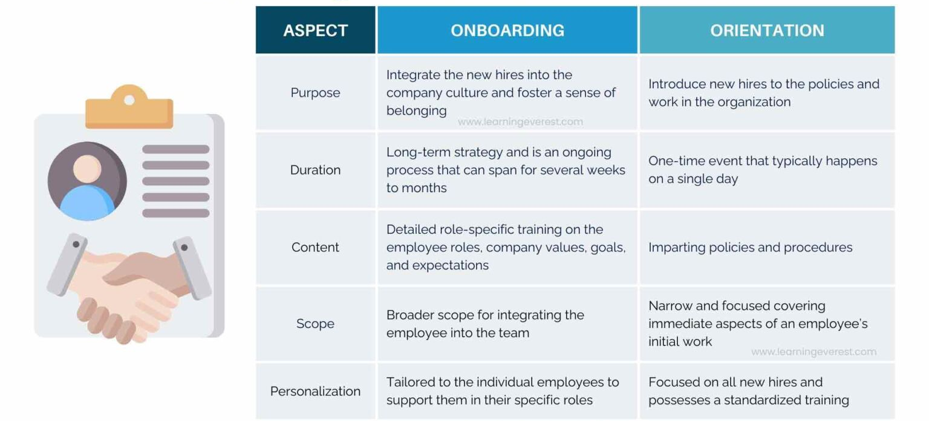
Figure 1: Onboarding vs Orientation
(Source: Learning Everest, 2025)
According to Van Maanen and Schein (1977), organisational socialisation is defined as a process of learning through which new members of organisations acquire required values and attitudes needed to perform efficiently. Contrary to the conventional onboarding process, strategic organisational socialisation goes beyond the initial few days after recruitment and is aimed at developing commitment, competency, and organisational identity among the employees (Liao et al., 2022). The socialisation issues facing HUM, therefore, are clear pointers to the lack of strategic socialisation processes.
Psychological Contract Theory also provides an explanation for the high rate of graduate turnover in the organization. As proposed by Robinson, and Rousseau, (1994), employees have implicit expectations of the employer related to career development, mentoring, recognition, and meaningfulness. When such expectations go unfulfilled, employees consider themselves violated in their psychological contract, causing them to become dissatisfied and disengaged with work (Ngobeni et al., 2022). The low employee engagement score of 54% and the high graduate turnover of HUM indicate the violation of such expectations.
Social Identity Theory also suggests that the commitment of employees is increased by organizational identity becoming part of the identity of the employee (Mittal et al., 2022). Organizational commitment in terms of behaviour is increased if the organization becomes part of the identity of the employee. The challenges facing HUM in engagement can thus be due to a lack of organizational identity due to inadequate socialization processes.
Thus, all the above theories together indicate that the human capital problems facing HUM cannot be solved by administrative onboarding.

2.2 Section 2: Structured Socialisation Framework for Helios Urban Mobility
Stage One: Pre-boarding
Socialization should occur after the acceptance of the job offer by the employee. The HUM department has to design an AI-based onboarding system through which the employee can get information related to organizational history, mission, sustainability objectives, portfolio of products, and business relations abroad (Sharma et al., 2025). A welcoming package containing all the information relating to organizational culture and educational material should also be prepared for the employee. Finally, a mentor should be assigned to the employee before the joining date at the workplace. These steps would help in developing psychological contracts and setting realistic expectations for the employees.
Stage Two: First 90 Days
The first 90 days should be focused on combining skill development with organisational assimilation. Employees need to participate in projects that require collaboration within diverse departments and locations as well. Executive round tables may assist employees in grasping organisational strategy and forming relationships with executive members of the team (Engelbrecht, and Ferreira, 2022).
Ethical training will be valuable in ensuring that the employees get educated about the ethical application of AI, sustainability, and stakeholder management because the organisation operates in public infrastructure and smart cities (Chang, and Ke, 2024). Innovation challenges will be instrumental in nurturing innovation and encouraging employees to come up with innovative ideas for the organisation.
All these activities will result in the development of relationships and fast organisational learning, which will overcome the eight months required by the organisation for organisational learning.
Stage Three: Year 1
After completion of the integration process, there should be a procedure of socialization through the international project rotation program that would enable the employees to gain cross-cultural experience and develop global competence. The leadership shadowing program can act as exposure to the process of strategic thinking and help potential employees become future leaders (Nicolini, and Korica, 2025).
These quarterly career development sessions should address career plans and learning objectives, and thereby enhance employee commitment and reduce their intention to leave the organization. Hence, the model will transform the onboarding process into a development process for the employees.

2.3 Section 3: Organisational Identification, Ethical Professionalism and Business Activism
Organizational Identification plays a key role in creating commitment and engagement from the employees’ side. As is defined in Social Identity Theory, organizational identification allows for creating a psychological affiliation with the organization due to the organizational identification (Holmes, and Howard, 2023). Organizational Identification can be improved within HUM by using such approaches as storytelling about HUM’s commitment to providing sustainable urban mobility solutions, customer stories, and regular interactions with top management.
Similarly, professional ethics are equally important because HUM develops AI-based tools that affect the transport systems and infrastructures in the city (Almulhim, 2025). The workers have to be educated about their use of AI from the perspective of ethics, data protection, sustainability, and stakeholder engagement. Professional ethics have to be a part of the business operations.
As stated by Pandey, and Risal, (2022), the Human Resources Department must act as a strategic partner that is responsible for developing organizational capabilities and initiating changes within an organization due to the HR Business Partner theory. This perspective highlights the role of a business activist who takes into consideration the interests of other stakeholders apart from increasing organizational effectiveness.
However, the concept of Stakeholder Capitalism would suggest that organisations create value not just for themselves but also for their employees, customers, government, communities, and the environment (Mhlanga, 2022). Hence, via HUM, organisations need to motivate their employees to participate in projects and initiatives that help them to create value for the organisation as well as for society as a whole.
Through the development of organisational identification, professionalism, and business activism through HUM, organisations can create an extremely motivated workforce that will be able to help them achieve their renewal and competitive edge.

Task B: Job Design

3.1 Innovative Job Design Strategy for Helios Urban Mobility
Applying the Job Characteristics Model
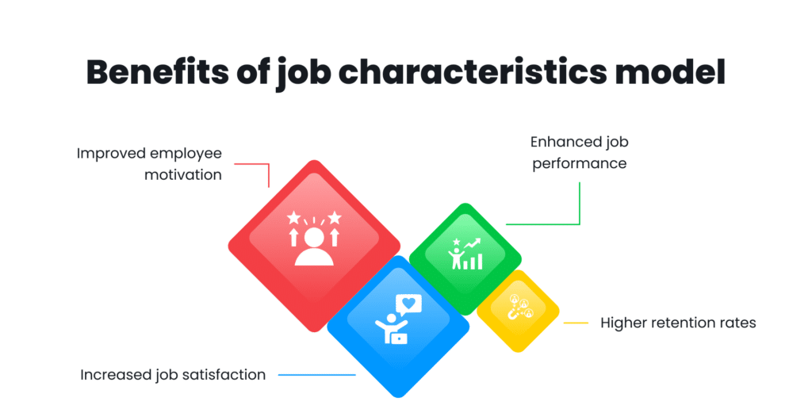
Figure 2: Benefits of Job Characteristics Model
(Source: Testlify, 2026)
According to Winkelhaus et al., (2022), Job Characteristics Model states that five critical job dimensions play an important role in the motivation and performance of employees. Skill variety refers to the range of activities and skills required by a particular job. In the case of HUM, the organization should include projects that involve collaboration between engineers, data analysts, software developers, and customer service teams.
The task identity refers to how much employees perform an entire task from start to finish (Boccoli et al., 2023). Instead of dividing tasks, HUM needs to allow its workers to oversee their project through its whole lifecycle, right from conception to execution and evaluation. In this way, the workers will be able to see the results of their efforts.
The significance of employees' perception of their jobs because HUM is developing sustainable transportation technologies that provide better public transport systems and are environmentally friendly (Ahuchogu et al., 2024). Management should constantly remind the employees of the significance of the projects by highlighting how they have impacted society through customer feedback, case studies, and community involvement activities.
Autonomy refers to the freedom an employee has when performing his/her job. HUM needs to support self-managing teams that have the freedom to decide on how and when projects will be done. Increased autonomy gives an employee the power to make decisions, increases responsibility, and fosters creativity.
Feedback is used to provide employees with information about their performance and development (Vuong, and Nguyen, 2022). In order for HUM to have its employees receive ongoing developmental feedback, it should use coaching sessions, performance dashboards, and reviews that take place every quarter.
Applying Job Crafting Theory
As per Job Crafting Theory, employees tend to redesign different elements of their jobs to give them more meaning and motivation (Costantini et al., 2022). In addition, employees can be allowed to engage in innovative tasks and sustainable practices that go beyond what is formally defined as part of their job description. Such an approach will allow employees to acquire new competencies and do something that they find interesting (Bukartaite and Hooper, 2023). It is the responsibility of HUM to promote the interaction between staff members from different departments and foreign locations via cross-functional teams and communities of practice. It will contribute to knowledge sharing and organizational learning.
Therefore, the employees are motivated to reflect on the significance of what they are doing, for they know the importance of their role in ensuring sustainable urban mobility of individuals and bettering the quality of their lives.

Figure 3: Job Crafting Theory
(Source: Self-developed)
Skills-Based Architecture and Internal Talent Marketplace
The traditional job design restricts organizational flexibility, as workers are bound by their designated roles (Kossek, and Kelliher, 2023). As such, HUM needs to incorporate the Skills-Based Architecture, where the capabilities of individuals will be taken into account instead of the traditional job design approach. The company needs to determine the current skills of its workers as well as their future capability needs through skill analysis.
The employees can be encouraged to take part in short-term projects beyond their jobs, both overseas and within the organization itself, which help them to learn more while increasing organizational flexibility (Griep et al., 2025). With the help of artificial intelligence, a talent marketplace can be created where the employees will get the chance to take up suitable projects according to their skills and goals.
By implementing such an initiative, HUM will not only be able to utilize its talents better but also lessen the reliance on external hires.

3.2 How the Proposed Design Stimulates Motivation and Innovation
Enhancing Intrinsic Motivation
This design of work will greatly enhance the intrinsic motivation among employees. As per the Job Characteristics Model, the skill variety, autonomy, and significance of tasks are the components that help to create meaningful jobs and increase the motivation level of employees (Winkelhaus et al., 2022). Employees who find meaning in their jobs tend to be committed and perform better.
Improving Employee Engagement
The current level of employee engagement stands at 54%, which means there is little chance for development among employees. Through job crafting and internal mobility, employees can be part of determining their career paths, thus enhancing their engagement and organisational commitment.
Supporting Creativity and Innovation
Innovations require collaboration, experimentation, and sharing of knowledge. Diversity of cross-functional teams and internal gigging helps people come across individuals from various walks of life, which makes them innovative and problem solvers (Lindblom, and Martins, 2022). The ability to act independently helps people experiment with novel concepts and approaches.
Retaining High-Potential Graduates
Purposeful careers and professional development are the main things that graduate personnel need to find. In the company, the talent market and personal development possibilities can fulfil these needs and contribute to the improvement of the psychological contract (Griep et al., 2025). In turn, employees will be inclined to stay committed to HUM.
Enhancing Organisational Agility
Skills-based architecture provides the company with the ability to redeploy its employees swiftly as per business requirements. Such flexibility is important for HUM because it will help the company to cope with changing technology and uncertain market situations (Sony et al., 2023).

Figure 4: How the Proposed Design Stimulates
(Source: Self-developed)
Critical Evaluation
While the proposed model is advantageous in some ways, some challenges may arise with its implementation. Autonomy and job crafting may lead to role ambiguity and inconsistency in work processes because roles have to be well-defined. Workers who participate in several projects at once may suffer from workload and may become more stressed. Besides, there will be high expenses for implementing AI-based talent marketplaces and skills mapping tools.
However, the strengths of this strategy are more significant than the aforementioned weaknesses. The incorporation of the Job Characteristics Model, Job Crafting Theory, and Skills-Based Architecture would result in a highly motivated, innovative, and adaptive workforce that could help HUM achieve its strategic rebirth and competitive advantage.

Task C: Reflective Report

4.1 Using AI as a Decision-Support Tool Without Eroding Human Judgement
The use of artificial intelligence (AI) has greatly changed the field of human resources management by enabling informed decisions in less time. In my future career, I intend to utilize AI in aiding me to make decisions rather than making the decisions for me. The capacity for artificial intelligence is to analyse large amounts of data and predict trends in the labour force, attrition, hiring, talent management, and others.
Nevertheless, I know that depending on artificial intelligence technologies too much will endanger some critical human decisions. Algorithms used in AI technology may be biased, incorrect data might be used, and there may not be enough understanding of the context in which AI makes a decision, leading to an unethical decision. In that case, I feel that human judgment should always be at the centre of any strategic HR decision-making process.
I also understand that there is a need for ethical principles during the implementation of AI. Questions regarding data privacy, transparency, and biases in algorithms should be addressed appropriately. In light of the above, I will take up a strategy that involves human involvement during decision-making, whereby the HR managers make the final decisions using evidence and information from AI.

4.2 Personal Capability Development Plan
I have understood the necessity to acquire skills that match the changing needs of the international workplace environment so that my future employability can be improved. Since many companies today use workforce analytics, I have planned to build skills of data interpretation and analysis using tools like Microsoft Excel, Power BI, and HR Analytics software. Building such skills will help me make data-driven decisions for improving organizational performance.
My first goal, which I have set, is to gain knowledge about using AI for recruiting, planning, and engaging employees. Also, professional certificates in human resource technology and artificial intelligence will help work with new technologies and understand their ethical issues.
An efficient HR manager should be able to influence decision-making in organizations and offer strategic advice. Hence, I plan to enhance my abilities in communication, negotiation, and managing stakeholders through various professional activities. This will ensure that I am able to become a strategic partner within the organization.
Cultural intelligence and global mobility have become two very important aspects of employability, with companies operating on an international scale becoming more common. To gain knowledge in international HRM and cross-cultural communications, I will undertake multicultural projects and engage in professional development.
Therefore, this capability development plan is going to help me to develop into a flexible and future-ready HR professional.

Conclusion
From the above discussion, it can be concluded that there are ways in which Helios Urban Mobility could overcome the problems with its human capital by means of organisational socialization, job design, and intelligent utilization of AI-driven decision-making. With an active, knowledgeable, and flexible human resource team, the company will be able to ensure retention, innovation, and competitive advantage.

Reference
Ahuchogu, M.C., Sanyaolu, T.O. and Adeleke, A.G., (2024). Enhancing employee engagement in long-haul transport: Review of best practices and innovative approaches. Global Journal of Research in Science and Technology, 2(01), pp.046-060. https://www.researchgate.net/profile/Temitope-Sanyaolu/publication/384110724_Enhancing_employee_engagement_in_long-haul_transport_Review_of_best_practices_and_innovative_approaches/links/66eb10a5fc6cc464896179d5/Enhancing-employee-engagement-in-long-haul-transport-Review-of-best-practices-and-innovative-approaches.pdf \
Almulhim, A.I., (2025). Integrating artificial intelligence into smart infrastructure management for sustainable urban planning. Technologies, 13(11), p.481. https://www.researchgate.net/profile/Abdulaziz-I-Almulhim/publication/396853775_Integrating_Artificial_Intelligence_into_Smart_Infrastructure_Management_for_Sustainable_Urban_Planning/links/690f9cfb4baee1659191bda9/Integrating-Artificial-Intelligence-into-Smart-Infrastructure-Management-for-Sustainable-Urban-Planning.pdf
Boccoli, G., Gastaldi, L. and Corso, M., 2023. The evolution of employee engagement: Towards a social and contextual construct for balancing individual performance and wellbeing dynamically. International Journal of Management Reviews, 25(1), pp.75-98. https://onlinelibrary.wiley.com/doi/pdf/10.1111/ijmr.12304
Bukartaite, R. and Hooper, D., (2023). Automation, artificial intelligence and future skills needs: an Irish perspective. European Journal of Training and Development, 47(10), pp.163-185. https://www.emerald.com/ejtd/article-pdf/47/10/163/182342/ejtd-03-2023-0045.pdf
Chang, Y.L. and Ke, J., (2024). Socially responsible artificial intelligence empowered people analytics: a novel framework towards sustainability. Human Resource Development Review, 23(1), pp.88-120. https://journals.sagepub.com/doi/pdf/10.1177/15344843231200930
Costantini, A., Demerouti, E., Ceschi, A. and Sartori, R., (2022). Implementing job crafting behaviors: Exploring the effects of a job crafting intervention based on the theory of planned behavior. The Journal of Applied Behavioral Science, 58(3), pp.477-512. https://www.academia.edu/download/65153901/Accepted_Costantini_et_al._2020_._Implementing.pdf
Engelbrecht, R. and Ferreira, E., (2022). An exploration of the institutionalisation of public relations at executive level in the top 100 companies listed on the Johannesburg Stock Exchange (JSE). Communicare: Journal for Communication Sciences in Southern Africa, 41(2), pp.50-64. https://journals.co.za/doi/pdf/10.36615/jcsa.v41i2.1294
Griep, Y., Hansen, S.D., Kraak, J.M., Sherman, U. and Bankins, S., (2025). Sustainable human resource management: The good, the bad, and making it work. Organizational Dynamics, 54(2), p.101112. https://www.sciencedirect.com/science/article/pii/S0090261624000871
Griep, Y., Hansen, S.D., Kraak, J.M., Sherman, U. and Bankins, S., (2025). Sustainable human resource management: The good, the bad, and making it work. Organizational Dynamics, 54(2), p.101112. https://www.sciencedirect.com/science/article/pii/S0090261624000871
Holmes, P.E. and Howard, M.C., (2023). The duplicitous effect of organizational identification: Applying social identity theory to identify joint relations with workplace social courage and unethical pro-organizational behaviors. The Journal of Positive Psychology, 18(5), pp.784-797. https://www.researchgate.net/profile/Matt-Howard-3/publication/362526372_The_duplicitous_effect_of_organizational_identification_applying_social_identity_theory_to_identify_joint_relations_with_workplace_social_courage_and_unethical_pro-organizational_behaviors/links/62ee980a0b37cc344776d2cf/The-duplicitous-effect-of-organizational-identification-applying-social-identity-theory-to-identify-joint-relations-with-workplace-social-courage-and-unethical-pro-organizational-behaviors.pdf?_sg%5B0%5D=started_experiment_milestone&origin=journalDetail
Kossek, E.E. and Kelliher, C., (2023). Making flexibility more i-deal: Advancing work-life equality collectively. Group & Organization Management, 48(1), pp.317-349. https://journals.sagepub.com/doi/pdf/10.1177/10596011221098823
Learning Everest, (2025), Job characteristics model 101: A complete guide. Available at: https://testlify.com/job-characteristics-model/ (Accessed on 13 July, 2026)
Learning Everest, (2025), Onboarding vs Orientation: Understanding the Differences and Benefits. Available at: https://www.learningeverest.com/onboarding-vs-orientation-understanding-the-differences-and-benefits/ (Accessed on 13 July, 2026)
Liao, G., Zhou, J. and Yin, J., (2022). Effect of organizational socialization of new employees on team innovation performance: A cross-level model. Psychology Research and Behavior Management, pp.1017-1031. https://www.tandfonline.com/doi/pdf/10.2147/PRBM.S359773
Lindblom, J. and Martins, J.T., (2022). Knowledge transfer for R&D‐sales cross‐functional cooperation: Unpacking the intersections between institutional expectations and human resource practices. Knowledge and Process Management, 29(4), pp.418-433. https://onlinelibrary.wiley.com/doi/pdf/10.1002/kpm.1726
Mhlanga, D., (2022). Stakeholder capitalism, the fourth industrial revolution (4IR), and sustainable development: Issues to be resolved. Sustainability, 14(7), p.3902. https://www.mdpi.com/2071-1050/14/7/3902
Mittal, S., Gupta, V. and Motiani, M., (2022). Examining the linkages between employee brand love, affective commitment, positive word-of-mouth, and turnover intentions: A social identity theory perspective. IIMB Management Review, 34(1), pp.7-17. https://www.sciencedirect.com/science/article/pii/S0970389622000234
Ngobeni, D.A., Saurombe, M.D. and Joseph, R.M., (2022). The influence of the psychological contract on employee engagement in a South African bank. Frontiers in psychology, 13, p.958127. https://www.frontiersin.org/journals/psychology/articles/10.3389/fpsyg.2022.958127/pdf
Nicolini, D. and Korica, M., (2025). Structured shadowing as a pedagogy. Management Learning, 56(2), pp.206-232. https://journals.sagepub.com/doi/pdf/10.1177/13505076231221531
Pandey, D.L. and Risal, N., (2022). Strategic partnership: A better route to human resource management. PYC Nepal Journal of Management, 15(1), pp.17-27. https://nepjol.info/index.php/pycnjm/article/download/56362/42443
Robinson, S.L. and Rousseau, D.M., 1994. Violating the psychological contract: Not the exception but the norm. Journal of organizational behavior, 15(3), pp.245-259. https://onlinelibrary.wiley.com/doi/pdf/10.1002/job.4030150306
Sharma, R., Singh, D. and Gupta, K., (2025). AI in Employee Lifecycle Management: Current Practices and Future Prospects. human resources, 5(8). https://www.academia.edu/download/124337714/Paper26968.pdf
Sony, M., Antony, J. and Mc Dermott, O., (2023). How do the technological capability and strategic flexibility of an organization impact its successful implementation of Industry 4.0? A qualitative viewpoint. Benchmarking: An International Journal, 30(3), pp.924-949. https://www.emerald.com/bij/article-pdf/30/3/924/284525/bij-09-2021-0541.pdf
Van Maanen, J.E. and Schein, E.H., (1977). Toward a theory of organizational socialization. https://dspace.mit.edu/bitstream/handle/1721.1/1934/?sequence=1
Vuong, T.D.N. and Nguyen, L.T., (2022). The key strategies for measuring employee performance in companies: a systematic review. Sustainability, 14(21), p.14017. https://www.mdpi.com/2071-1050/14/21/14017
Winkelhaus, S., Grosse, E.H. and Glock, C.H., (2022). Job satisfaction: An explorative study on work characteristics changes of employees in Intralogistics 4.0. Journal of Business Logistics, 43(3), pp.343-367. https://onlinelibrary.wiley.com/doi/pdf/10.1111/jbl.12296
Winkelhaus, S., Grosse, E.H. and Glock, C.H., (2022). Job satisfaction: An explorative study on work characteristics changes of employees in Intralogistics 4.0. Journal of Business Logistics, 43(3), pp.343-367. https://onlinelibrary.wiley.com/doi/pdf/10.1111/jbl.12296

