Sales and merchandise Management
Jonathan Booth – P148104

Task Description 2
Executive Summary 3
Introduction 4
1.0 What is Athleisure? 5
2.0 Athleisure and it’s cross branding 6
3.0 Athleisure and its marketing power? 7
4.0 Social Media Marketing 9
5.0 How and why has the athleisure trend grown? 11
6.0 Consumer Behaviour in relation to athleisure? 13
6.01 Perception 15
6.02 Brand Loyalty 16
7.0 What makes people follow along with new trends? 18
7.0 Conclusion 19
8.0 References 20
Appendices 1 – Celebrities linked to athleisure wear. 25
Appendices 2 – Differences between digital and traditional media 26
Appendices 3 – Dwayne ‘The Rock ‘Johnson and Virat Kohli’s Social Media Following 27
Appendices 4 – Factors that affect Consumer Behaviour 28
28
Appendices 5 – Nike Interactive Window Display 29
Appendices 6 – Brand Innovation Diagram 30
Appendices 7 – Brand Language 31
Appendices 8 – Nike Fuel Band 32

Task Description

In recent years the market value of “athleisure” (sporty casual wear) has grown dramatically. According to recent figures athleisure has boosted retail over the past six years by 4.1% compared to 0.2% growth in non-athletic apparel. The sector is said to be now worth 219 billion pounds. Source: Chartered Institute of Marketing
Your task for this assignment is to;
Produce a 5,000-word report that critically evaluates the rise in the athleisure industry and explores the way in which sales and merchandising has been used to support this growth. You report should give consideration to the key themes covered throughout the module.

Executive Summary

In the report to follow, there shall be a critical evaluation into the rise of the athleisure wear industry and an insight into how sales and merchandising has been used to support this growth.
Involved in the report shall be several sub sections, which shall be evaluated and reviewed whilst also providing examples on situations in the current market. Extensive research has been done to ensure that the examples and opinions provided are in line with the aim of the report.
The sub sections shall be dissected into the following;
- What is Athleisure?
- Athleisure and its cross branding.
- Athleisure and its marketing power.
- Athleisure’s use of social media marketing.
- How and why has the Athleisure trend grown?
- Consumer behaviour in relation to Athleisure.
- Perception
- Brand Loyalty
- What makes people follow along with new trends?

Introduction

In the following report the rise in the athleisure industry shall be evaluated, and in turn the sales and merchandising strategies of high street clothing stores and brands will be identified and analysed in detail.
Following on from this, several other themes shall be critically evaluated. It shall range from analysing athleisure and its marketing power, to how it uses social media to market products, why the athleisure trend has grown significantly in recent times and what impact consumer behaviour has had on athleisure wear and its significant market growth.
Research has been conducted, by analysing and reviewing academic books, newspaper articles, journals and website’s. Several brands are mentioned in the follow report, but there is an in depth look at Nike, Under Armour and Puma and how they conduct themselves in marketing terms and sell themselves to the consumer to be a market leader.

1.0 What is Athleisure?

In the opinion of Deirdre Clemente, a professor at the University of Nevada, Las Vegas she states that ‘athleisure is a weird hybrid of business casual and athletic wear, which has created and entirely new category of clothing, the reason for this is down to the fact that it perfectly fits with a variety of trends that have been culminating for around a century’ (Green,2017).
The athleisure trend in recent times has become extremely popular, and in doing so has been entered into the Merriam – Webster dictionary. In the dictionary athleisure can be defined as “casual clothing meant to be worn for both exercising and general use” (Forbes.com, 2016).
Ben Preuss, president of sports fashion at Under Armour states that ‘Athleisure is not a trend that is a moment in time, eventually it will evolve in to modern day sportswear’ (Kell,2016).
A Wall Street Journal report simply called athleisure ‘a phenomenon and the biggest trend to hit fashion since the skinny jean’ (Barrabi, 2015).

2.0 Athleisure and it’s cross branding.

It is not only in sport and fashion that athleisure has taken a stronghold, but it has also found itself to be popular in the beauty industry and has been labelled as ‘athleisure beauty’. It has been identified by several cosmetic and beauty brands, as the area which there is now a target market to be hit. Karissa Bodnar the CEO of Thrive Causemetics, outlines that “fitness conscious consumers and gym goers are a rising demographic; we plan to continue to keep them in mind as we formulate new products, we figure that if makeup can last through a real marathon, it will most definitely keep up in this marathon that we call life” (Azam,2017).
According to Rochelle Rae, founder of Rae Cosmetics ‘we have now entered into a new era of going out to the gym, no make-up is not really an option, the active lifestyle and culture has changed – going to the gym, to a yoga or pilates class is much more than just working out. Now it’s a social experience’ (Raphael, 2017).
With the first introduction of athleisure and its partnerships with celebrities, one of the most successful brands in doing this cross partnership is Fabletics. An example of this is the partnership between TechStyle Fashion Group, Kate Hudson and Demi Lovato in 2013 (see appendices 1). It is a partnership between a company who knows the industry along with two recognisable names in the music and film industry. The brand also wanted to be a “fashion forward athleisure brand, designed to be inclusive and empowering’ (Ward, 2016),
In the opinion of Fabletics they had identified a gap in the market where there was no stylish, reasonably priced, quality athleisure wear brand. The brand identifies themselves as a brand that produces ‘high quality clothing, which is trendy and affordable’ (Fabletics, n.d).

3.0 Athleisure and its marketing power?

Marketing can be defined as “the process by which companies create value for customers and build strong customer relationships in order to capture value from customers in return” (Kotler and Armstrong, 2012. P29).
In the midst of this boom in sales with regards to the athleisure trend, marketing and celebrity endorsement has had a huge impact on helping it along the way. Kristina Rodulfo (Elle.com, 2016) reported that ‘the athleisure phenomenon has got so big, that it’s even spawned its own microtrends, like celebrity athleisure lines’. Not only are brands attaching themselves to sporting athletes and superstars, but in more recent times they have aligned themselves with popstars and actors.
An example of this is Nike, one of the world’s most recognisable and popular brands who have aligned themselves alongside actor and comedian Kevin Hart. By aligning themselves with Kevin Hart they now have the ability to reach out to a wider demographic and not just athletes and people interested in sport. Nike Chief Executive Mark Parker stated that “part of our mission statement is, if you have a body, you are an athlete’ (Kell, 2016), this statement has fitted in well with the enthusiastic, likeable personality of Kevin Hart.
More importantly for a sporting super power like Nike ‘Hart has the power of a celebrity, a wider reach on Twitter and Instagram than Drake, and more importantly can get 7,000 people running with him at short notice. His focus on running and training make him perhaps the most desirable celebrity any performance brand could ever want’ (P, 2016). Since the brands affiliation with Kevin Hart they have created a whole new movement, where you can run with Hart, share your training sessions, and listen to a podcast which is conducted by him.
In a similar circumstance to this in the 1980’s and with the same brand, Nike identified NBA superstar Michael Jordan as the athlete that they were going to use as the driving force behind enhancing their sales. At this time in the mid 1980’s, the Nike brand was flailing in its sales figures and they needed to do something to change their fortune. They had a reputation of building their brand on figures who were clean living and honourable, by the time Michael Jordan had been signed up by Nike, they had already fallen behind Reebok in the sales and global trade war. The impact of his signing and the success of Nike can be clearly seen with its increase in profit figures. David Halberstam (1999) cited by Cashmore (2005 P381) writes in his book Playing for Keeps: Michael Jordan and the world he made “Not all of Nike’s growth was attributable to Jordan’s presence of course, but in 1984 the company had revenues of $919 million and a net income of about $40 million and by the end of 1997, Nike’s revenues were over $9 billion, with a net worth of around $800”. With the figures detailed, it just shows the sheer impact and influence that one sportsman/personality can have on an entire market.
‘Brands are extremely important to a consumer, it allows them to shop with confidence in what is an increasingly competitive market place’ (Stobart, 1996, P10).
Just as Nike did back in the 1980’s, there are now brands which identify specific celebrities/actors to endorse their products with the goal of selling to a particular target market (Under Armour – Dwayne Johnson, Adidas – Lionel Messi). Ideally these brands are targeting the fitness fanatics and healthy people of the world and offering them an opportunity to relate to the people who are endorsing these brands. What is happening in the modern day, and especially with the introduction of the athleisure trend ‘ brands are having to evolve, so as to remain contemporary for each new generation of consumers’ (Keough) cited by (Stobart,1996, P19).

4.0 Athleisure’s use of Social Media Marketing.
Social media marketing can be described as “a collection of tools, websites and online platforms that enable people to share content; it includes blogs, podcasts, on line video, photo sharing sites, social networks, virtual words and social bookmarking sites” (Blythe,2014. P616).
With the development of technology and more apps on the market than ever before, it is much easier for brands to promote and market their products (see appendices 2). For example, there is probably nobody bigger and more recognisable in the film world at the moment that Dwayne ‘The Rock’ Johnson. His social media popularity is through the roof, with currently 102 million Instagram followers and 12.7 million Twitter followers everything he says and does is under scrutiny (see appendices 3). With his role in several blockbuster films “he’s not only marketable as leading man, but also his mega star power in the marketing campaign itself” (Ahmed, 2016). Alongside this ‘his Instagram captions and his social media interactions read as genuine and are mostly directly personally at his fans’ (Ahmed, 2016).
Continuing with this example and more in line with athleisure wear, Under Armour announced a multi-faceted brand partnership with Dwayne Johnson which was to be inspired by his lifestyle and fitness regime. When it was finally released and unveiled as Project Rock, “Under Armour used a careful blend of brand advertisement and influencer involvement, using Johnson’s immense social following and status as a global icon as the key marketing driver” (This I’ve Found.com. 2017). It is not only Under Armour that have identified social media marketing as a cheaper and more globally reachable form of marketing, Puma, Adidas and Nike have all followed suit.
In the example of Puma, they have decided to align themselves with Indian cricket captain Virat Kohli (24 million twitter followers and 20 million Instagram followers) who in India would hold the same popularity figures as Dwayne ‘The Rock ‘Johnson would have in the United States or David Beckham would have in Europe. By doing this, Puma have identified a new market which they can target with their new products, which has a population of 1.34 billion people. With this new partnership in place, Puma will be producing ‘athleisure apparel, performance apparel, footwear and accessories’ (ERetial.com, 2017). At the same time as doing this, Puma have also teamed up with four-time Formula 1 champion Lewis Hamilton. They have identified Lewis Hamilton as the new face of a “24/7 campaign which is aimed to redefine Puma’s performance philosophy in a time when workouts are no longer constricted to the gym” (Mail Online, 2017). In this instance it is very similar to Nike’s campaign with Kevin Hart, where they have branched out to a celebrity/sportsperson to promote their brand with a different set of fans.
Social media marketing is a much cheaper way of promoting new products and services, whilst also having the ability to reach out globally to people from all walks of life.
Once again in relation to the Fabletics brand and their growth in the athleisure wear market, it is extremely interesting and unique in the way in which they decide to grow and interact with their customers. From the outset they have used a data gathering program to canvas people’s opinions and find out exactly what they are looking for. Fabletics president Gregg Throgmartin stated that ‘data runs our business, it tells us what customers are responding to on social media, and the amount of product we need to make and the type of product we need to design’ (Ward, 2016). Martin and Blythe (n.d. P101) explain that this type of ‘data mining is an important component of database marketing, in which a database drives everything the company does’.

5.0 How and why has the athleisure trend grown?
It is clear to see, that even in such a competitive market and with more and more brands deciding to enter the athleisure wear battle, the sales of athleisure wear continue to increase year on year. “Whatever the genesis, the trend has since exploded due to an Instagram led cult around healthy living and clean eating, which has spurred 128,384 athleisure posts of so call yoga bunnies, posing in lycra clutching green juices” (Armstrong, 2016).
With more brands entering the market it is important for a brand to a conduct a competitor orientation analysis before deciding whether to enter a new market. “As well as focusing on its customers, a firm should look at how well its competitors are able to satisfy buyer’s needs. It should understand the short term strengths and weaknesses and long term capabilities and strategies of current and potential competitors’ (Palmer, 2012. P7).
‘The rise of the athleisure trend has been part of an entire movement, one pegged to fitness classes and eating healthily and well’ (Schlossberg, 2015). It seems that there has been more emphasis put on healthy living and being physically fit than ever before. Starcount in partnership with Euromonitor were able to calculate that ‘for customers of Sweaty Betty and Lululemon health and fitness is on average 1.3 times more important than passion’. So this in turn, proves that people in the United Kingdom are placing health and fitness highly on their agenda.
In relation to people placing more emphasis of health and fitness, it is also becoming more common to see people wearing athleisure wear out as casual wear or even to work on a daily basis. ‘ More people are wearing workout gear whether they are working out or not , an increasing number of women are sporting yoga pants instead of jeans, and for many males trainers and hoodies have become everyday work wear’ (The Business of Fashion, 2014).
Mariana Mitova, a lecturer for Bowling Green State University’s Apparel Merchandising and Product Development studies says that ‘ the majority of people buy athleisure wear for comfort, it is breathable, moisture wicking and extremely stretchy. It really goes along with the movement of people trying to live a better life, eat better and exercise more’ (Cafarello, 2015).
This is also backed up by Christina Kelly (2015) who says that’ fast fashion has recently become less popular, meaning less people are running towards clothing coming off the catwalk. Fitness and exercise have become much more important in today’s society, which is led by social media accounts such as Instagram in which there are accounts solely dedicated to health and fitness’.
An interesting statistic that goes along with the rise of athleisure wear, is that other brands which are not associated with fashion have seen a decline in their sales. ‘McDonalds revenue has fallen consecutively for seven straight quarters, people are now focused on eating right and living a healthy lifestyle. Gym memberships in the United States have increased from 41.3 million in 2004 to 54.1 million in 2014’ (Forbes.com. 2016).
On the flip side to this, with more people being active and looking at staying healthy and fit this is no doubt a key reason why the athleisure market is booming and is continuing to do so.

6.0 Consumer Behaviour in relation to athleisure?
Consumer behaviour is ‘the process involved when individuals or groups select, purchase, use or dispose of products, services, ideas or experiences to satisfy needs and desires’ (Solomon et al.,2016. P6).
The American Marketing Association see consumer behaviour as “the dynamic interaction of affect, cognition, behaviour and the environment by which human beings conduct exchange aspects of their lives” (Mooij, M,2016. P94).
Kotler and Armstrong (2012, P157) simply define consumer buyer behaviour as ‘the buying behaviour of final consumers- individuals and households that buy goods and services for personal consumption’. There are several factors that can affect whether an individual is going to purchase and item, these range from cultural, social, personal and psychological reasons. (See appendices 4). A key factor in this process in the modern day, is the emphasis and pressure that is put on individuals to look good and stay physically fit and in shape.
For example, the marketing of a product can have a huge effect on whether a consumer will buy a product. Blythe and Martin (n, d. P52) believe that ‘environmental stimuli, which can include in store promotions’ can have an effect on a consumer’s behaviour. Mathew (2008) cited by Hefer and Cant 2013) state that, “A visual merchandising display is the presentation of merchandise at its finest. Display is the glamour, the spark the stage, the oomph and sparkle that surrounds a stores and makes the consumers stop, look and buy what has been placed together with care and presented with skill”. This can be seen with Nike in 2013, when they partnered with Staat, a Dutch creative agency and decided to trial a new way of window marketing by installing kinetic powered window display’s in one of their central London stores. The opinion of Staat’s Martijn Lambada is that “we are convinced that if you want to reach a digital and savvy target audience through a meaningful experience, you should also connect online and offline” (Campbell – Dollaghan, 2013). In doing so, they created a window display, where the window reacted to passing customers and measured their height and speed. This then gives the consumer a direct interaction with the brand, and mentally and psychologically affiliates themselves with what is going on in the window display (see appendices 5).
A consumer’s behaviour can depend on several different things which are going on in the surrounding environment, these can range from being employed or unemployed which will than have an effect on an individual’s disposable income. It has also become a lot more difficult for companies to attract consumers to purchase in their stores, with it becomingly easier and cheaper to purchase items online. ‘Consumers are now becoming a lot smarter in their use of the internet to purchase goods and will also use the internet to research products based on other customer’s views. In doing so they will then seek out the best deals possible and use comparison sites to help them in their purchase’ (Currie and Rowley, 2010). A statement backing this up is that ‘ 39% of people are more likely to buy a product online rather that in person, and when they find something they want in-store that are 37% more likely to seek out a better deal online’(Bailis,2016).
In the opinion of Engel, Blackwell and Miniard (1995. P143) there are three categories which help with a consumer’s decision making ‘individual differences, environmental influences and psychological processes’.
In previous years gone by there would be a particular time for a sale to take place (January Sales), but it now seems as if in some stores there are sales on all year round. This once again makes it increasingly difficult for the companies to compete with each other, as the price of items in constantly being lowered.
An aspect where the athleisure trend has been able to be successful, is that it can be used for several different activities. Some business such as Google, Virgin and Admiral now encourage their staff to wear their own clothes into work on a daily basis. With the being the case, athleisure wear does not now only have to be worn outside of the working environment. ‘The most obvious case for people wanting to wear athleisure wear, stems from people who are seeming to be embracing healthier lifestyles, while also demanding more functionality from their wardrobes’(Wilson,2014) .

6.01 Perception

Harrell (1986) cited by Foxall and Goldsmith (1997. P50) understands perception to mean “the process of recognizing, selecting, organising, and interpreting stimuli in order to make sense of the world around us”.
Whilst Rice (1995, P76) understands perception to be “the term used to cover the processes which give coherence , unity and meaning to a person’s sensory input, It involves all the processes we use to select, sort, organise and interpret sensory data to make a meaningful and coherent picture of our world “.
Among many of the important factors which can change a consumer’s behaviour, the way in which an individual perceives a brand or a marketing message is of high importance.
With this being the case it becomes a huge challenge for brands to attract consumer’s to their brand, and in turn make these consumers loyal to their brand. In turn this can force the hand of a brand, who then must set out a brand strategy and explain the different facets of their business such as their sustainability, charity work and customer service. It is important for a brand to know their customers and what they expect of them, and also for consumers to have a good perception of the brand as their opinions and future purchases will have a direct financial impact on the brand.
It is not only brands which are perceived in a particular way, individuals and consumers are also. Stylist Kirstyn Chapman is of the belief that ‘ you want people to perceive you as being fit and healthy, people are more attracted to you, they want to be your friend and see you as more competent’.

6.02 Brand Loyalty

Brand loyalty/affinity can be down to something as simple as following a particular athlete or celebrity that promotes that brand, or the affiliation and support that you may have for a particular team. It is suggested that there are four factors which lead to a consumer’s loyalty/affinity to a brand ‘cognitive, emotional, language and action’ (The Balance, 2017).
Once again, with the huge celebrity advertising and marketing campaigns which are rolled on a regular basis with new products. Consumers will sometimes feel that they will have an allegiance to a certain person or brand and therefore they are loyal to them.
Loyalty can be defined as ‘a deeply held commitment to rebuy or re-patronize a preferred product/service consistently in the future’ (Pappu and Quester, 2016).
Hand in hand with this comes the innovativeness of a brand which attracts consumers to purchase from the outset. Eisingerich and Rubera (2010) cited by Pappu and Quester (2016) highlight brand innovativeness as ‘the extent to which consumers perceive brands as being able to provide new and useful solutions to their needs’. ‘Brands were originally developed as labels of ownership, but in the modern day a great brand is one you want to live your life by, one you trust and hang on to whilst everything around you is changing, one that articulates the type of person you are or want to be, one that enables you to do what you couldn’t have otherwise achieve’ (Fisk, n.d).
As mentioned previously with Michael Jordan and Nike in the 1980’s and the huge boom in sales they had on the back of that marketing campaign, Adidas were no different when the aligned themselves with David Beckham in the 1990’s. Cashmore (2002) cited by Horne (2007,P82) states that “Beckham has become a product that we all consume because his life is desirable, we’re part of a generation of emotionally repressive self-aware, brand conscious , label observant, new man attentive, gossip hungry , celebrity worshippers”. This has continued even since David Beckham has retired from playing football, whether it being with his Beckham brand or more recently his HAIG Club Whiskey.
Nike President, CEO and Director Mark Parker and the opinion of Nike as a whole is that ‘with Nike everything we do starts with the consumer, it’s our obsession with serving the customer that sharpens our focus and drives our growth. We have a level of knowledge and insight that is unmatched in our industry, we are able to use the insights we gain to create new products and services that drive new levels of performance innovation across all of our categories’ (Tierney, 2015) (see appendices 6).
With this statement above in mind, it is fairly obvious to see why Nike are so far ahead of their competitors when it comes to their customer relationship management. This again links back to the psychology and behaviour of a consumer.
In 2013, and on the 25th anniversary of the ‘Just Do It’’ tag line Nike decided to redefine the message. Davide Grasso, Nike Global Chief Marketing Officer commented that “ With ‘Possibilities we’re taking ‘Just Do It’ to a whole new place, showing people a whole new way to set goals and think about their own athletic potential, then helping them to achieve goals through products, services and inspiration”(Nike News, 2013) (see appendices 7). Nike are setup in a way where they use a strategic customer relationship marketing strategy where they are dedicated to ‘ winning and keeping customers by delivering value better than its competitors’ (Buttle,2008). For example Nike introduced the Nike Fuel Band (see appendices 8) , which can enable a consumer to buy a product (watch/trainers) and record their progress as they use it whilst also being able to compare their progress in comparison with other celebrities which are branded by Nike.
Jeannie Walters, CEO of customer experience consulting firm 360 Connext identified that “Nike was the pioneer in this, with both their Nike + and Nike Fuelband fitness trackers. They are still the leader here, introducing more personalised experiences by connecting their customers with coaches” (Forte, 2018).

7.0 What makes people follow along with new trends?
A trend can simply be described as ‘a general development or change in a situation or in the way that people are behaving’ (Dictionary, n.d). A scientific view on this topic comes from Dr Vasily Klucharev from the FC Donders Centre of Cognitive Neuroimaging in Holland who states;’ we often change our decisions and judgements to simply conform with normative group behaviour’ (Alleyne,2009).
A lot of this can depend on the disposable income of an individual, and whether they have the tendencies to simply buy products beyond their affordable means. With this being the case, it is of paramount importance that the brands who produce active wear for both male and females are able to satisfy their needs and to entice them to spend their money on their products. For example, in Australia it was identified in research conducted by the Australian Bureau of Statistics that ‘the number of females participating in non-organised physical activity was 4.7 million (51% of the population), almost double the participation rate for organised activity 2.4 million (27% of the population) (O’Sullivan et al., 2017). This has a lot to do with the trends of individuals, as it can influence what they are going to purchase whether it being athleisure wear clothing or team wear for their selected sport.
JD Sports one of the first companies to latch on to the athleisure wear trend in the United Kingdom, has caught on to the Australian statistics and started to invest in their companies. Hilton Seskin founder of Rebel Sport and Chairman of Next Athleisure commented that ‘we want to dominate the sport lifestyle market, we think it’s a massive market because it’s not confined to sports, its fashion and sports, it’s a lifestyle’ (Powell, 2017). They are hoping to offer ‘in store digital kiosks which will give shoppers the opportunity to browse the global catalogue and purchase on the spot in an interactive, multichannel shopping experience’ (McCauley, 2017).

7.0 Conclusion
To conclude the report, it is certain that the athleisure boom and trend is here to stay for the long term. This is partly down to the sheer number of brands that are getting involved in creating and producing athleisure wear, and the competition that has ultimately been created in the market due to this.
Another factor alongside the brand competition, is the involvement of celebrity endorsement deals and the amount social media marketing/advertising that is now taking place. With consumers being given the ability to interact and compare their workouts to the celebrities who endorse the clothes, this will only enhance a consumer’s brand affiliation (Kevin Hart and Nike).
As was identified, the athleisure trend has now branched over into the make-up sector of fashion and undoubtedly it will continue to cross over into other sectors.
With all this being said, the main factor and driving force behind the increased sales of athleisure wear is the behaviour of consumers and the fact that they are now thinking more about living a healthy lifestyle and keeping fit. If this trend and mindset is to continue, it will mean that more and more athleisure will be getting designed and in turn more will be getting purchased by the consumer.

8.0 References

Ahmed, T. (2016). Dwayne Johnson is changing Hollywood, one social media post at a time. [online] Newsweek. Available at: http://www.newsweek.com/dwayne-johnson-changing-hollywood-one-social-media-post-time-436028 [Accessed 15 Mar. 2018].
Armstrong, A. (2016). The rise of athleisure: how the high street is cashing in on office-to-gym wear. [online] The Telegraph. Available at: https://www.telegraph.co.uk/business/2016/09/17/the-rise-of-athleisure-how-the-high-street-is-cashing-in-on-offi/ [Accessed 26 Mar. 2018].
Azam, S. (2017). How Fashion's Athleisure Obsession Is Taking Over the Beauty Industry. [online] Fashionista. Available at: https://fashionista.com/2017/01/athleisure-beauty-trend [Accessed 22 Mar. 2018].
Bailis, R. (2016). Why Millennials Love Activewear- The Numbers ... - Hitwise. [online] Hitwise.com. Available at: http://www.hitwise.com/articles/millennials-love-activewear/ [Accessed 20 Mar. 2018].
Barrabi, T. (2015). Nike Inc. (NKE) Q1 Earnings Preview: 'Athleisure' Apparel Key To Brand's Growth. [online] International Business Times. Available at: http://www.ibtimes.com/nike-inc-nke-q1-earnings-preview-athleisure-apparel-key-brands-growth-2107054 [Accessed 26 Mar. 2018].
Blythe, J. (2014). Principles & practice of marketing. London: Sage Publications.
Blythe,J and Martin, J. (n.d). Essentials of marketing. 6th ed.
Buttle, F. (2008). Customer Relationship Management. [s.l.]: Elsevier professional.
Cafarello, N. (2015). ‘Athleisure’ wear blends athletic wear, fashion, casual clothing. [online] The Blade. Available at: http://www.toledoblade.com/Culture/2015/07/05/Athleisure-wear-blends-athletic-wear-fashion-casual-clothing.html [Accessed 27 Mar. 2018].
Campbell - Donaghan, K. (2013). Nike’s Kinect-Powered Window Displays Are Watching You. [online] Co.Design. Available at: https://www.fastcodesign.com/1672213/nikes-kinect-powered-window-displays-are-watching-you [Accessed 26 Mar. 2018].
Cashmore, E. (2005). Making Sense of Sports. London: Taylor & Francis Ltd.
Currie, C. and Rowley, I. (2010). Consumer behaviour and sales forecast accuracy: What's going on and how should revenue managers respond?. Journal of Revenue and Pricing Management, [online] 9(4), pp.374-376. Available at: https://search-proquest-com.ezproxy.uwtsd.ac.uk/docview/733056539?accountid=130472&rfr_id=info%3Axri%2Fsid%3Aprimo [Accessed 20 Mar. 2018].
Dictionary (n.d.). trend Meaning in the Cambridge English Dictionary. [online] Dictionary.cambridge.org. Available at: https://dictionary.cambridge.org/dictionary/english/trend [Accessed 17 Mar. 2018].
Eisingerich and Rubera (2010) cited by Pappu, R. and Quester, P. (2016). How does brand innovativeness affect brand loyalty? European Journal of Marketing, [online] 50(1/2), pp.2-28. Available at: https://search-proquest-com.ezproxy.uwtsd.ac.uk/docview/1767533608?accountid=130472&rfr_id=info%3Axri%2Fsid%3Aprimo [Accessed 17 Mar. 2018].
Engel, J., Blackwell, R. and Miniard, P. (1995). Consumer behavior. Forth Worth, Tex. [u.a.]: Dryden Press.
ETRetail.com. (2017). Virat Kohli launches his brand One8 with Puma - ET Retail. [online] Available at: https://retail.economictimes.indiatimes.com/news/apparel-fashion/apparel/virat-kohli-launches-his-brand-one8-with-puma/61579276 [Accessed 15 March. 2018].
Fabletics. (n.d.). Fabletics. [online] Available at: https://www.fabletics.co.uk/meet-kate-hudson [Accessed 28 Mar. 2018].
Fisk, P. (n.d.). Brand Innovation. [online] Thegeniusworks.com. Available at: http://www.thegeniusworks.com/wp-content/uploads/2015/10/Brand-Innovation-Article-by-Peter-Fisk-2015.pdf [Accessed 27 Mar. 2018].
Forbes.com. (2016). For Athletic Wear Vendors, How Athleisure Can Continue To Grow By Remaining "Trendy". [online] Available at: https://www.forbes.com/sites/greatspeculations/2016/01/14/for-athletic-wear-vendors-how-athleisure-can-continue-to-grow-by-remaining-trendy/#24c967f65419 [Accessed 27 Mar. 2018].
Forbes.com. (2016). Forbes Welcome. [online] Available at: https://www.forbes.com/sites/greatspeculations/2016/10/06/the-athleisure-trend-is-here-to-stay/#37e5cc0d28bd [Accessed 3 Mar. 2018].
Forte, D. (2018). Fitness Brands Building Brand Loyalty by Becoming Part of the Lifestyle. [online] Multichannel Merchant. Available at: http://multichannelmerchant.com/must-reads/fitness-brands-building-brand-loyalty-becoming-part-lifestyle/ [Accessed 27 Mar. 2018].
Foxall, G. and Goldsmith, R. (1997). Consumer psychology for marketing. London [u.a.]: Intern. Thomson Business Press.
Green, D. (2017). Athleisure is not just a trend — it's a fundamental shift in how Americans dress. [online] Business Insider. Available at: http://uk.businessinsider.com/athleisure-is-more-than-a-trend-2017-2?r=US&IR=T [Accessed 3 Mar. 2018].
Horne, J. (2007). Sport in consumer culture. Basingstoke [u.a.]: Palgrave Macmillan.
Kell, J. (2016). [online] Fortune.com. Available at: http://fortune.com/2016/03/19/nike-adidas-kevin-hart-kanye/http://fortune.com/2016/03/19/nike-adidas-kevin-hart-kanye/ [Accessed 13 Mar. 2018].
Kell, J. (2016). A Bunch of New Brands Are Joining the Athleisure Wear Craze. [online] Fortune. Available at: http://fortune.com/2016/10/22/fashion-brands-athleisure-trend/ [Accessed 22 Mar. 2018].
Kelly, C. (2015). Christina Kelly Investigates Athleisure. [online] Bizjournals.com. Available at: https://www.bizjournals.com/prnewswire/press_releases/2015/12/04/MN73173 [Accessed 27 Mar. 2018].
Keuogh, D. cited by Stobart,P. (1996). Brand power. Basingstoke [u.a.]: Macmillan.
Kotler, P. and Armstrong, G. (2012). Principles of marketing. Boston: Pearson Prentice Hall.
Mail Online. (2017). Lewis Hamilton launches Puma's new '24/7' campaign. [online] Available at: http://www.dailymail.co.uk/sport/formulaone/article-5094681/Lewis-Hamilton-launches-Puma-s-new-24-7-campaign.html [Accessed 15 March. 2018].
Mathew (2008) Hefer, Y. and Cant, M. (2013). Visual Merchandising Displays Effect On Consumers: A Valuable Asset Or An Unnecessary Burden For Apparel Retailers. International Business & Economics Research Journal (IBER), 12(10), p.1217.
McCauley, D. (2017). JD Sports in Australia: Retail giant coming to our shores. [online] www.news.com.au. Available at: http://www.news.com.au/finance/business/retail/uk-retail-giant-jd-sports-is-about-to-shake-up-australias-athleisure-market/news-story/0970b0da652c1a6571cc99d6a88f08bd [Accessed 17 Mar. 2018].
Mooij, M. (2006). Consumer behavior and culture. Thousand Oaks [u.a.]: SAGE
Nike News. (2013). Nike Redefines "Just Do It" with New Campaign. [online] Available at: https://news.nike.com/news/nike-evolves-just-do-it-with-new-campaign [Accessed 27 Mar. 2018].
P, R. (2016). Why Kevin Hart Deserved a Nike Shoe More Than Anyone. [online] TheShoeGame.com - Sneakers & Information. Available at: http://theshoegame.com/articles/why-kevin-hart-deserved-a-nike-shoe-more-than-any-other-celebrity.html [Accessed 13 Mar. 2018
Palmer, A. (2012). Introduction to marketing. Oxford: Oxford University Press.
Pappu, R. and Quester, P. (2016). How does brand innovativeness affect brand loyalty?. European Journal of Marketing, [online] 50(1/2), pp.2-28. Available at: https://search-proquest-com.ezproxy.uwtsd.ac.uk/docview/1767533608?accountid=130472&rfr_id=info%3Axri%2Fsid%3Aprimo [Accessed 17 Mar. 2018].
Powell, D. (2017). JD Sports looks to unlock "athleisure" niche with Aussie store launch tomorrow - SmartCompany. [online] SmartCompany. Available at: https://www.smartcompany.com.au/industries/retail/jd-sports-looks-unlock-athleisure-niche-aussie-store-launch-tomorrow/ [Accessed 17 Mar. 2018].
Raphael, R. (2017). Athleisure Makeup Has The Cosmetics Industry Breaking A Sweat. [online] Fast Company. Available at: https://www.fastcompany.com/3067727/athleisure-makeup-has-the-cosmetics-industry-breaking-a-sweat [Accessed 27 Mar. 2018].
Rodulfo, K. (2016). A Detailed Guide to Celebrity Athleisure Lines. [online] ELLE. Available at: https://www.elle.com/fashion/celebrity-style/news/g28130/celebrity-athleisure-collections/ [Accessed 13 Mar. 2018].
Schlossberg, M. (2015). Why one of 2015's biggest clothing trends is here to stay. [online] Business Insider. Available at: http://uk.businessinsider.com/why-athleisure-is-here-to-stay-in-2016-2015-12?r=US&IR=T [Accessed 26 Mar. 2018].
Solomon, M., Bamossy, G., Askegaard, S. and Hogg, M. (2016). Consumer behaviour. Harlow: Pearson.
Stobart, P. (1996). Brand power. Basingstoke [u.a.]: Macmillan.
The Balance. (2017). What Were You Thinking...Just Before You Bought That?. [online] Available at: https://www.thebalance.com/brand-perception-inside-the-minds-of-consumers-2297136 [Accessed 26 Mar. 2018].
The Business of Fashion. (2014). 'Athleisure' Trend Booms As Sweatpants Leave the Gym. [online] Available at: https://www.businessoffashion.com/articles/news-analysis/athleisure-trend-booms-sweatpants-leave-gym [Accessed 26 Mar. 2018].
This I've Found. (2017). How ‘The Rock’ Became the Most Successful Businessman in the World. [online] Available at: https://thisivefound.wordpress.com/2017/09/23/how-the-rock-became-the-most-successful-businessman-in-the-world/ [Accessed 15 Mar. 2018].
Tierney, J. (2015). Brand Loyalty for Nike Starts with Placing the Customer First. [online] Loyalty360.org. Available at: https://loyalty360.org/content-gallery/daily-news/brand-loyalty-for-nike [Accessed 27 Mar. 2018].
Ward, T. (2017). Kate Hudson: From 'Almost Famous' To Fabletics Greatness. [online] Forbes.com. Available at: https://www.forbes.com/sites/tomward/2017/06/06/kate-hudson-from-almost-famous-to-fabletics-greatness/#2882e66260e5 [Accessed 26 Mar. 2018].
Wilson, E. (2014). Now You Know: Just How Far Should You Take ... - InStyle.com. [online] Inthestyle.com. Available at: http://www.instyle.com/news/now-you-know-just-how-far-should-you-take-athleisure-trend [Accessed 20 Mar. 2018].

Appendices 1 – Celebrities linked to athleisure wear.

Celebrity | Brand | Year
Heidi Klum | New Balance | 2010
Selena Gomez | Adidas Neo | 2013
Brooke Burke | Charvet's Caelum | 2013
Kate Hudson | Fabletics | 2013
Rita Ora | Adidas Originals | 2014
Carrie Underwood | Calia | 2015
Shay Mitchell | Fit to Wander | 2015
Jessica Simpson | The Warm Up | 2015
Julianne Hough | MPG Sport | 2016
Beyonce | Ivy Park | 2016
Behati Prinsloo | Juicy Couture | 2016
Whitney Port | Target | 2016

Data compiled from https://www.elle.com/fashion/celebrity-style/news/g28130/celebrity-athleisure-collections/

Appendices 2 – Differences between digital and traditional media

Traditional Marketing | Digital Marketing
Dominated by one way communication | Dominated by dialogue
Marketers control the amount of information released | Information is widely available and few secrets can be kept
Communication and purchase behaviour happen in different places | Communication and purchase often happen in the same place
Segments are created by dividing up large groups into smaller ones with similar needs | Segments are created by individuals in joining up groups with similar needs.
Research is time consuming and expensive | Research is fast, accurate and cheap
Marketers control the process | Consumers control the process
Corporate reputation is the key to success | Individuals are the key to success.

Data sourced from - Blythe, J. (2014). Principles & practice of marketing. London: Sage Publications.

Appendices 3 – Dwayne ‘The Rock ‘Johnson and Virat Kohli’s Social Media Following

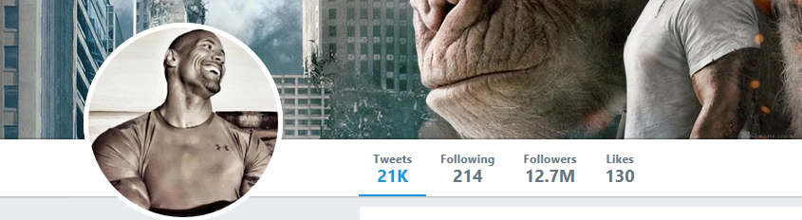


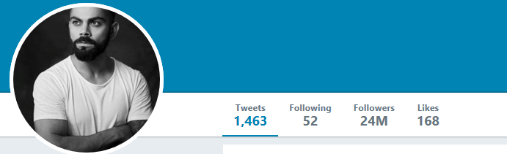
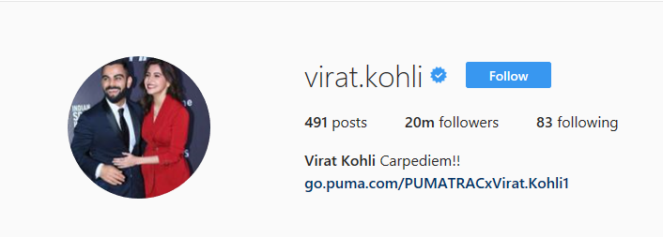

Appendices 4 – Factors that affect Consumer Behaviour

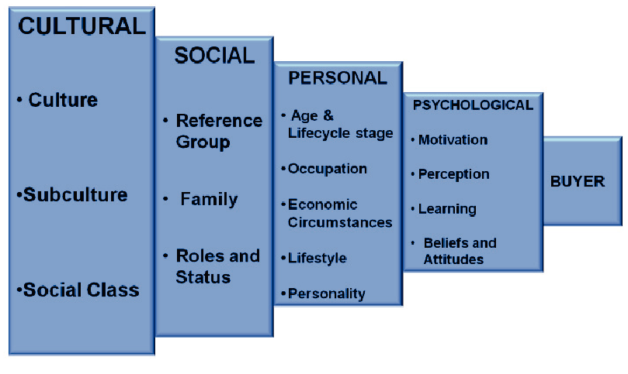

Appendices 5 – Nike Interactive Window Display



Appendices 6 – Brand Innovation Diagram

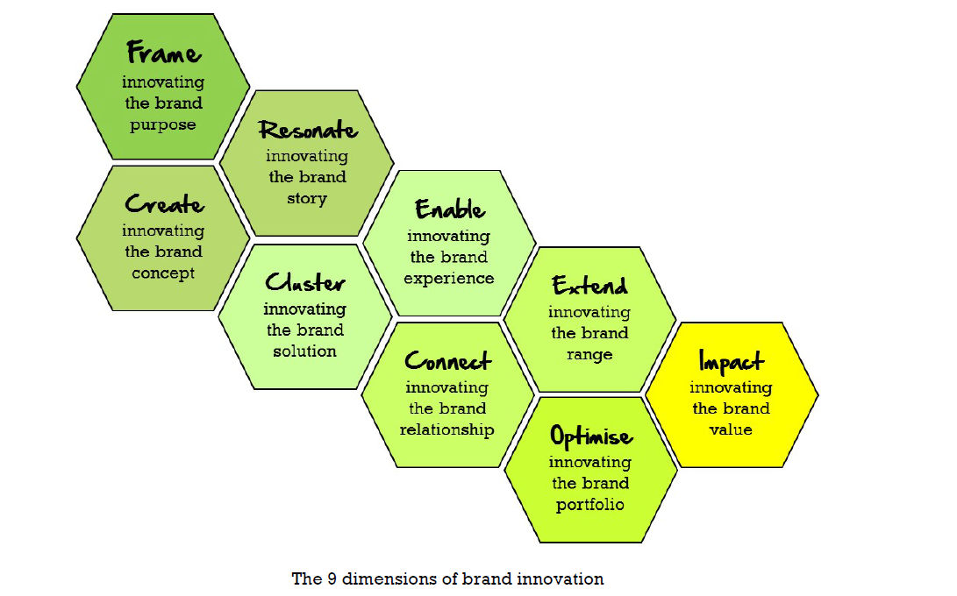
http://www.thegeniusworks.com/wp-content/uploads/2015/10/Brand-Innovation-Article-by-Peter-Fisk-2015.pdf

Appendices 7 – Brand Language

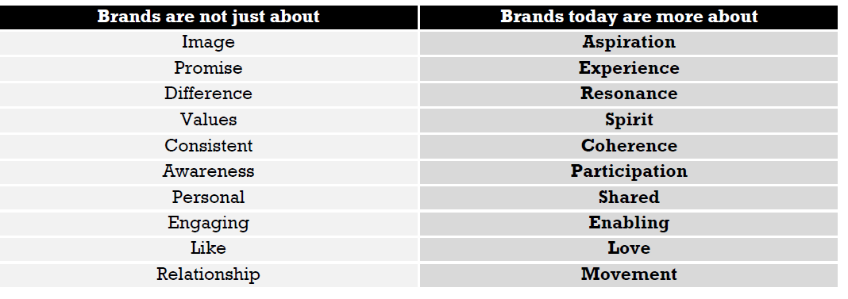

http://www.thegeniusworks.com/wp-content/uploads/2015/10/Brand-Innovation-Article-by-Peter-Fisk-2015.pdf

Appendices 8 – Nike Fuel Band



