Lloyd Case (1818917)

ACCA5034
DATA SECURITY AND COMPLIENCE

ASSIGNEMENT 1: RESEARCH AND CASE SCENARIO IN DATA SECURITY AND COMPLIANCE

Task 1

Research in Data Security and Compliance

Security Technologies

Firewall
[1]
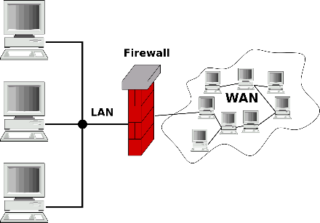
A firewall is used to make your connection safe when communicating with other computers or downloading files from the internet [1]. This means that the firewall protects your computer from any harmful files or any unauthorized access to your network [1]. When using a firewall, it is important to note that there can be some false positives that come with it. While uncommon it can happen, and this will lead to a website getting blocked or a download getting blocked because the firewall thinks it is harmful [1]. You will have to manually allow the website or download while in the settings of your firewall application [2]. Firewalls can packet filter and this means that it can block any data packets if it is coming from a known harmful IP address, or if it is a virus or a trojan that is coming through the packet [3]. It will only filter the packets if it from an unknown IP address, which would be from outside your LAN (local area network). Firewalls are often included in VPNs which are used to protect yourself when browsing the internet.

VPN
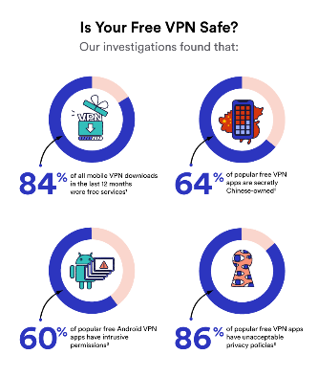
[4]
A VPN (Virtual Private Network) is used to encrypt your data over the internet [5]. What this does is hide your IP address when visiting websites, this allows you to click on websites that were previously blocked because of your firewall as well as access websites that are region locked. You can set a specific location for the VPN to show you where you are meaning that you are untraceable when browsing the web as this makes browsing the web much safer as if you clicked on a dangerous website that can track your IP address, it will not show up as the VPN has placed you somewhere completely different, therefore protecting you [5]. VPNs offer privacy and security when using, it is recommended that you almost always use one because it makes searching and browsing on the web much safer. You still must be careful when using a VPN because you can still download or go to harmful sites that can still damage your device [6].
The great thing about VPNs is their ease of use, they are very simple to set up correctly. They will not interrupt your browsing as they do not slow down your internet. They are available digitally and physically in the form of a router, both ways are very simple to set up [7]. VPN will also keep you anonymous when browsing [6].

Antivirus
Antivirus is used to stop your computer from getting harmed by malware. This could be anything from a harmful link that you clicked on from an email, visiting a website which can steal your data and downloading a harmful file onto your computer [8]. Antivirus works by scanning programs that are on your computer to see if there are any files that are potentially harmful [8]. Antivirus programs can come with additional features such as their own firewall [8].
From Security.org, it is stated that there are 2.76 million cyber-attacks between the years of 2017 and 2021 [9]. This is a very high number and this mostly effects businesses the most as if this happens, they could have data that is compromised and therefore no longer be private information. If this happens to a business, then they could lose a serious amount of money as they will have to make sure this issue is resolved [10]. Antivirus is not needed on devices such as a mobile device because if you download from the official app store on the device, all applications have been approved and therefore will not cause any harm to your device [11].

Cryptography
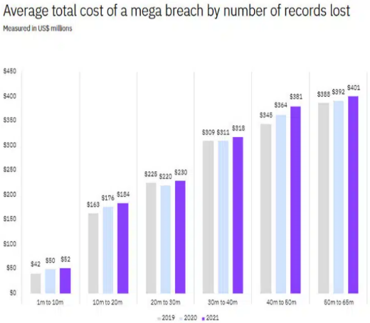
Cryptography is all about encryption and decryption. What it does is simple in that it turns your basic text into ciphertext [12]. The encryption occurs when you use a key that allows the user to decrypt the message. What this means is that if someone was too hack into your account and see the messages, they would not be able to view the messages because they will be encrypted, as a result this means that cryptography is a very safe way to message private details [13].
[14]
There can however be problems with using cryptography, these being that it can be too difficult to decrypt the message [15]. If this were to happen, then it would be nearly impossible for you to retrieve the message. If a hacker were to do this to you then you would have no way to get the key, therefore making it dangerous if not used correctly. However, its main uses are that of protecting sensitive data such as online banking [16], emails and even the government uses it for communication.

Physical Security
Physical Security is a way of physically protecting something, this can be the use of CCTV security cameras and alarms [17]. There are other methods to help with this such as fences as well as sign to show that you are trespassing. These are a great help because they make sure that there is no unwanted access by criminals [17]. There is also access control, which is the use of keys, locks, biometric systems [18]. It is very important to have emergency protocols in place in case of a hazard such as a fire [19] were to break out. You need to have backups of data in case of emergencies. Good lighting in dark areas to make sure that trespassers cannot hide in the dark away from the cameras [18], just make sure that the cameras and lights are able to see everywhere and that there are no blind spots that can be taken advantage of.
In 2022 it is stated that 32% of companies do have a form of access control as physical security [20]. This means that the use of keys or a biometric scanner are somewhat popular and on the rise in terms of use.

Information Security Maintenance
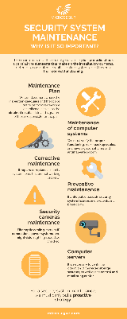
[21]
With information security maintenance, the goal is to make sure all the security measures are working as intended and that there are no faults in any of it [22]. Maintenance will be performed on all systems to ensure that they are all up to date and working correctly. This works well with other forms of security; maintenance must be performed on the computer systems to make sure the antivirus software is all updated as well as the firewall and any other programs that are in use for security [21]. This also goes for the physical element too, make sure the hardware of the computers is not old and a security risk, make sure all the security cameras are working correctly.
As stated by Processing Magazine, 68% of manufacturing professionals said that cybersecurity is critical [23]. This is important to note because it shows that the majority of companies do keep up with their security, this means that there is a lot of maintenance work on all aspects of security to ensure that the cyber security side is safe and working correctly [23]. In doing so they stop risking any breaches that can happen and makes sure that the employees can continue working without the need to troubleshoot their problems [24]. Continuing to care for the maintenance of their systems can improve the overall security as well as performance of the devices as they will be up to date with the latest improvements and security that is available, for the best performance they can offer [24].

Review
This is the review on why modern organizations need to create an environment that protects, detects, reacts and safeguards applications using organizations IT systems and infrastructure.
As stated earlier there are many reasons as to why organizations need to create this environment. It is important for them to protect; this means preventing hackers or trespassing. They can do this by using digital security such as antivirus, firewalls and VPNs. All of these will drastically increase the security of their devices by ensuring that they browse the internet safely as well as download files safely. Physical security will also be a huge help here as this will stop people physically trespassing such as criminals. To help with this you can use security cameras as well as alarms to be able to protect your property, such as the server room or anything else important. You can use fences to stop people from getting onto your property, as well as not having any blind spots so that the cameras cover all possible locations, and nothing is left vulnerable.
Using cryptography as a way of communication is another great method to ensure that the organization will be safe. As stated earlier this method is great for encrypting messages as well as decrypting them, obviously this comes with its own issues, however it is still one of the safest ways to protect what the organization is doing in terms of communication. As seen in the graph used, the cost of a breach is very expensive, and you do not want to lose that much money on something they could have prevented for a much cheaper price than what they will now pay. Certain policies will be crucial in making sure that the cryptography is used correctly and efficiently within the organization.
Having emergency measures in place in case of an emergency is very important as you don’t want to lose your data because of a fire hazard. The organisation must be able to react accordingly to anything, this can be from theft to a hazard, there must be measures in place. To help with this an organisation can use cloud storage to help with alleviating the pain. The security maintenance is what will really help with this because they will be on top what everything and seeing what is and isn’t working accordingly and will issue fixes for the issues to be resolved as soon as possible. This is the safeguarding of the applications as this is what will be updating the systems and ensuring they are up to date with all the latest security fixes as well as the software’s that will be in use. This is also the reacting to issues as the security team will be the ones reacting to what is going wrong and then the specific team that is working in the sector with the problem will be the ones trying to deal with it. There should also be specialised people that can help alleviate any issues that arise.

Task 2

Case Scenario

Organization Structure
Looking at the organizational structure of StresSolution would be a great starting point. With the information that is known, it seems the organization is split up into multiple little areas. We know that StresSolution has a part that offers and sells their services online. This service is aimed at assisting businesses with cyber-attacks. They also offer a consultancy service which helps their customers with providing the right tools and framework solutions to help with data recovery and risk management, which also includes their cloud services.
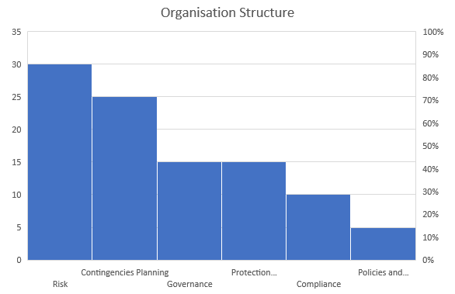
Knowing all this information is important because it shows how the organization is set up. Using this information my own approach to this would be too constantly update the website that the customers purchase from to show all the latest updates as well as offers they currently have. This would allow them to potentially gain new customers as they would be able to see what they offer differently to other competitors. To do this you will need to have employees constantly working on the website to ensure it is all working correctly, updating the information and showcasing why their product is better than the rest.
The organisation would have to have employees constantly working ensuring that their cloud services are always up and running, making sure that the service they sell works. The organisation will need a lot of employees just to ensure the basics are available to them.
The graph shows the percentage of people that will be working in each of the different sectors, this mainly consists of the higher being the one that requires more people to work on it at the same time comparatively to the lowest which requires the least amount of people to work on it at the same time. This does not indicate which is more important as without any of these the organisation will fall apart; it is simply which requires the most resources on any given moment.

Policies and Procedures
For the policies and procedures, these must be followed thoroughly to ensure that everything is within the industry standards. They must do this as to not fall behind any competitors. The organisation must have their own set of policies and procedures that cover everything that they offer to ensure the best safety possible when purchasing the services that they offer.
These policies must include procedures that cover all their data protection, this is important as this will be everything that the organisation is in terms of anything they need to know as well as the customer information, which they do not want to be hacked and leaked out as this will cause serious problems.
Access control is another policy which must be followed as this will further protect information as well as trespassing. What this will do is allow only certain people/employees to access certain information by using keys, or biometric scanners. This will further help with protecting information, further securing the data and following along with the policies and procedures.
All employees must follow a certain procedure whether this is in training for becoming an employee or learning how to do something new within the company, it is important that all employees follow these procedures as each sector within the organization will have certain exclusive policies and procedures to follow as well as companywide ones.

Compliance (Laws and Ethics)
Similarly, to policies and procedures, the compliance of laws and ethics is important, as a breach of any of these could result in the firing of the said employee that broke them. There are certain laws which must be followed when creating a service as well as hosting a cloud service and a website as well as their consultancy service. There needs to be audits that are regularly set through to the help desk, just for them to keep up to date with any issues and tell a specific sector about it as well as keeping a note of the issues in case of any legal issues that may occur.
The organisation must follow industry standards and regulations as to not break any laws. The ethics within the organisation should also be fair and valued for everyone within the organisation, with any form of breaking or breaching these to result in a penalty which will be up to the organisation.
Data privacy is another important part of this, as every customer wants the insurance that their data will be fully protected and not sold or used in any other way. The terms and conditions will specify what the data will be and won’t be used for, this is why it is important for the customer to read what they are. Encrypting the data is important for privacy as even in the scenario the organisation does get attacked and information stolen, they would still want the information to be encrypted just to add that extra layer of security just in case.

Governance and Strategic Planning for Security
The governance will be focusing on making sure that the security is tight within the organisation as well as strategically planning how this can affect the organisation is a positive manner. A great use of this would be to look at the security and see how to also turn that into a positive that can help the organisation make more money. Checking to see if this can help certain aspects of the organisation such as the digital security aspect would be a great help and could even help cut costs as this could effectively be a 2-in-1 job as this can tackle both the security of the organization as well as making sure this helps the organization publicly and privately. So strategically this aspect of the organization can help the organization with its objectives as well as its security.
This will be having certain people in certain positions in power to make sure the organization is running efficiently. The person in charge must be hand on in making sure there are no problems at any given moment. This is also a good thing as it ensures the employees are always working hard and doing their best. The higher ups will also be developing a long- and short-term plan that will be in use by the organization to see if they can meet their targets simply or if they would require more time and effort. In this plan the organization would tell all employees about the goals of the organization and what milestones to hit at certain periods of time.

Risk Management
Risk management is always important as this prioritises the risks and takes steps to minimise as much risk as possible. The way this is implemented into the organisation is by having a piece of software that constantly scans and detects any unusual software that is not normally on any of the computers. It will constantly be checking for any breaches into the network and try and detain them as soon as possible, a great way to know if this is effective is by trying to hack into the network yourself to see where the weaknesses are within the network. By doing this you can scan and see how likely it is that you will be breached by an attacker.
They must make sure that the cloud service is completely free from any attacks too. This is important to consider because if one file was to get infected and uploaded to the cloud then every time that file gets downloaded, the computer it gets downloaded too can then also catch the virus and then it will spread through all the computers, and then the cloud will get infected then all the files will be unusable and then you would have lost all your files. This is why backups are important!

Contingencies Planning
Contingencies planning is like risk management, in that this prepares the organization for any sort of hazard or unforeseen circumstances that can occur due to stuff that is out of the organizations control. This includes any breaches, like a cyberattack, fire or a natural disaster, anything that will fully disrupt the organization that is difficult to prepare for.
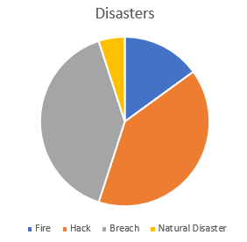
A cyberattack can be prepared for by using what was learned in the risk management, however that will not always work and therefore can be a surprise and be unable to account for it. Natural disaster is on the extreme side of circumstances, but still possible. If this was to occur and destroys the organizations workplace, then they should be able to claim insurance and all the data, and any backups should be safe as they should be off site or on the cloud. The employees must know what to do in case of emergency and should have had training to help for moments like these.
This chart shows the likely hood of a certain disaster occurring, meaning that the organization should prepare for the most likely one first before the others as that will have a higher chance of occurring, but does not always mean that it will be the one that will occur if there is a disaster meaning that the organization must be fully always prepared for any of these to ensure maximum safety.

Protection Mechanisms
Again, protection mechanisms are like the policies and procedures and the risk management that are used within the organisation. What protection mechanisms do is help with security, this is essentially all the extra security that is needed to help fully secure the organisation. How this helps the browsing is things such as firewalls and VPNs. This helps make browsing safer and more secure, so you don’t download any suspicious flies from a scam email or an unknown website. The firewall will kick in and tell you that it does not trust what you just downloaded.
Encryption is another protection mechanism that is used. As mentioned earlier this can help when sending confidential information over the internet via email or a message. What this does is fully encrypt the message so that if an attacker was to see the message, they would not be able to decrypt it as they do not have the key therefore to them is scrambled letters and numbers that they cannot do anything with.
Antivirus is another this will simply help when installing unknown files as it will warn you that the file could potentially have a virus on it. Securing the cloud with its own antivirus so that virus do not find there way into the cloud to infect it is another great method to help, as this can help ensure the cloud is safe for everyone to use, always helps to have backups just in case anything does happen. Reporting anything that goes wrong is vitally important as this allows the experts of said area to get on the problem immediately and start fixing what needs to be done.

References

[1] | K. Glamoslija, “What Is a Firewall & Can It Protect Your Computer?,” Safety Detectives, 26 October 2023. [Online]. Available: https://www.safetydetectives.com/blog/what-does-a-firewall-do-and-is-it-enough-for-your-computer/. [Accessed 12 December 2023].
[2] | “Firewall Benefits: The Importance of Firewall Security,” Fortinet, [Online]. Available: https://www.fortinet.com/resources/cyberglossary/benefits-of-firewall. [Accessed 12 December 2023].
[3] | M. Rouse, “Packet Filtering,” Techopedia, 25 January 2017. [Online]. Available: https://www.techopedia.com/definition/4038/packet-filtering. [Accessed 12 December 2023].
[4] | S. Migilano, “The Best Free & Paid VPNs to Get a UK IP Address,” Top10VPN, 6 November 2023. [Online]. Available: https://www.top10vpn.com/best-vpn/uk/. [Accessed 13 December 2023].
[5] | “What is a VPN?,” Microsoft, [Online]. Available: https://azure.microsoft.com/en-us/resources/cloud-computing-dictionary/what-is-vpn. [Accessed 12 December 2023].
[6] | “How A VPN Can Help Hide Your Search History and Is Private Browsing Really Secure?,” Kaspersky, [Online]. Available: https://www.kaspersky.com/resource-center/definitions/how-does-vpn-keep-me-safe-online. [Accessed 12 December 2023].
[7] | C. Castro, “What are the benefits of using a VPN,” Tech Radar, 19 March 2022. [Online]. Available: https://www.techradar.com/vpn/benefits-of-vpn. [Accessed 12 December 2023].
[8] | G. T. Aliza Vigderman, “How Does Antivirus Software Work?,” Security, 20 September 2023. [Online]. Available: https://www.security.org/antivirus/how-does-antivirus-work/#:~:text=Antivirus%20software%20scans%20your%20device,software%20to%20cover%20any%20vulnerabilities.. [Accessed 12 December 2023].
[9] | G. T. Aliza Vigderman, “A 2023 Guide to Personal Digital Security & Online Safety,” Security, 11 August 2023. [Online]. Available: https://www.security.org/digital-safety/. [Accessed 12 December 2023].
[10] | “What is Antivirus Software?,” Webroot, [Online]. Available: https://www.webroot.com/gb/en/resources/tips-articles/what-is-anti-virus-software. [Accessed 12 December 2023].
[11] | “What is an antivirus product? Do I need one?,” National Cyber Security Centre, 21 January 2019. [Online]. Available: https://www.ncsc.gov.uk/guidance/what-is-an-antivirus-product. [Accessed 12 December 2023].
[12] | “What is Cryptography in security? What are the different types of Cryptography?,” Encryption Consulting, [Online]. Available: https://www.encryptionconsulting.com/education-center/what-is-cryptography/. [Accessed 12 December 2023].
[13] | “What is cryptography?,” Synopsys, [Online]. Available: https://www.synopsys.com/glossary/what-is-cryptography.html. [Accessed 12 December 2023].
[14] | C. Mccart, “15 Encryption Statistics in 2023,” Comparitech, 29 March 2022. [Online]. Available: https://www.comparitech.com/blog/information-security/encryption-statistics/. [Accessed 13 December 2023].
[15] | “Cryptography Benefits & Drawbacks,” Tutorials Point, [Online]. Available: https://www.tutorialspoint.com/cryptography/benefits_and_drawbacks.htm. [Accessed 12 December 2023].
[16] | D. Team, “Cryptography Pros & Cons: A Digital Security Guide,” Daisie, 7 August 2023. [Online]. Available: https://blog.daisie.com/cryptography-pros-cons-a-digital-security-guide/. [Accessed 12 December 2023].
[17] | “GUIDE TO PHYSICAL SECURITY CONTROLS, PLANNING, POLICIES AND MEASURES,” Pelco, [Online]. Available: https://www.pelco.com/blog/physical-security-guide. [Accessed 13 December 2023].
[18] | “Safeguarding Your Assets: The Critical Role of Physical Security in Cybersecurity,” Devoteam, [Online]. Available: https://www.devoteam.com/expert-view/cybersecurity-the-importance-of-physical-security/. [Accessed 13 December 2023].
[19] | “Protecting Your System:,” NCES, [Online]. Available: https://nces.ed.gov/pubs98/safetech/chapter5.asp. [Accessed 13 December 2023].
[20] | “Why Physical Security Matters,” Benchmark, 28 July 2023. [Online]. Available: https://benchmarkmagazine.com/why-physical-security-matters/#:~:text=As%20of%202022%2C%2032%25%20of,facial%20recognition%20and%20biometric%20authentication.. [Accessed 13 December 2023].
[21] | “Security System Maintenance. Why is it so important?,” Microsegur, [Online]. Available: https://microsegur.com/en/security-system-maintenance-why-is-it-so-important/. [Accessed 13 December 2023].
[22] | “CSS 111 - Introduction to Information System Security,” Steve Vincent, [Online]. Available: https://stevevincent.info/CSS111_2014_9.htm. [Accessed 13 December 2023].
[23] | F. B. Matthew Hudon, “Minimizing cybersecurity risks with preventive maintenance,” Processing, 3 November 2022. [Online]. Available: https://www.processingmagazine.com/process-control-automation/cybersecurity-safety/article/21286071/minimizing-cybersecurity-risks-with-preventive-maintenance. [Accessed 13 December 2023].
[24] | N. Mccracken, “The Importance of IT Maintenance,” ITSD, 1 August 2023. [Online]. Available: https://www.itsd.com/the-importance-of-it-maintenance/. [Accessed 13 December 2023].

